CAMBODIA – Phnom Penh – Penh House Hotel
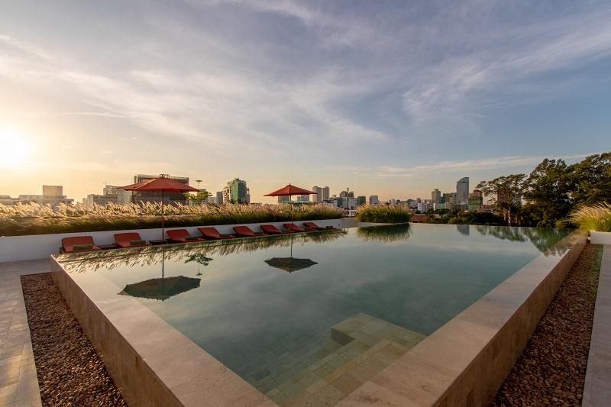

Over View

Theme
Classic

Country - City
Cambodia - Phnom Penh

Market segment
Thematic Leisure

Official category
4*

Easia category
Deluxe

Total number of rooms
52 rooms

Price level
$$$

Description

Overlooking the green treetops of the Royal Palace gardens and the many roofs of Wat Botum Royal Pagoda, popular shops and artsy café, Penh House Hotel offers two very distinctive options creating an Oasis in the heart of the Historical Phnom Penh :Penh House: Inspired by Cambodia’s tropical nature and New-Khmer architecture, an indoor oasis with breathtaking views over the historic quarter. Pagoda roofs and the Royal Palace’s majestic trees create an aura of serene tranquility amidst the high-rises and traffic of the city.

Selling points

- An Oasis of greenery in the city-center
- An unique concept hotel in Phnom Penh with 2 atmosphere, one contemporary and one colonial
- A rooftop infinity pool gliding over the treetops of the Royal Palace gardens, with exceptional 360 degrees views on Phnom Penh cityscape
- A good value for money

Time & Transportation

From | To | By | Km | Duration | Road Condition
Hotel | Phnom Penh International Airport | Tuk-tuk, car, van, bus | 9 km | 45 min. | Good

Rooms

Easia's recommend room type
Penh House & Jungle Addition Hotel offers 70 nice and well equipped rooms1.Penh House : 52 rooms
Deluxe Double : Respite from the bustling city thanks to harmonious design and soothing views upon our leafy district. King-size bed, streamlined furniture with modern Asian details, spacious armoire. Separate bathroom with state-of’the-art fixtures.
- 35 sqm
- City view
- Number of rooms in this category: 47
Suite : On the upper floors with splendid views over the parks and historic sites around, vast accommodation at a remarkable rate for its size and location. King-size bed, walk-in closet, sitting area, en-suite bathroom with state-of-the-art fixtures, including bathtub. Modern nomad decor throughout.
- 50 sqm
- Garden & City views
- Number of rooms in this category: 5

Room configuration

Connecting rooms
NA

Extra bed
Yes

Services & Facilities

Services
24 hour reception, 24h security service, Airport transfer, Buffet Breakfast, Butler Service, Complimentary bottle of water, Complimentary fresh towel, Concierge service, Credit Card payment, Currency exchange, Doctor on call, Handicap Accessible, In-Room Dining, Iron, Laundry service, Luggage Storage, Massage, Porter, Private event, partying, Room Service, Spa, Swimming Pool, Wake-up service, Wi-fi Free

Facilities
Air Conditioning, Bar, Business centre, Cable, satelite, coffee and tea making facilities, Coffee Shop, Courtyard, Disabled Facility, Elevator, Family Room, Fan, Fitness centre, Flat screen TV, Garden, Gift Shop, Hair Dryer, In-Room safe, Internet, Massage room, Meeting room, Mini Bar, Newspapers and magazine, Outdoor swimming pool, Restaurant, Safety Box, satellite LCD TV, Shower With Hot Water, Smoking Area, Steam/Sauna, Terrace, TV Room, Umbrella

Disabled Facilities
Outside access, Restaurants, Rooms are adapted, Swimming pool, Elevator

Business facilities details
Spacious, luminous area with high ceilings and a glass wall opening to a lush patios.
- 80 sqm
- seats 55 guests
- conference room appliances
- wide range of catering options, see samples below
- bookings here or by phone +855 23 212 200

Restaurant information

Restaurant Name | Rooftop Lounge & Restaurant
Type of food | - Western and Khmer style  - Breakfast  - Light lunch and dinner  - Cocktails
Operation hour | All day

Photos

Hotel Photos
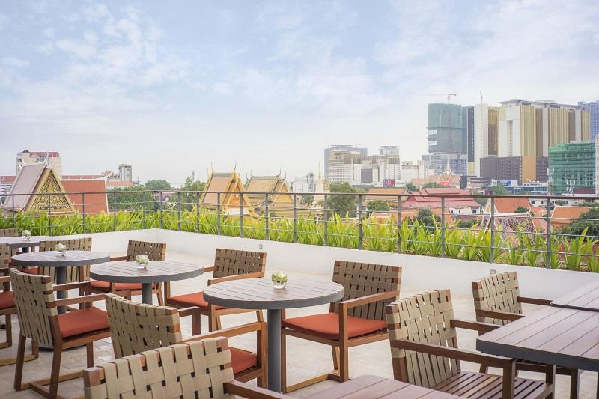
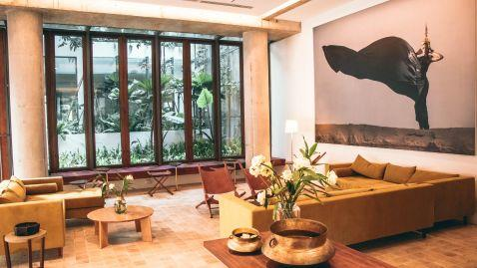

Rooms photos
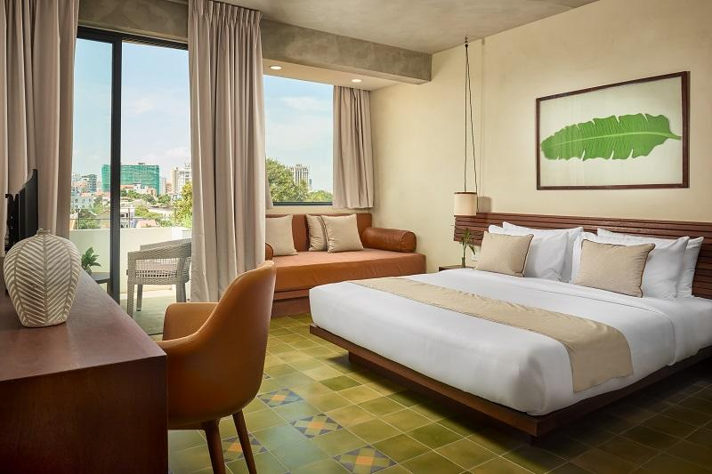
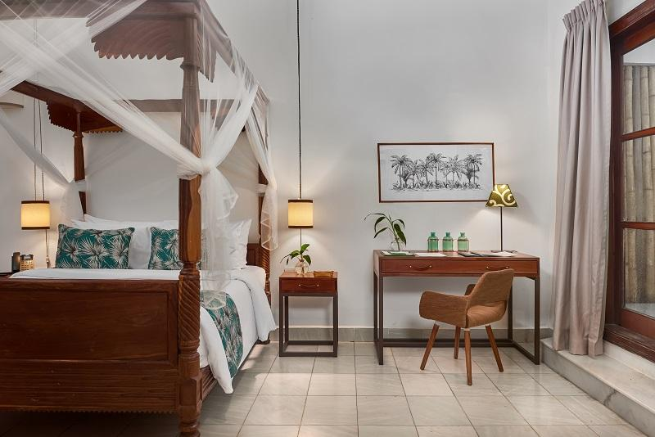
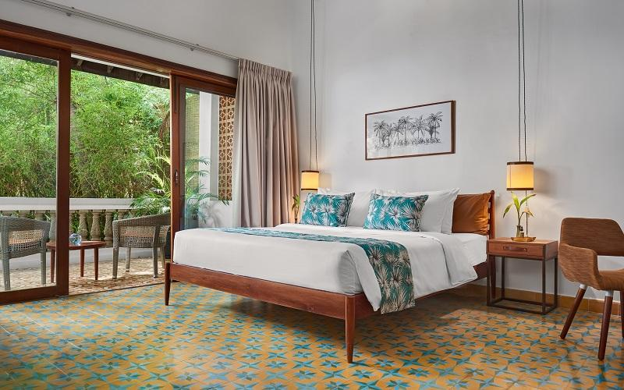
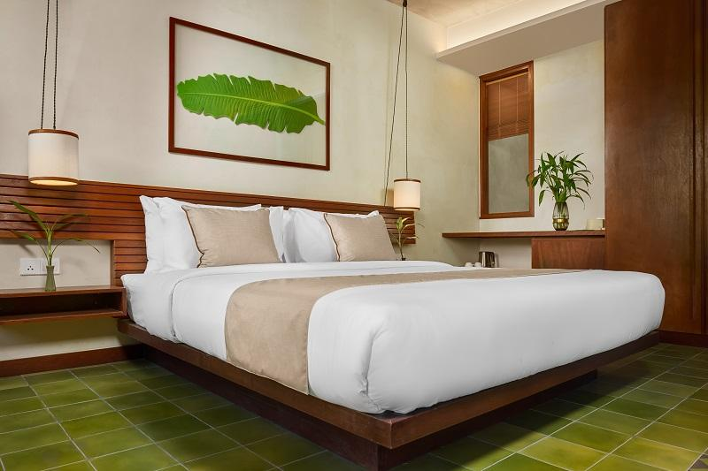
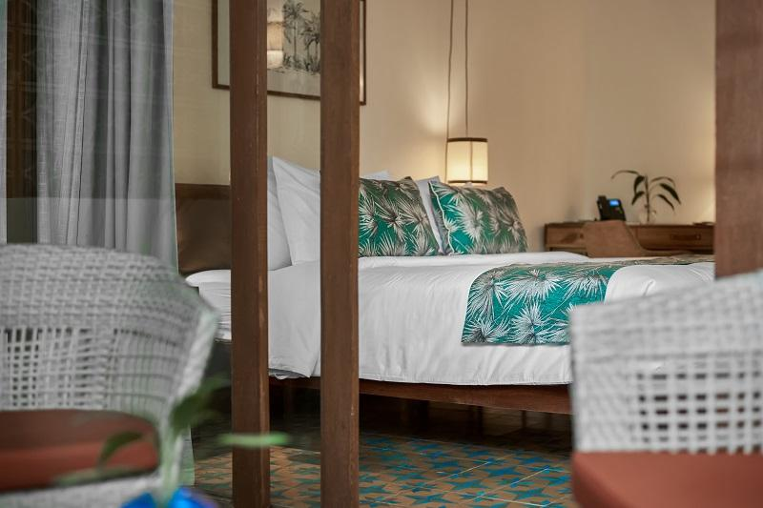
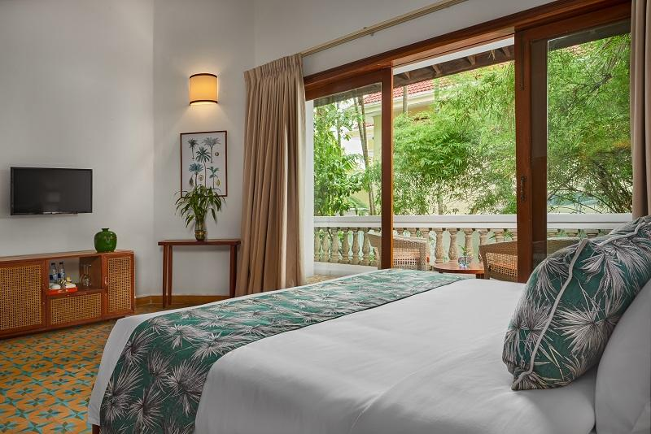

Restaurant photos
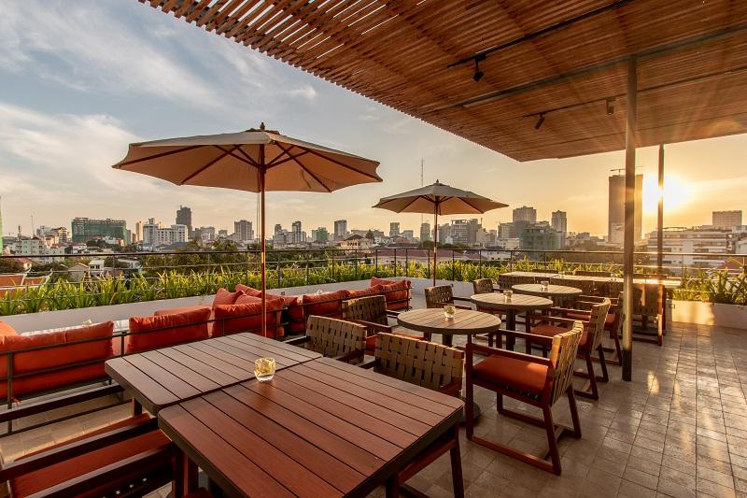
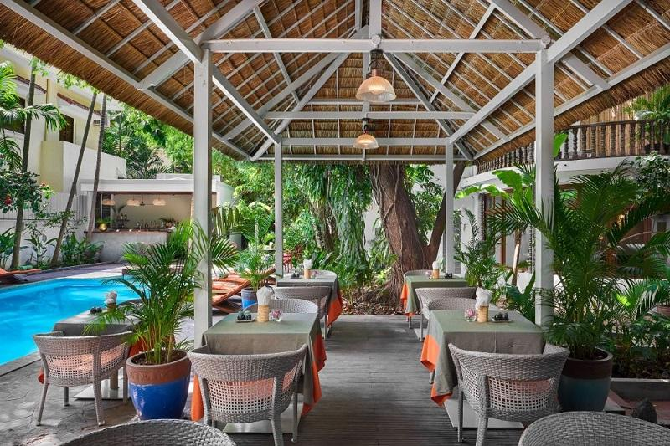
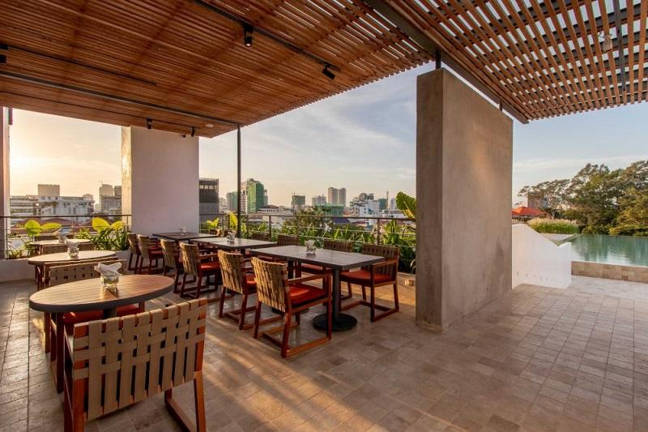

Business facilities photos
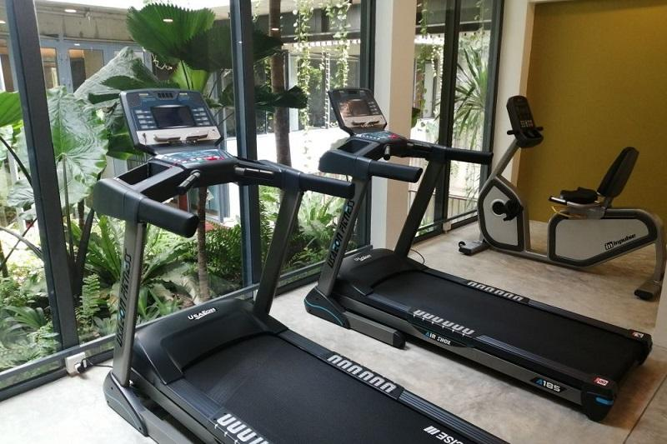

Services & facilities photos
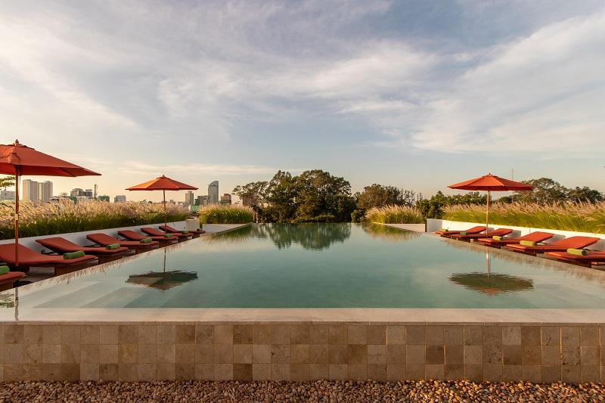
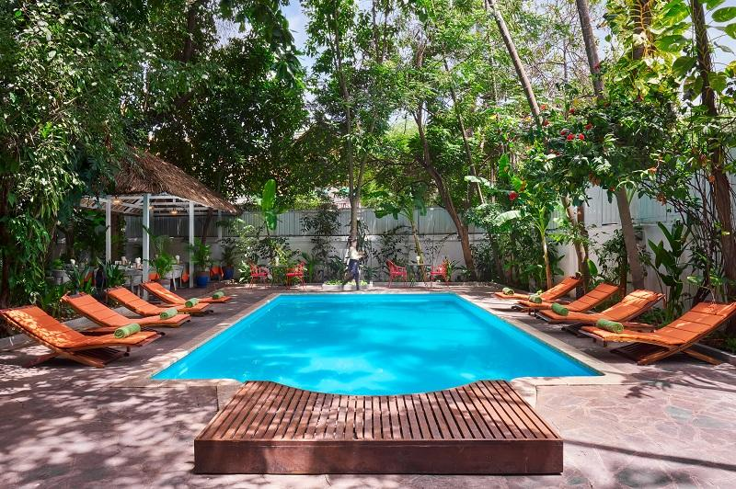

Easia Travel Head Office

Siem Reap BranchCharming City, No. R32 – R34, Road Rolouse, Trorpeangses Village, Sangkat Koukchork, Siem Reap Province – CambodiaTel: (855-63) 76 14 58Fax: (855-63) 76 14 58

