CAMBODIA – Kep – Tara Lodge
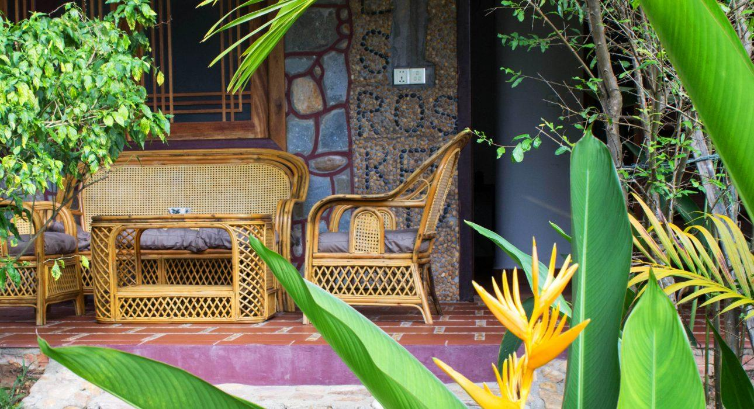

Over View

Theme
Classic

Country - City
Cambodia - Kep

Market segment
Thematic Leisure

Official category
4*

Easia category
First Class

Total number of rooms
9

Price level
$$

Description

Located on the hillside at the foot of the national park, Tara Lodge is a charming hotel nestled in the heart of a lush tropical garden.Tara Lodge features 9 rooms with clean and comfortable beds, a restaurant & bar and an outdoor swimming pool. Closed to Crab market and the beach, Tara Lodge is a haven of peace, ideally located to explore the charming city of Kep and its countryside.

Selling points

- A tranquil place, a haven of peace, for travelers looking for a silent place and willing to relax
- The hotel overlooks the sea and allows travelers to admire the incredible sunsets of Kep from the restaurant’s terrace.
- It is an excellent location to explore Kep and its countryside, 20 min to Crab Market, close to the entrance of Kep National Park.
- The pleasant swimming pool in the tropical garden

Time & Transportation

Rooms

Easia's recommend room type
The hotel is equipped with 9 comfortable rooms of 25m² each one.The rooms have a terrace, air conditioning or a fan. They have a flat-screen cable TV, wifi, minibar and amosquito net. Each has a private bathroom with shower and toiletries.The Standard rooms are located on ground floor whereas Superior ones are on first floor.
- Standard Double Room (1 room )
- Standard Twin Room (3 rooms )
- Superior Double Room (2 rooms )
- Superior Twin Room (2 rooms )
- Family Room (1 room until 4 perons)

Room configuration

Connecting rooms
No connecting room

Extra bed
yes

Twin beds
yes

Services & Facilities

Services
24 hour reception, 24h security service, Airport transfer, Bicycle Rental, Boat Transfer from/to, Complimentary bottle of water, Complimentary fresh towel, Cycling, In-Room Dining, Laundry service, Luggage Storage, Massage, Porter, Swimming Pool, Wake-up service, Wi-fi Free

Facilities
Air Conditioning, Bar, Bicycle, Cable, satelite, Family Room, Fan, Garden, Gift Shop, Internet, Jacuzzi, Mini Bar, Outdoor swimming pool, Shower With Hot Water, Smoking Area, Terrace, TV Room, Umbrella

Disabled Facilities
Outside access

Business facilities details
Upon request, it is possible to privatize the property

Restaurant information

Khmer or Western cuisine at the restaurant in a quiet and serene environment overlooking the garden. A selection of cocktails and wine is available.

Photos

Rooms photos
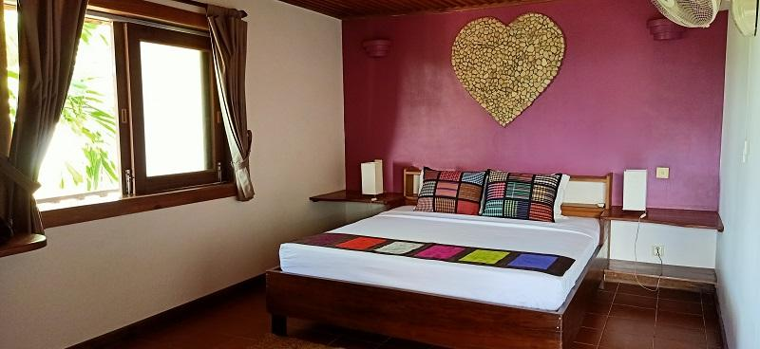
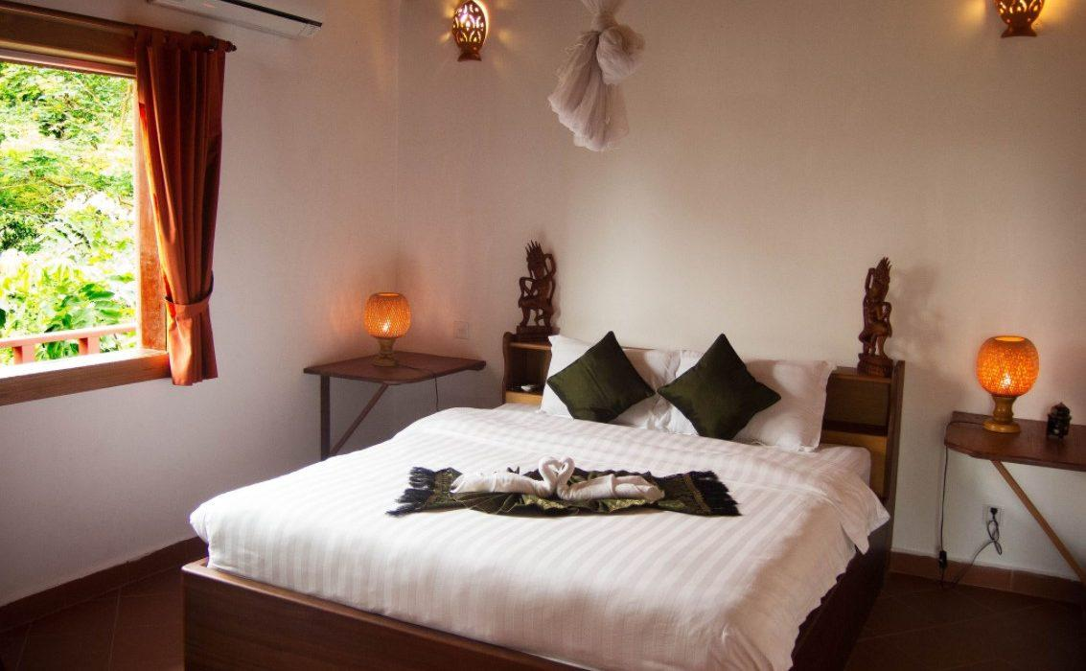
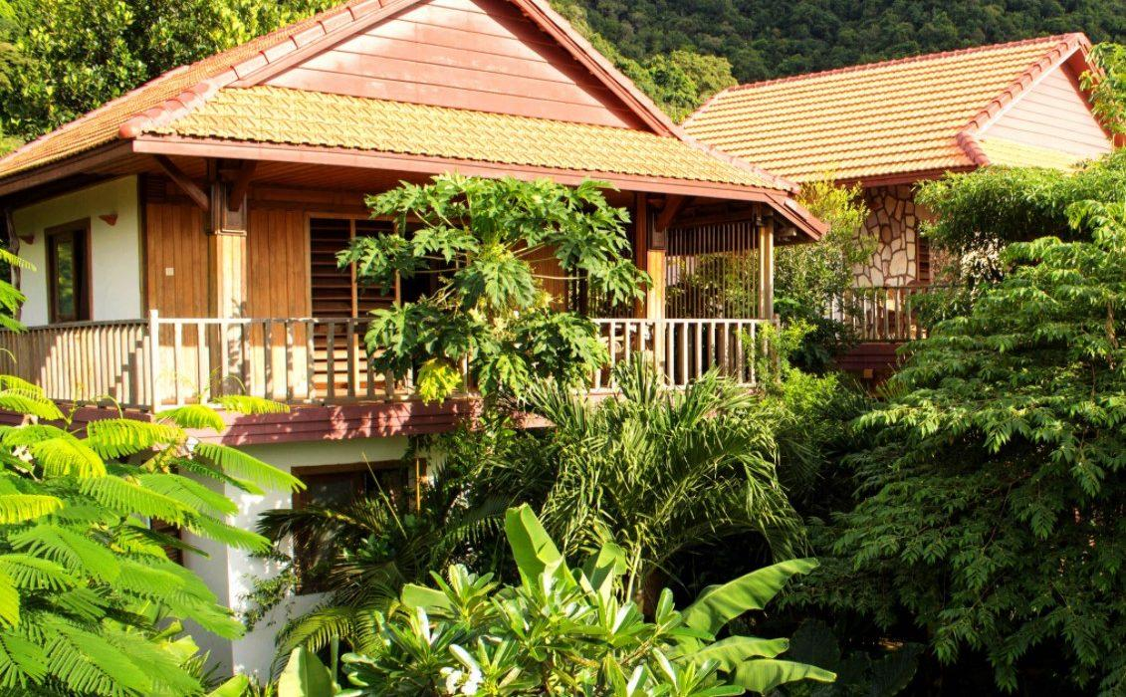
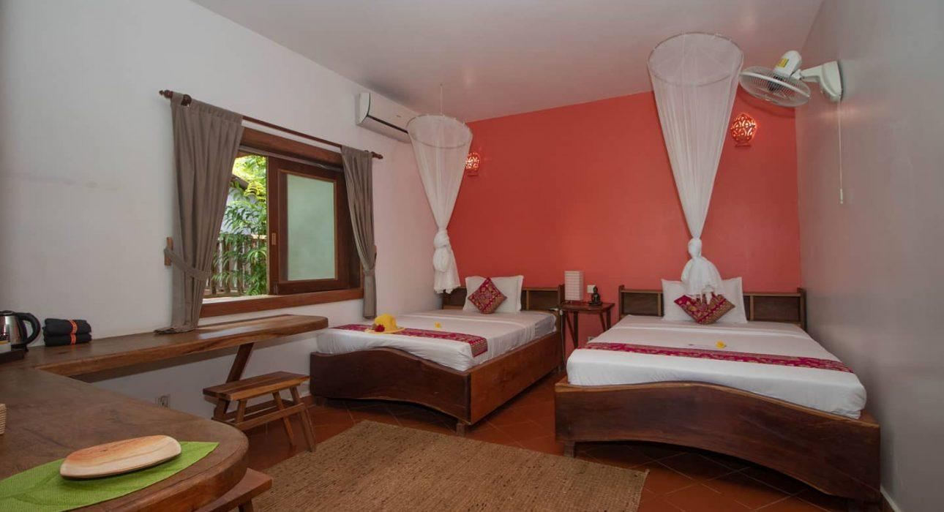
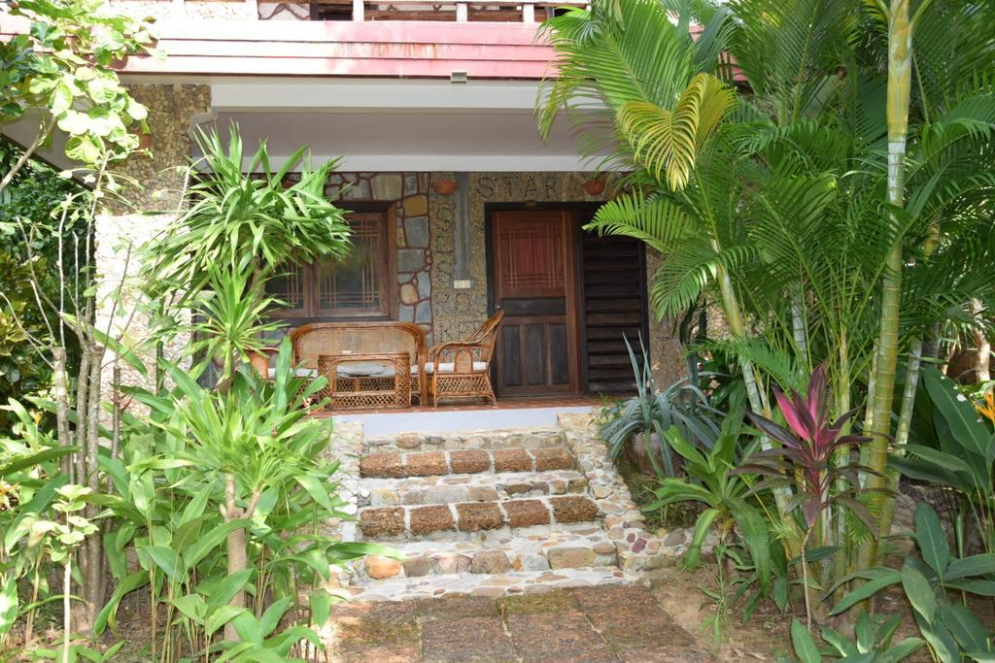
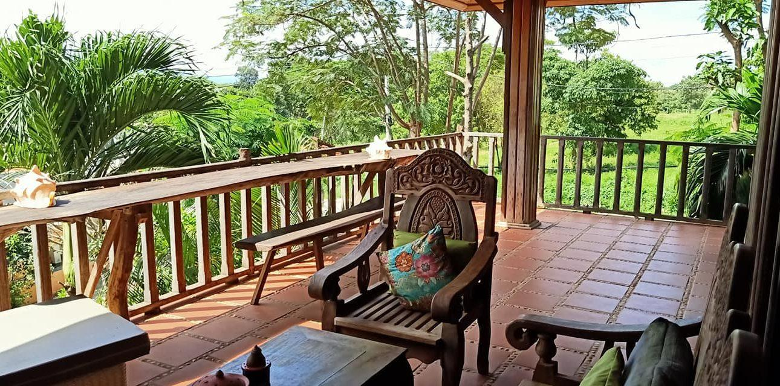

Restaurant photos
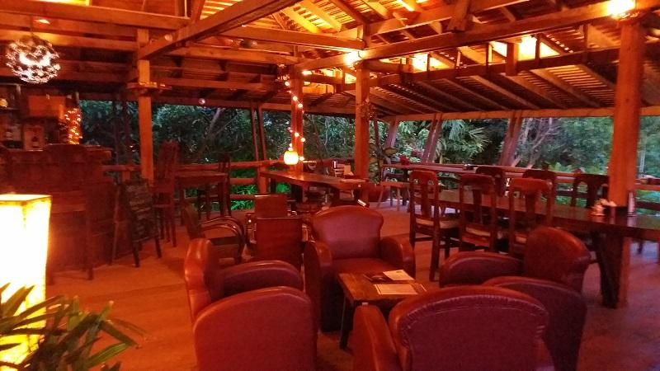

Services & facilities photos
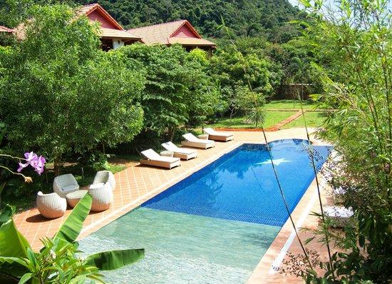
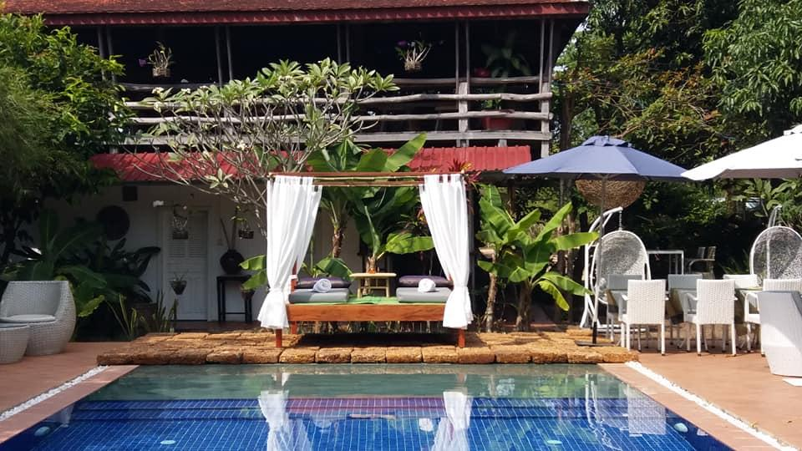
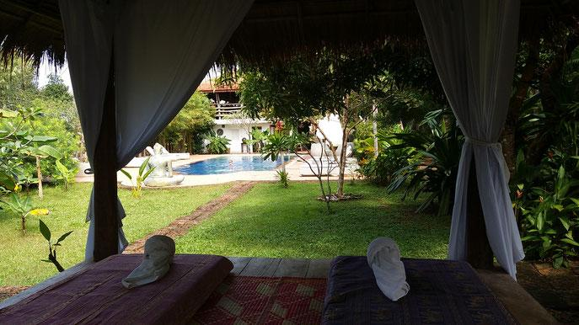

Easia Travel Head Office

Siem Reap BranchCharming City, No. R32 – R34, Road Rolouse, Trorpeangses Village, Sangkat Koukchork, Siem Reap Province – CambodiaTel: (855-63) 76 14 58Fax: (855-63) 76 14 58

