CAMBODIA – Koh Rong – Anaya Koh Rong
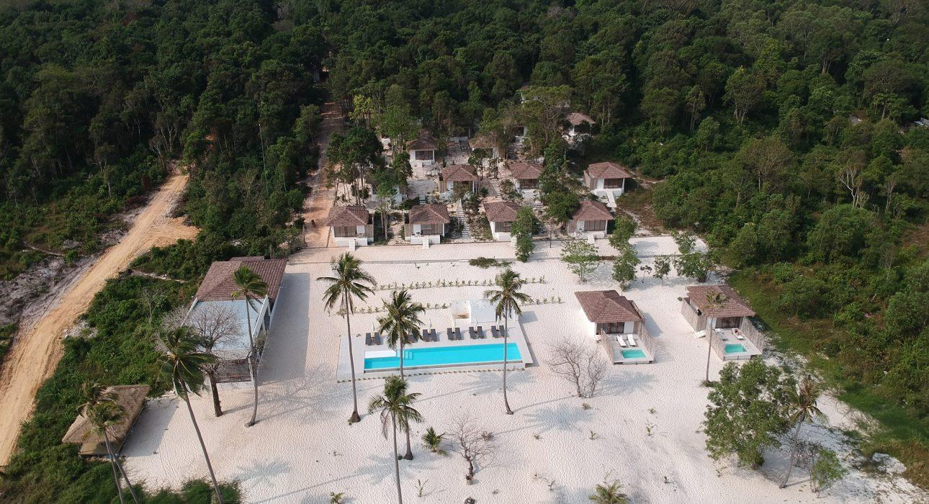

Over View

Theme
Beach Stay, Classic, Honeymoon

Country - City
Cambodia - Koh Rong

Market segment
Thematic Leisure

Official category
4*

Easia category
Deluxe

Total number of rooms
20 rooms

Price level
$$$

Description

Anaya Koh Rong is a perfect place to unwind and relax in a peaceful atmosphere. They offer 20 rooms surrounding by coconut trees and jungle that allow guests to enjoy a cozy experience and more relaxing vacation.
Anaya is a blend between modernity and nature opened on the surrounding lush jungle. The villas are made for people looking for the comfort of innovative design and panoramic views on the surrounding nature.

Selling points

- A recent hotel dating from 2019 offering spacious and bright villas overlooking the sea for some of them
- With turquoise water and a private white sandy beach, this is a great place to end a stay.
- Easy access thanks to a private boat transfer shared with other hotels on the beach.

Time & Transportation

From | To | By | Duration
Sihanoukville Port Gate 1 | Anaya Hotel | Private shared speed boat | 30 min

Rooms

Easia's recommend room type
The hotel is equipped with 20 comfortable modern rooms divided into 3 categories.Every villa furnished with the ultra-comfortable and high quality king-size and offers all the amenities you need for a comfortable stay.
- Private pool room – 2 rooms- Each room is overlooking the sea and has its own private small pool. They are equipped with King size beds and open bathroom.
- Deluxe room – 8 rooms Each Room provides view to the Swimming Pool and the Sea. Having easy access to the pool. They are equipped with King size beds and open bathroom.
- Double room – 10 rooms (including 3 twins) – Each rooms sets a benchmark with their modern styling and open bathroom. Scattered among the coconuts, they are positioned for privacy.

Room configuration

Connecting rooms
No connecting room

Extra bed
yes

King bed
10

Twin beds
3

Services & Facilities

Services
24h security service, Airport transfer, Boat rental, Boat Transfer from/to, Buffet Breakfast, Diving, Fishing, Laundry service, Luggage Storage, Massage, Mobile phone, Porter, Room Service, Snorkeling, Swimming Pool, Wake-up service, Wi-fi Free

Facilities
Air Conditioning, Bar, Cable, satelite, Garden, In-Room safe, Internet, Outdoor swimming pool, Private Beach, Private Pool, Restaurant, Safety Box, Shower With Hot Water, Terrace, Umbrella

Disabled Facilities
Outside access

Restaurant information

The restaurant is overlooking the pool, beach and jungle offering a blend of Italian and Khmer cuisine.Possible to book for private set up on the pier, or dinners poolside.Opens from 7 am for breakfast until late evening.

Photos

Hotel Photos

Rooms photos
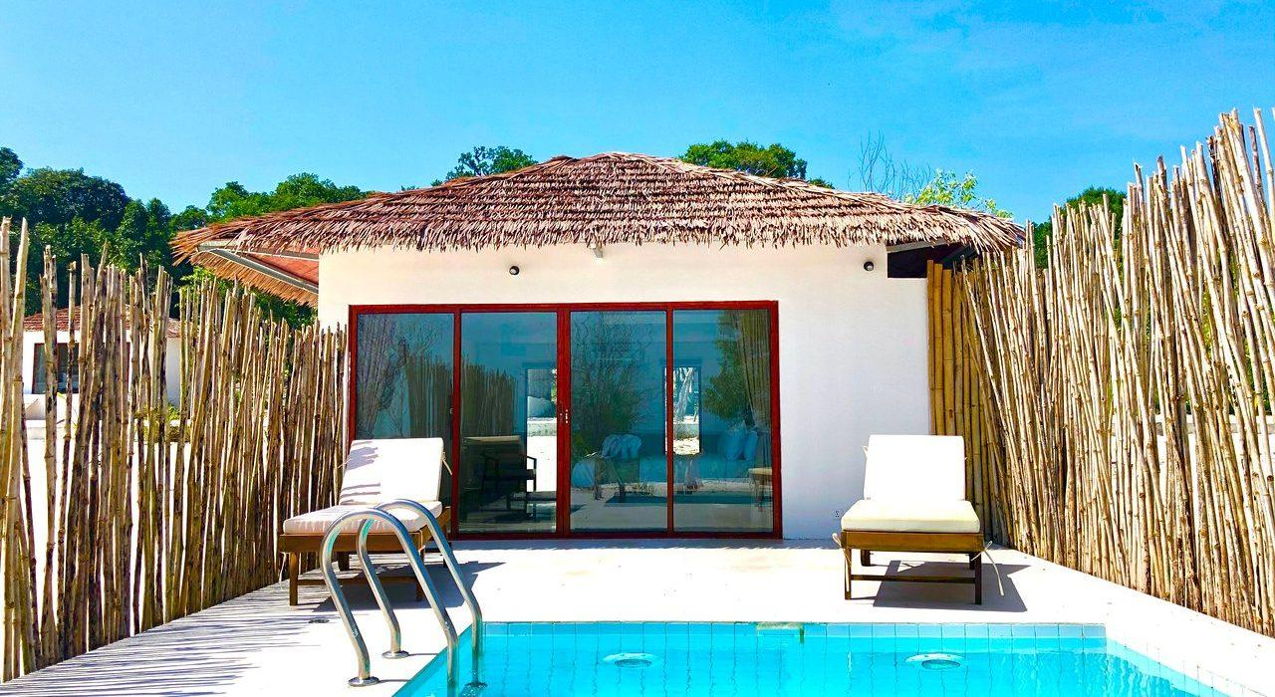
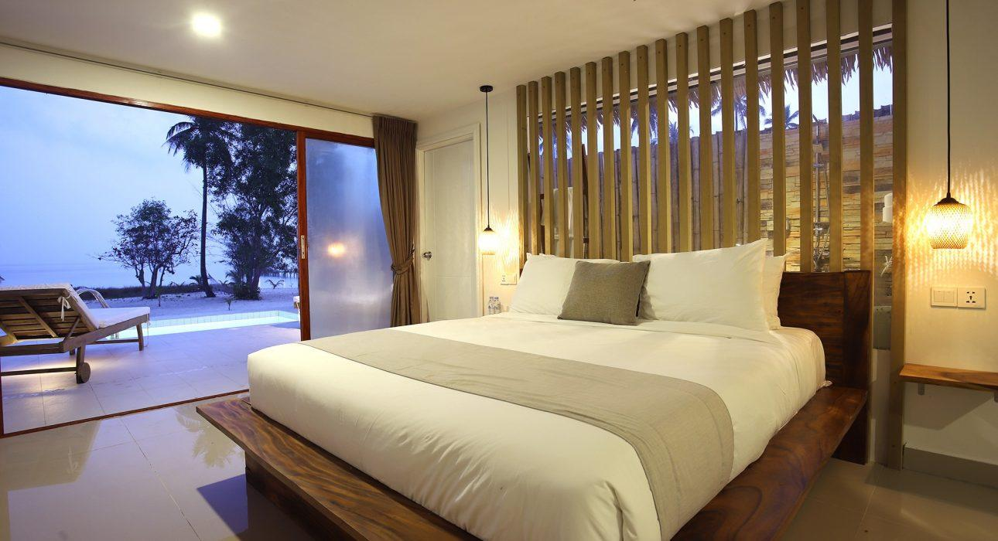
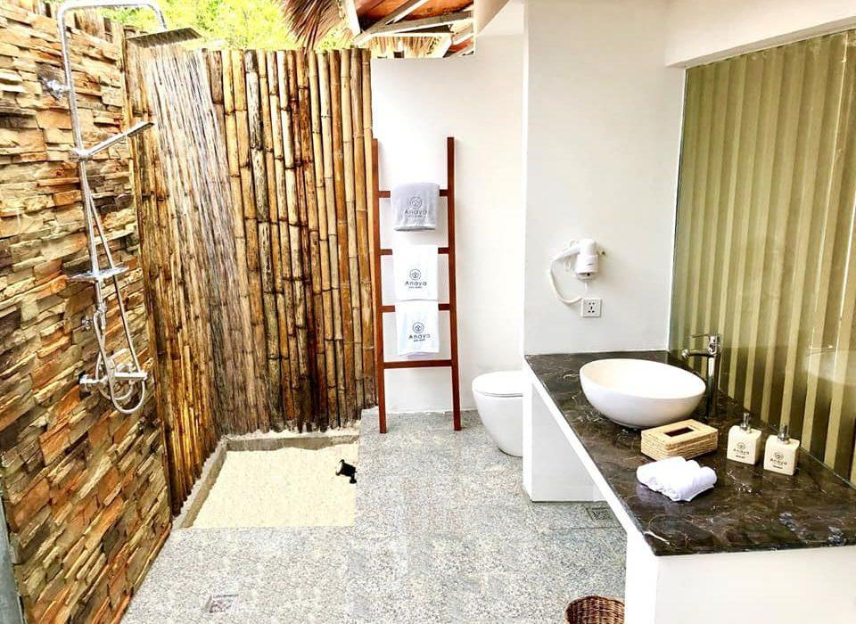
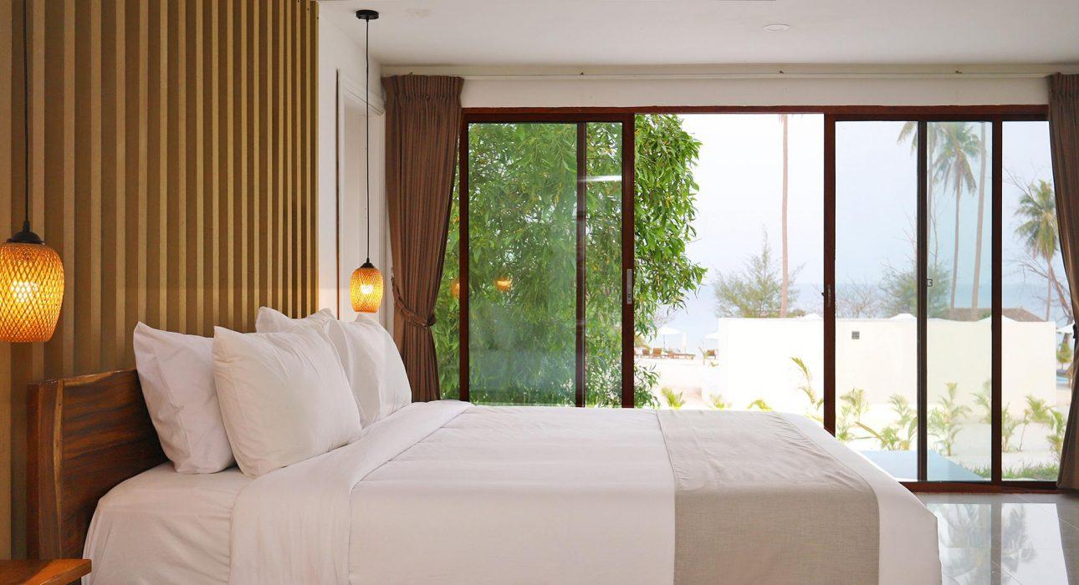
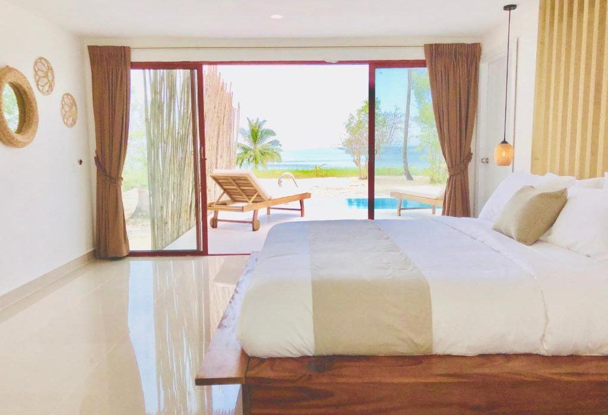
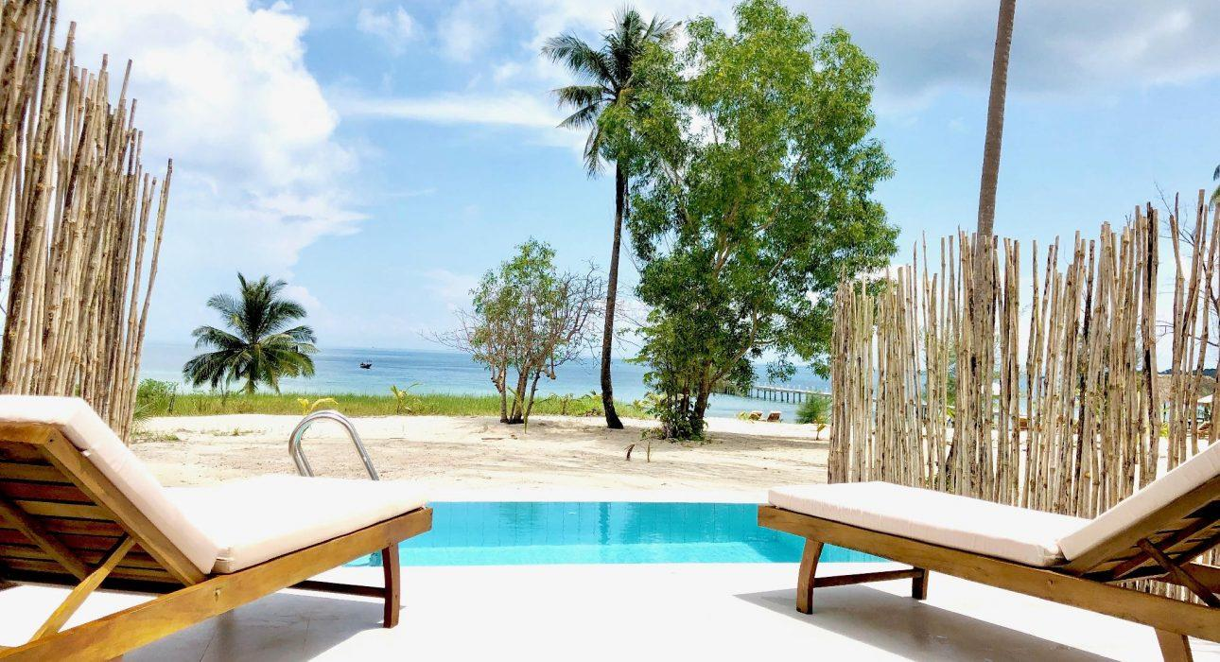
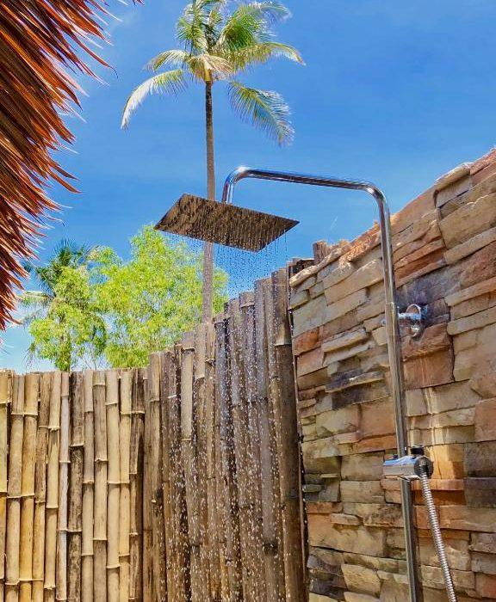

Restaurant photos
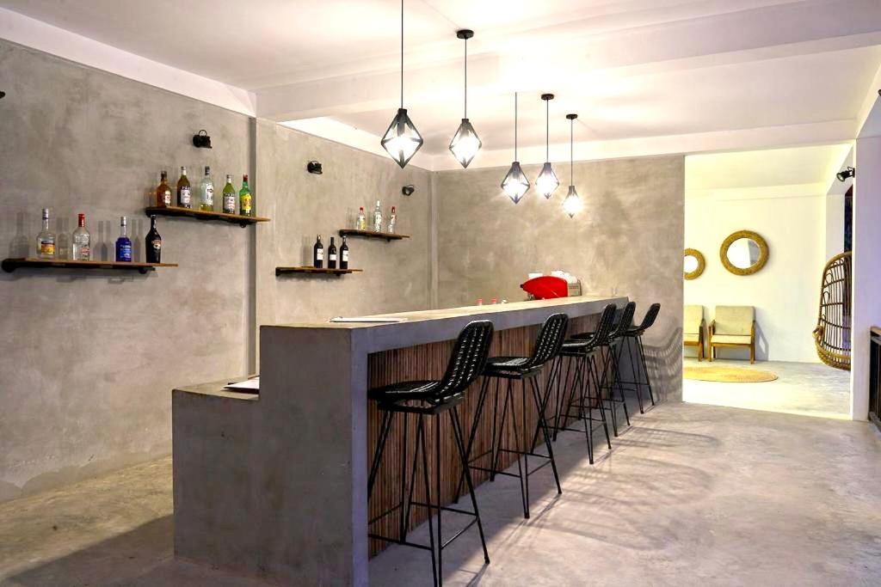
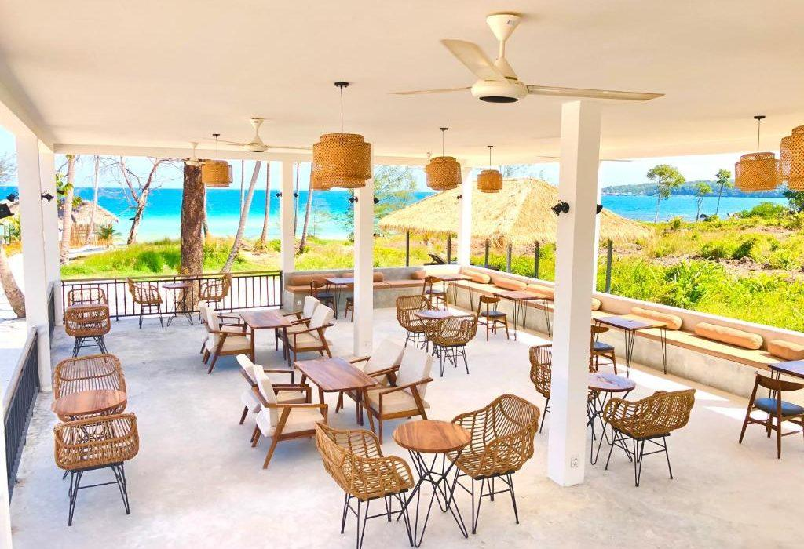

Services & facilities photos
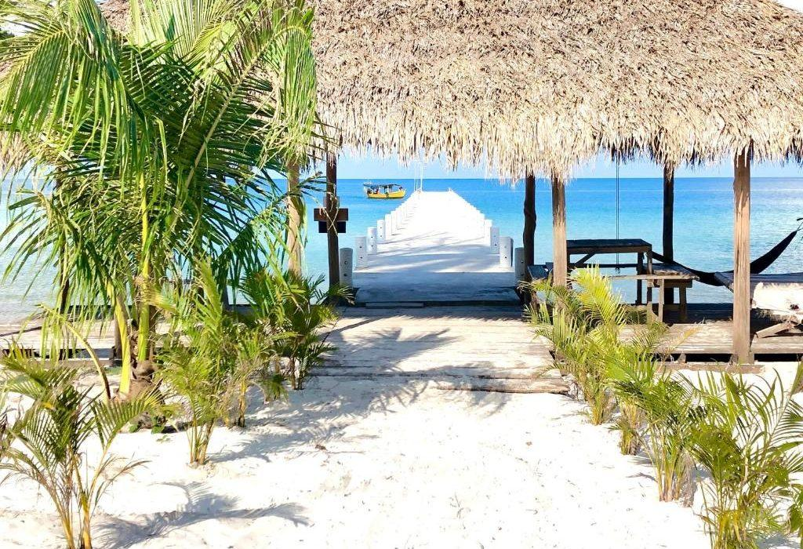
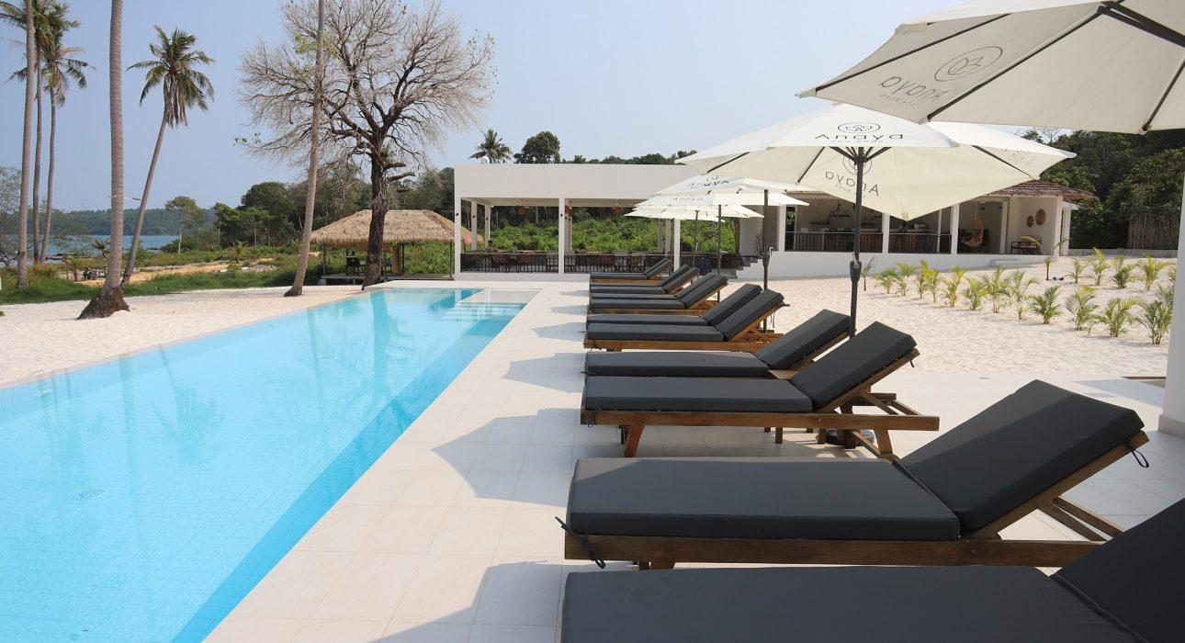
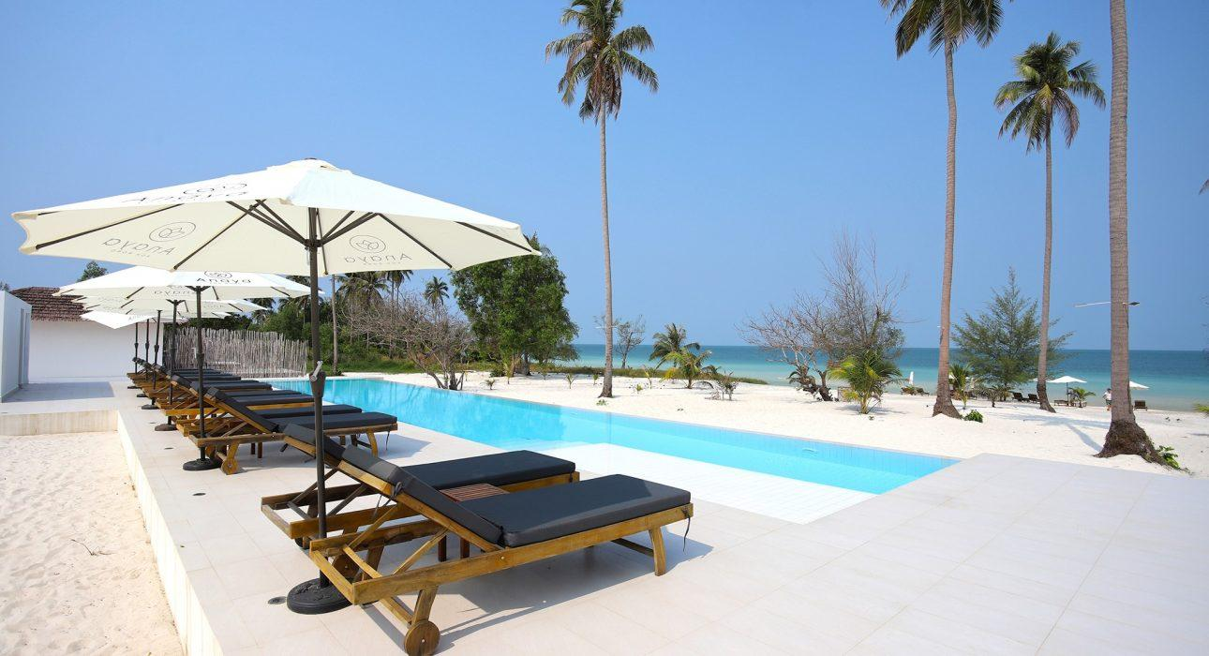

Easia Travel Head Office

Siem Reap BranchCharming City, No. R32 – R34, Road Rolouse, Trorpeangses Village, Sangkat Koukchork, Siem Reap Province – CambodiaTel: (855-63) 76 14 58Fax: (855-63) 76 14 58

