CAMBODIA – Phnom Penh – Phnom Penh 51 Hotel
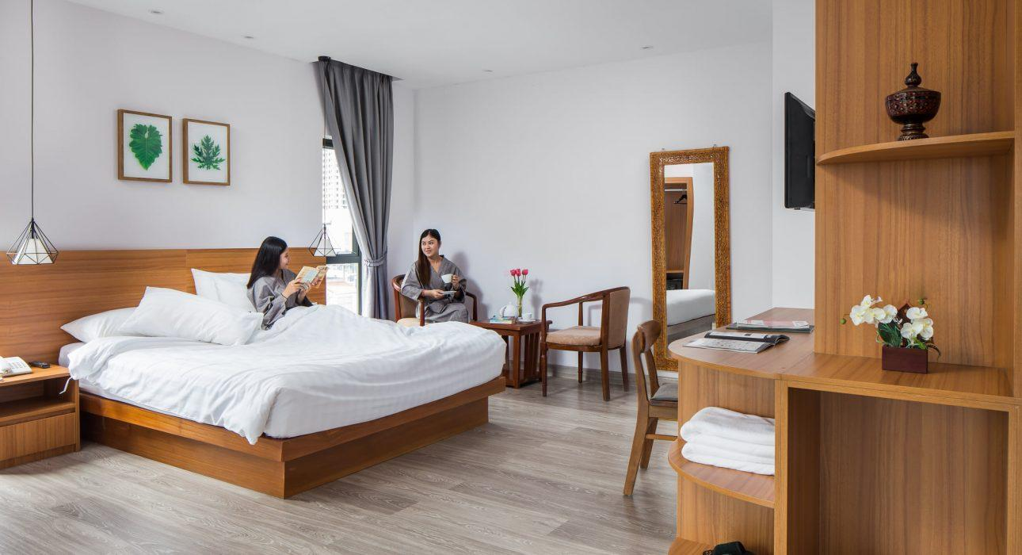

Over View

Theme
Classic

Country - City
Cambodia - Phnom Penh

Market segment
Groups, Thematic Leisure

Official category
3*

Easia category
Superior

Total number of rooms
54 rooms

Price level
$$$

Description

A city center modern hotel offering an ideal location and a rooftop overlooking the heart of Phnom Penh.Ideally located, from Phnom Penh 51 Hotel & Residences, it is easy to reach the most famous places of Phnom Penh, as the Central Market, Royal Palace, Riverside… The facilities of the hotel include restaurants, sky-bar, spa, fitness center and swimming pool.

Selling points

- A city-center hotel with a view overlooking Phnom Penh
- Comfortable and modern rooms
- A nice pool on the rooftop ideal to relax after a day of visit
- Ideal for groups

Time & Transportation

From | To | By | Km | Duration | Road Condition
Hotel | Phnom Penh International Airport | Tuk-tuk, car, van, bus | 11 km | 45 min. Depending on the traffic situation | Good
Hotel | City Center | Tuk-tuk, car, van, bus | 2.6 km | 15 min. Depending on the traffic situation | Good

Rooms

Easia's recommend room type
Phnom Penh 51 Hotel is equipped with 54 comfortable roomsEach room offers bathroom amenities, king-size bed or 2 single bed, flat-screen satellite TV, air conditioning, in room coffee and tea-making facilities, free Wi-Fi, hairdryer, minibar, and a safe with space for a laptop.Easia’s recommended room type :
- DELUXE double / twin room, 32 square meters in size.
- SUPERIOR triple room, up to 28 square meters squared and can accommodate up to 3 guests.

Room configuration

Connecting rooms
NA

Extra bed
NA

King bed
Yes

Twin beds
Yes

Services & Facilities

Services
24 hour reception, 24h security service, Airport transfer, ATM on site, Buffet Breakfast, Complimentary bottle of water, Credit Card payment, Currency exchange, Doctor on call, In-Room Dining, Iron, Laundry service, Luggage Storage, Massage, Porter, Private event, partying, Room Service, Spa, Swimming Pool, Wake-up service, Wi-fi Free

Facilities
Air Conditioning, Bar, Cable, satelite, coffee and tea making facilities, Coffee Machine Facilities, Coffee Shop, Conference hall, Elevator, Family Room, Fitness centre, Flat screen TV, Hair Dryer, In-Room safe, Internet, Massage room, Meeting room, Mini Bar, Outdoor swimming pool, Restaurant, Safety Box, satellite LCD TV, Shower With Hot Water, Smoking Area, Steam/Sauna, Terrace, TV Room, Umbrella

Business facilities details
One meeting room

Restaurant information

Restaurant Name | V-View Sky lounge
Capacities | 170 pax
Type of food | Western and Asian
Operation hour | 06am to 12am

Photos

Hotel Photos
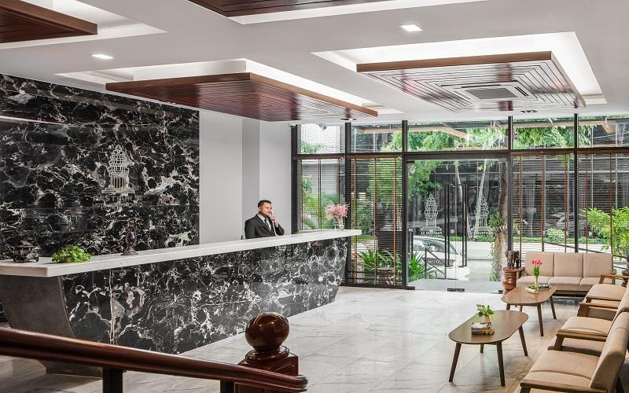
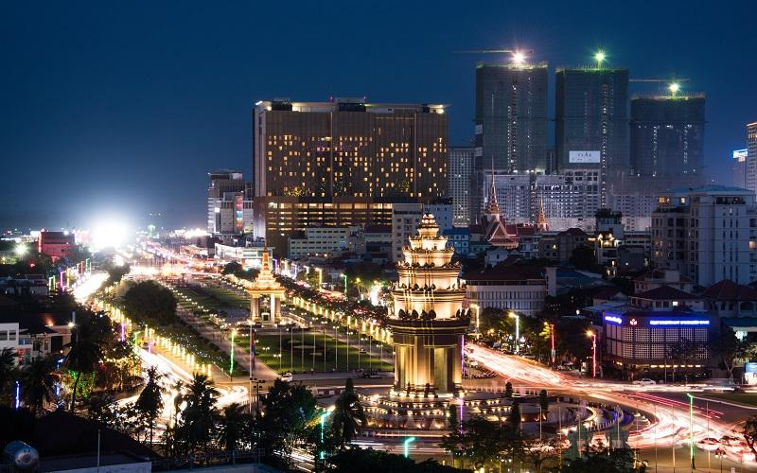
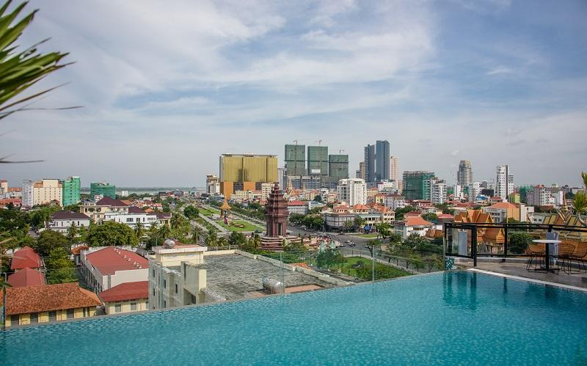
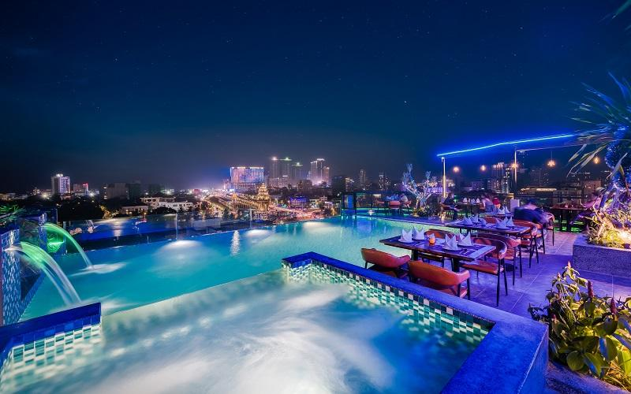
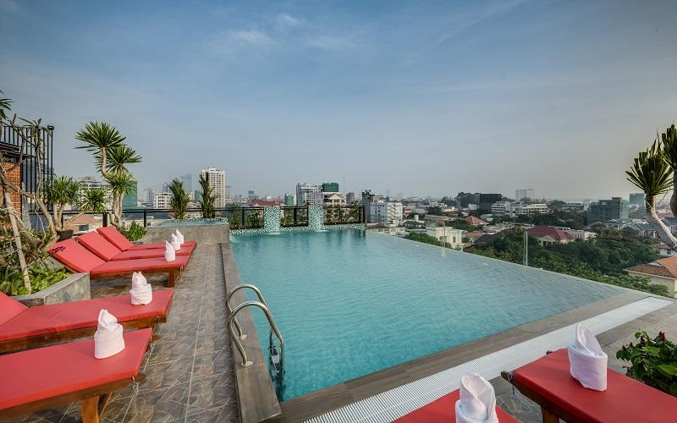

Rooms photos
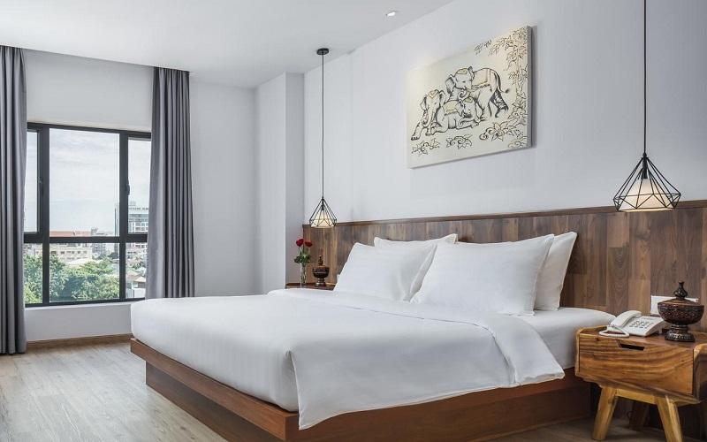
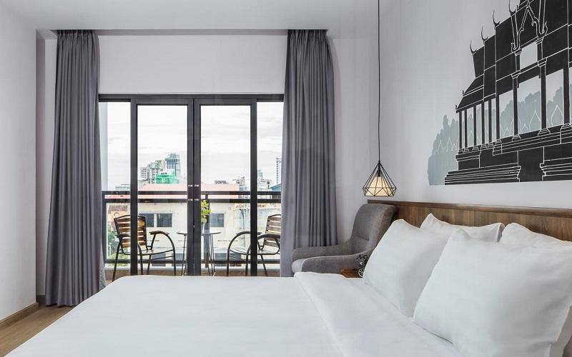
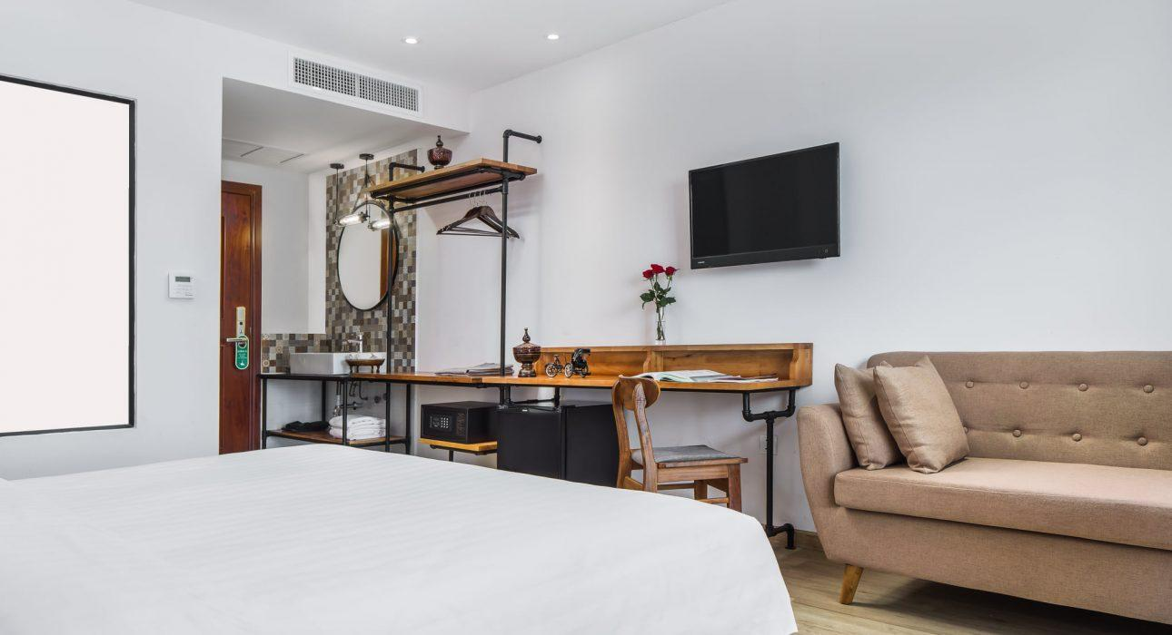
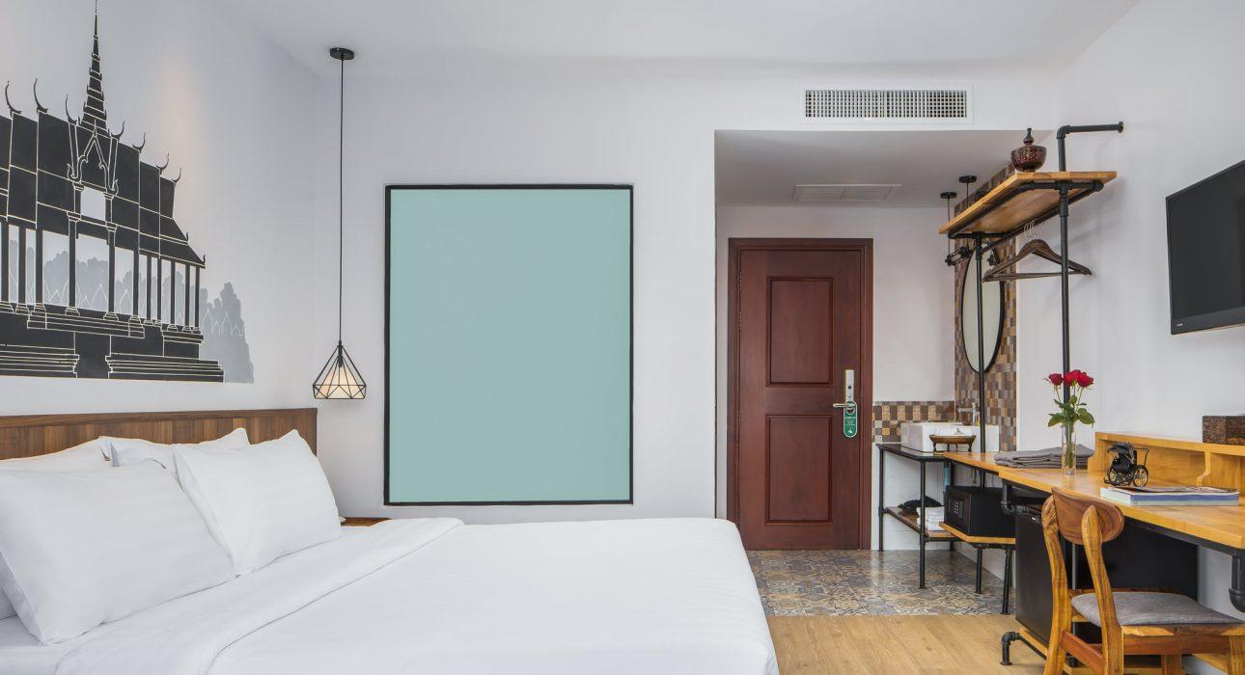
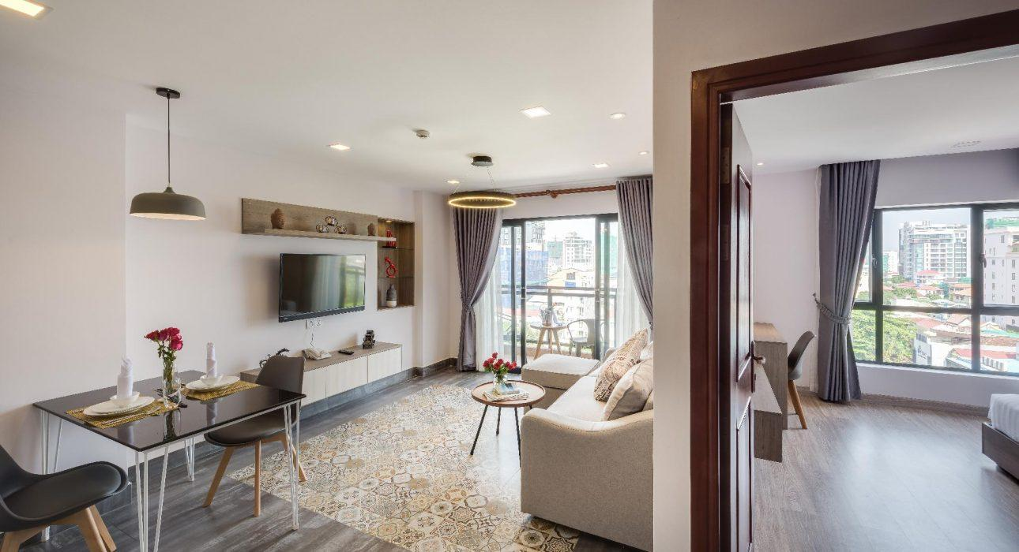
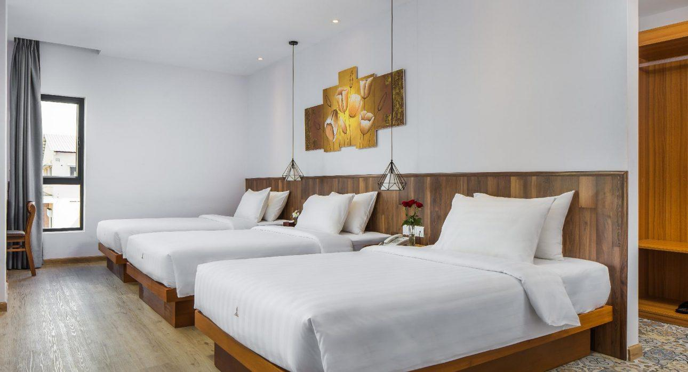
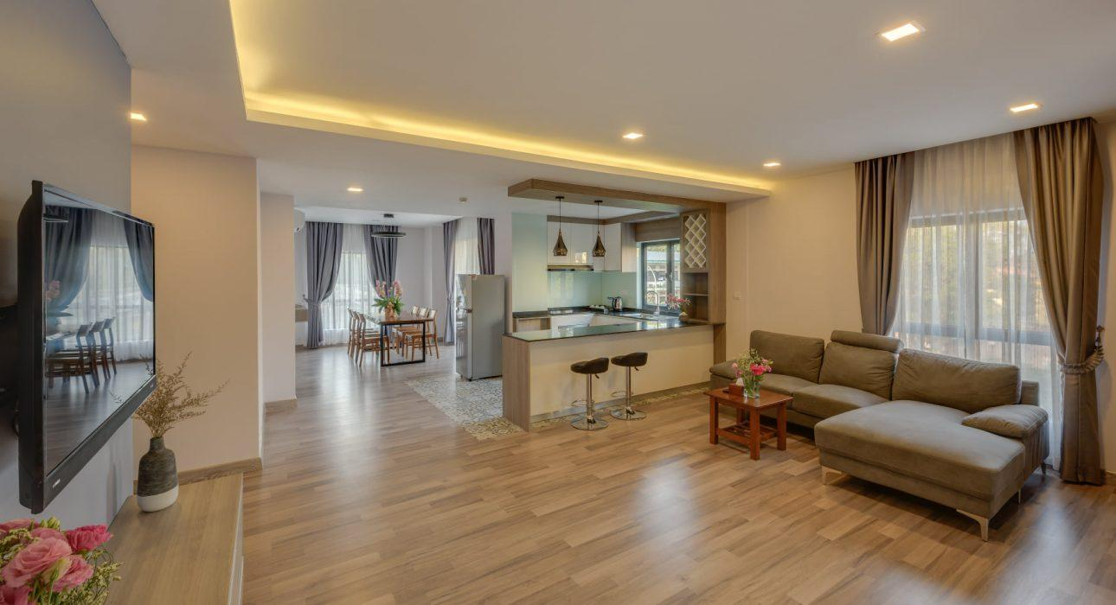
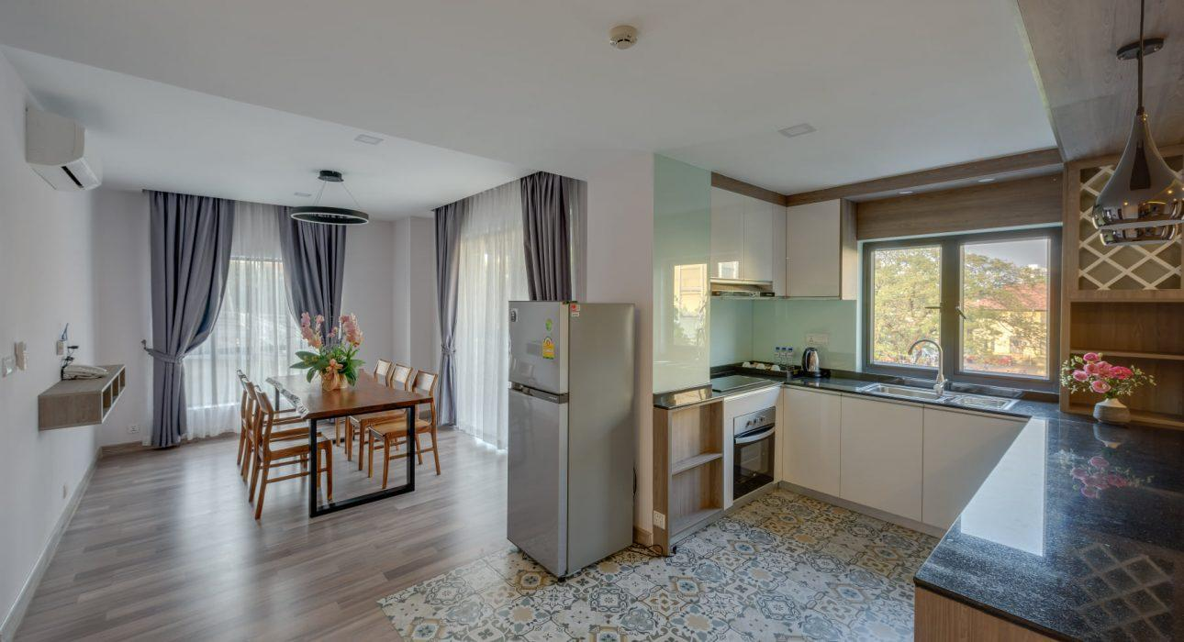
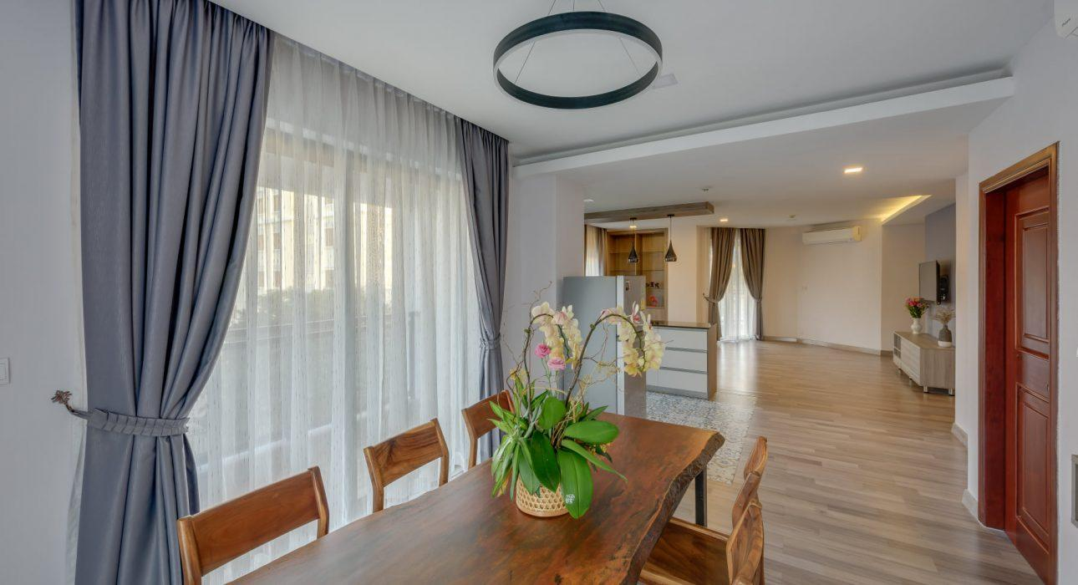
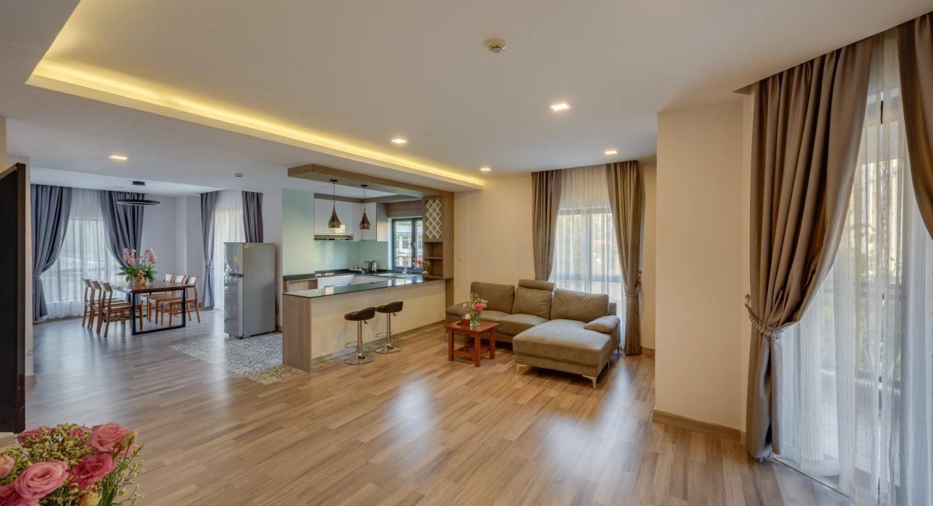
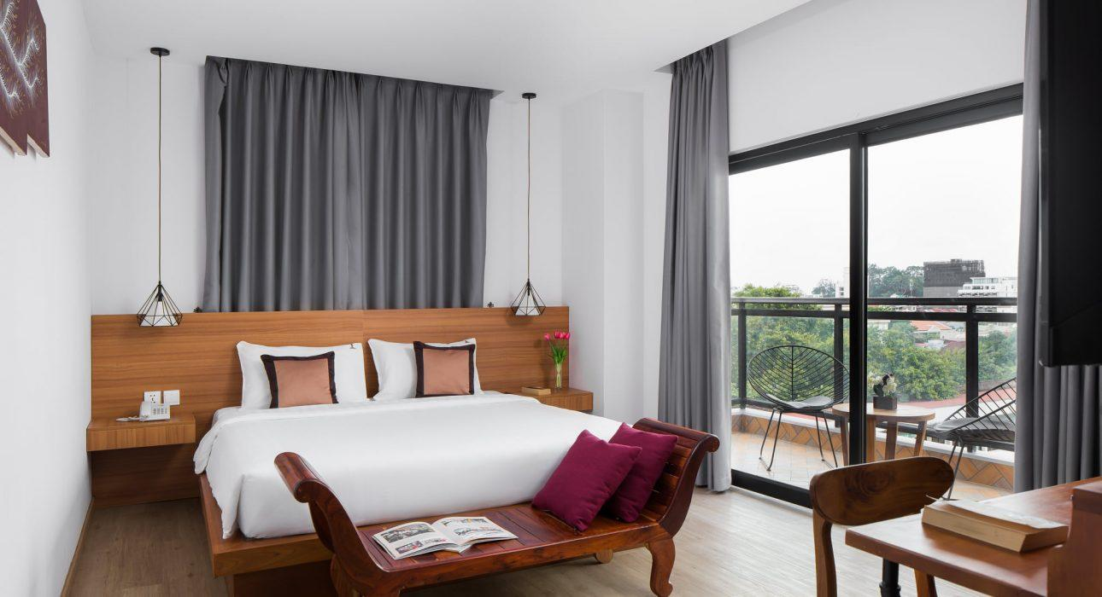
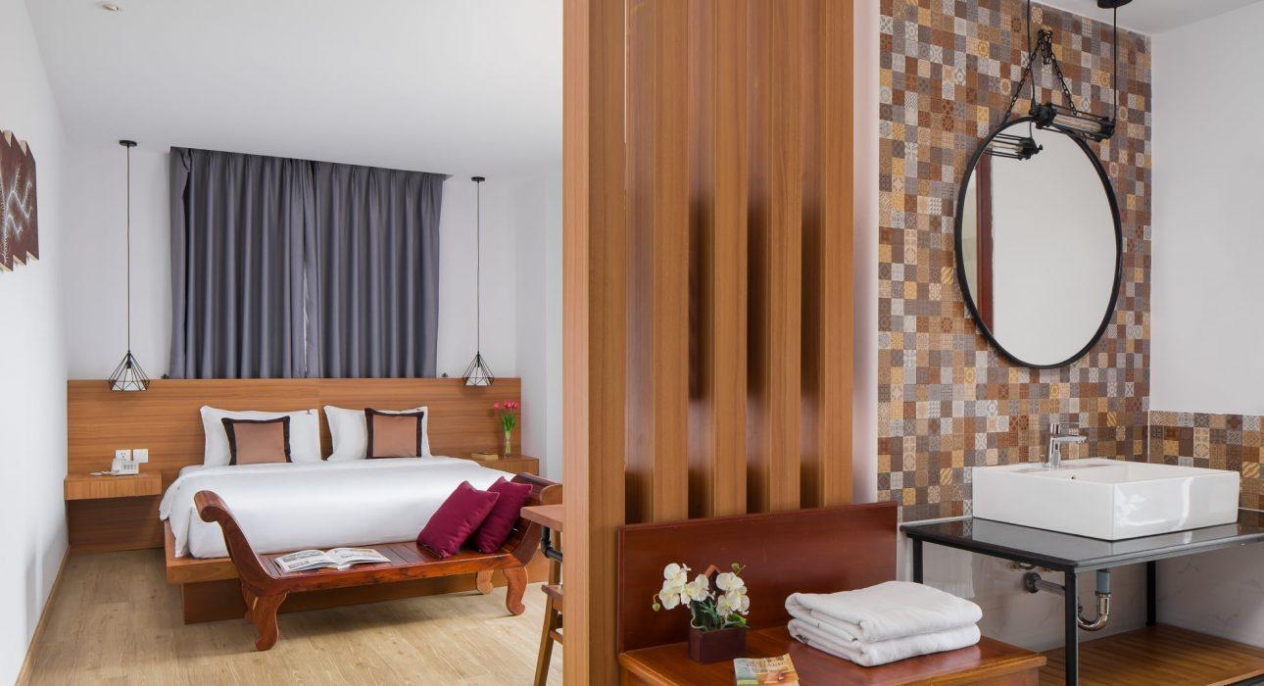
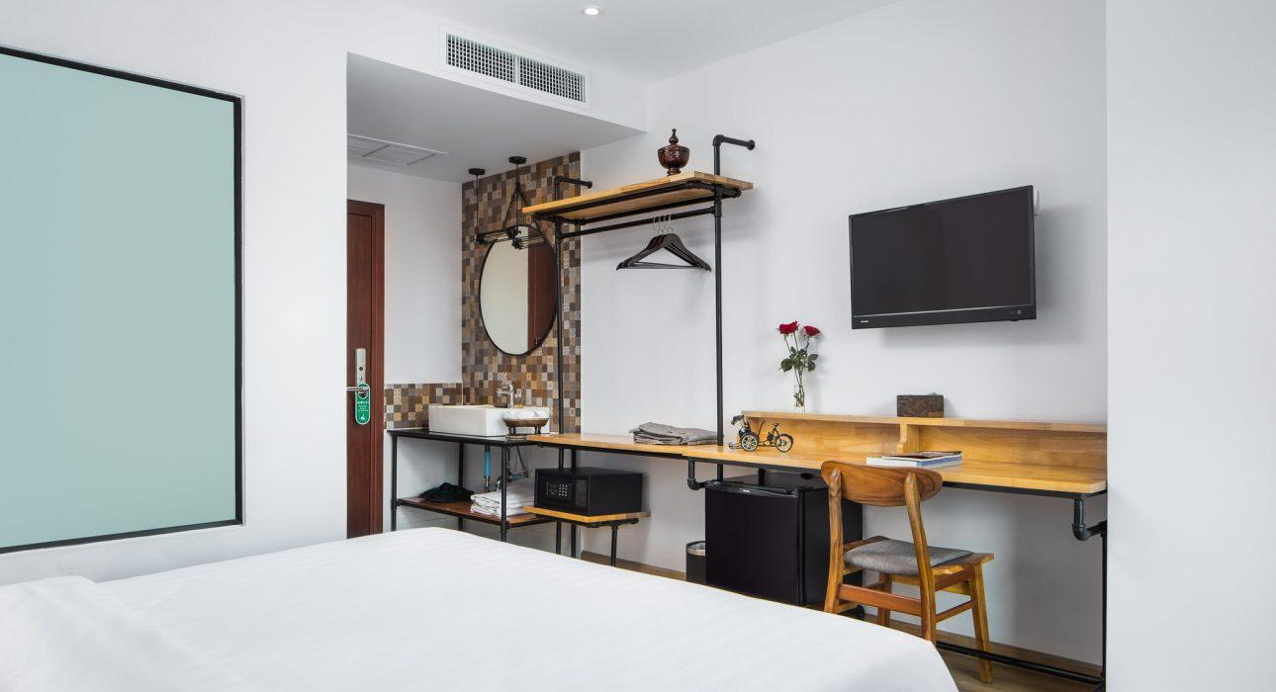
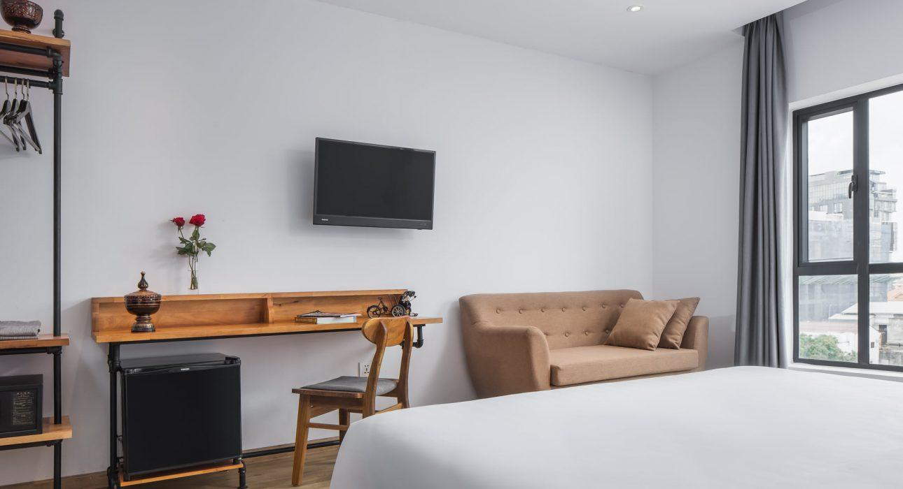
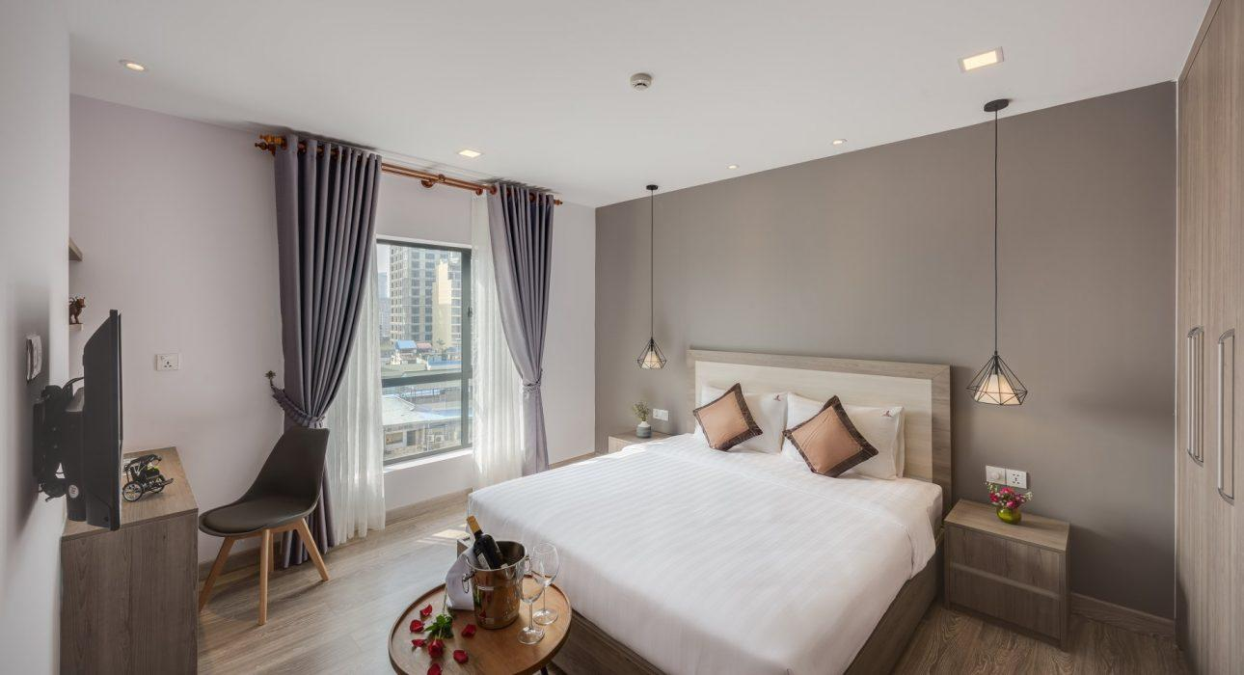
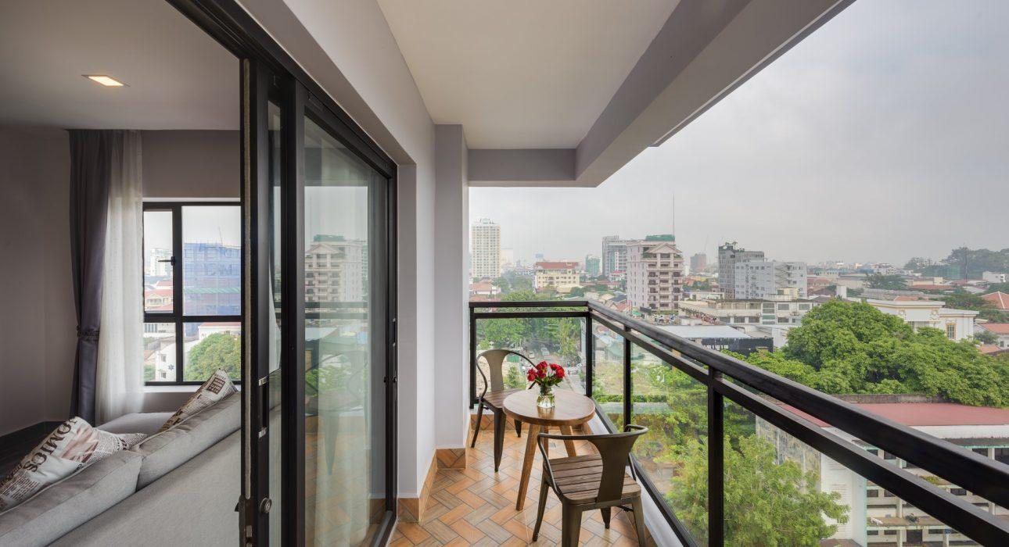

Restaurant photos
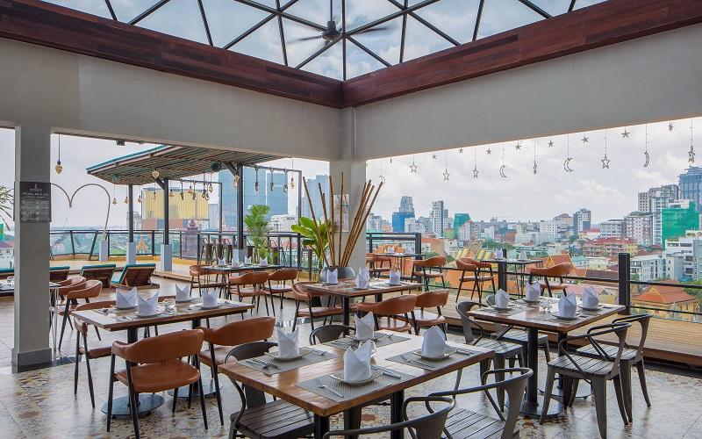
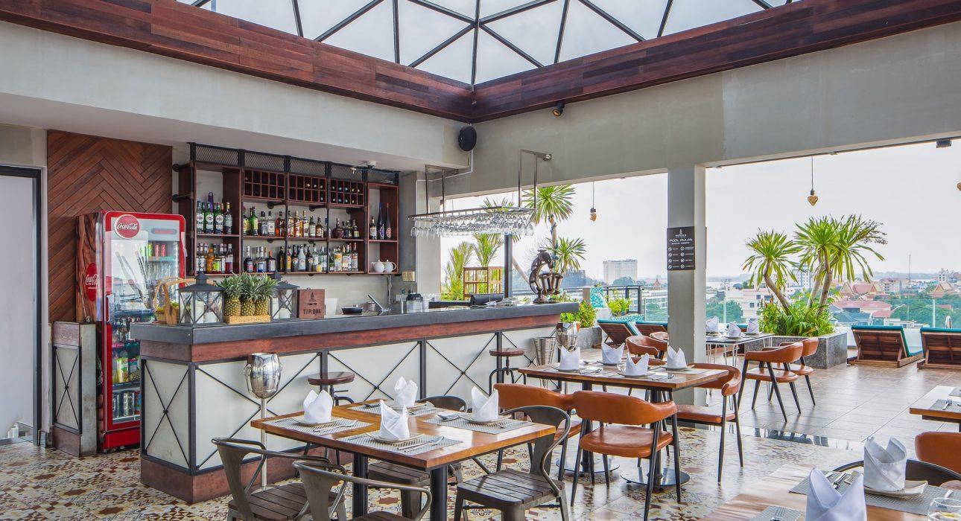
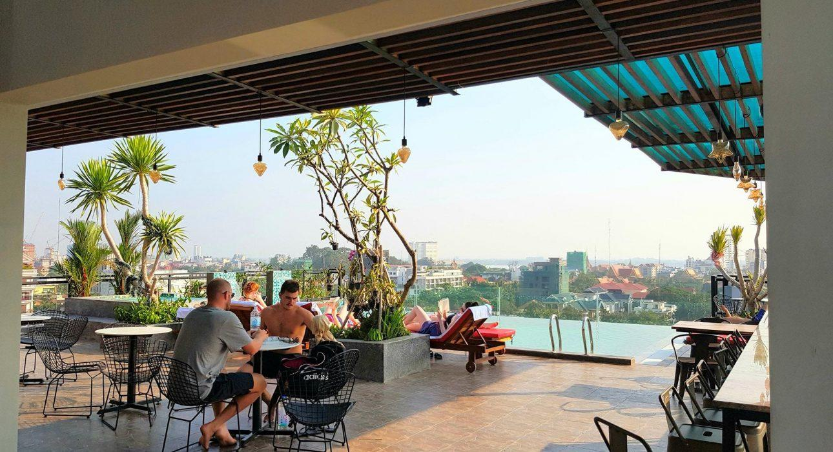
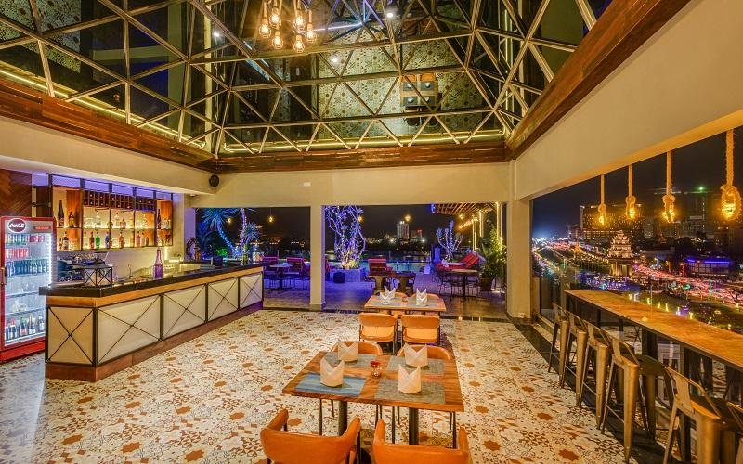

Business facilities photos
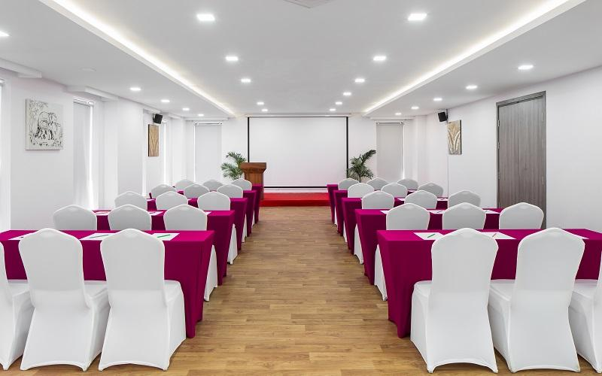
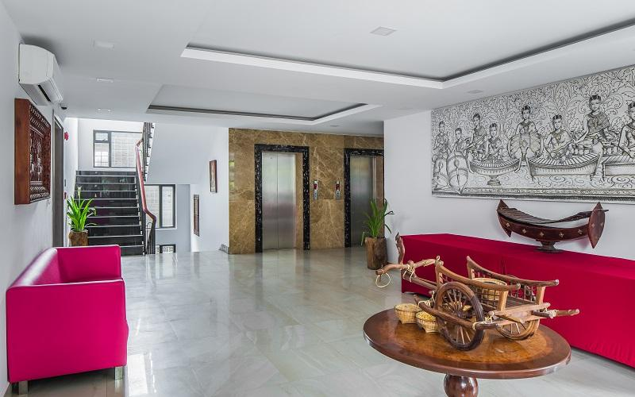

Services & facilities photos
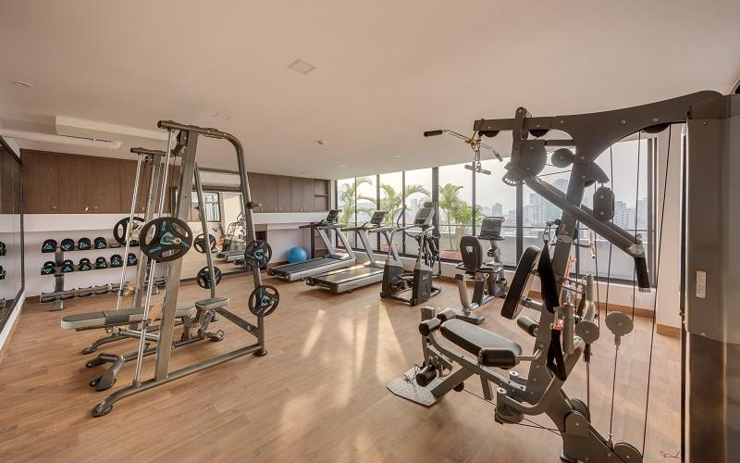
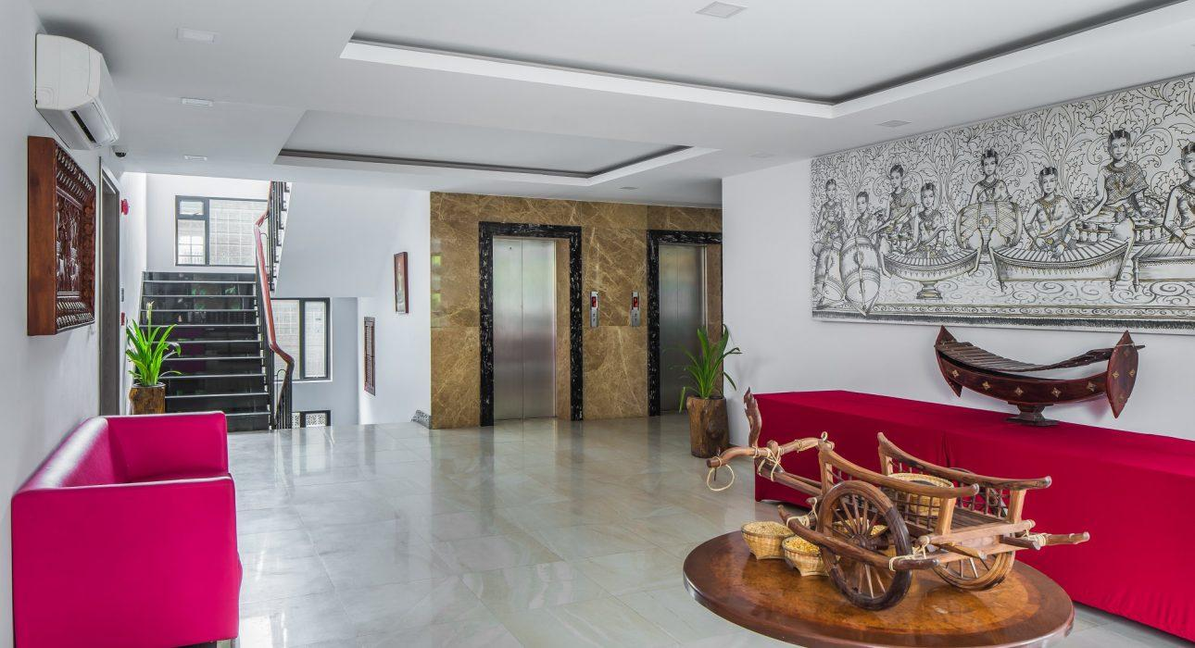
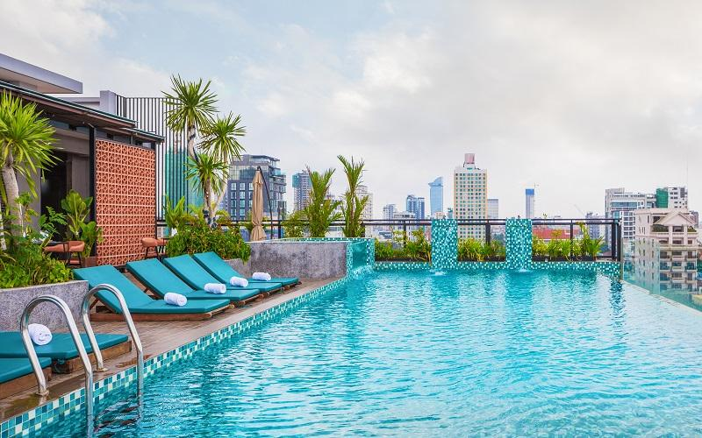
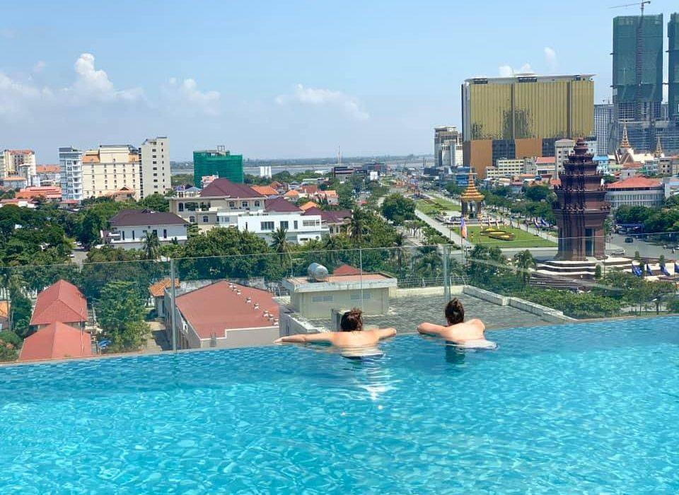
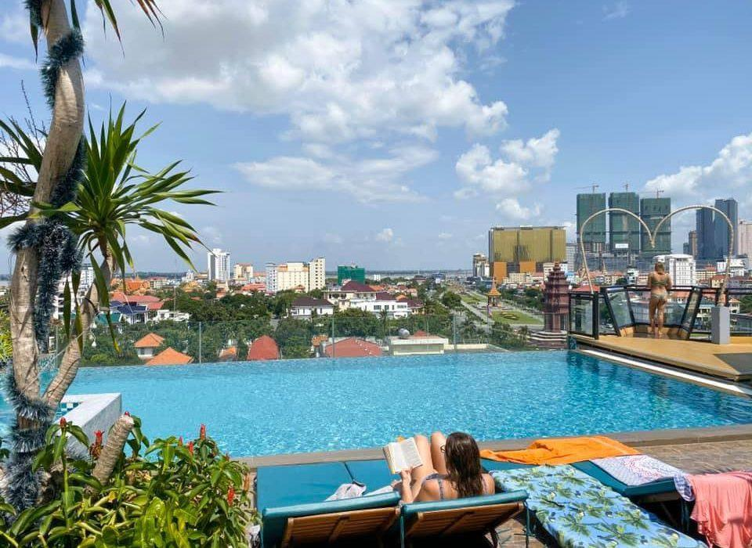
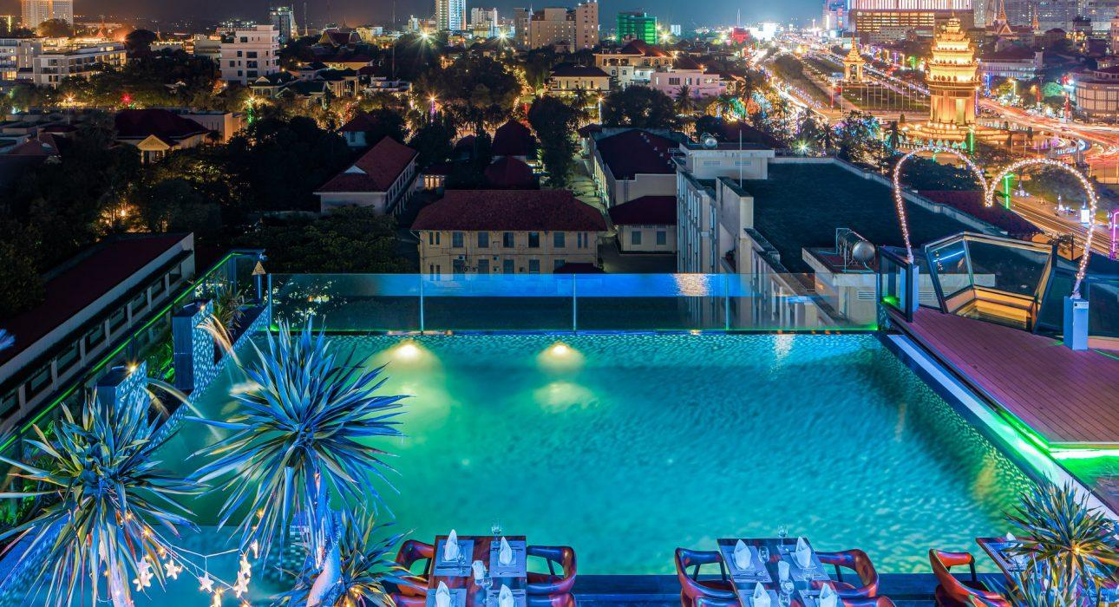

Easia Travel Head Office

Siem Reap BranchCharming City, No. R32 – R34, Road Rolouse, Trorpeangses Village, Sangkat Koukchork, Siem Reap Province – CambodiaTel: (855-63) 76 14 58Fax: (855-63) 76 14 58

