CAMBODIA – Phnom Penh – Anik Boutique Hotel Rainbow Bridge
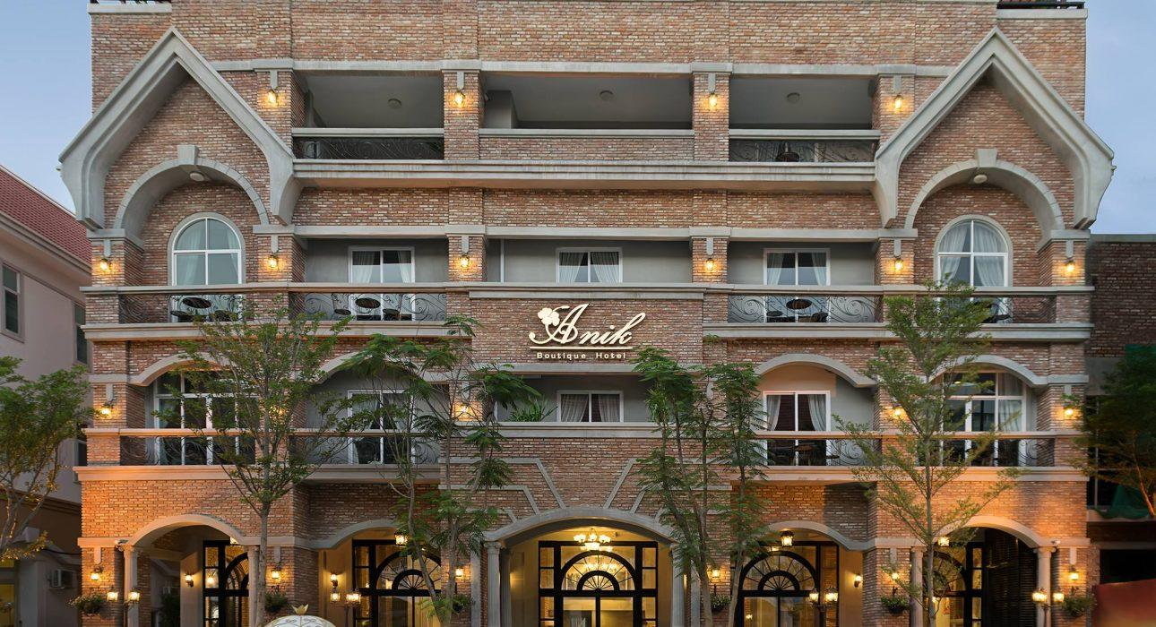

Over View

Theme
Classic

Country - City
Cambodia - Phnom Penh

Market segment
Groups, Thematic Leisure

Official category
4*

Easia category
First Class

Total number of rooms
38 rooms

Price level
$$$

Description

Ideally located in the city of Phnom Penh with a rooftop overlooking it. Anik Boutique Hotel has an appearance of a castle and all 38 rooms are designed with a classical theme.The hotel is closed to the finest dining, shopping, entertainment, as well as a nearby market venue all within walking distance.Each of the 38 elegant rooms is tastefully furnished, boasting of carefully chosen in-room amenities. All room come with city and garden view and modern technological such as wireless internet access.

Selling points

- A city-center hotel with a rooftop overlooking Phnom Penh
- Comfortable rooms with good bedding
- A beautiful swimming-pool on the rooftop (Indoor swimming pool)

Sustainability

Supplier Actions
Protection of Environment

Time & Transportation

From | To | By | Km | Duration | Road Condition
Hotel | Phnom Penh International Airport | Tuk-tuk, car, van, bus | 11 km | 50 min. Depending on the traffic situation | Good
Hotel | City Center | Tuk-tuk, car, van, bus | 2.6 km | 15 min. Depending on the traffic situation | Good

Rooms

Easia's recommend room type
Deluxe Room
- Unit:19 rooms
- Size: 26sqm
- Bed: King/Twin
Landmark Room
- Unit: 9 rooms
- Size: 38 sqm
- Bed: King
Landmark Family
- Unit: 5 rooms
- Size: 39sqm
- Bed: Twin bed
Apartment 1 Bedroom
- Unit: 3 rooms
- Size: 90sqm
- Bed: King
Apartment 2 Bedroom
- Unit: 2 rooms
- Size: 120 sqm
- Bed: 02 double

Room configuration

Connecting rooms
NO connecting room (Only Apartment 2 Bedroom )

Services & Facilities

Services
24 hour reception, 24h security service, Buffet Breakfast, Complimentary bottle of water, Credit Card payment, Currency exchange, Doctor on call, Handicap Accessible, In-Room Dining, Iron, Laundry service, Massage, Porter, Private event, partying, Room Service, Spa, Swimming Pool, Wake-up service, Welcome fruits in room upon arrival, Wi-fi Free

Facilities
Air Conditioning, Bar, Business centre, Cable, satelite, Coffee Shop, Disabled Facility, Elevator, Family Room, Fitness centre, Flat screen TV, Gift Shop, Hair Dryer, In-Room safe, Internet, Massage room, Meeting room, Mini Bar, Newspapers and magazine, Outdoor swimming pool, Restaurant, Safety Box, satellite LCD TV, Shower With Hot Water, Smoking Area, Steam/Sauna, Terrace, TV Room

Restaurant information

The Anik Restaurant
- A fusion of Asian and international Cuisine, Wine and drinks
- 06:30am to 10:00pm (Last order 9:30pm)
- 38 seat indoor (In-door)
Lobby Lounge
- Coffee, Tea & Drink
- 7:00pm to 10:00pm (last order 9:30pm)
- 16 seats

Photos

Hotel Photos
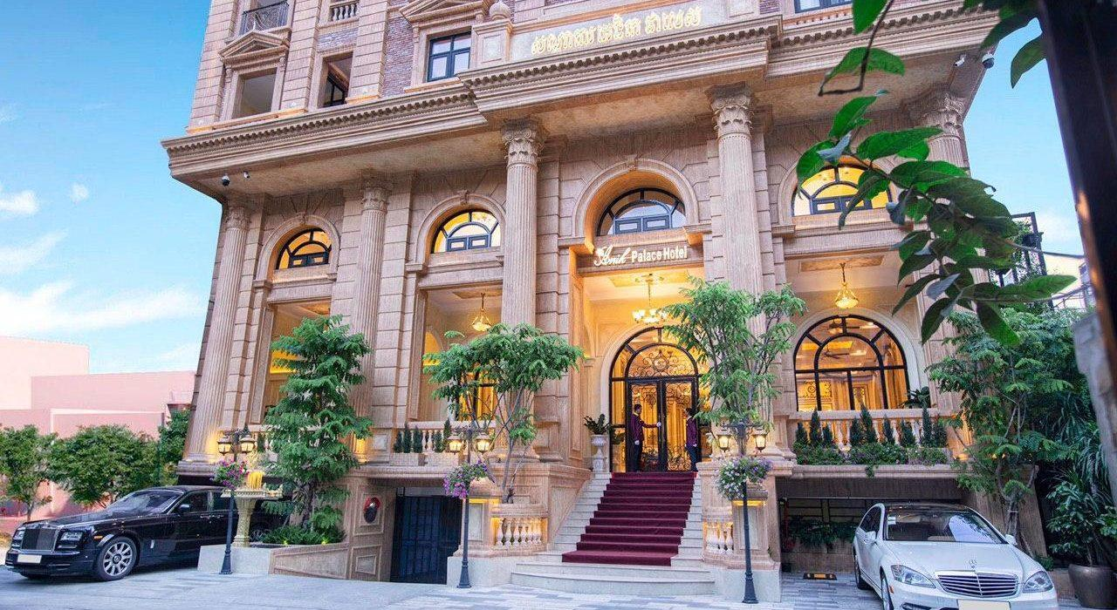
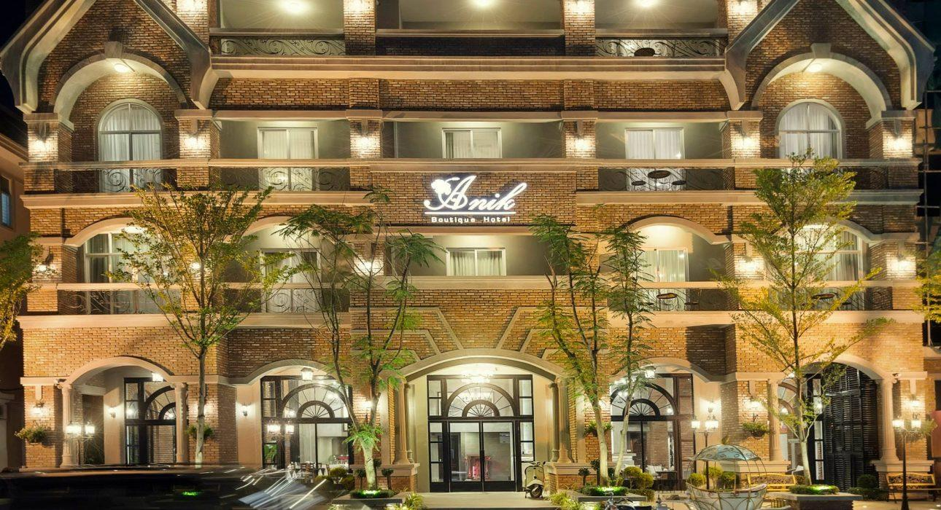
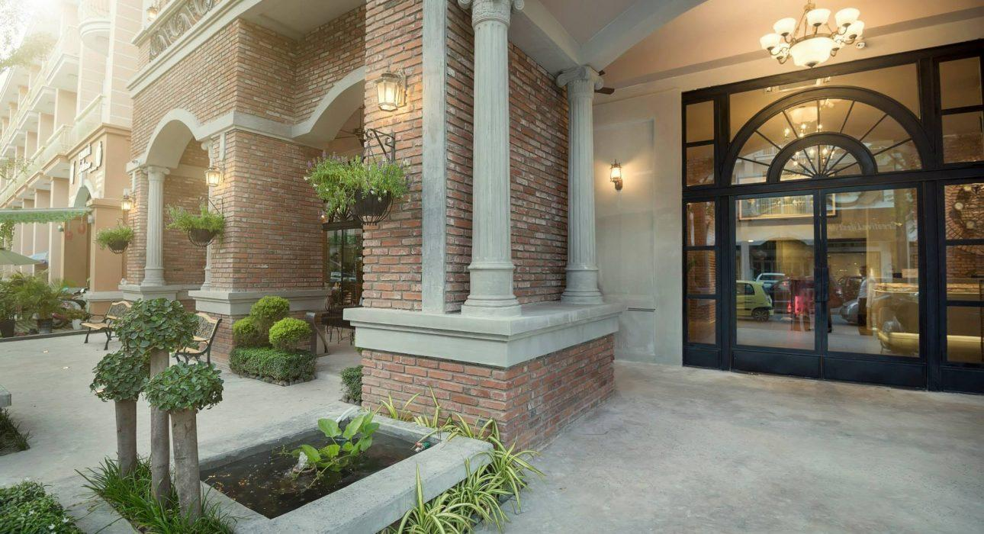

Rooms photos
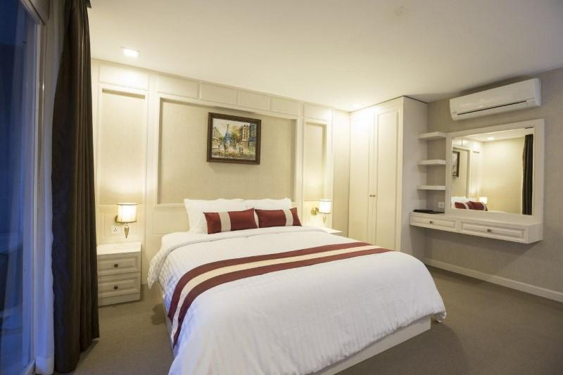
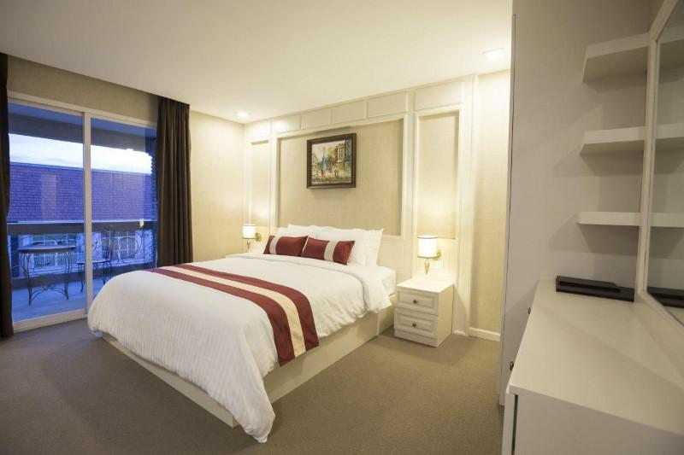
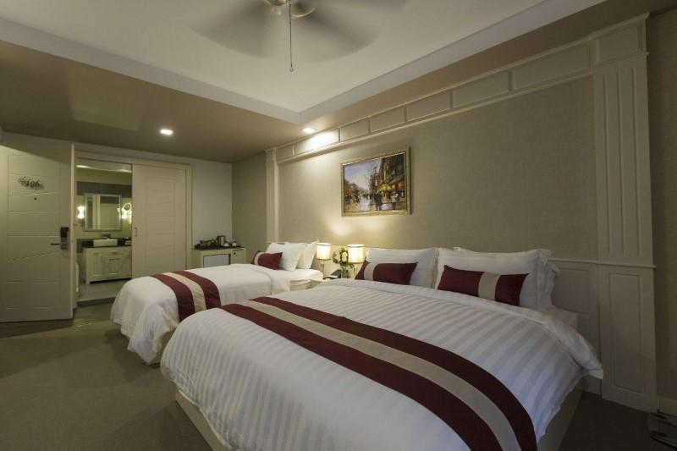
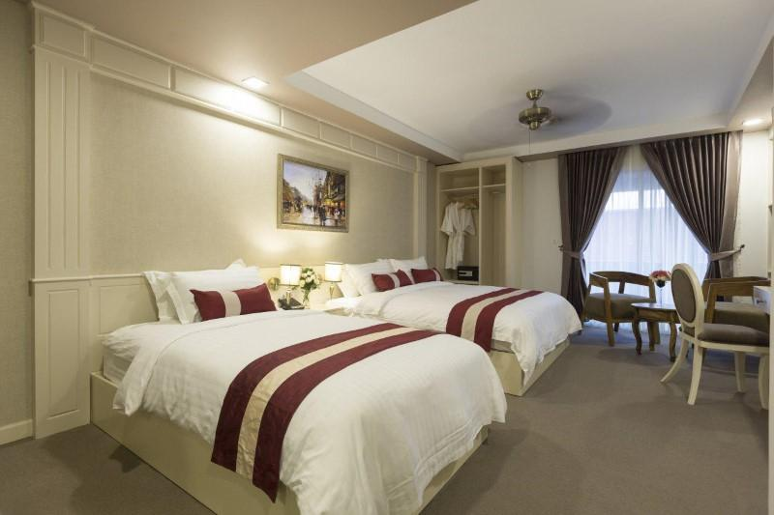
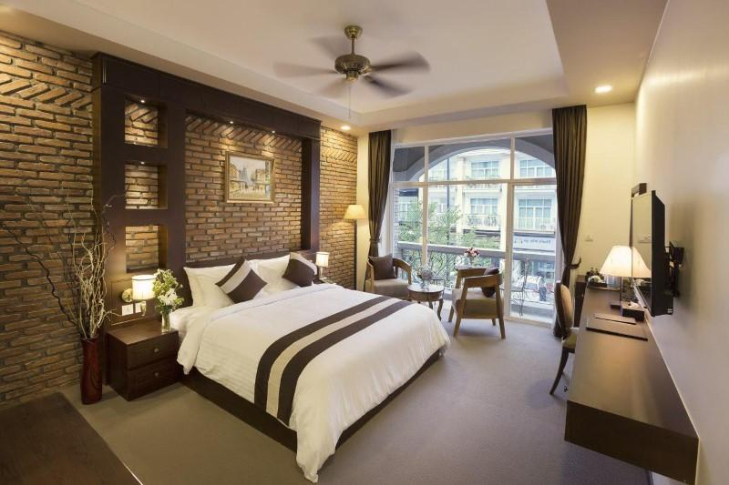
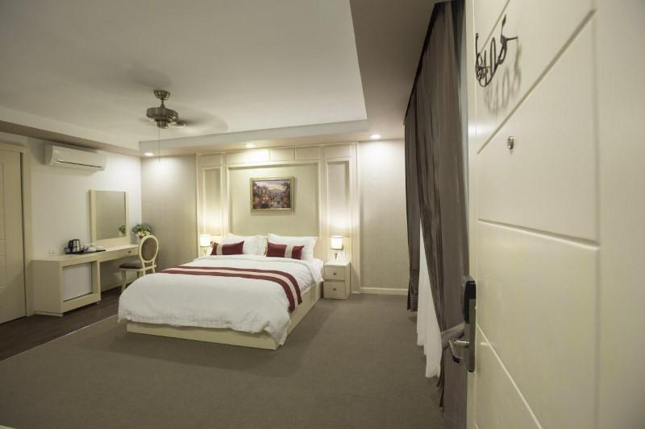
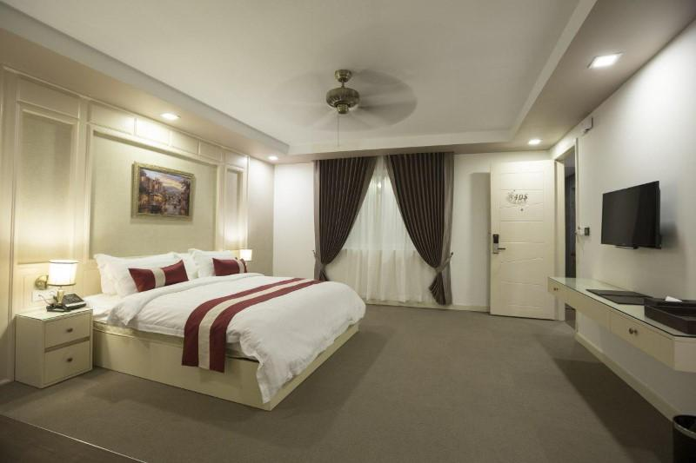
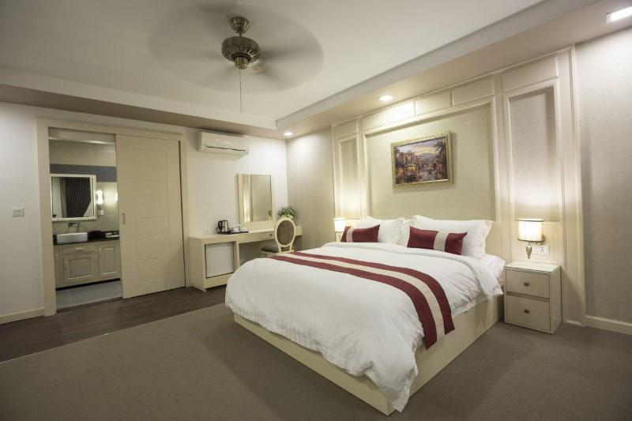
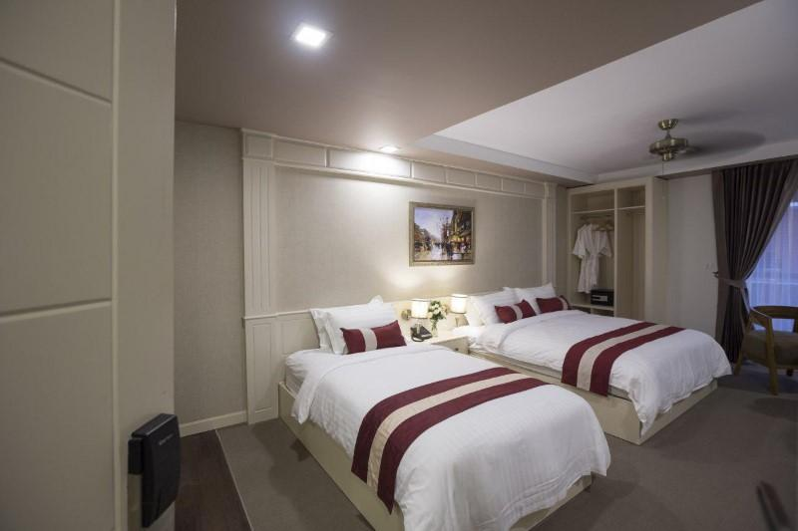
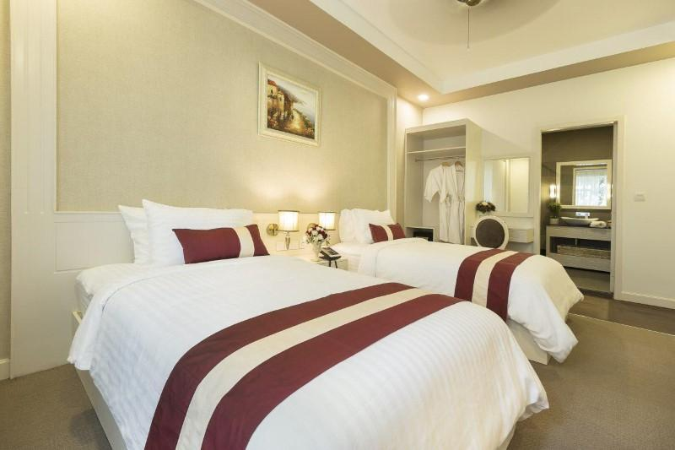
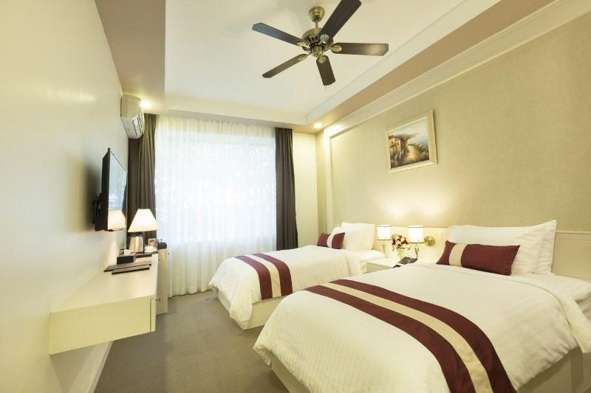
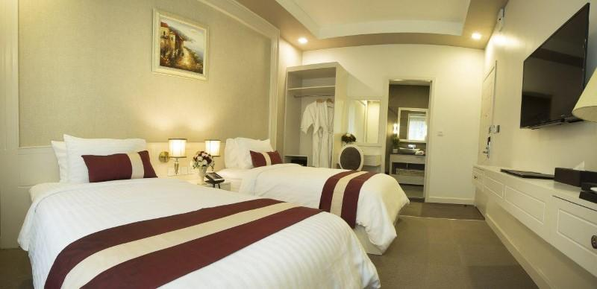
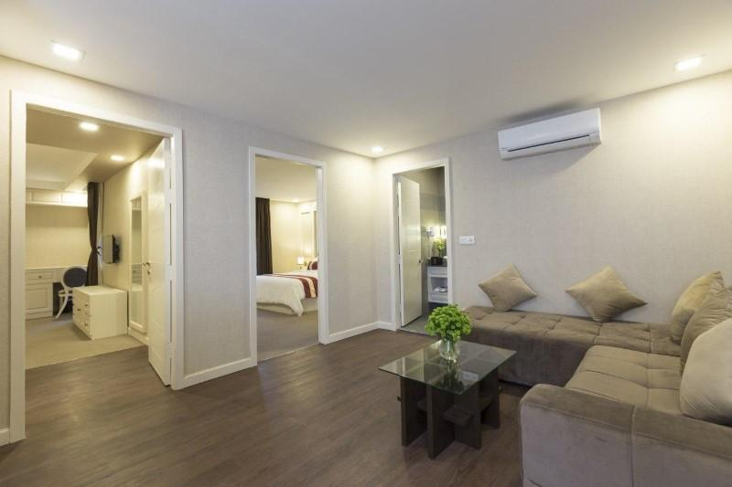
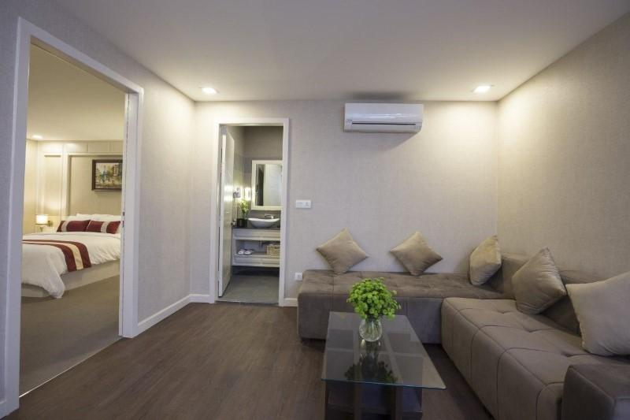
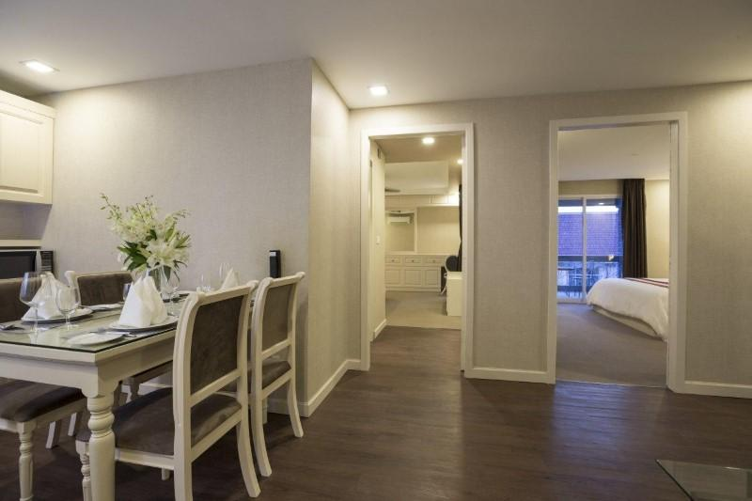

Restaurant photos
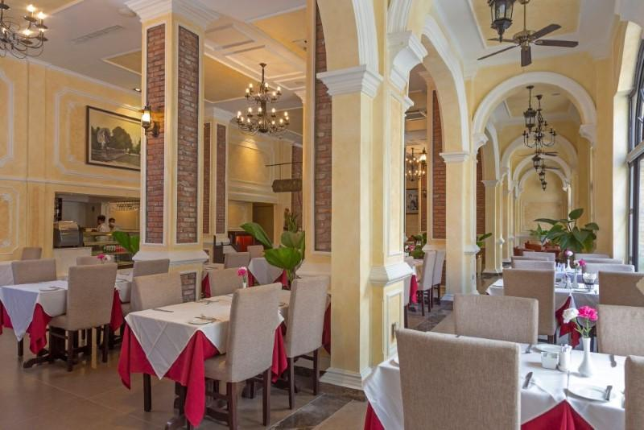
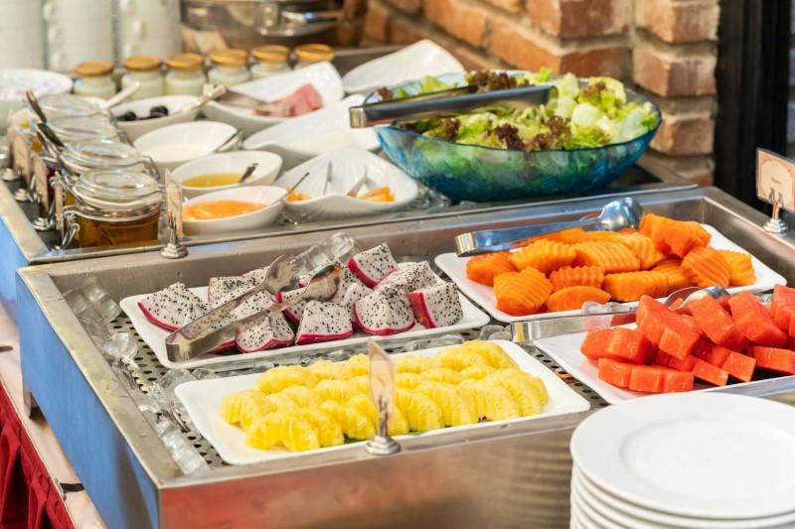
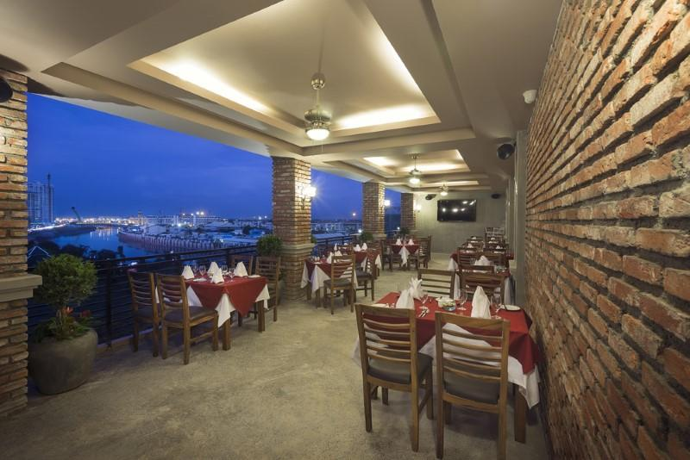

Services & facilities photos
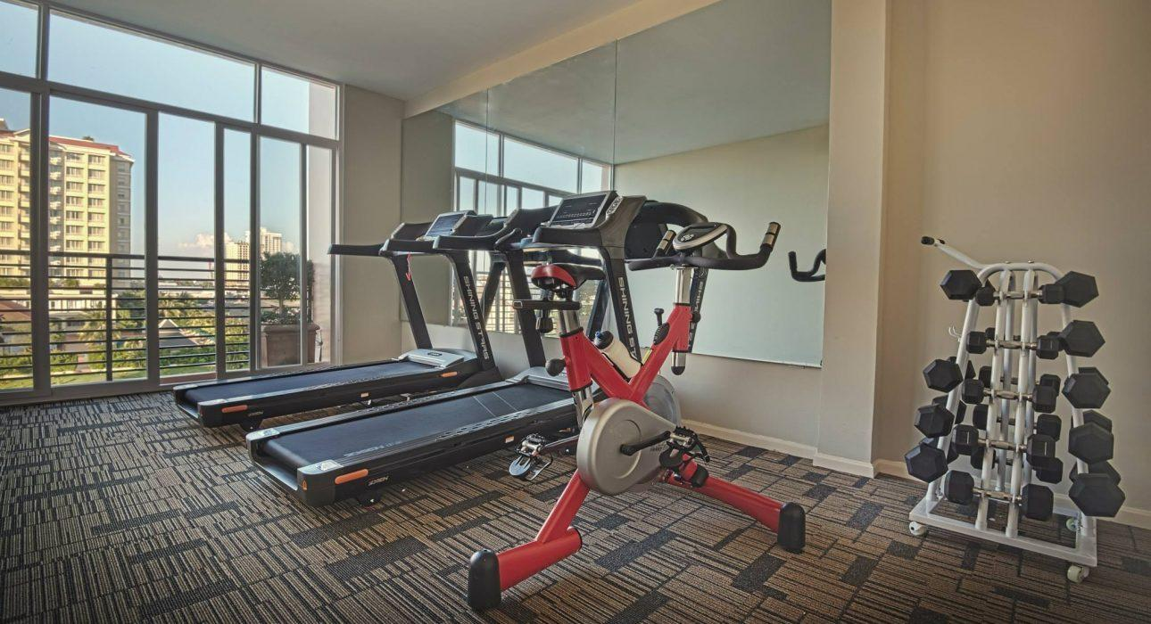
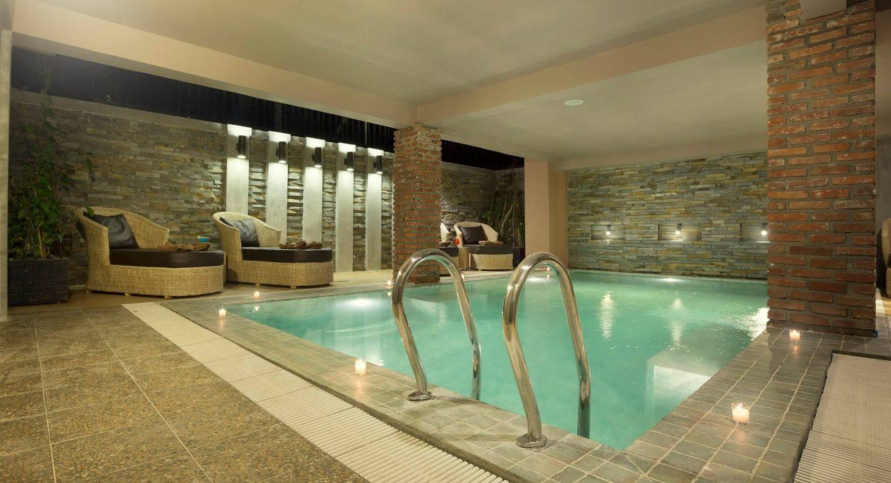

Easia Travel Head Office

Siem Reap BranchCharming City, No. R32 – R34, Road Rolouse, Trorpeangses Village, Sangkat Koukchork, Siem Reap Province – CambodiaTel: (855-63) 76 14 58Fax: (855-63) 76 14 58

