Vietnam – Mai Chau – Avana Retreat
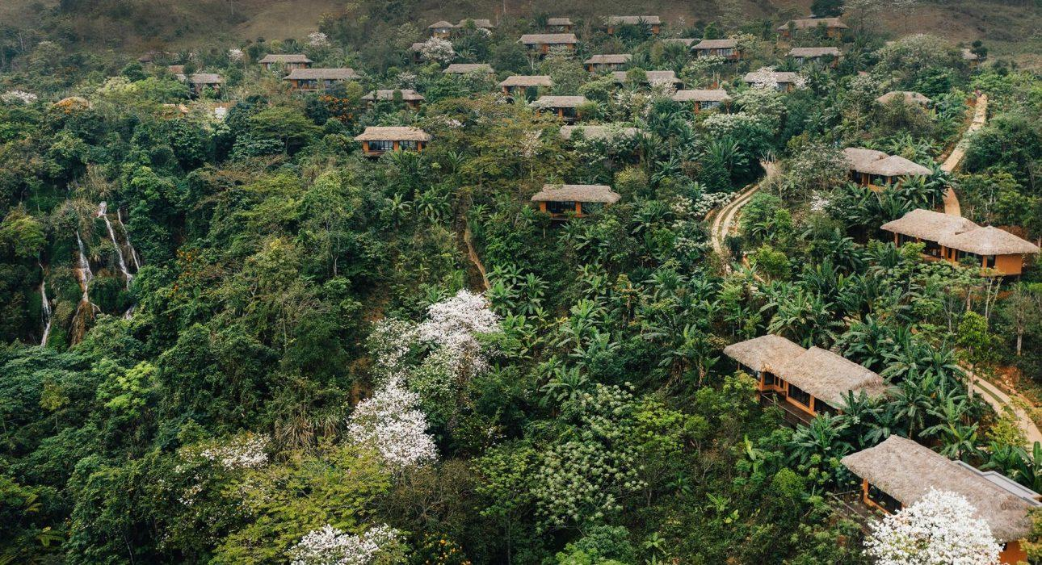

Over View

Theme
Art &amp; Culture, Classic, Family, Honeymoon, Sustainable, Wellness

Country - City
Vietnam - Mai Chau

Market segment
Thematic Leisure

Official category
5*

Easia category
Luxury

Total number of rooms
36

Price level
$$$

Description

Avana, which translates to “a beautiful flower”, portrays a beautiful wild blossom nourished by nature and its environment to bloom at its best in its native land.Imagined, conceptualized, built and managed by the Co-Owners of Easia Travel, Avana Retreat is a high-end mountain resort in Northern Vietnam that has been designed to represent a genuine love for the environment. Located within walking distance of nearby ethnic villages, Avana Retreat is able to simultaneously absorb and showcase local heritage while being far enough away to remain tranquil and secluded.Avana Retreat is a genuine synergy of nature, culture & sustainability.The Pung Waterfall, the heart of Avana, is the very origin of the Retreat. Ten years ago, Avana’s founders came upon a natural waterfall while trekking through the Pung Village. The stunning beauty they discovered was the seed that inspired the project.A decade later, a total of 41 Villas, including 3 luxurious Pool Villas, dot the mountainside overlooking the unspoiled beauty of Mai Chau just 3.5 hours from the country’s capital Hanoi.Every element of Avana Retreat, even the smallest detail, has been carefully curated to develop a calm, relaxing environment in total harmony with nature and local ethnic people.Avana Retreat is a true sustainable property – 5,000+ trees planted– 90% local manpower– Plastic-free retreat– Purified drinking water produced on spot at Avana’s on-site bottling center to reduce deliveries– Green programs created in harmony with local authorities

Selling points

- A pure 5-star escape surrounded by nature, waterfall and serenity
- Authentic representation of Vietnam: Rice fields, ethnic traditions, people, buffalo, and karst mountains
- First sustainable hotel in the mountainous area of Mai Chau
- Convenient access from Hanoi
- Stunning spa integrated and immersed in the forest near the waterfall
- Excellent spot for photographers to catch images of “cloud hunting”, a highlight of Avana Retreat during most of the year
- Extensive hiking or cycling possibilities around the resort for leisure or adventurous travelers

Sustainability

Supplier Actions
Protection of Environment, Support local communities, Child Protection, Animal Welfare

Time & Transportation

FROM | TO | DISTANCE (KM) | BY | DURATION | ROAD CONDITION
Hanoi | Avana Retreat | 170 km | car | 3.5 hours | Good
Ninh Binh | Avana Retreat | 170 km | car | 4 hours | Good
Mai Chau Town | Avana Retreat | 29 km | car | 35 minutes | Correct

Rooms

Easia's recommend room type
Lantana Mountain Bungalow 2 Bedrooms – 124sqm – 5 Rooms Lantana Mountain Bungalow 2 Bedrooms offers 124sqm of living space including a spacious balcony. The bungalow features twin beds that can be converted into King beds upon guest request and two seating areas in each room. Each room has a large bathroom with a vanity basin, a separated rain shower, and a bathtub. Max Guests: 4 adults, 4 children or 6 adults, 2 childrenThe Bauhinia Mountain Suite – 98sqm – 22 roomsGraceful living space includes a 36sqm balcony. The Bauhinia Mountain Suite features a king bed or twin bed, a large, separated seating area, and beautiful views. It has a large bathroom with a vanity basin, a separated rain shower, and a bathtub. Max Guests: 2 adults, 2 children or 3 adults, 1 child Ferns Grand Mountain Suite – 115sqm – 6 roomsA spacious suite with one bedroom and a generous balcony. The Grand Mountain Suite features a king bed, and a large, separated seating area. The private bathroom with a vanity basin, a separated rain shower, and a bathtub offers an amazing view of the surrounding nature.Max Guests: 2 adults, 2 children or 3 adults, 1 child Senna One Bedroom Hilltop Pool Villa -194sqm – 1 roomSet on the hill, this romantic one-bedroom pool villa offers spacious living space and stunning views of the rice terraced field and valley. It features a king bedroom, a living room, a large bathroom with a vanity basin, a separated rain shower, and a bathtub. There is a 61sqm private heated pool and a terrace with sun loungers.Max Guests: 2 adults, 2 children or 3 adults, 1 childSenna Two Bedroom Hilltop Pool Villa – 229sqm – 2 roomsSet on the hill, this two-bedroom pool villa features a spacious living area. It offers a king bedroom, a twin bedroom, a living room, two private bathrooms with vanity basin, separated rain shower and bathtub, and a panoramic view of the rice terraced field and valley. The 89sqm private heated pool has a terrace with sun loungers.Max Guests: 4 adults and 4 children or 5 adults and 3 childrenAll rooms are equipped with large balconies offering views of the rice fields, mountains and valley, complimentary minibar, complimentary Wi-Fi, rain shower, bathtub, individual safety deposit box, tea & coffee making facilities.

Room configuration

Connecting rooms
yes

Extra bed
yes

King bed
yes

Twin beds
yes

Services & Facilities

Services
24 hour reception, 24h security service, Babysitting, Buffet Breakfast, Catering (beach, river, cave, other), Children Activities, Complimentary bottle of water, Concierge service, Cooking Lesson, Credit Card payment, Cycling, E-bike rental service, Fishing, In-house English speaking tour guide, In-Room Dining, Laundry service, Limousine Service, Luggage Storage, Massage, Porter, Private event, partying, Room Service, Services for children, Spa, Swimming Pool, Traditional show, Visiting local villages, Wake-up service, Wi-fi Free, Yoga Retreat

Facilities
Air Conditioning, Bar, BBQ Facility, Bicycle, Bond fire, Buggy, coffee and tea making facilities, Coffee Machine Facilities, Family Room, Fan, Fitness centre, Garden, Hair Dryer, In-Room safe, Internet, Library, Mini Bar

Restaurant information

GREEN CHILI RESTAURANTOpening Hours: 06:00 – 22:00Serving breakfast 06:00 – 10:00; coffee, tea, andbeverage service throughout the day; lunch 11:00 – 14:00;and À la carte dinner 18:00 – 22:00.Capacity: 138 seatsCLOUD POOL BAROpening Hours: 11:00 – 22:00À la carte lunch: 11:00 – 14:00Happy Hour Buy 1 Get 1 Free: 15:00-18:00Afternoon snack: 16:00 – 17:00Capacity: 56 seats

Photos

Hotel Photos
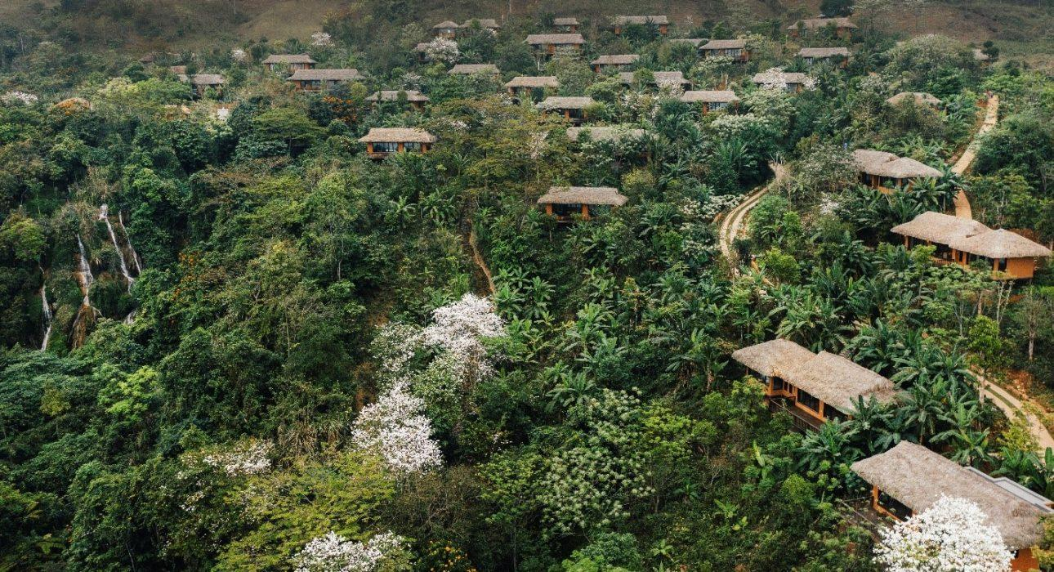
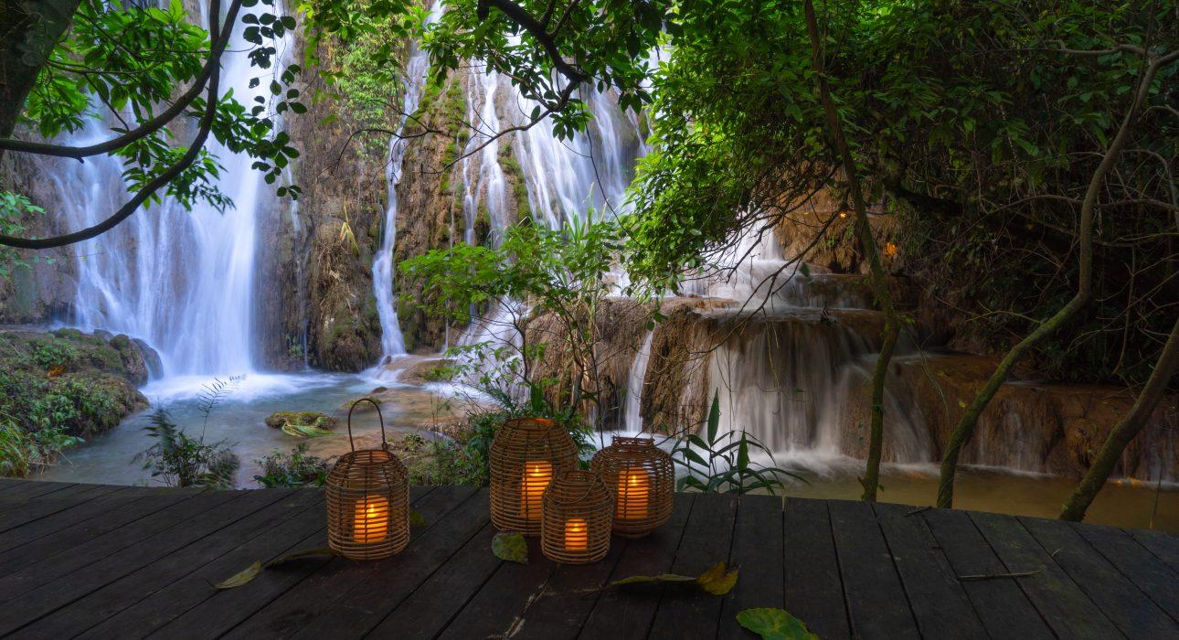
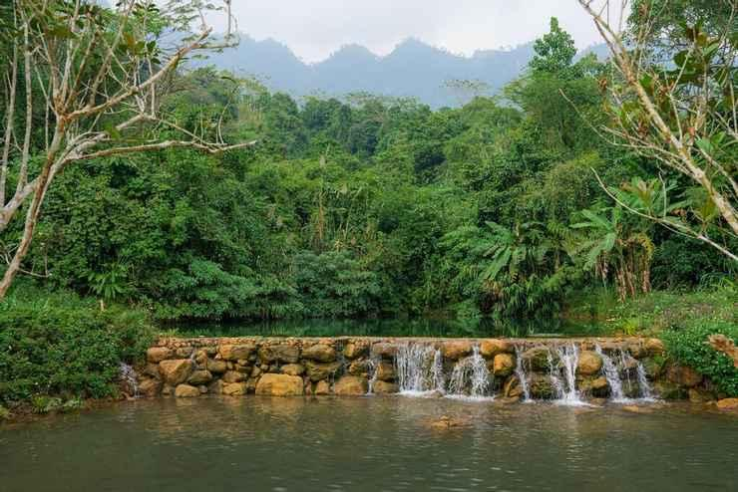
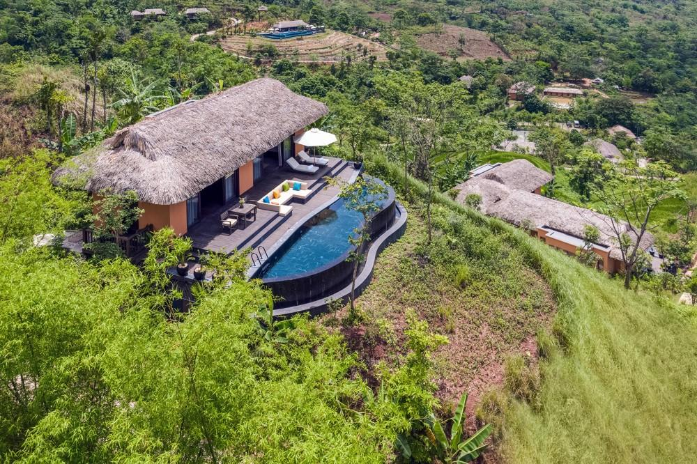
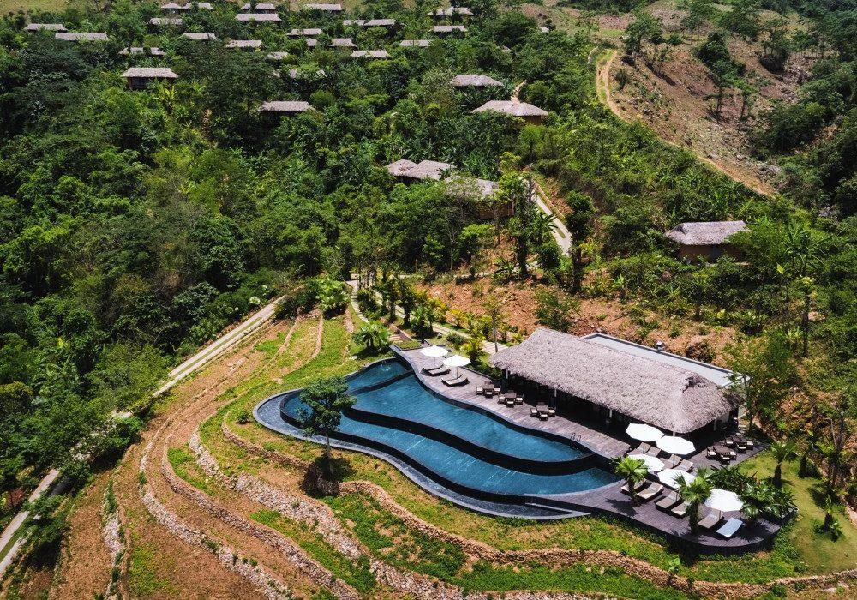
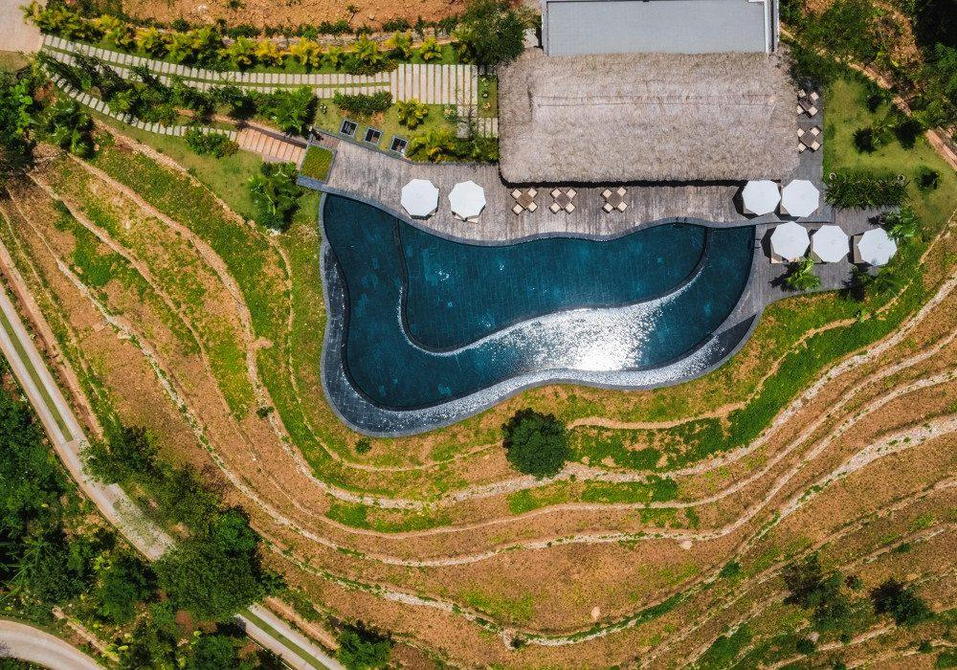
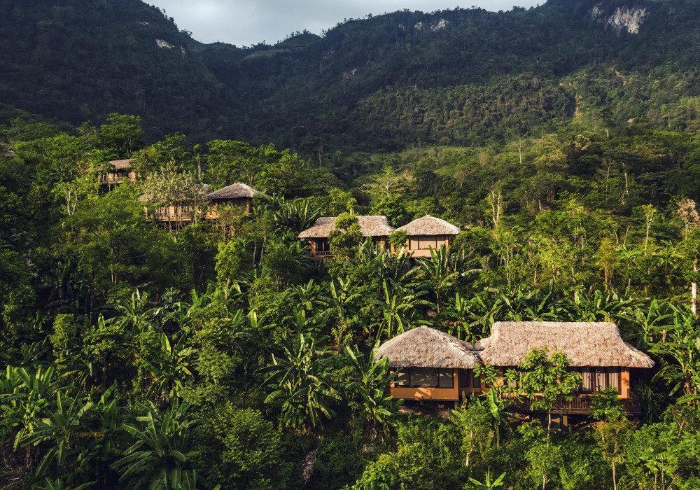

Rooms photos
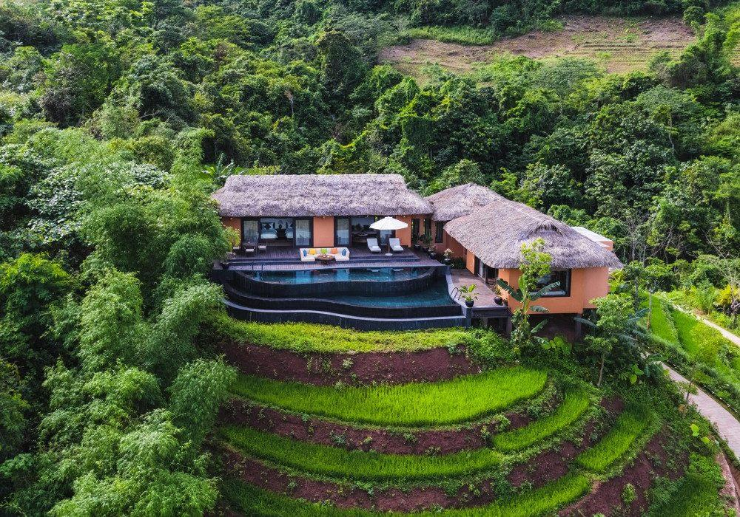
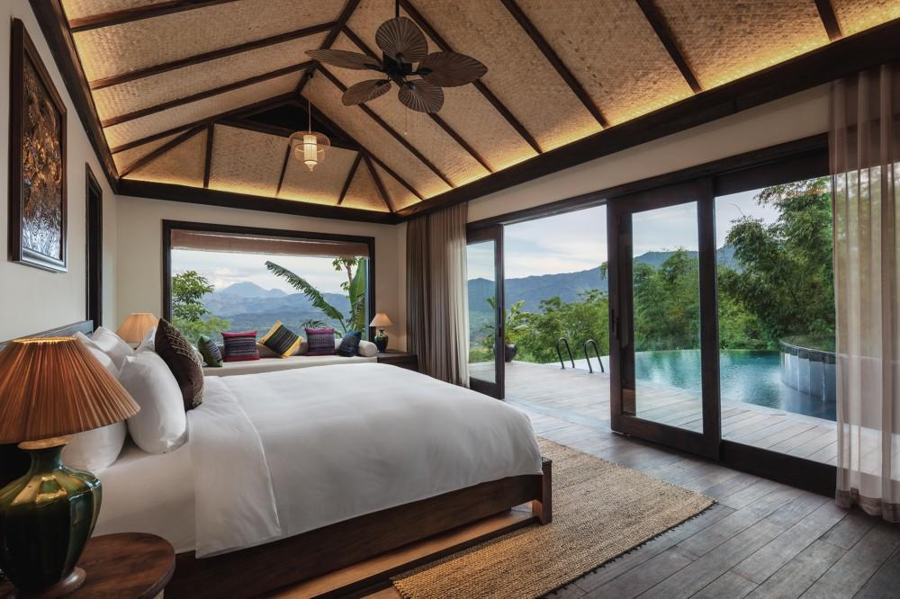
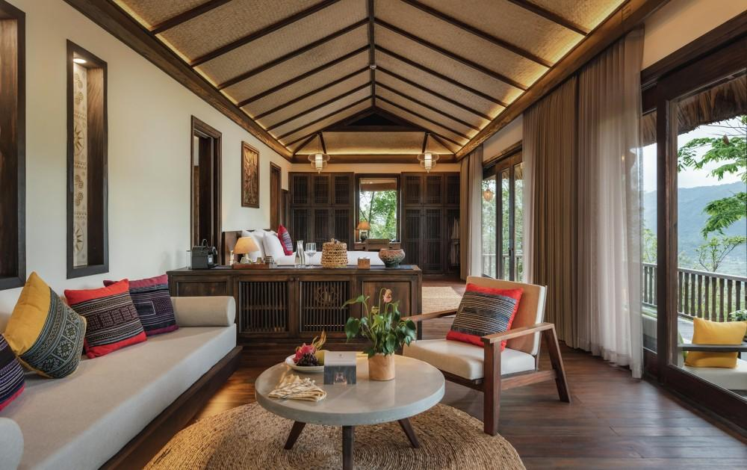
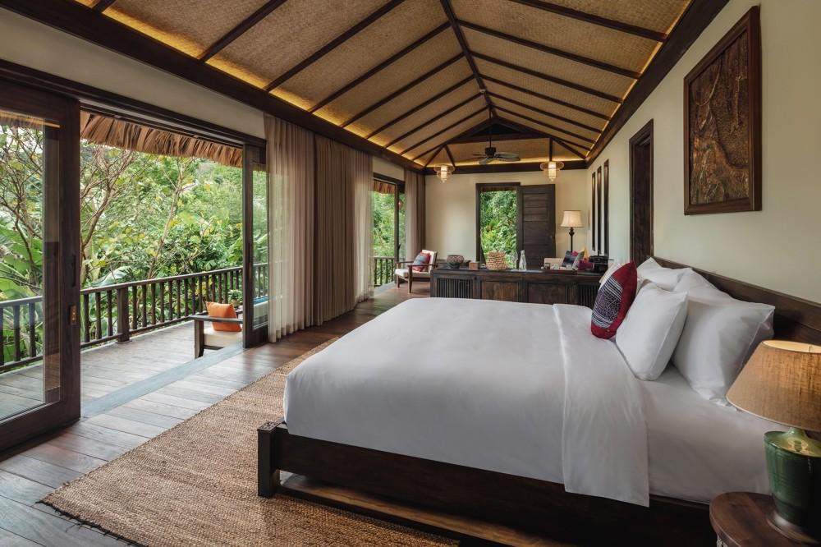
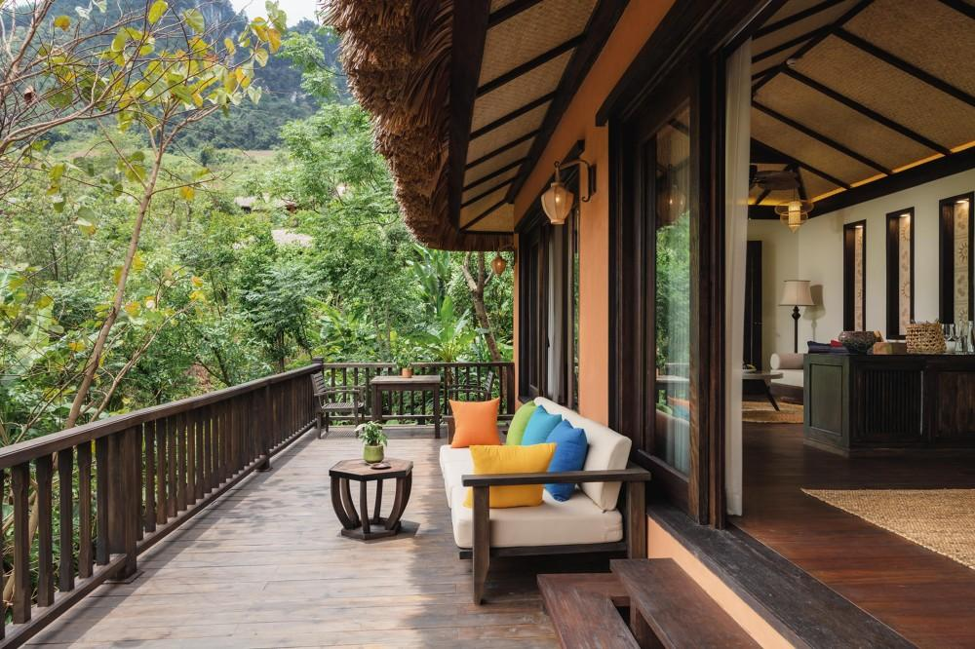
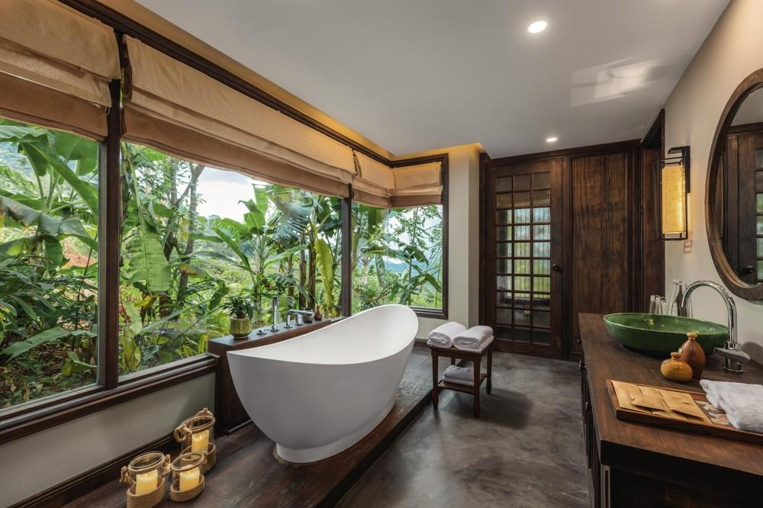
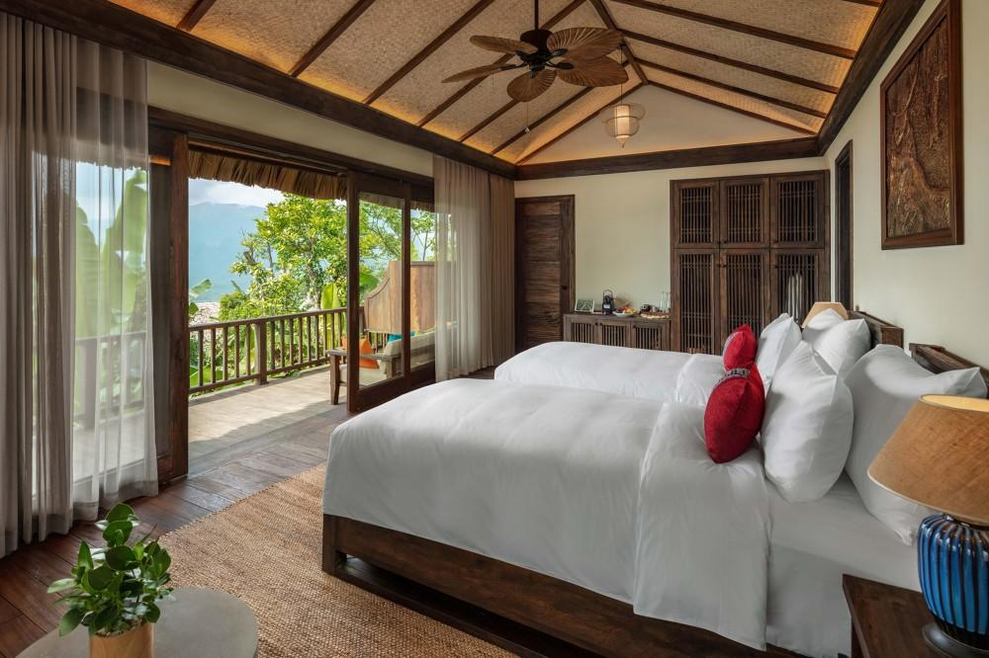

Restaurant photos
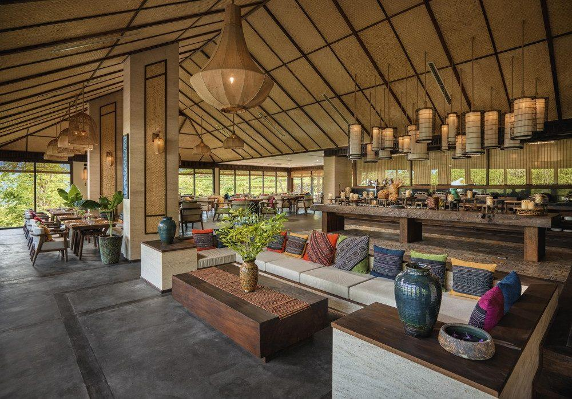
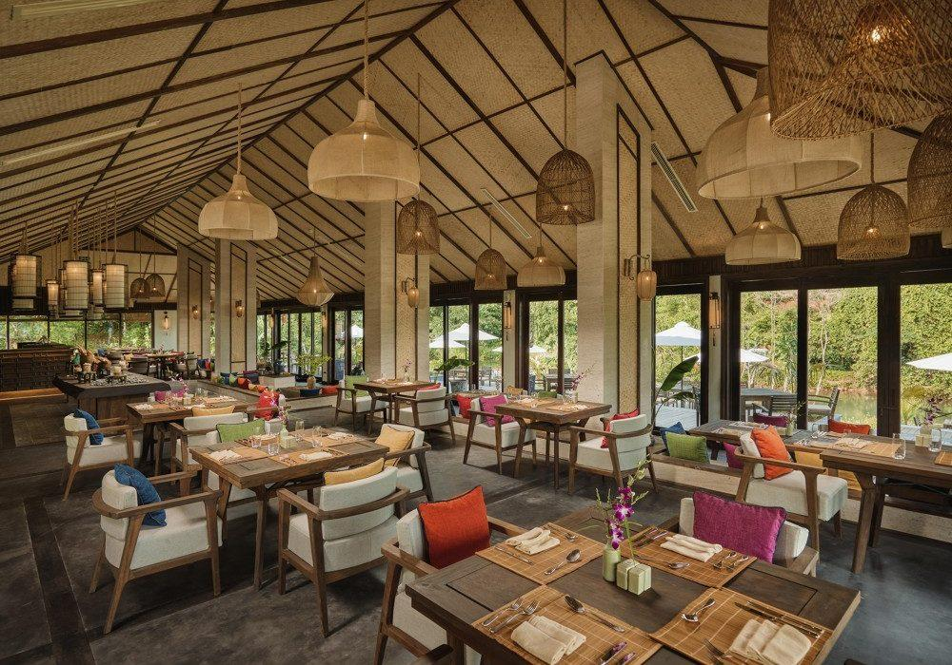
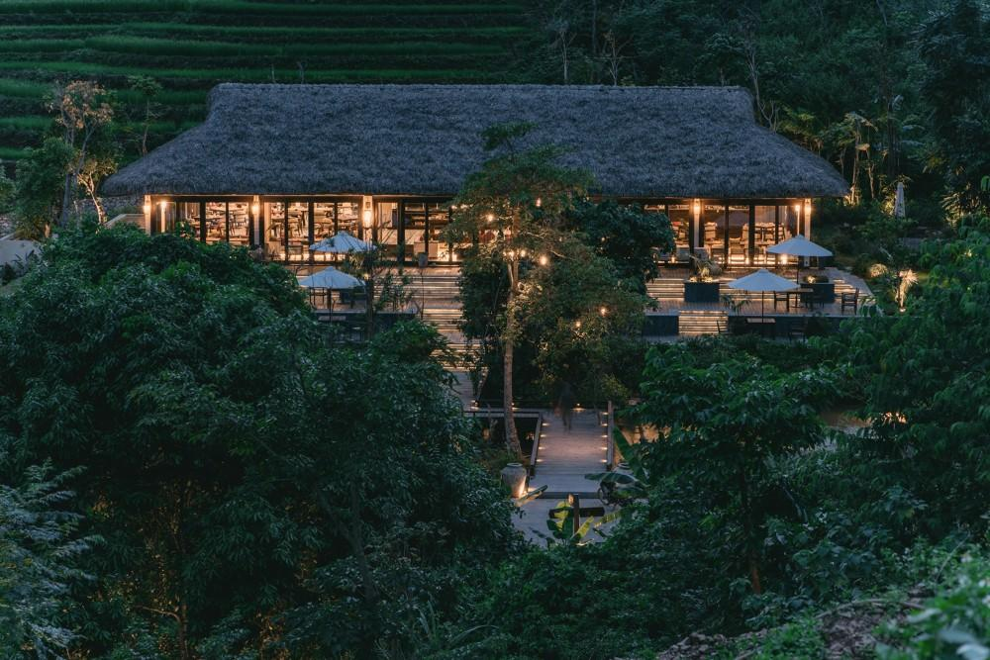
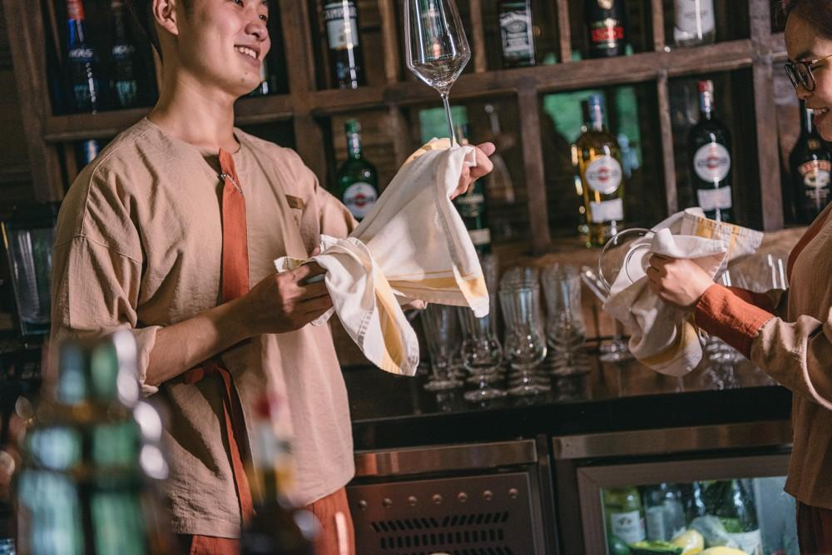
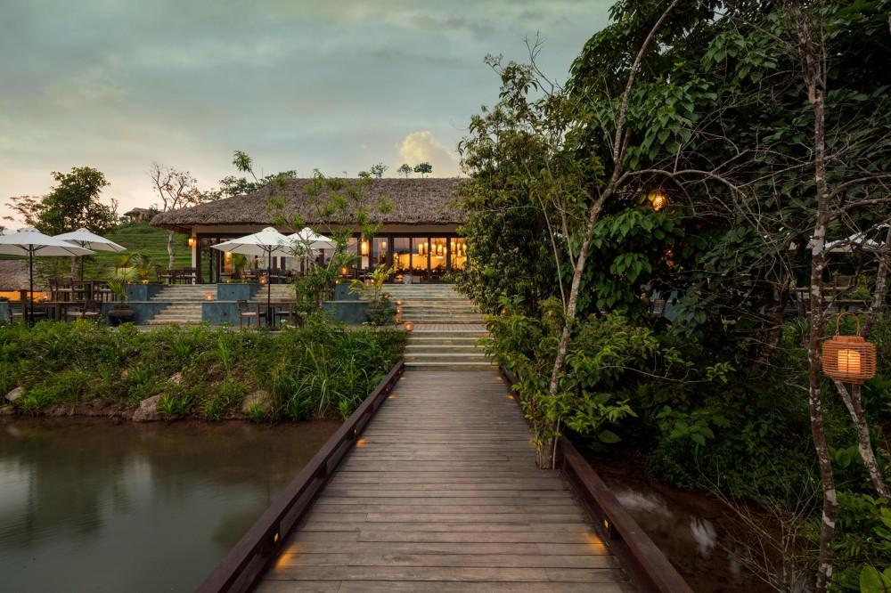
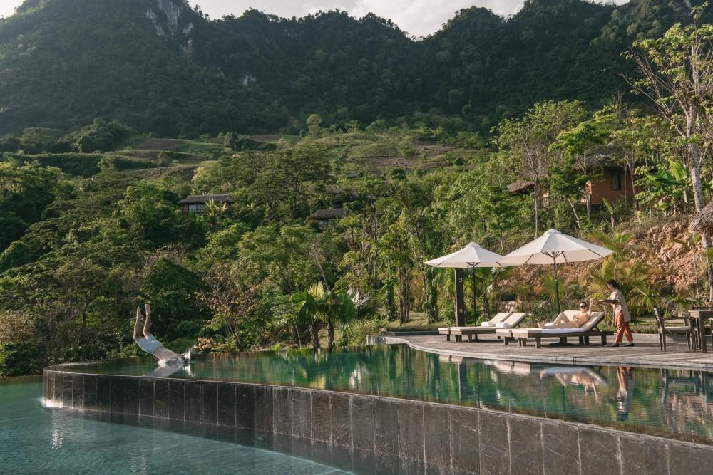
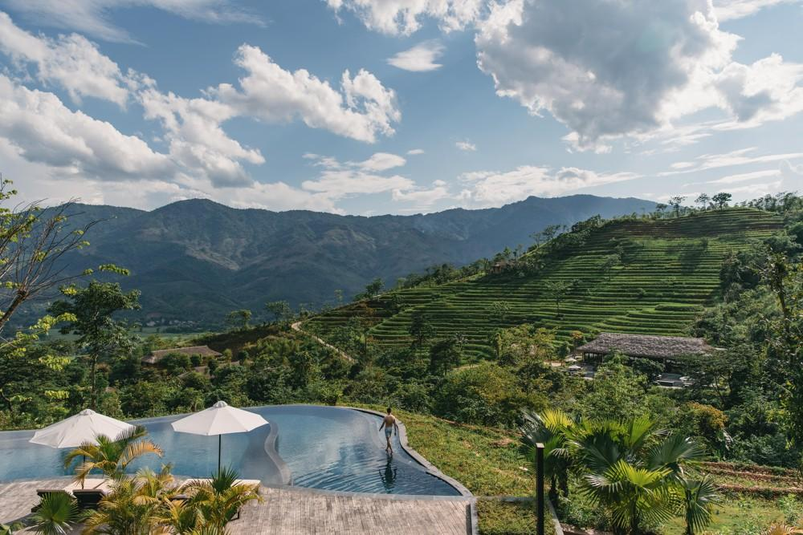

Services & facilities photos
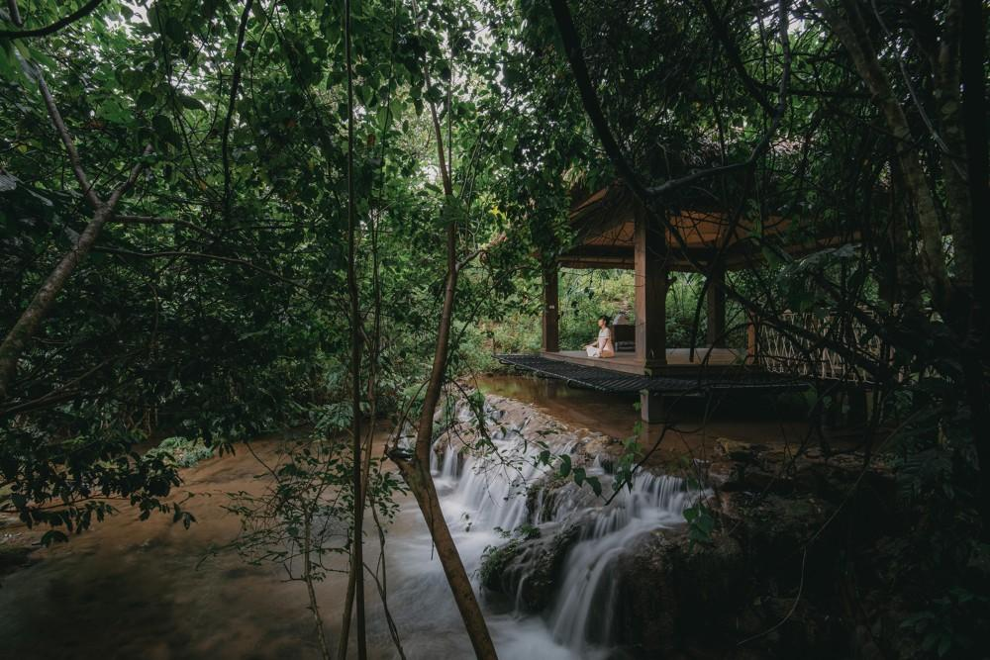
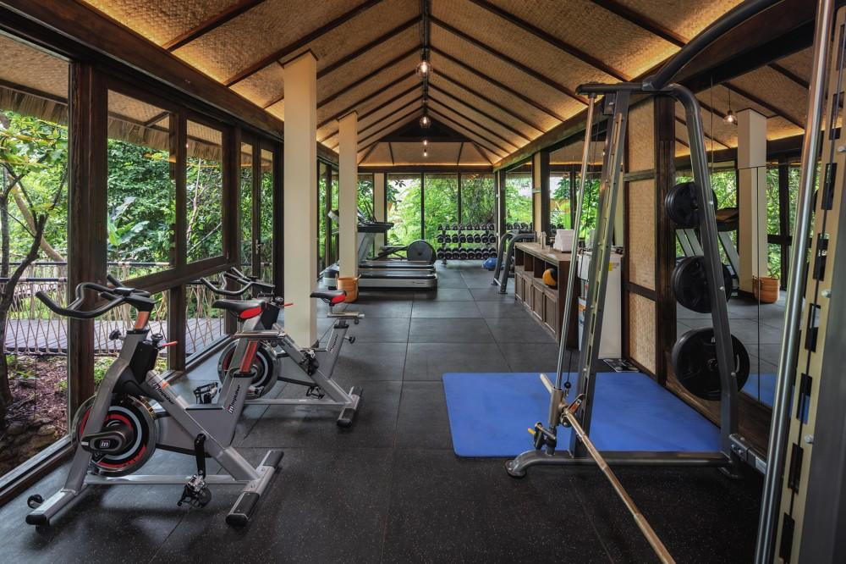
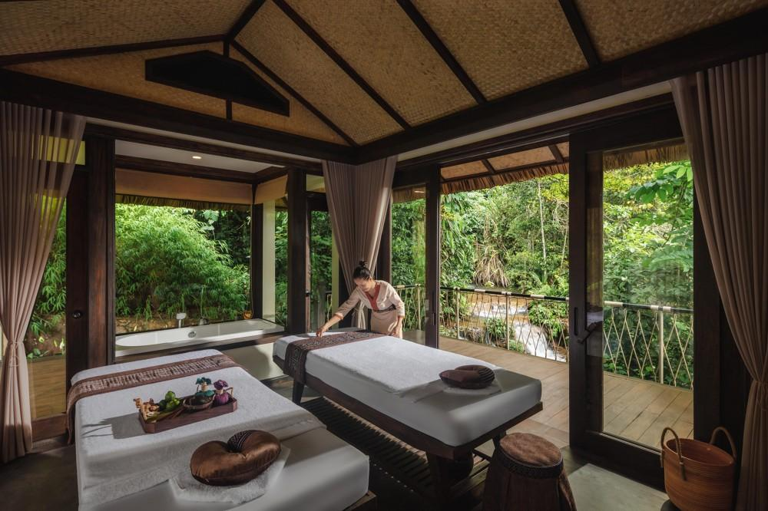
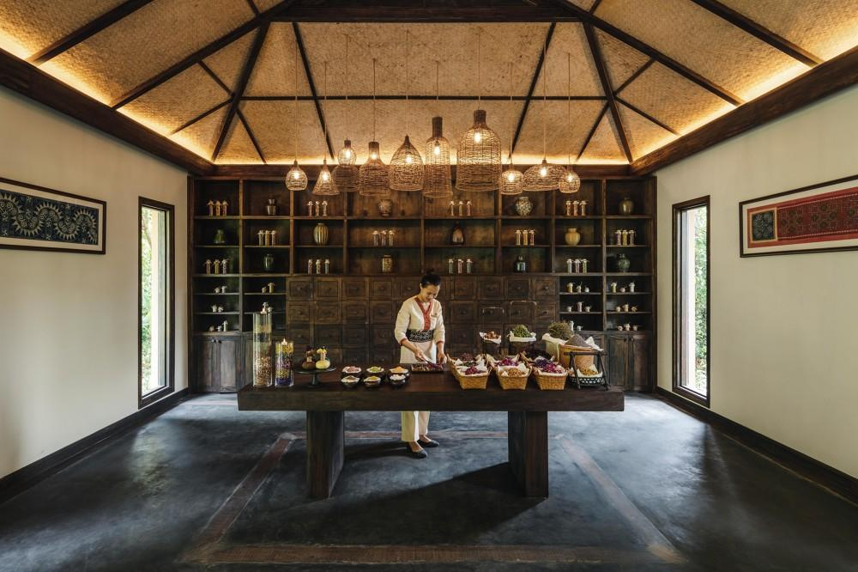
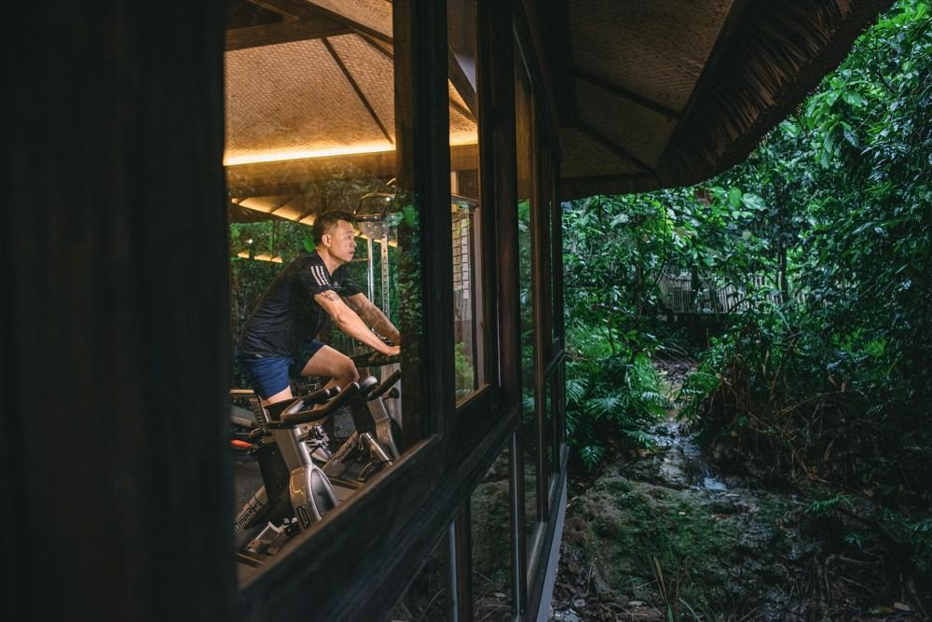
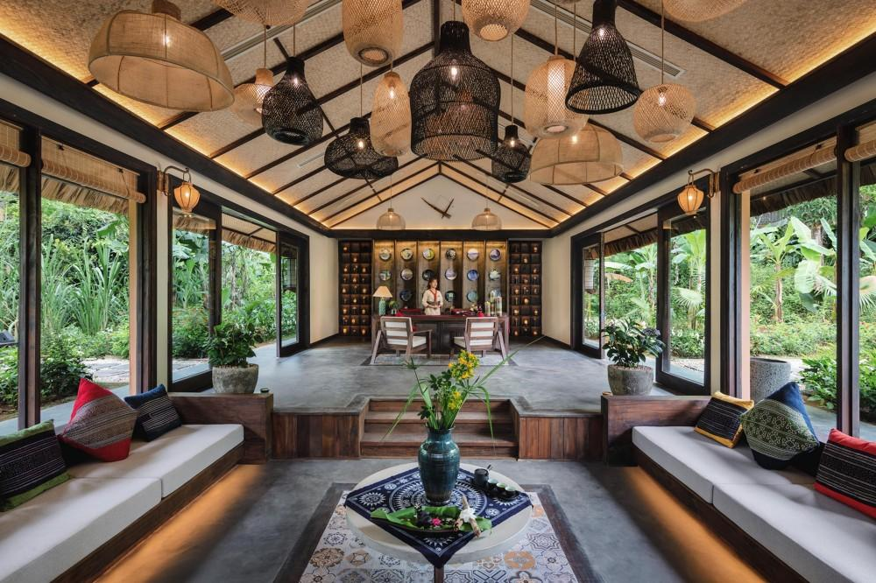

Easia Travel Head Office

Vietnam Head OfficeC/o: ATS Hotel, Suite 326 &327, 33B Pham Ngu Lao Street, Hanoi, VietnamTel: +84 24-39 33 13 62www.easia-travel.com

