Vietnam – Phan Thiet – Azerai Ke Ga Bay
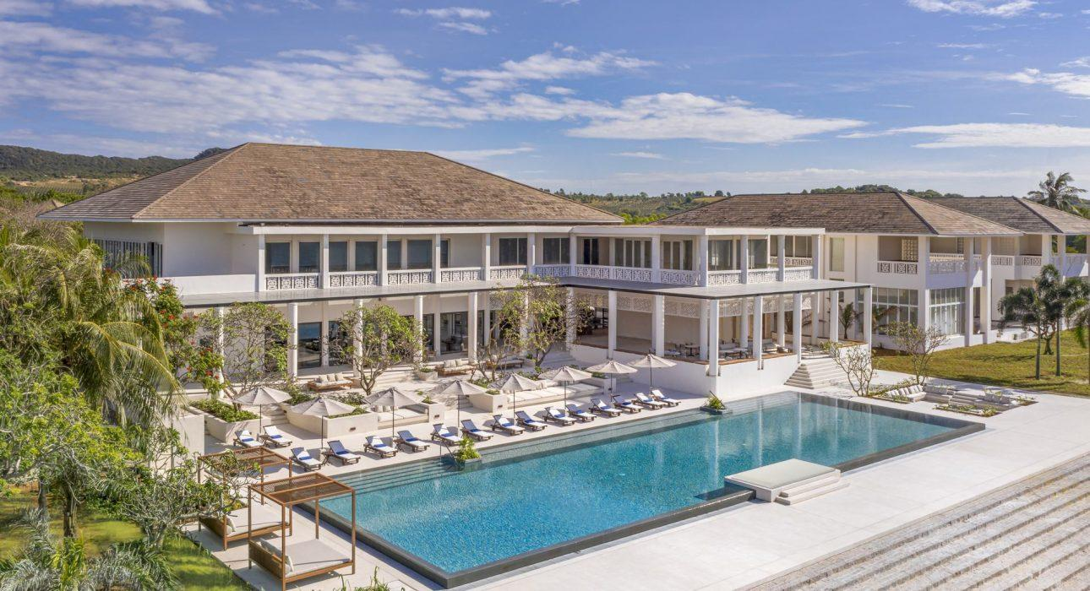

Over View

Theme
Beach Stay, Classic, Family, Honeymoon

Country - City
Vietnam - Phan Thiet

Market segment
Thematic Leisure

Official category
5*

Easia category
Deluxe

Total number of rooms
57

Price level
$$$$

Description

Aman founder Adrian Zecha is back with a new brand, Azerai, and while it’s distinct from his other work in its specifics, the overarching purpose is the same: to create a travel experience that’s nothing short of transformative. Any hotel that can do that is one for our listings, and Azerai Ke Ga Bay, on the southeastern coast of Vietnam, achieves it, with Zecha’s characteristic ease.Located in the coastal province of Binh Thuan, Azerai Ke Ga Bay is set on a five-kilometer stretch of secluded shoreline on the East Sea and next to the historic 1899-built colonial French lighthouse. The white sand beach is framed to the west with soaring dunes and, to the east, by a rocky headland and islet. The lush and mature gardens of the resort make for a tranquil environment, perfect for retreat and relaxation.The property’s 57 suites, pool suites and pavilions welcome guests with their clean lines and comfortable materials. A muted colour palette of whites and granites echo the shades of local sand and stone, while elegant villas open to outdoor terraces and gardens. Generously appointed rooms offer views of the gardens or private courtyards, and several spacious villas feature private plunge or swimming pools.

Selling points

- Azerai’s flagship resort
- Most Luxurious resort in Binh Thuan province.
- Framed to the north by Ke Ga Island, with its historic 1899-built colonial French lighthouse, and to the south by soaring sand dunes
- Spacious suites from 65 sqm – 145 sqm with 10 gorgeous private pool suites, 4 swimming pools
- Top-notch spa facilities & wellness services

Time & Transportation

FROM | TO | DISTANCE (KM) | BY | DURATION | ROAD CONDITION
TSN Airport | Hotel | 180 | Car | 2.5 hours | Excellent
Hotel | PGA Nova Golf | 15 | Car | 30 – 45 minutes | Excellent
Hotel | Phan Thiet City | 35 | Car | 60 minutes | Good
Hotel | Mui Ne | 55 | Car | 90 minutes | Good

Rooms

Easia's recommend room type
Total: 57 RoomsRoom Type:
Room Type | Number of rooms |  |  | Size | Capacity | Bed(King/Queen/Single) | View | Extra Bed
DBL | TWN | Total | Yes/No
Deluxe Suite Garden View | 20 | On Requestmaximum 20per night | 20 | 65 | 2A or 2A+1C | KING | Garden | Sofa bed
Deluxe Suite with Pool View | 16 | 16 | 65 | 2A or 2A+1C | KING | Pool | Sofa bed
Pool Suite with Plunge Pool(Private plunge pool, 2,1m x 3,6m) | 15 | 15 | 130 | 2A + 2C | KING | Private | Extrabed
Pool Deluxe Suite(Private pool, 3m x 6m) | 3 | 3 | 145 | 2A + 2C | KING | Private | Extrabed
Ke Ga Bay Pavilion(Private pool 8 x 4m) | 3 | On request | 3 | 185 | 3A or 2A + 2C | KING | Private | No

Room configuration

Connecting rooms
Yes, 07 Pairs (available for Deluxe Suite Garden View)

Extra bed
Sofa bed (0.8m x 2m) for Deluxe Suite &amp; Deluxe Suite pool view and Extra bed (1.2m x 2m) for Pool Suite &amp; Pool Deluxe Suite

King bed
2m x 2m (57 Pieces)

Queen bed
NO

Twin beds
1m2 x 2 m

Services & Facilities

Services
24 hour reception, 24h security service, Afternoon Tea, Airport transfer, Billiards, Buffet Breakfast, Catering (beach, river, cave, other), Chef- Prepared meals and cooking lession, Children Activities, Children Swimming Pool, Complimentary bottle of water, Complimentary fresh towel, Concierge service, Cooking Lesson, Credit Card payment, Currency exchange, Dry Cleaning, Fishing, Golf, In-Room Dining, Iron, Kayaking, Kid Corner, Laundry service, Limousine Service, Luggage Storage, Massage, Picnic boxes, Private event, partying, Room Service, Services for children, Spa, Swimming Pool, Visiting local villages, Wake-up service, Welcome fruits in room upon arrival, Wi-fi Free, Yoga Retreat

Facilities
Air Conditioning, Bar, BBQ Facility, Beauty Shop, Bicycle, Bond fire, Children Pool, Club Lounge/ Executive Lounge, coffee and tea making facilities, Coffee Machine Facilities, Conference hall, Family Room, Fitness centre, Flat screen TV, Free private parking, Full Board - B/L/D, Garden, Gift Shop, Hair Dryer, In-Room safe, Indoor swimming pool, Internet, Jacuzzi, Massage room, Meeting room, Mini Bar, Outdoor swimming pool, Private Beach, Private Dining Room, Private Pool, Restaurant, Safety Box, satellite LCD TV, Shower With Hot Water, Smoking Area, Steam/Sauna, Table Tennis, Terrace, Umbrella

Disabled Facilities
No disable access

Business facilities details
ROOM NAME | SIZE(m2) | CLASSROOM | THEATER | U SHAPE | BOARDROOM | BANQUET
Meeting Room 1 | 12.5 x 12 | 60 | 70 | 30 | 50 | 60
Meeting Room 2 | 12.8 x 5 | 28 | 42 | 18 | 20 | N/A

Restaurant information

Name: The Dining Room
- Capacity: 60 pax
- Opening Hours: 13:00 – 22:00
- Type of Cuisine: Vietnamese and International
Name: The Living Room
- Capacity: 30 pax
- Opening Hours: 6:30am – 22:00
- Type of Cuisine: Vietnamese and International

Photos

Hotel Photos
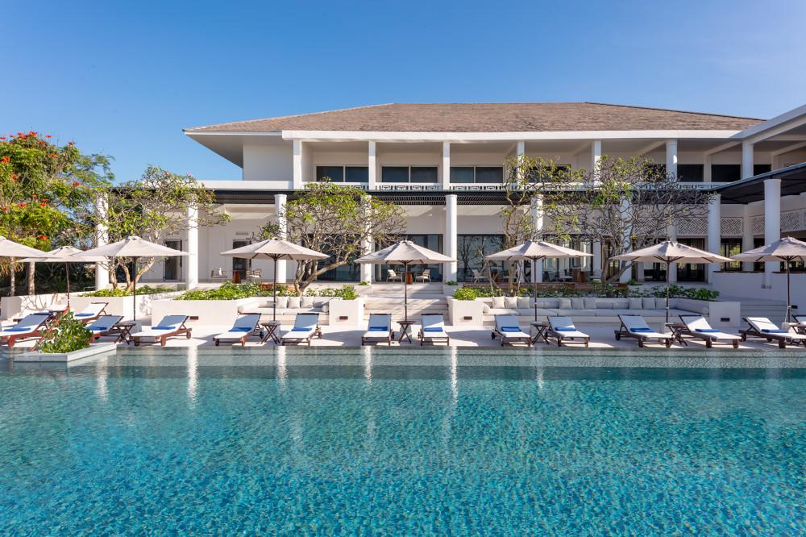
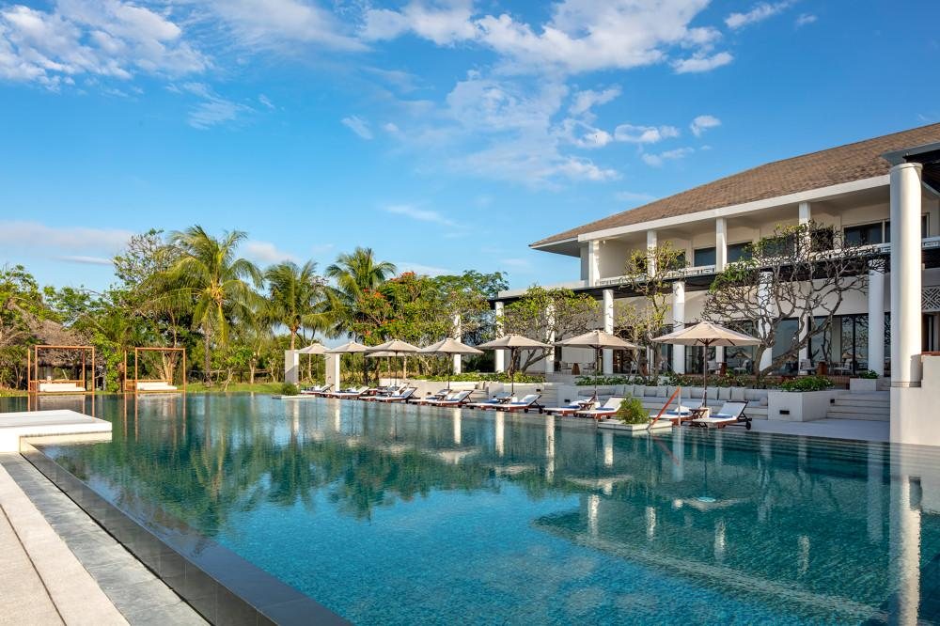
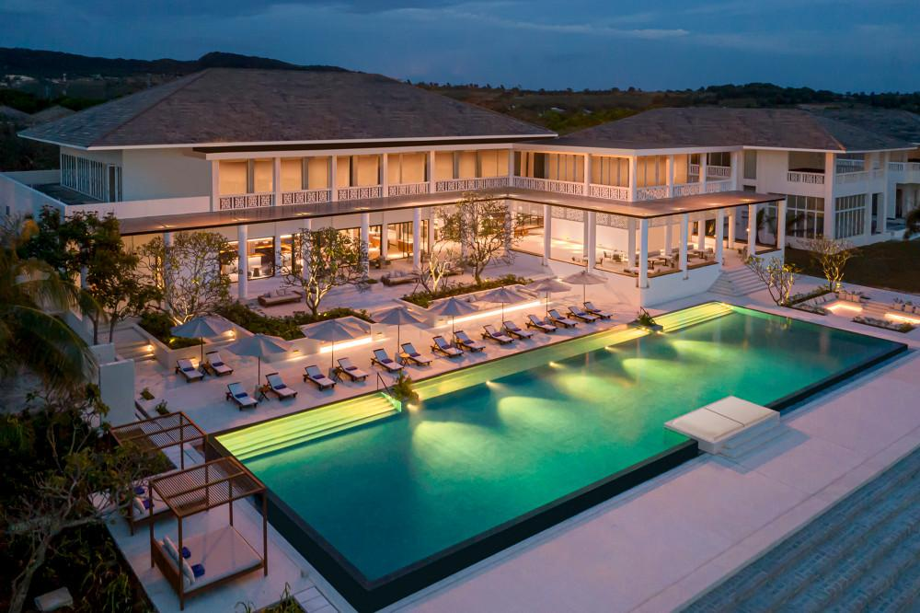
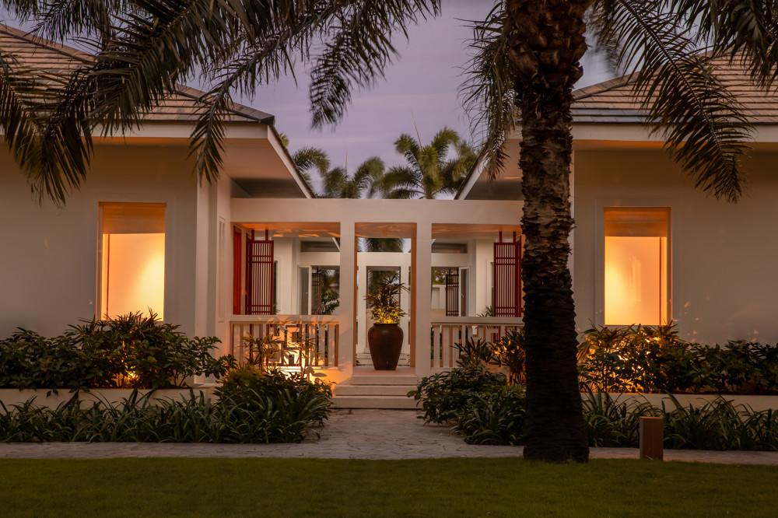
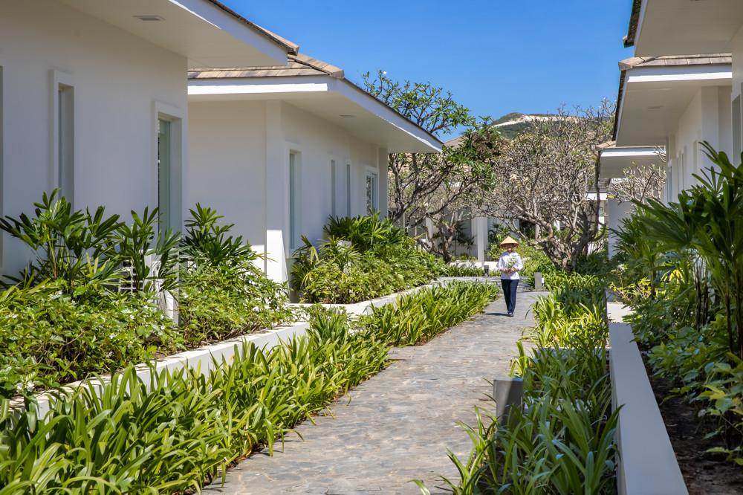
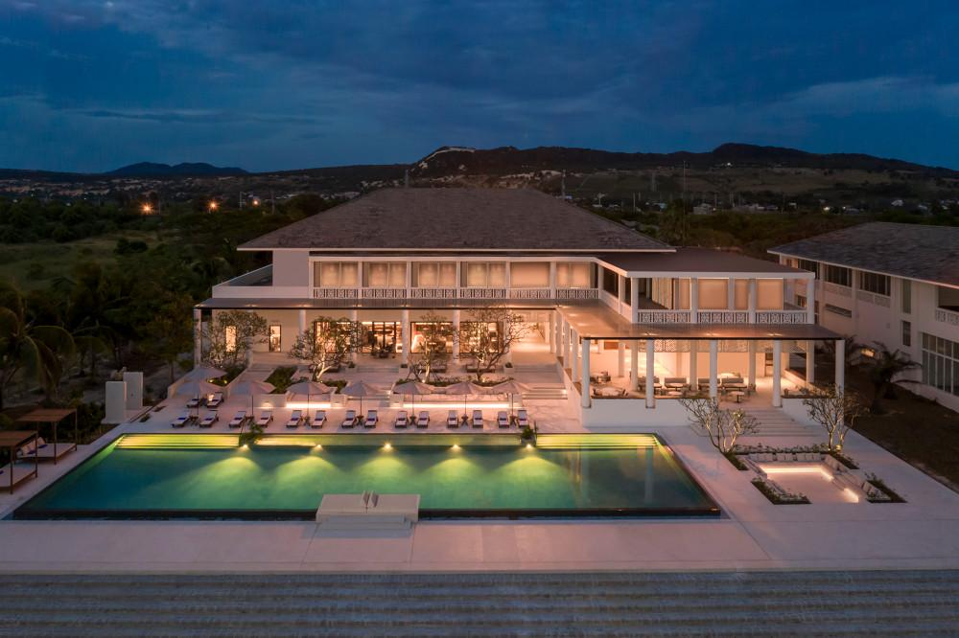

Rooms photos
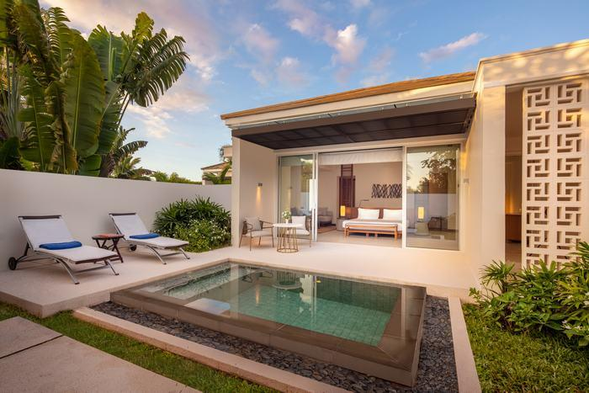
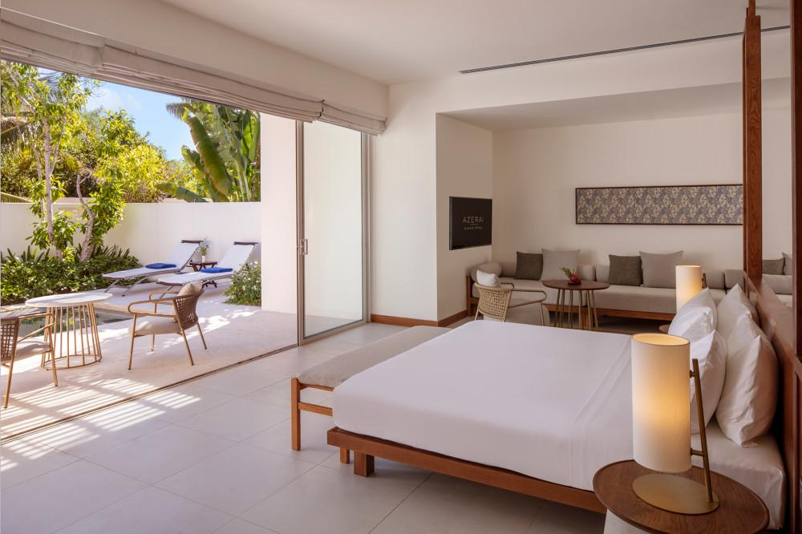
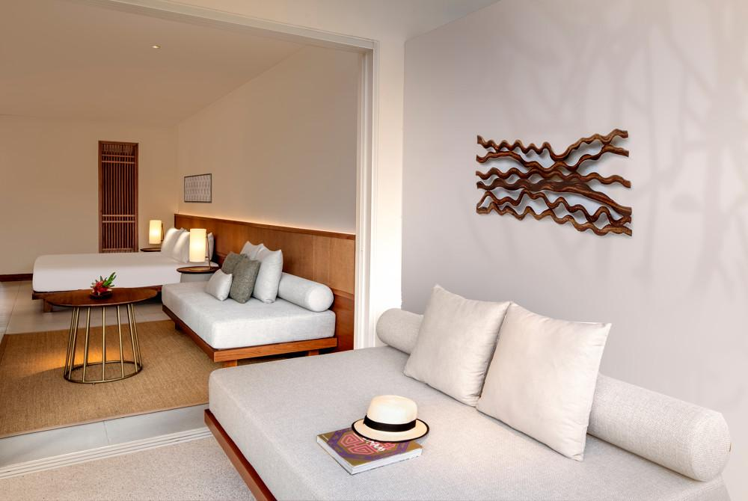
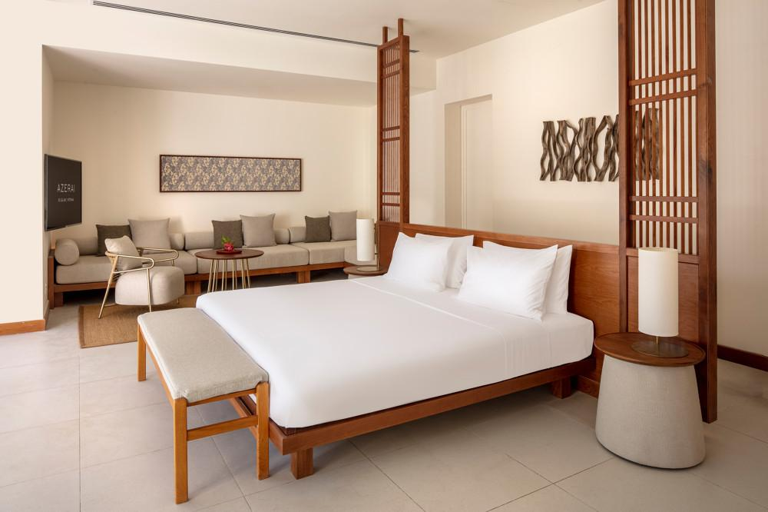
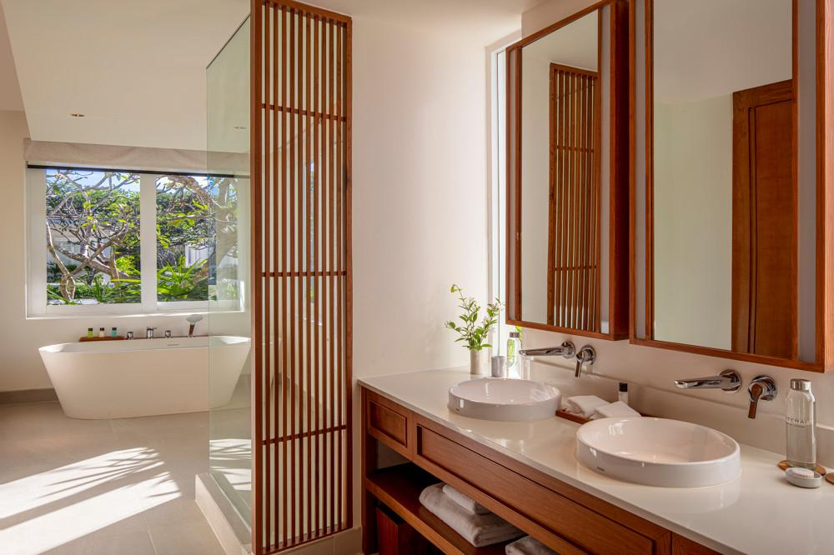
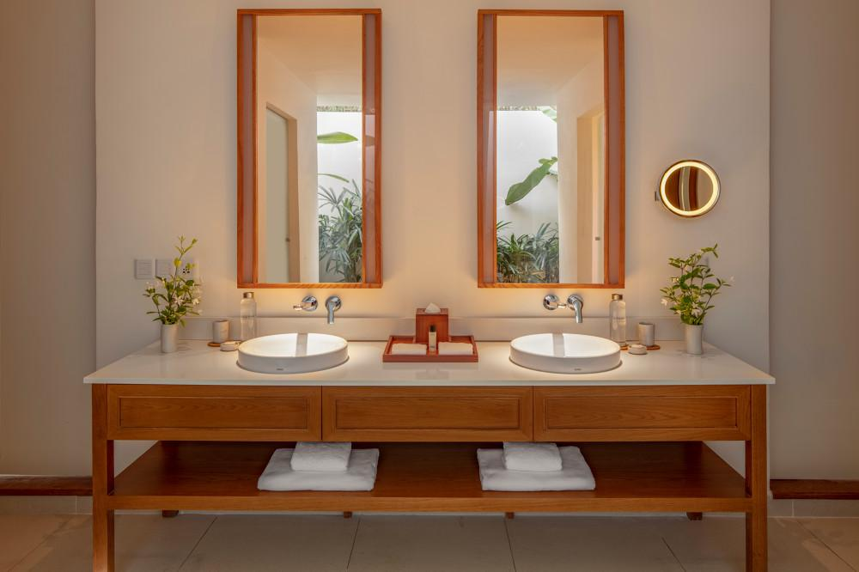
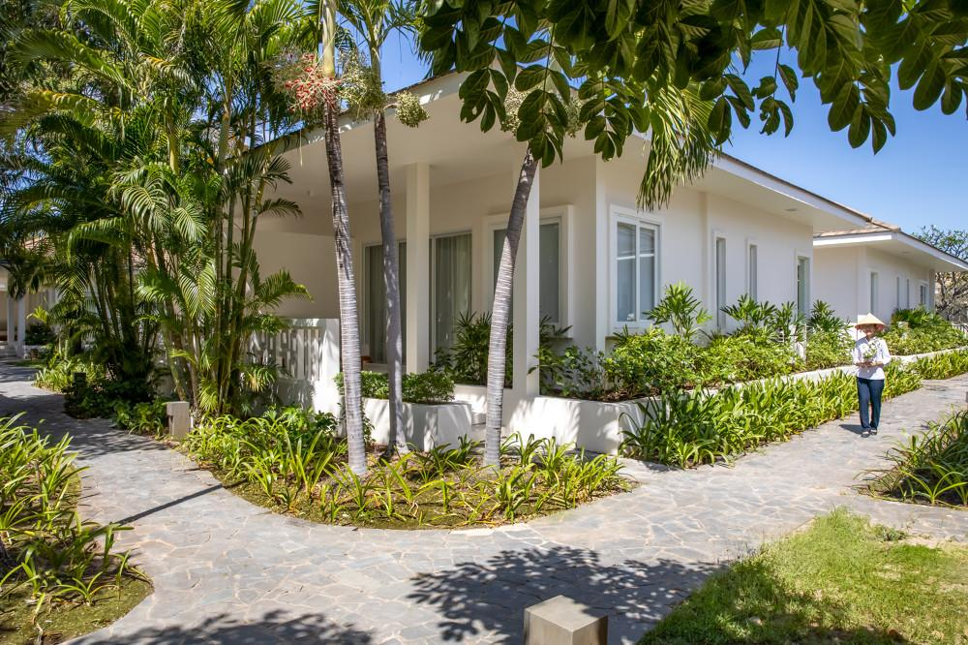
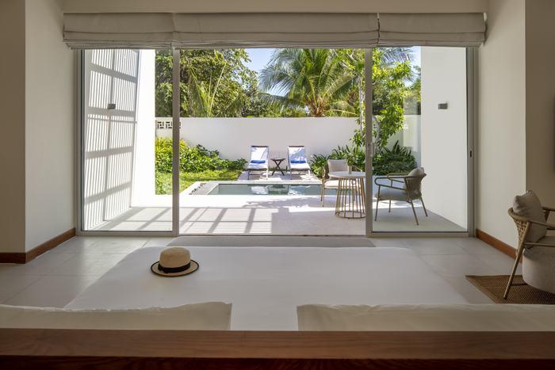
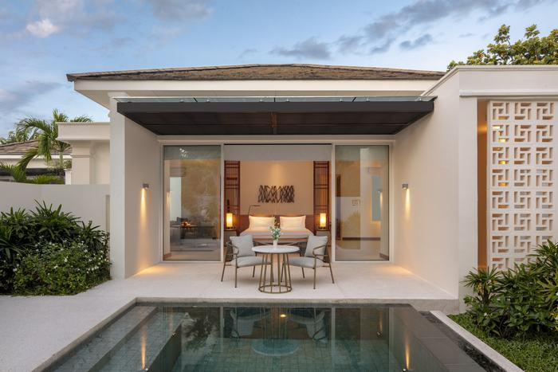
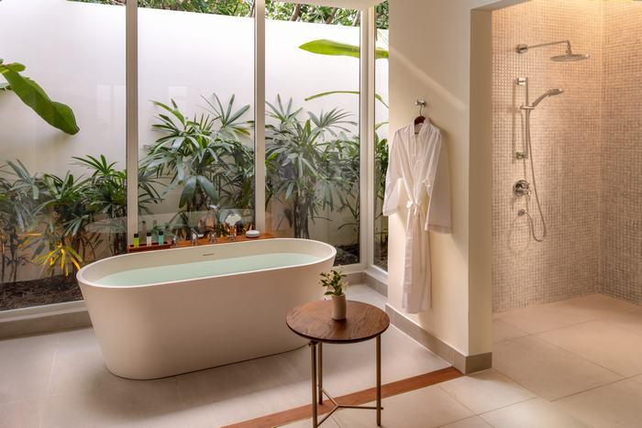

Restaurant photos
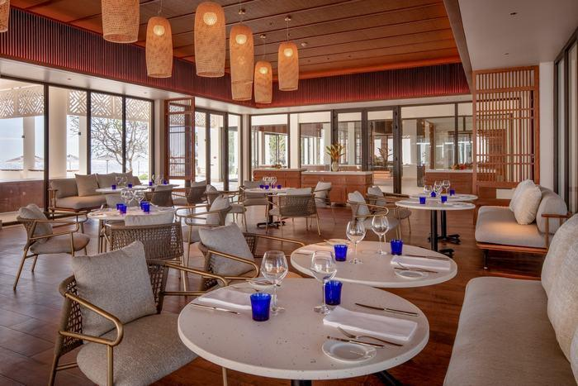
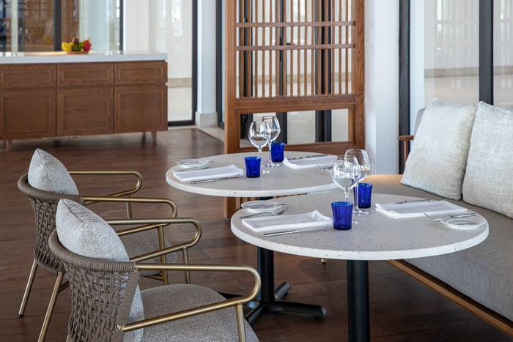
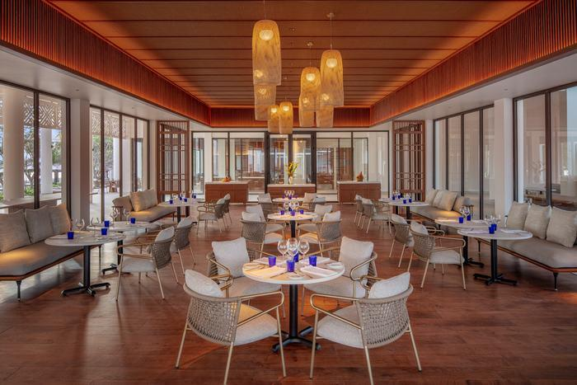
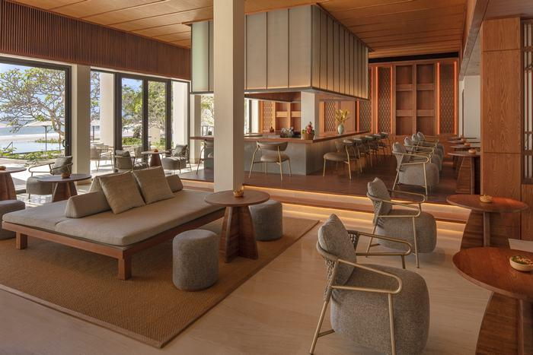
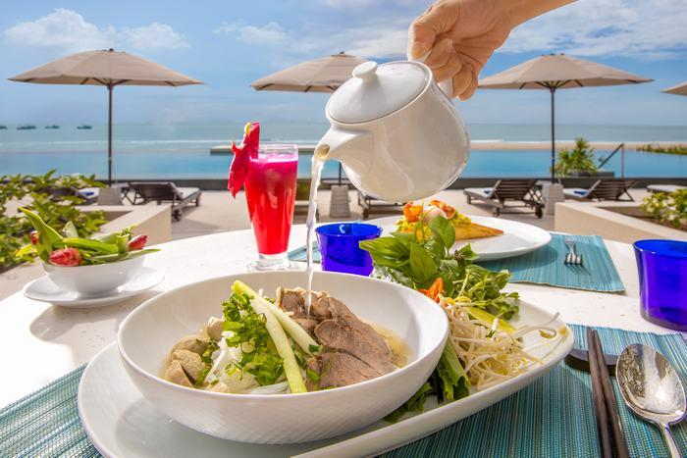
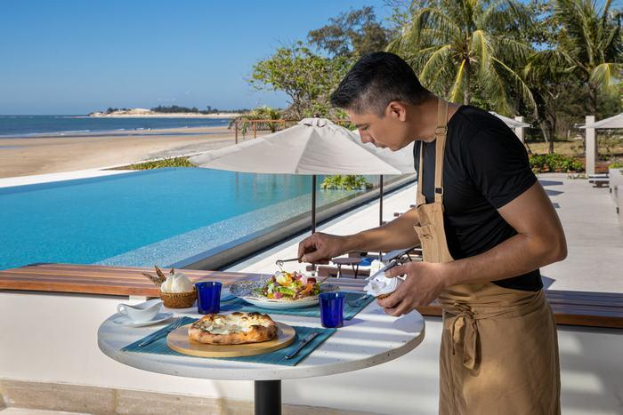
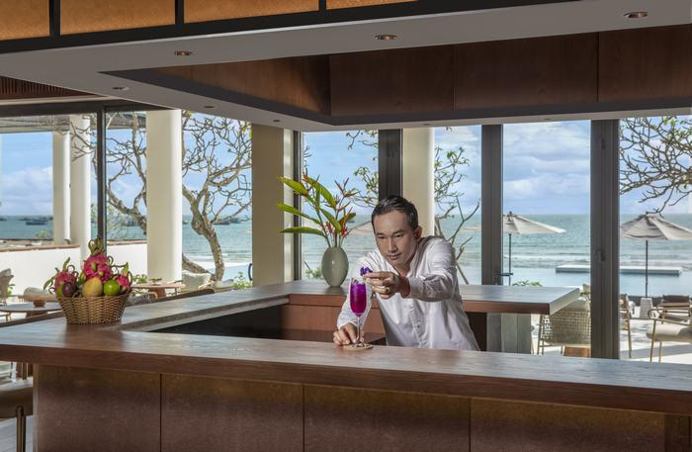

Services & facilities photos
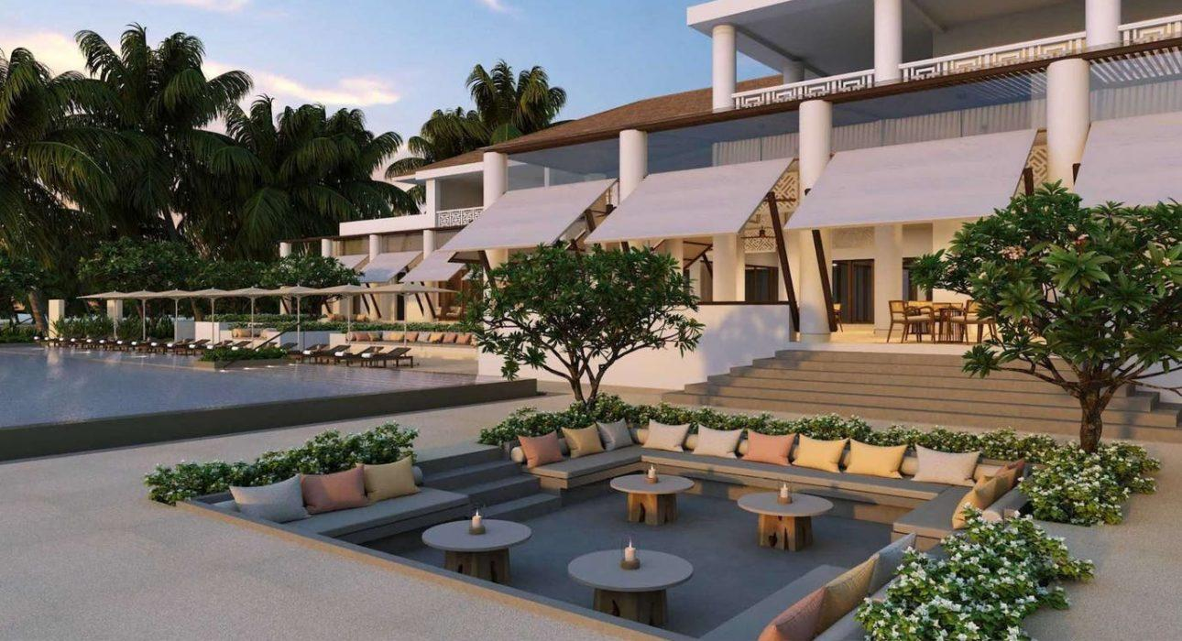
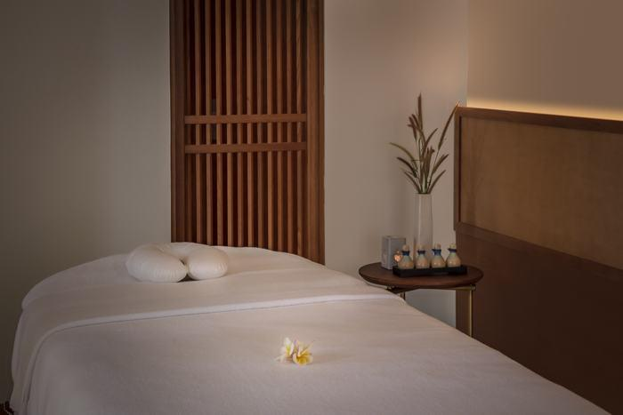
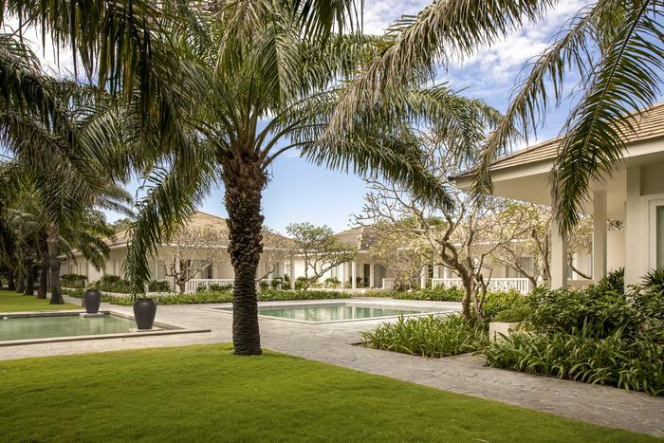
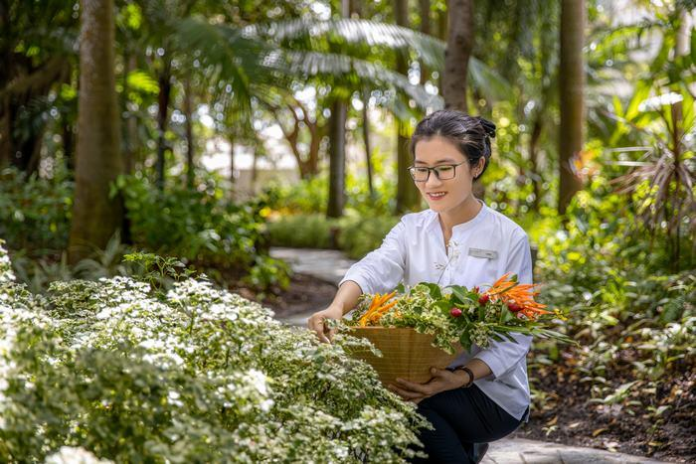
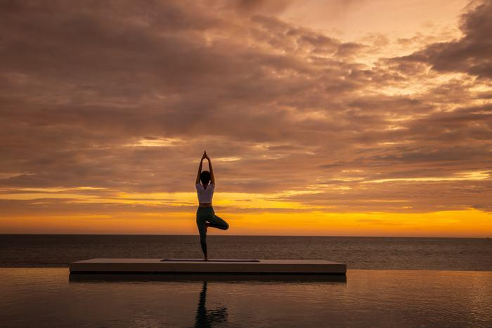

Easia Travel Head Office

