Vietnam – Ho Chi Minh City – Mai House Hotel Sai Gon
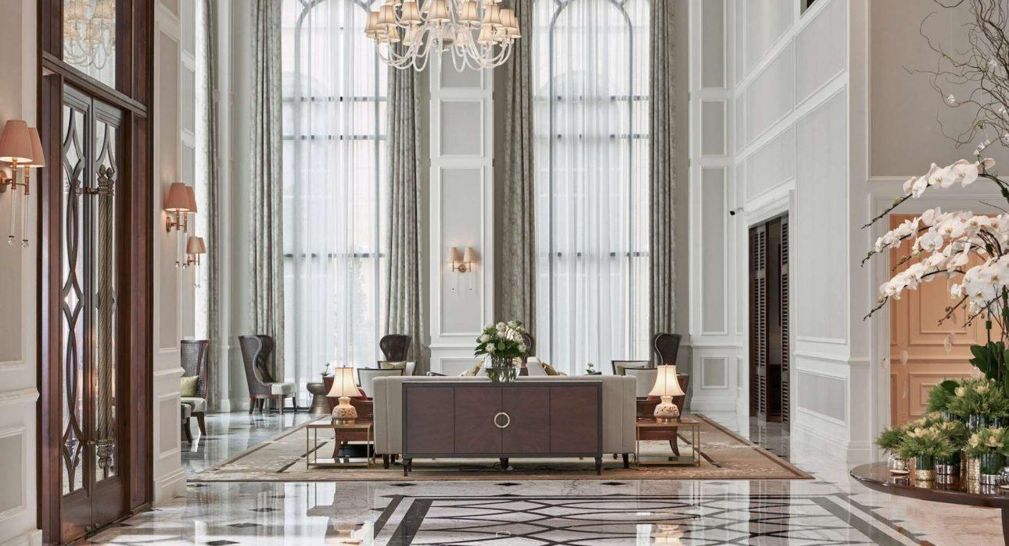

Over View

Theme
Classic, Family, Honeymoon

Country - City
Vietnam - Ho Chi Minh City

Market segment
Groups, Thematic Leisure

Official category
5*

Easia category
Deluxe

Total number of rooms
223

Price level
$$$

Description

Mai House is an independent boutique hotel nestled between colonial villas. Founded by a self-made Vietnamese businessman, unlike other luxury hotels in the city that belong to global hospitality groups, it can make decisive choices that allow it to adapt to visitor preferences quickly.Mai House Saigon embraces elegant old-world grandeur mixed with modern, stylish design, ideally situated in charming colonial district 3, minutes from the city’s heart, with easy airport access. Every corner of Mai House Saigon is imbued with a desire to share Vietnam’s rich culture with the world. Mai House Saigon takes every guest through an authentic journey filled with the spirit of Vietnamese hospitality, making each traveler feel at home yet utterly indulgent.With 223 beautifully appointed guestrooms, suites, and serviced apartments, Mai House Saigon honors its guests with a calming and compelling experience. With impeccable harmony between lighting, ventilation, and decoration, each room rewards guests with peace of mind, uninterrupted rest, and revitalizing energy for a new day. Lavish glass bathrooms with classic claw-foot bathtubs and luxurious amenities by European designer Roberto Cavalli guarantee the utmost comfort to unwind after a day of exploration.THƠM LOUNGE, located in the lobby, is the first to welcome every guest to Mai House Saigon. The charming lounge honors Vietnamese tea culture with 29 types of tea, including exquisite selections from the Northwest mountains, representing lasting prosperity. Opting for an Afternoon Tea experience here, guests are captivated by the pleasing scent and beautiful piano melodies.C’EST LA VIE, the all-day dining room on the 2nd floor, elaborates on traditional Vietnamese and French dishes with inspiration from the love-filled kitchen of devoted grandmas in folk stories, bringing refined yet hearty meals to diners. The restaurant, featuring an extensive wine list, is a gathering place for families and friends while savoring the delicate gastronomical offers.MAI’S SKY CLUB LOUNGE – Situated on the 14th floor is an exclusive lounge + rooftop for Mai’s Sky Club members. Guests will enjoy the utmost privacy in this relaxing space while contemplating the expansive views of the modern city from above.Mai House Hotel wellness and recreational venues include Four Elements Spa, The Fifth Element Pool & Bar, and LifeFitness Gym, all located on the 5th floor connecting to an airy, quiet open space.

Selling points

- Upscale hotel in Ho Chi Minh with a choice of guestrooms, suites, and one-and-two-bedroom apartments
- Located on a quiet street in the busy city center, just 5 to 10 minutes from the tourist attractions of Ho Chi Minh City.
- Splendid French-Indochinese decor with luxurious touches
- Ideal for both leisure & business guests

Sustainability

Supplier Actions
Protection of Environment, Support local communities, Animal Welfare, Facilities for people with reduced mobility (PRM), Water refill station

Certifications
Mai House Saigon Hotel is honored to be nominated by the World Luxury Hotel Awards 2023 in 3 categories, including:
- “Luxury Art Hotel”
- “Luxury Lifestyle Hotel”
- “Luxury Urban Hotel”

Time & Transportation

FROM | TO | DISTANCE (KM) | BY | DURATION | ROAD CONDITION
Hotel | War Remnants Museum | 400M | Walk | 4p | Good
Hotel | Independence Palace | 750M | Walk | 10p | Good
Hotel | Saigon Notre-Dame Cathedral | 1KM | Walk | 15p | Good
Hotel | Ho Chi Minh City Museum | 1.1KM | Car | 7p | Good
Hotel | Remnants Saigon Central Post Office | 1.2KM | Car | 8p | Good
Hotel | Ben Thanh Market | 1.5KM | Car | 9p | Good
Hotel | Ho Chi Minh Opera House | 1.6KM | Car | 8p | Good
Hotel | Saigon Center | 1.7KM | Car | 9p | Good
Hotel | Nguyen Hue Walking Street | 2KM | Car | 11p | Good
Hotel | Ho Chi Minh Museum of Fine Arts | 2KM | Car | 10p | Good
Hotel | Bui Vien Walking Street | 2.8KM | Car | 13p | Good
Hotel | Tan Son Nhat International Airport | 5.8KM | Car | 16p | Good

Rooms

Easia's recommend room type
- Deluxe Room (24 King): 30sqm – Each feature, like curved lines, plush carpets, high ceilings, marble bathrooms, cleansing equipment, and plenty of space, are thoughtfully disposed to call your own.
- Premium Room (74 King – 47 Twin): 34 sqm – Rich brown tones and natural oak woods create calming and muted sanctuaries, wonderfully enhanced by elegant furnishings.
- Premium Club Room (16 King): 38 sqm – Plenty of extra space for luxurious relaxation and sweeping views over the city. Premium Clubs is the perfect haven for a weekend break or romantic getaway.
- Junior Suite Room (16 King): 55 sqm – The combination of natural light from colossal glass panel windows and the luxurious color theme creates an ideal accommodation for business and leisure travelers. This is a valuable opportunity to escape from the hustle and bustle of Saigon and enjoy the panoramic landscape of this city the most comfortably and satisfactorily.
- Mai Suite Room (2 King): 67 sqm – This old-world ambiance is delightfully offset by contemporary flashes of color in cushions, upholstery, light shades, and modern comfort that quickly puts guests at ease.
- Presidential Suite Room (1 room): 139 sqm – The spectacular landscape of the city and the exclusive benefits of the Presidential Suite Room will bring every guest an extraordinary level of service for ultimate relaxation.
APARTMENT:
- 1 Bedroom Service Apartment:
- 1 Bedroom 50 sqm – 26 rooms: Spacious, warm, and welcoming. If you want more independence or longer-term accommodation, the 1-Bedroom Serviced Apartments can provide that home away from home.
- 1 Bedroom 75 sqm – 8 rooms: Crave for some extravagance while keeping the privacy and utilities; the 1-Bedroom Luxury Serviced Apartments can live up to you.
- 2 Bedroom Service Apartment 95 sqm – 8 rooms: Provided all services and amenities you need for an extended Saigon stay, each of our 2-Bedroom Serviced Apartments is equipped with two appointed bedrooms (King and Twin), plus other upgrade facilities.
- 2 Bedroom Service Apartment 163 sqm – 1 room: Provided all services and amenities you need for an extended Saigon stay, each of our 2-Bedroom Serviced Apartments is equipped with two appointed bedrooms (King and Twin), plus other upgrade facilities.

Room configuration

Connecting rooms
Yes, 10 Pais (Premium King + Premium Twin)

Extra bed
0,9m x 2m

King bed
1.8m x 2m

Twin beds
1.2m x 2m

Services & Facilities

Services
24 hour reception, 24/7 nursing &amp;amp; medical services, 24h security service, Afternoon Tea, Airport transfer, Babysitting, Buffet Breakfast, Car rental, Children Swimming Pool, Complimentary bottle of water, Concierge service, Credit Card payment, Doctor on call, Dry Cleaning, Handicap Accessible, In-Room Dining, Iron, Laundry service, Limousine Service, Luggage Storage, Luxury car rental, Massage, Mobile phone, Private event, partying, Room Service, Services for children, Spa, Swimming Pool, Visa service, Wake-up service, Welcome fruits in room upon arrival, Wheelchair, Wi-fi Free

Facilities
Air Conditioning, Bar, Business centre, Children Pool, Club Lounge/ Executive Lounge, coffee and tea making facilities, Coffee Machine Facilities, Coffee Shop, Conference hall, Disabled Facility, Elevator, Family Room, Fitness centre, Flat screen TV, Free private parking, Full Board - B/L/D, Full Time Medical Facilities, Hair Dryer, In-Room safe, Internet, Massage room, Meeting room, Mini Bar, Newspapers and magazine, Outdoor swimming pool, Private Dining Room, Restaurant, Safety Box, satellite LCD TV, Shower With Hot Water, Smoking Area, Steam/Sauna, Umbrella

Disabled Facilities
Rooms are adapted, Elevator

Business facilities details
ROOM | SIZE | AREA | HEIGHT | THEATER | CLASS | U-SHAPE | BANQUET | RECEPTION | BOARD
Grand Saigon | 15m x 31m7 | 475.5 | 4.5 | 504 | 306 | – | 310 | 400 | –
Saigon 1 | 15m x 20m | 300 | 4.5 | 264 | 180 | 105 | 216 | 250 | –
Saigon 2 | 15m x 11m7 | 175.5 | 4.5 | 72 | 54 | 33 | 96 | 120 | –
Pre-function space | 29m5 x 22m5 | 460 | 5.5 | – | – | – | – | 300 | –
Bến Thành Board Room | 7m7 x 8m4 | 65 | 2.9 | 40 | 27 | 18 | 30 | 20 | 12
Gia Định(Executive Meeting Suite) | 12m x 7m9 | 120 | 2.9 | – | – | – | 15 | 15 | 12
TBS Land Large Room | 15m x 6m8 | 102 | 2.6 | 88 | 54 | 42 | 60 | 80 | –
TBS Land Small Room | 7m4 x 6 | 44 | 2.6 | 32 | 18 | 18 | 20 | 15 | 12
TBS Land Board Room 1 | 5m2 x 3m7 | 19 | 2.6 | – | – | – | – | – | 12
TBS Land Board Room 2 | 6m7 x 4m6 | 30 | 2.6 | – | – | – | – | – | 12
B1 Large Room | 19m4 x 8m2 | 159 | 2 | 142 | 69 | 45 | 60 | 100 | –
B1 Small Room | 8m1 x 4m1 | 33 | 2 | 36 | 24 | 15 | 60 | 20 | –
B1 BoardRoom 1 | 4m5 x 3m5 | 15 | 2 | – | – | – | – | – | 6
B1 BoardRoom 2 | 4m1 x 3m1 | 12 | 2 | – | – | – | – | – | 6

Restaurant information

Name: C’est La Vie– Capacity: 150pax– Opening Hours: 6am – 10pm– Type of Cuisine: International &amp; Traditional Vietnamese Cuisine– Note: Hearty, rustic provincial French and Vietnamese cuisine is created by the integration of the best Vietnamese and foreign seasonal ingredients. The creativity, inspiration, thoroughness, and professionalism of our chef enhance the image of Vietnamese – French cuisine but still preserve the original antique taste. The homey atmosphere and professional staff in our restaurant greatly elevate your dining experience with your family and friends. Name: Thom Lounge– Capacity: 50pax– Opening Hours:+ Sun – Thu: 8:00 AM – 9:00 PM+ Fri & Sat: 8:00 AM – 11:00 PM– Type of Cuisine: Café and Drink, Afternoon high tea– Note: Savor the fragrant cups of tea, the sweet taste of cake and the beautiful piece of music in the magnificent and classic space. This unique combination brings you a memorable and relaxing afternoon chatting with your beloved ones and partners and slowing down in the heart of bustling Saigon. Besides the unique and specialized High Tea Buffet, the carefully selected menu with variety dishes adds more distinctive flavors for an afternoon chatting to be more meaningful and impressive.

Photos

Hotel Photos
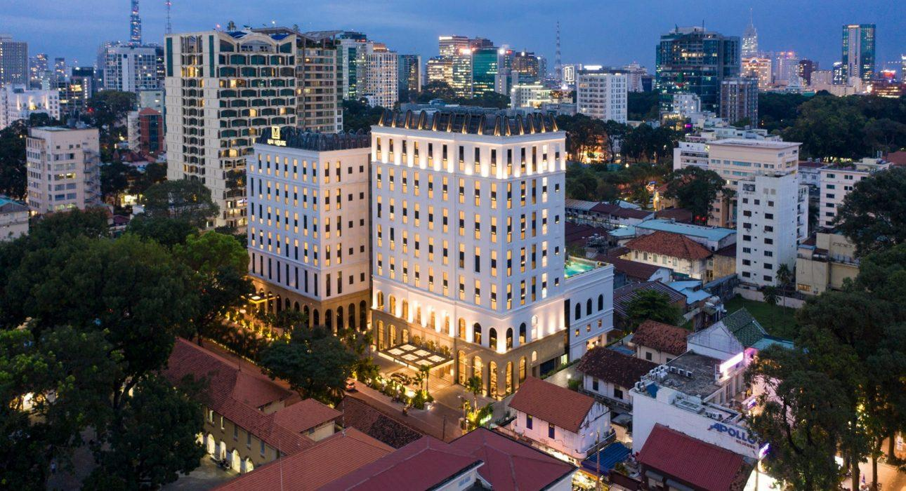
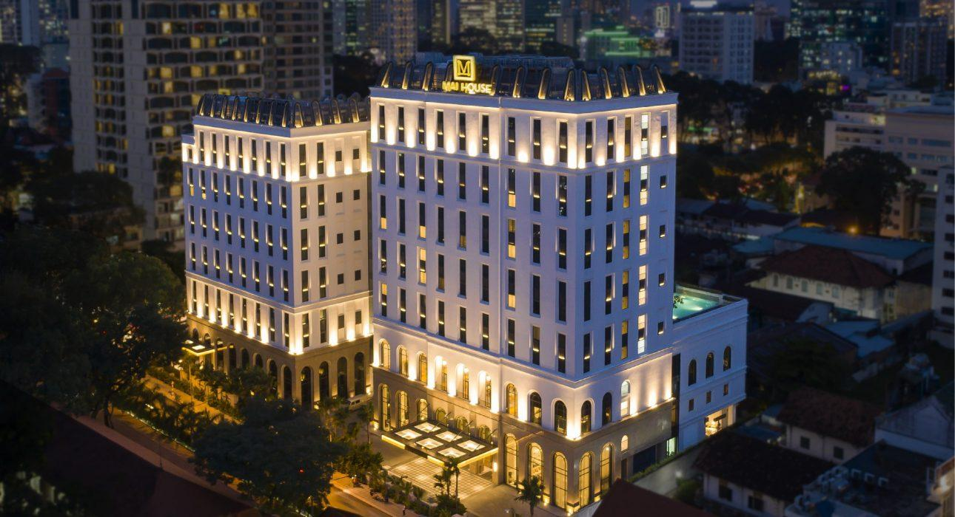

Rooms photos
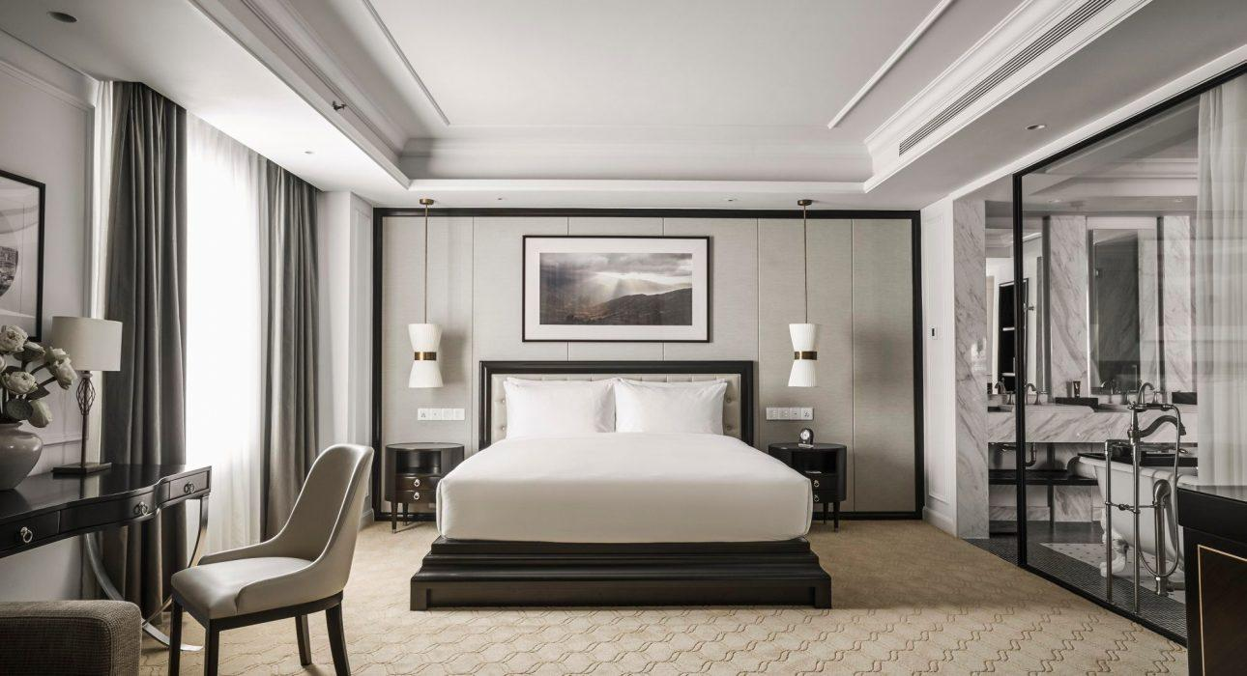
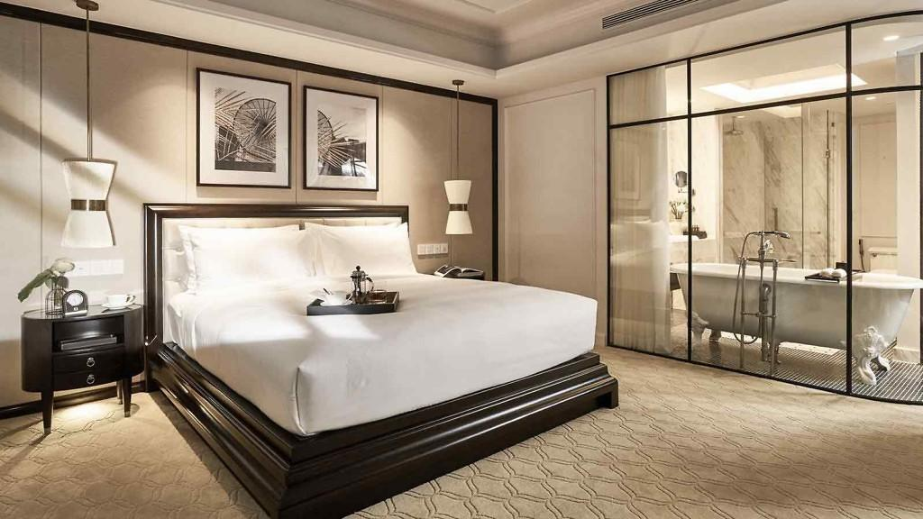
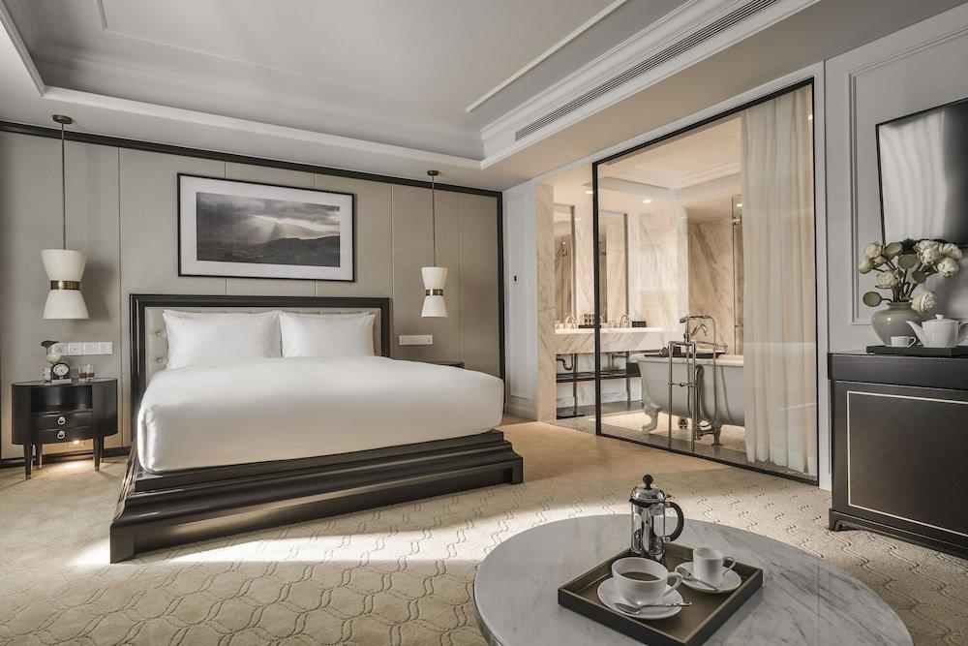
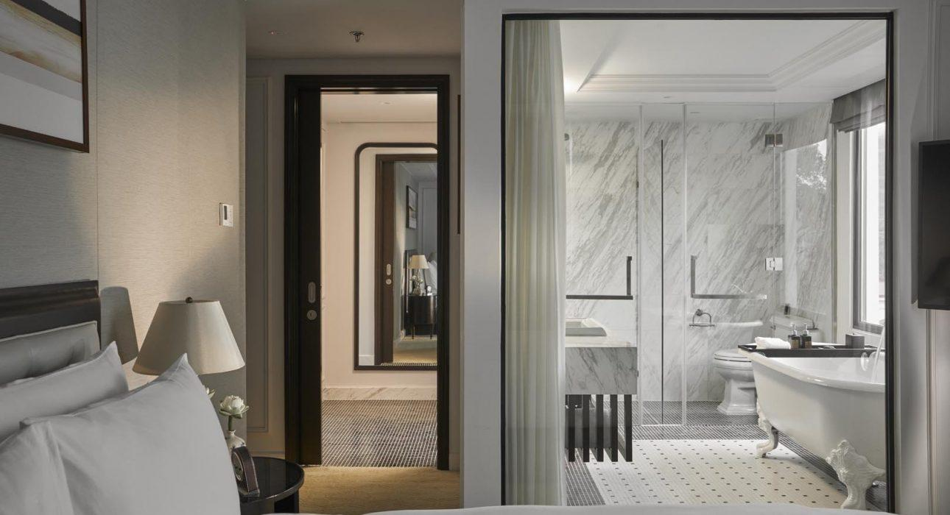
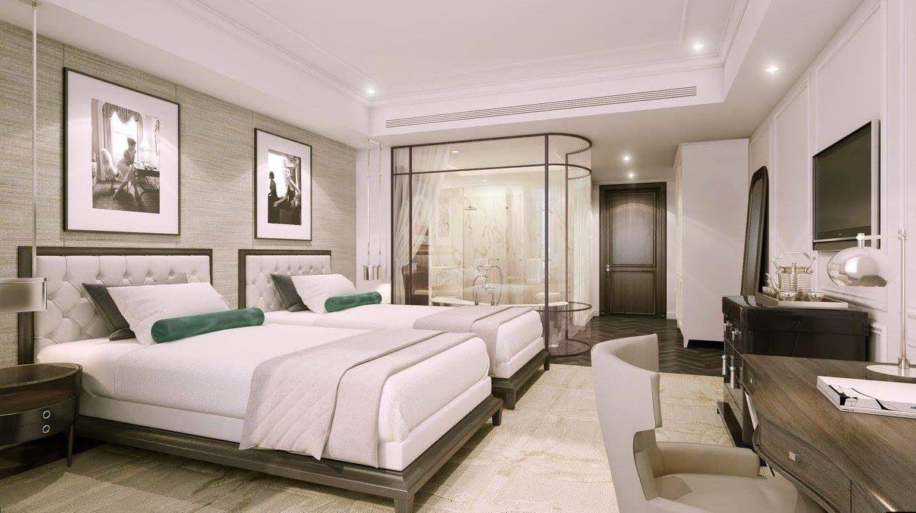
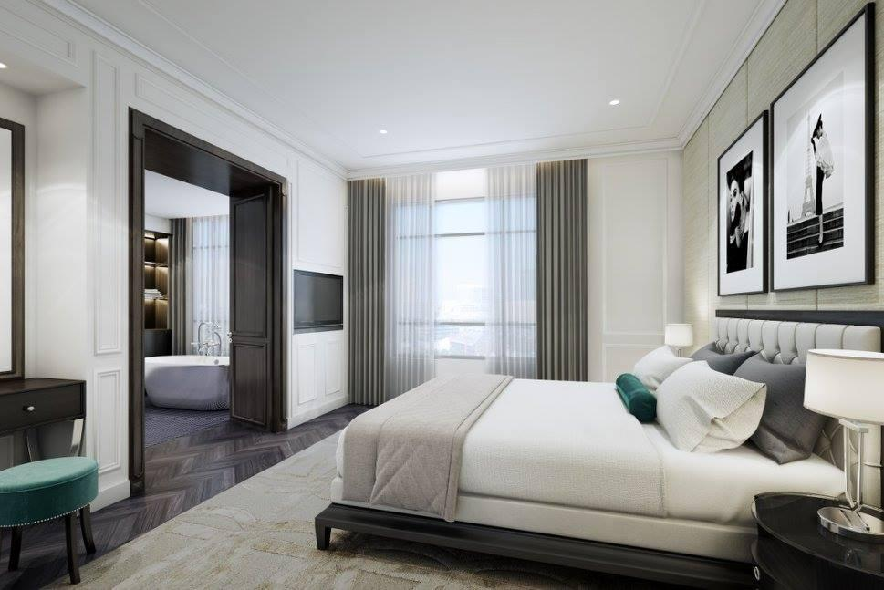
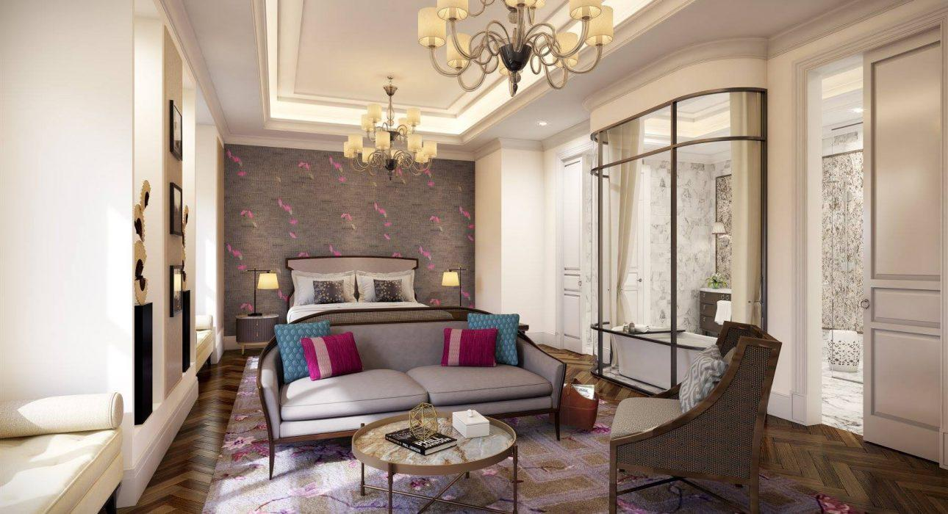
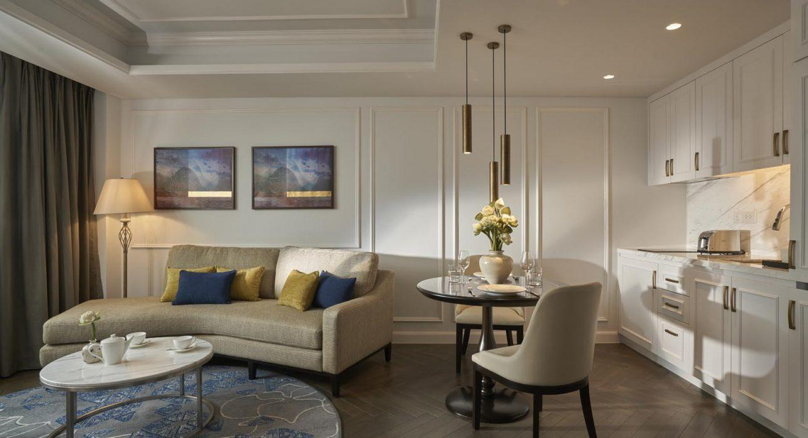
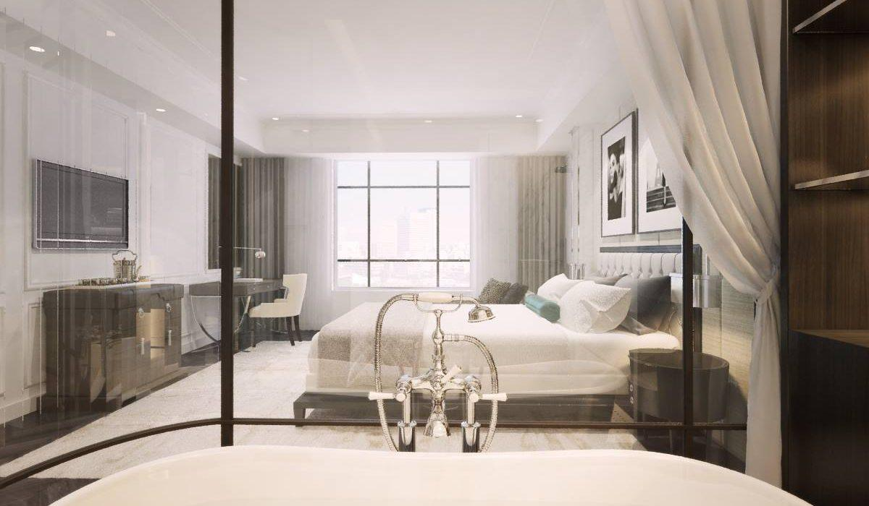
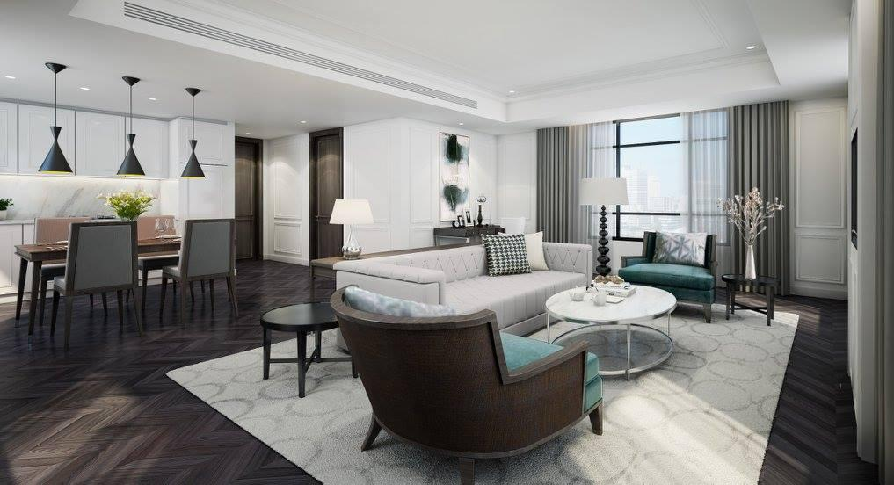
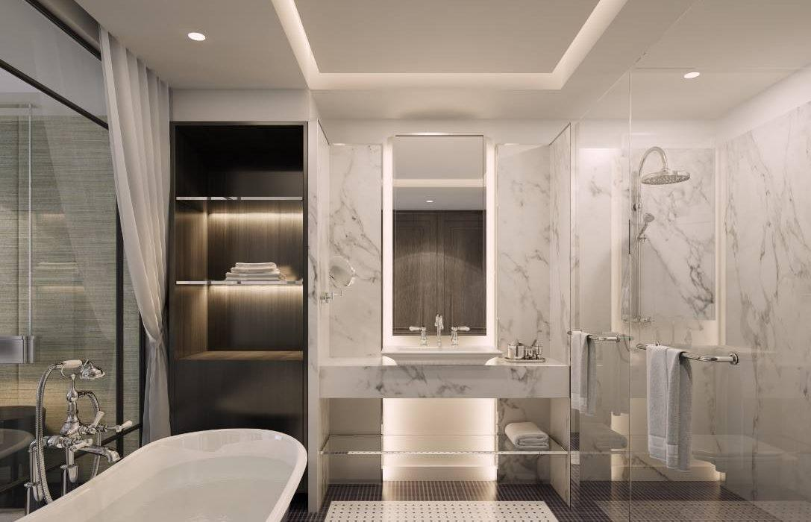
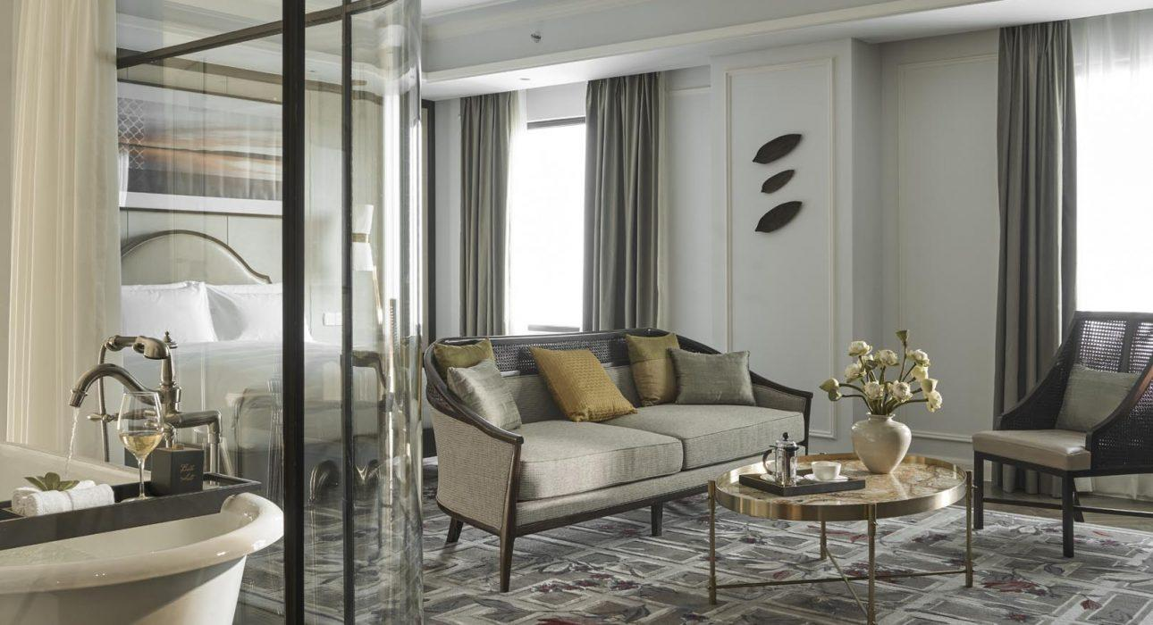
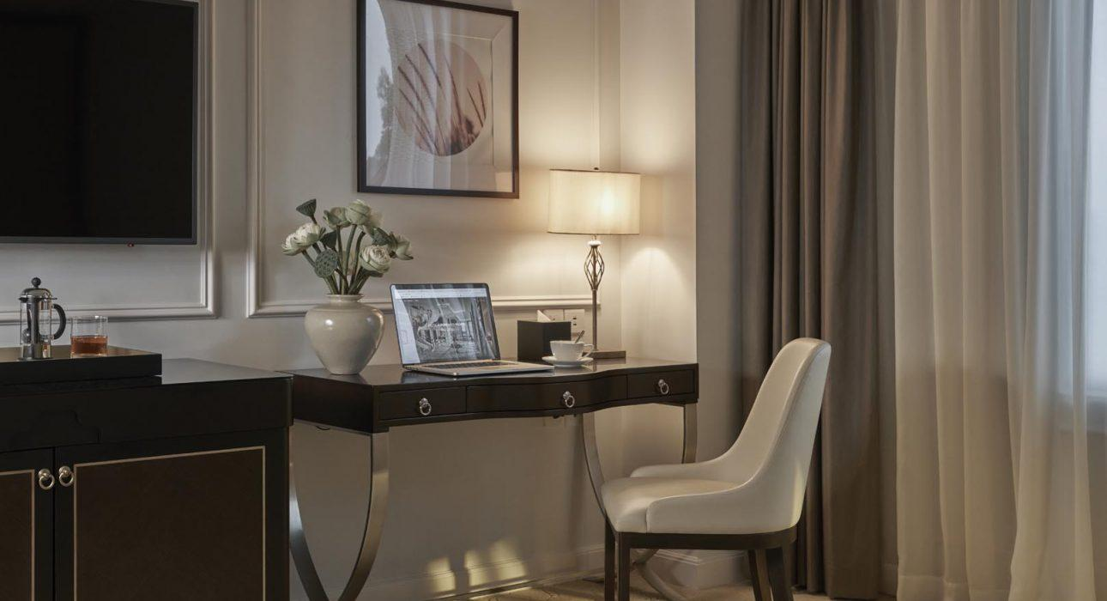

Restaurant photos
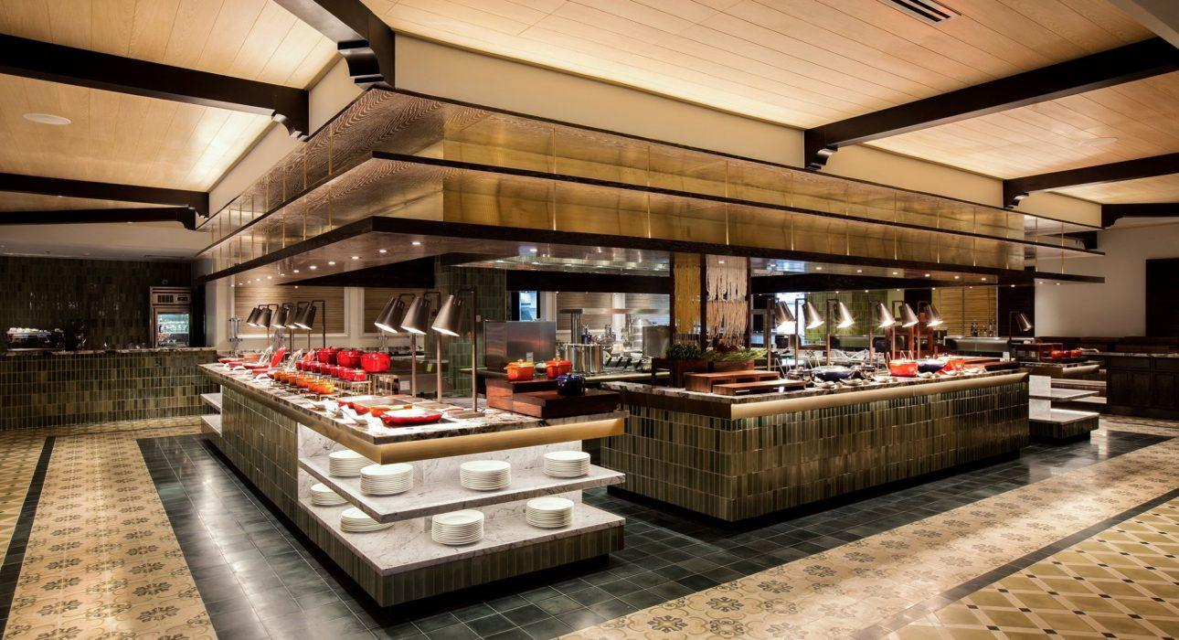
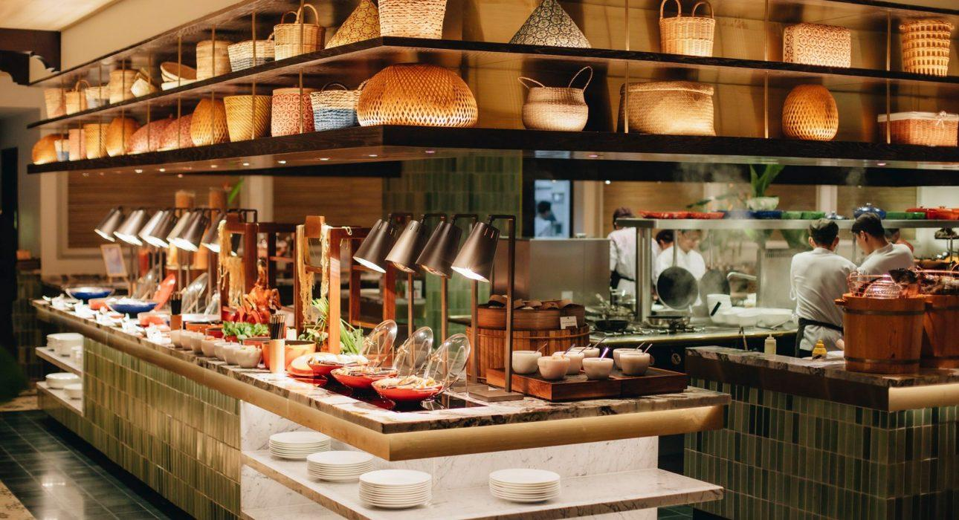
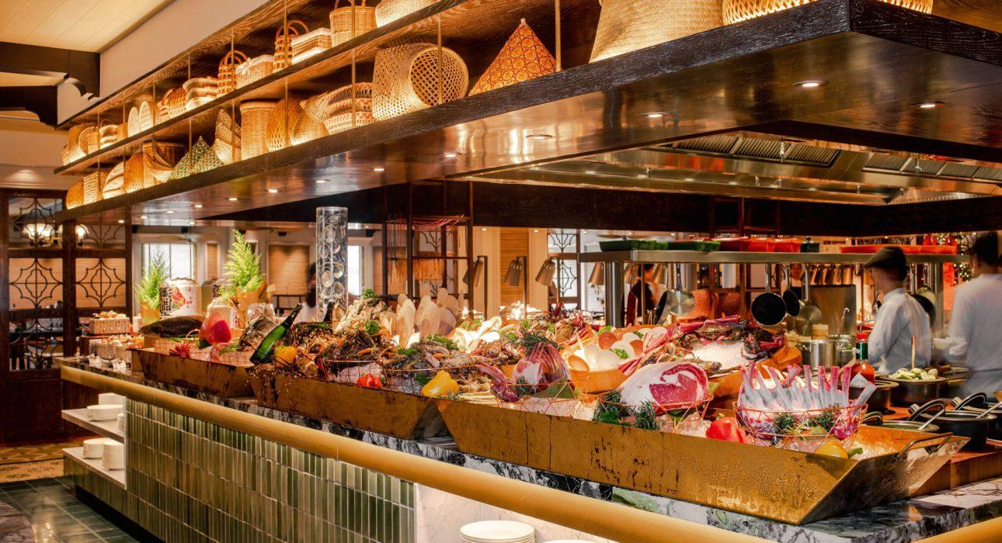
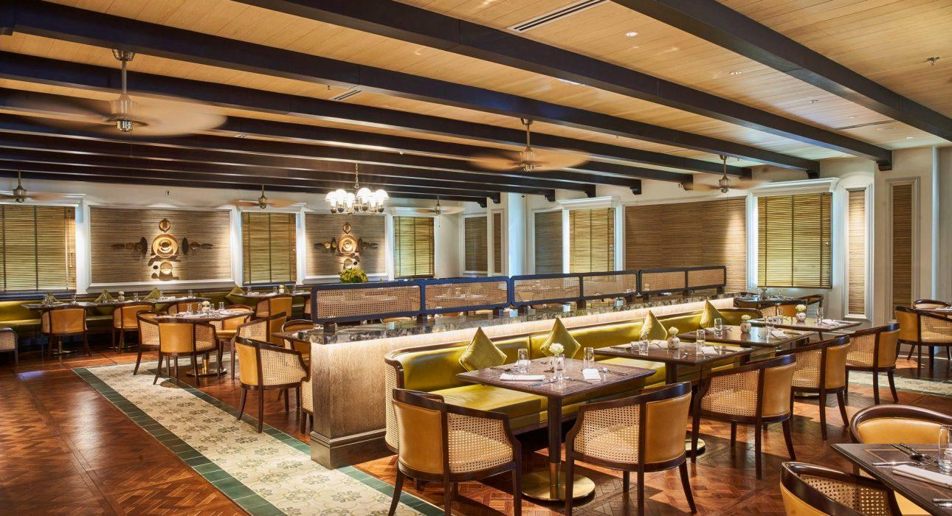
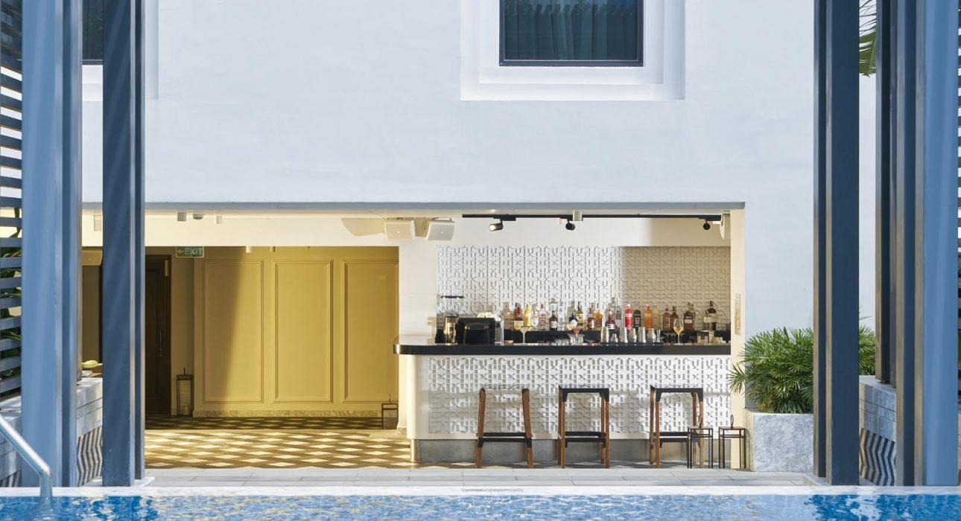
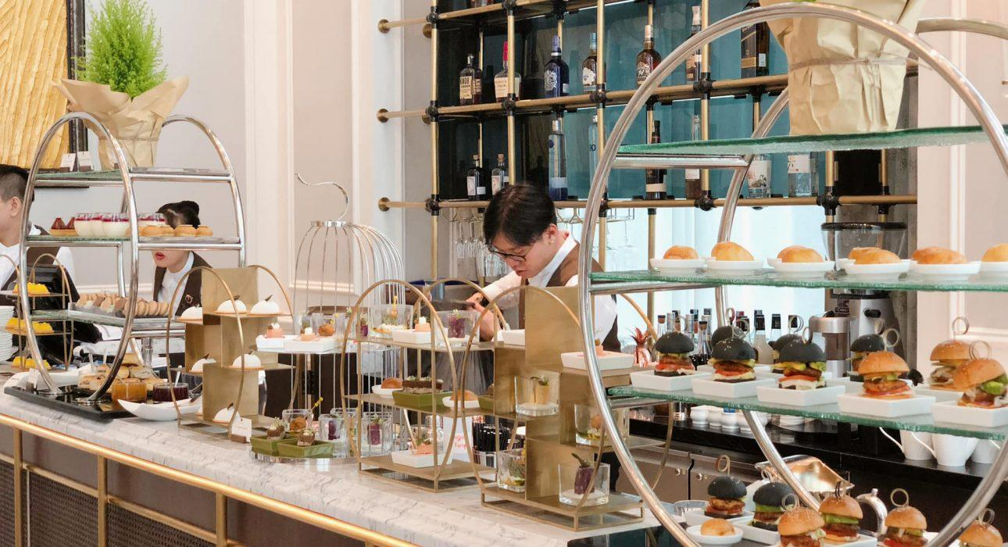
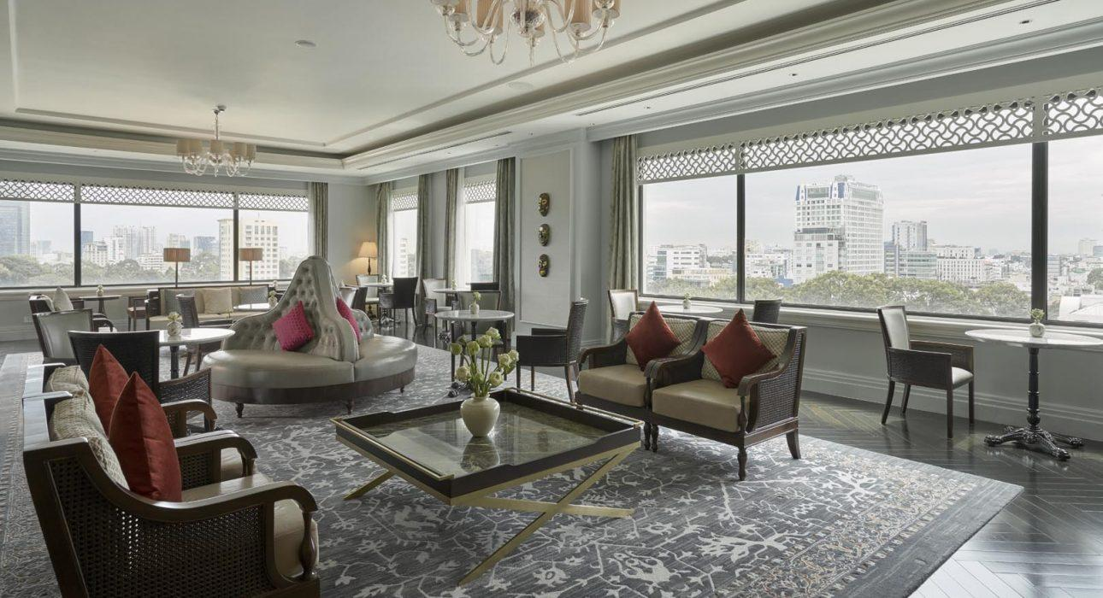

Services & facilities photos
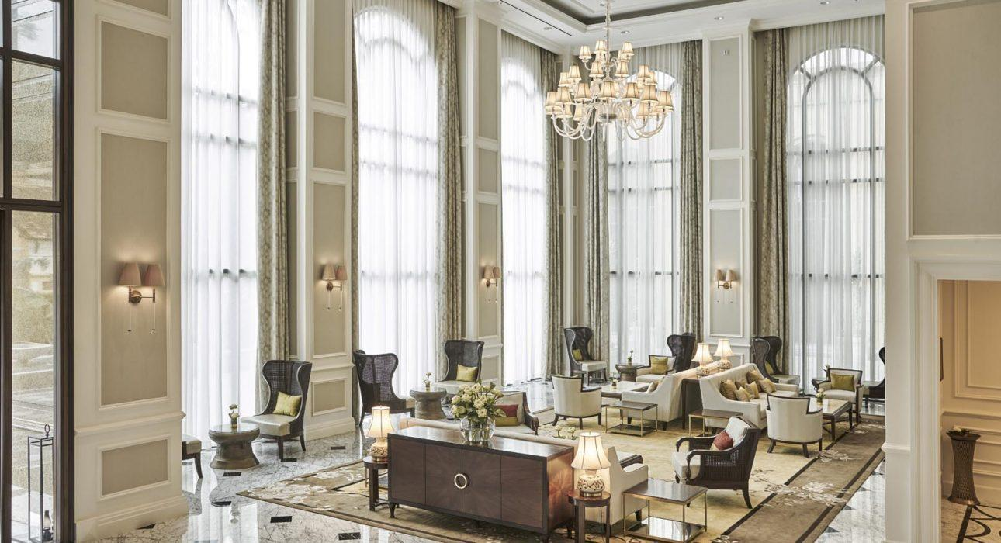
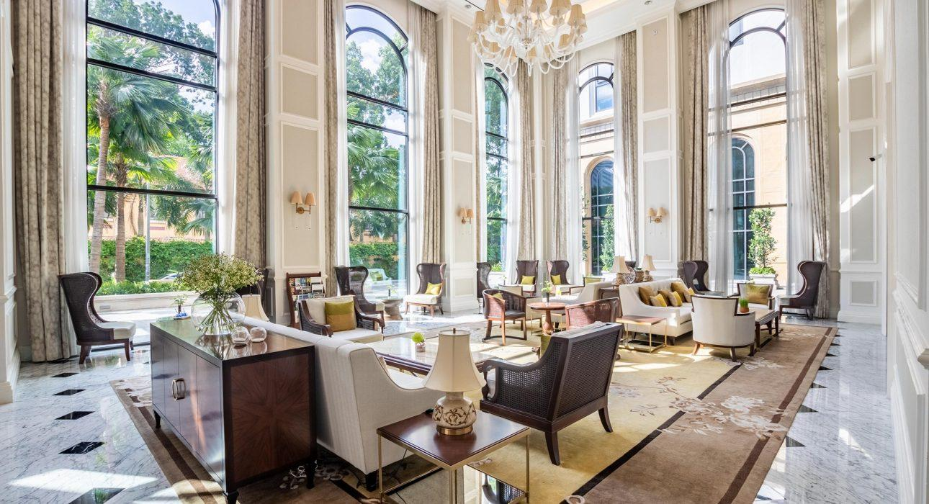
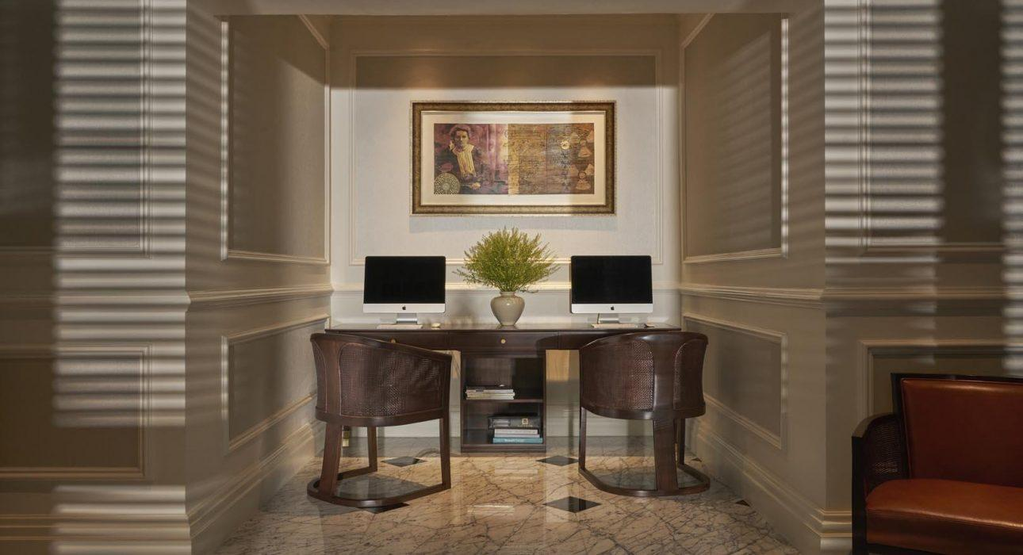
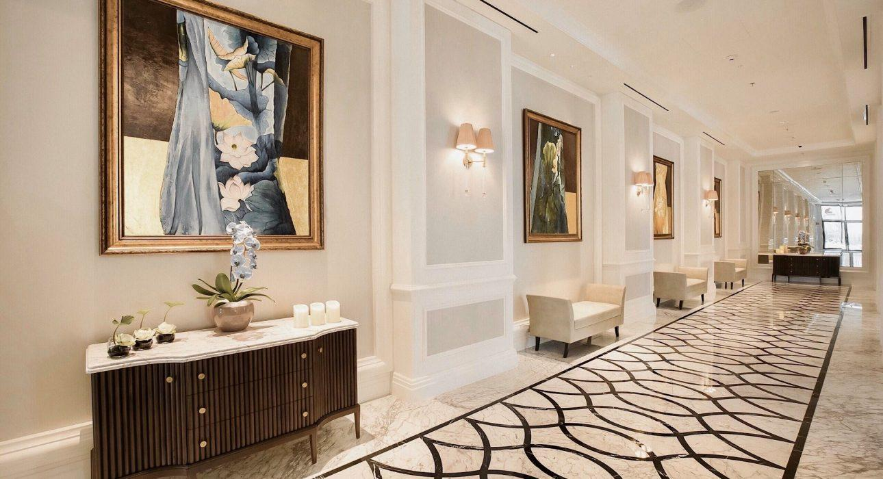
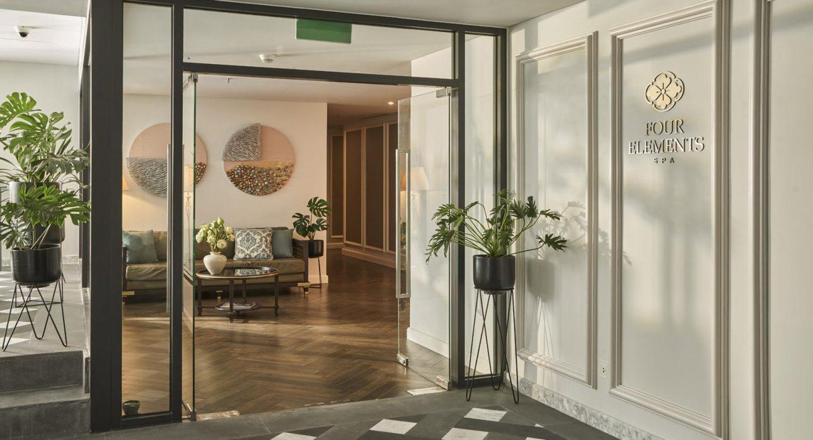
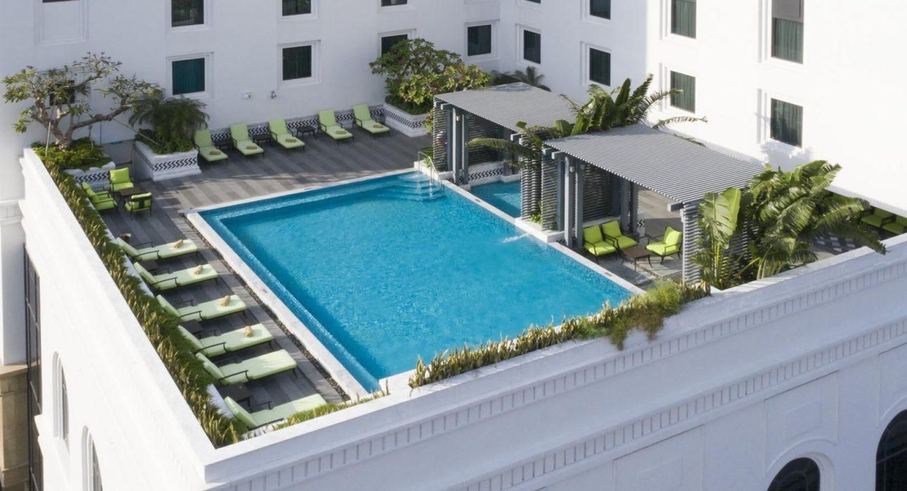
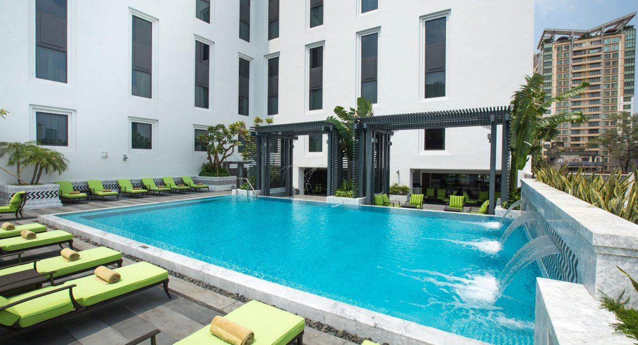
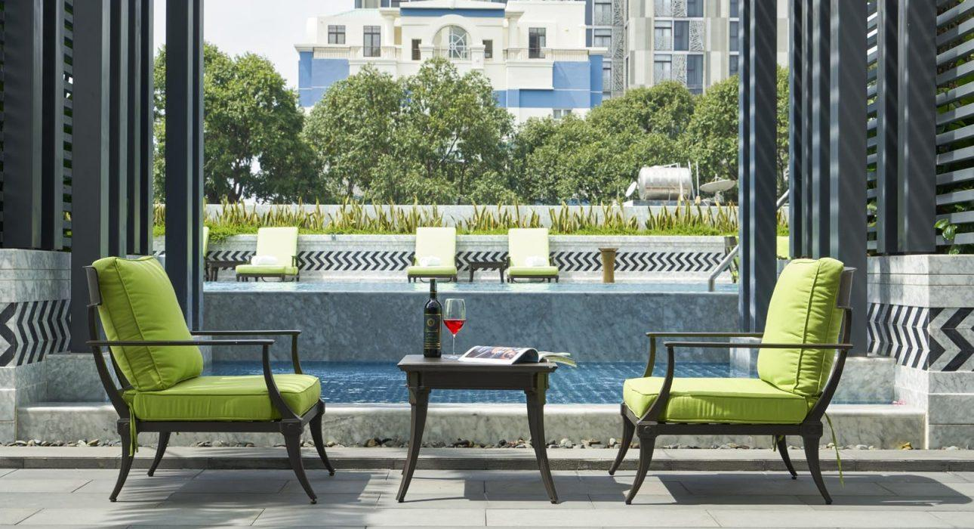
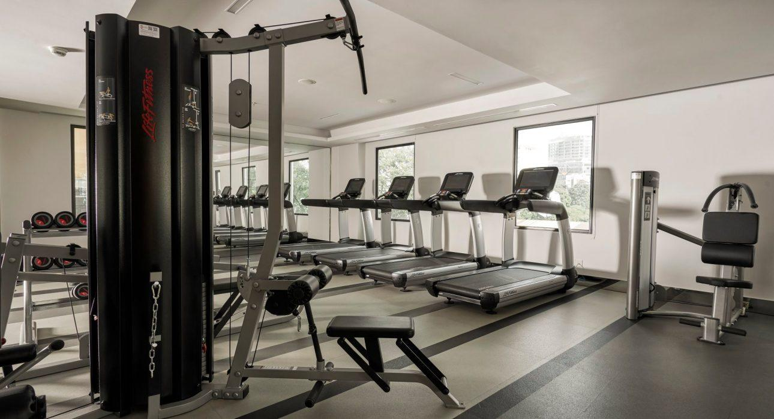
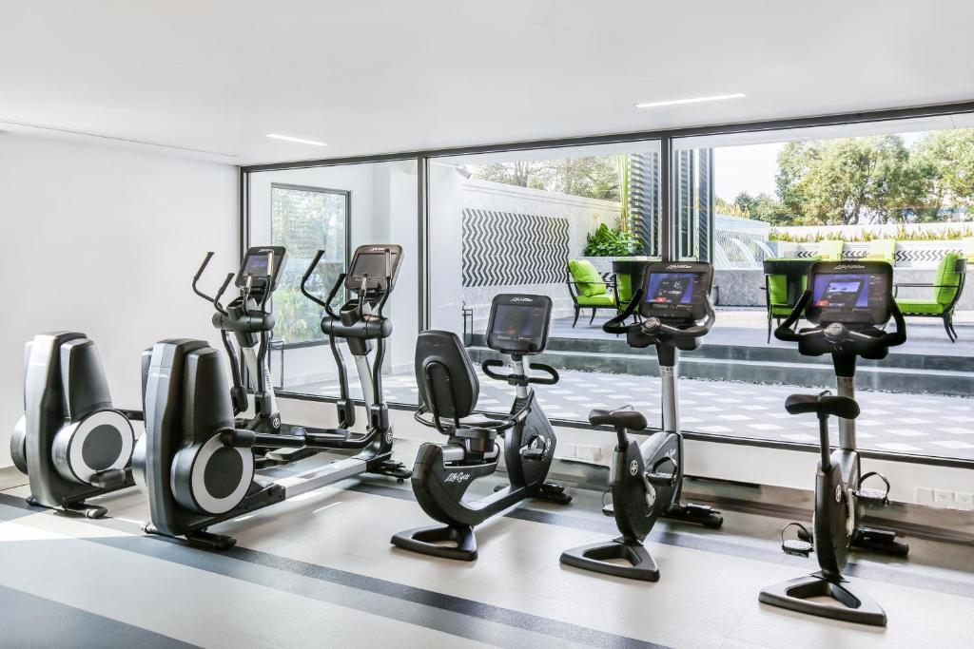
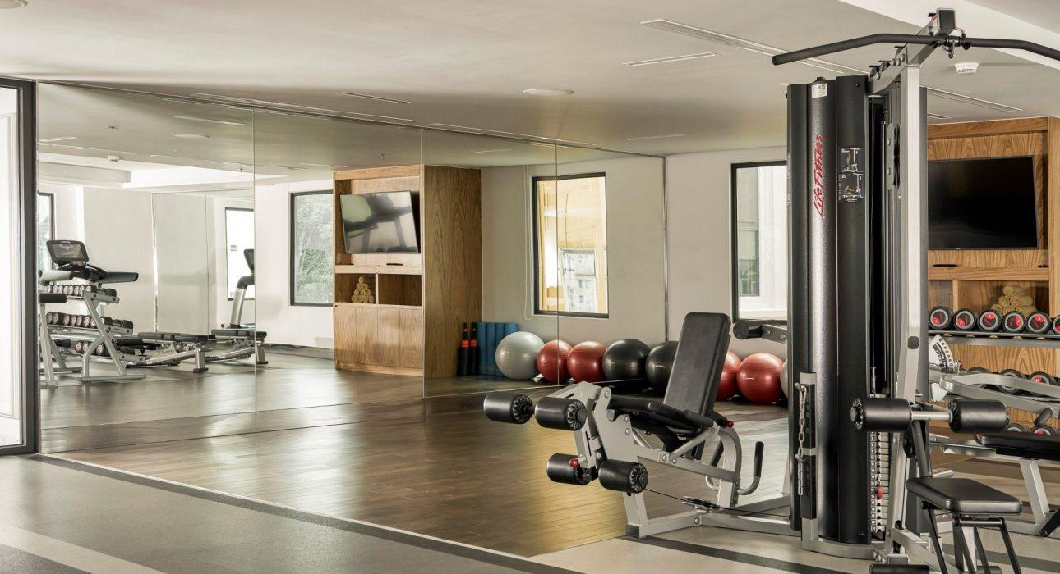

Easia Travel Head Office

