CAMBODIA – Kampot – AMBER Kampot
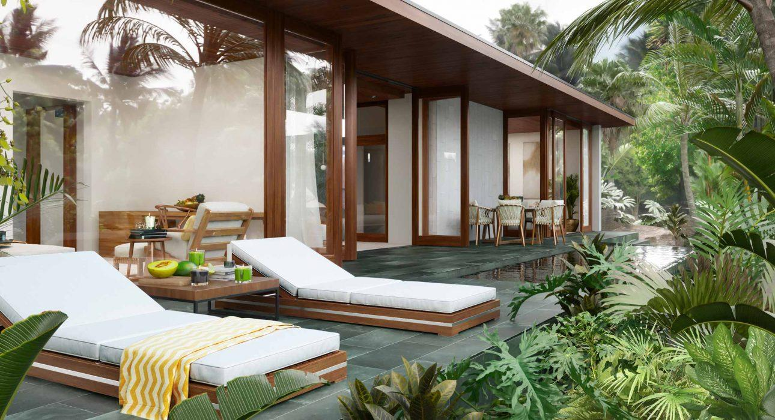

Over View

Theme
Classic, Honeymoon

Country - City
Cambodia - Kampot

Market segment
Thematic Leisure

Official category
5*

Easia category
Deluxe

Total number of rooms
25 Villas

Price level
$$$$

Description

Amber Kampot resort takes inspiration from Cambodia’s ancient forest and modern minimalism, integrating wood, neutral colors and plenty of texture to reflect the area’s natural beauty. Experience the uninterrupted flow by leaving the twisted mangroves behind and entering the modern indoor spaces, uncluttered and minimal so as not to detract from the surrounding scenery.
Savor a delicious meal at an on-site restaurant and indulge in a feast of fresh, local produce combined with exquisite recipes to create tantalizing, mouth-watering dishes. The guests may also soak up spectacular views of the serene Kampot River from a rooftop bar surrounded by lush vegetation, then unwind after a day of exploration with one of the world-class spa treatments.The resort also provides a private beach area and water sports facilities, as well as a garden and a terrace.Pool suites feature a single bedroom, offering an intimate setting for a private escape. Furnished with a double bed, comfortable seating, television and full bath (including shower, tub and divided toilet).Pool villas feature two private en-suite bedrooms separated by a large cooking and dining area, perfect for a family getaway. Furnished with a double and twin beds, comfortable poolside loungers, two full baths (including shower, tub and divided toilet), televisions, and a fully-equipped kitchen.Private estates are two-tiered private villas, offering plenty of space to spread out, relax and enjoy your paradise surroundings. The estates feature two large en-suite double bedrooms: a master on the first floor and a secondary bedroom or guest room on the ground floor.A sweeping private pool stretches the entire width of the exterior, while inside you can enjoy the carefully designed open-concept kitchen, dining and living area.

Selling points

- Modern style (mix of concrete & wood)
- Spacious room with huge bathroom and individual small outside pool and grade
- An extra infinity pool in the resort
- It offers new possibilities for high-end travelers who want luxury near the Sea Coast but not necessarily on the islands.

Time & Transportation

From | To | By | Km | Duration | Road Condition
Phnom Penh | Amber Kampot | Car | 143 | 3 hours | Good
Sihanoukville | Amber Kampot | Car | 101 | 2 hours | Good
Kep | Amber Kampot | Car | 21 | 30 minutes | Good

Rooms

Easia's recommend room type
- Private Pool Villa: 20 rooms/villas with 1-bedroom – 77.7 square
- Private Pool Villa: 5 rooms/villas with 2-bedroom – 187.8 square

Room configuration

Connecting rooms
No

Extra bed
Yes

Queen bed
Yes

Twin beds
Yes

Services & Facilities

Services
24 hour reception, 24h security service, Airport transfer, Babysitting, Bicycle Rental, Boat rental, Boat Transfer from/to, Buffet Breakfast, Catering (beach, river, cave, other), Complimentary bottle of water, Complimentary fresh towel, Concierge service, Credit Card payment, Currency exchange, Cycling, Dry Cleaning, In-Room Dining, Kayaking, Laundry service, Live Music, Luggage Storage, Massage, Spa, Swimming Pool, Wake-up service, Welcome fruits in room upon arrival, Wi-fi Free

Facilities
Air Conditioning, Bar, Business centre, coffee and tea making facilities, Fitness centre, Flat screen TV, Garden, Hair Dryer, In-Room safe, Indoor swimming pool, Internet, Meeting room, Mini Bar, Outdoor swimming pool, Restaurant, Safety Box

Business facilities details
Name | Dimension In M | Capacity
Classroom | Theatre | U-Shape | Board | Banquet without Stage | Banquet with Stage | Standing Cocktail
Amber Meeting 1 | 6.34 x 5.76 | 18 | 24 | 14 | 12 | 30 | 20 | 30
Amber Meeting 2 | 7.75 x 5.78 | 24 | 30 | 20 | 18 | 30 | 20 | 40
Amber Grand | 11.54 x 7.05 | 36 | 60 | 32 | 30 | 60 | 40 | 70

Restaurant information

Arvi RestaurantCapacity: 60pax
- Breakfast: 06:00 – 10:00
- Lunch: 12:00 – 14:00
- Dinner: 18:00 – 22:00
Pool Side BarCapacity: 10pax
- 07:00 – 23:00
Room Service07:00 – 22:00

Photos

Hotel Photos
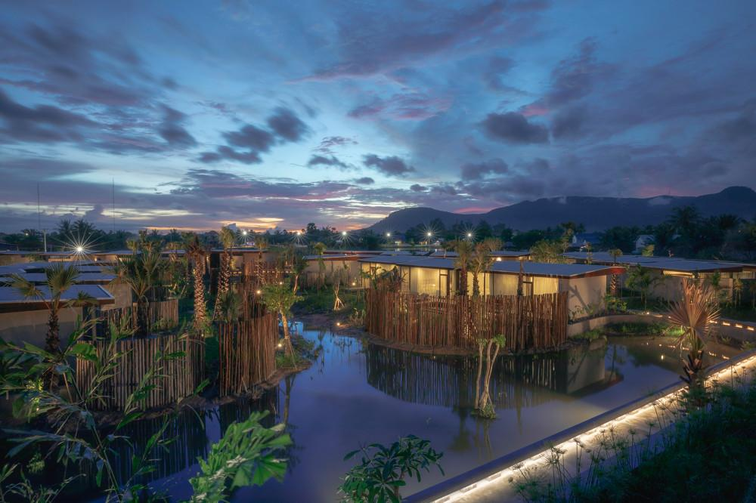
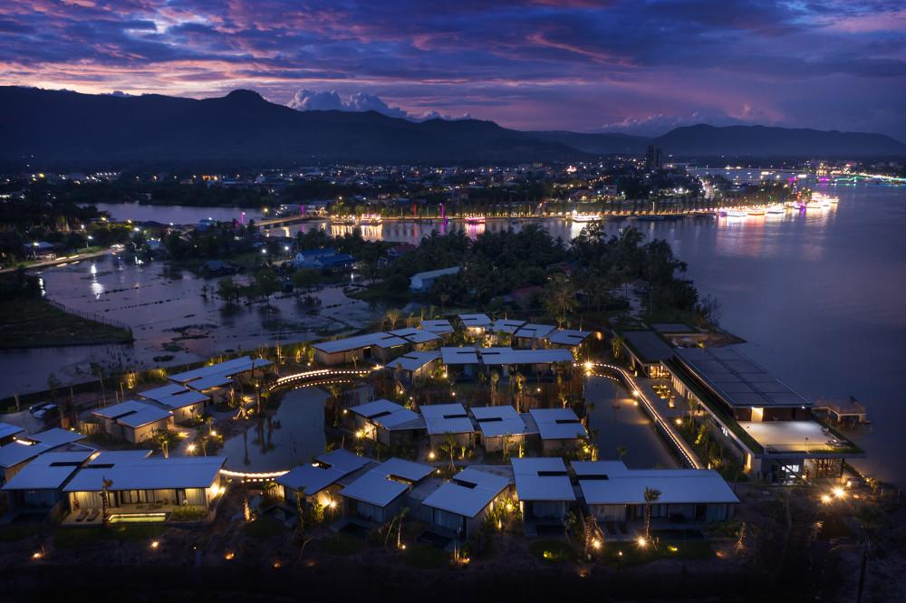
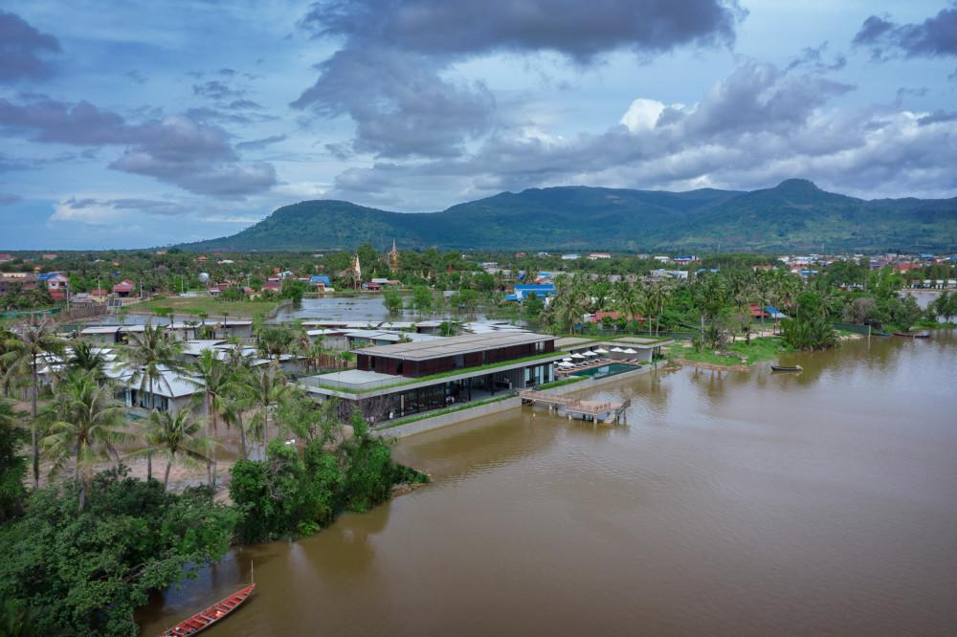
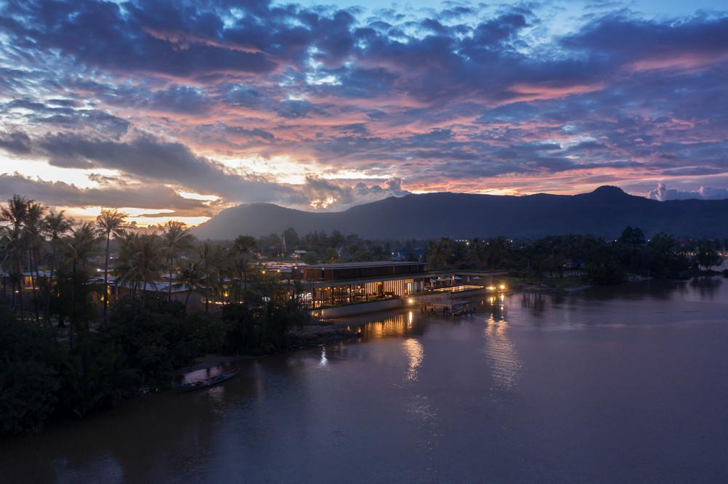

Rooms photos
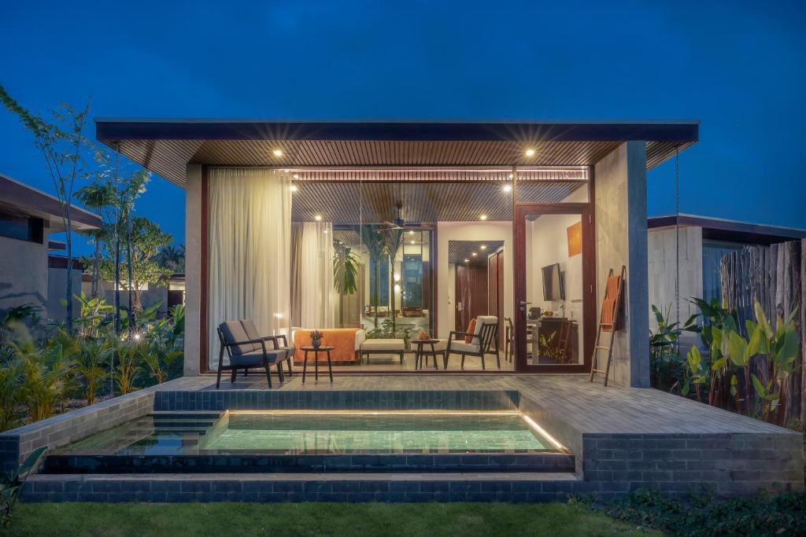
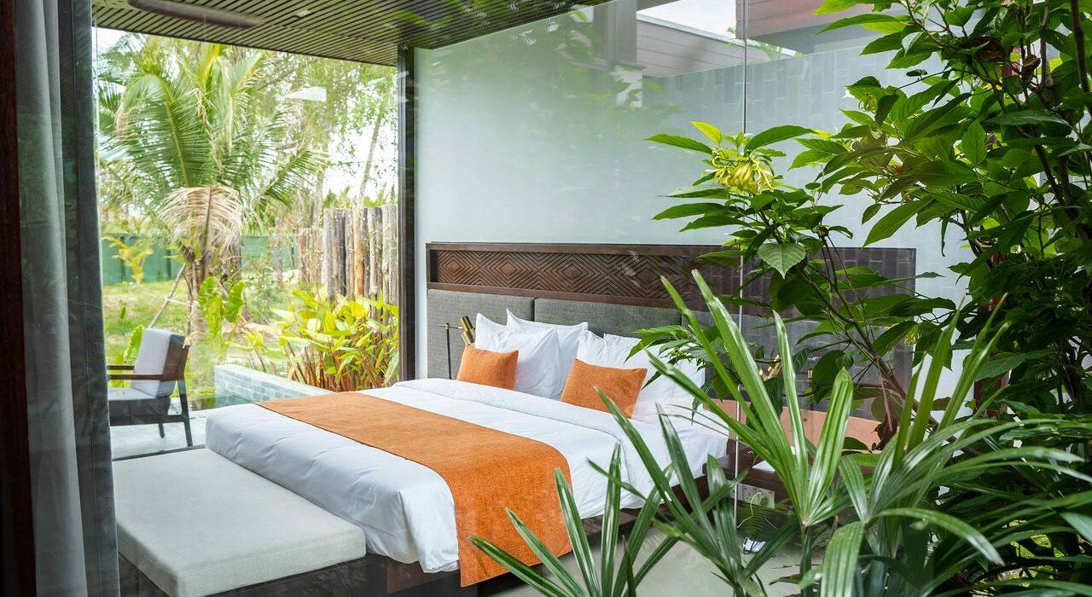
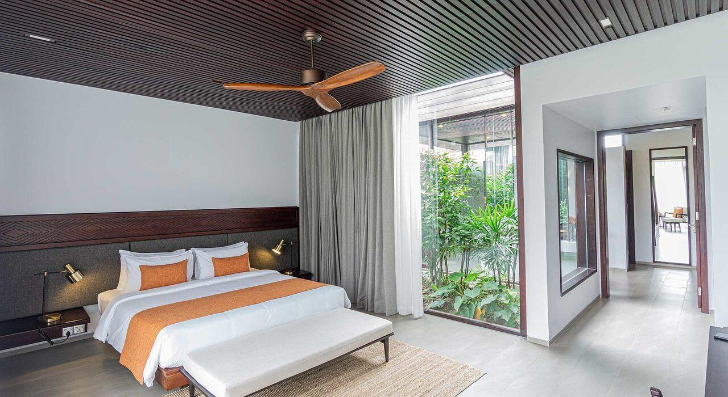
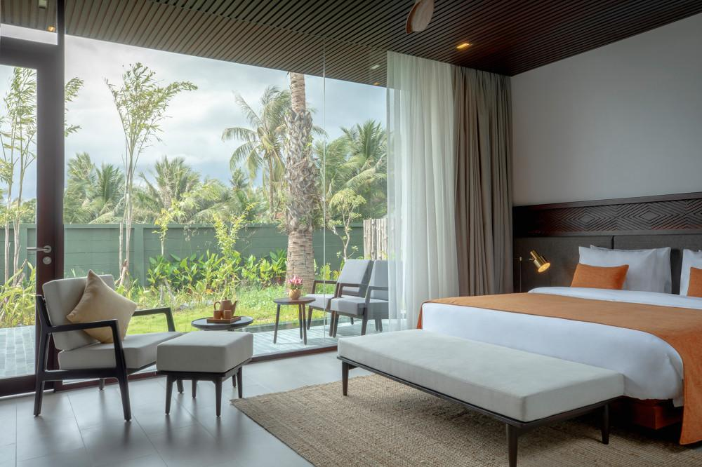
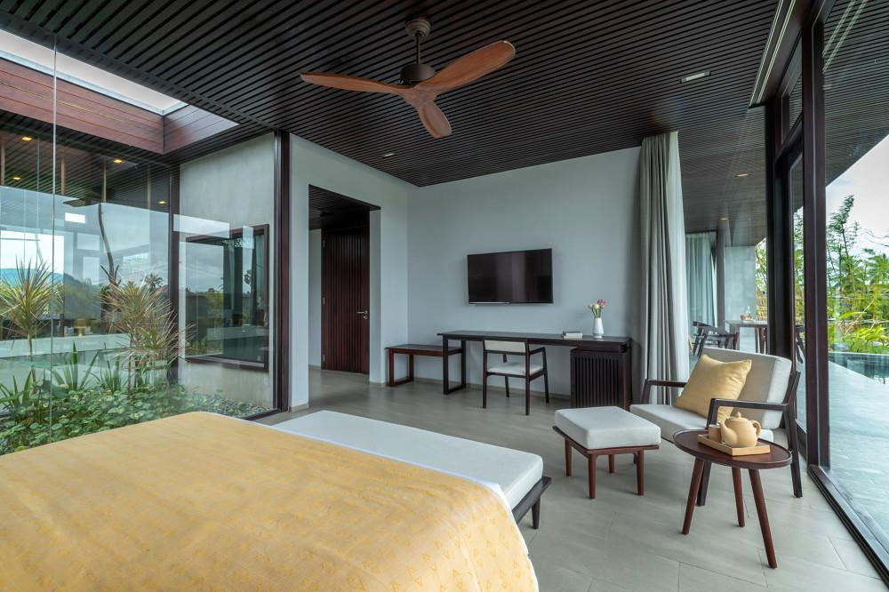
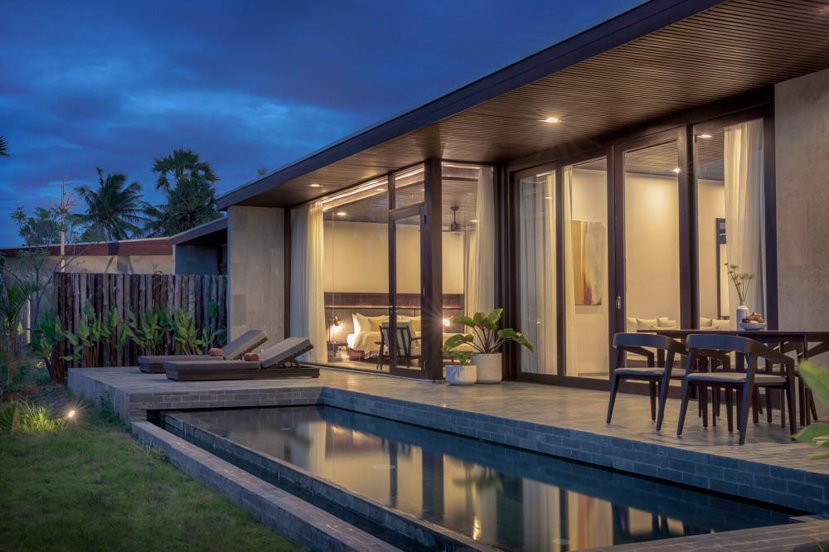
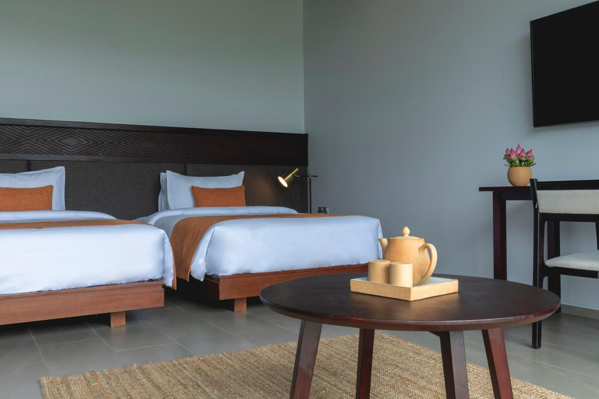
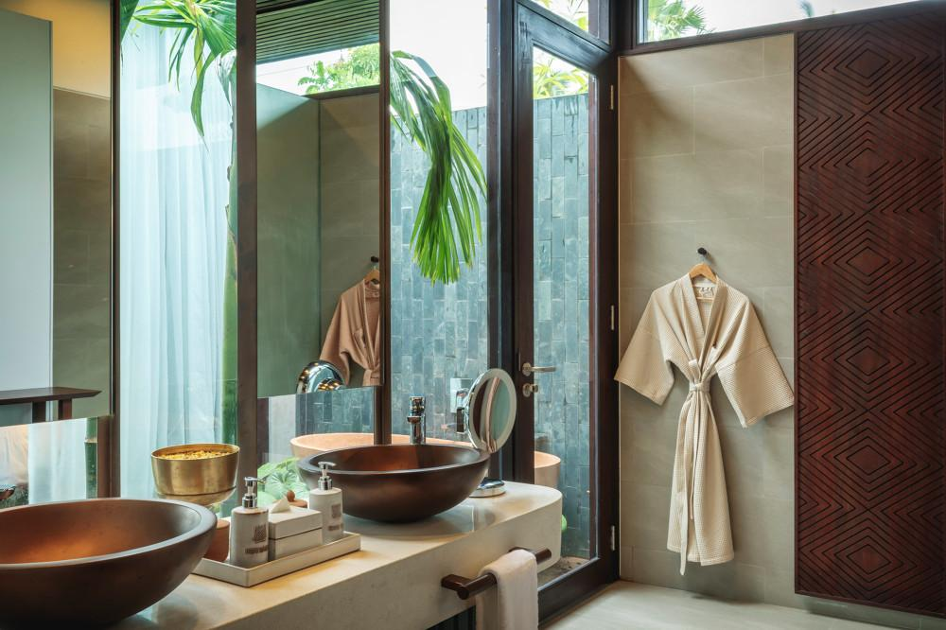
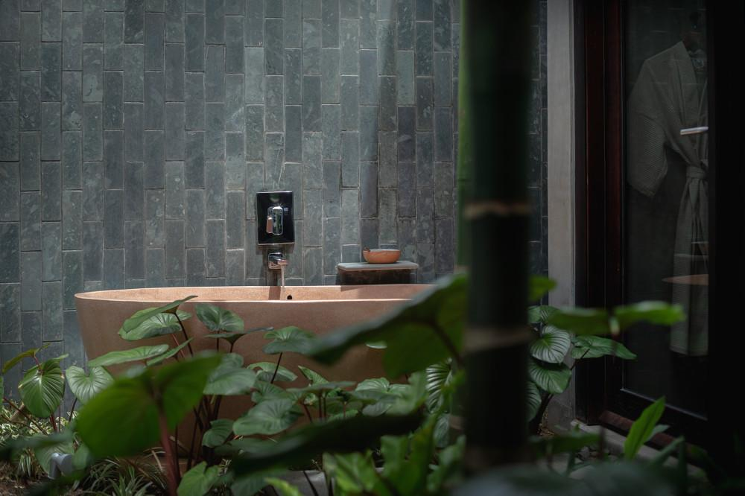
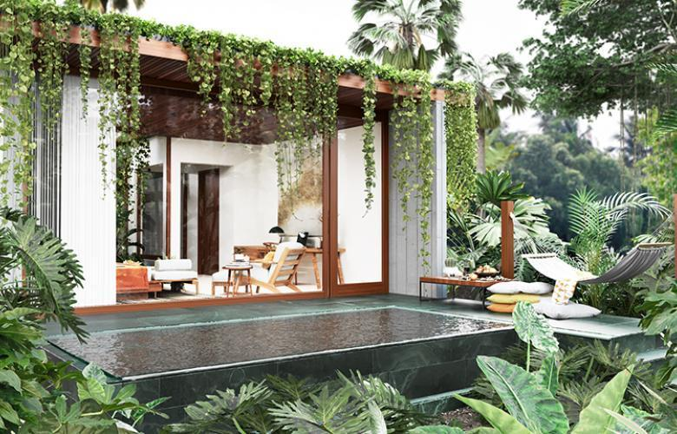
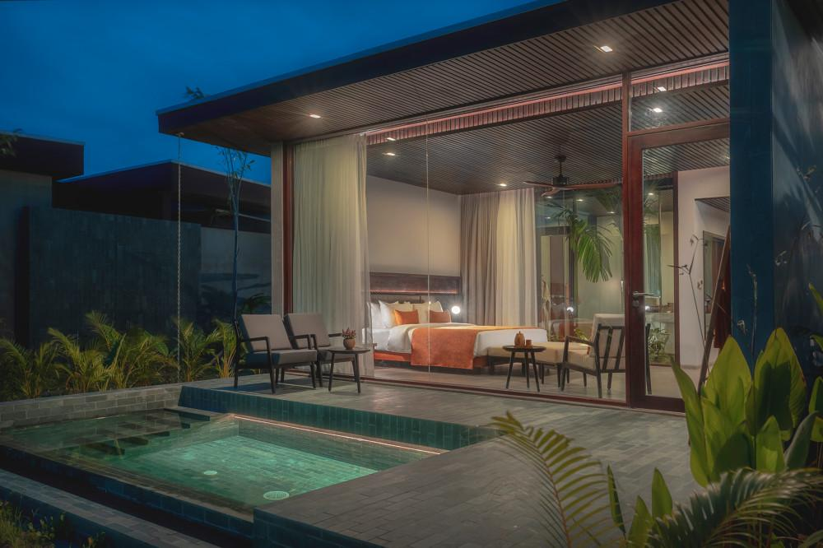

Restaurant photos
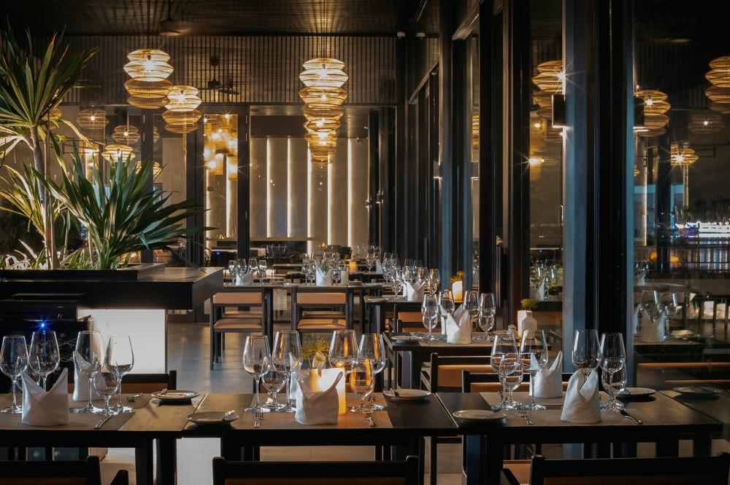
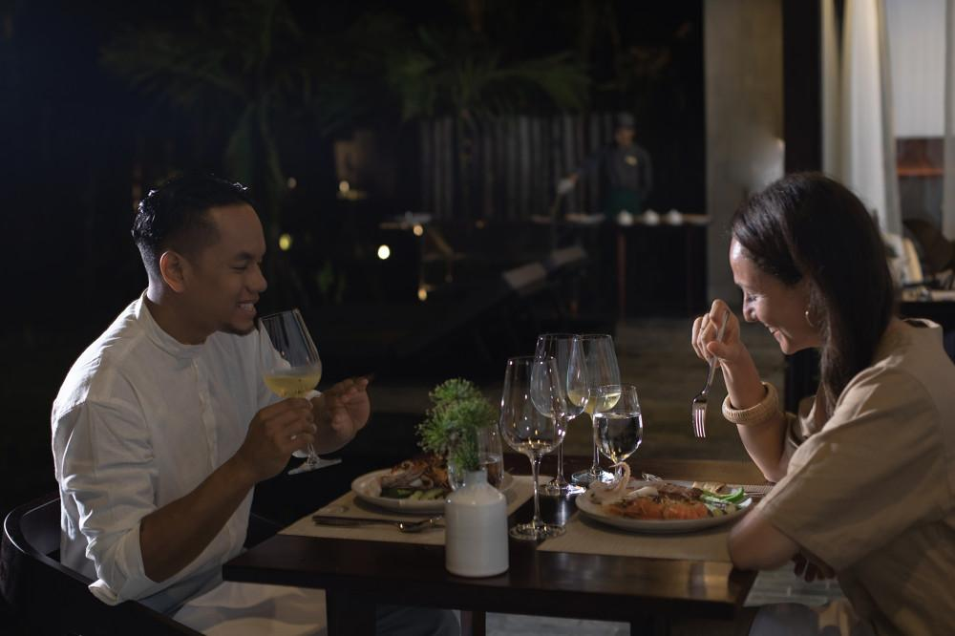
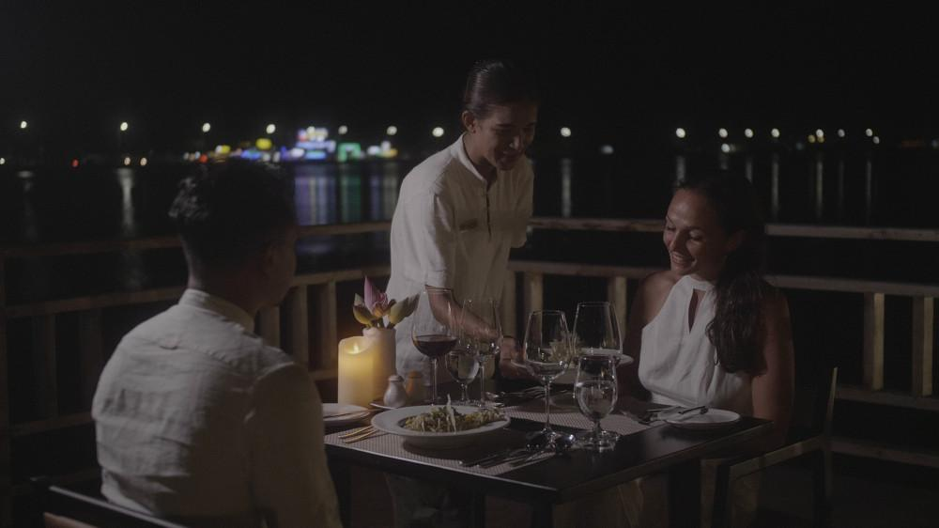

Services & facilities photos
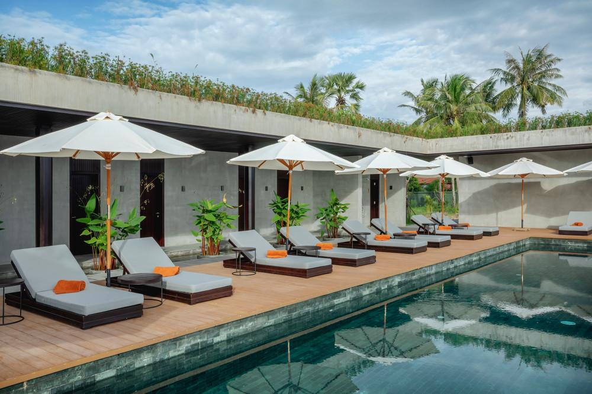
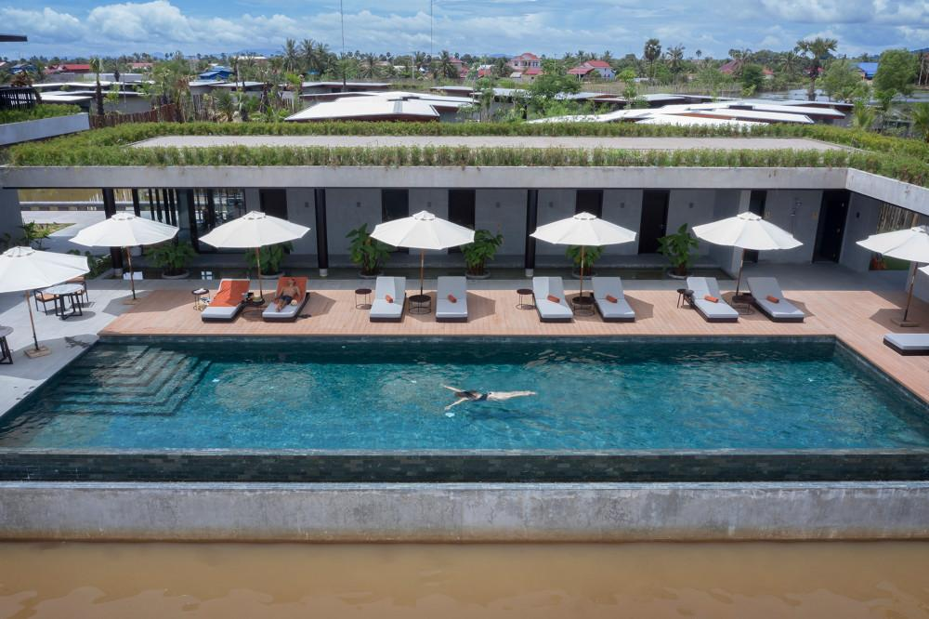
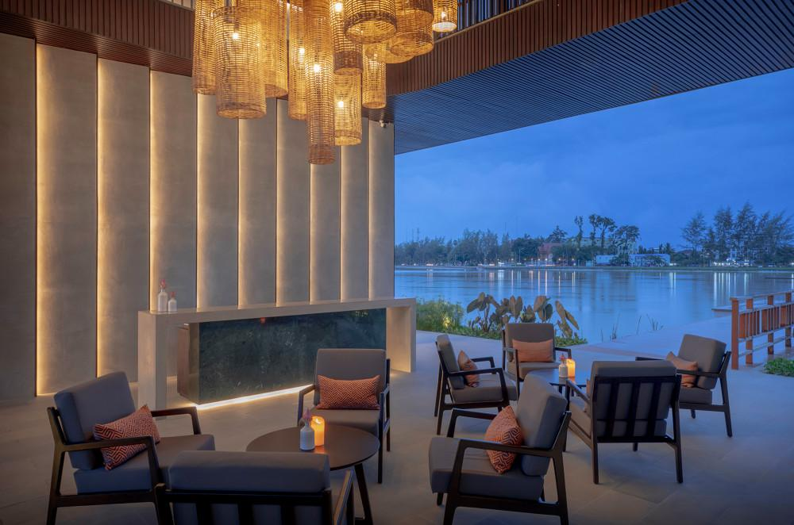
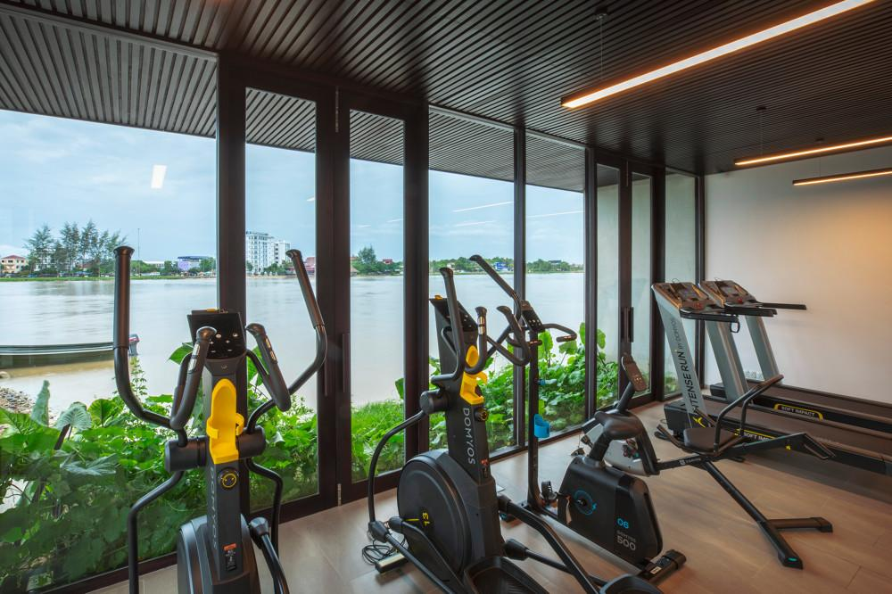
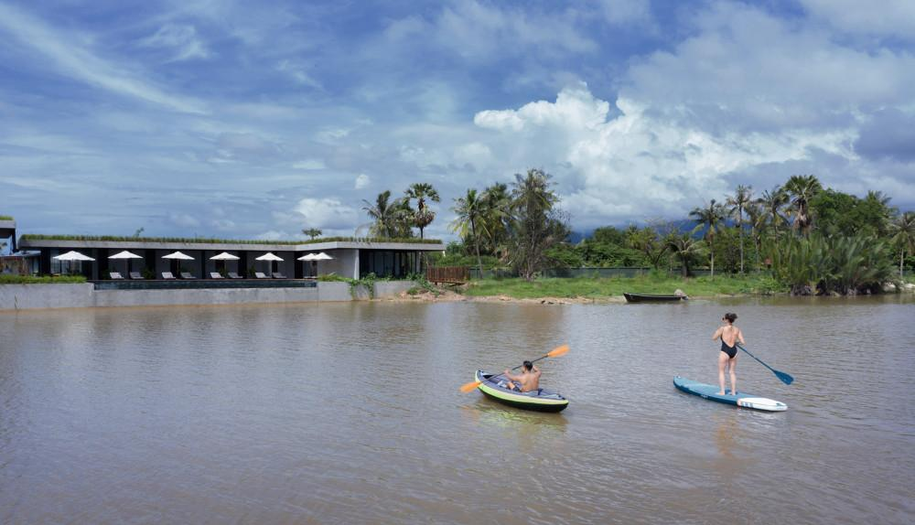
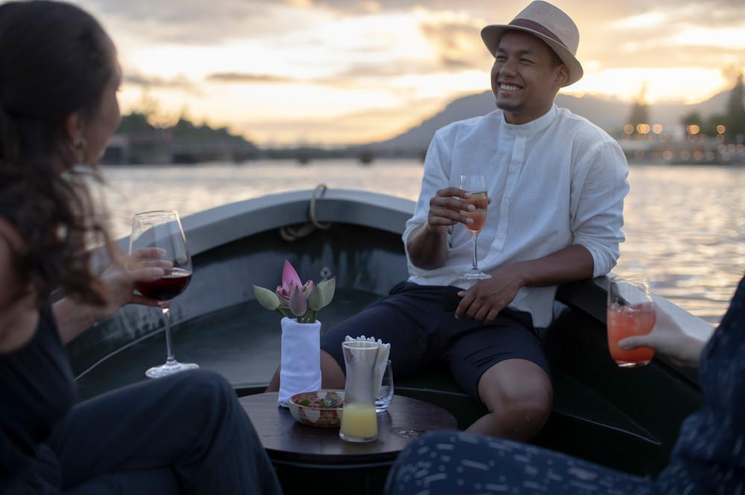
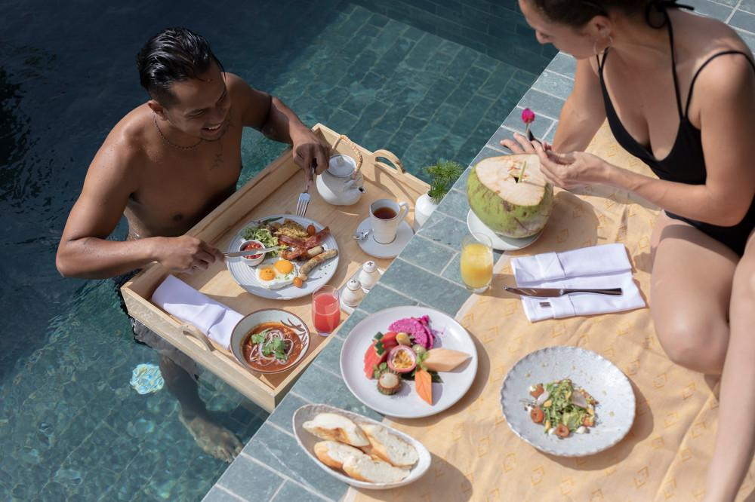
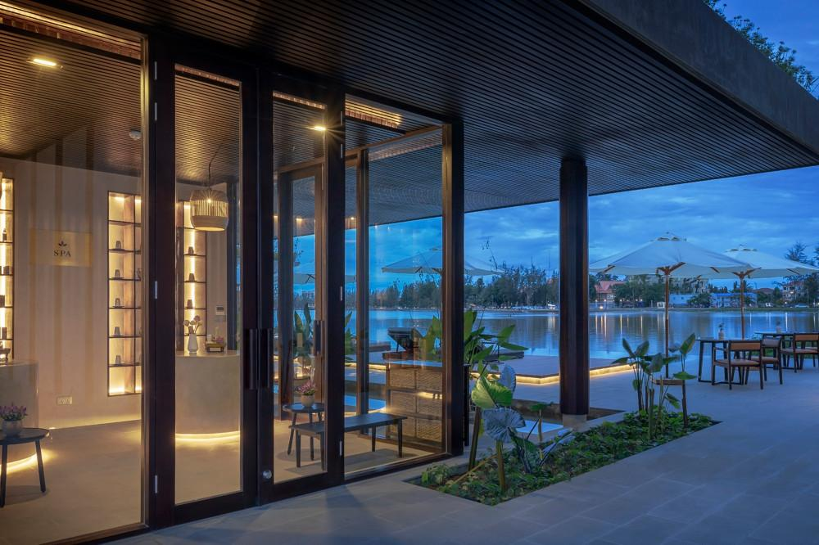
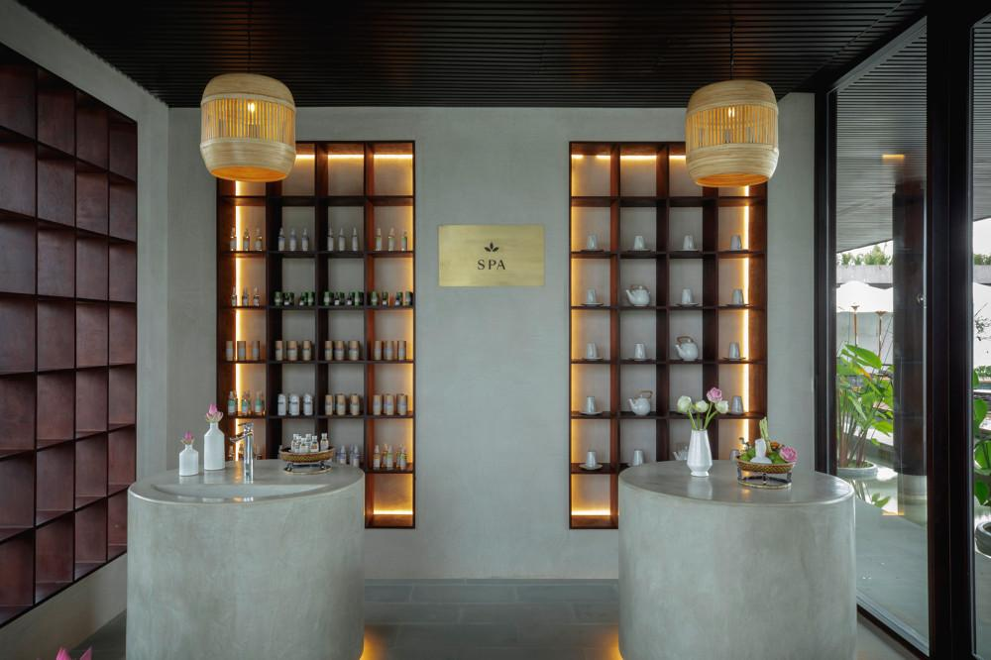
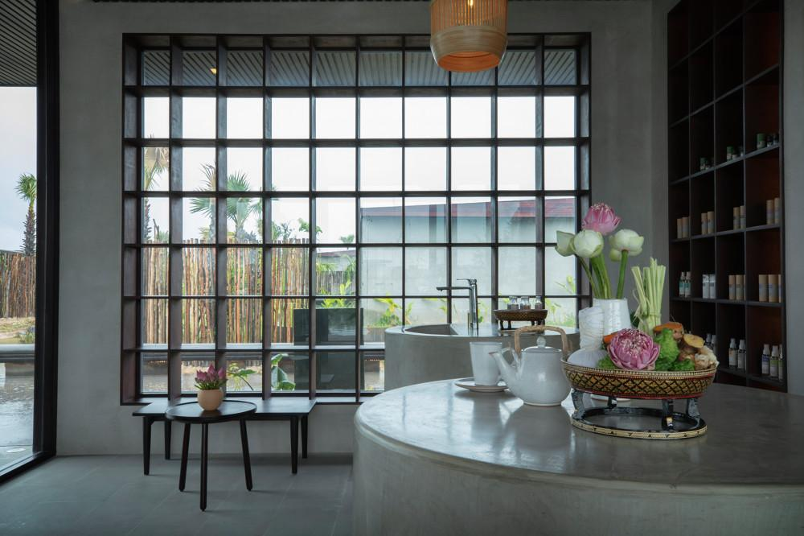

Easia Travel Head Office

