VIETNAM- Phu Quoc – Intercontinental Phu Quoc Long Beach Resort
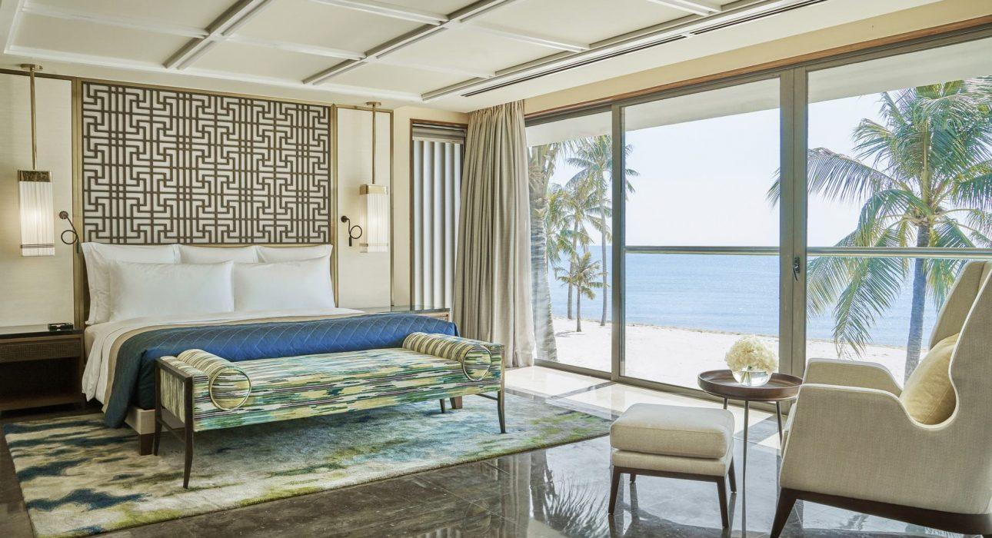

Over View

Theme
Beach Stay, Classic, Family, Honeymoon

Country - City
Vietnam - Phu Quoc

Market segment
Groups, Thematic Leisure

Official category
Homestay

Easia category
Deluxe

Total number of rooms
459 rooms

Price level
$$$

Description

The InterContinental Phu Quoc Long Beach Resort opened in June 2018. The resort is on Vietnam’s largest island, Phu Quoc, experiencing massive growth.The design of the resort, with a 19-story middle tower flanked by two wings that wrap around the main pool, is impressive but not imposing, thanks to an abundance of tropical plants – especially the palms and rooftop gardens that work to almost blend the resort into the natural landscape of the island.The resort has 459 rooms, suites, and villas that vary in size to cater to groups, families, and couples. The rooms are large (the smallest start at 50m2), comfortable, and very well-equipped: walk-in wardrobe, espresso machine, electric blinds, a terrace with pool-, garden- or ocean-view, centrally controlled lamp lighting, living area with sofa, freestanding bathtub and separate rain shower, wide-screen TV and Bluetooth speakers. The color scheme is restrained, featuring pale blue and beige tones, and embellishments like shells and waves are ocean-themed. Everything is immaculately clean, well-made, and well-maintained, and everything works.There are six restaurants and bars to choose from with various cuisines. A full buffet breakfast is served at Sora & Umi, and it is also a Japanese and Vietnamese restaurant at night. The rooftop bar – the highest sky bar on the island – is the work of Australian-born interior designer Ashley Sutton. He’s famous for his Iron Fairies bar in Tokyo and The Bookshop in Bangkok, and INK 360 is the latest in his growing list of fantastical creations. The ginormous octopus tentacles that spill out from the roof to envelop the bar will have you feeling like you’ve stumbled upon a shipwreck floating in the sky.The beach is wide, long, and sandy. Coconut palms lean over the waves, and the water quality is excellent and calm during the dry season (November-April). Two substantial swimming pools occupy the resort’s central gardens. Both are over 50m long, surrounded by loungers, gazebos, and tropical trees. There’s also a children’s pool with slides and other play equipment. The gym operates 24 hours a day, and the HARR Spa is supposed to be one of the most sophisticated on the island (although I’m not one to judge as I don’t tend to use spas). No island holiday is complete without a spa treatment, and the HARNN Heritage Spa is a tranquil oasis of indulgence that is too good to be missed. Eight spa treatment rooms are set within individual retreats overlooking a large lagoon of koi fish.

Selling points

- International brand resort with high-quality services and facilities
- Massive inventory with 19 room categories offers more options to guests and is easy to sell. The Hotel is suitable for big leisure groups, MICE group
- Good location from airport and downtown; plenty of options in dining (6 restaurants and sky bar);
- International standard conference system with large meeting spaces.

Sustainability

Certifications
- 2019, Winner of Asia’s Leading Luxury Family Resort, Asia’s Leading MICE Resort, World Luxury Hotel Awards, Hitchbird Wedding Awards
- 2020, Winner of World Luxury Restaurant Awards and World Luxury Spa Awards

Time & Transportation

FROM | TO | DISTANCE (KM) | BY | DURATION | ROAD CONDITION
Resort | Phu Quoc Airport | 12 kilometers | Car | 15 minutes | Good
Resort | Duong Dong Town | 15 kilometers | Car | 20 minutes | Good
Resort | Hon Thom Cable Car | 15 kilometers | Car | 20 minutes | Good
Resort | North Island | 40 kilometers | Car | 40-45 minutes | Good

Rooms

Easia's recommend room type
- Total number of rooms: 459
- Room type: rooms – suites – residences and villas
Resort Classic Room:
- Resort Classic Room (134 kings, 64 twins): 49sqm, designed to blend contemporary elegance and elements from the local Vietnamese culture. King bed or twin beds, garden or pool view to accommodate up to 02 adults and 02 children.
- Resort Classic Ocean View Room (74 kings, 32 twins): 49sqm, situated on the higher floors of the resort wings. The Ocean View rooms combine privacy with breathtaking views of the sparkling ocean. King bed or twin beds to accommodate up to 02 adults and 02 children.
Residence (located in Sky Tower)
- Pearl Residence: Mountain view. Our Pearl Residences have been crafted in the style of an elegant residence and a home away from home.
- One Bedroom Pearl Residence (64sqm, 23 kings) accommodates up to 02 adults and 02 children.
- Two-Bedroom Pearl Residence (103sqm, 25 units, 01 king bed, and 01 single bed per unit) accommodates up to 02 adults and 03 children or 03 adults and 01 children.
- Long Beach Residence: Evoking the sense of luxury apartment living, partial ocean view.
- One Bedroom Long Beach Residence (64sqm, 19 kings) accommodate 02 adults and 02 children.
- Two-Bedroom Long Beach Residence (103spm, 09 units, 01 king bed, and twin beds per unit) accommodates up to 04 adults and 02 children.
- Three Bedroom Long Beach Residence (166sqm, 05 units, 02 king beds, and twin beds per unit) accommodates up to 06 adults and 03 children.
- Grand Ocean View Residence: Luxuriate in one of the Grand Ocean View Residences, with large balconies, spacious living rooms, kitchen, and stunning views of the sparkling ocean.
- Two-Bedroom Grand Ocean View Residence (142sqm, 22 units, 02 king beds, and twin beds per unit) accommodates up to 04 adults and 02 children.
- Three-Bedroom Grand Ocean View Residence (166sqm, 12 units, 02 king beds, and twin beds per unit) accommodates up to 06 adults and 03 children.
Resort Suite
- Tropical Suite (10 king and 02 twin): 101sqm, garden view a combination of both modern and locally inspired décor retains the feel and charm of Vietnamese cultural aesthetics, accommodates up to 02 adults and 02 children.
- Two Bedroom Family Suite (08 units, 01 king bed and twin beds per unit): 158sqm, garden view, located in close proximity to the Planet Trekkers children’s club where children can enjoy one of the many enthralling activities available with our compliments, accommodates up to 04 adults and 02 children.
- Panoramic Suite (02 kings and 02 twins): 101sqm, panoramic ocean view, some of our most romantic accommodations, picturesquely positioned directly in front of our white sandy beach and the azure ocean beyond, accommodates up to 02 adults and 02 children.
Club Suite (Club InterContinental Privileges included)
- InterContinental Club Panoramic Suite (06 kings and 02 twins): 104sqm, panoramic ocean view, the beautifully appointed suites boast an oversized balcony with private cabana and dramatic views across the azure ocean below;
- One Bedroom Penthouse Suite (02 kings): 136sqm, oceanview, boasts a large sundeck with private cabana providing exceptional sea views, accommodates up to 02 adults and 02 children
- Bridge Suite (01 unit, 01 king and twin beds per unit): 307sqm, oceanview, boasts the finest ocean views from a large balcony and features 2 bedrooms and an exquisite living room with dining area, accommodates up to 04 adults and 02 children.
Villa (Club InterContinental Privileges included)
- Three Bedroom Club InterContinental Villa (04 units, 02 king and twin beds per unit): 869sqm, garden, and lagoon view, located close to the beach, featuring a large living room, dining room, a private pool, and outdoor gazebo; accommodates up to 06 adults and 03 children.
- Four Bedroom Club InterContinental Villa (01 unit, 03 king and twin beds): 1284sqm, located directly in front of the beach, boasting the utmost privacy and expansive sea views. The Villa features a lap pool, plunge pool, and large outdoor gazebo that accommodates up to 08 adults and 04 children.
- ***Connecting Rooms: Yes
Resort Classic Room (King bed) x Resort Classic Room (Twin Bed)Resort Classic Ocean View Room (King bed) x Resort Ocean View Classic Room (Twin Bed)Tropical Suite (King bed) x Tropical Suite (Twin bed)Panoramic Suite (Kind bed) x Panoramic Suite (Twin bed)

Room configuration

Connecting rooms
Yes, Classic Garden View connect Classic Garden View; Classic Resort View connect Classic Resort View

Extra bed
Yes ( 1m x 2m )

King bed
2m x 2m

Queen bed
1m6 x 2m

Twin beds
1,2m x 2m

Services & Facilities

Services
24 hour reception, 24h security service, Afternoon Tea, Airport Shuttle, Airport transfer, Babysitting, Bicycle Rental, Billiards, Buffet Breakfast, Butler Service, Car rental, Chef- Prepared meals and cooking lession, Children Activities, Children Swimming Pool, Complimentary bottle of water, Complimentary fresh towel, Concierge service, Cooking Lesson, Credit Card payment, Currency exchange, Dry Cleaning, Handicap Accessible, In-Room Dining, Iron, Kayaking, Kid Corner, Laundry service, Limousine Service, Live Music, Luggage Storage, Luxury car rental, Massage, Mobile phone, Porter, Private event, partying, Room Service, Services for children, Spa, Special entertaining programs for groups, Swimming Pool, Tour desk, Wake-up service, Welcome fruits in room upon arrival, Wi-fi Free, Yoga Retreat

Facilities
Air Conditioning, Bar, Bicycle, Buggy, Business centre, Cable, satelite, Children Pool, Cinema, Club Lounge/ Executive Lounge, coffee and tea making facilities, Coffee Shop, Conference hall, Elevator, Fitness centre, Flat screen TV, Free private parking, Free shutter bus, Full Board - B/L/D, Garden, Gift Shop, Hair Dryer, In-Room safe, Internet, Massage room, Meeting room, Mini Bar, Outdoor swimming pool, Private Beach, Private Dining Room, Private Pool, Restaurant, Safety Box, satellite LCD TV, Shower With Hot Water, Smoking Area, Terrace

Disabled Facilities
Rooms are adapted, Elevator

Business facilities details
ROOM NAME | SIZE (sqm) | CLASSROOM | THEATER | U SHAPE | BOARDROOM | BANQUET
Magnolia Grand Ballroom | 856 | 70 | 1320 | – | – | 528
Orchid Junior Ballroom | 267 | – | – | 45 | – | 120
Begonia Meeting Room | 190 | 100 | 180 | 55 | – | 144
Frangipani Meeting Room | 190 | 100 | 180 | 55 | – | 144
Dahlia Board Room | 86 | – | – | – | N/A | –
Dahlia Board Room | 86 | 45 | 70 | 28 | – | 72

Restaurant information

Sora & Umi
- Capacity: Extra.
- Opening Hours: 6:30 am – 10:00 pm
- Type of Cuisine: Vietnamese
- Note: Breakfast and Traditional Vietnamese cuisine
Sea Shack
- Capacity: Extra.
- Opening Hours: 11:00 am – 10:00 pm
- Type of Cuisine: BBQ & Asian
- Note: Casual-style comfort food showcasing modern Asian and Western cuisine, BBQ (Lunch-Dinner)
INK 360
- Capacity: Extra.
- Opening Hours: 5:00 pm til late ( Closed on Monday )
- Type of Cuisine: Cocktails & light snacks
- Note: Platters from different parts of the world. Cocktail/wine/spirit
Mercado
- Capacity: Extra
- Opening Hours: 10:00 am-6:00 pm
- Type of Cuisine: Refreshments
- Note: Deli Shop with Coffee, bread, pastries, bakery …
Lava
- Capacity: Extra.
- Opening Hours: 5:00 pm-10:00 pm
- Type of Cuisine: Fine dining
- Note: Premium cuts of meats from Australia, the US, local seafood with a wide range of sommelier selection wines (Dinner)
Ombra
- Capacity: Extra.
- Opening Hours: 11:00 am-6:30 pm
- Type of Cuisine: Italian
- Note: Italian Cuisine with Fresh Pizza, Pasta, Italian desserts, and homemade Gelato (Lunch)
Pearl Lounge
- Capacity: Extra.
- Opening hours: 1:00 pm – 7:00 pm (closed on Monday and Wednesday)
- Note: Room for deserts and Afternoon Tea

Photos

Hotel Photos
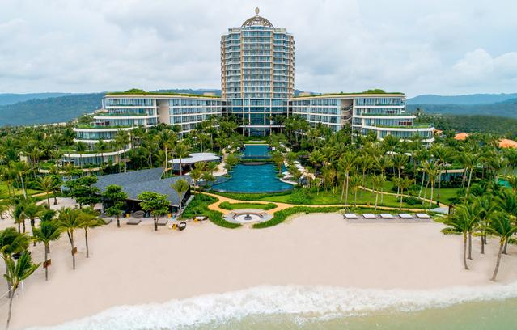
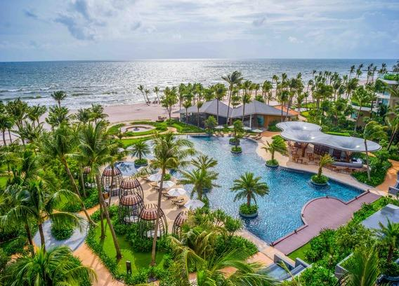
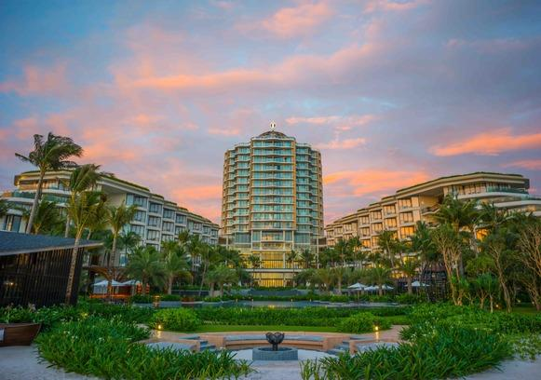
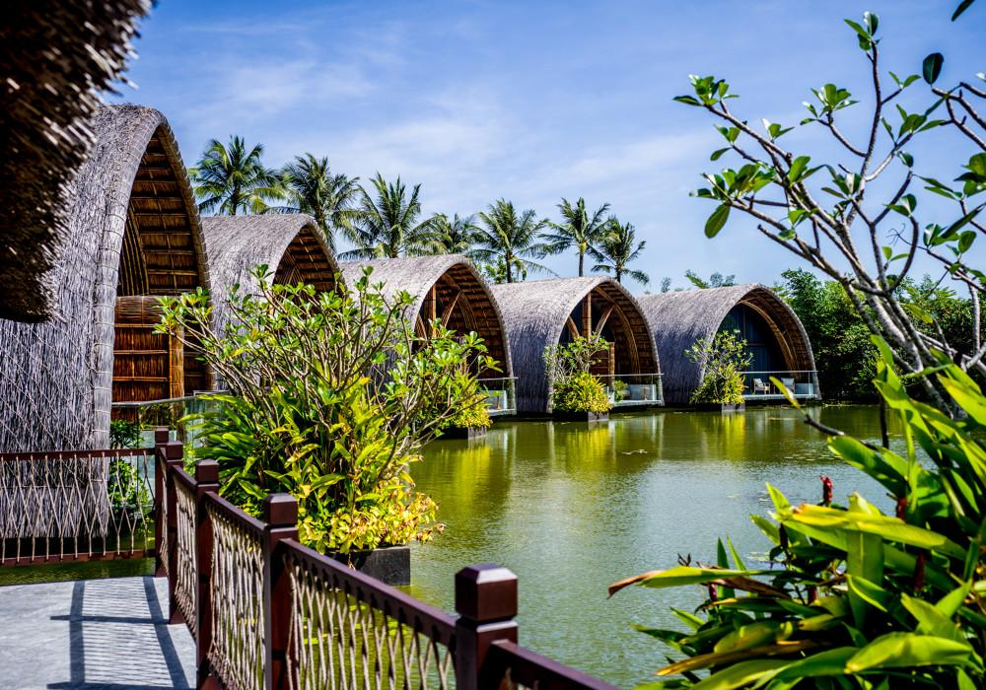
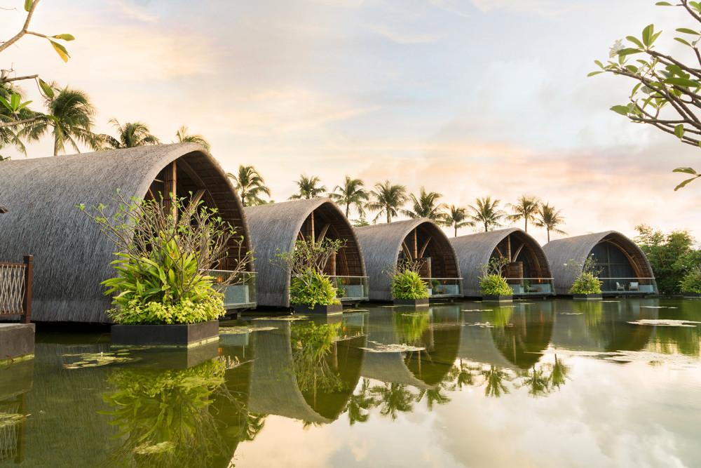
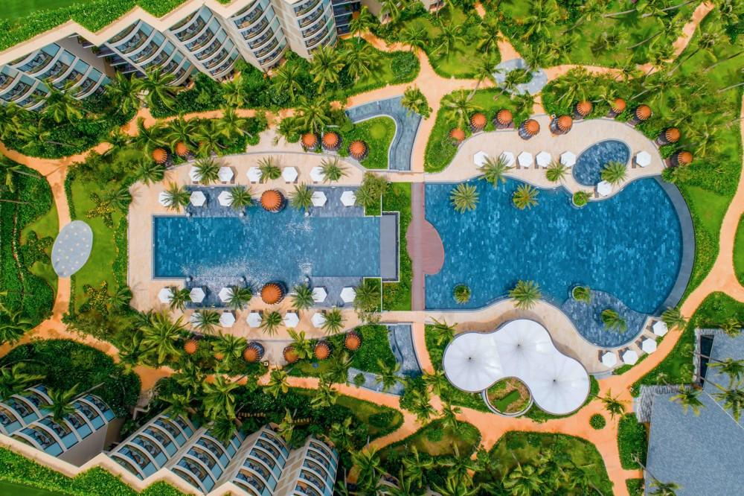

Rooms photos
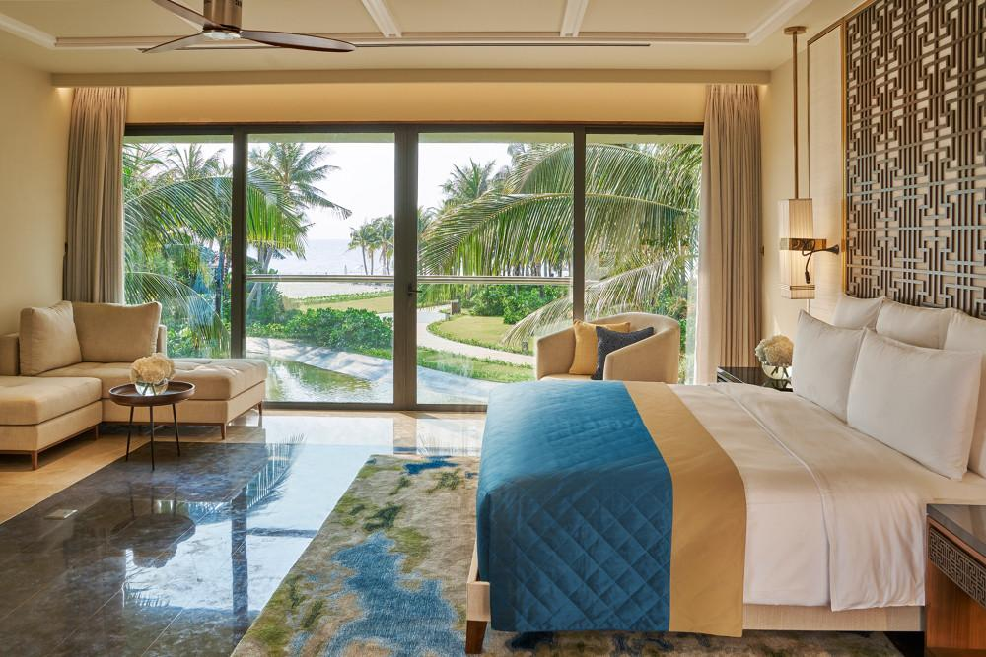
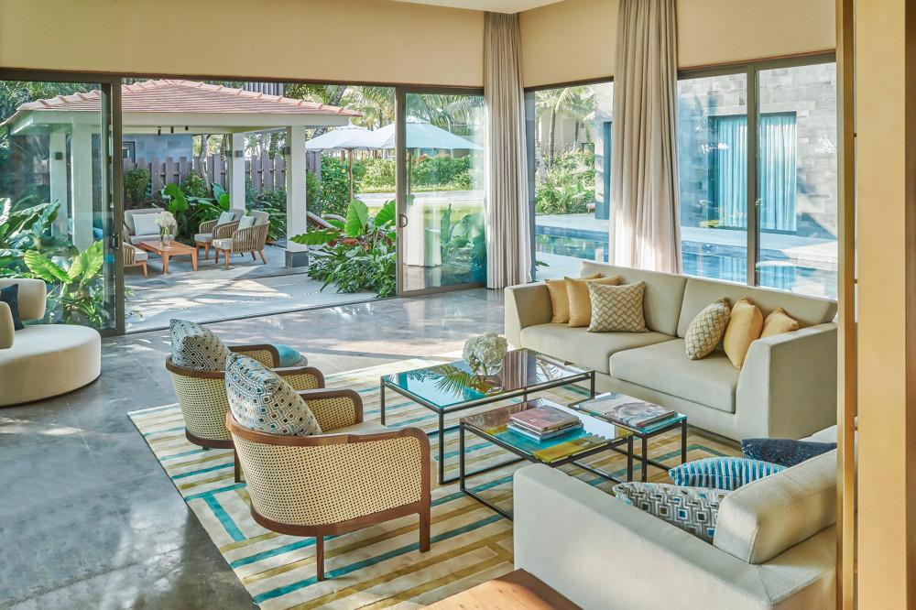
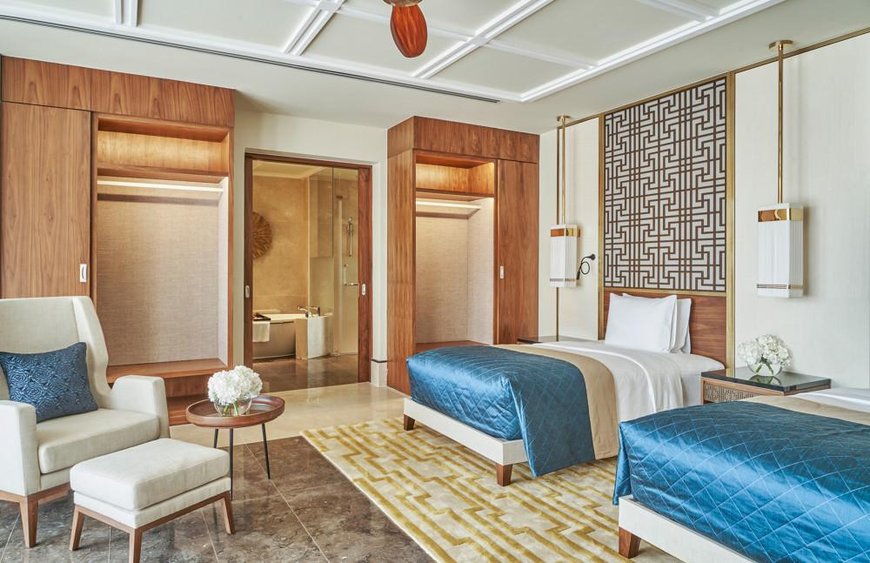
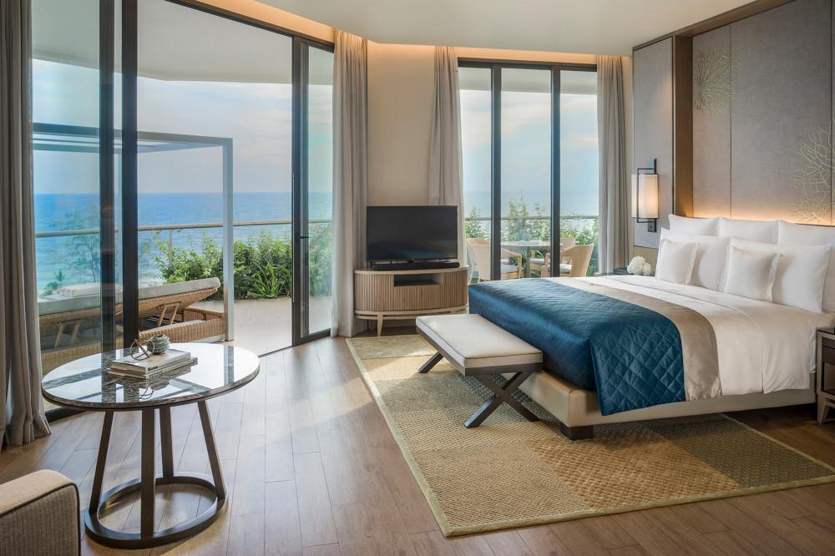
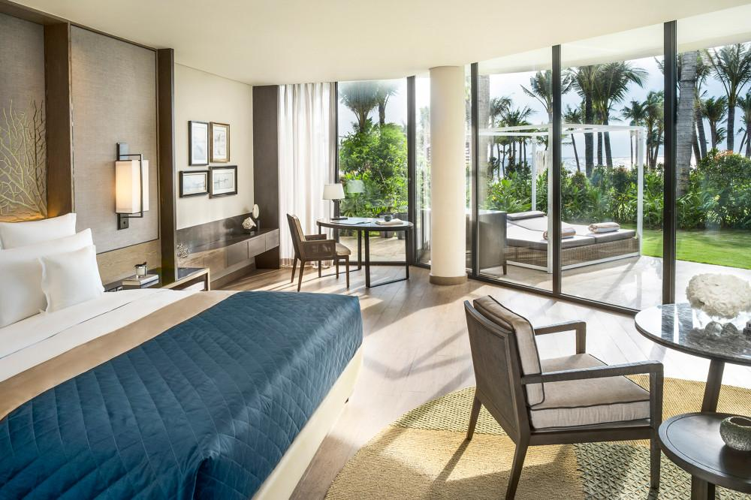
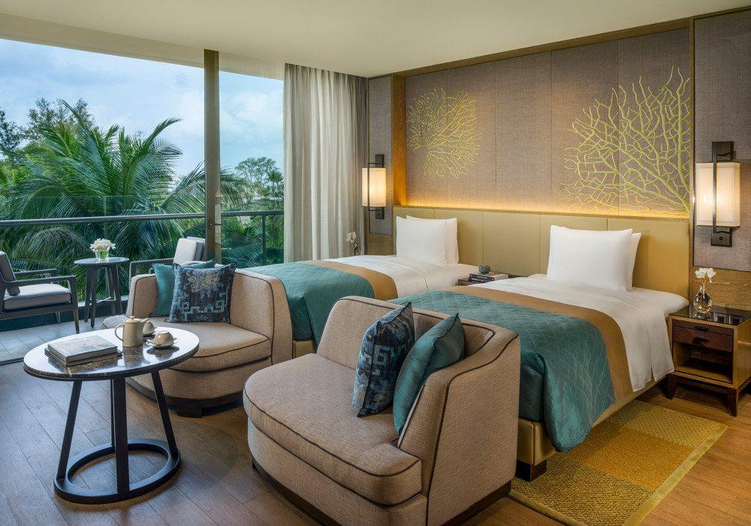
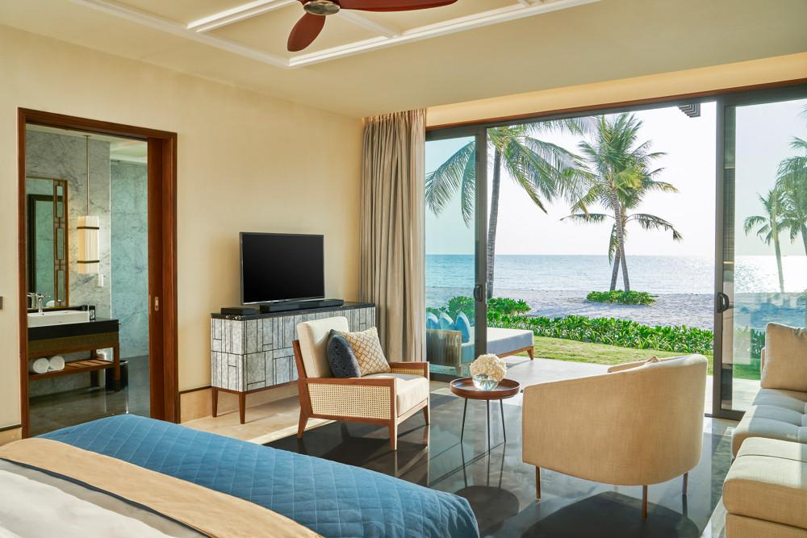
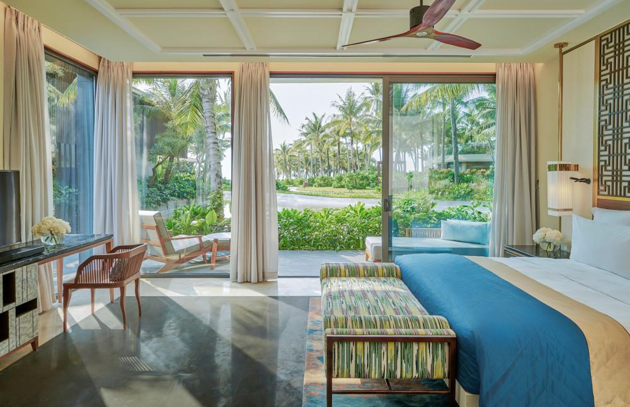
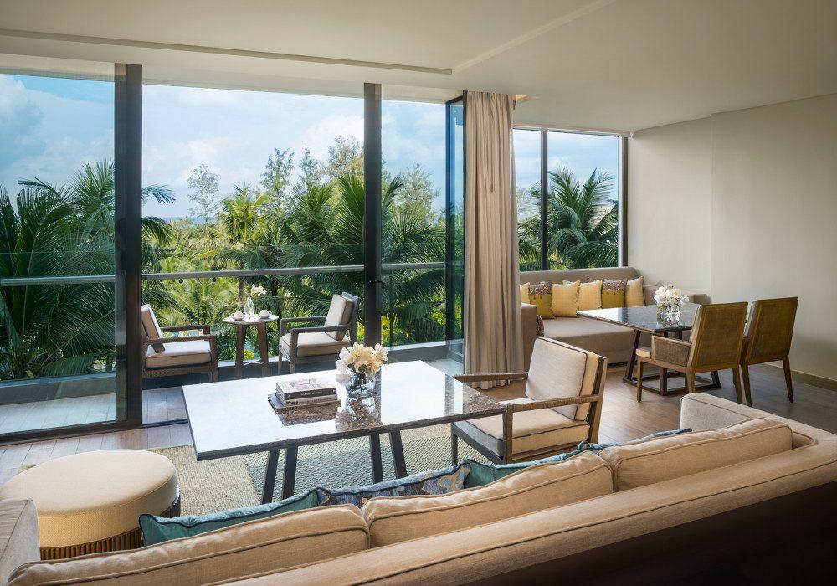
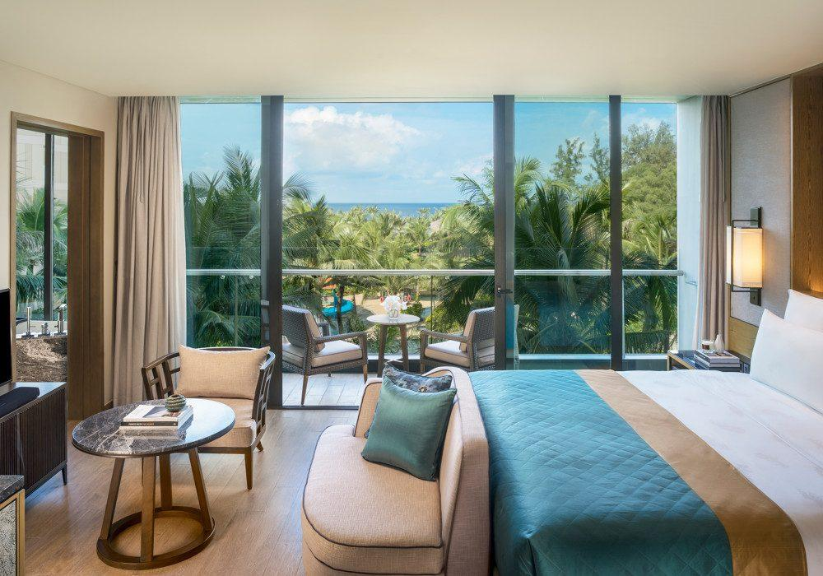
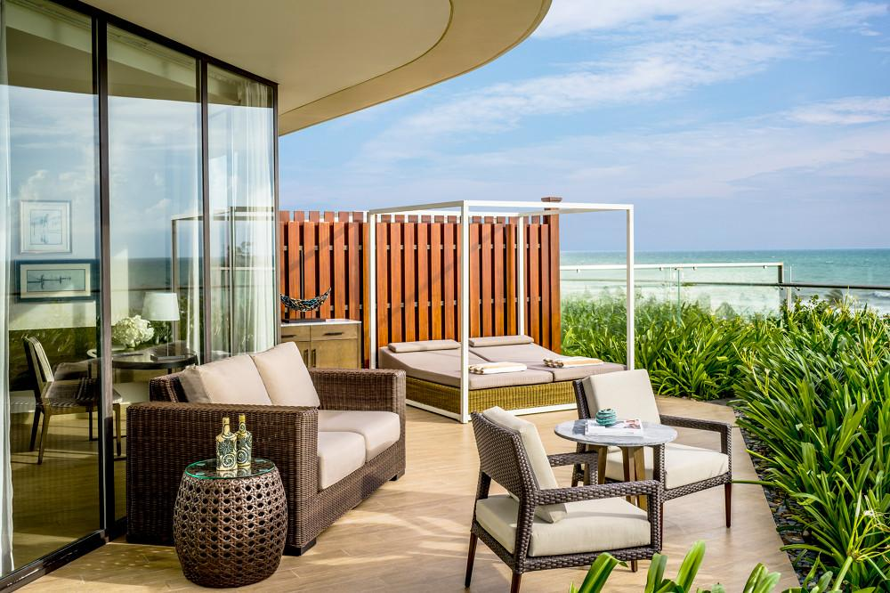
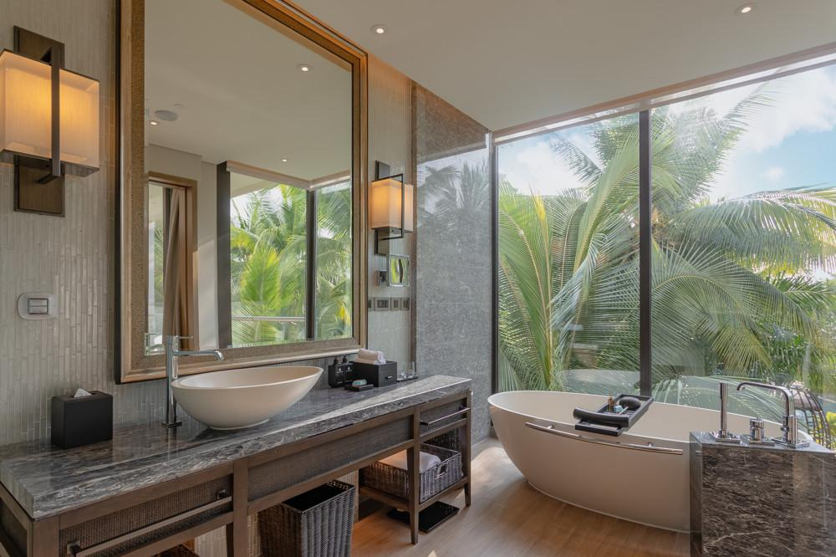
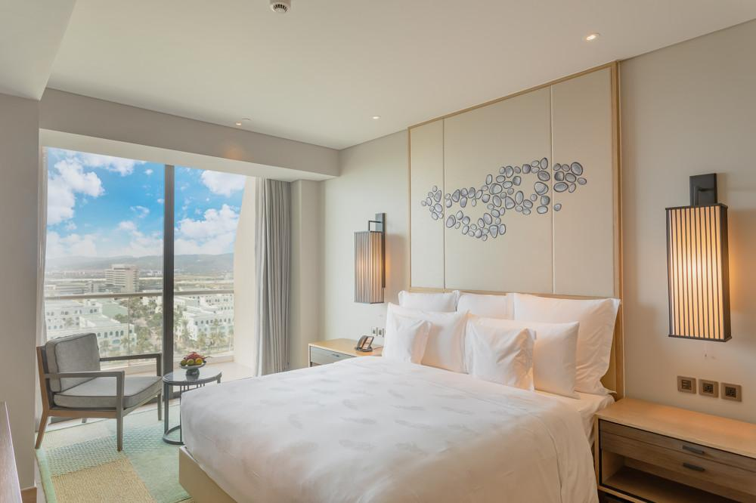
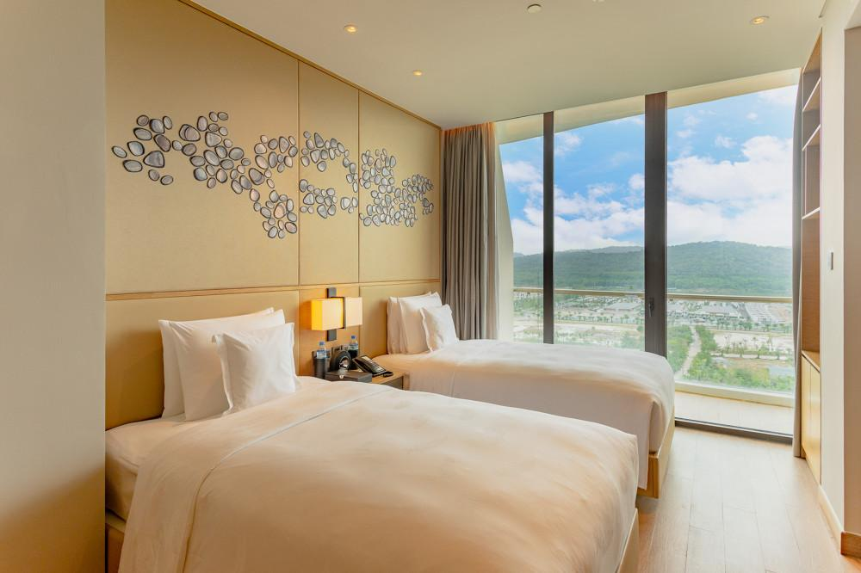
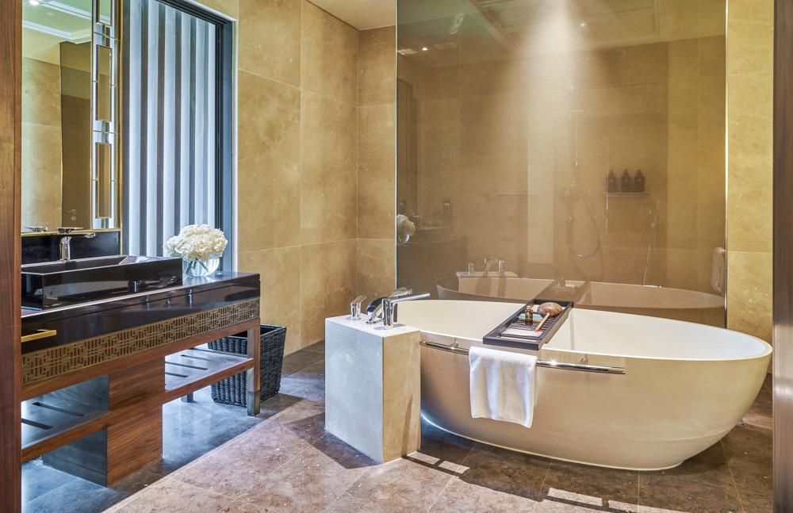
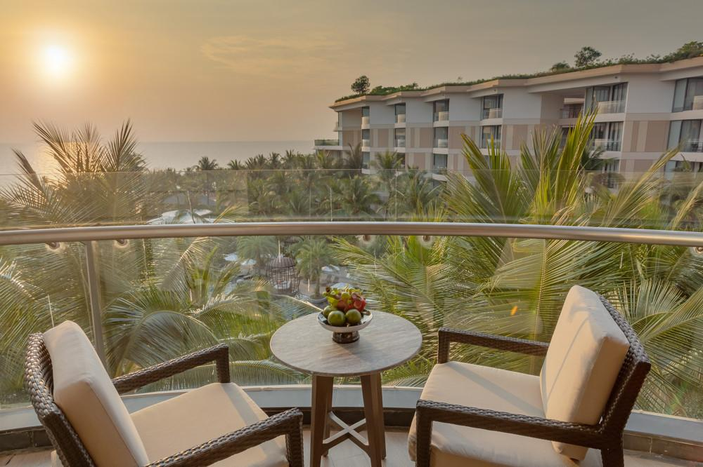
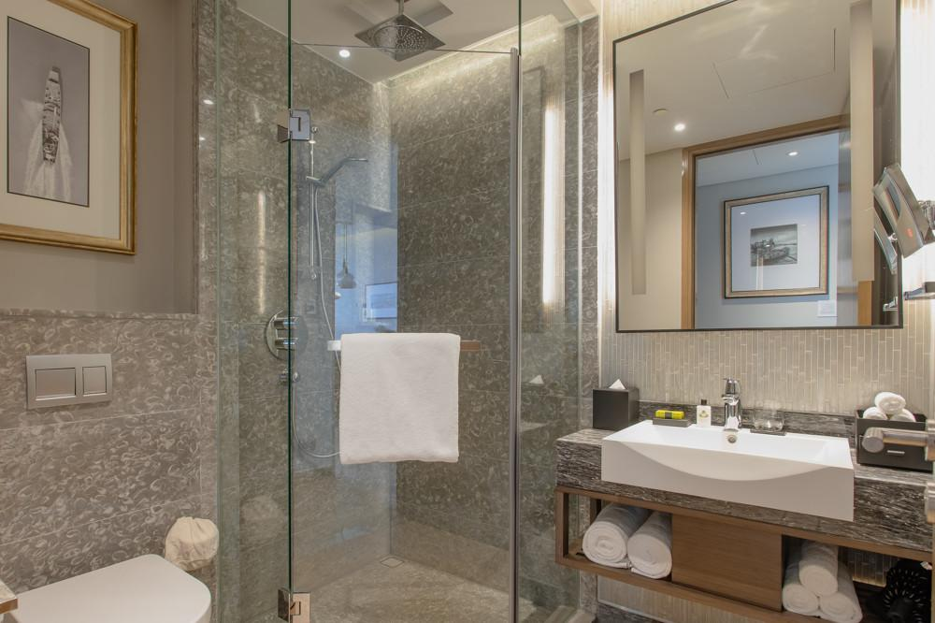

Restaurant photos
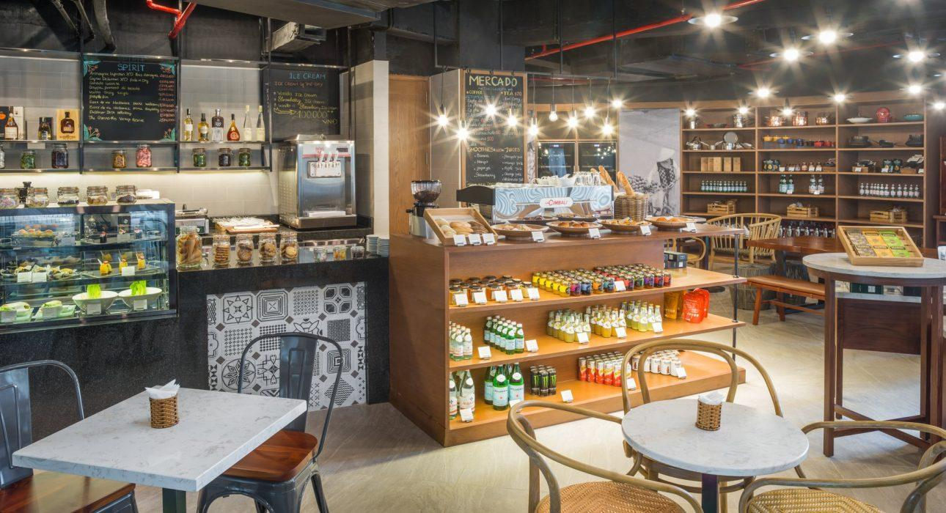
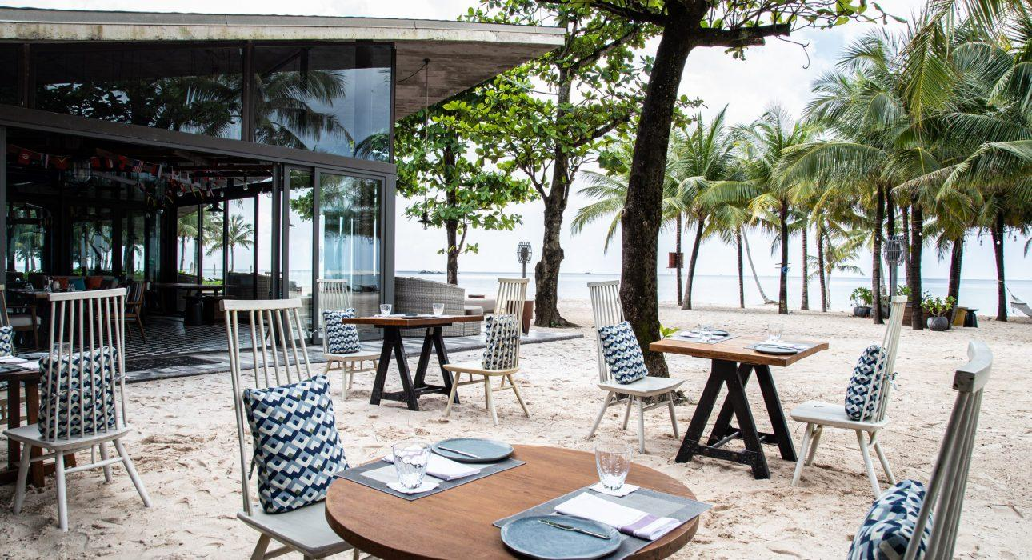
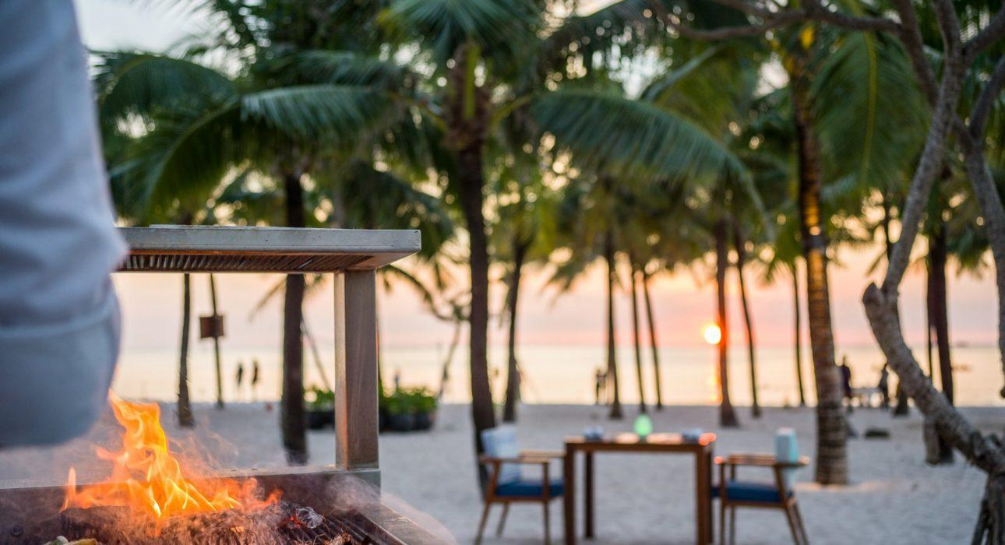
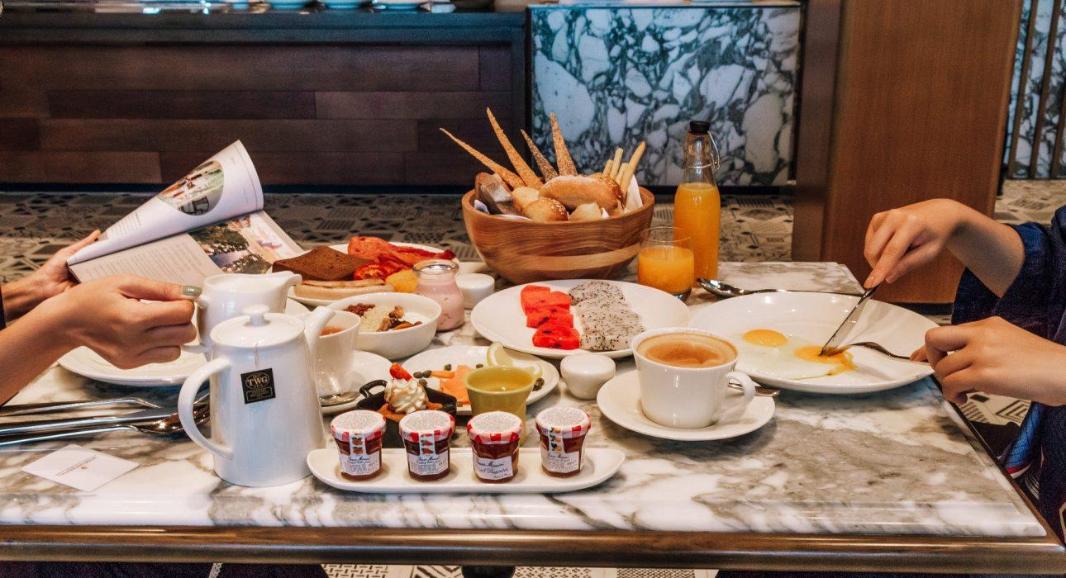
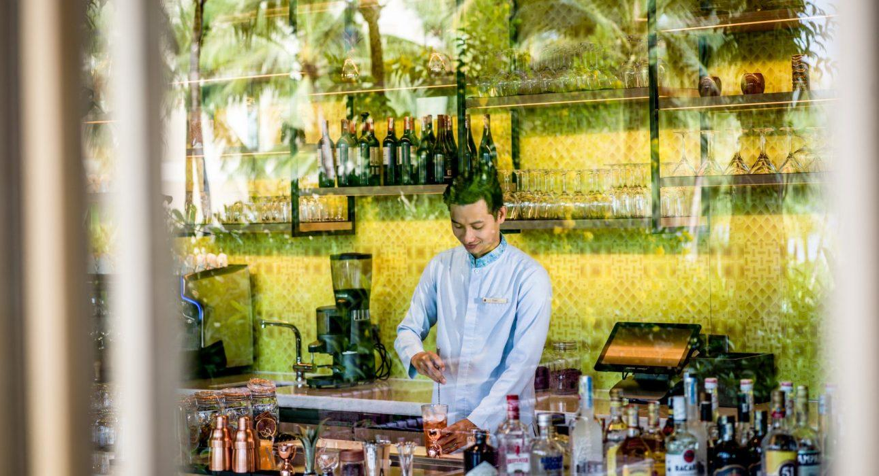
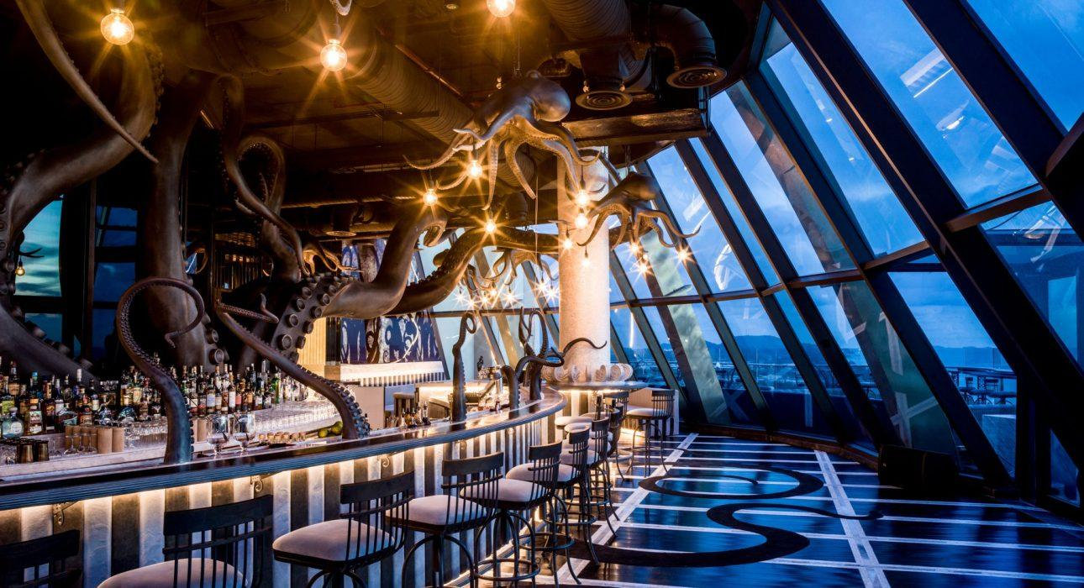
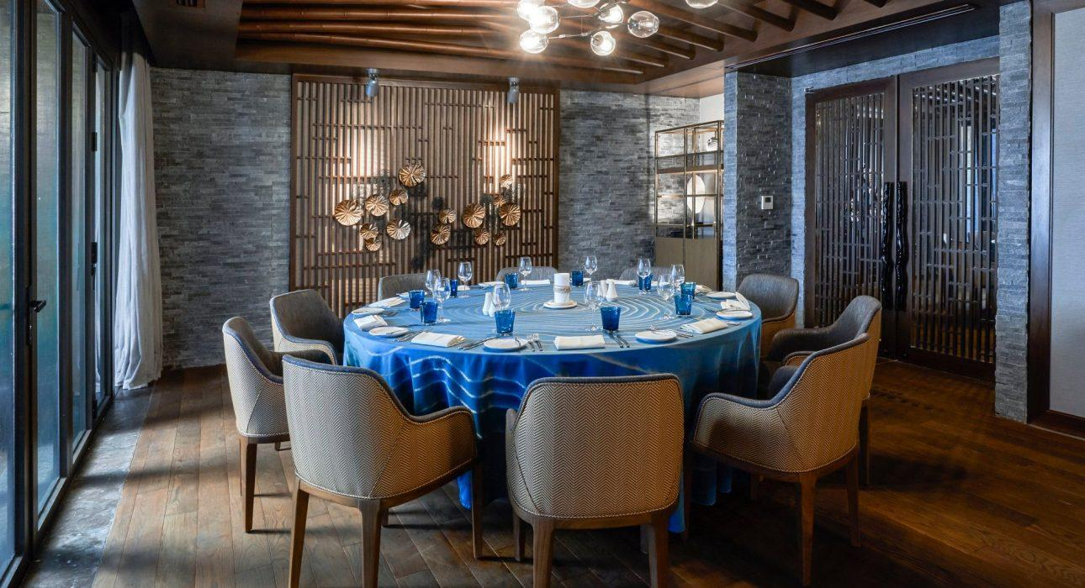

Services & facilities photos
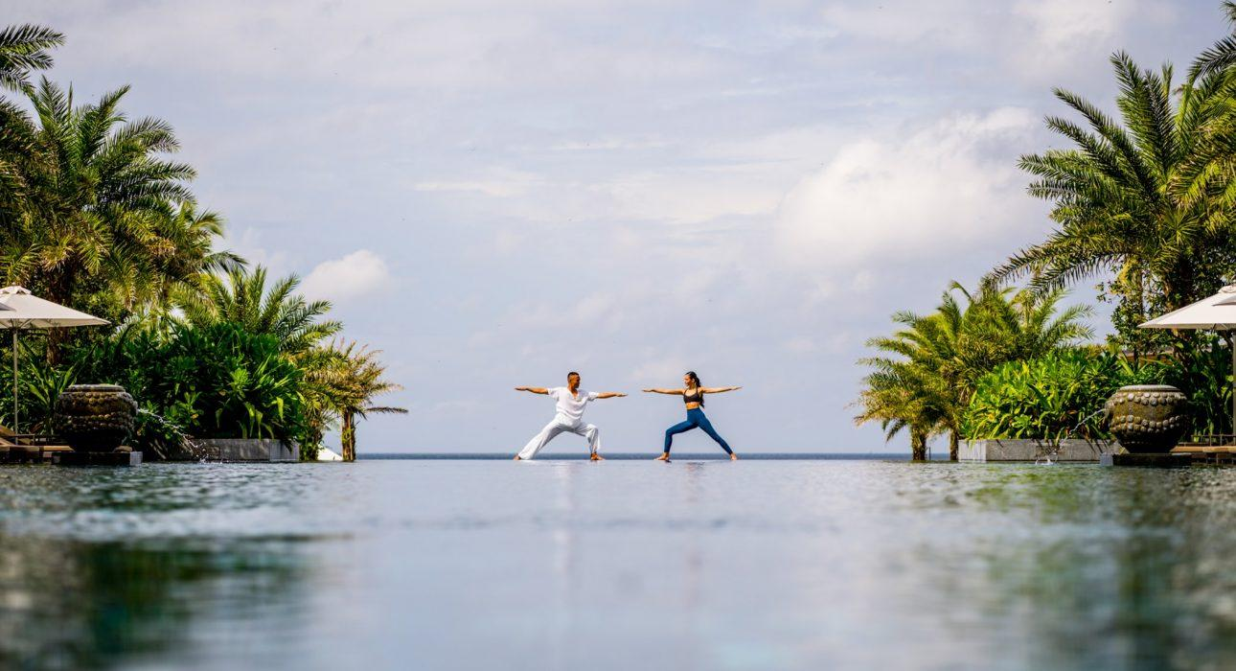
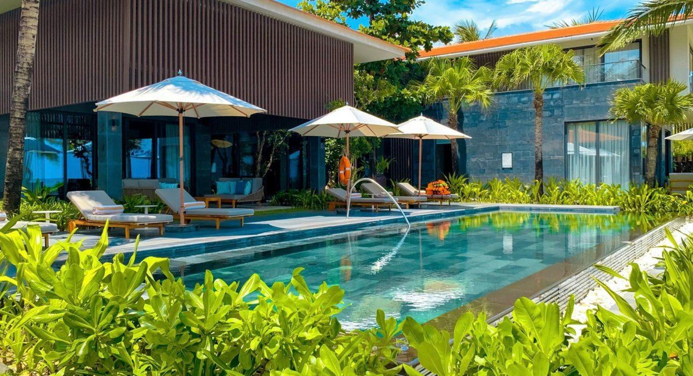
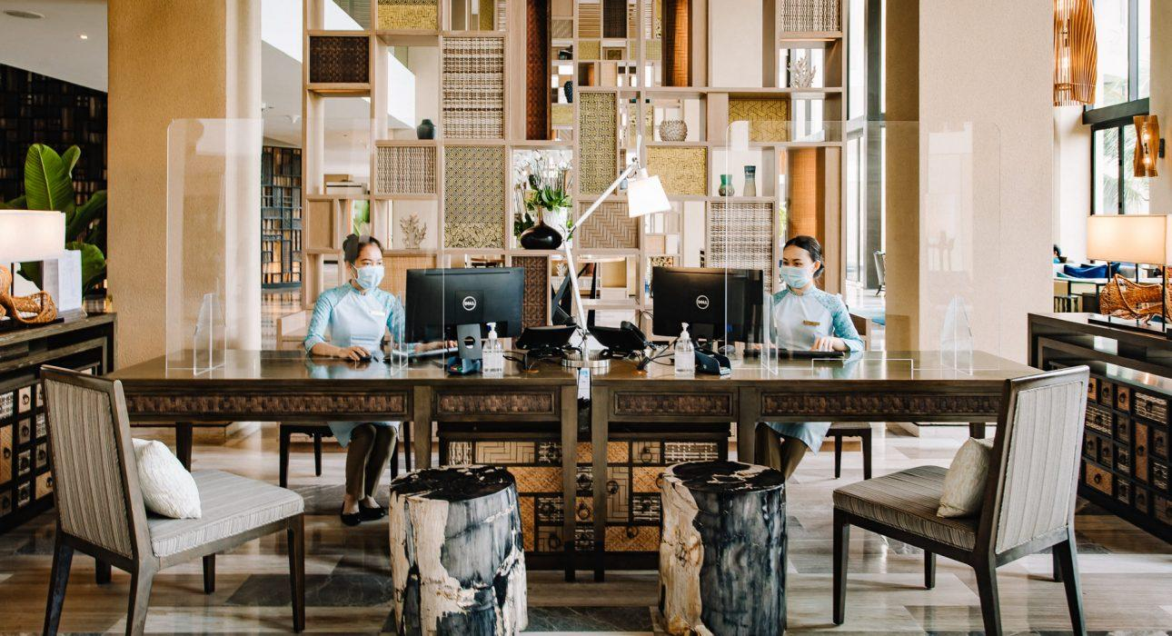
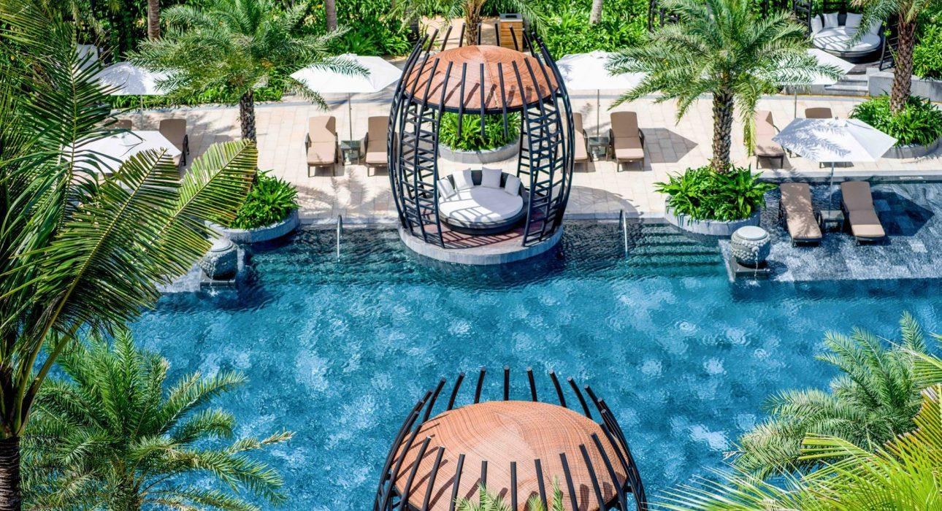
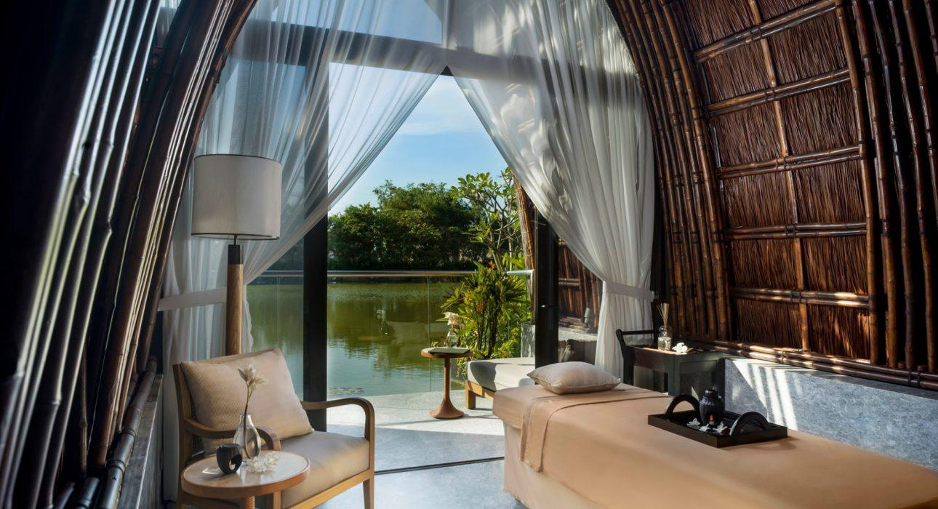
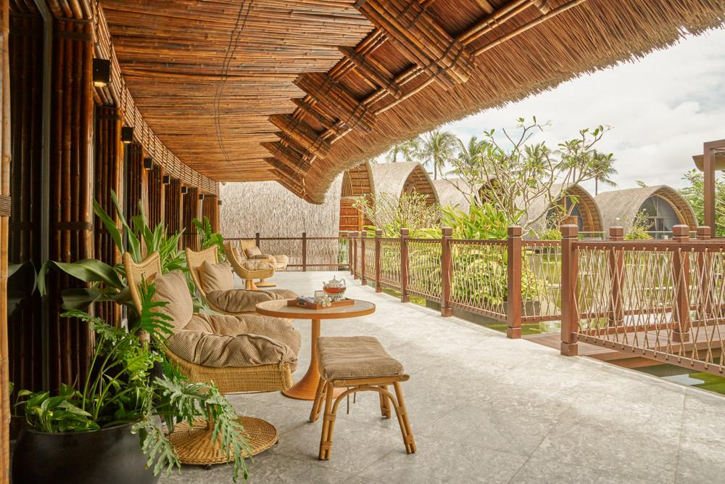
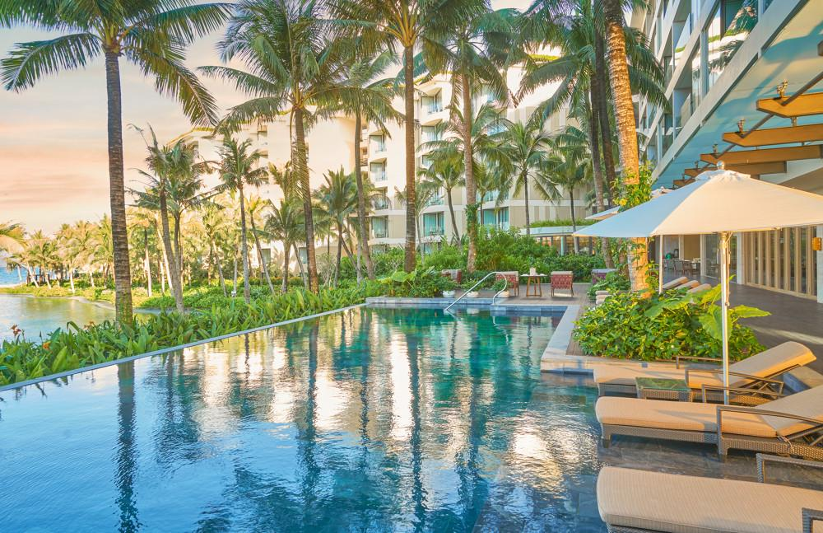
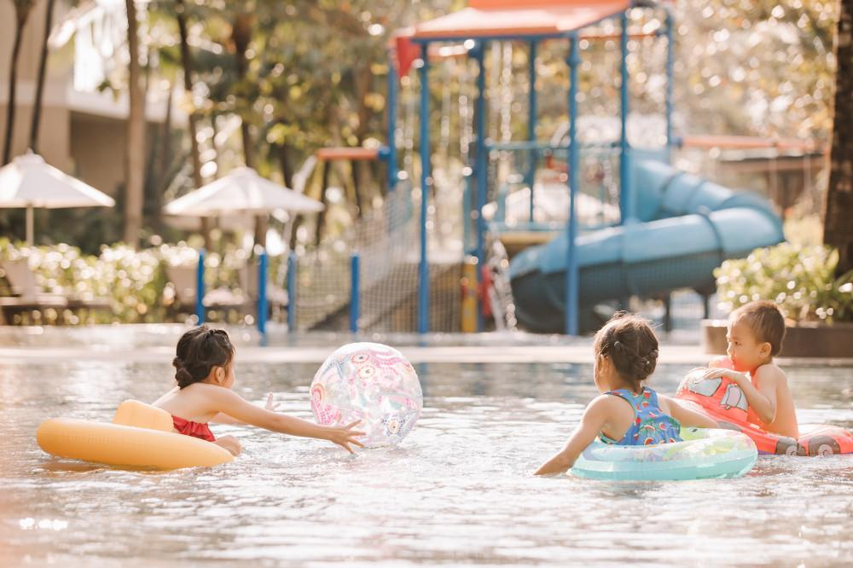
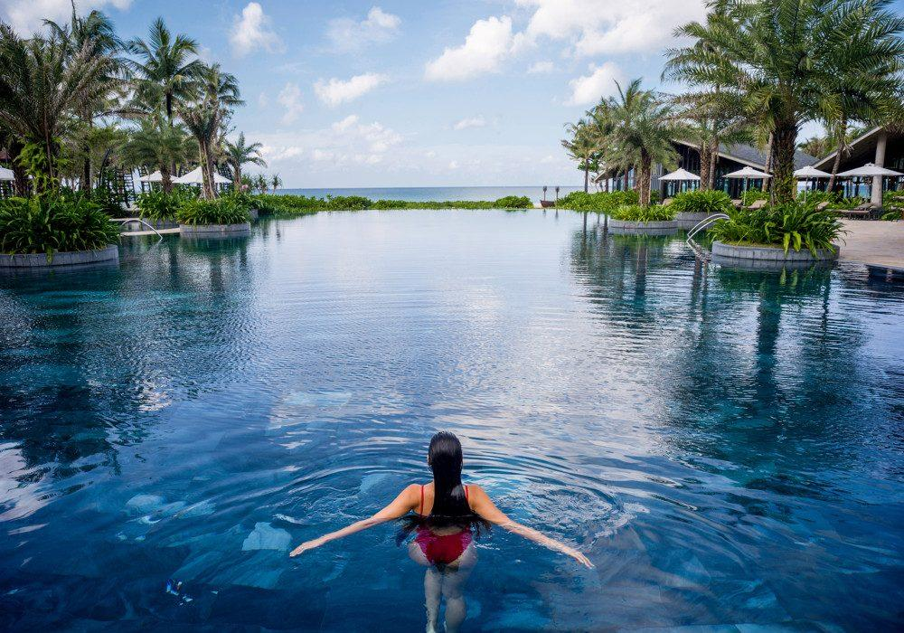

Easia Travel Head Office

