CAMBODIA – Phnom Penh – Rambutan Resort
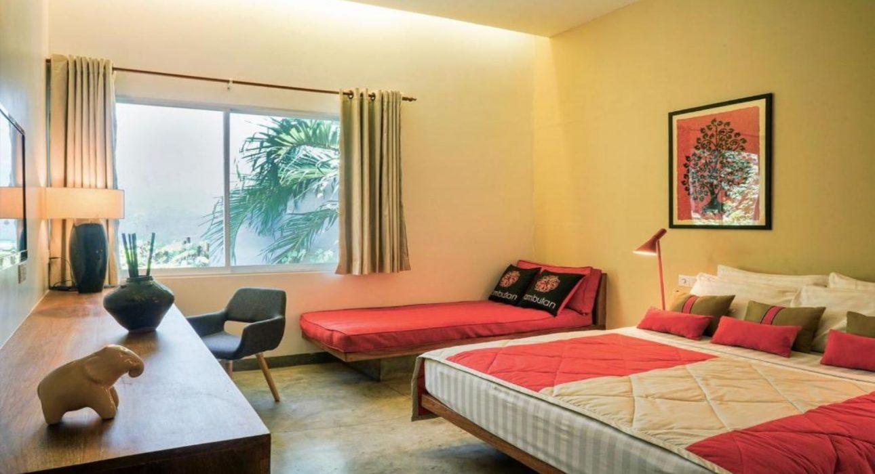

Over View

Theme
Classic, Honeymoon

Country - City
Cambodia - Phnom Penh

Market segment
Thematic Leisure

Official category
4*

Easia category
Superior

Total number of rooms
24

Price level
$$$

Description

The Rambutan Resort – Phnom Penh is an oasis in a city environment. It consists of a 1960’s Khmer-style city villa and a newly built modern designed wing overlooking a refreshing pool. The Rambutan Resort – Phnom Penh is located in the heart of Phnom Penh, the capital city of Cambodia, and it’s just 5 minutes from the city center.Rambutan Resort – Phnom Penh’s design is modern Asian style with all luxuries, locally crafted furniture, modular terrazzo surfaces, vibrant Asian art, framed Cambodian silks, secluded balconies, Al-fresco private stone bathtubs, and local tiles floors. The resort has a salted-water swimming pool with waterfall, pool bar, restaurant, and massage, all set within a lush tropical garden. All room has a rain shower and amenities, a large flat-screen TV with 82 channels, and a writing desk with comfortable furniture inside and outside.

Selling points

- The resort with beautiful design 1960’s Khmer style city villa with salted-water swimming pool
- Located in the heart of Phnom Penh the capital city of Cambodia and just 5 minutes from the center of the city
- The resort provide unlimited scholarship for English & university, environmental awareness, child’s safe training to their staff

Sustainability

Supplier Actions
Protection of Environment, Child Protection

Time & Transportation

From | To | By | Distance | Duration | Road Condition
Rambutan Resort – Phnom Penh | Royal Palace Phnom Penh | Car | 2.1 km | 5 mn | Good
Rambutan Resort – Phnom Penh | Phnom Penh International Airport | Car | 8.5 km | 15 mn | Good
Rambutan Resort – Phnom Penh | Wat Phnom Doun Penh | Car | 3.4 | 10 mn | Good

Rooms

Easia's recommend room type
Balcony Villa Double
- Unit : 3 rooms
- Size : 36sqm
- Bed : Queen size bed
Balcony Villa Twin
- Unit : 4 rooms
- Size : 36sqm
- Bed : Queen size bed + 1 single bed
Deluxe Terrace Double
- Unit : 6 rooms
- Size : 40sqm
- Bed : Queen size bed
Deluxe Terrace Twin
- Unit : 5 rooms (2 original twin , 3double + extra bed)
- Size : 40sqm
- Bed : Queen size bed + single
Deluxe Rooftop Terrace Double
- Unit : 2rooms
- Size : 40sqm
- Bed : King size bed
Deluxe Rooftop Terrace Twin
- Unit : 2 rooms
- Size : 40sqm
- Bed : King size bed + single

Room configuration

Connecting rooms
No

Extra bed
Yes, (0.9m x2m)

King bed
Yes, (1.8m x 2m)

Queen bed
Yes, (1.6m x 2m)

Twin beds
Yes

Services & Facilities

Services
24 hour reception, 24h security service, Concierge service, Credit Card payment, Dry Cleaning, Iron, Laundry service, Massage, Mobile phone, Room Service, Spa, Swimming Pool, Wake-up service, Wi-fi Free

Facilities
Air Conditioning, Bar, coffee and tea making facilities, Coffee Machine Facilities, Fan, Flat screen TV, Full Board - B/L/D, Garden, Hair Dryer, In-Room safe, Internet, Jacuzzi, Massage room, Outdoor swimming pool, Restaurant, Safety Box, satellite LCD TV, Terrace, TV Room, Umbrella

Restaurant information

The Rambutan Restaurant & BarThe Rambutan Restaurant serves a wide variety of Western and Khmer favorites. The team consists of 3 young Khmer who were trained by Mr. Mengly Mork a Khmer chef who received excellent training at Ecole Paul Du Brule, one of the most highly qualified hospitality schools in Siem Reap.This results in their current varied menu with a unique fusion selection. Guests can order breakfast, lunch, or dinner at the restaurant or in the privacy of their own room. Next to the a la carte menu the resort serves also some weekly specials.The Resort Lounge Bar is located near the pool and features a quiet environment with comfortable lounge chairs and couches. Here, guests can enjoy exciting cocktails, spirits, and wines or choose from a wide range of international and local beers.Operating HoursRestaurant
- Breakfast : 6:15 AM – 11:00 AM
- Lunch : 11:45 AM – 3:00 PM
- Dinner : 6:00 PM – 8:45 PM
*Breakfast serves A la carte stylePool & Bar10:00 AM – 8:45 PM

Photos

Hotel Photos
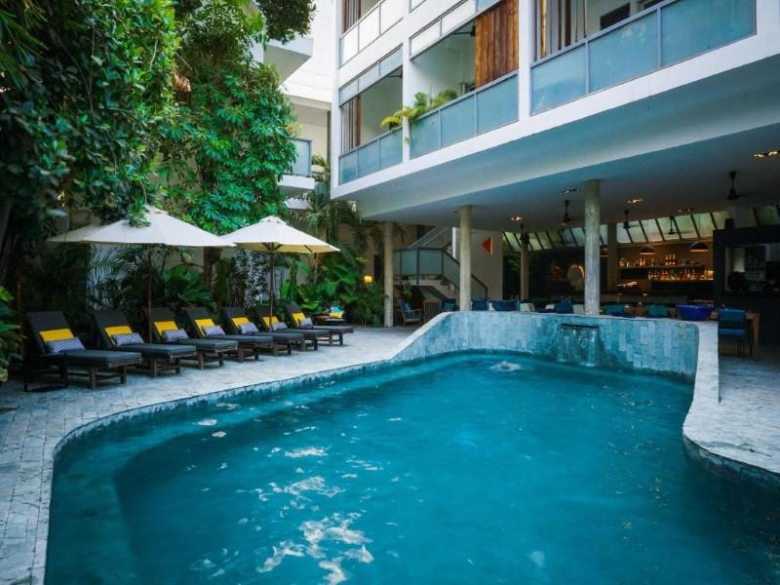
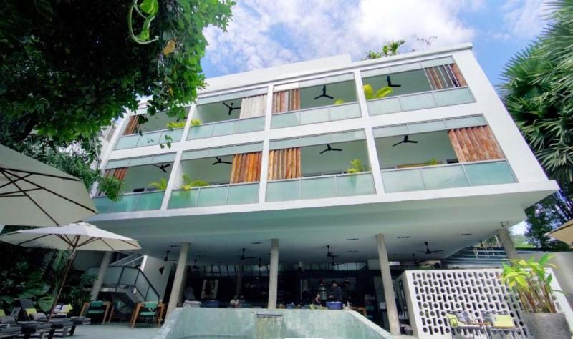
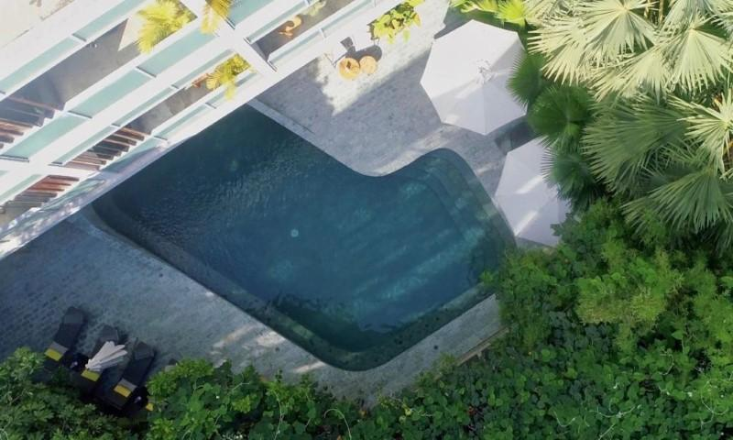
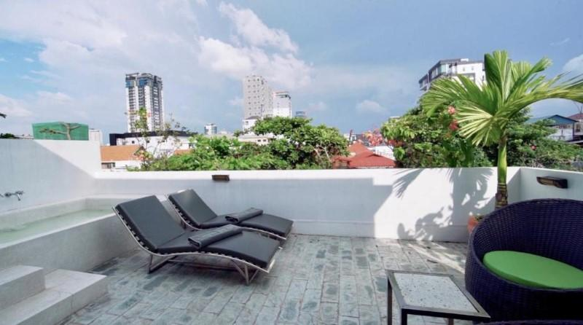
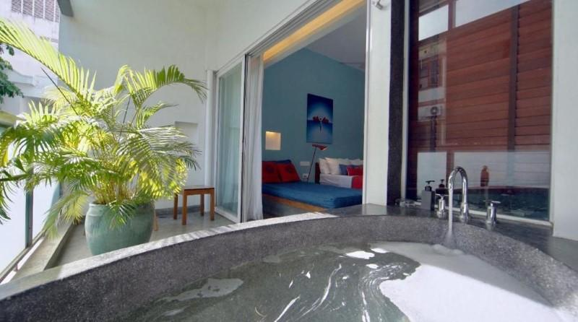

Rooms photos
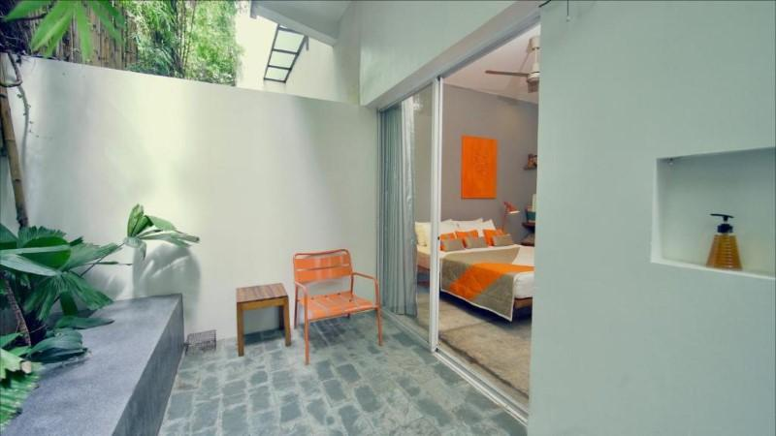
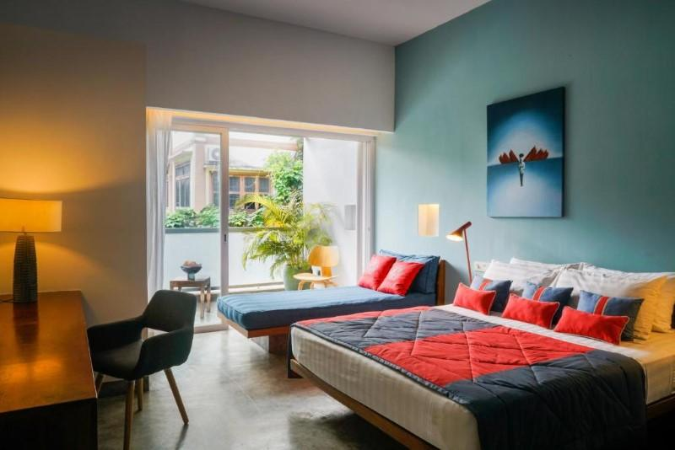
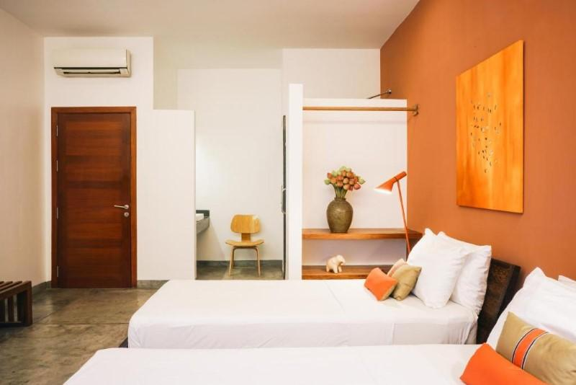
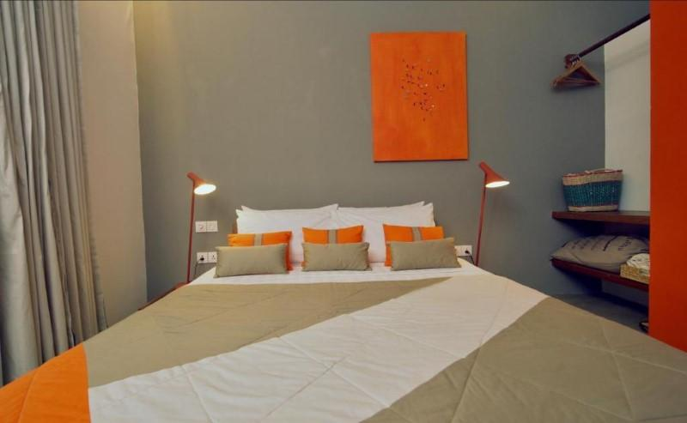
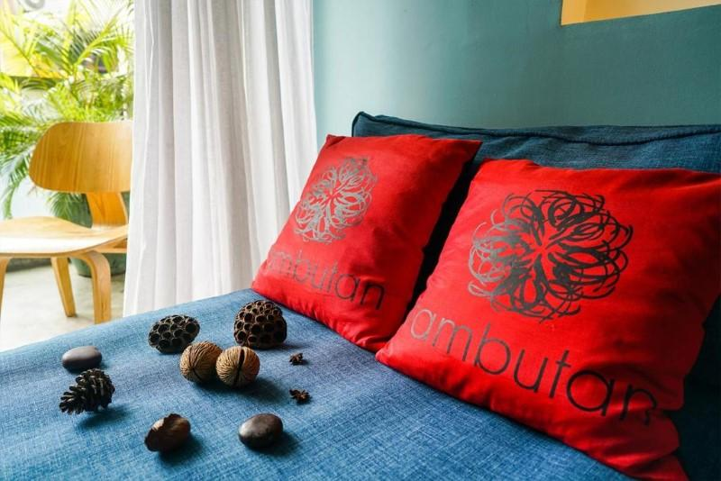
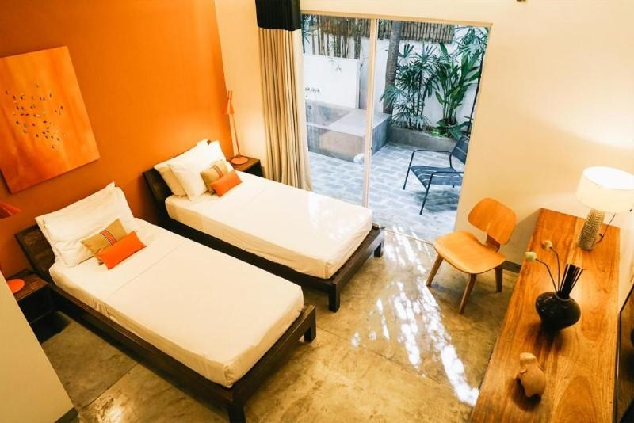
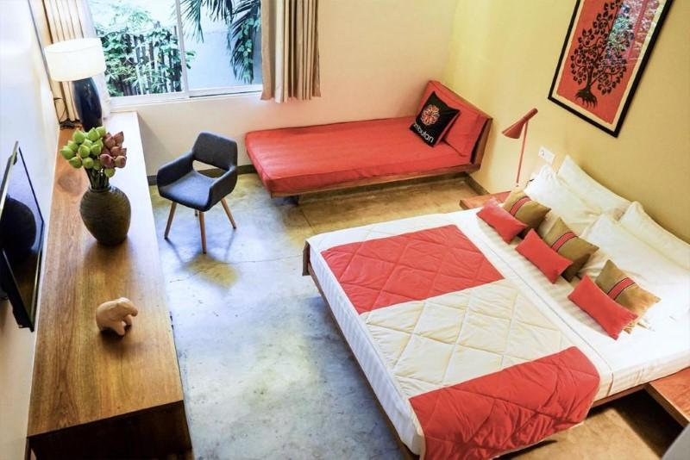
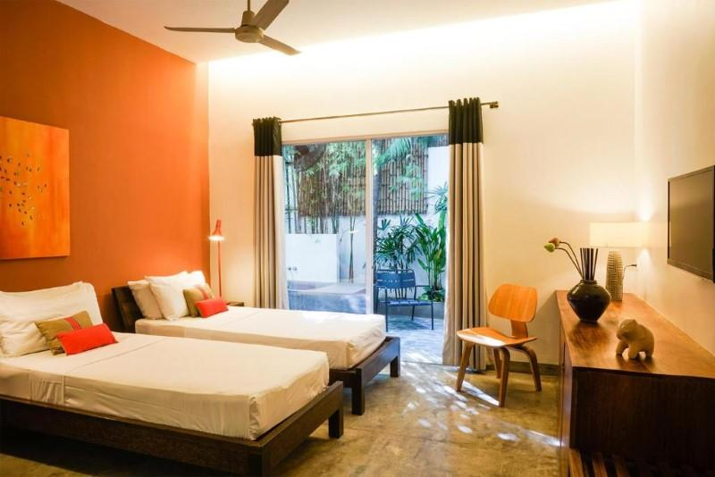
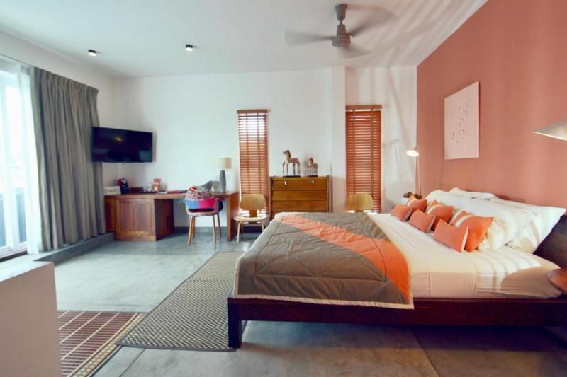
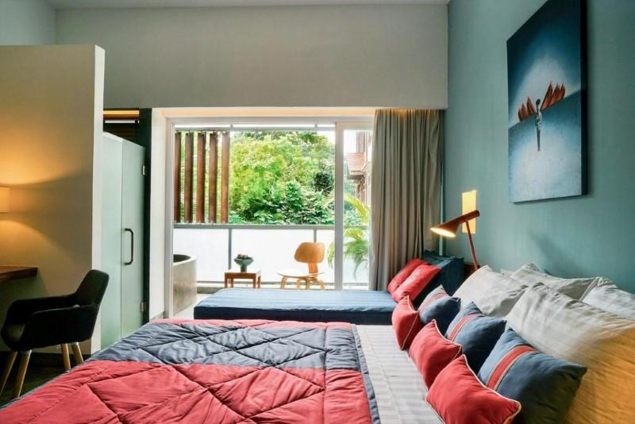
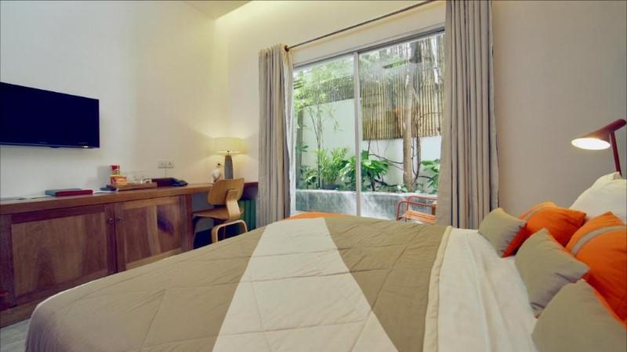

Restaurant photos
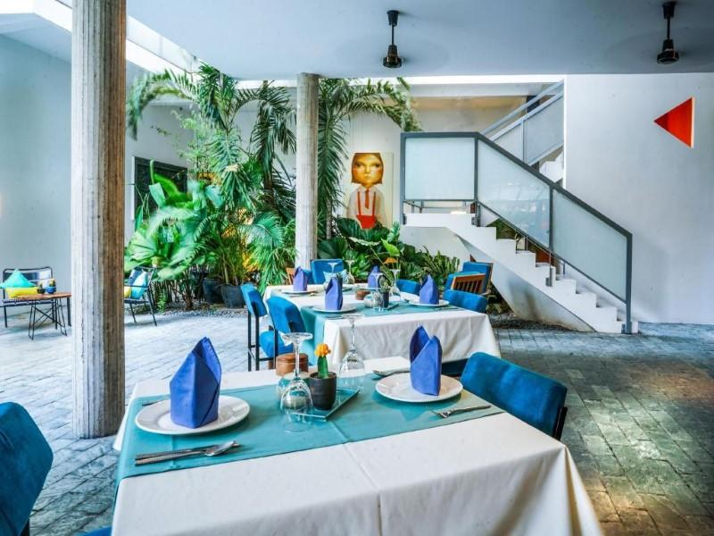
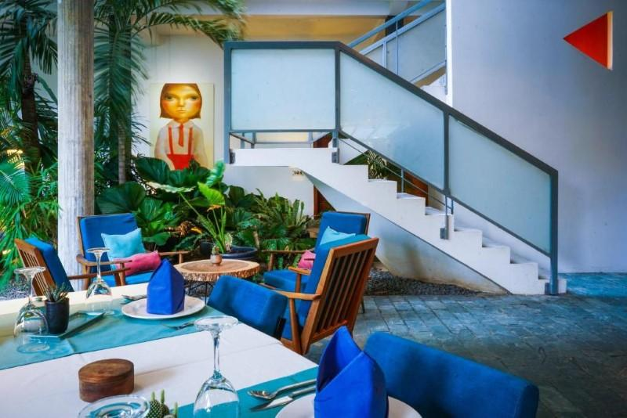
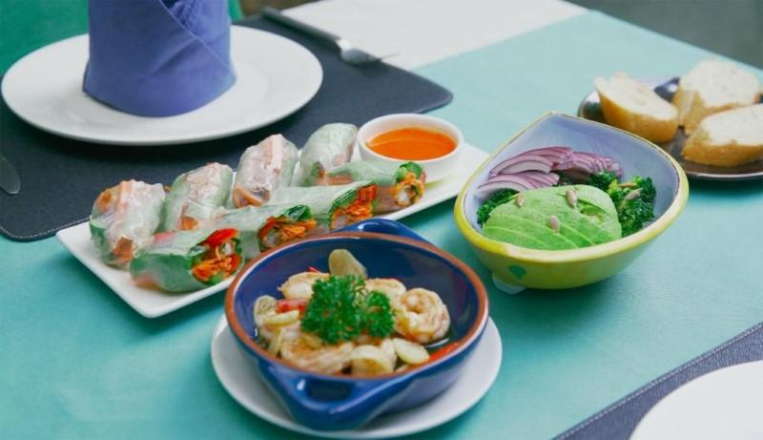
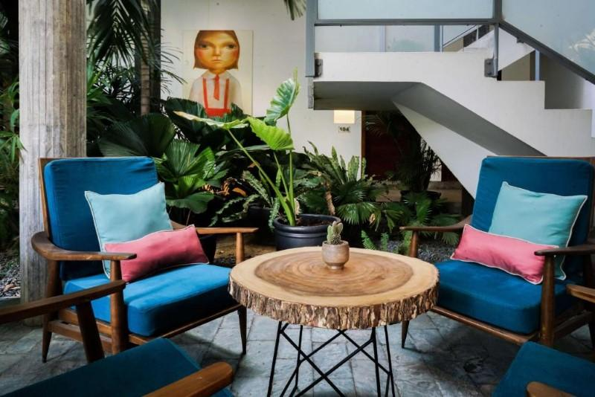
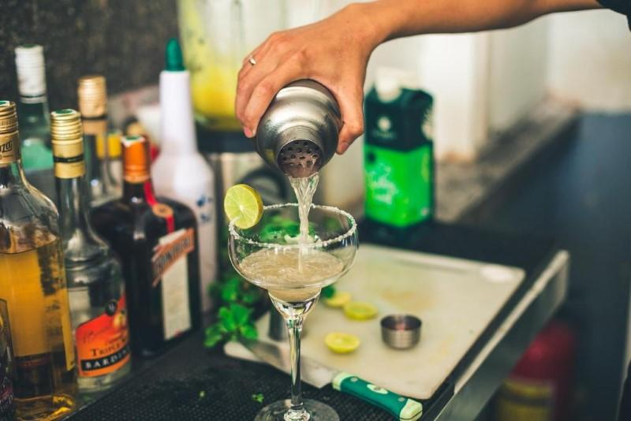
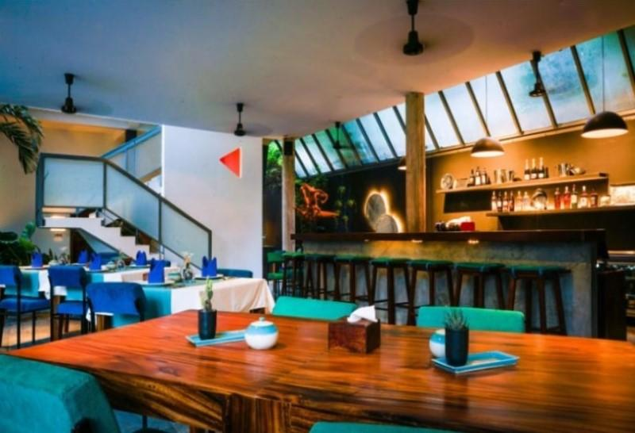

Services & facilities photos
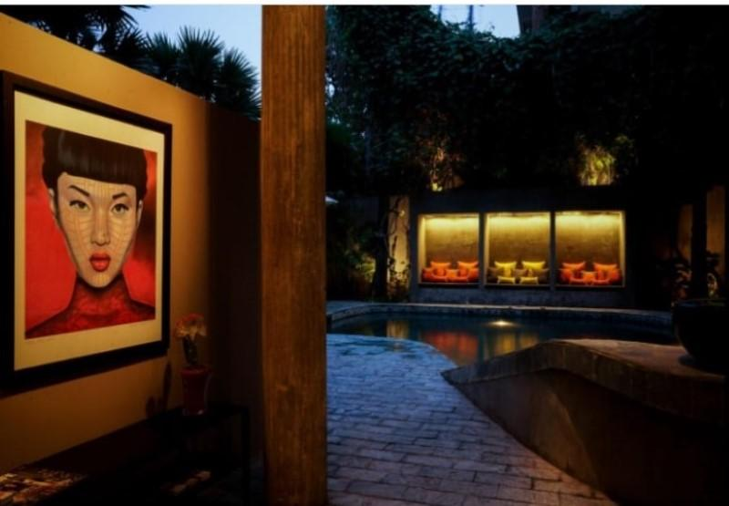

Easia Travel Head Office

