CAMBODIA – Siem Reap – La Palmeraie D’angkor Charming Hotel
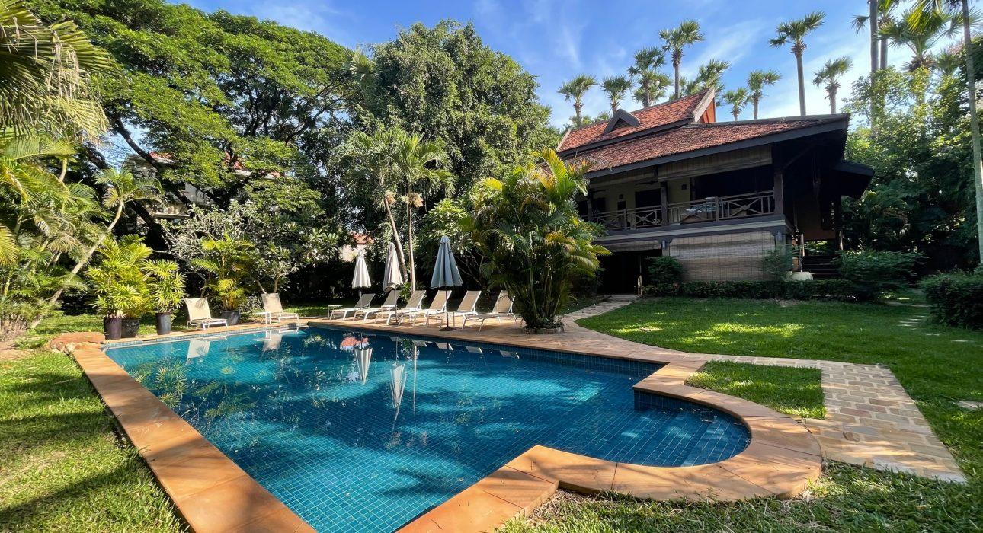

Over View

Theme
Classic, Family

Country - City
Cambodia - Siem Reap

Market segment
Thematic Leisure

Official category
4*

Easia category
Superior

Total number of rooms
9

Price level
$$$

Description

Located just a 4-minute drive from Siem Reap International Airport, La Palmeraie d’Angkor is a family-friendly hotel in a tropical garden with a very nice outdoor swimming pool and friendly service.Next to a golf course and in the business district, La Palmeraie d’Angkor is in an area with good airport proximity. La Palmeraie d’Angkor has an outdoor swimming pool, a restaurant, and a poolside bar available at this smoke-free hotel. This hotel offers nine air-conditioned accommodations accessible via exterior corridors and features iPod and MP3 docking stations. Rooms open to furnished balconies or patios. Each accommodation is individually furnished and decorated. Select Comfort beds feature Egyptian cotton sheets and premium bedding. Flat-screen televisions come with premium satellite channels, pay movies, and Netflix. Bathrooms include showers, slippers, a hair dryer, and complimentary toiletries. A safety box, complimentary bottled water, and daily housekeeping service are provided. Free WIFI is provided throughout this property.

Selling points

- Very charming family – friendly hotel with comfortable accommodation and very nice design
- Very clean room and sustainable
- Very good location and set in green tropical garden with charming outdoor swimming pool

Sustainability

Supplier Actions
Protection of Environment, Child Protection

Time & Transportation

From | To | By | Distance | Duration | Road Condition
La Palmeraie | Angkor Wat | Car | 8 Km | 10 mn | Good
La Palmeraie | Siem Reap Angkor International Airport | Car | 56.6 km | 1hr 20 mn | Good
La Palmeraie | Old Market | Car | 7 Km | 10 mn | Good

Rooms

Easia's recommend room type
Family Suite Multiple BedsStyle: Modern
- 958 sq ft size
- Five people sleeps at capacity
- Two double beds size and one queen bed size
- 1 unit suite
- Two bathrooms
- Connecting is available
- Furnished balcony or patio for outdoor space
- Extra bed is not available
Deluxe Triple RoomStyle: Modern
- 646 sq ft size
- Three people sleeps for capacity
- One queen bed size and one twin bed size or three twin beds size
- 1 unit suite
- Partially open bathroom
- Extra bed is not available
- Connecting room is available
- Pool view
- Furnished balcony or patio for outdoor space
Deluxe Villa, 4 Bedrooms, Private Pool, Pool ViewStyle: Modern
- 4843 sq ft size
- Ten people sleeps for capacity
- Four queen beds size and two twin beds size
- 1 unit villa
- Four bedrooms
- Three living rooms
- Private pool
- Extra bed (surcharge)
- Connecting room is available
- Pool view
- Furnished balcony or patio for outdoor space
Deluxe RoomStyle: Modern
- 646 sq ft size
- Three people sleeps for capacity
- One queen bed size or two twin beds size
- 1 unit
- Extra bed is not available
- Connecting room is available
- Pool view
- Furnished balcony or patio for outdoor space

Room configuration

Connecting rooms
Yes

Extra bed
Yes

King bed
No

Queen bed
Yes

Twin beds
Yes

Services & Facilities

Services
24 hour reception, 24h security service, Airport transfer, Babysitting, Children Swimming Pool, Complimentary bottle of water, Complimentary fresh towel, Credit Card payment, Dry Cleaning, Iron, Laundry service, Luggage Storage, Massage, Mobile phone, Room Service, Services for children, Spa, Swimming Pool, Wake-up service, Wi-fi Free

Facilities
Air Conditioning, Bar, coffee and tea making facilities, Coffee Machine Facilities, Family Room, Fan, Flat screen TV, Free private parking, Full Board - B/L/D, Garden, Hair Dryer, Massage room, Outdoor swimming pool, Private Pool, Restaurant, satellite LCD TV, Terrace, Umbrella

Restaurant information

La Palmeraei
- Breakfast 6:30 AM – 11:00 AM
- 1 restaurant
- 1 coffee shop
- 1 poolside bar

Photos

Hotel Photos
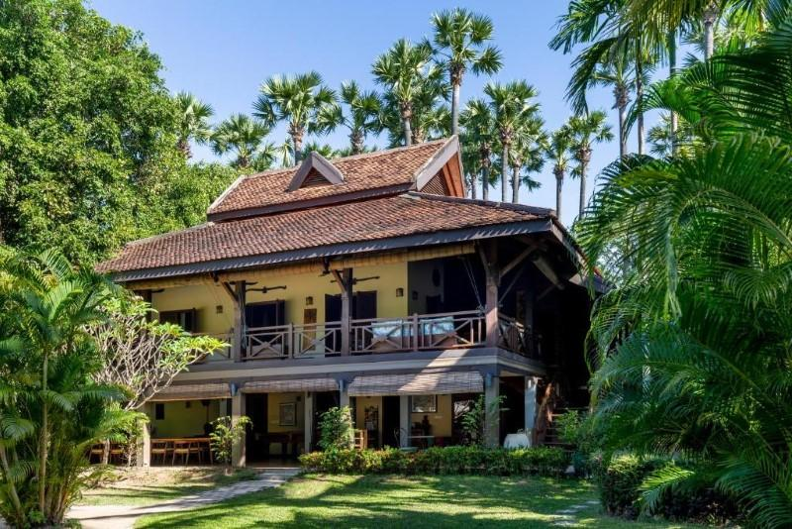
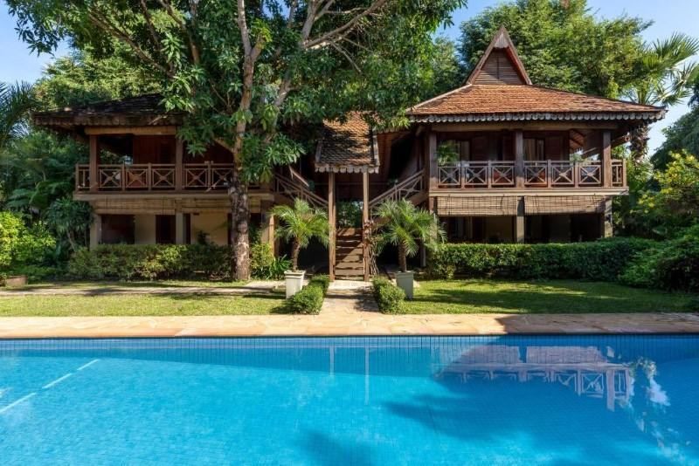
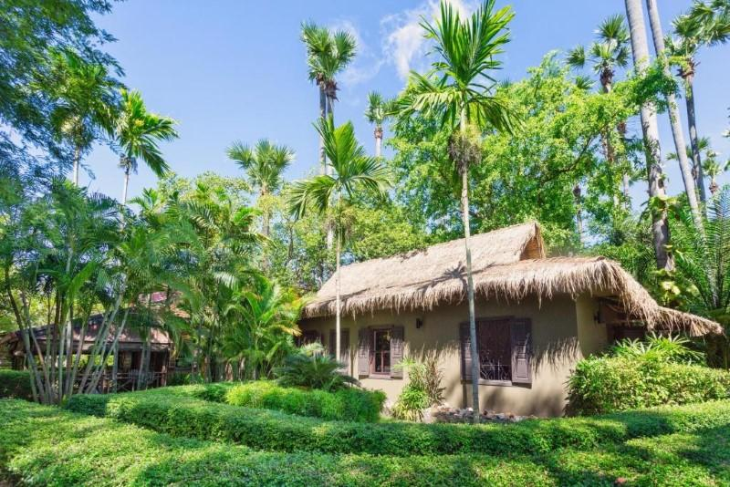
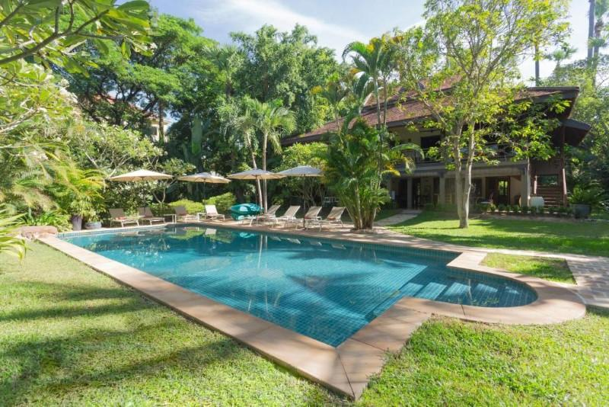
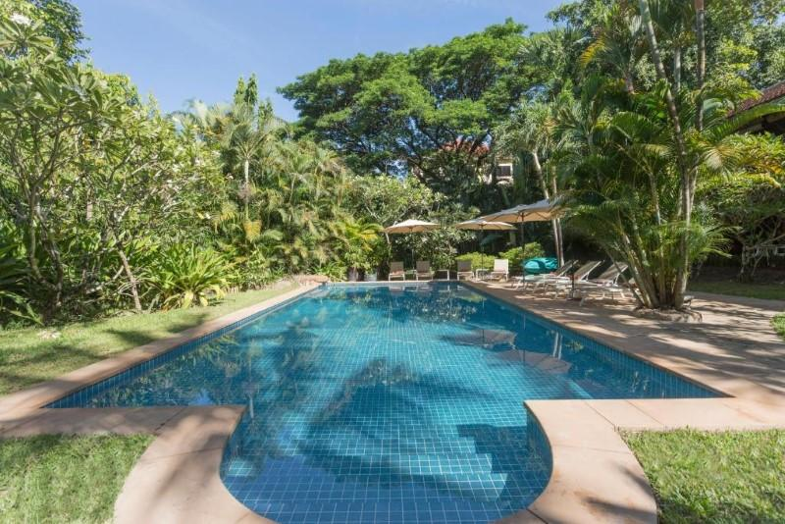
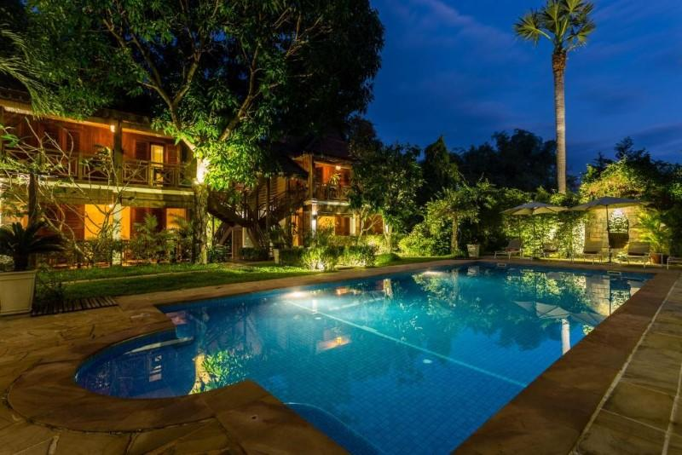

Rooms photos
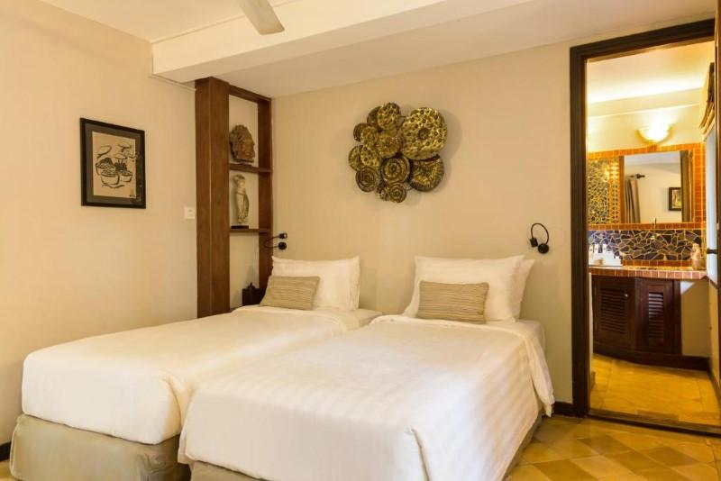
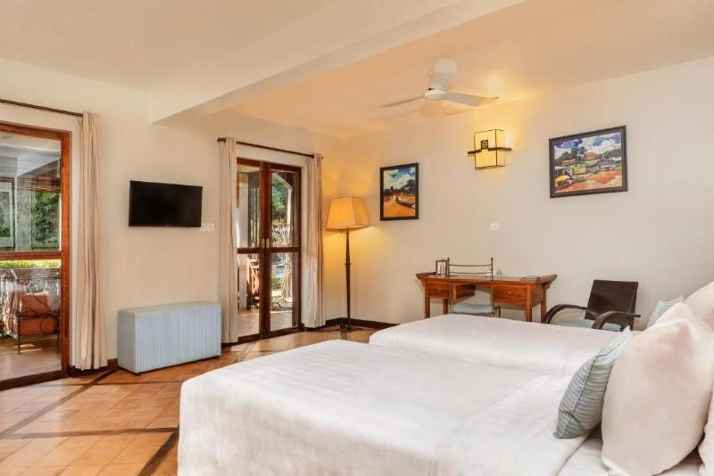
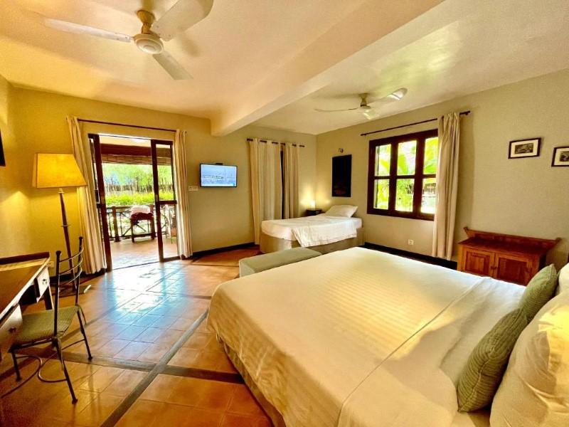
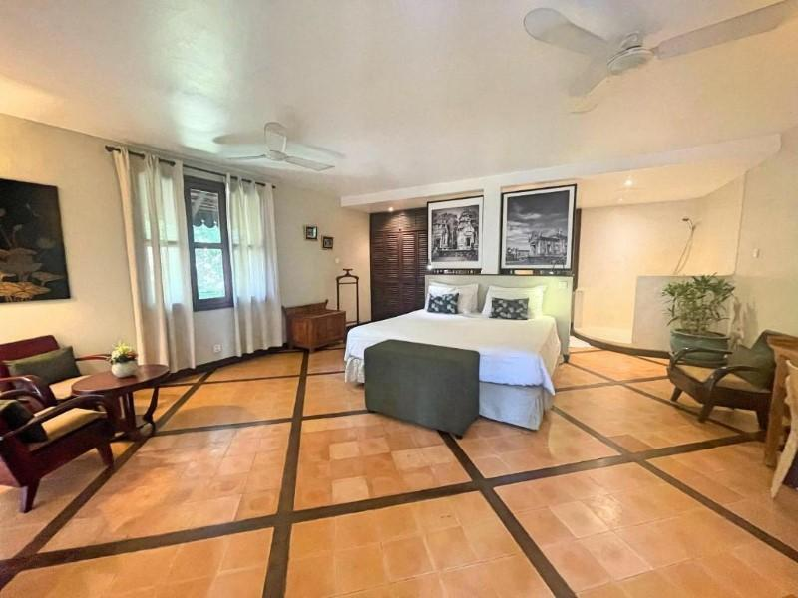
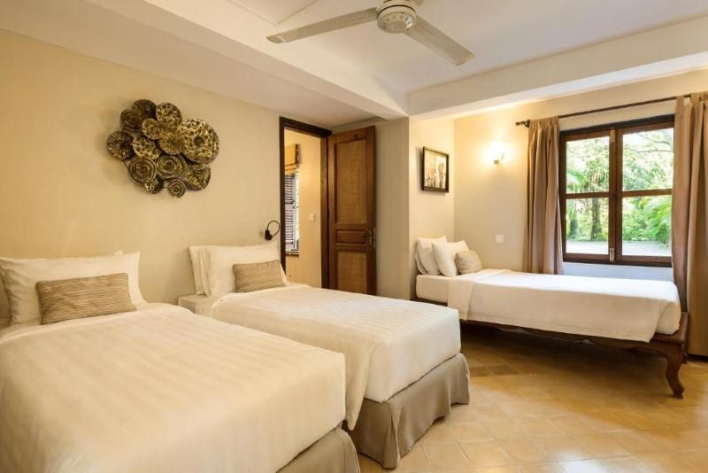
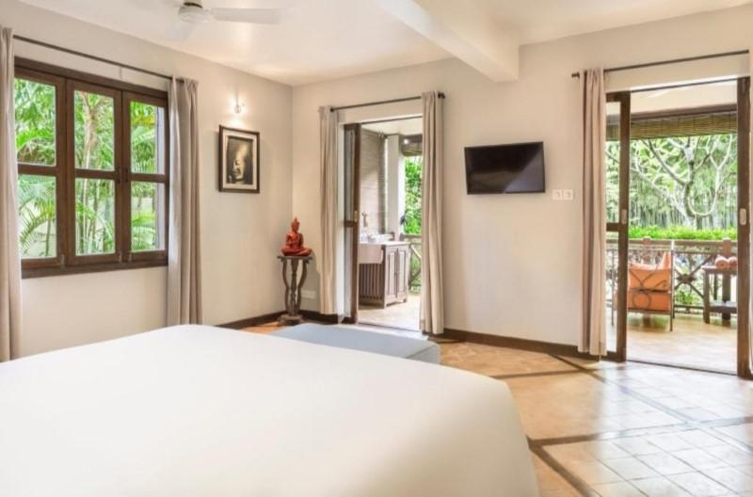
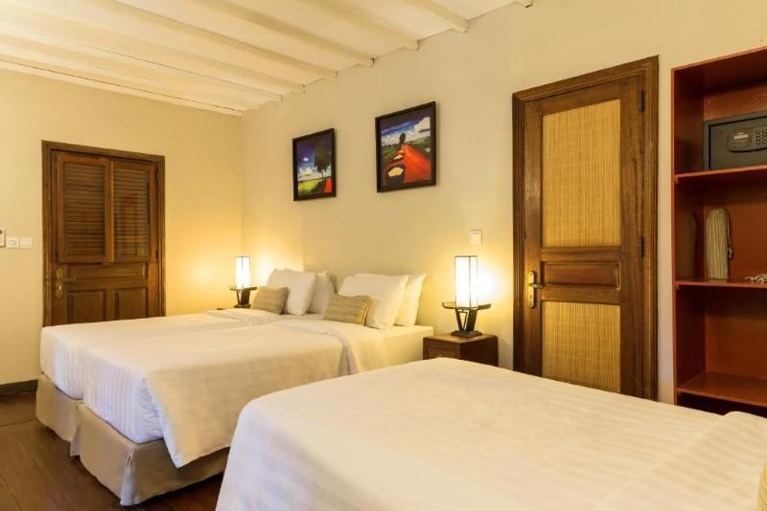
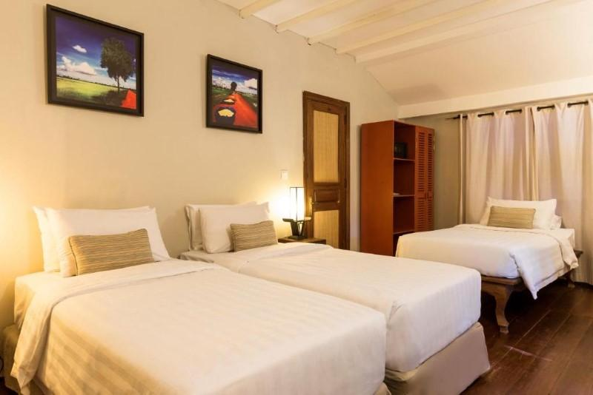
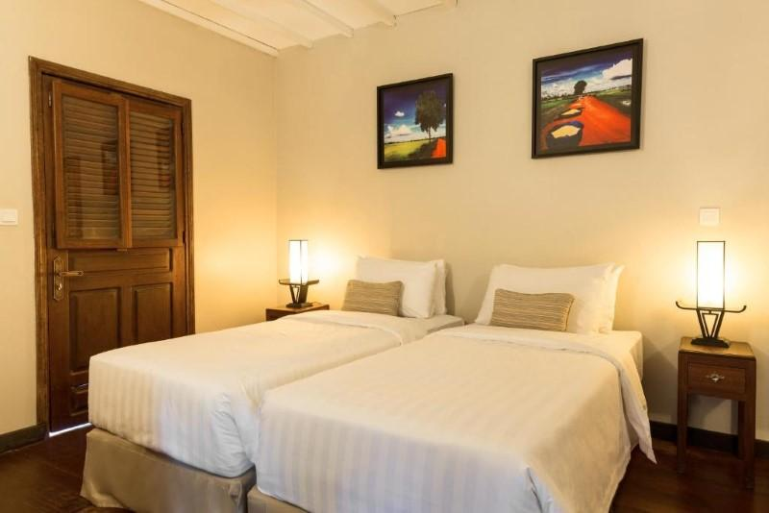
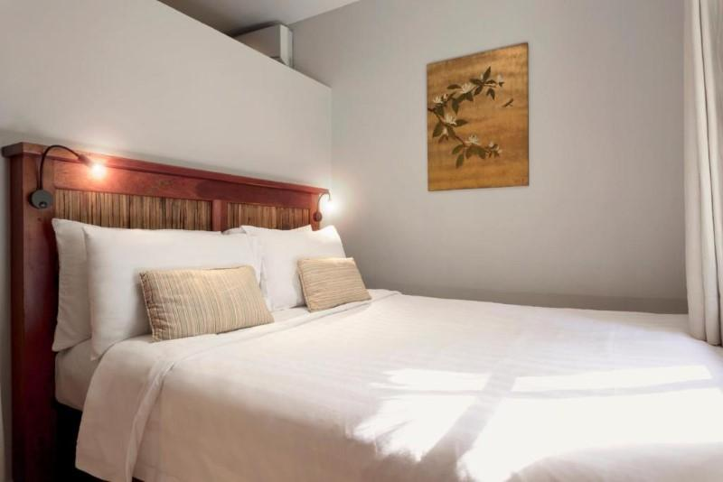
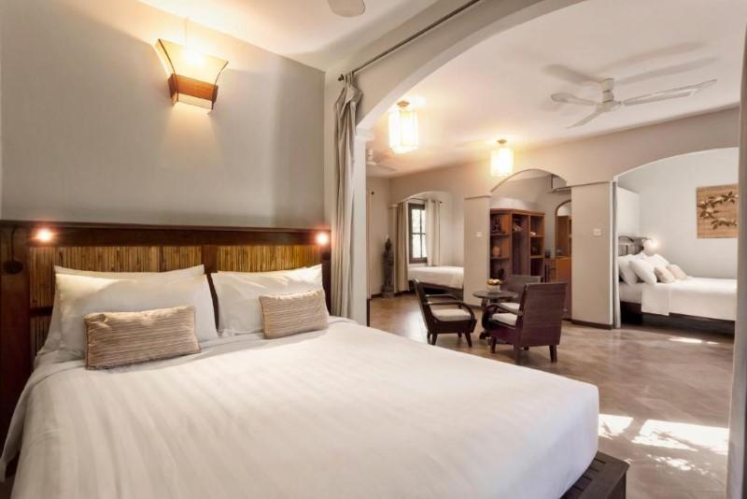
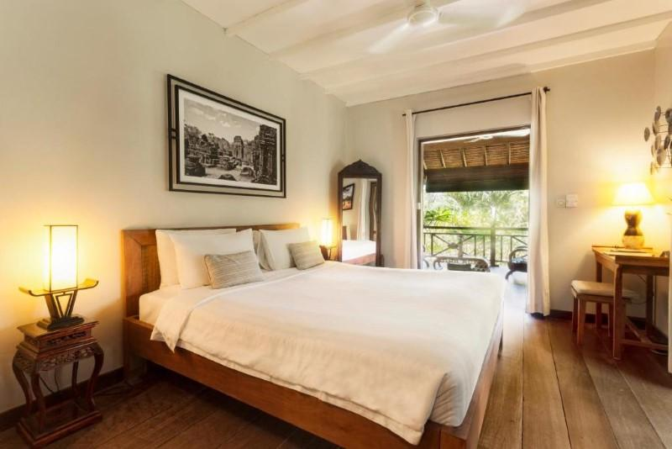
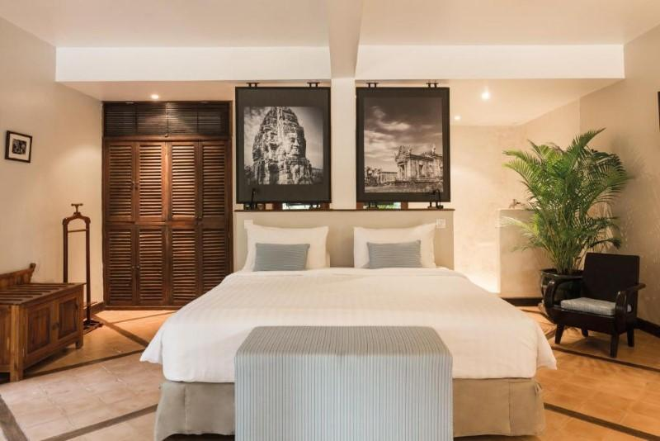
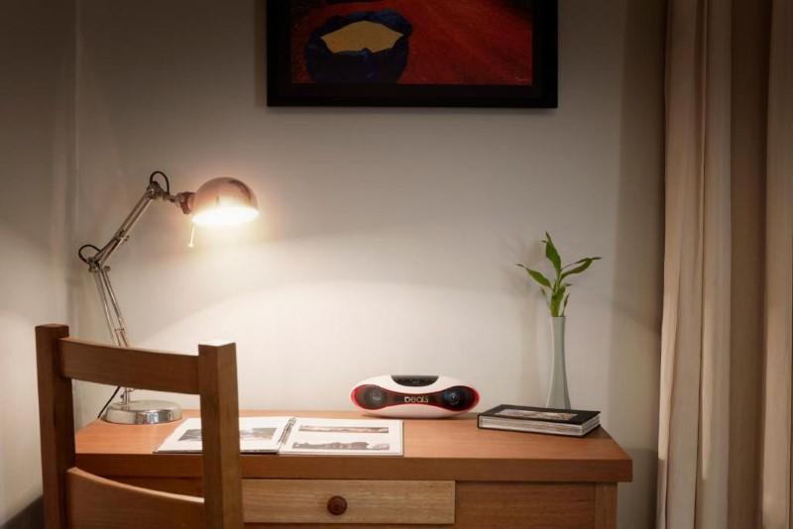
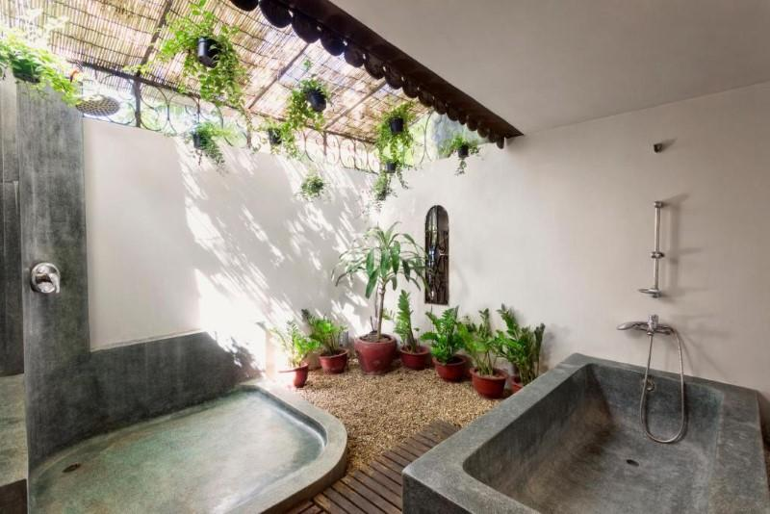
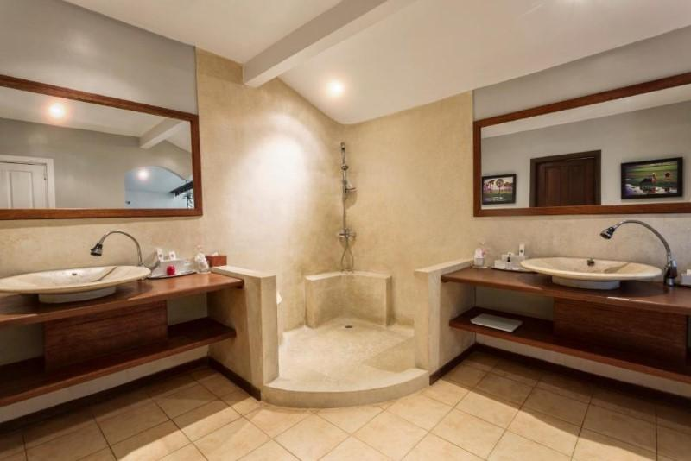
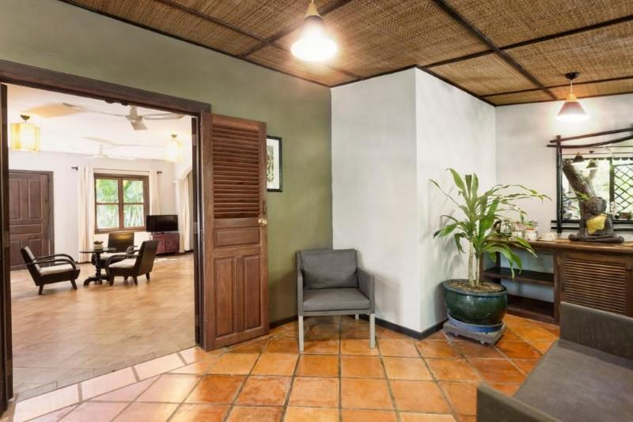
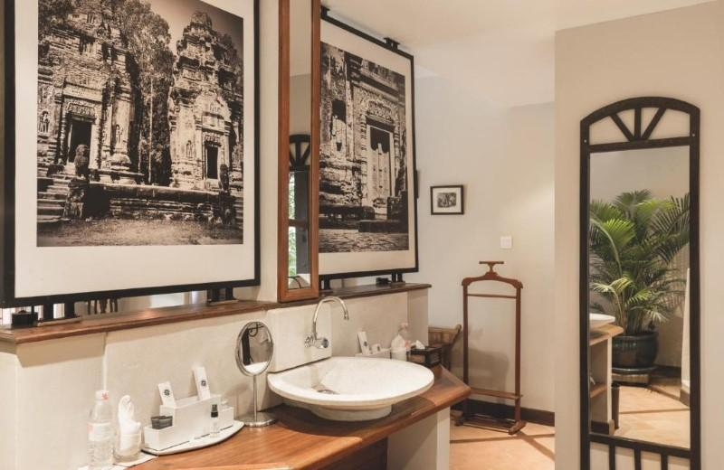
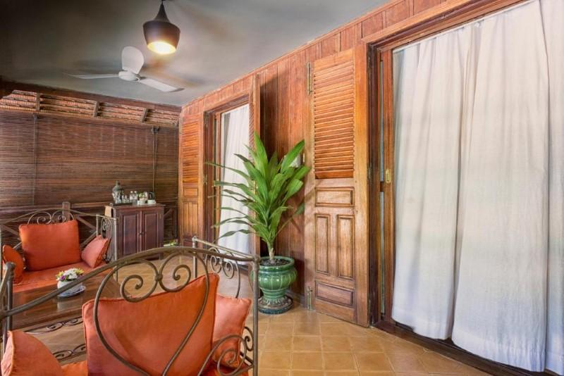

Restaurant photos
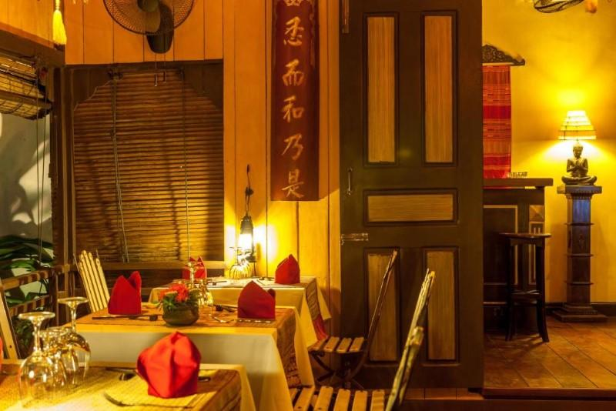
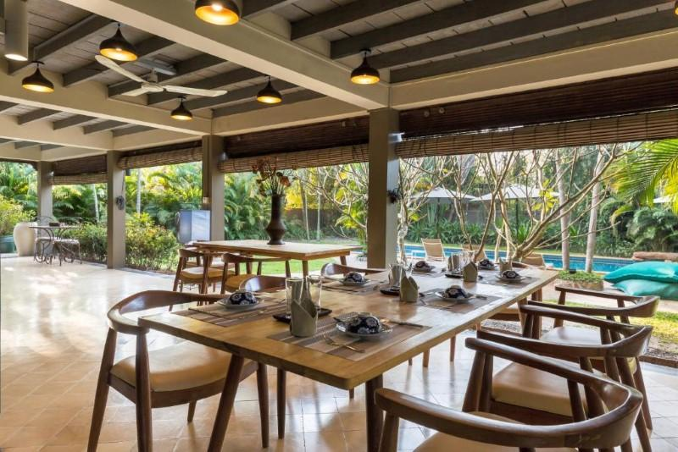
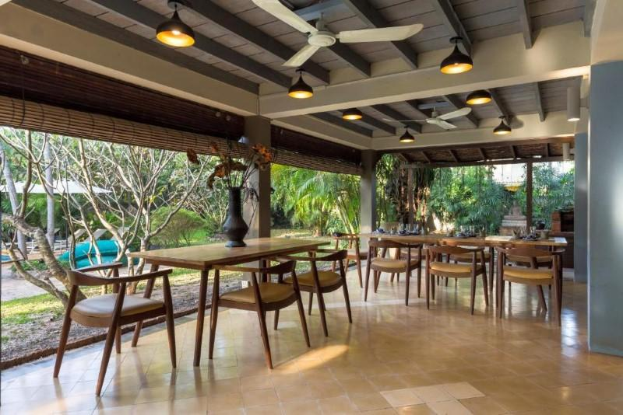
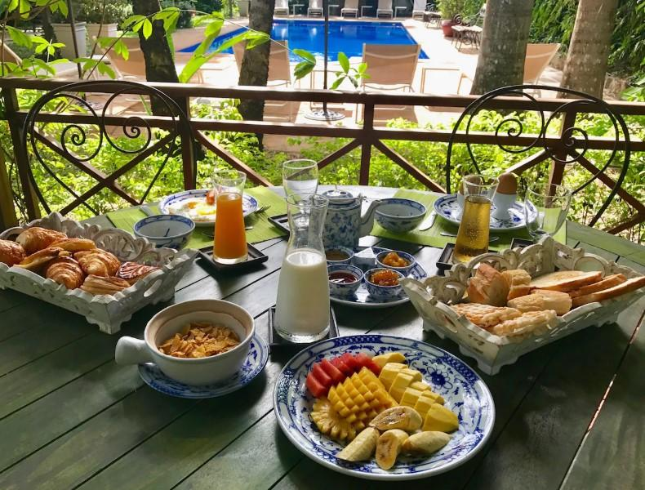
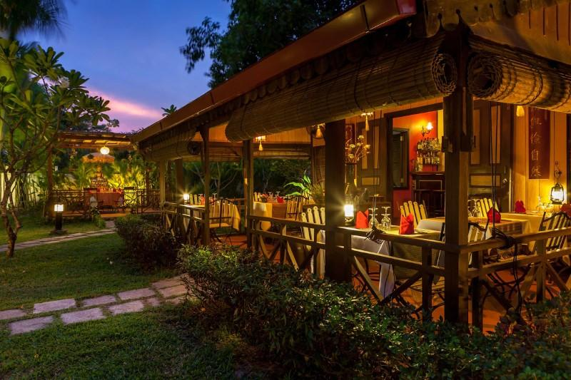

Services & facilities photos
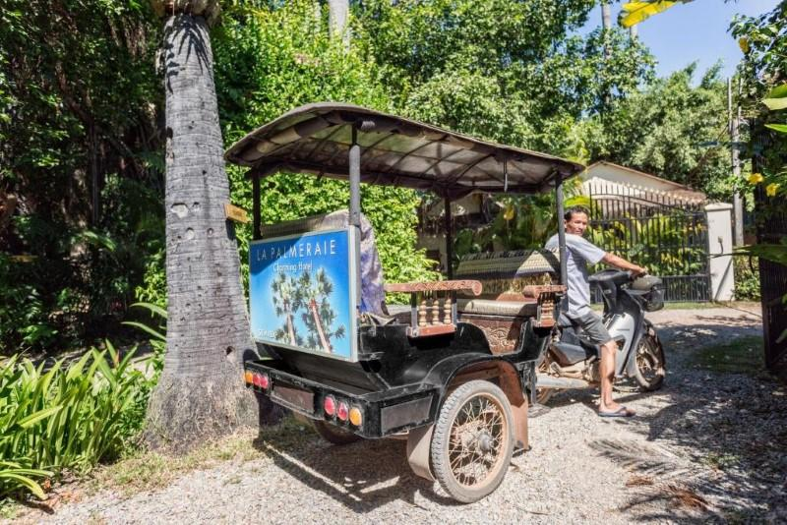
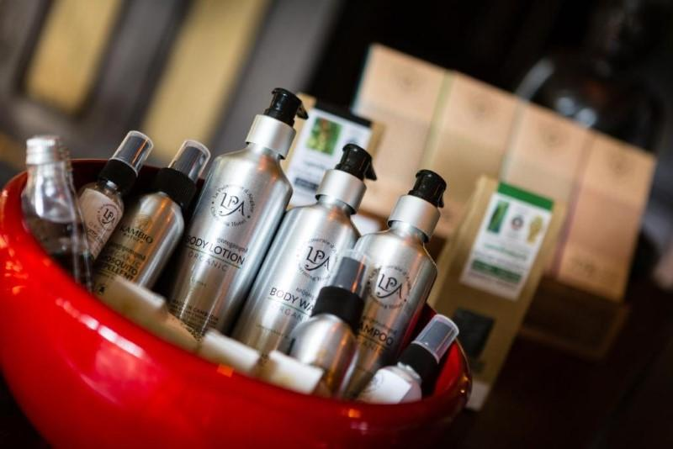
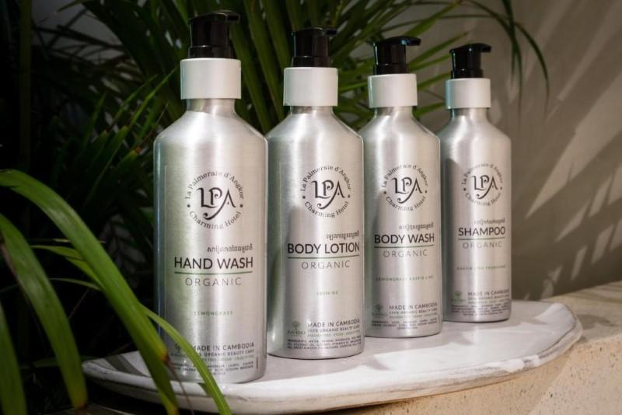
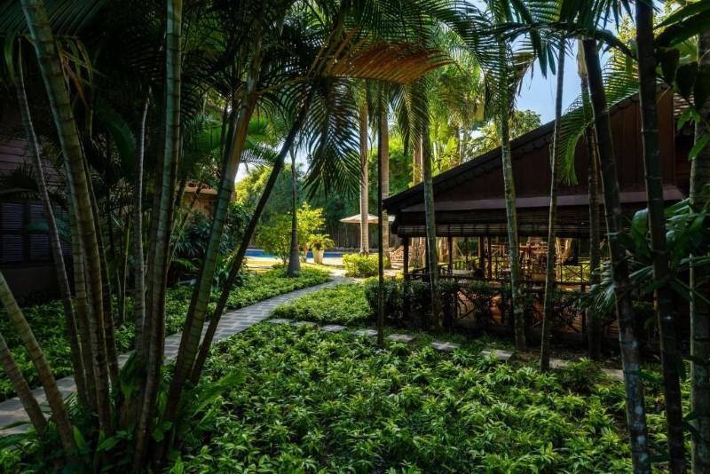
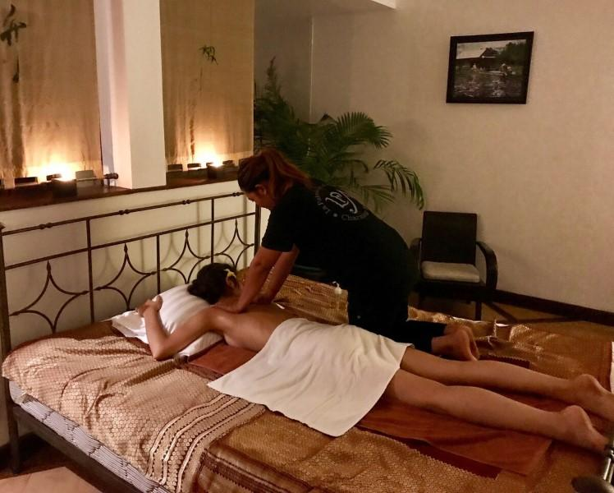
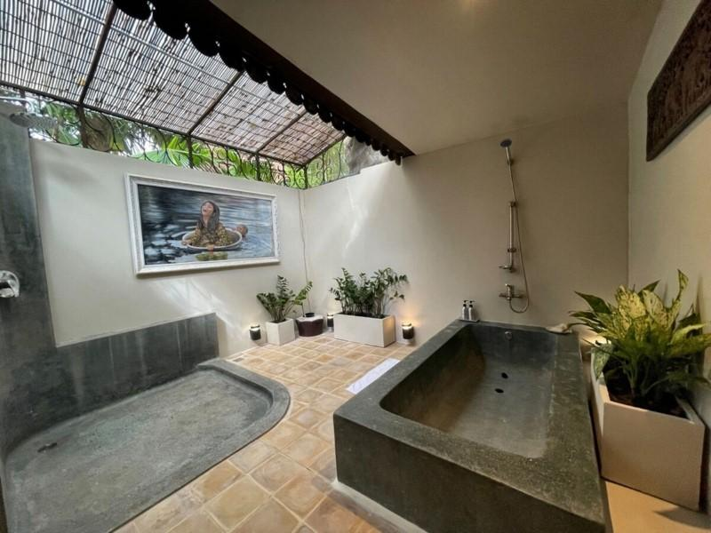
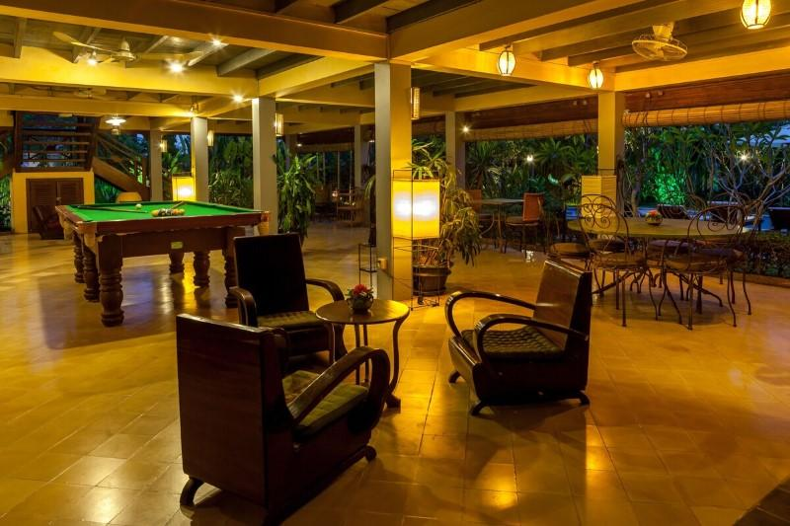
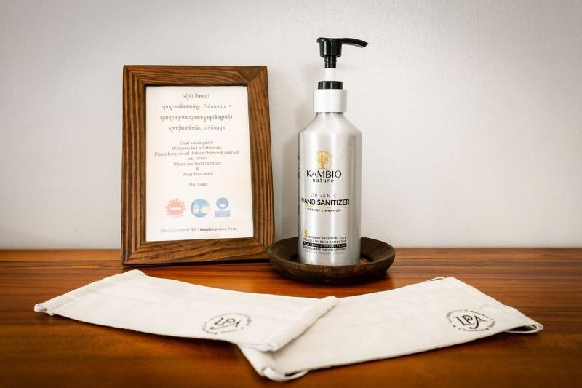
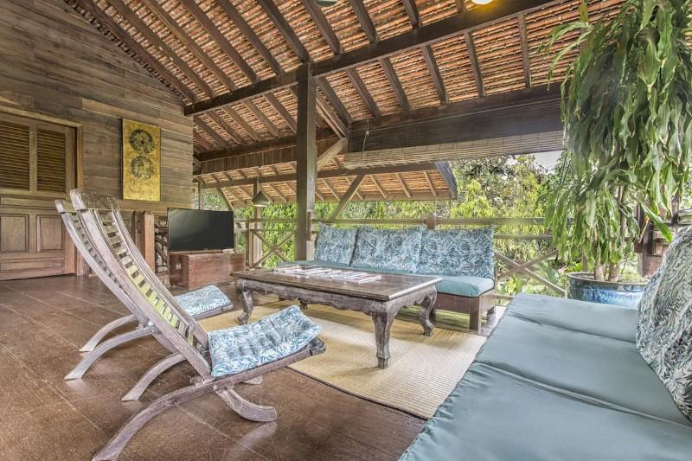

Easia Travel Head Office

