CAMBODIA – Phom Penh – Baitong Hotel & Resort Phnom Penh
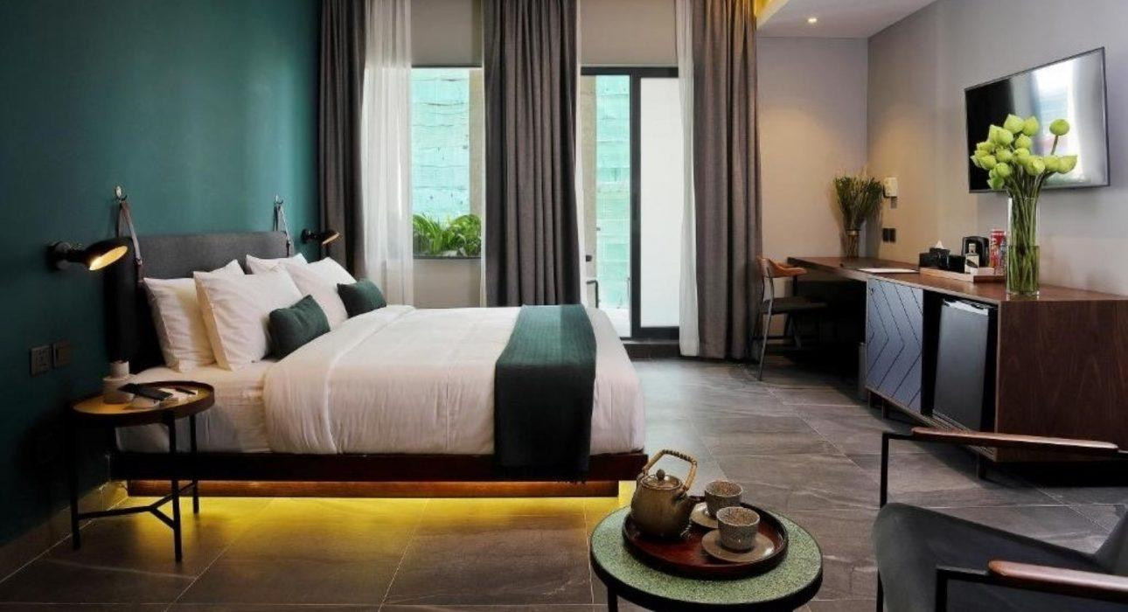

Over View

Theme
Classic, Sustainable

Country - City
Cambodia - Phnom Penh

Official category
4*

Easia category
Superior

Total number of rooms
106

Price level
$$$$

Description

Baitong Hotel & Resort Phnom Penh is located in the heart of Phnom Penh city, the capital city of the Kingdom of Cambodia, and just 1.6 Km from Phnom Penh Royal Palace. The modern-style hotel building with 106 rooms features a restaurant, fitness center, rooftop bar, spa, and two swimming pools surrounded by a green garden.Inspired by Mother Nature and the hanging garden of Babylon with its mythical water pool, this sanctuary will transport travelers to a peaceful environment with modern facilities. The hotel provides 10 room categories with different types and a 24-hour front desk and room service. All room types include a safety – deposit box, hair dryer, minibar, flat-screen TV, wardrobe, shower/ bathtub, and Air-conditioned. Breakfast at Baitong Hotel & Resort Phnom Penh offers American Breakfast buffet style. Free WIFI is provided for guests throughout the property.

Selling points

- Located in the hear of Phnom Penh the capital city of Kingdom of Cambodia
- Hotel modern style with beautiful swimming pool, clean & nice decoration room
- It’s just a 5- minute drive from Phnom Penh Royal Palace
- Very good for group or serie medium and high budget
- A good hotel supplier which easily to work with

Sustainability

Supplier Actions
Protection of Environment, Child Protection

Time & Transportation

From | To | By | Distance | Duration | Road Condition
Hotel | Phnom Penh Royal Palace | Car | 1.6 km | 5 mn | Good
Hotel | Phnom Penh International Airport | Car | 8.6 mk | 20 mn | Good
Hotel | Phnom Penh national Museum | Car | 2 km | 5 mn | Good

Rooms

Easia's recommend room type
Standard RoomStyle: Modern Style
- 29 sqm room size
- Twin or King size bed
- 21 rooms with a Patio view
- Extra bed available
Superior Balcony City ViewStyle: Modern Style
- 30 sqm room size
- Twin or King size bed
- 25 rooms with a City view
- Extra bed available
Deluxe Balcony City ViewStyle: Modern Style
- 38 sqm room size
- King size bed
- 10 rooms with a City view
- Extra bed available
Superior Balcony Pool ViewStyle: Modern Style
- 29 sqm room size
- King size bed
- 18 rooms with a Forest Pool view
- Extra bed available
Deluxe Balcony Pool ViewStyle: Modern Style
- 38 sqm room size
- King size bed
- 14 rooms with a Forest Pool view
- Extra bed available
Superior Garden TerraceStyle: Modern Style
- 29 sqm room size
- King size bed
- 5 rooms with a Private Garden Terrace
- Extra bed available
Deluxe Garden TerraceStyle: Modern Style
- 33 sqm room size
- King size bed
- 4 rooms with a Private Garden Terrace
- Extra bed available
Deluxe JacuzziStyle: Modern Style
- 29 sqm room size
- King size bed
- 6 rooms with a Private Jacuzzi
- Extra bed available
Suite JacuzziStyle: Modern Style
- 42 sqm room size
- King size bed
- 1 room with Private Jacuzzi
- Extra bed available
Suite RoomStyle: Modern Style
- 50 sqm room size
- King size bed with 200 x 200
- 2 rooms with Balcony Pool View
- Extra bed available

Room configuration

Connecting rooms
No

Extra bed
Yes

King bed
Yes

Queen bed
No

Twin beds
Yes

Services & Facilities

Services
24 hour reception, 24h security service, Airport Shuttle, Airport transfer, Babysitting, Buffet Breakfast, Children Swimming Pool, Complimentary bottle of water, Complimentary fresh towel, Concierge service, Credit Card payment, Dry Cleaning, Iron, Laundry service, Luggage Storage, Massage, Mobile phone, Room Service, Spa, Swimming Pool, Wi-fi Free

Facilities
Air Conditioning, Bar, Children Pool, coffee and tea making facilities, Conference hall, Elevator, Fan, Fitness centre, Flat screen TV, Free private parking, Garden, Hair Dryer, In-Room safe, Internet, Jacuzzi, Massage room, Meeting room, Mini Bar, Outdoor swimming pool, Restaurant, Safety Box, satellite LCD TV, Shower With Hot Water, Terrace, Umbrella

Business facilities details
Meeting
- Conference room : up to 60 guests
- Meeting room : up to 12 guests
- VIP room : up to 12 guests
Celebrate/ Event
- Kuang seafood Restaurant : up to 150 guests
- Lantern Rooftop Bar : up to 150 guests
- Deck Pool : up to 50 guests

Restaurant information

BreakfastBuffet breakfast with Western and Asian cuisine
- Open daily 6:00 AM – 10:30 AM
Lantern Rooftop BarExplore a selection of craft cocktails, wines, and spirits and nibble on small bites. Take in a gorgeous sunset in a romantic dimly lit atmosphere, whiles listening to music by local and international DJs & Live Bands. Bookings are essential on weekends and special events nights.
- Open daily 5:30 PM – 11:00 PM
Kuang Seafood RestaurantA famous seafood restaurant in Japan, Korea, China, Taiwan, and now in Cambodia. The fresh is prepared by BBQ or grilling and then perfectly paired with the renowned ” Seafood sauce recipe “. This sauce was created by Mr. Kuang using the finest ad freshest ingredients, and has been passed down from generation to generation.Open daily
- 11:00 AM – 2:00 PM
- 5:00 PM – 10:00 PM
Cafe Kayser
- Open daily 7:00 AM – 7:00 PM
Room ServiceLast food order is 9:45 PM
- Open daily 11:00 AM – 10:00 PM
Forest Pool & Jacuzzi
- Open daily 8:00 AM – 10:00 Pm
Deck Pool
- Open daily 6:00 AM – 5:00 PM
Baitong Spa by BODIA
- Open daily 10:00 AM – 10:00 PM
Gym
- Open daily 6:00 AM – 10:00 PM

Photos

Hotel Photos
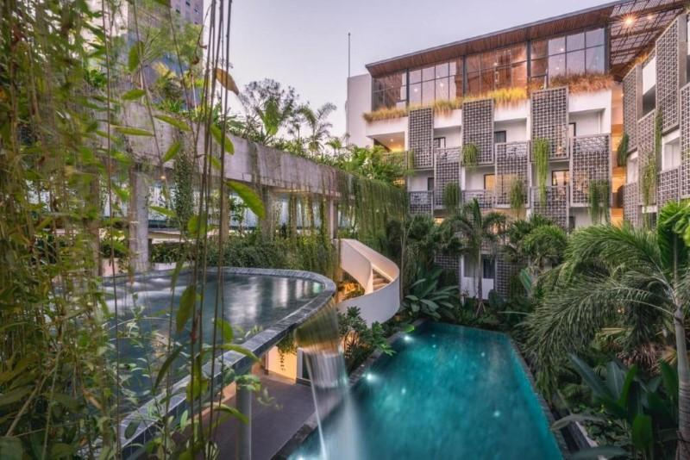
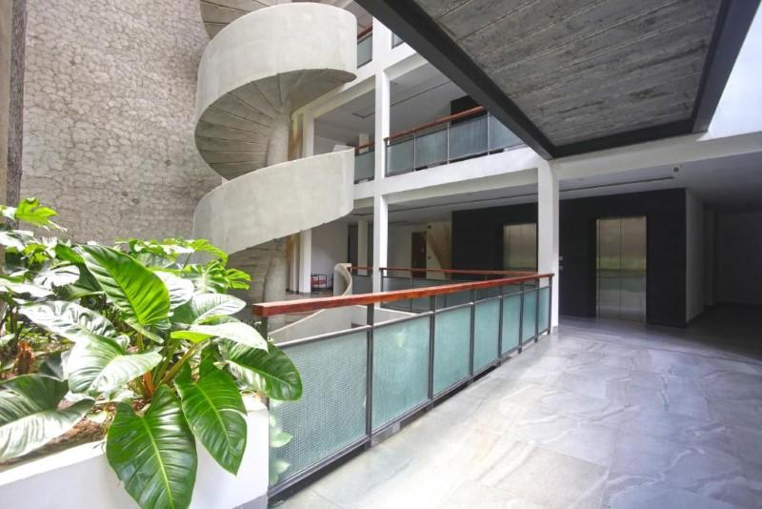
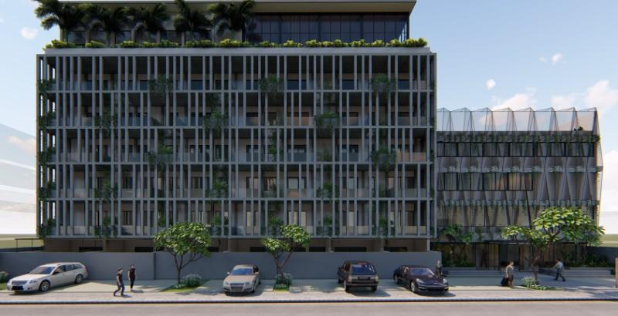

Rooms photos
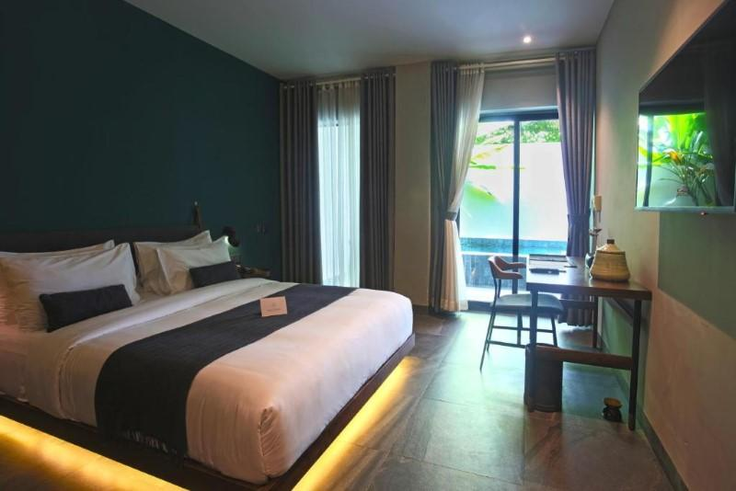
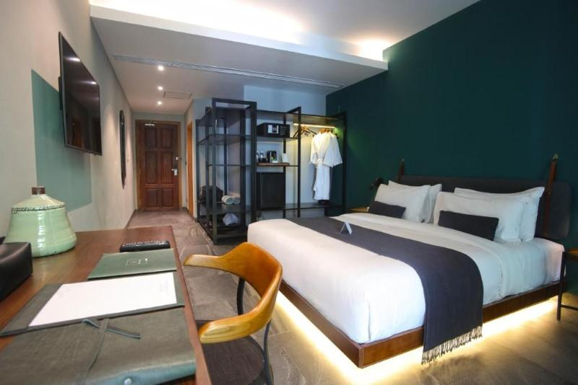
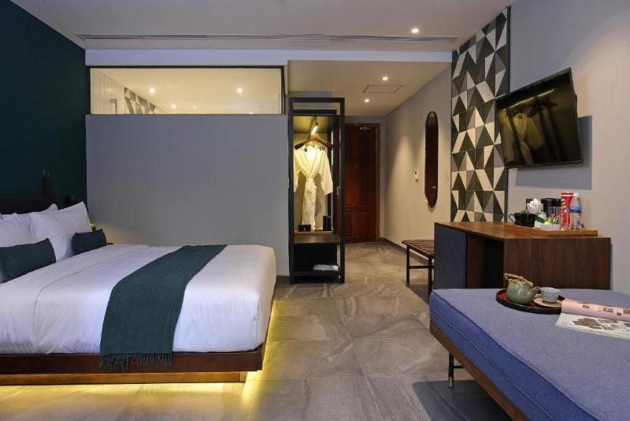
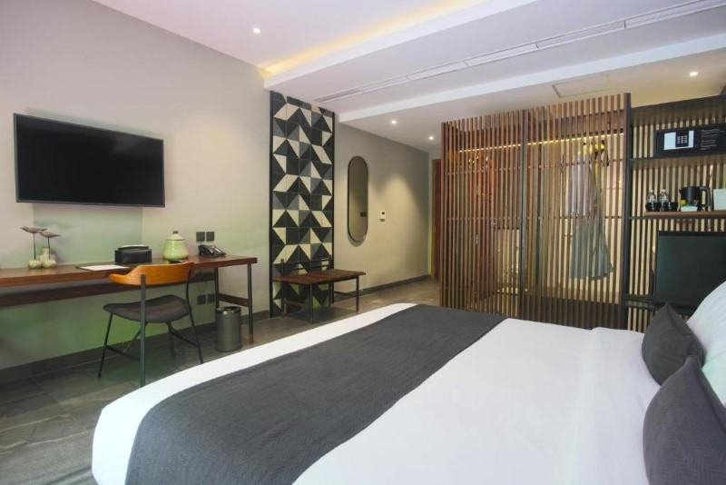
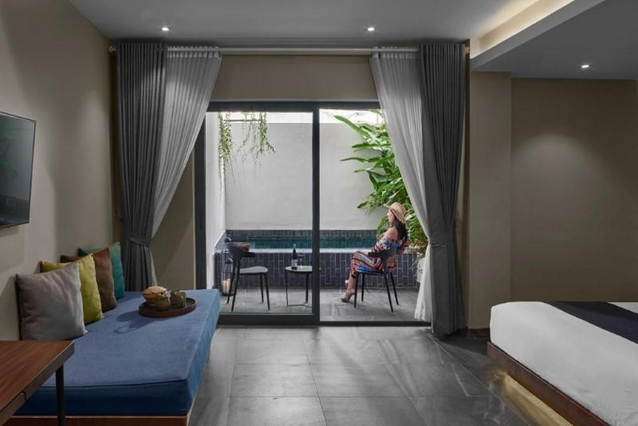
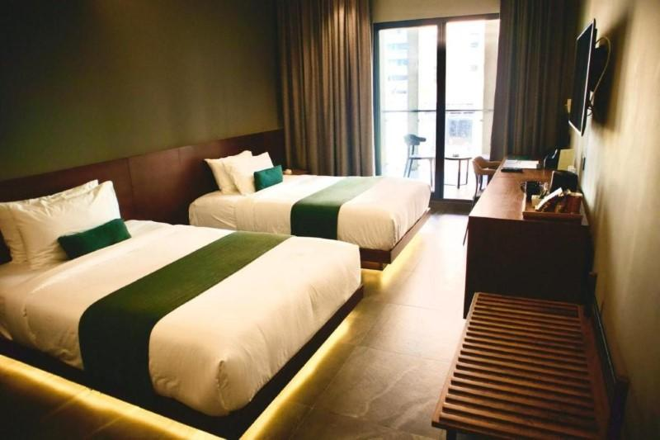
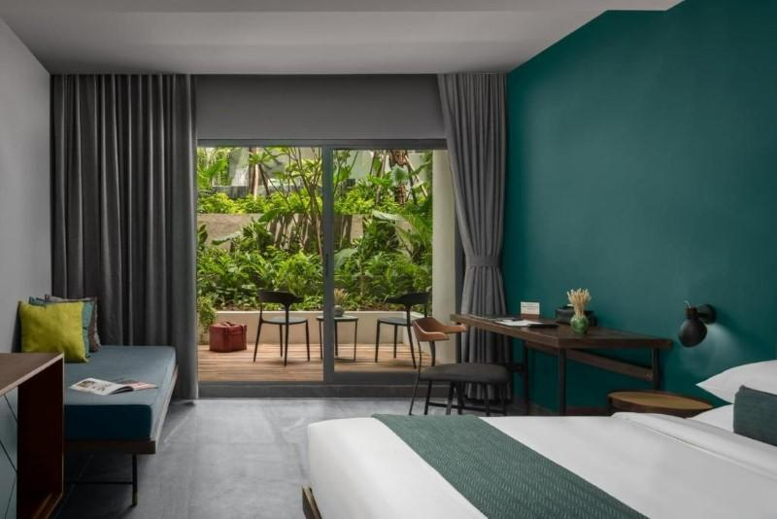
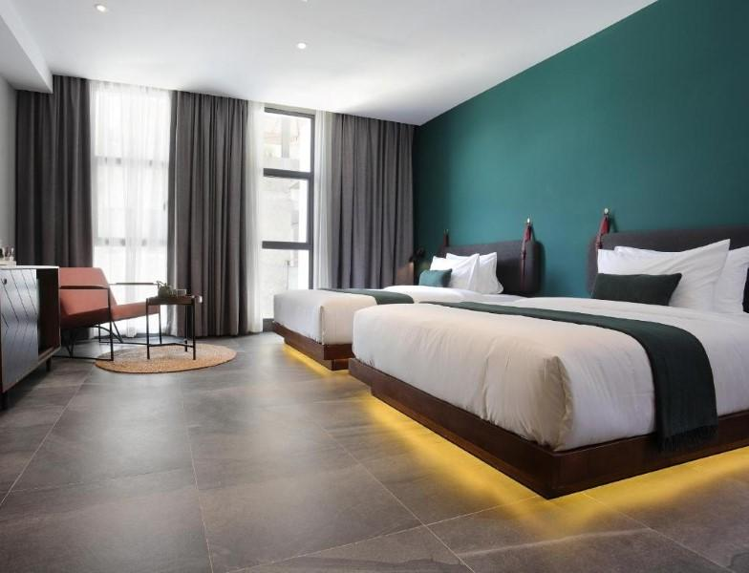
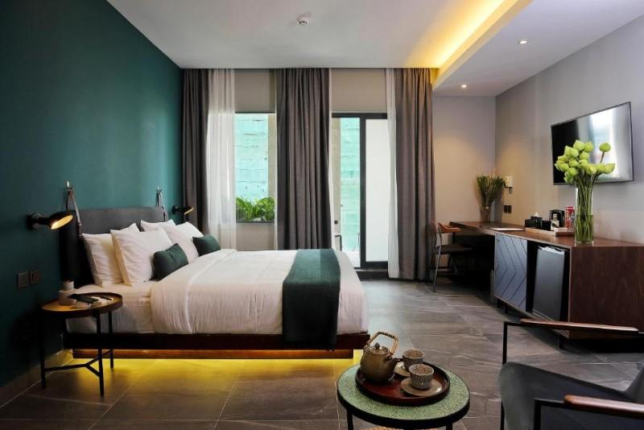
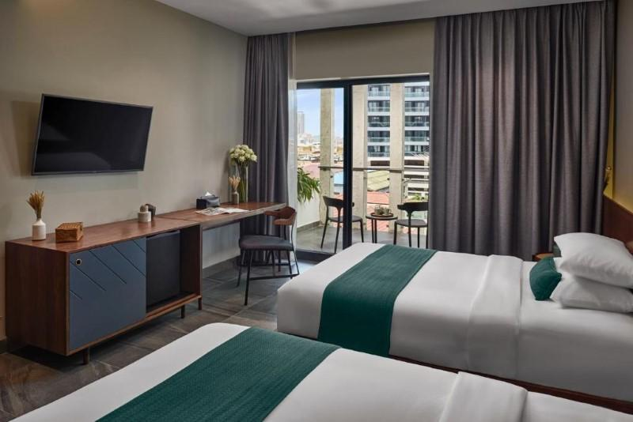
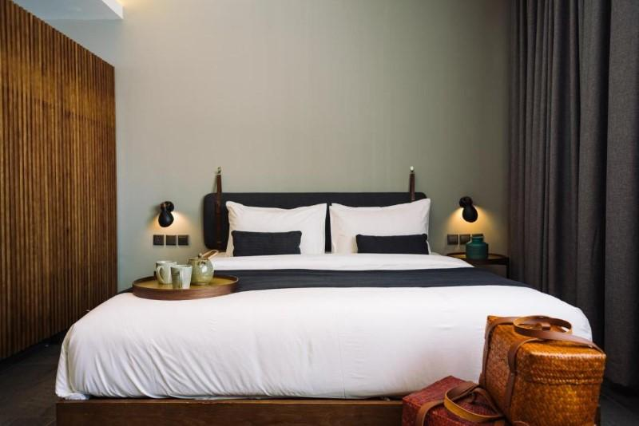
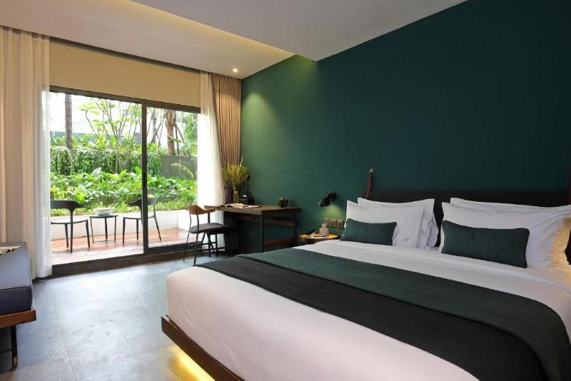
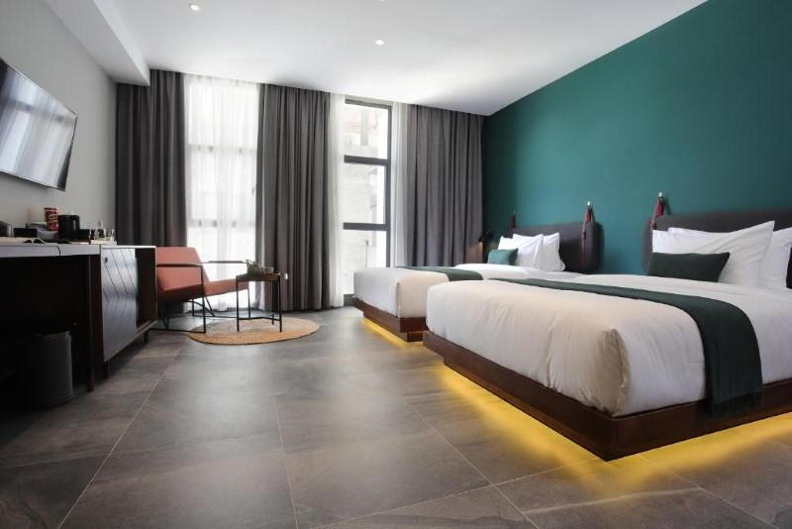
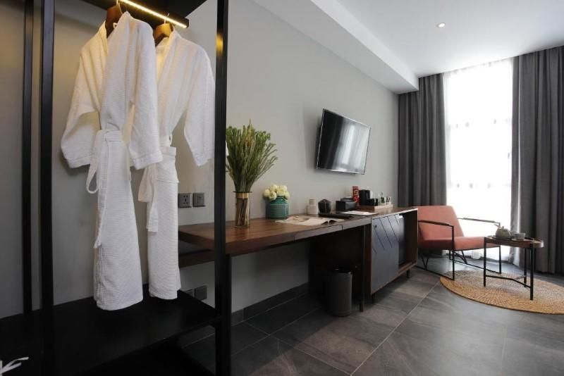

Restaurant photos
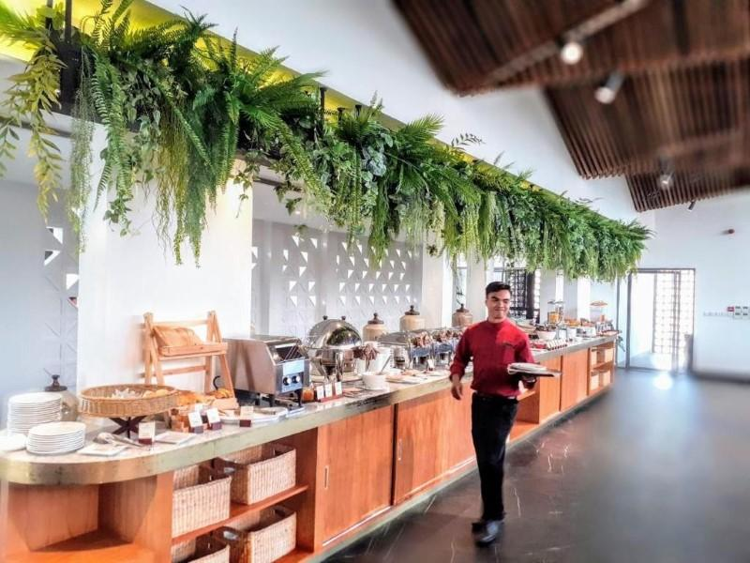
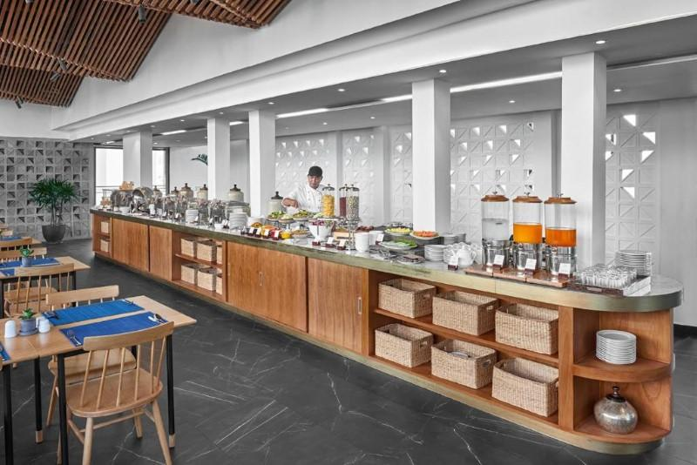
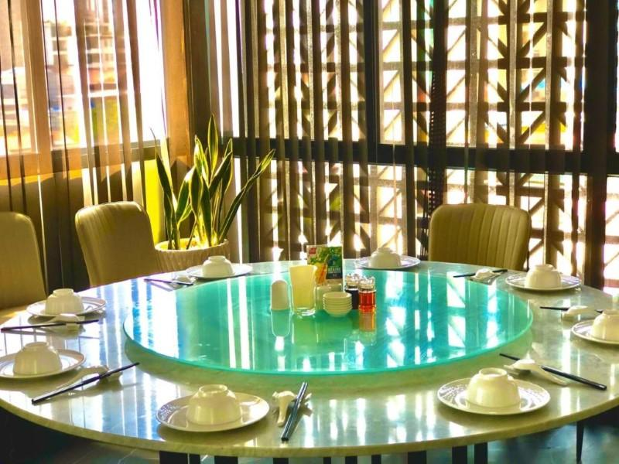
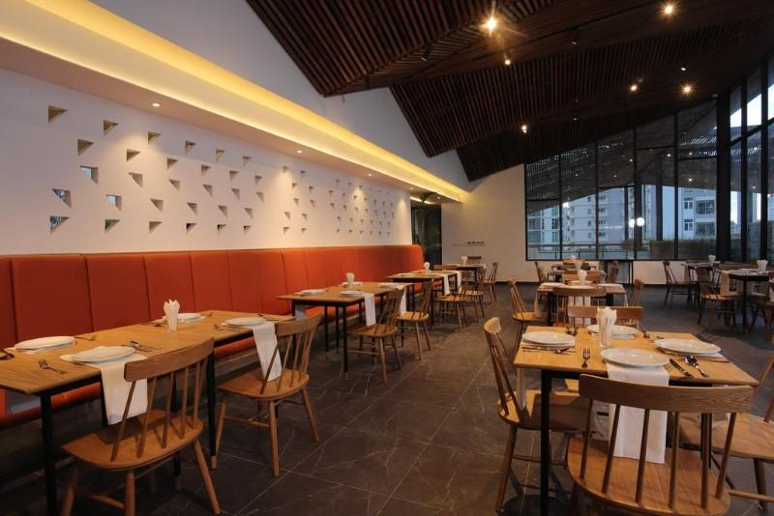
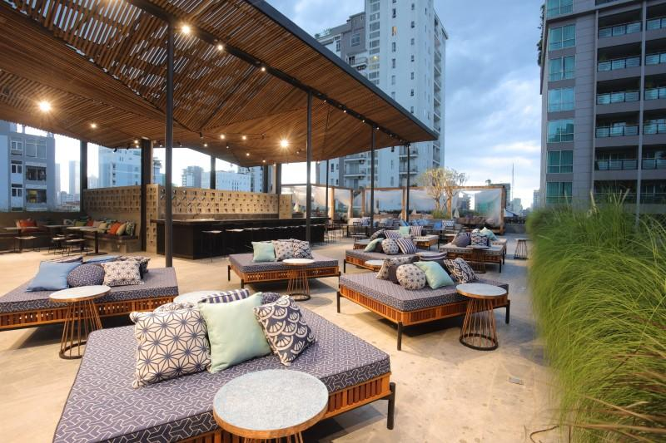
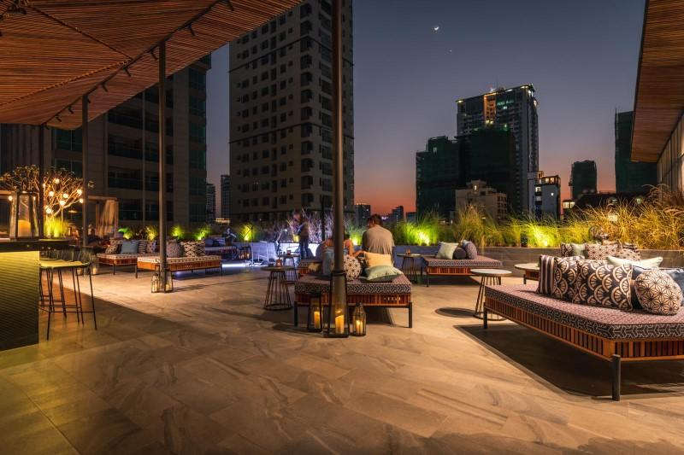
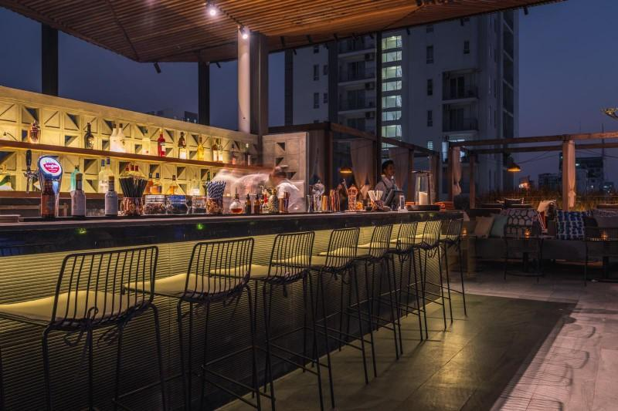

Business facilities photos
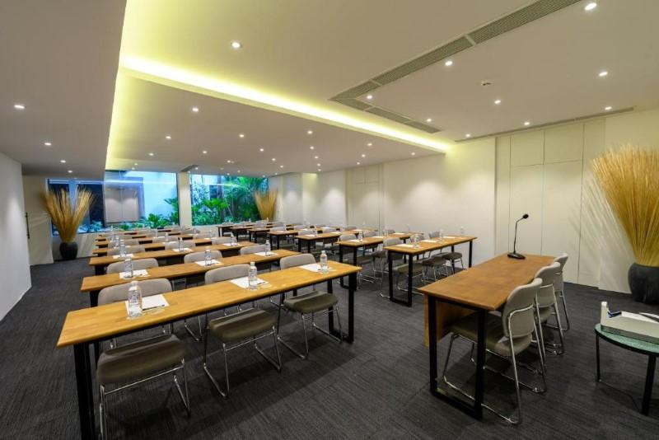
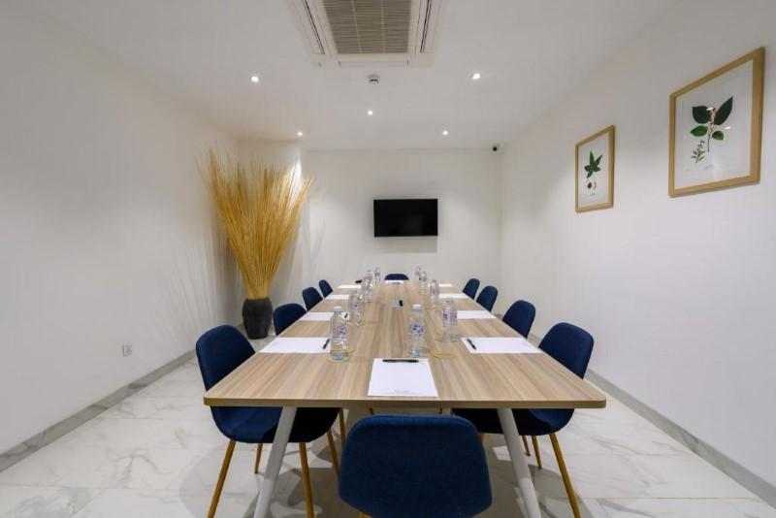
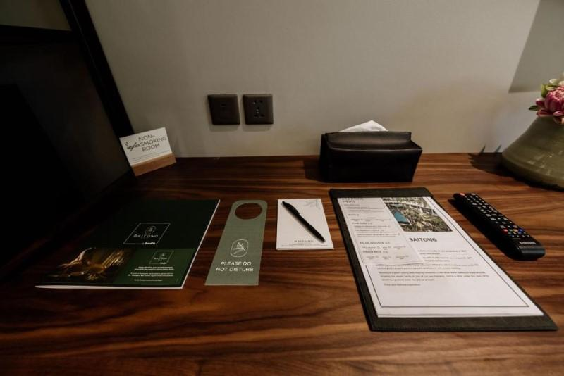

Services & facilities photos
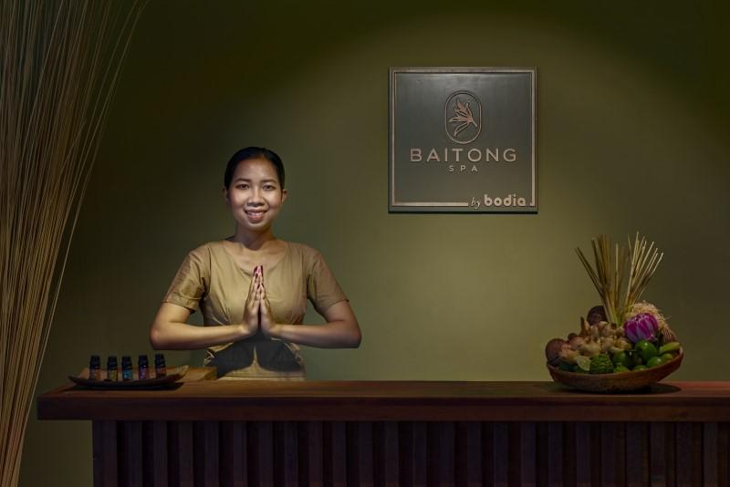
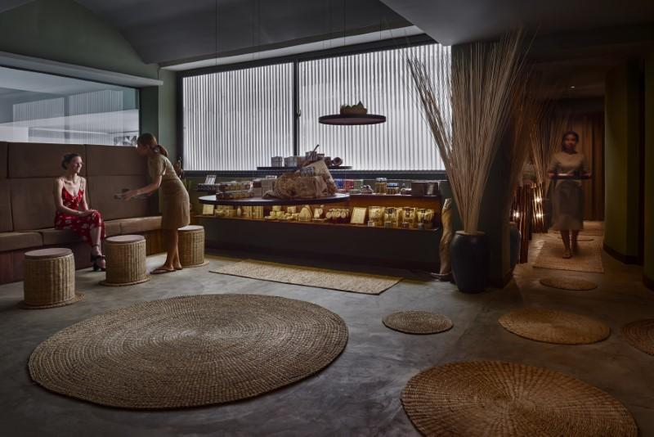
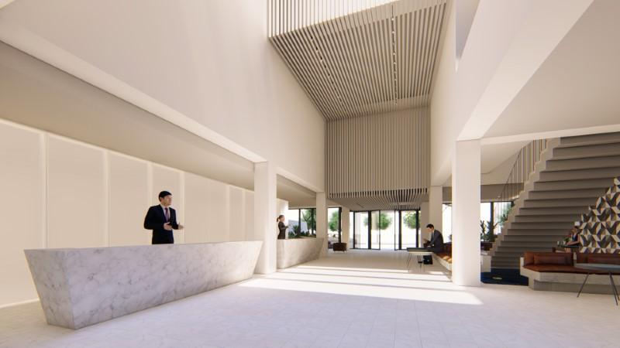
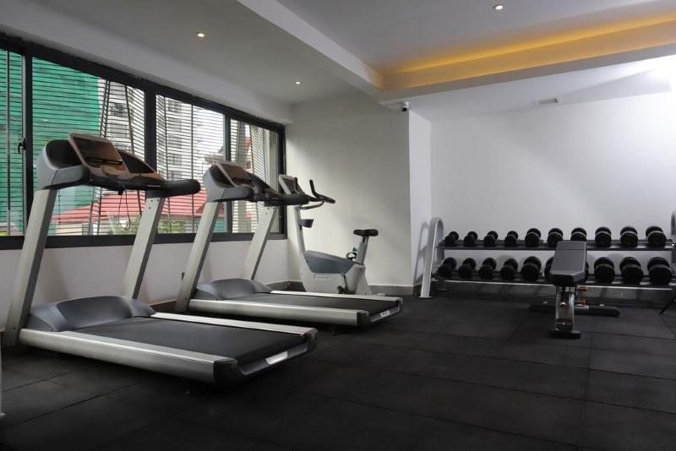
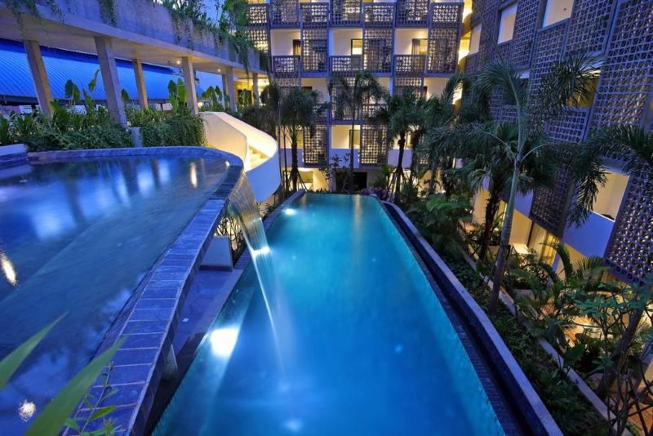
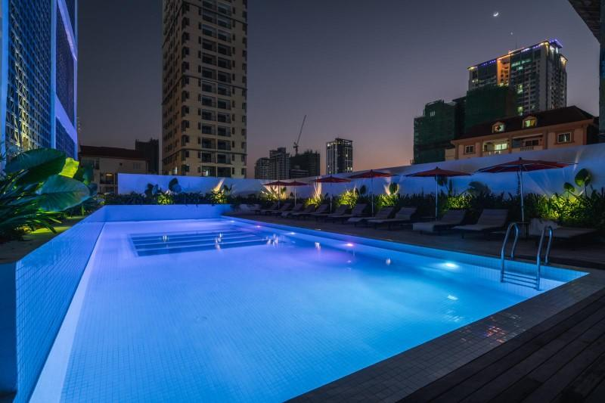
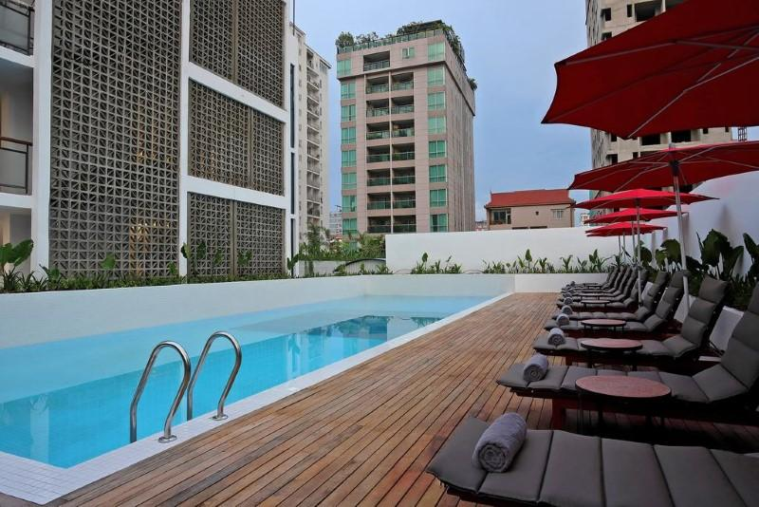
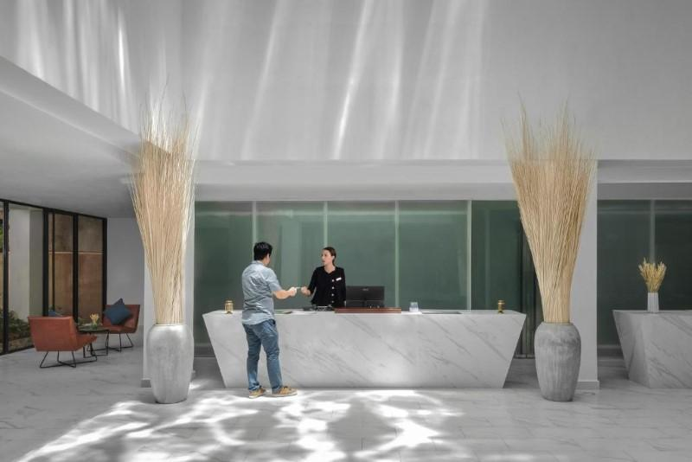

Easia Travel Head Office

