CAMBODIA – Phnom Penh – iRoHa Garden Hotel & Resort
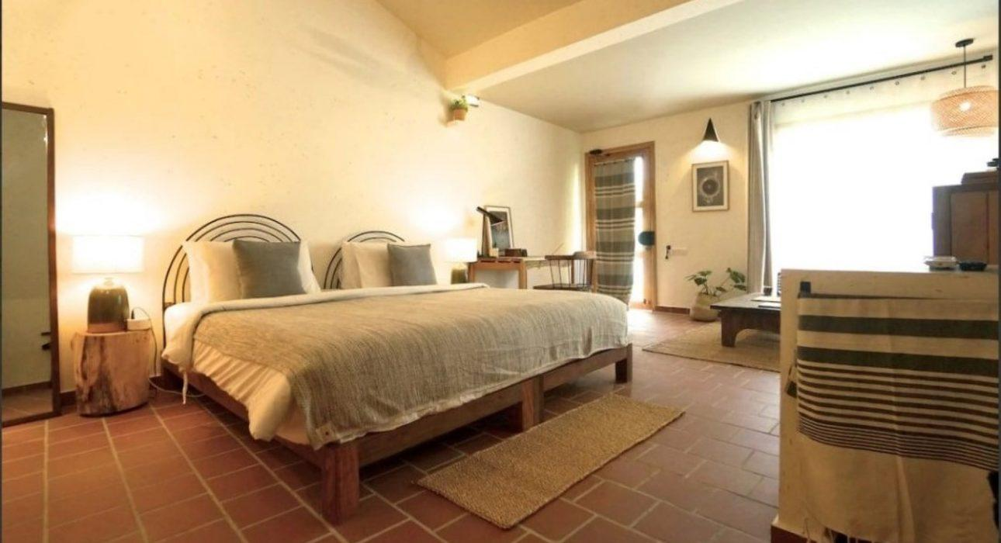

Over View

Theme
Classic, Family, Honeymoon

Country - City
Cambodia - Phnom Penh

Market segment
Groups, Thematic Leisure

Official category
4*

Easia category
First Class

Total number of rooms
66

Price level
$$$$

Description

Located in Khan Chamkar Mon, iRoHa Garden Hotel & Resort is just a 5- or 20-minute drive from the city center of Phnom Penh, the capital city of Cambodia. The hotel has a nice clean outdoor swimming pool set in a tropical garden and friendly service.This hotel features a full-service Spa, an outdoor swimming pool, and a restaurant. Breakfast is complimentary, free WIFI is provided throughout the property, and complimentary self-parking. Iroha Hotel & Resort offers air-conditioned accommodation with minibars and safes. Refrigerators, tea/coffee makers, bathrobes, slippers, and hairdryers are offered. Complimentary wireless Internet access, 32 – inch television comes with cable channel, and the additional room includes complimentary bottled water. Guests can also enjoy service at the Spa, with various treatment therapies.

Selling points

- Spacious room with comfortable balcony
- Very nice design and clean room
- Offers ample facilities and friendly service
- Beautiful outdoor swimming pool set in a tropical garden

Sustainability

Supplier Actions
Protection of Environment, Child Protection

Time & Transportation

From | To | By | Distance | Duration | Road Condition
iRoHa Garden | Wat Phnom | Car | 5.1 km | 20 mn | Good
iRoHa Garden | National Museum of Phnom Penh | Car | 4 km | 15 mn | Good
iRoHa Garden | Phnom Penh International Airport | Car | 12 km | 40 mn | Good
iRoHa Garden | Tuol Sleng Genocide Museum | Car | 1.5 km | 7 mn | Good

Rooms

Easia's recommend room type
Comfort Room Balcony Double Pool ViewStyle : Modern style
- 323 sq ft size
- 1 King size bed
- 5 units
- Not available for extra bed
Deluxe Balcony Double Pool FrontStyle : Modern style
- 376 sq ft size
- 1 king size bed
- 2 units
- Extra bed available
Deluxe Balcony Twin Pool FrontStyle : Modern style
- 376 sq ft size
- 1 king size bed
- 2 units
- Extra bed available
iRoHa Suite DoubleStyle : Modern style
- 646 sq ft size
- 1 king size bed
- 1 unit
- Extra bed available
Villa Theato DoubleStyle : Modern style
- 376 sq ft size
- 1 King size bed
- 3 units
- Not available for extra bed
Villa Theato TwinStyle : Modern style
- 376 sq ft size
- 2 twin beds size
- 3 units
- Not available for extra bed
Villa Theato Private Terrace DoubleStyle : Modern style
- 484 sq ft size
- 1 King size bed
- 1 unit
- Not available for extra bed
Villa Theato Private Terrace TwinStyle : Modern style
- 484 sq ft size
- 2 Twin beds size
- 1 unit
- Not available for extra bed

Room configuration

Connecting rooms
No

Extra bed
Yes (1m x 2m)

King bed
Yes (1.8m x 2m)

Queen bed
No

Twin beds
Yes (1.2m x 2m)

Services & Facilities

Services
24 hour reception, 24h security service, Babysitting, Children Swimming Pool, Complimentary bottle of water, Complimentary fresh towel, Credit Card payment, Dry Cleaning, Iron, Laundry service, Luggage Storage, Massage, Mobile phone, Room Service, Spa, Swimming Pool, Wake-up service, Wi-fi Free, Yoga Retreat

Facilities
Air Conditioning, Bar, Children Pool, coffee and tea making facilities, Family Room, Fan, Flat screen TV, Free private parking, Garden, Gift Shop, Hair Dryer, In-Room safe, Massage room, Mini Bar, Newspapers and magazine, Outdoor swimming pool, Restaurant, Safety Box, satellite LCD TV, Shower With Hot Water, Terrace, Umbrella

Disabled Facilities
Rooms are adapted

Business facilities details
- Swimming Pool
Open daily from 7:00 AM until 10:00 PM
- Spa
Open daily 10:00 AM until 10:00 PM (last booking 8:30 PM)
- Business Center
Open daily 24 hours (2 computers)
- Parking
24 hours

Restaurant information

- Breakfast/ Lunch/ Dinner
Operating hour from 6:30 AM until 10:00 PM
- Bar
Operating hour from 6:30 AM until 11:00 PM

Photos

Hotel Photos
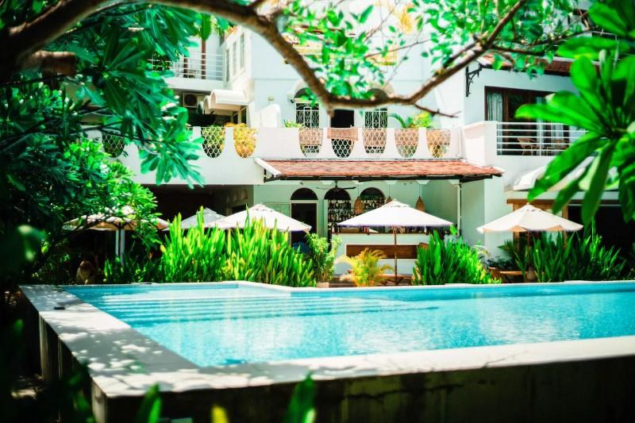
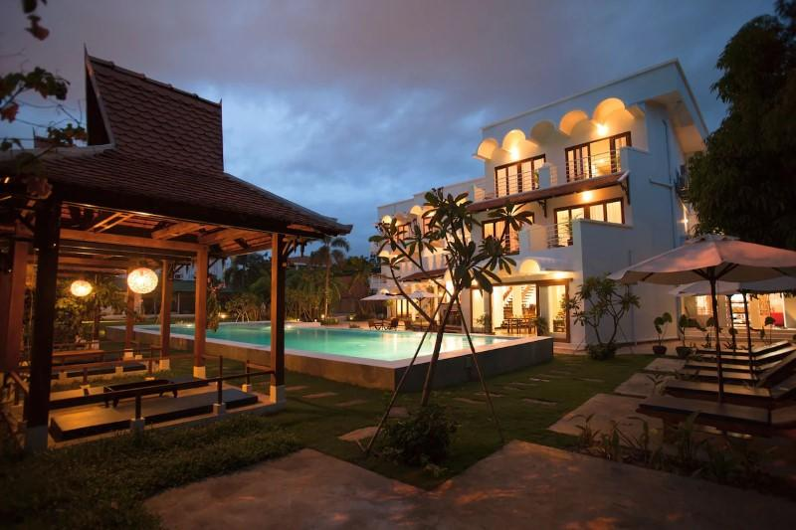
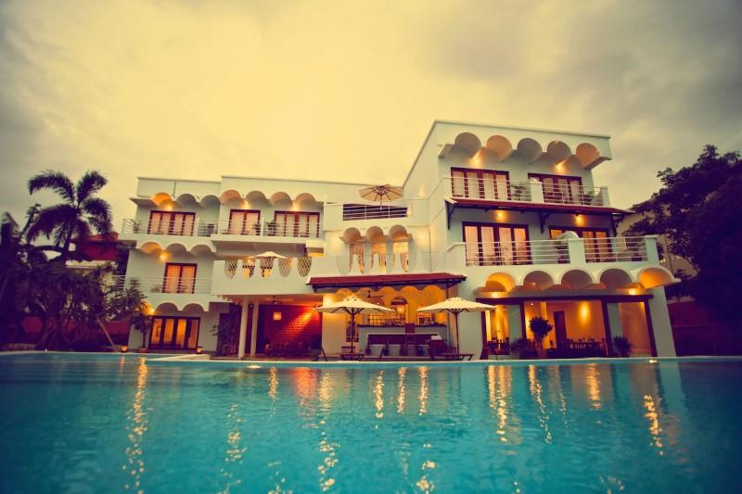
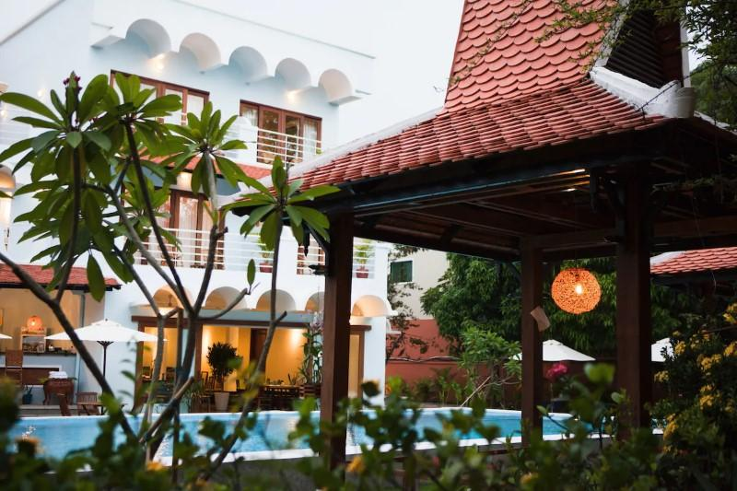

Rooms photos
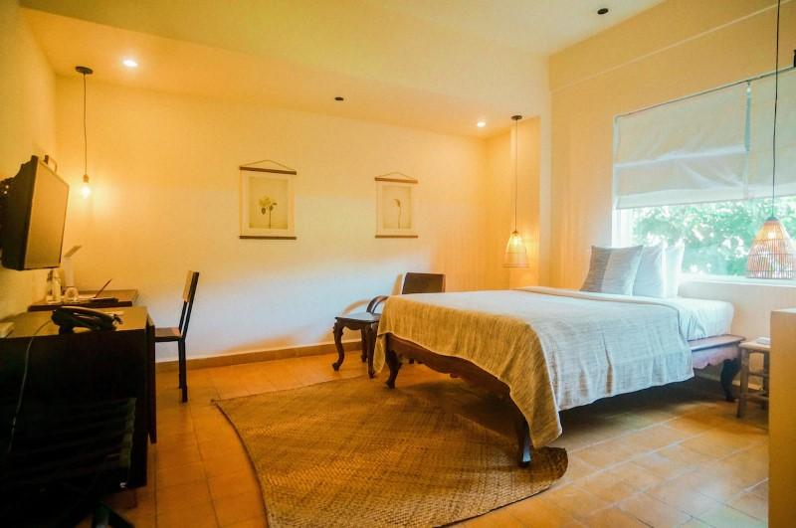
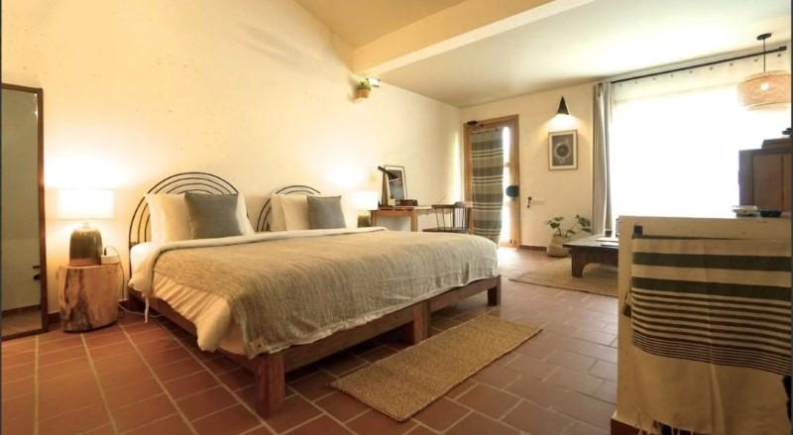
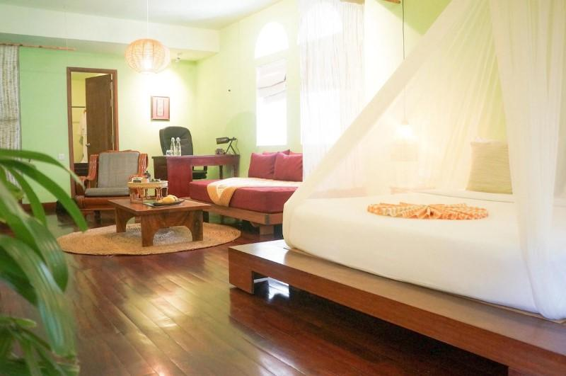
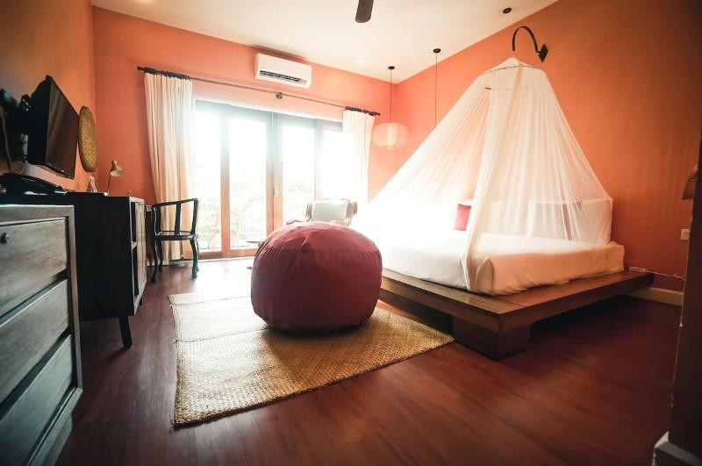
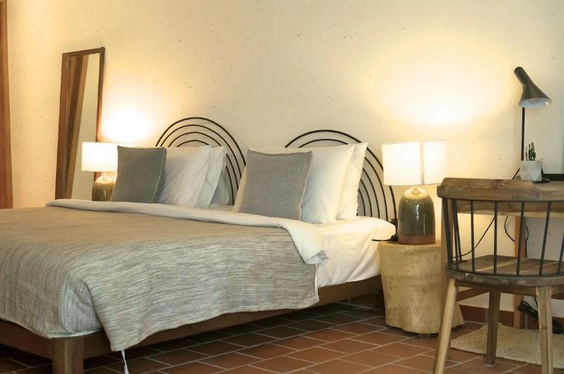
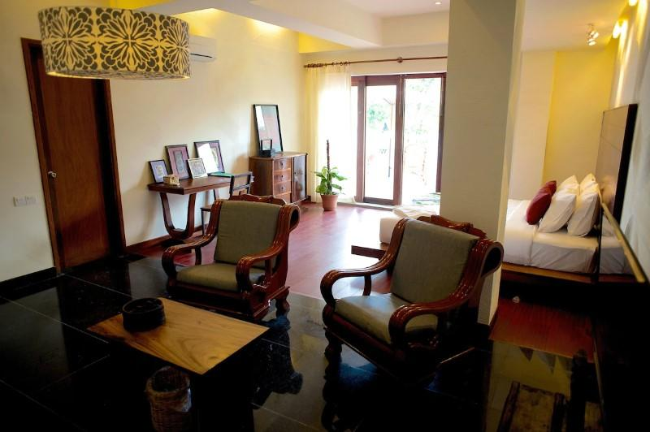
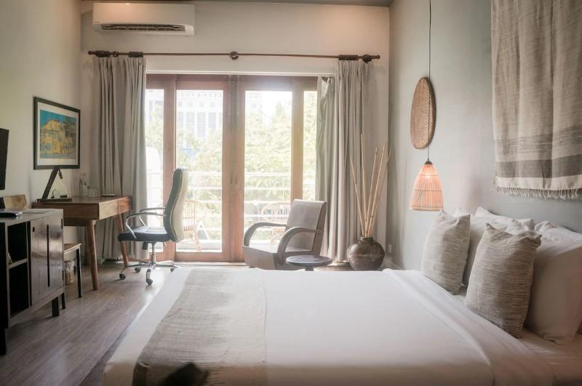
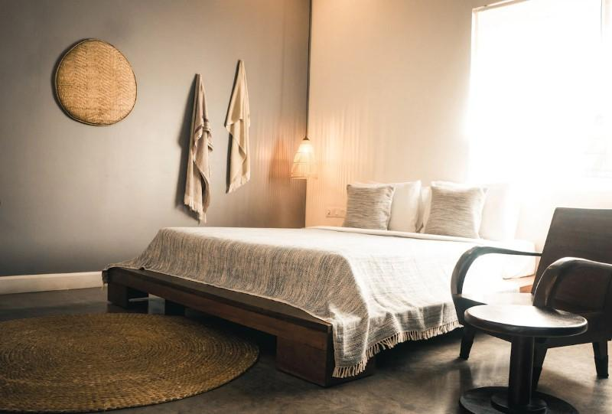
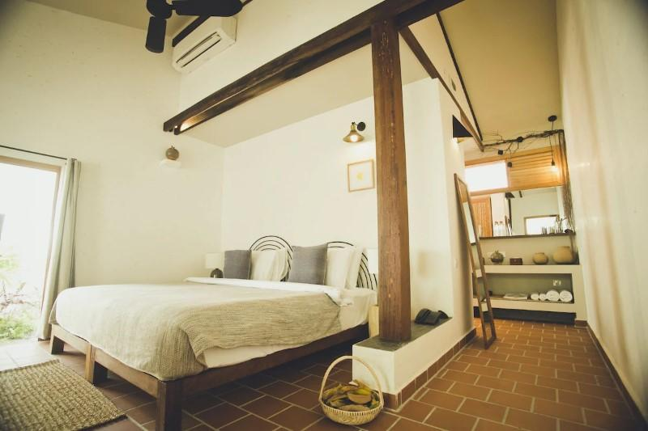
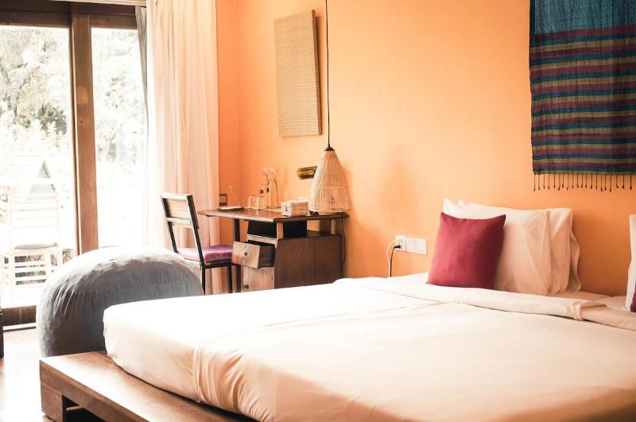
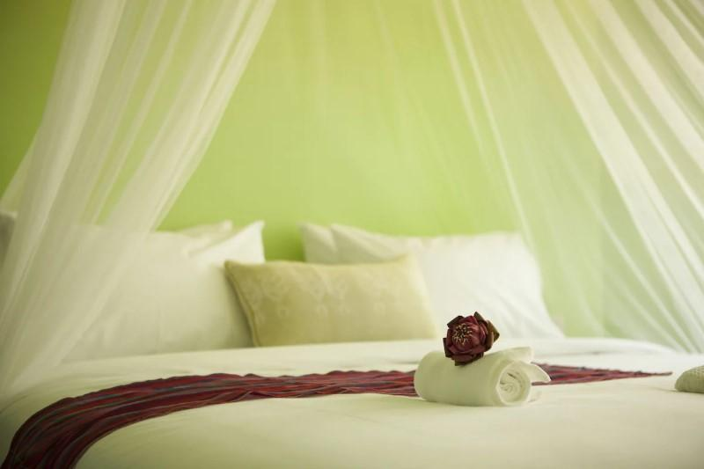
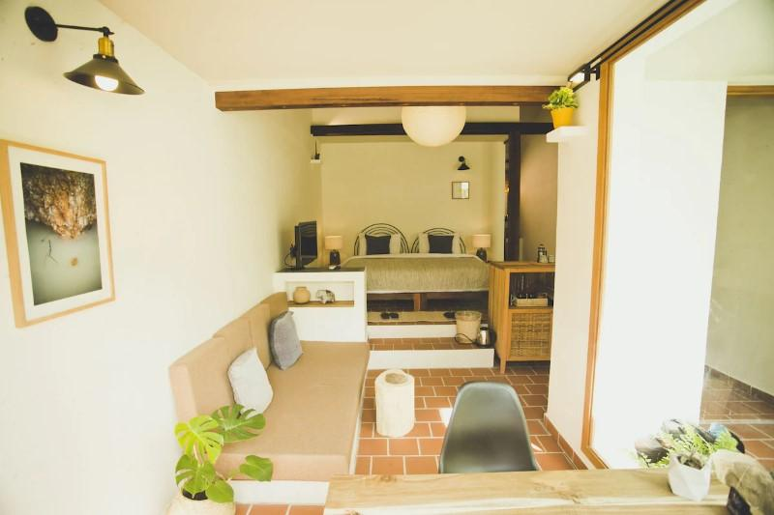
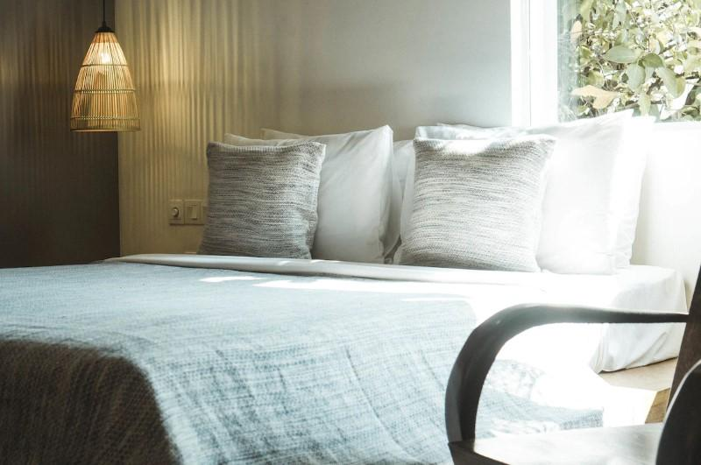
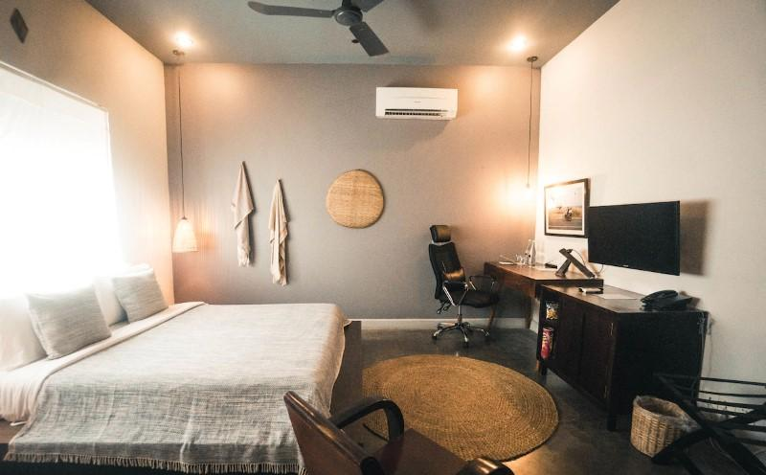
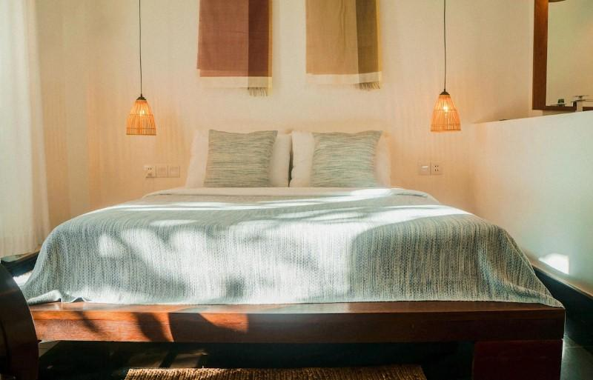
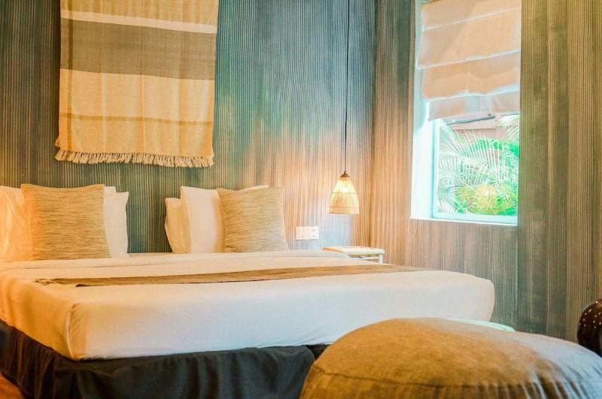
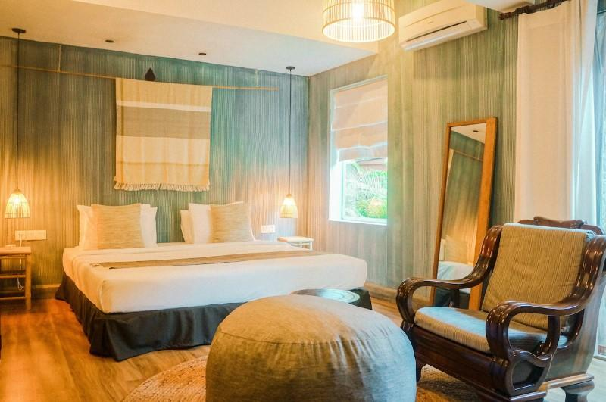
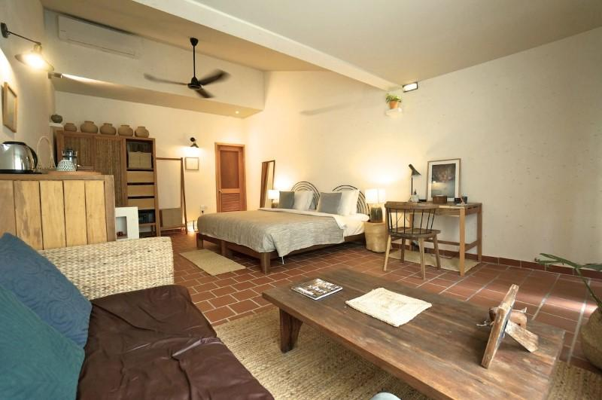
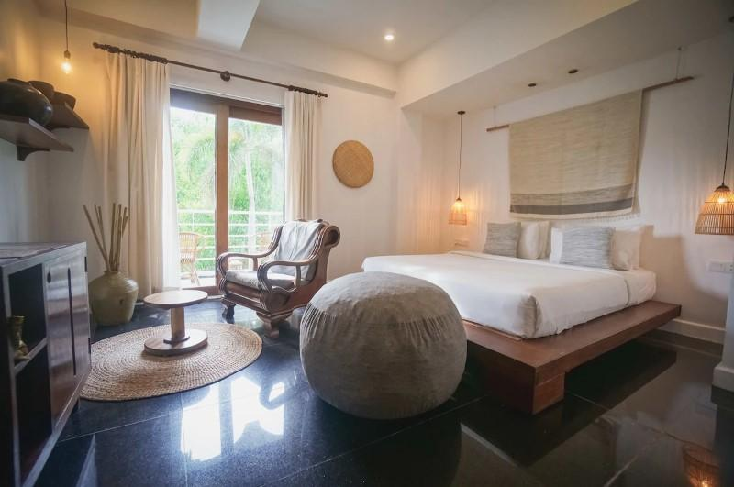
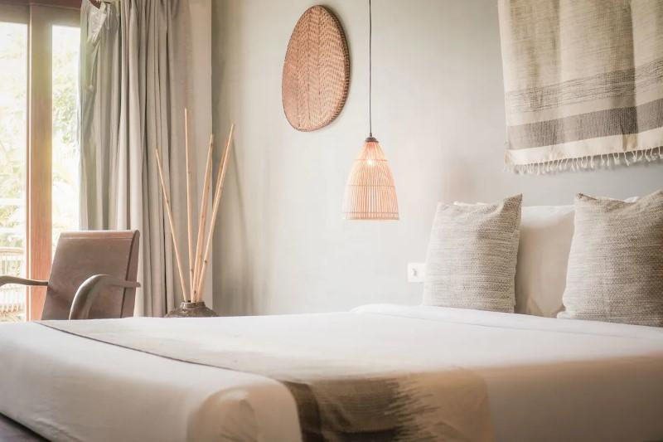
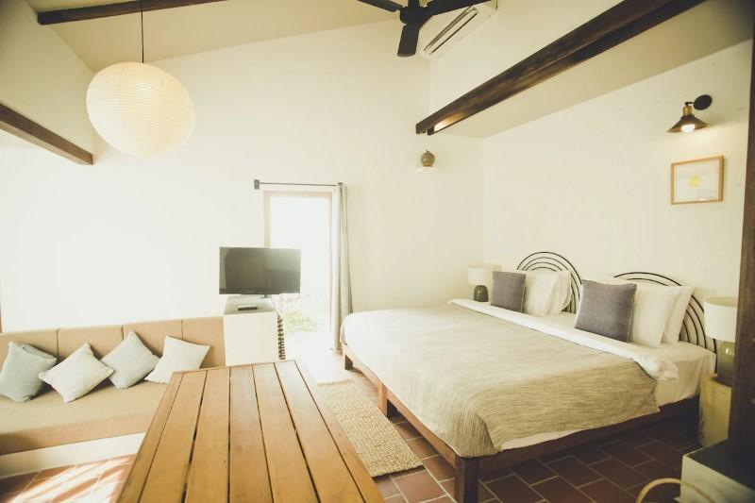
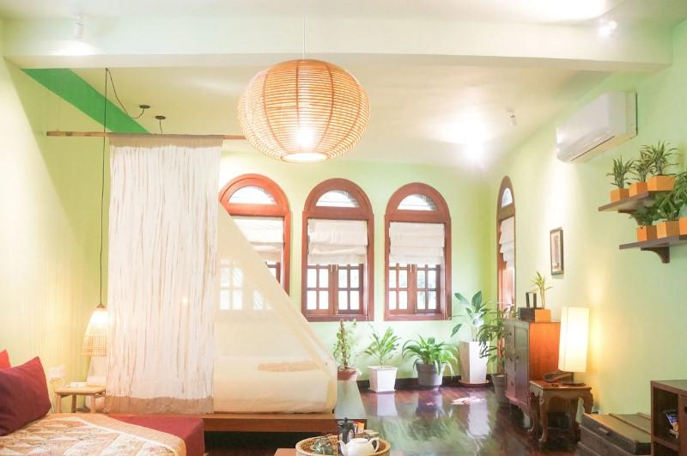
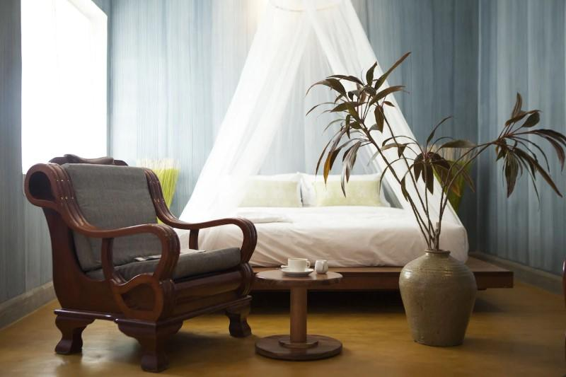
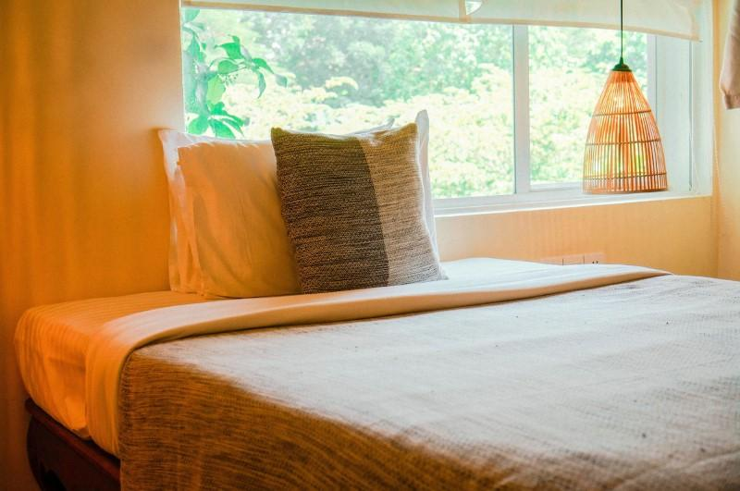
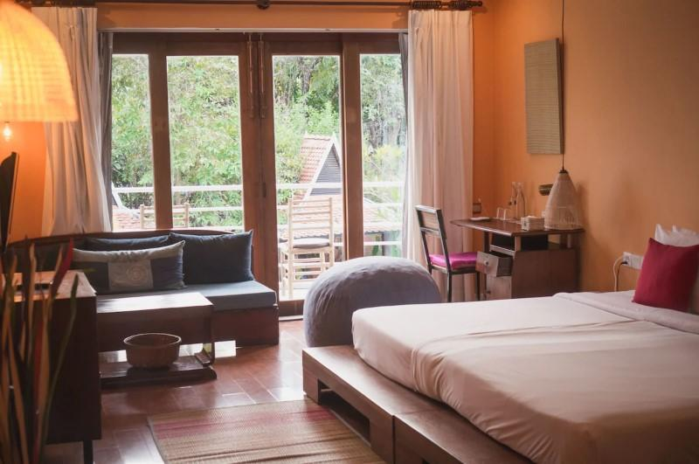
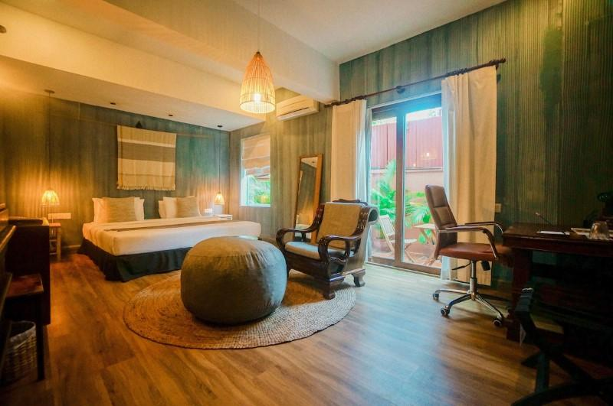

Restaurant photos
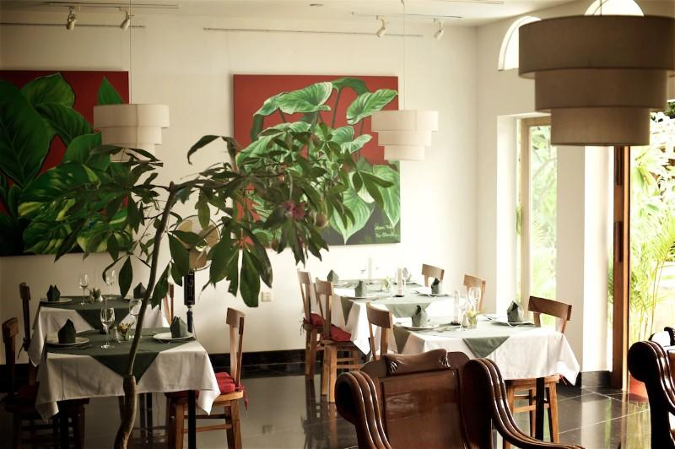
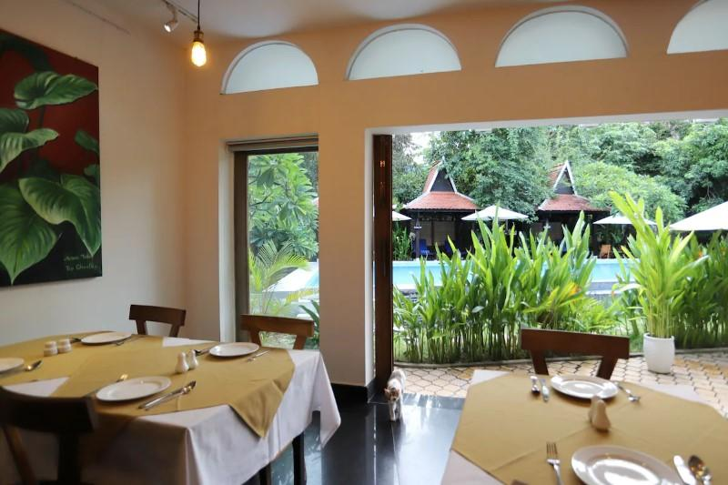
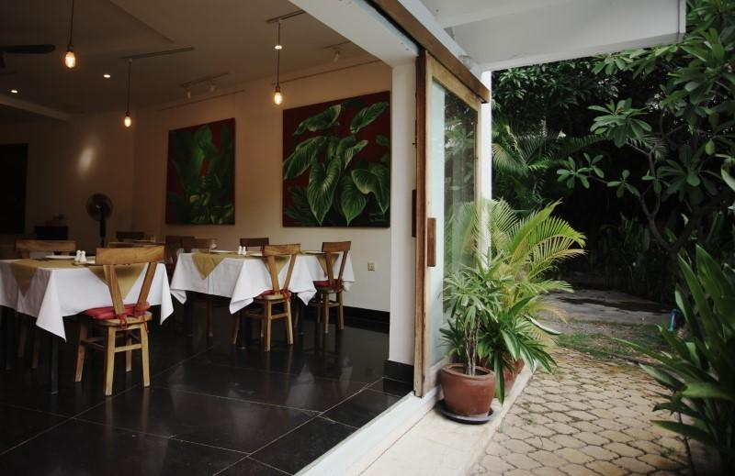
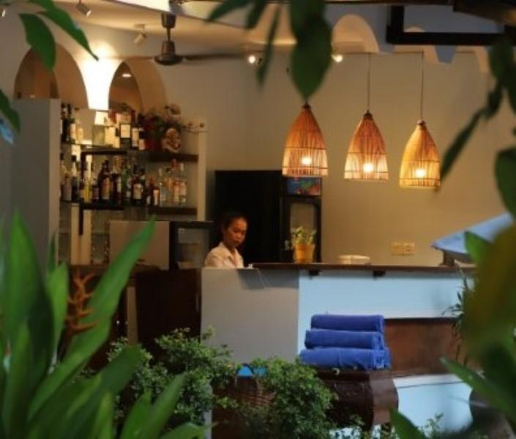

Services & facilities photos
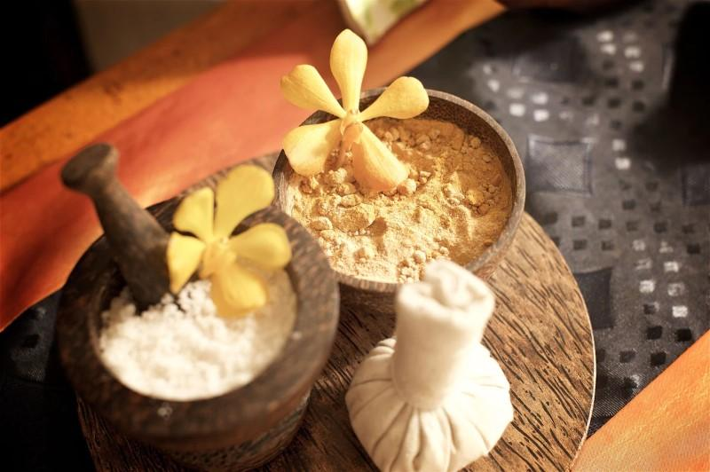
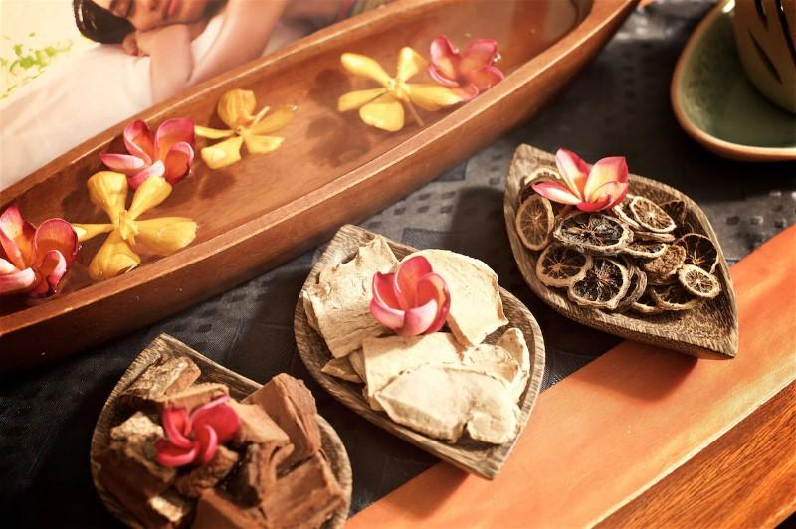
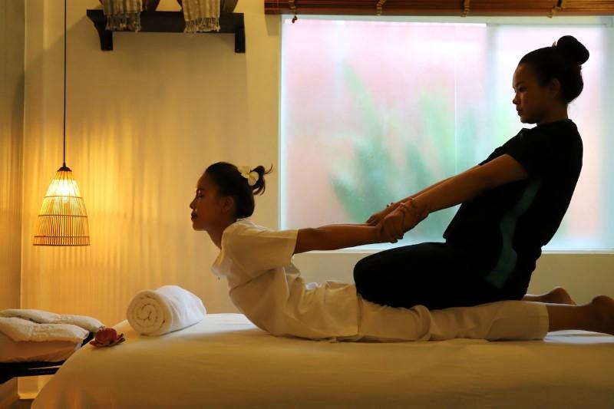
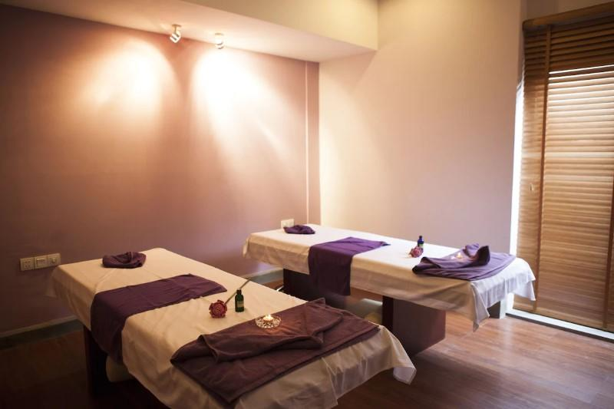
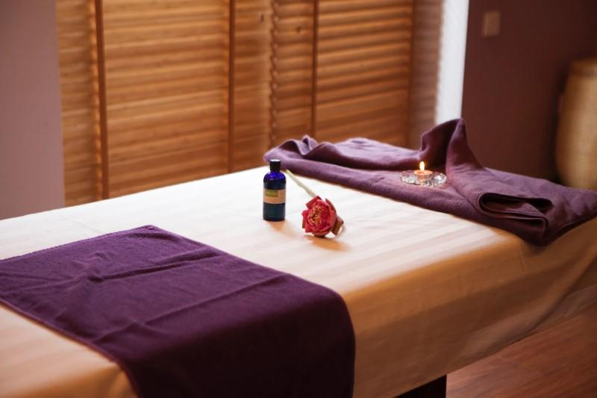
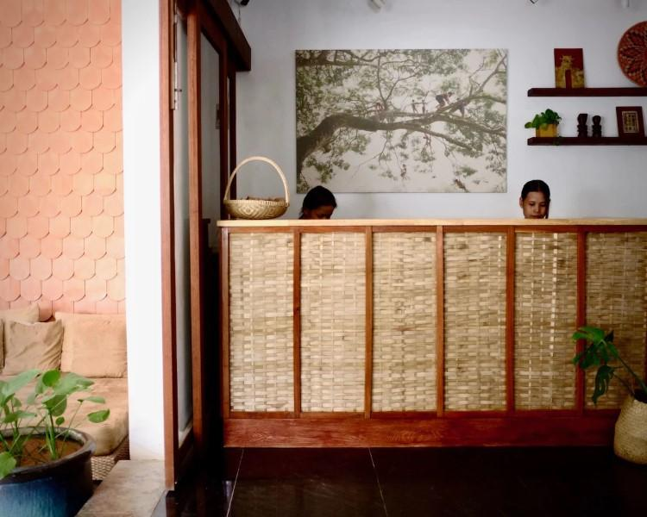
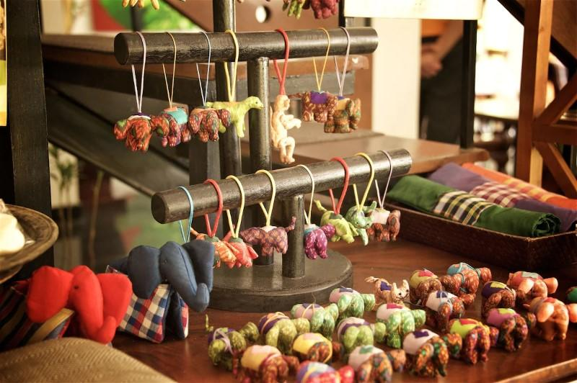
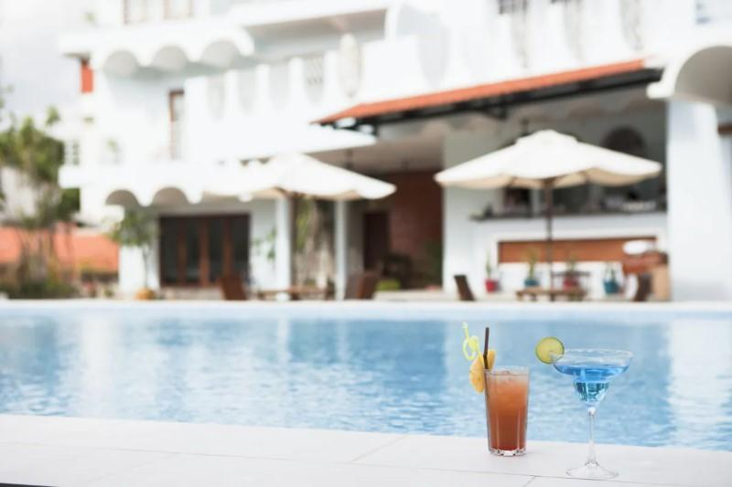
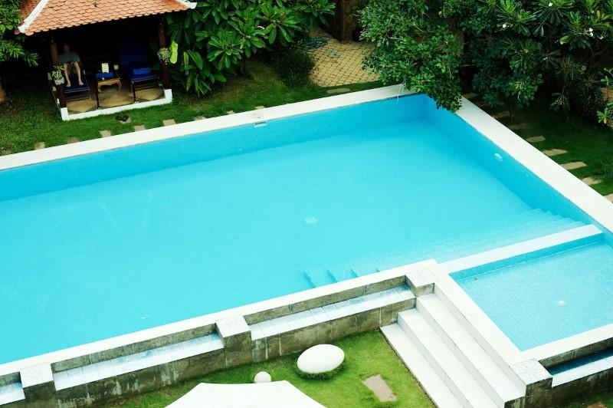
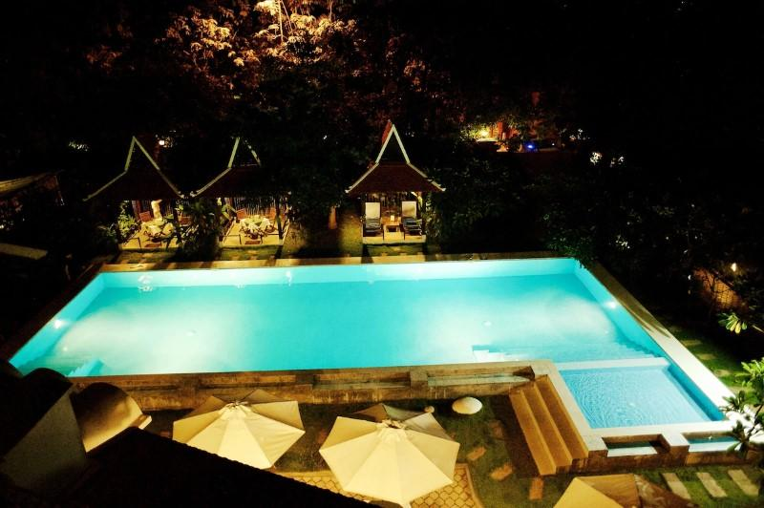
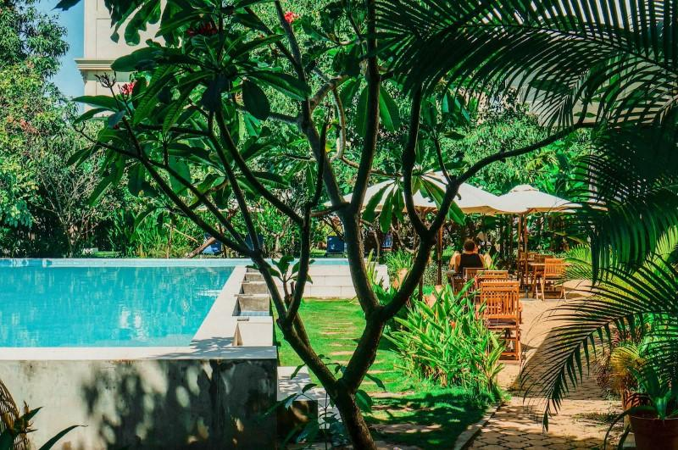
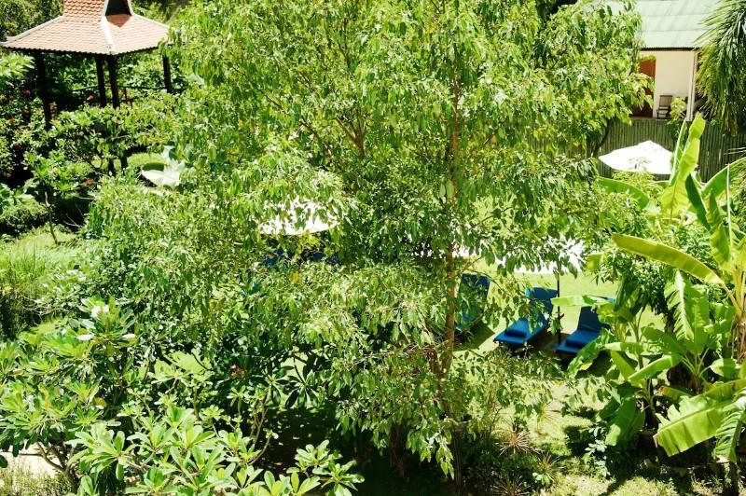
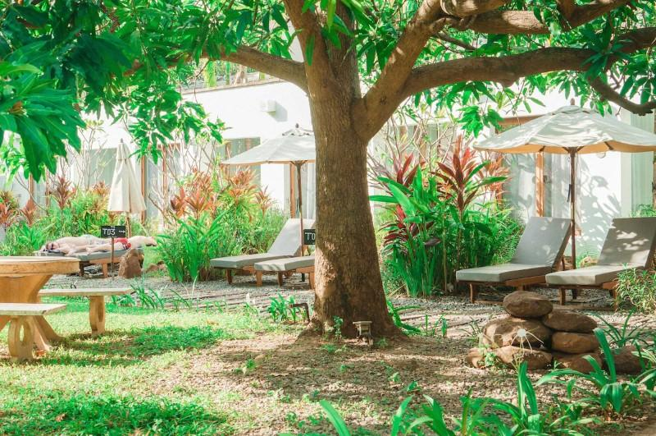
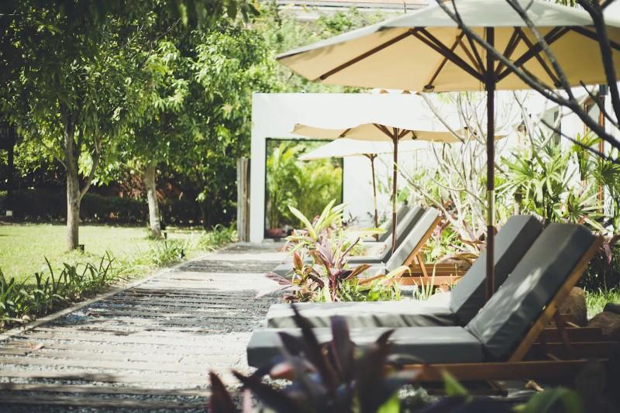
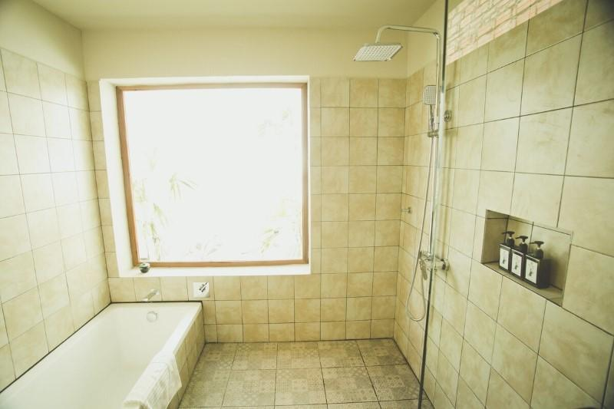

Easia Travel Head Office

