CAMBODIA – Siem Reap – Templation Hotel Siem Reap
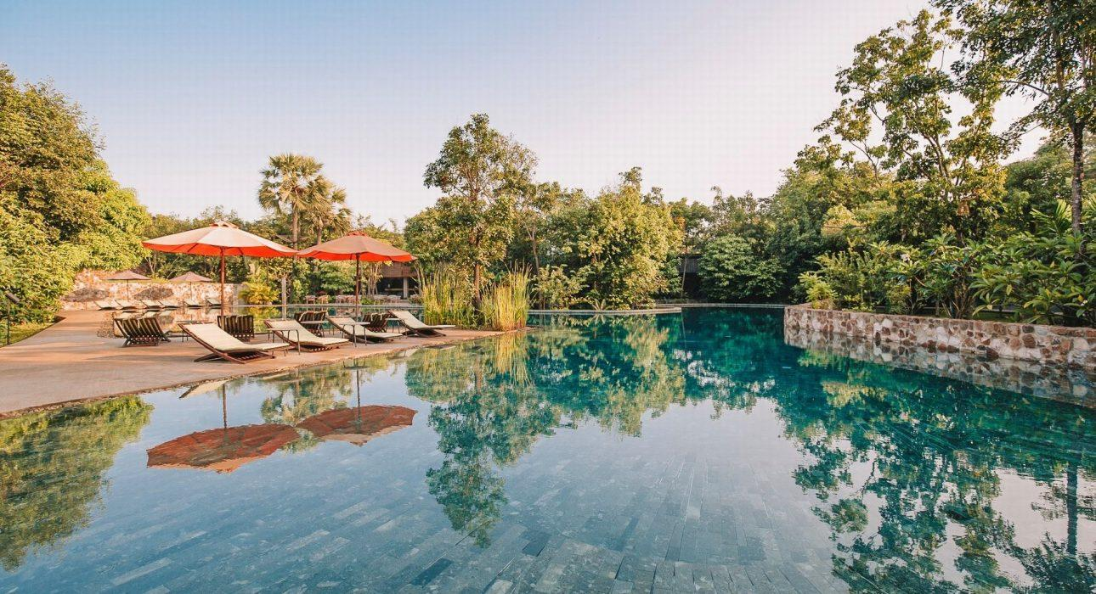

Over View

Theme
Classic, Family, Sustainable, Wellness

Country - City
Cambodia - Siem Reap

Market segment
Groups, Thematic Leisure

Official category
5*

Easia category
Deluxe

Total number of rooms
42

Price level
$$$$

Description

TEMPLATION Hotel Siem Reap is located near the heart of Siem Reap town, set in a lush tropical garden with a hug and beautiful swimming pool, and is the closest resort to Angkor Wat Temple, only 3.5 km or a 5 – minute drive from this resort. It is a green modernist estate composed of hidden suites and villas, most with their private pool.The resort offers 42 air-conditioned accommodations, immaculate, spacious rooms with charming design and decoration, and friendly service. They are featured with a 700 square meters main swimming pool, restaurant, bar, gift shop, spa, gym, and green garden. Every room has air conditioning and a fan option. The seating area is fitted with a flat-screen cable TV and a desk, a private bathroom equipped with a bath; extras include bathrobes and slippers. Guests can approach the 24 – hour front desk for concierge services. There is a gift shop available on-site that is exclusive, locally made handicrafts, and supports Cambodian artisans. Also, Free WIFI is provided throughout the property.

Selling points

- Very charming resort with lovely design suites and villas
- Immaculate and spacious room with very nice decoration
- Very nice resort located in the lush tropical garden with a substantial main swimming
- The closest resort to Angkor Wat temple and also near the city center
- The resort is sustainable support activity and supports the local community, such as locally made handicrafts

Sustainability

Supplier Actions
Protection of Environment, Support local communities, Child Protection

Time & Transportation

From | To | By | Distance | Duration | Road Condition
Hotel | Angkor Wat | Car | 3.5 km | 5 mn | Good
Hotel | Old Market | Car | 3.3 km | 5 mn | Good
Hotel | Tonle Sap | Car | 15 km | 25 mn | Good

Rooms

Easia's recommend room type
Junior SuiteStyle: Modern
- Size: 40 sqm, private studio
- Unit: 12 units with terrace, garden & pool view
- Bed: 1 double bed or 2 single beds
- Extra Bed: available; the number of extra Bed depends on room type
Private Pool One-bedroom VillaStyle: Modern
- Size: 70 sqm, private suite
- Unit: 11 units with terrace, garden & pool view, private pool, 2 sofa beds
- Bed: 1 double bed
- Extra Bed: available; the number of extra Bed depends on room type
Private Pool Two-bedroom VillaStyle: Modern
- Size: 104 sqm, Entire Villa
- Unit: 16 units with terrace, garden & pool view, private pool, Ensuite bathroom
- Living Room: 1 Living Room with 1 sofa
- Bedroom 1: 1 double bed
- Bedroom 2: 1 double bed
- Bed: 2 double beds in total
- Extra Bed: available; the number of extra Bed depends on room type
Private Pool Three-bedroom VillaStyle: Modern
- Size: 140 sqm, Entire Villa
- Unit : 3 units with terrace, garden & pool view, private pool, Ensuite bathroom
- Living Room: 1 living room with 2 sofa beds
- Bedroom 1: 1 double bed
- Bedroom 2: 1 double bed
- Bedroom 3: 2 single beds
- Bed: 2 double beds and 2 single beds in total
- Extra Bed: available; the number of extra Beds depends on room type.

Room configuration

Connecting rooms
10 connecting rooms ( With category of Private Pool Two-bedroom Villa)

Extra bed
Yes (1m x 2m)

King bed
1.80m x 2m

Queen bed
No

Twin beds
1.20m x 2m

Services & Facilities

Services
24 hour reception, 24h security service, Afternoon Tea, Bicycle Rental, Car rental, Children Swimming Pool, Complimentary bottle of water, Complimentary fresh towel, Concierge service, Credit Card payment, Currency exchange, Dry Cleaning, Iron, Laundry service, Massage, Mobile phone, Room Service, Tour desk, Wake-up service, Wheelchair, Wi-fi Free, Yoga Retreat

Facilities
Air Conditioning, Bar, BBQ Facility, Beauty Shop, Bicycle, Business centre, Children Pool, coffee and tea making facilities, Family Room, Fan, Fitness centre, Flat screen TV, Free private parking, Garden, Gift Shop, Hair Dryer, In-Room safe, Internet, Massage room, Meeting room, Mini Bar, Outdoor swimming pool, Private Pool, Restaurant, Safety Box, satellite LCD TV, Shower With Hot Water, Terrace, Umbrella

Disabled Facilities
Outside access, Restaurants, Rooms are adapted

Business facilities details
The Meeting RoomA multipurpose space seating up to 60 people for meetings, conferences, private functions, and celebrations.

Restaurant information

The RestaurantKhmer and Asian cuisine are offered alongside western classics right by the pool
- Breakfast
Time : 6:30 AM – 10 AMStyle: A la carte/ Buffet for the group (exception breakfast setup)The Lounge & BarOpen on three sides, the poolside lounge and bar area keeps one close to the natural surrounding.

Photos

Hotel Photos
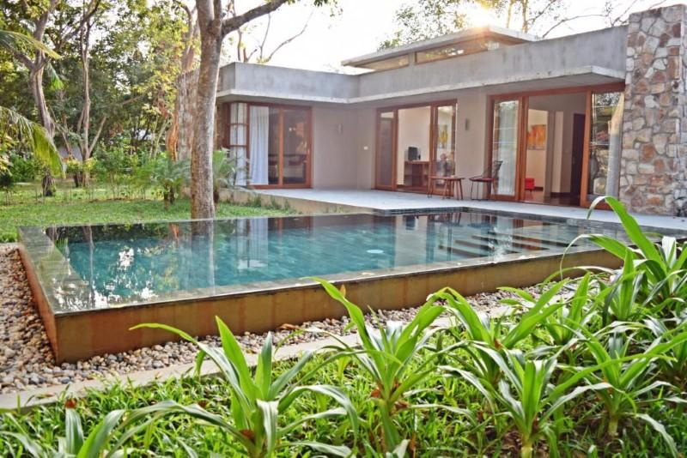
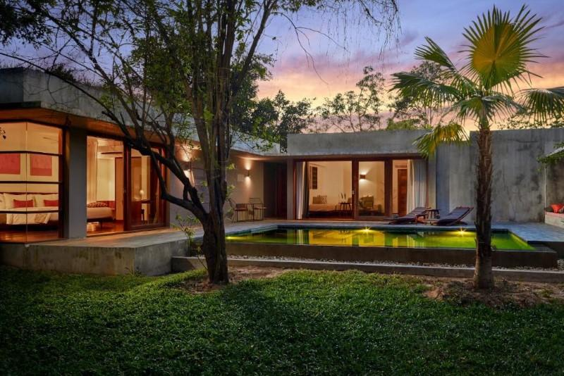
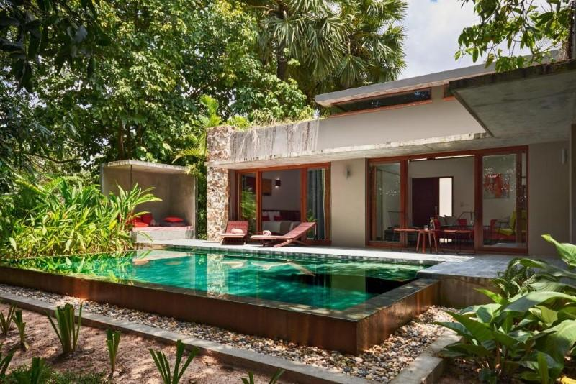
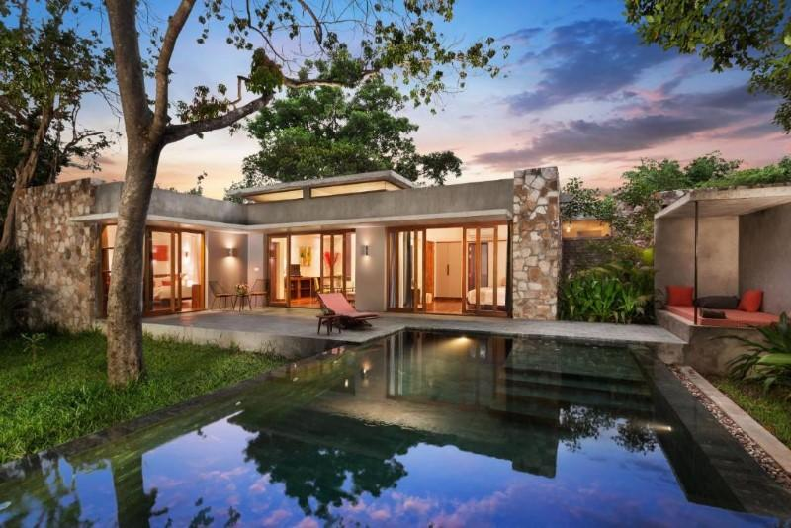
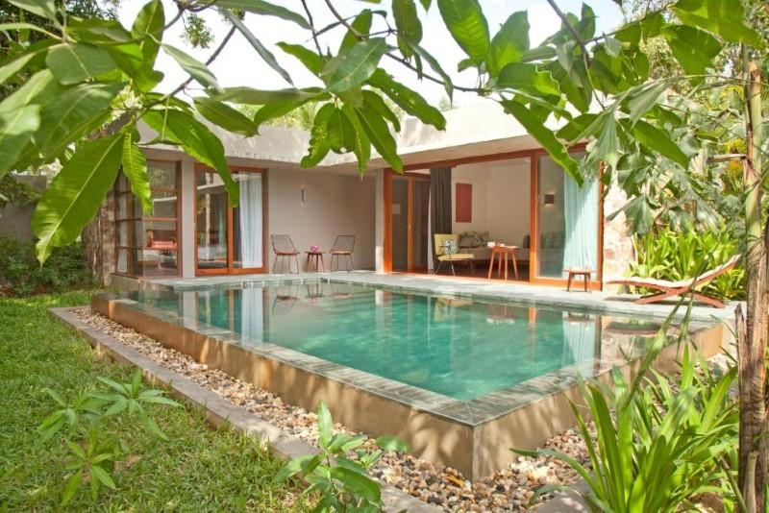
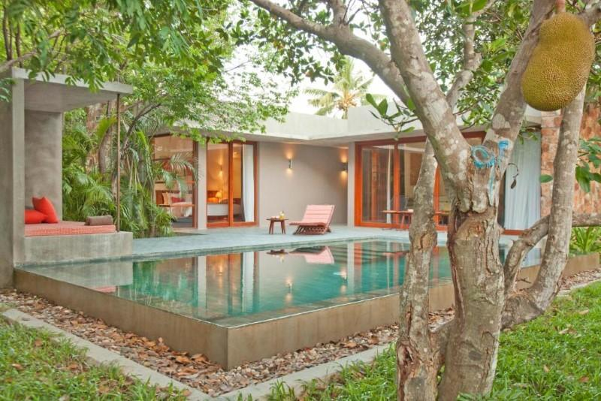
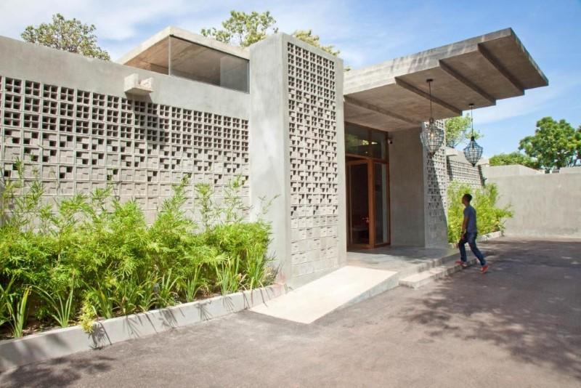
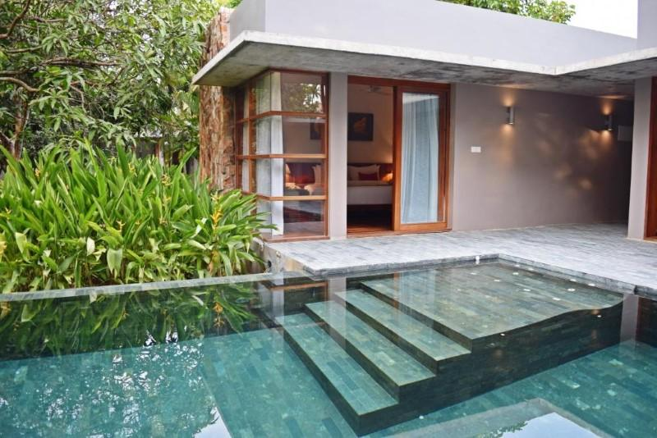
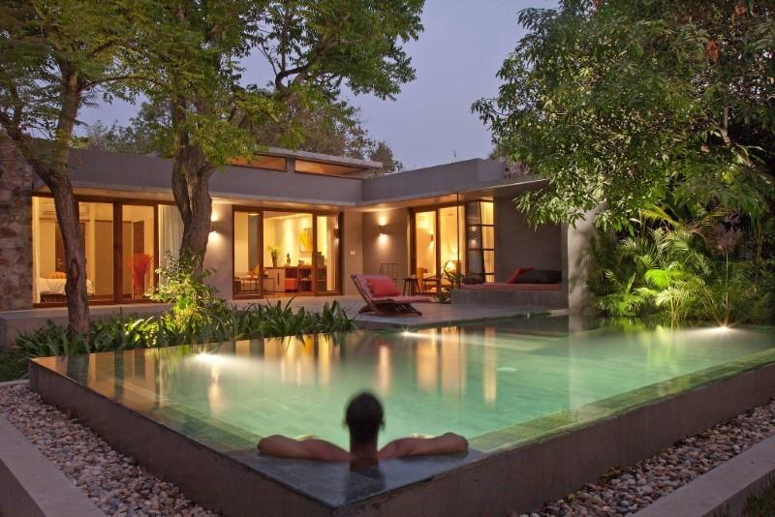
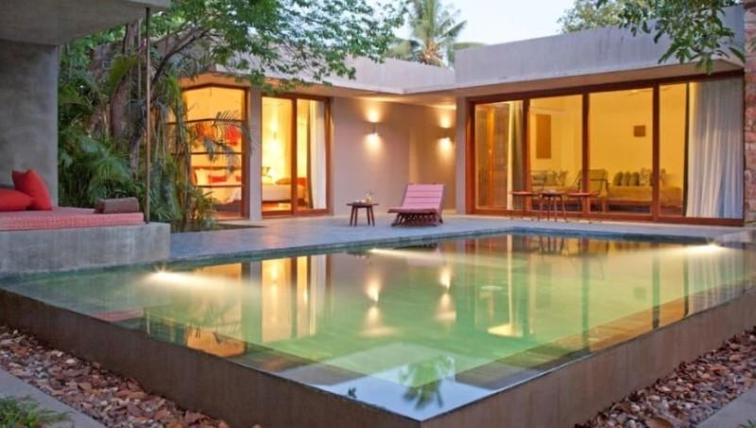
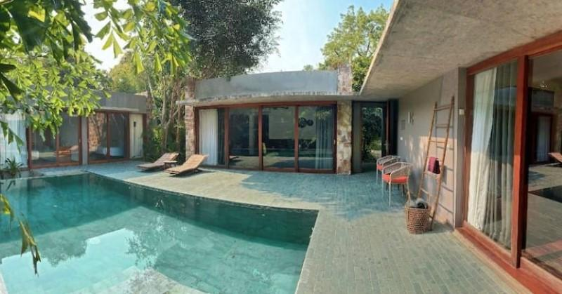
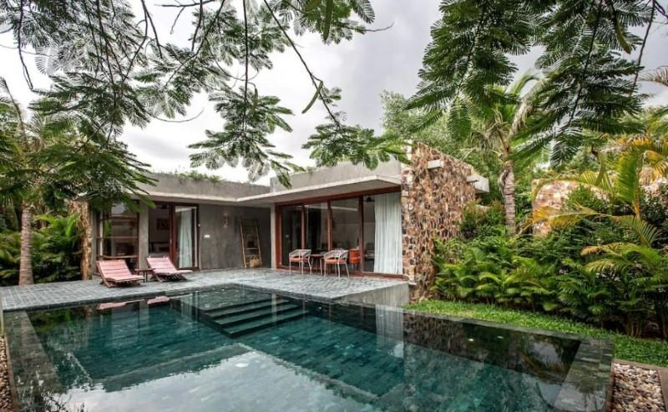
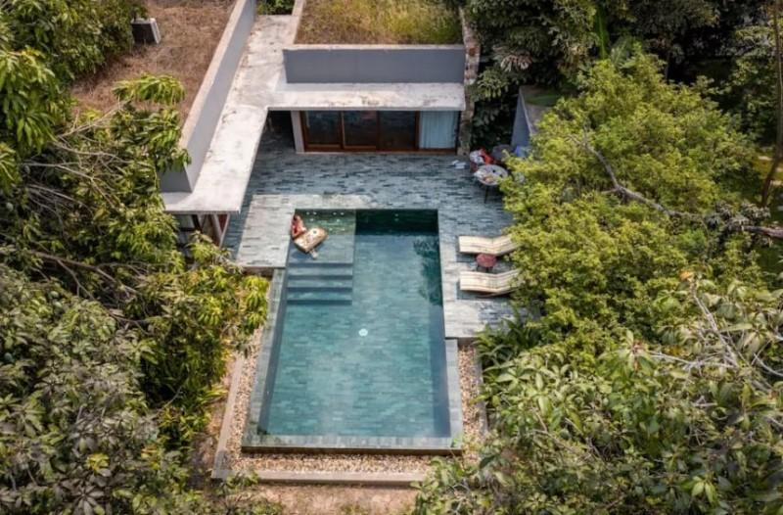

Rooms photos
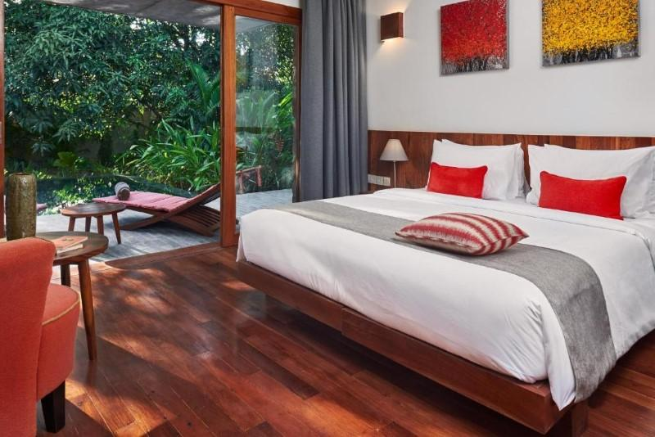
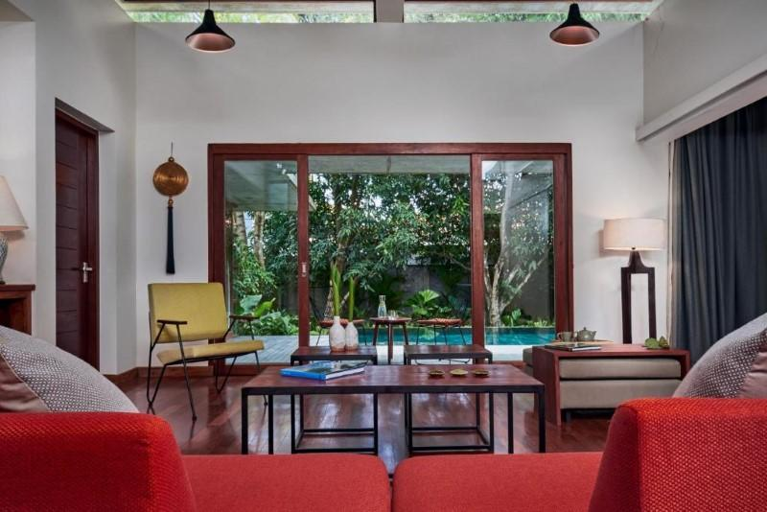
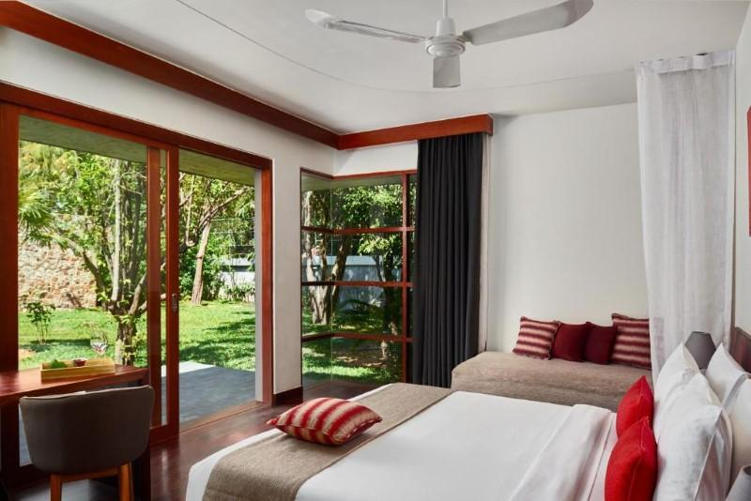
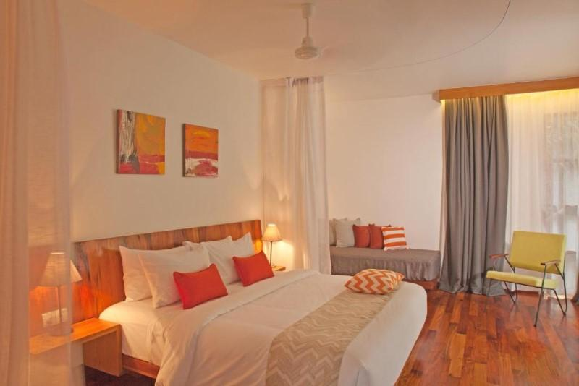
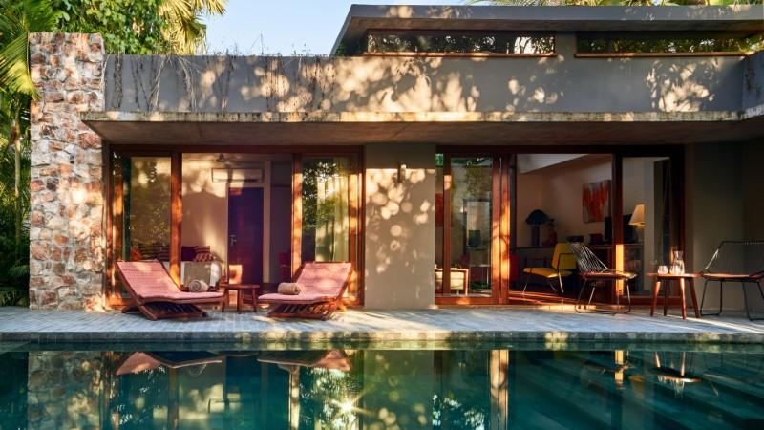
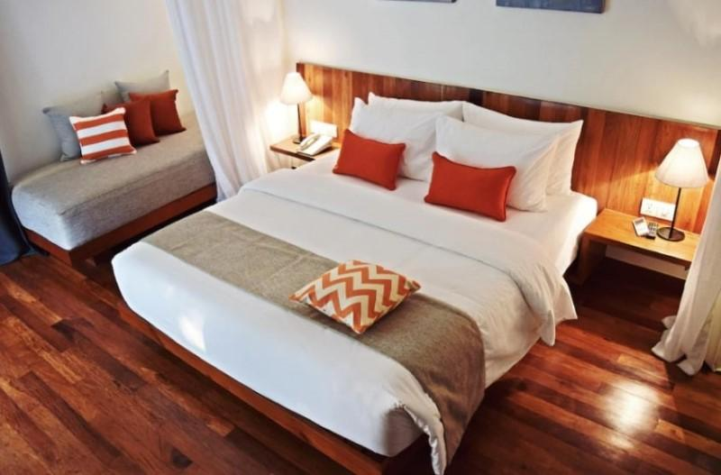
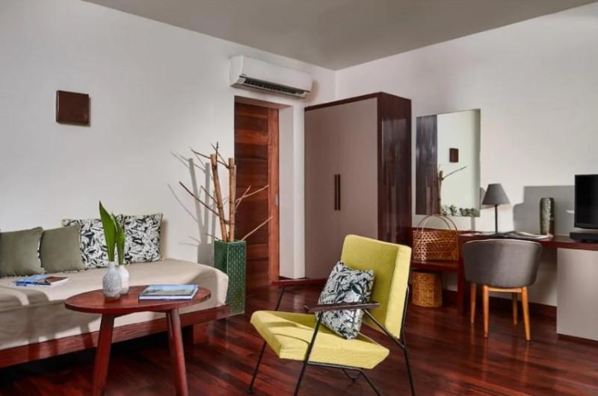
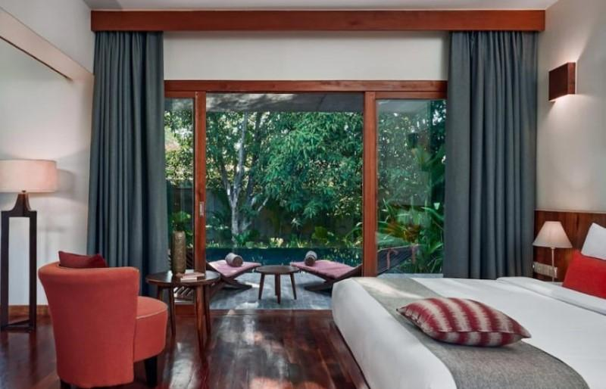
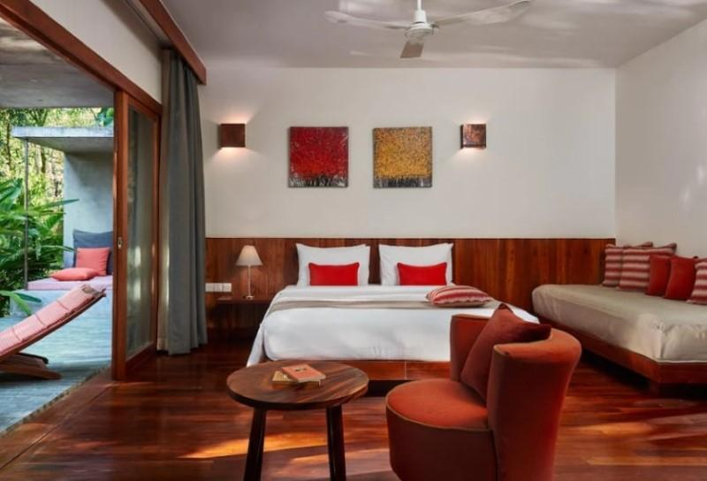

Restaurant photos
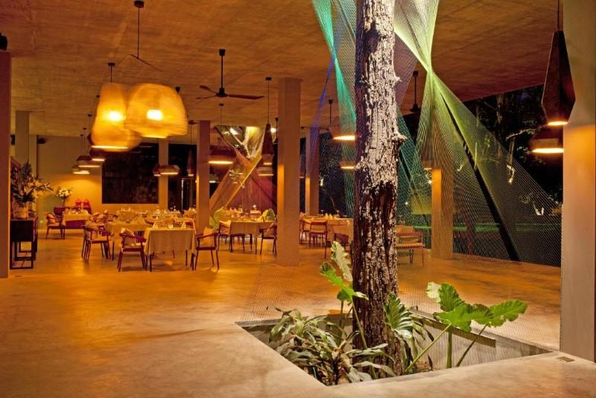
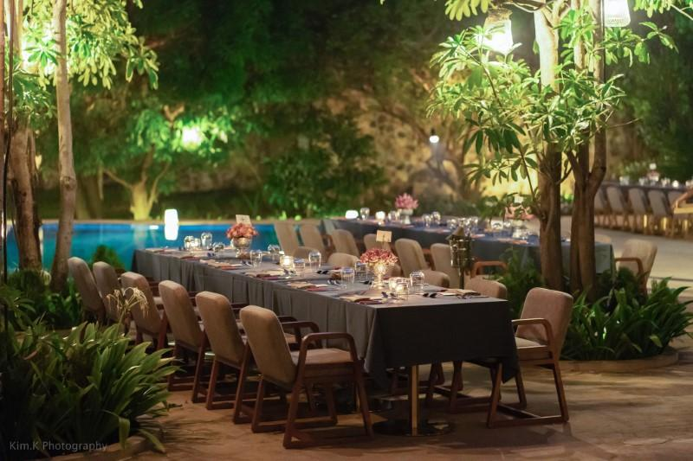
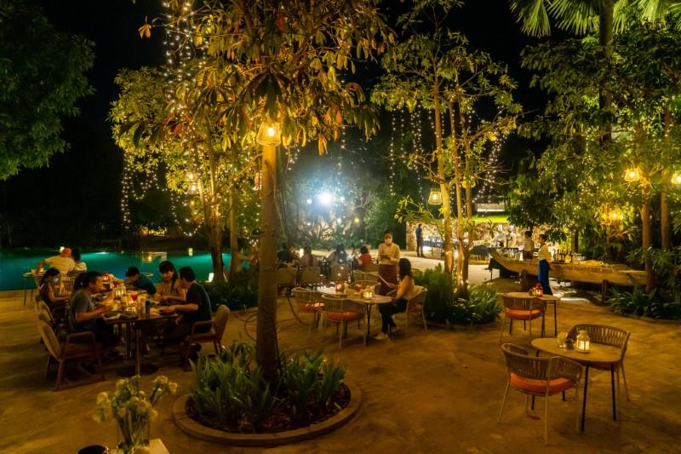
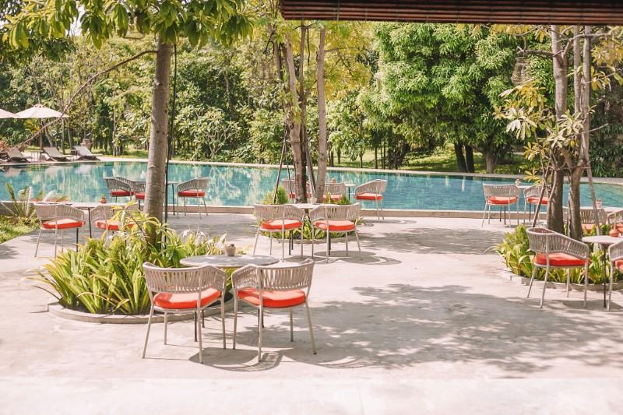
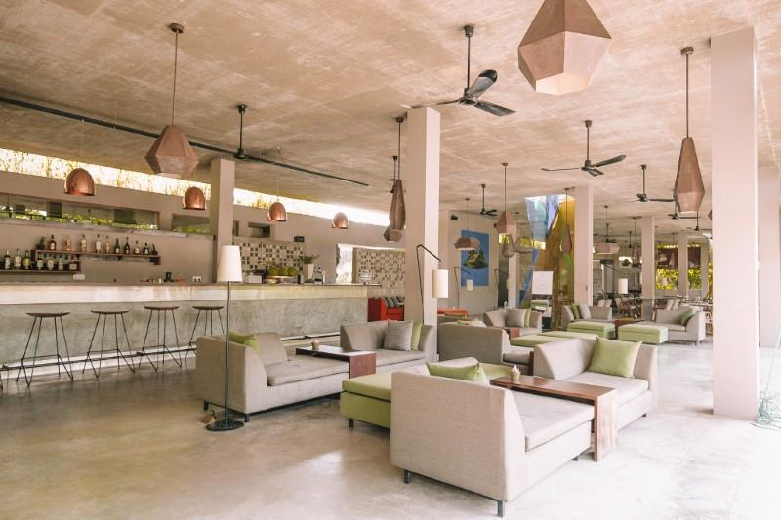
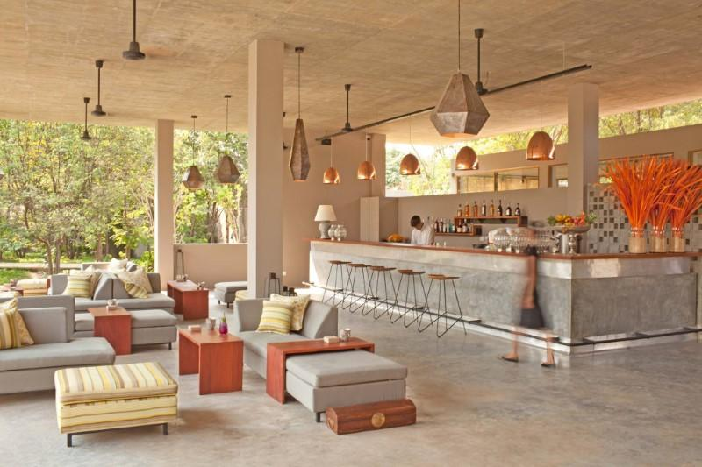
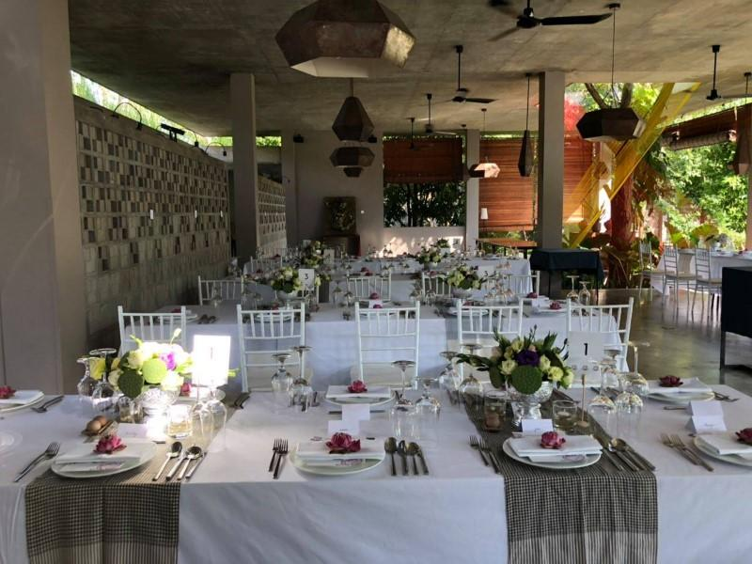
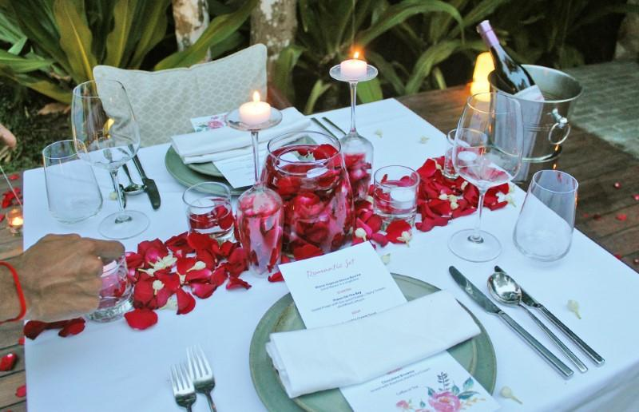

Services & facilities photos
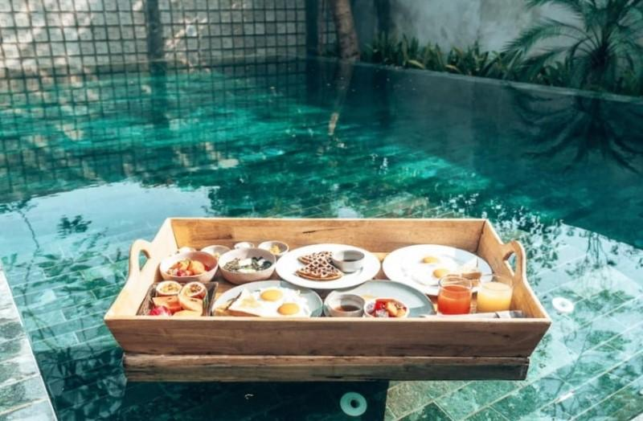
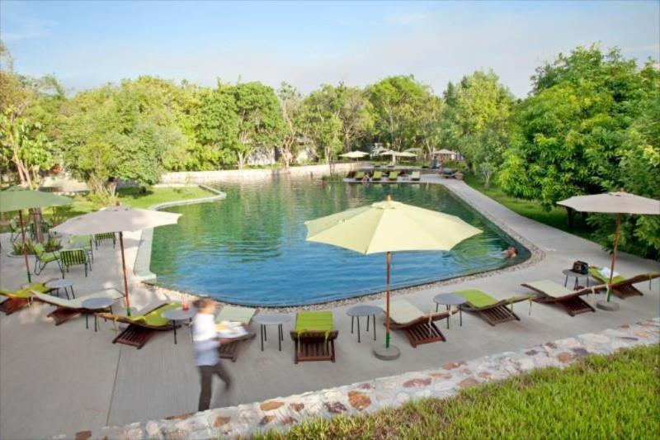
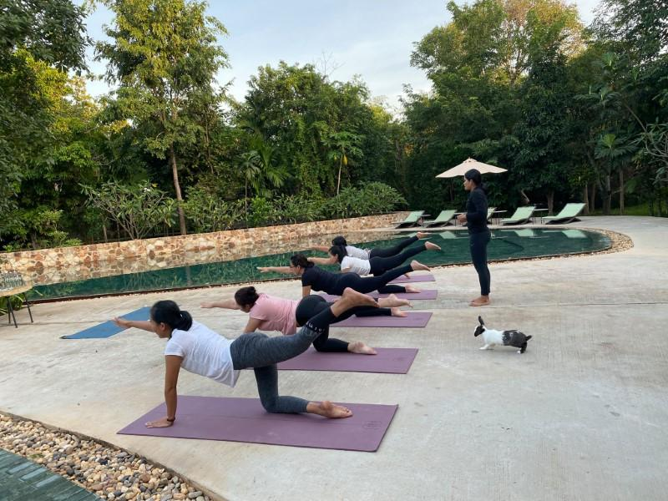
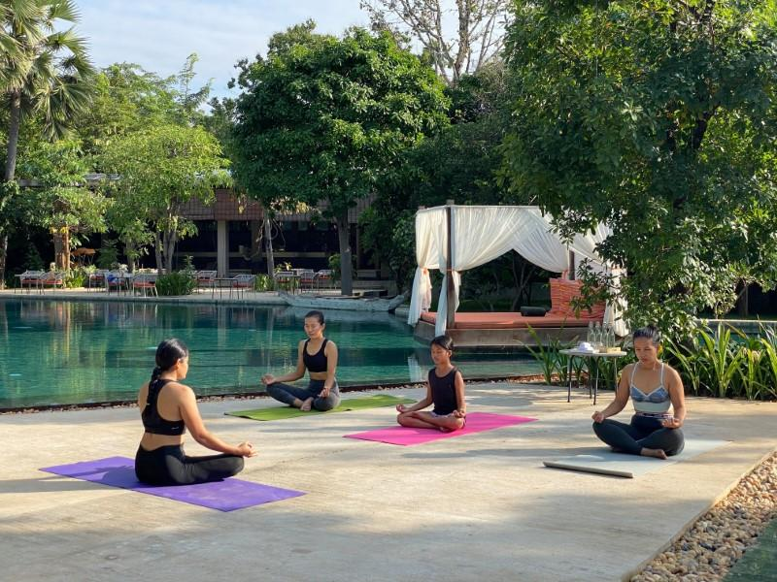
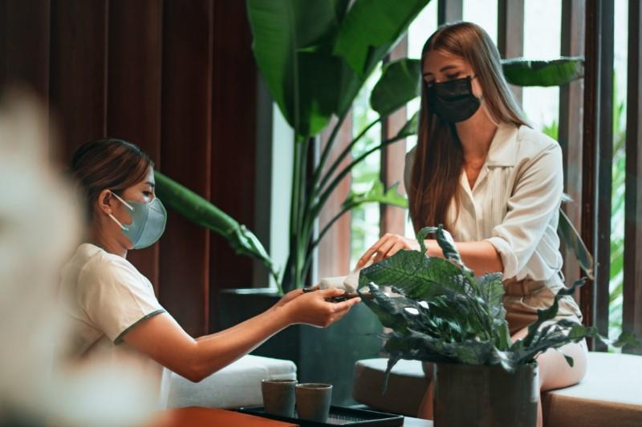
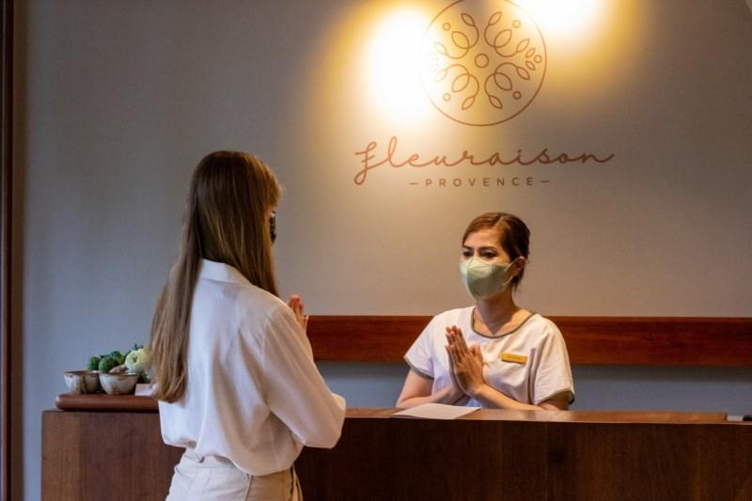
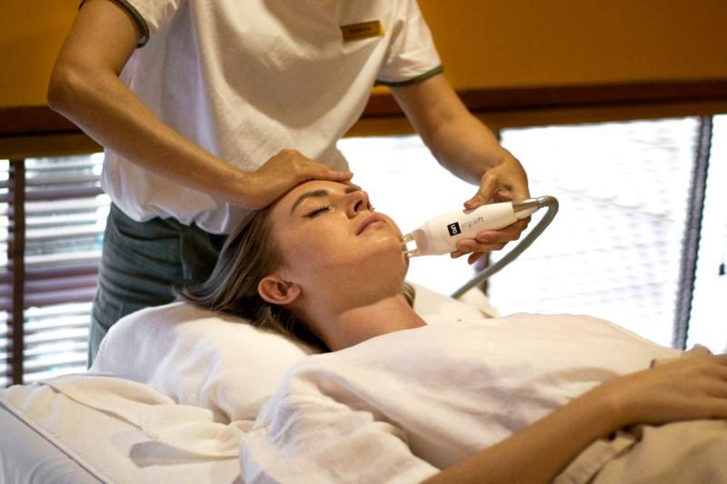
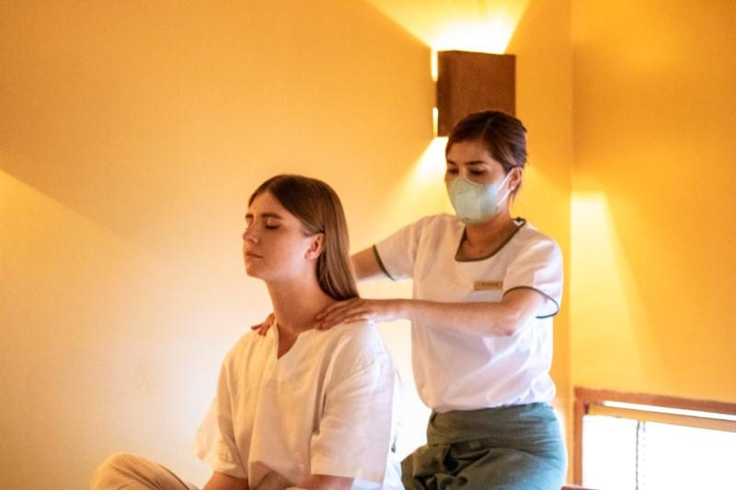
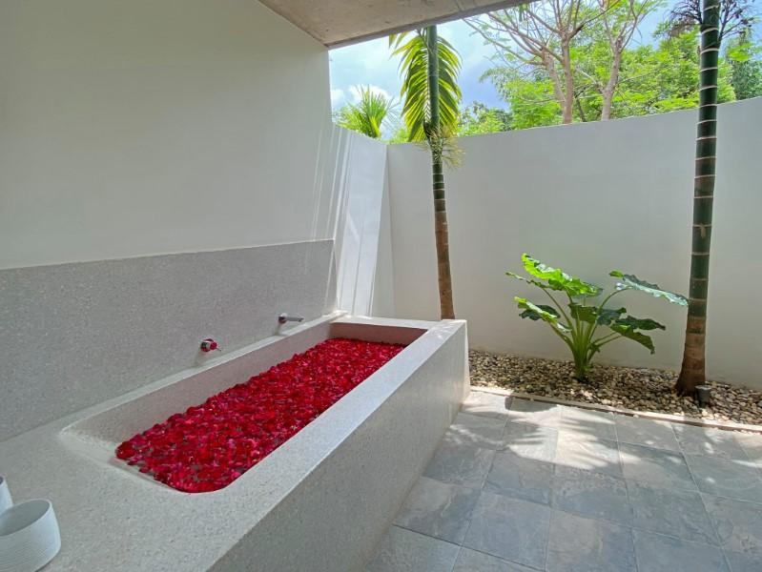
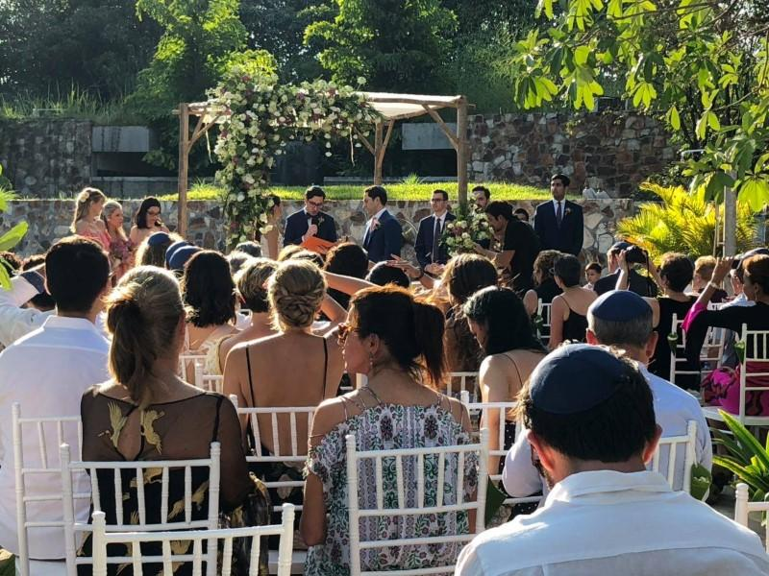
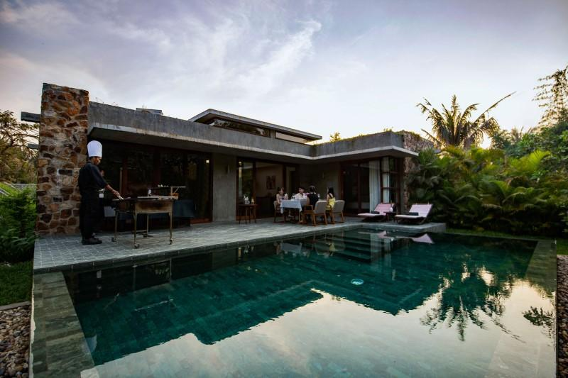
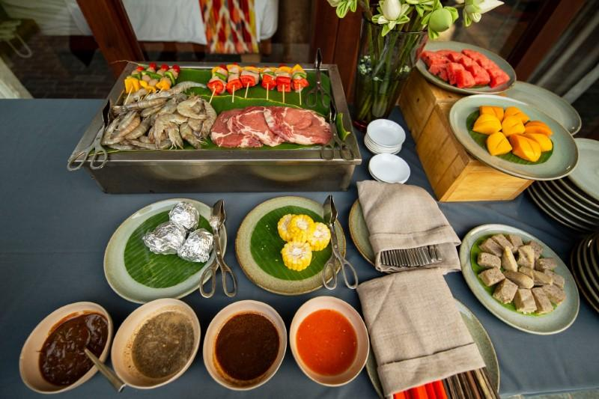
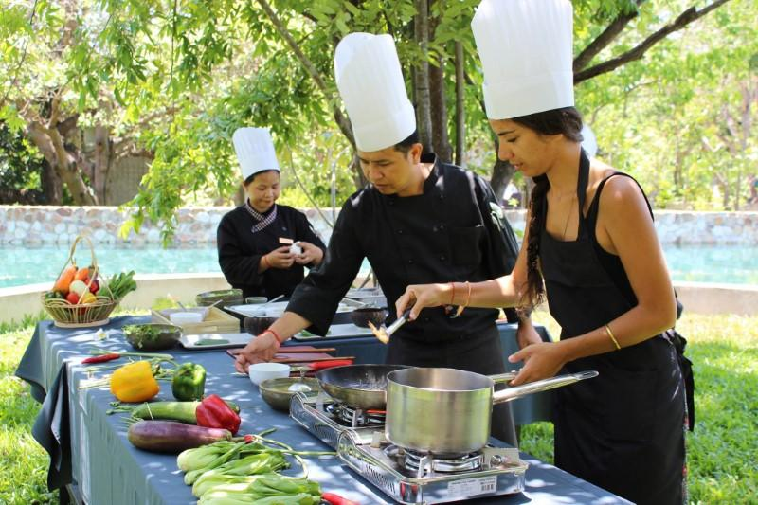
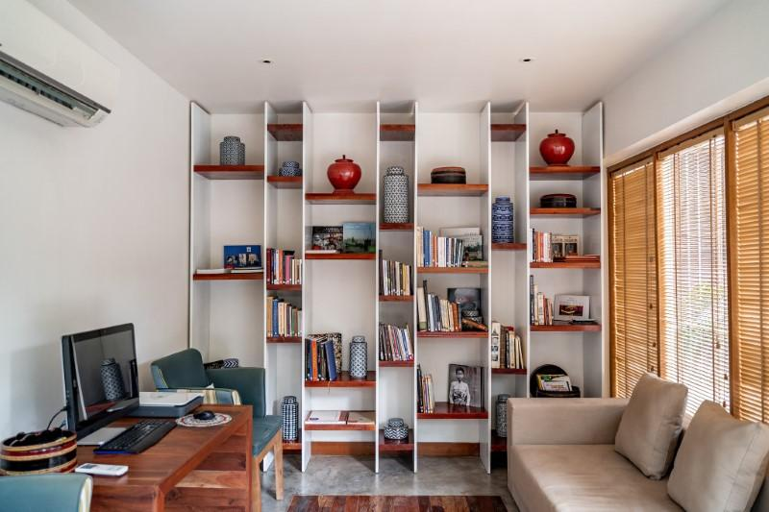
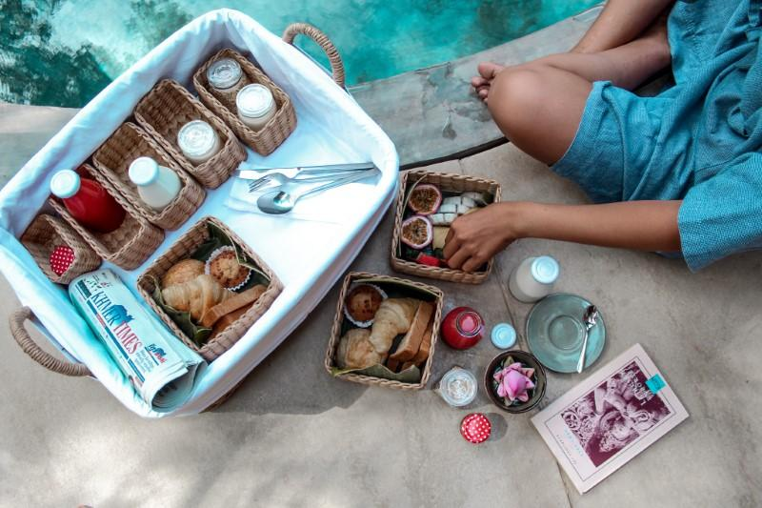

Easia Travel Head Office

