CAMBODIA – Siem Reap – Sokkhak Boutique Resort
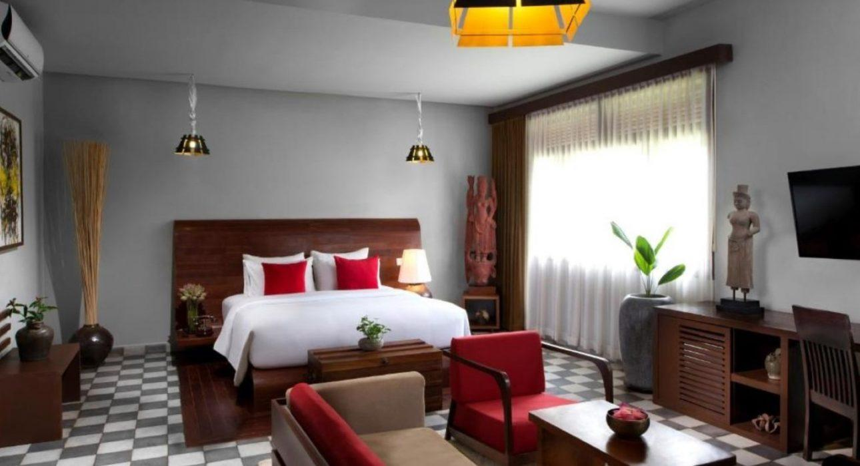

Over View

Theme
Art &amp; Culture, Classic, Family, Honeymoon, Sustainable, Wellness

Country - City
Cambodia - Siem Reap

Market segment
Groups, Thematic Leisure

Official category
5*

Easia category
First Class

Total number of rooms
12

Price level
$$$$

Description

Nestled with tropical gardens, Sokkhak Boutique Resort offers stylish and luxury accommodations away from the hustle and bustle of Siem Reap. It is located just a 5-minute drive from the city center and also a 5-minute drive from Angkor Wat temple, the world-famous heritage site.This boutique resort offers 12 accommodations: luxury rooms and suites featuring Khmer Decor, antique furniture, and classic artwork. Rooms are facilitated with high-quality premium linen and bedding material for guests’ comfort. All rooms and suites come with air conditioning, antique-style tiles, hardwood flooring, a flat-screen cable TV, and a writing desk. Some units have a pool and garden. Ensuite bathrooms include a rain shower, a beautiful vanity counter, a full range of bathroom amenities, slippers, and toiletry. Sokkhak Boutique Resort has an outdoor salted-water swimming pool; guests can enjoy meals at the well-decorated in-house restaurant or drink at the bar or lounge. Free WIFI is available throughout the property.

Selling points

- Stylish and luxury accommodations
- All room are well decorated by Khmer Decor, antique furniture, and classic artwork
- Room are facilitated with high quality premium linen and bedding material for guests’ comfort
- Spacious and very clean room
- Staff are very friendly, helpful, and best quality of hospitality

Sustainability

Supplier Actions
Protection of Environment, Child Protection

Time & Transportation

From | To | By | Distance | Duration | Road condition
Hotel | Angkor Wat | Car | 3.80 km | 5 mn | Good
Hotel | Old Market | Car | 2.80 km | 5 mn | Good
Hotel | Siem Reap International Airport | Car | 53.4 km | 1hr 12mn | Good
Hotel | Tonle Sap Lake | Car | 25 km | 30 mn | Good

Rooms

Easia's recommend room type
Deluxe Twin RoomStyle: Modern
- Room Size: 30 sqm
- Bed: 2 twin beds
- Unit : 01
- Extra Bed : Yes
- Remark: Private kitchenette, Ensuite bathroom, garden view, landmark view, inner courtyard view
Deluxe Double RoomStyle: Modern
- Room Size: 30 sqm
- Bed: 1 double bed
- Unit : 02
- Extra Bed : Yes
- Remark: Private kitchenette, Ensuite bathroom, balcony, garden view, landmark view, inner courtyard view
Deluxe Balcony RoomStyle: Modern
- Room Size: 30 sqm
- Bed: 1 double bed
- Unit : 03
- Extra Bed : Yes
- Remark: Private kitchenette, Ensuite bathroom, balcony, garden view, landmark view, inner courtyard view
Junior Suite Room (Pool View Suite) Style: Modern
- Room Size: 45 sqm
- Bed: 1 double bed, 1 sofa
- Unit : 02
- Extra Bed : Yes
- Remark: Private kitchenette, Ensuite bathroom, garden view, landmark view, inner courtyard view
Terrace Suite Room (Pool View Suite) Style: Modern
- Room Size: 45 sqm
- Bed: 1 double bed, 1 sofa
- Unit : 02
- Extra Bed : Yes
- Remark: Private kitchenette, Ensuite bathroom, garden view, landmark view, inner courtyard view
Sokkhak SuiteStyle: Modern
- Room Size: 65 sqm
- Bed: 1 double bed, living room with 1 sofa bed
- Unit : 01
- Extra Bed : Yes, can put 02 extra bed
- Remark: Private kitchenette, Ensuite bathroom, garden view, landmark view, inner courtyard view, spa bath, terrace
One-bedroom Villa (Home Suite)Style: Entire Villa with Modern Style
- Room Size: 90 sqm
- Bed: 1 double bed, living room with 1 sofa bed
- Unit : 01
- Extra Bed : Yes, can put 02 extra bed
- Remark: Private kitchenette, Ensuite bathroom, garden view, landmark view, inner courtyard view, spa bath, terrace

Room configuration

Connecting rooms
No

Extra bed
Yes 1m x 2m

King bed
1.80 m x 2 m

Queen bed
1.80 m x 2 m

Twin beds
1.20 m x 2 m

Services & Facilities

Services
24 hour reception, 24h security service, Airport transfer, Babysitting, Children Swimming Pool, Complimentary bottle of water, Complimentary fresh towel, Credit Card payment, Dry Cleaning, Iron, Laundry service, Luggage Storage, Massage, Mobile phone, Room Service, Spa, Wake-up service, Wi-fi Free

Facilities
Air Conditioning, Bar, Cable, satelite, Children Pool, Coffee Machine Facilities, Courtyard, Disabled Facility, Family Room, Fan, Flat screen TV, Free private parking, Garden, Hair Dryer, In-Room safe, Internet, Massage room, Mini Bar, Outdoor swimming pool, Restaurant, Safety Box, satellite LCD TV, Shower With Hot Water, Terrace, Umbrella

Disabled Facilities
No disable access

Restaurant information

In-house RestaurantCapacity : 25 pax
- Breakfast : 06:30 AM – 10:00 AM
- Lunch : 11:30 AM – 02:00 PM
- Dinner : 05:30 PM – 09:30 PM
Sokkhak SpaOpen daily from 11:00 AM – 10:00 PM
- In-house massage room capacity 02 guests only
- Available for room service of massage

Photos

Hotel Photos
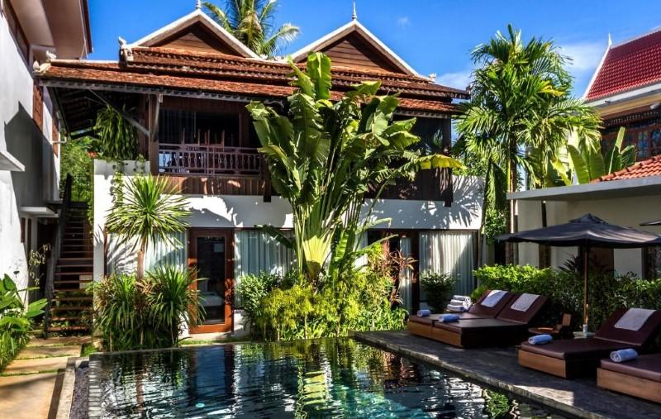
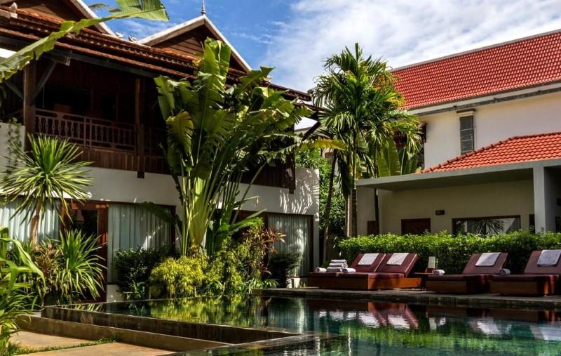
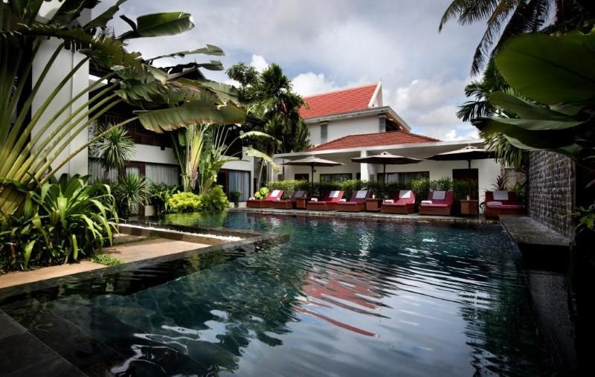

Rooms photos
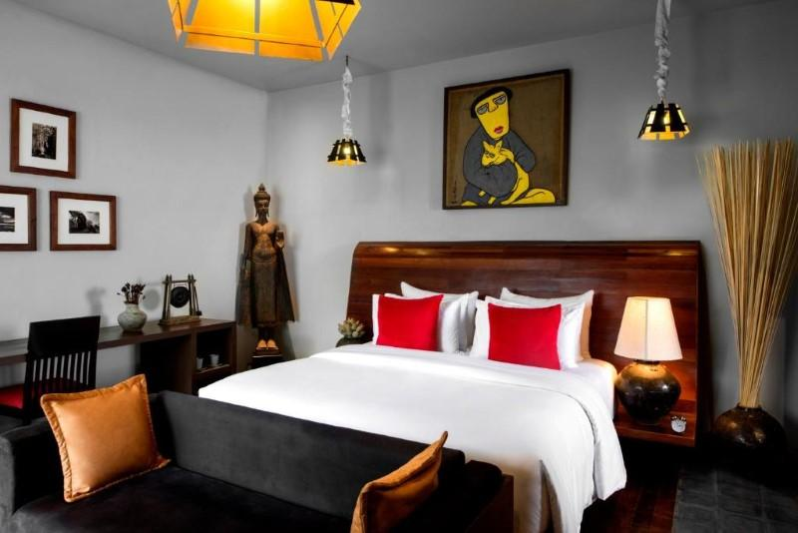
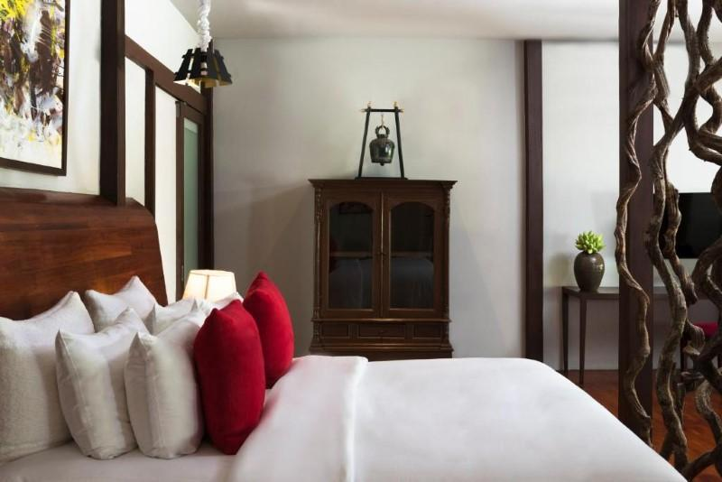
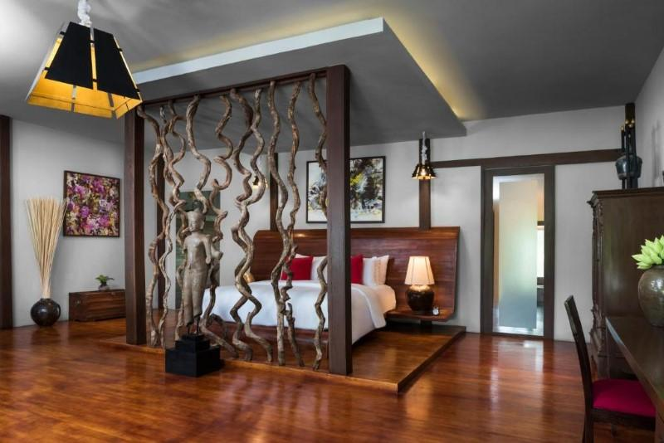
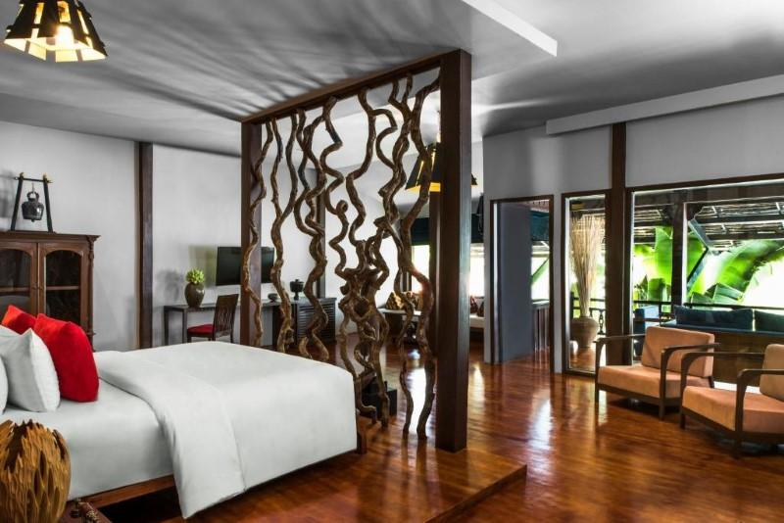
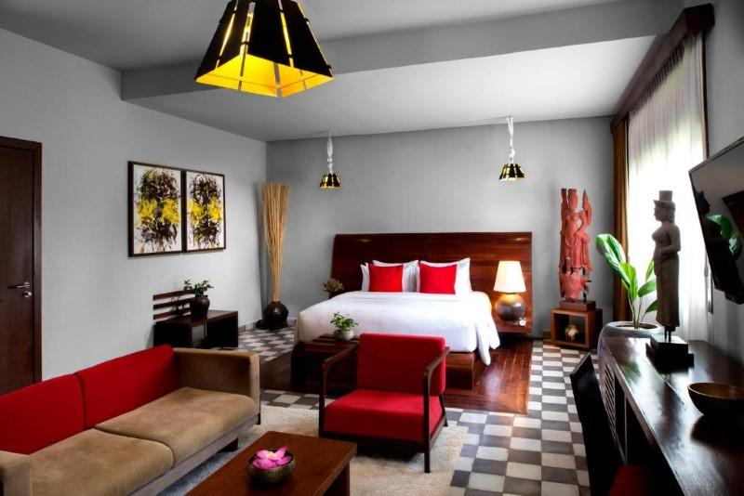
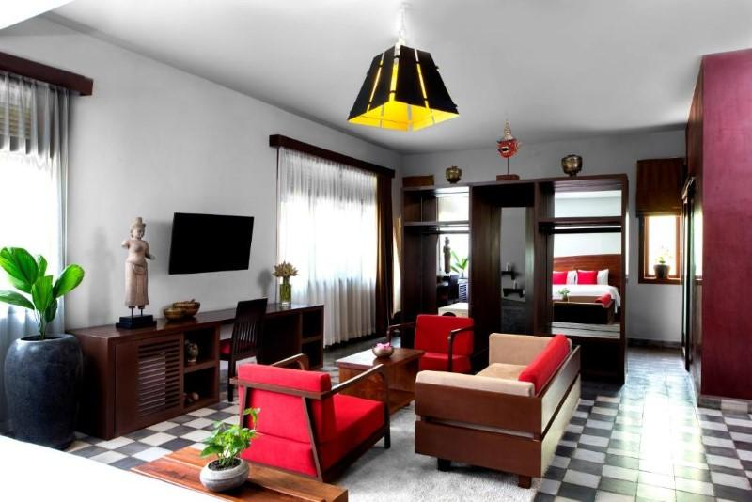
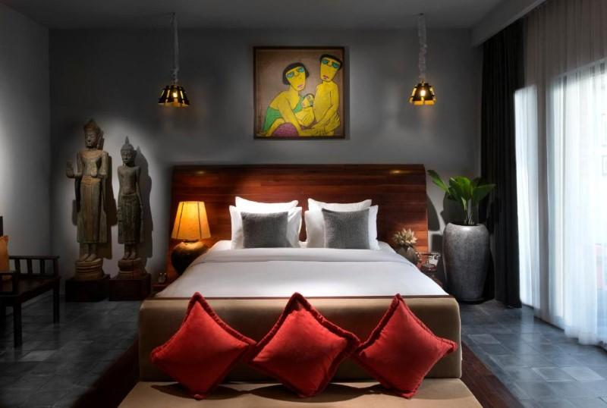
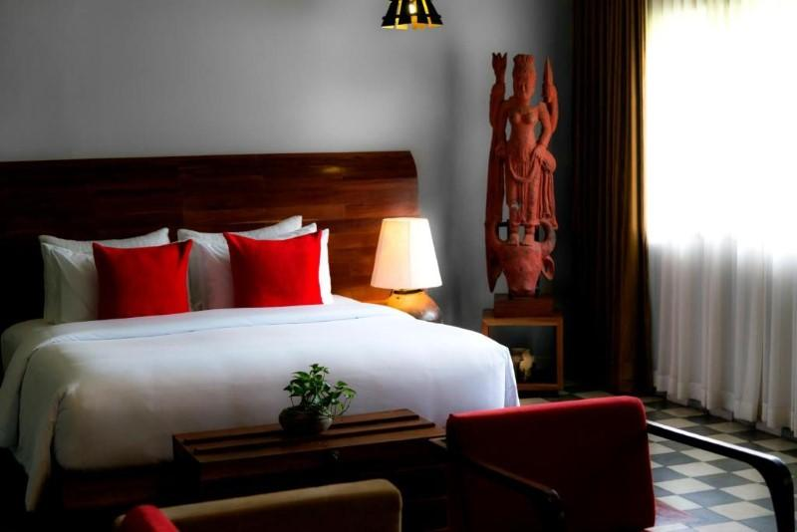
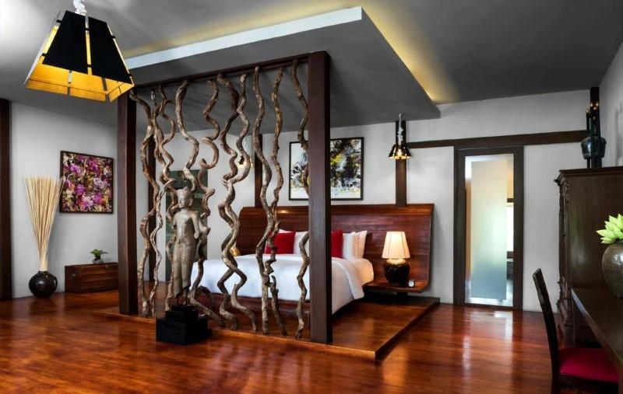
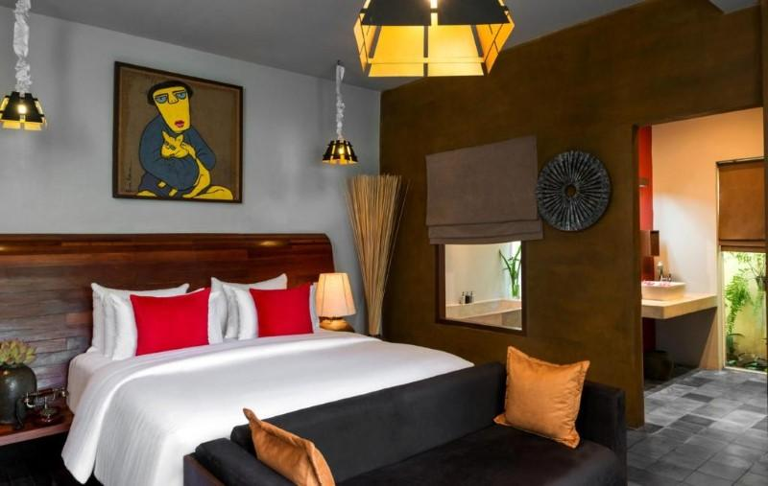
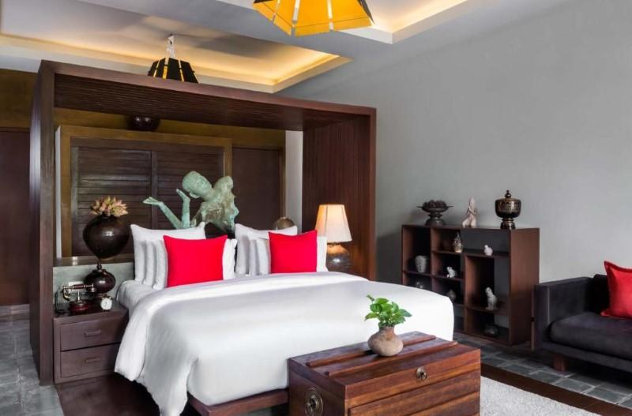

Restaurant photos
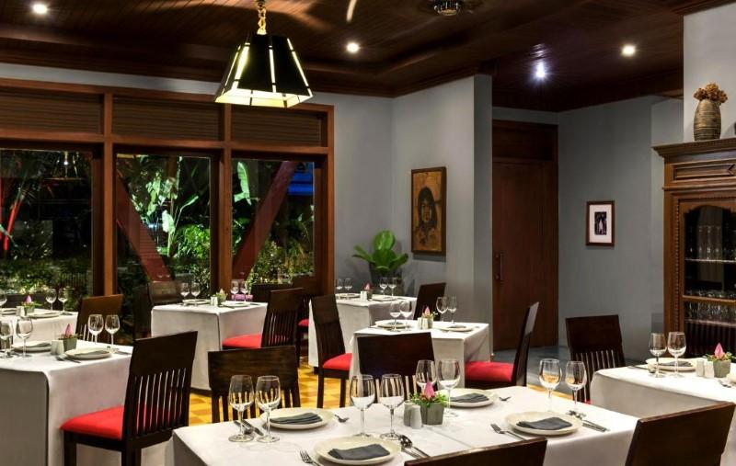
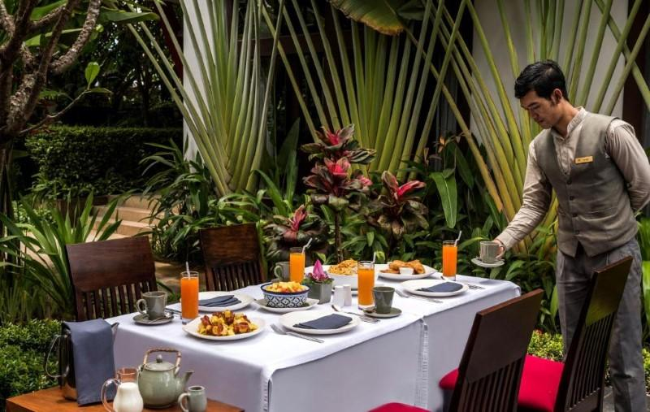
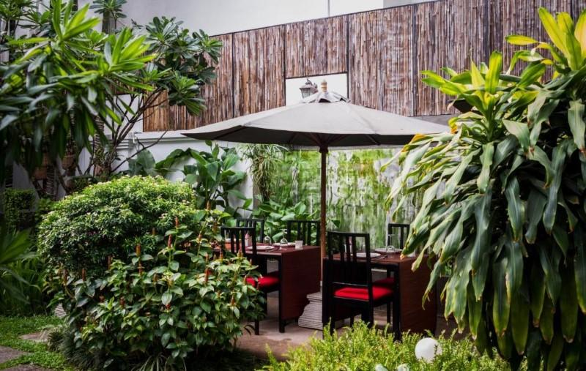
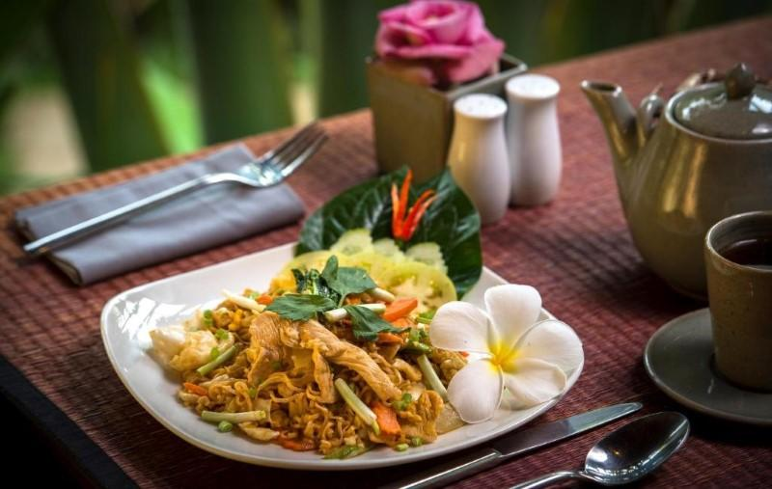

Services & facilities photos
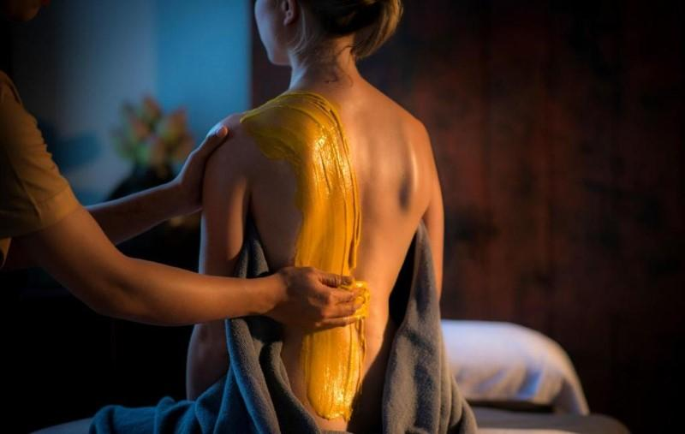
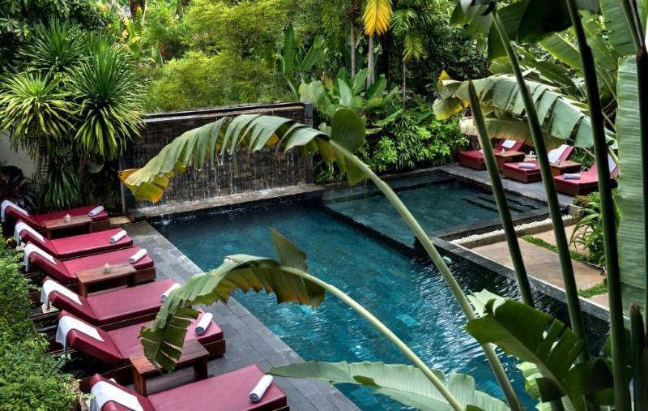
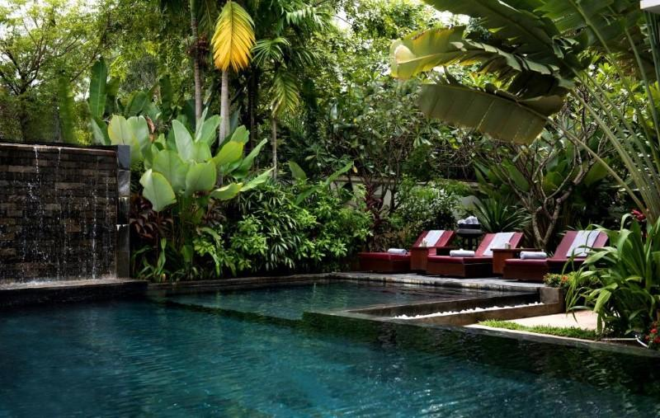
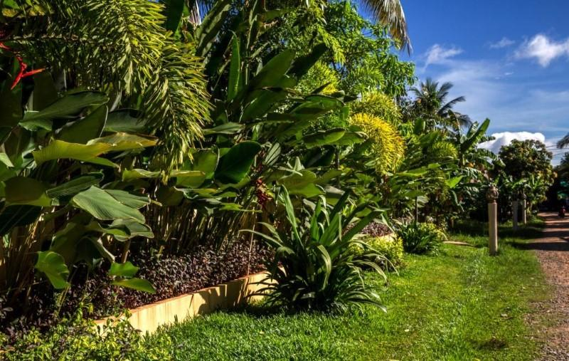
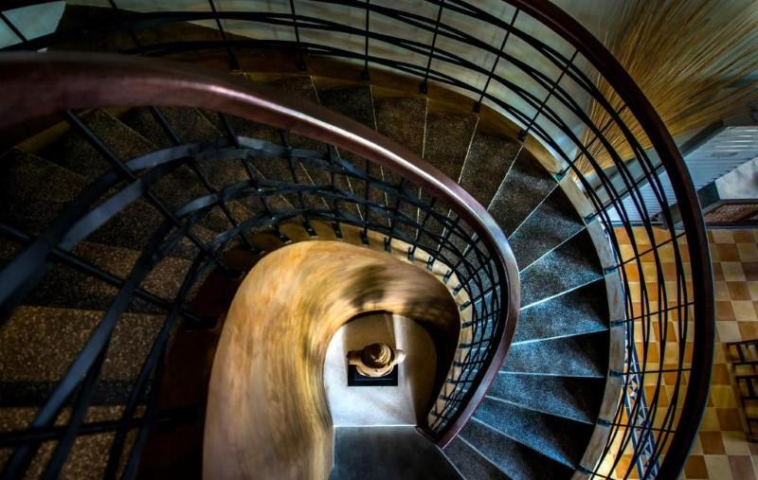
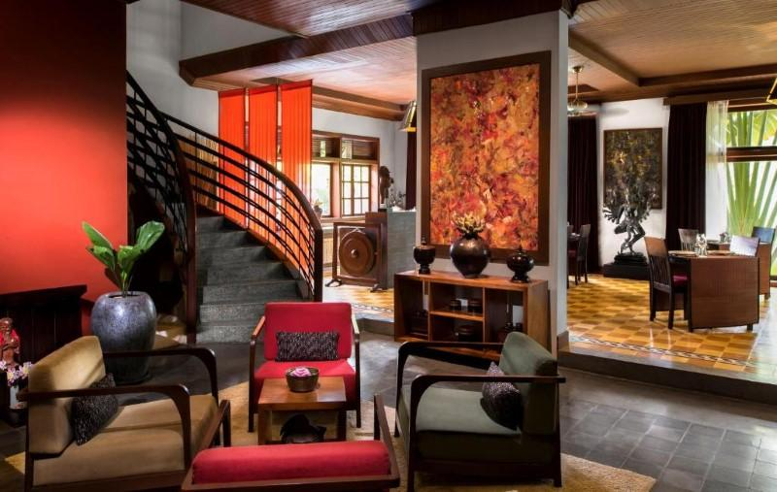
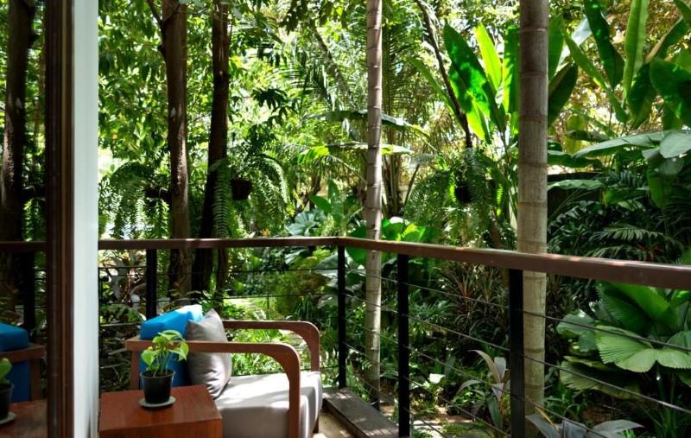
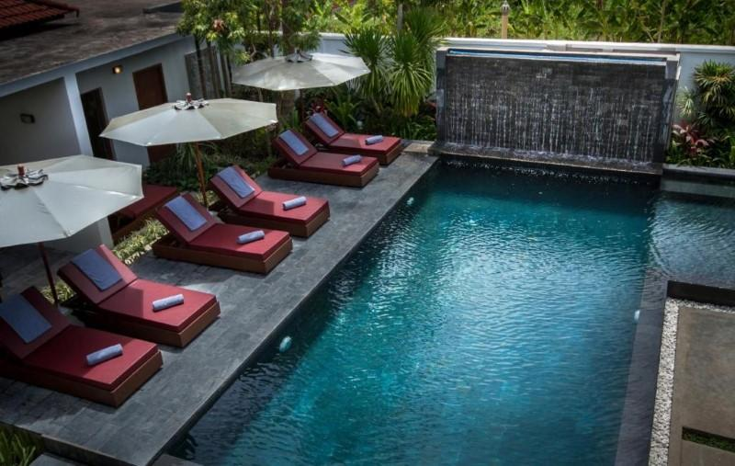
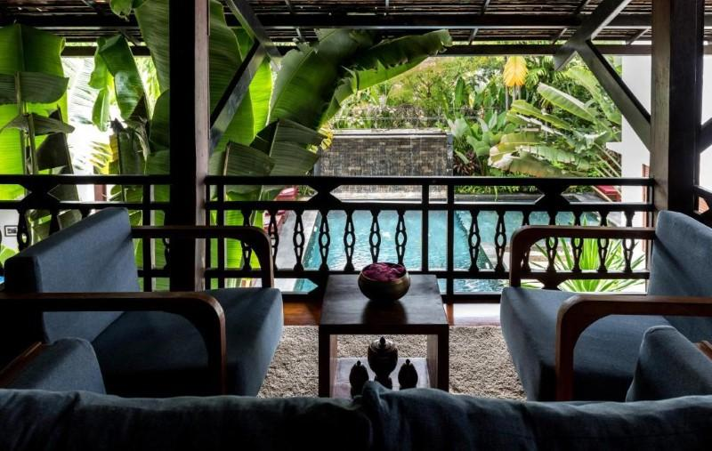
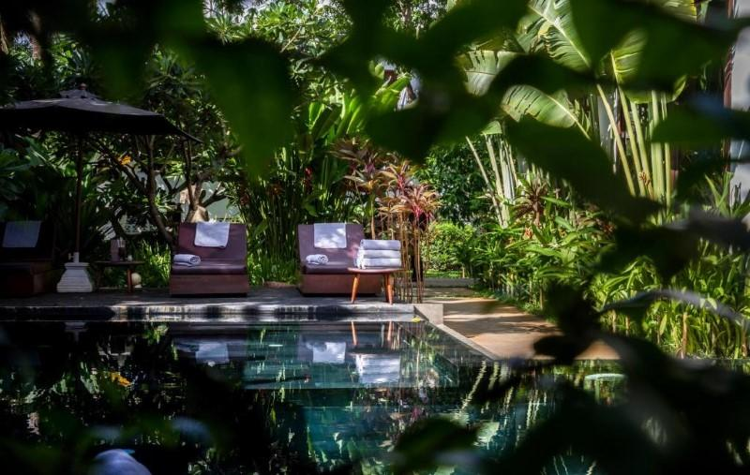

Easia Travel Head Office

