THAILAND – Koh Tao – The Haad Tien Beach Resort
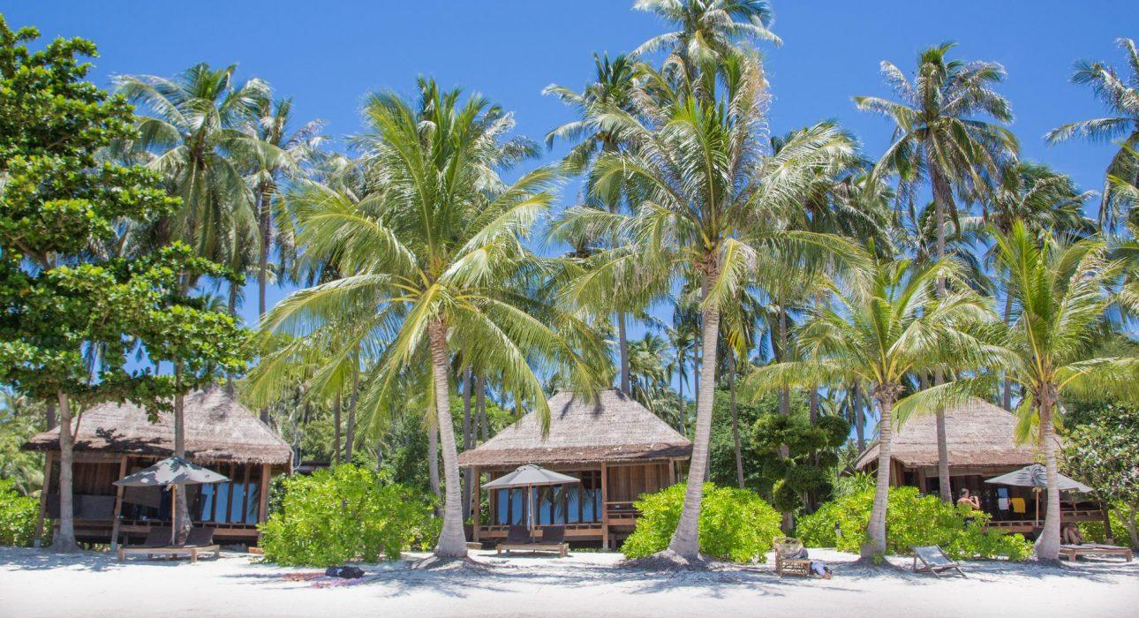

Over View

Theme
Beach Stay, Honeymoon

Country - City
Thailand - Koh Tao

Market segment
Thematic Leisure

Official category
4*

Easia category
First Class

Price level
$

Description

Boutique charm nestled upon golden swathes of beachfront awaits you at Haad Tien Beach Resort on the southern tip of Koh Tao. With a 380-meter beach to call its own, the resort has limited its accommodations to just 70 private villas, spaced thoughtfully throughout 45 acres of lush, tropical greenery. Excellent amenities and gold-standard service come together with sleek design and furnishings to create a unique experience. Carbon-neutral practices such as home-grown produce and natural resources allow the resort to existing in harmony with its surroundings.First-class facilities like free wifi, LCD TVs and air-con are available to make your stay as comfortable as possible. Holistic therapies at the spa center add to a philosophy of true relaxation, embodied by a barefoot approach to luxury.Choose a villa with a private pool or soak up the fun in the resort’s beachfront pool that looks out across the stunning panorama of Haad Tien bay. Stroll along the white beach and bask in the warm weather. The clear blue bay lends itself perfectly to watersports – from the leisurely to the adventurous – try swimming, kayaking, or PADI-certificate diving.

Selling points

- Barefoot luxury on unique Tao island
- Property overlooking Gulf of Thailand

Time & Transportation

The Haad Tien beach resort is at Thian Og Bay (Shark Bay), which lies on the southeast corner of Koh Tao, sheltered from the prevailing winds meaning that the weather is great throughout the year. The resort is approximately twenty-minutes by taxi from the ferry port of Mae Haad, or twenty-five minutes by taxi boat.If you want to get to Koh Tao the quickest and most comfortable route is via Koh Samui.Bangkok Airways have scheduled services departing from Bangkok, Krabi, Phuket, Singapore and Kuala Lumpur.

Rooms

Easia's recommend room type
HIDEAWAY VILLA : 40 sqm / king bed only / max guest 2+1 ( 2 adult + 1 child )Hideaway villas are nestled amongst the lush natural forest of a 45-acre private estate. Individual villas setin the coconut plantation with stunning view, Private balcony and outdoor furniture 40 sq. metres of living space,private balcony King-sized bed LCD TV with satellite channels & DVD player with a complimentary.GETAWAY VILLA : 40 sqm/king bed only / max guest 2+1 ( 2 adult + 1 child )Haad Tien’s interpretation of the perfect beach bungalow, meticulously designed in harmony with our concept of barefoot luxury. Stunning View and located within close proximity to the beach 40 sq. metres of living space Oversized outdoor 6ft by 6ft covered day bed with comfy throw pillows King-sized bed 36”.HAADTIEN VILLA : 55 sqm.king bed onlymax guest 2+1 ( 2 adult + 1 child )Haad Tien’s interpretation of the perfect seaside villa… Stunning views and located within close proximity to the beach 55 sq. metres of living space Oversized outdoor 6ft by 6ft covered day bed with comfy throw pillows King-sized bed 36” LCD TV with satellite channels & DVD player.CASTAWAY BEACH VILLA : 40 sqm / king bed only / max guest 2+1 ( 2 adult + 1 child )Haad Tien’s interpretation of the perfect seaside villa… Stunning sea views and located within close proximity to the beach 55 sq. metres of living space Oversized outdoor 6ft by 6ft covered day bed with comfy throw pillows King-sized bed 36” LCD TV with satellite channels & DVD player.CASTAWAY BEACH FAMILY VILLA : 60 sqm / king bed only / max guest 2+2 ( 2 adult + 2 child )Escape to a coconut-fringed white coral beach with crystal clear turquoise waters and beautiful marine life just footsteps away from your very own private villa. Stunning beachfront location complete with a pair of private oversized deck chairs & umbrella in front of each villa 40 sq. metres of living space.HAADTIEN POOL VILLA : 82 sqm / king bed only / max guest 2+1 ( 2 adult + 1 child )The ultimate seaside pool villa, the Haadtien Pool Villa offers total comfort and privacy with breath-taking views of the bay. Stunning views and located within close proximity to the beach 82 sq. metres of living space, with private pool Oversized outdoor 6ft by 6ft covered day bed with comfy.GETAWAY FAMILY POOL VILLA : 130 sqm / king bed only / max guest 2+2 ( 2 adult + 2 child )Haadtien’s interpretation of the perfect family seaside villa with two separate bedrooms each with ensuite bathrooms, its own private swimming pool, and a large deck for family fun and relaxation Stunning beach view and located not far from the beach 130 sq. metres of living space, with private pool.

Room configuration

Connecting rooms
-

Extra bed
Yes

King bed
Yes

Services & Facilities

Services
Car rental, Diving, Massage, Snorkeling, Spa, Swimming Pool, Wi-fi Free, Water Activities

Facilities
Air Conditioning, Bar, coffee and tea making facilities, Hair Dryer, Private Pool, Restaurant, satellite LCD TV

Restaurant information

- INSEA BAR & GRILL (Thai & International Cuisine A la carte menu).
- THE BEACH BAR.
- CAPRI RISTORANTE ITALIANO (Italian Bistro).

Photos

Hotel Photos
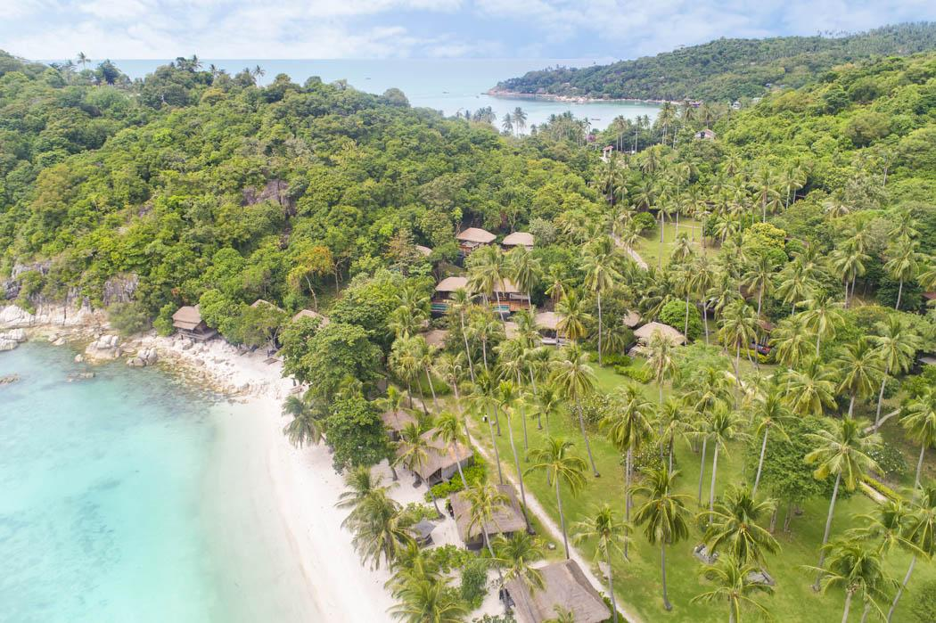
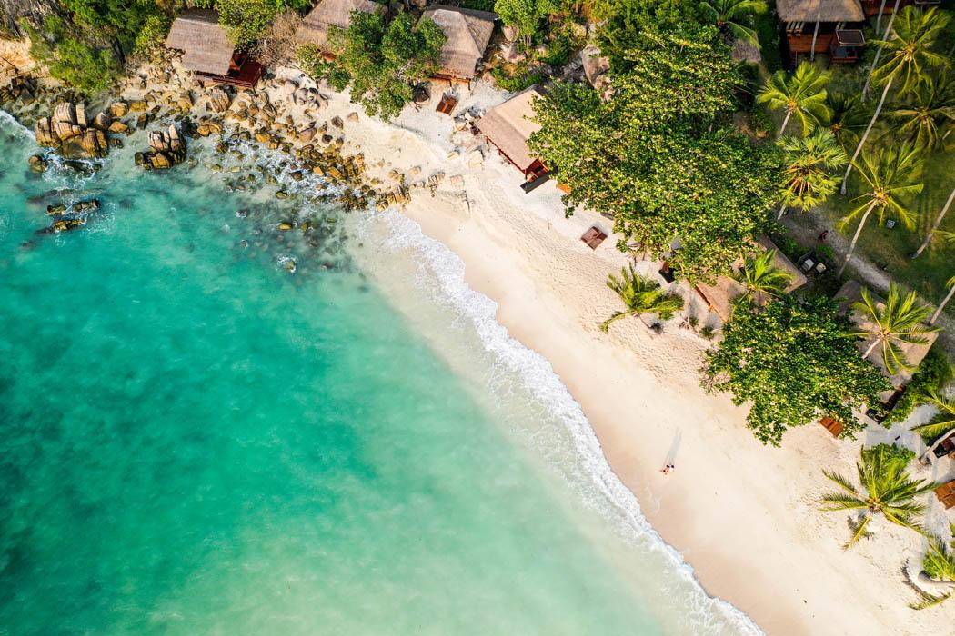
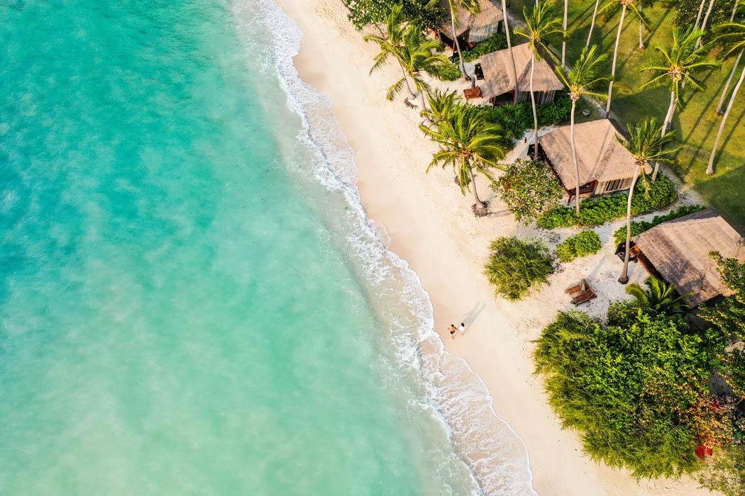
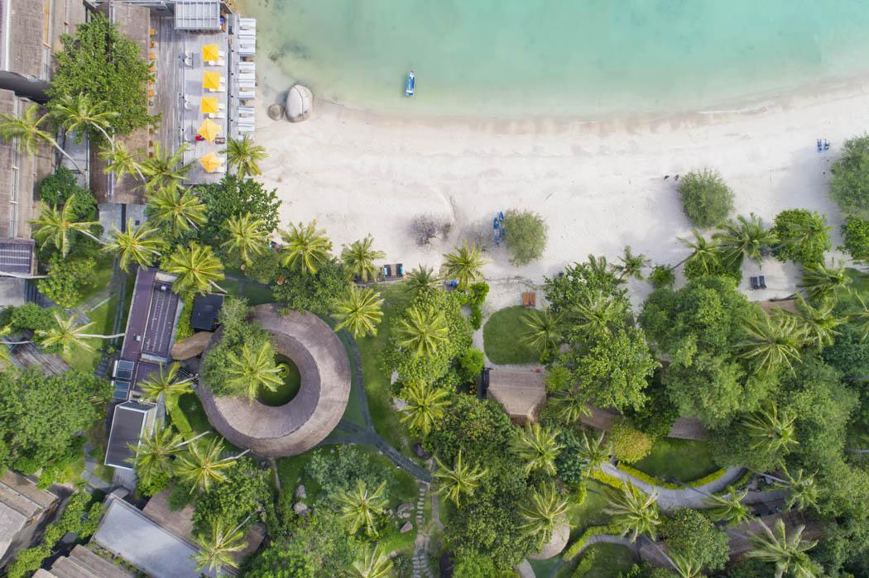

Rooms photos
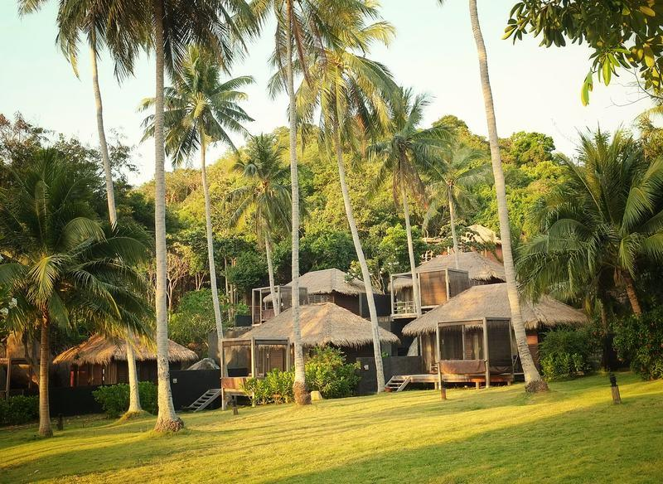
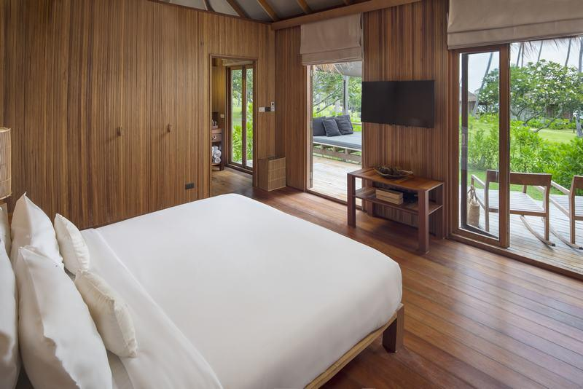
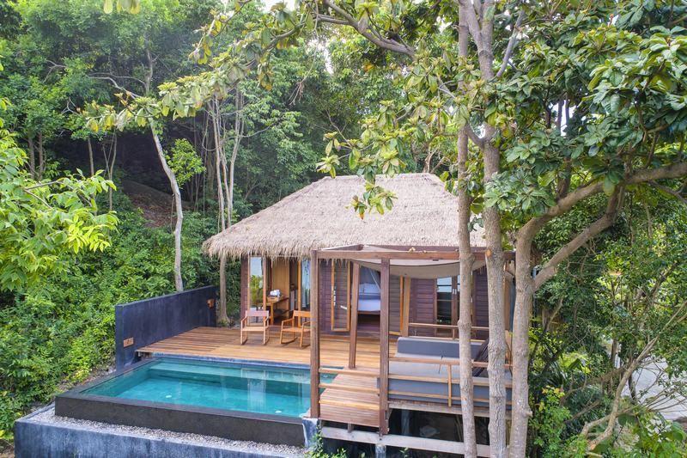
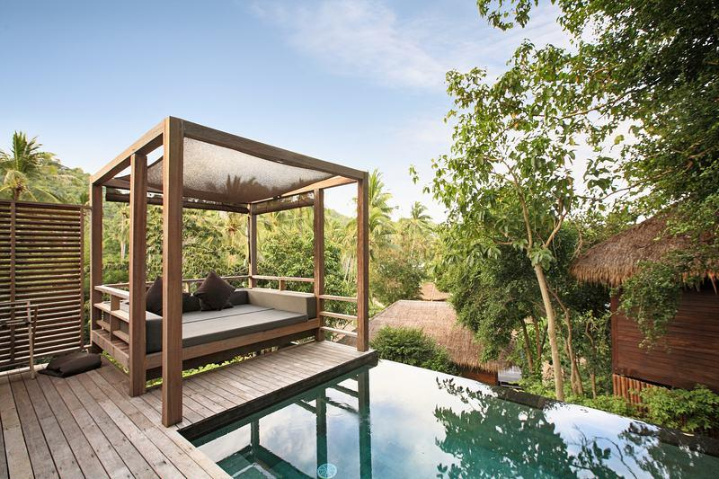
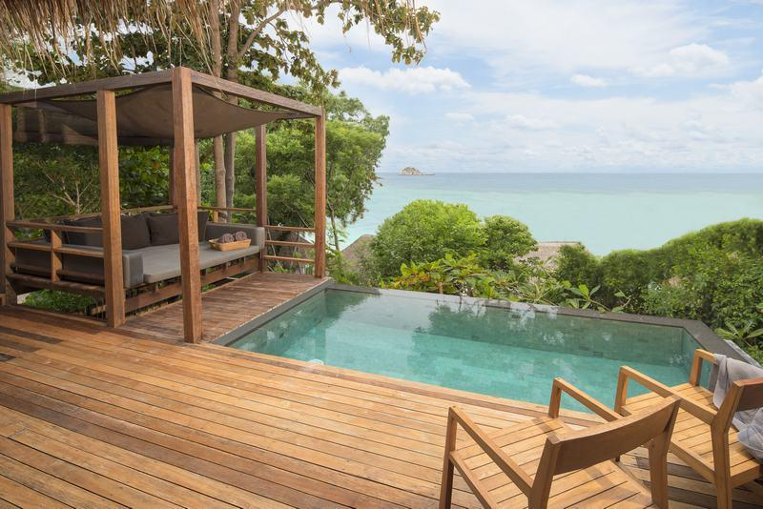
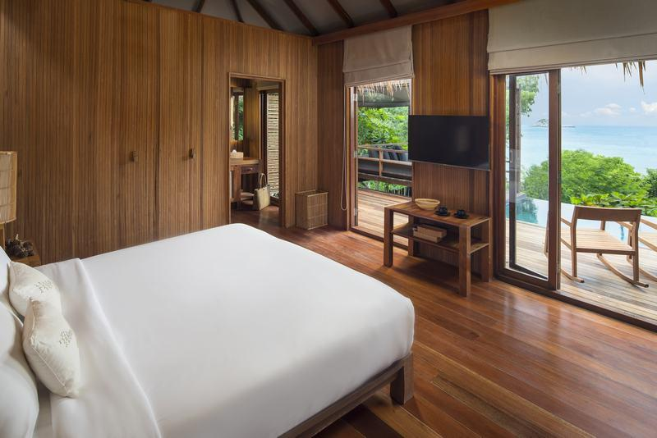
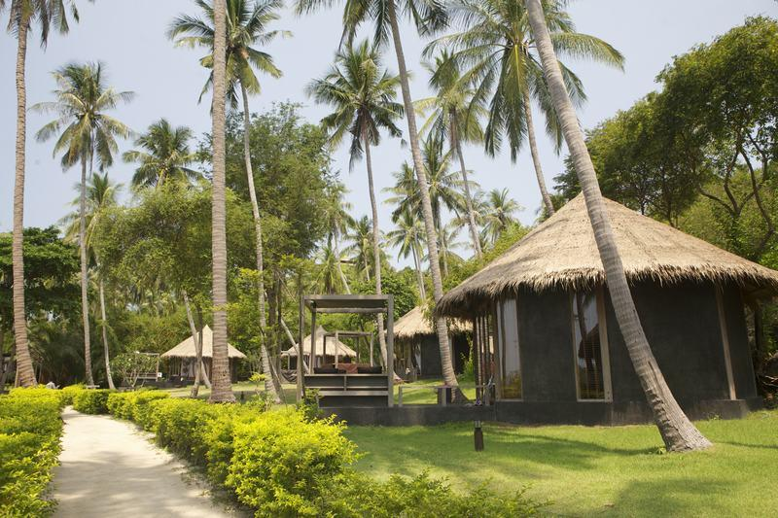
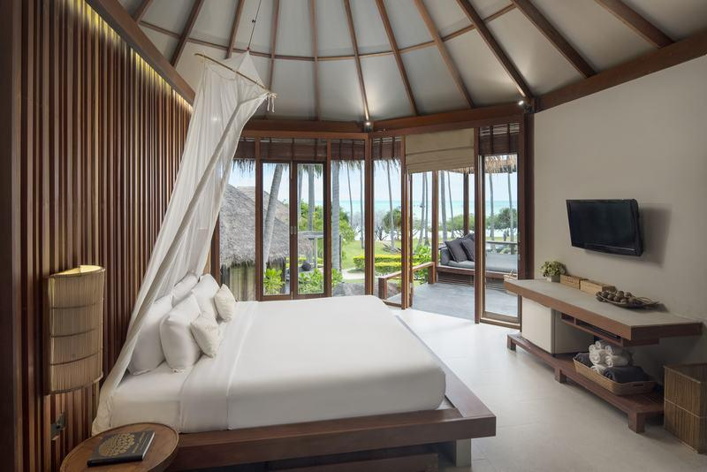
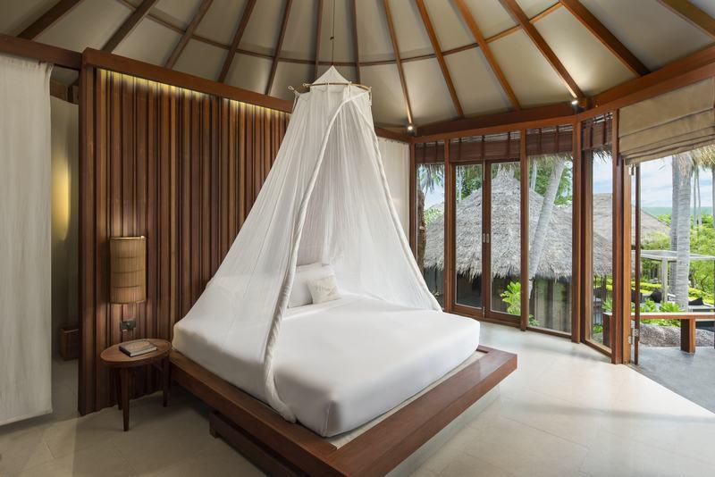
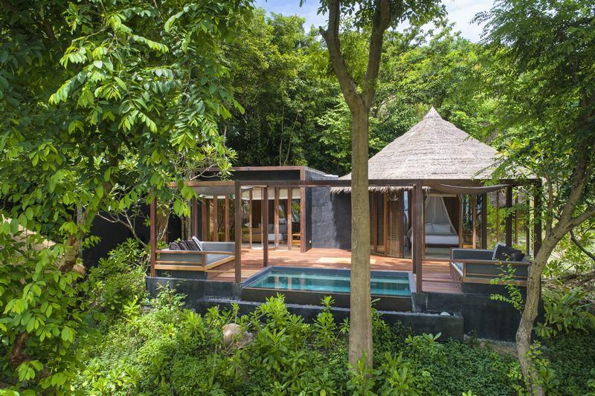
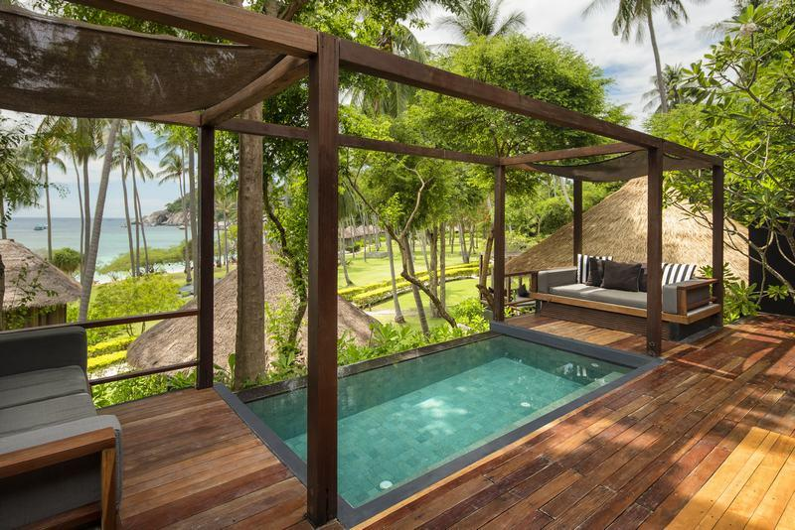
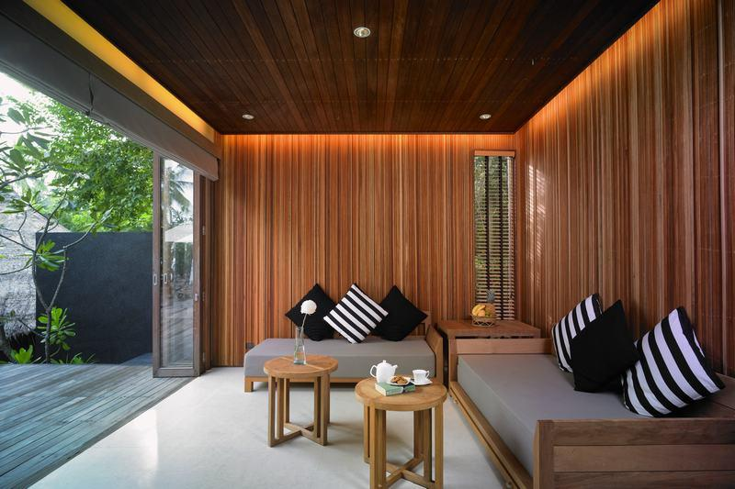
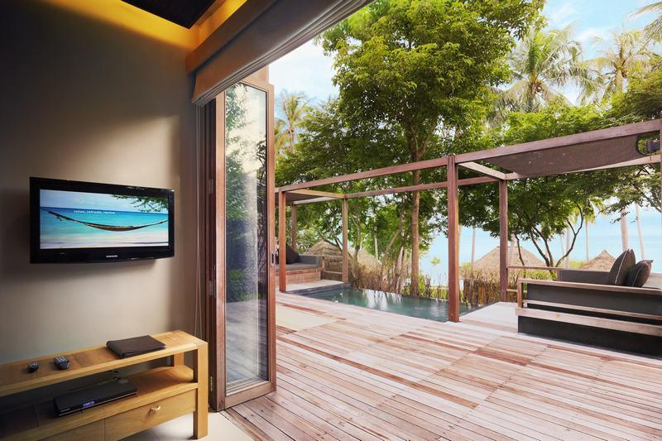
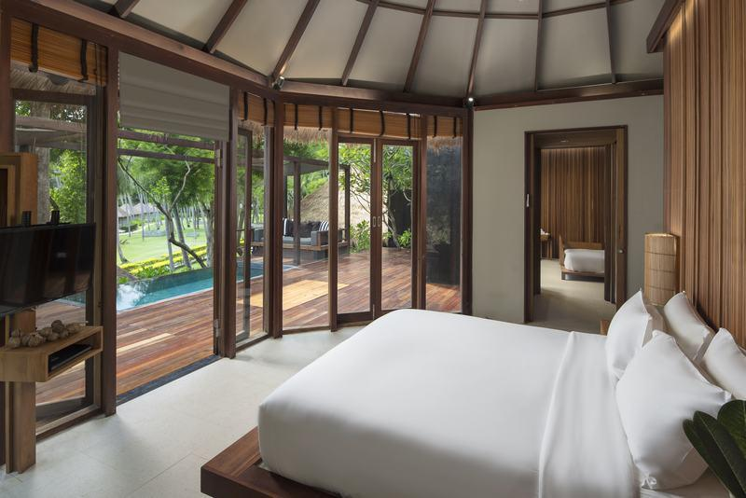
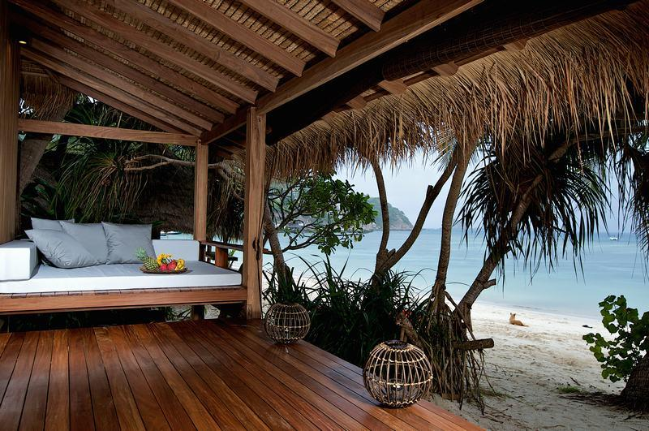
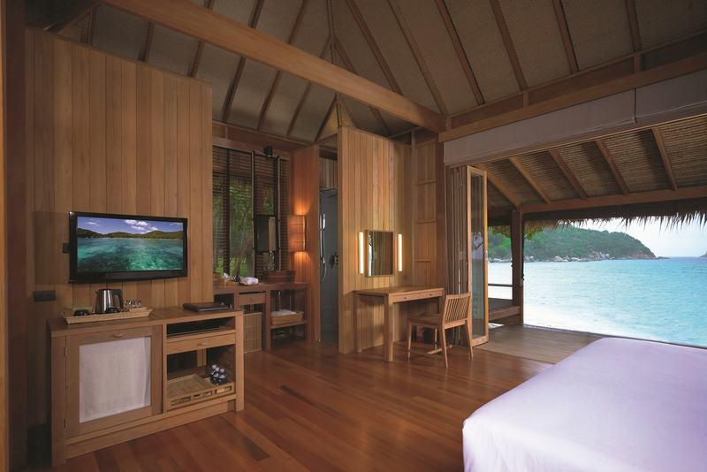
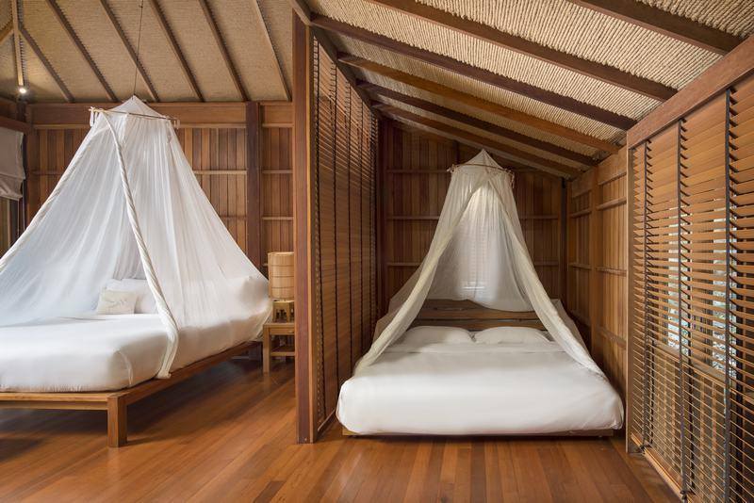
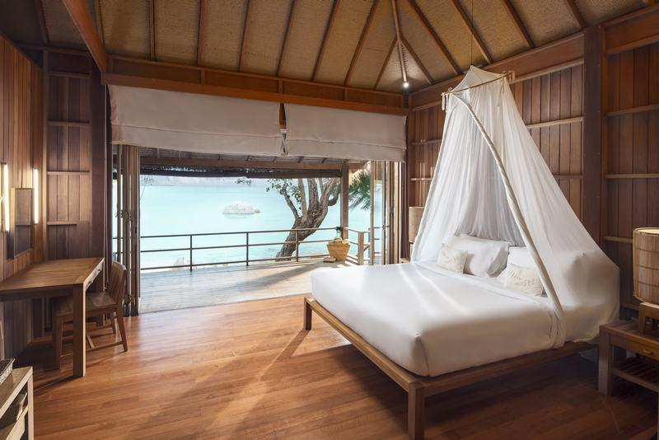

Restaurant photos
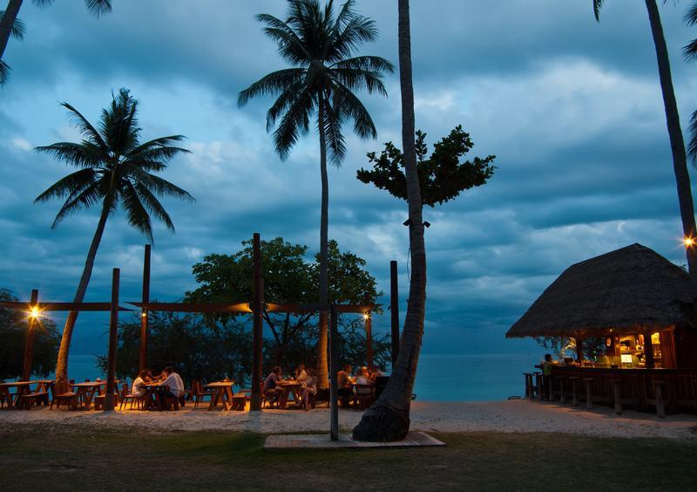
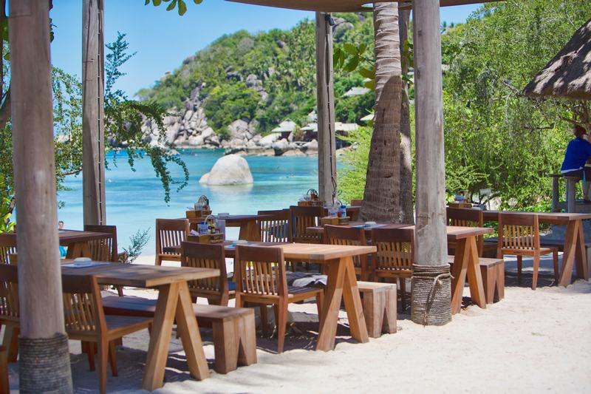
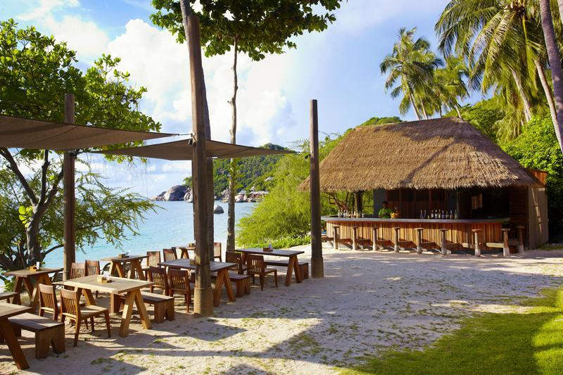
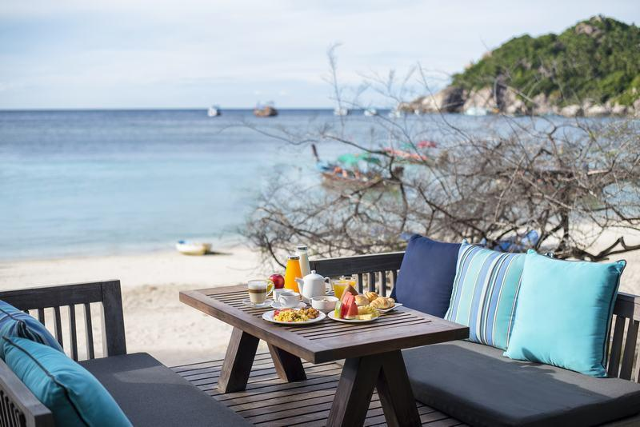
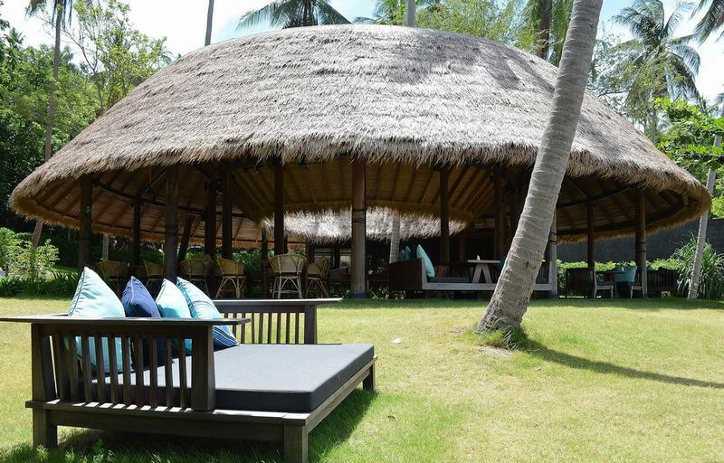
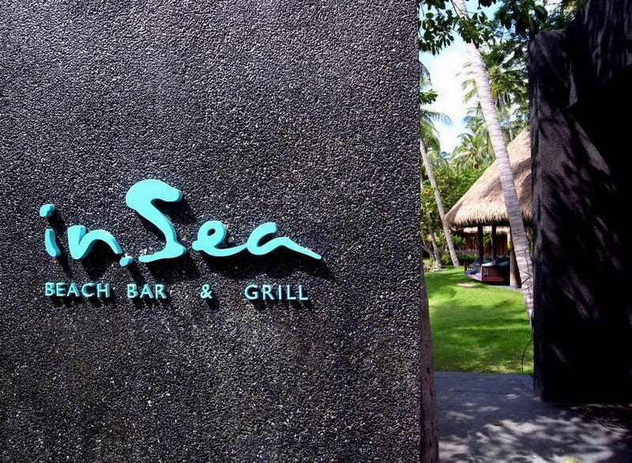

Services & facilities photos
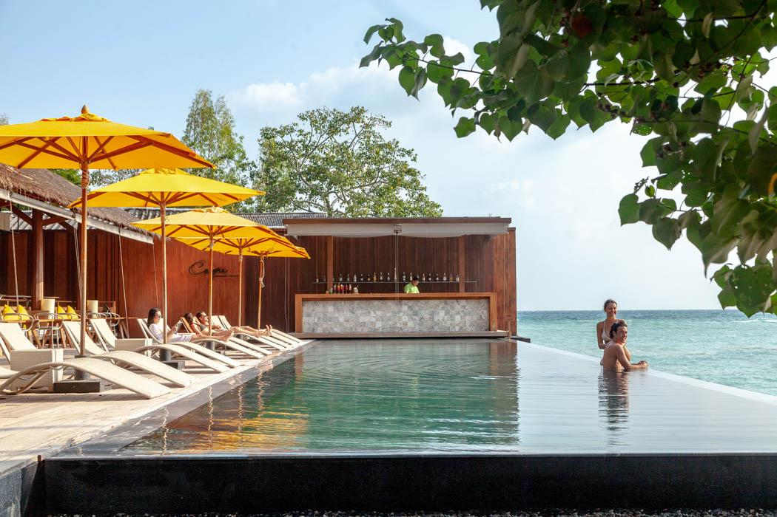
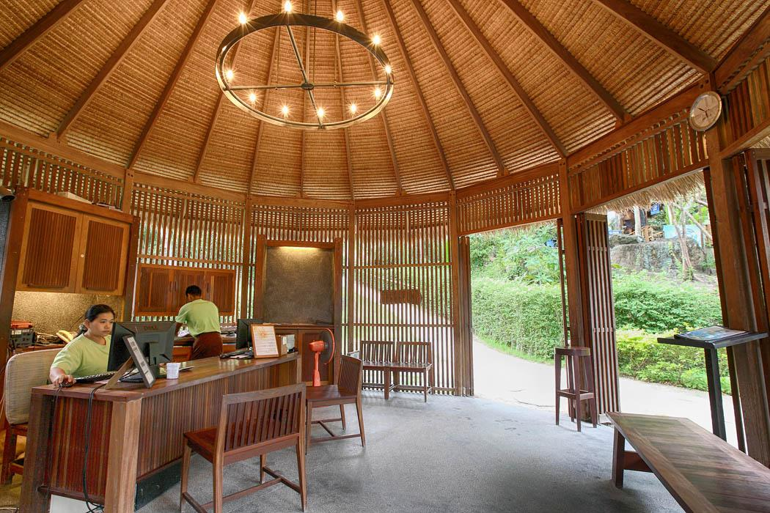
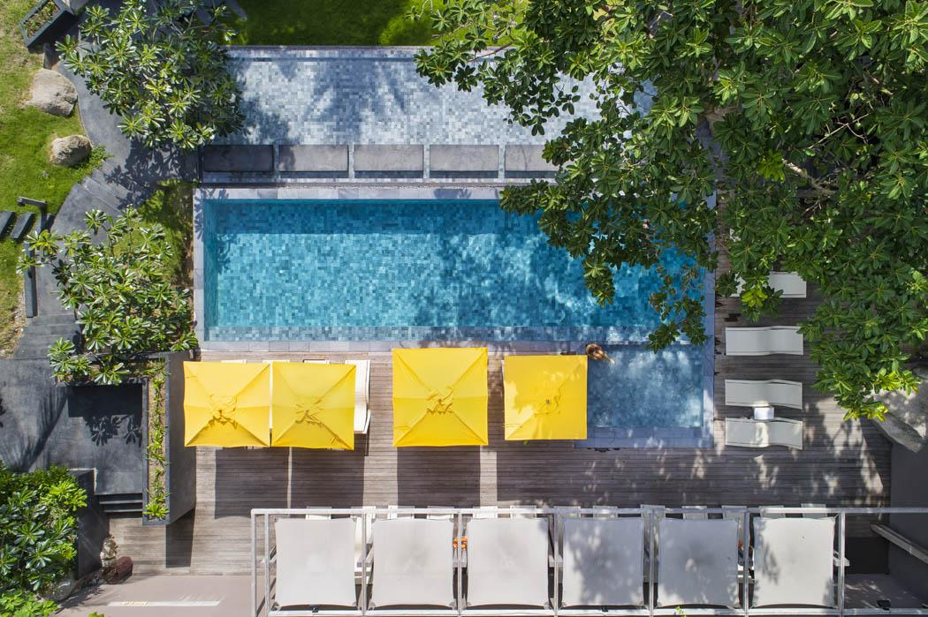
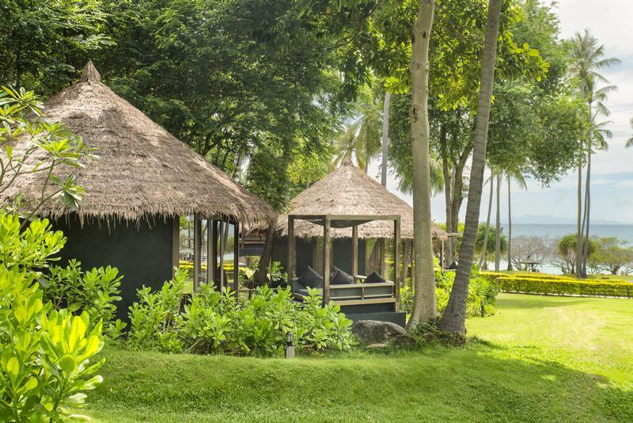
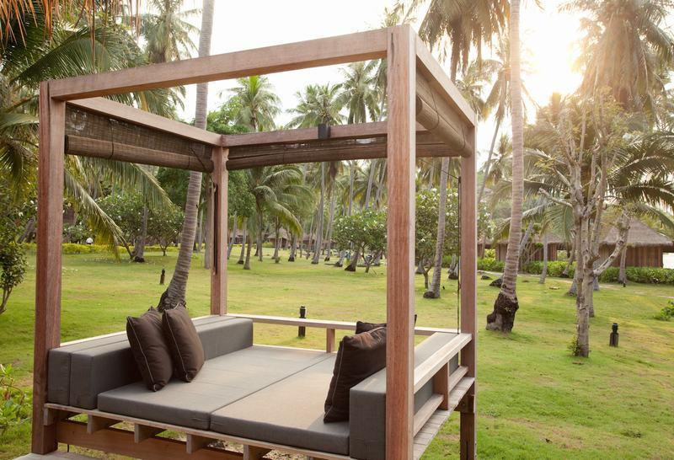

Easia Travel Head Office

