CAMBODIA – Battambang – Cambana La Riviere Hotel
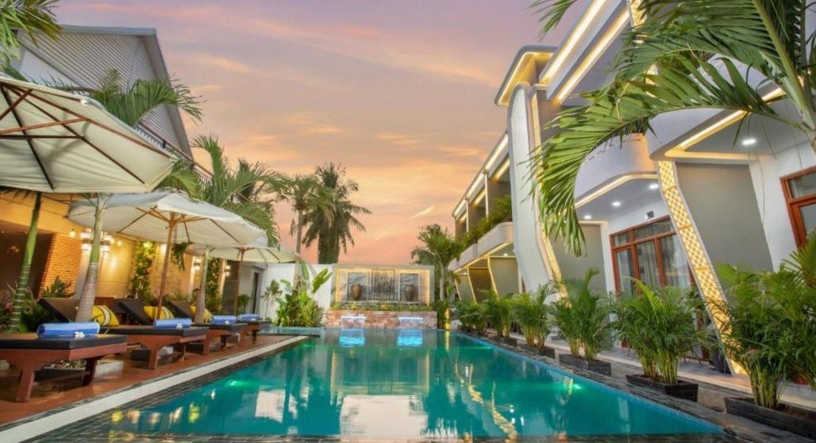

Over View

Theme
Classic, Family, Honeymoon

Country - City
Cambodia - Battambang

Market segment
Groups, Thematic Leisure

Official category
4*

Easia category
Superior

Total number of rooms
13

Price level
$$$$

Description

Located in Battambang city, Cambana La Riviere Hotel is 500 m from Colonial building which is the city center of this city. Cambana La Riviere Hotel features accommodation with a restaurant, free private parking, an outdoor swimming pool, and a bar.The hotel features with 13 air-conditioned rooms, a-24 hour front desk and room service. Room comes with air conditioning, a desk, a balcony with a view, a private bathroom, a flat-screen TV, bed linen and towel, and safety deposit box. The rooms will provide guests with a wardrobe and a kettle. Breakfast at Cambana La Riviere Hotel offers a continental or buffet breakfast. Guest can workout at the fitness center or relaxing with massage at Spa in this hotel. Also guest can enjoy with a refreshing cocktail and mocktail or another drink at poolside bar. Free WIFI is provide throughout the property.

Selling points

- Charming hotel in Battambang city
- Rooms are very nice design and decor
- Spacious and very clean room
- Friendly service and very helpful staff
- Only 500 m from Colonial building
- Located in the center of tourist attraction

Sustainability

Supplier Actions
Protection of Environment, Child Protection

Time & Transportation

From | To | By | Distance | Duration | Road condition
Hotel | Battambang Royal Railway Station | Car | 0.90 km | 5 mn | Good
Hotel | Colonial building | Car | 0.50 km | 5 mn | Good
Hotel | Battambang Museum | Car | 0.70 km | 5 mn | Good
Hotel | Phnom Sampeau Bat cave | Car | 14 km | 20 mn | Good

Rooms

Easia's recommend room type
Deluxe King Suite Private BalconyStyle : Modern
- Size : 38 sqm room size
- Unit : 06 units
- Bed : 1 double bed or King size bed1.80 m x 2m
- Extra bed : yes 0.90 m x 1.90 m
- Remark : Private balcony, ensuite bathroom, terrace, city view
Deluxe Family Suite Private BalconyStyle : Modern
- Size : 42 sqm room size
- Unit : 04 units
- Bed : 1 double bed or King size bed 1.80m x 2m and 1 single bed 1.20m x 2m
- Extra bed : yes 0.90m x 1.90m
- Remark : Private balcony, ensuite bathroom, terrace, city view, and pool view
Junior SuiteStyle : Modern
- Size : 50 sqm room size
- Unit : 01 unit
- Bed : 1 double bed or King size bed 1.80m x 2m
- Extra bed : yes 0.90m x 2m
- Remark : Private balcony, ensuite bathroom, terrace, city view
Cambana Royal SuiteStyle : Modern
- Size : 40 sqm room size
- Unit : 01 unit
- Bed : 1 double or king size bed
- Extra bed : Yes 0.90m x 1.90m
- Remark : Private balcony, ensuite bathroom, terrace, city view
Presidential Suite Private BalconyStyle : Modern
- Size : 44 sqm room size
- Unit : 01 unit
- Bed : 1 double or king size bed
- Extra bed : Yes 0.90m x 1.90m
- Remark : Private balcony, ensuite bathroom, terrace, city view

Room configuration

Connecting rooms
No

Extra bed
Yes 0.90m x 1.90m

King bed
1.80m x 2m

Queen bed
No

Twin beds
1.20m x 2m

Services & Facilities

Services
24 hour reception, 24h security service, Babysitting, Buffet Breakfast, Children Swimming Pool, Complimentary bottle of water, Complimentary fresh towel, Credit Card payment, Dry Cleaning, Iron, Laundry service, Luggage Storage, Massage, Mobile phone, Room Service, Spa, Swimming Pool, Wake-up service, Wheelchair, Wi-fi Free

Facilities
Air Conditioning, Bar, Children Pool, coffee and tea making facilities, Disabled Facility, Family Room, Fan, Fitness centre, Flat screen TV, Free private parking, Hair Dryer, In-Room safe, Internet, Massage room, Outdoor swimming pool, Restaurant, Safety Box, satellite LCD TV, Shower With Hot Water, Terrace, Umbrella

Disabled Facilities
Outside access, Rooms are adapted

Restaurant information

Cambana Restaurant & BarOffer Asian and Western dish. Breakfast is exceptional.Capacity : 35 seatsBreakfast : 6:30 AM – 10:00 AMLunch : 11:30 AM – 2:00 PMDinner : 6:00 PM – 9:30 PMRoom Service : 11:30 AM – 9:30 PM

Photos

Hotel Photos
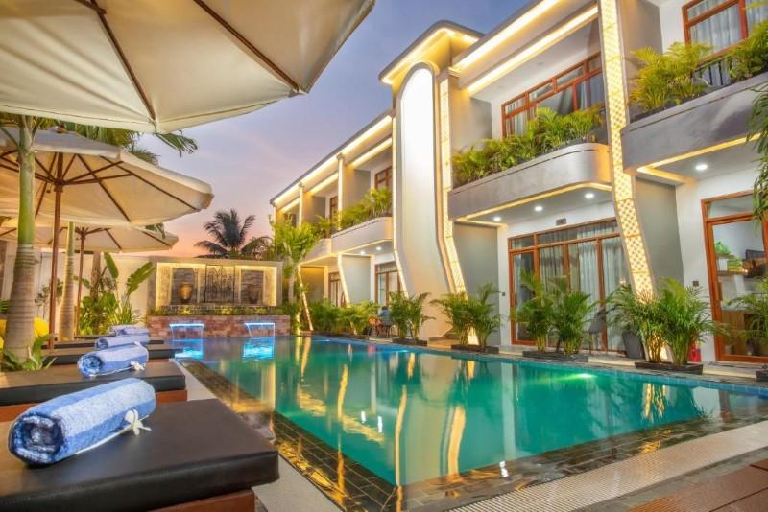
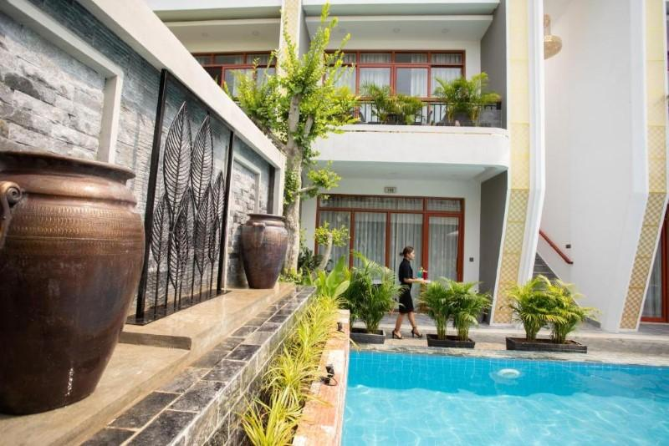
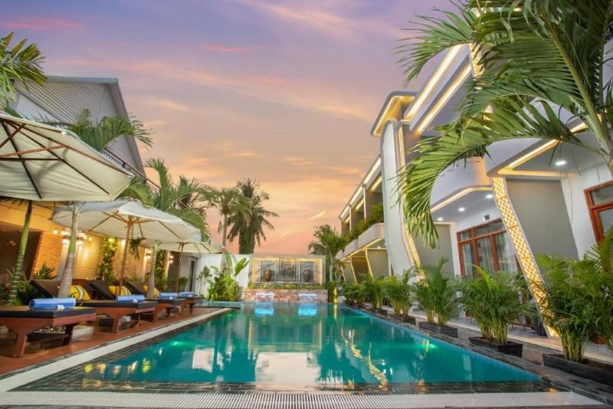
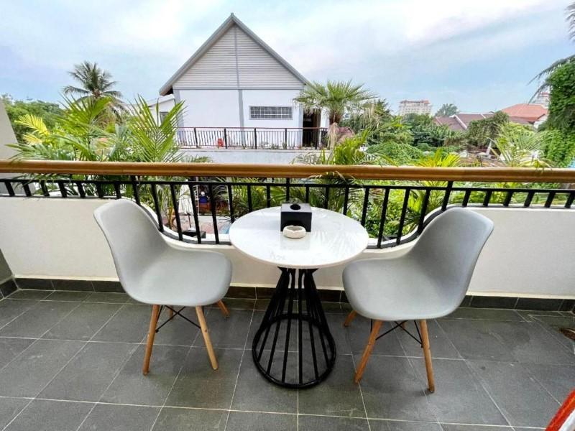
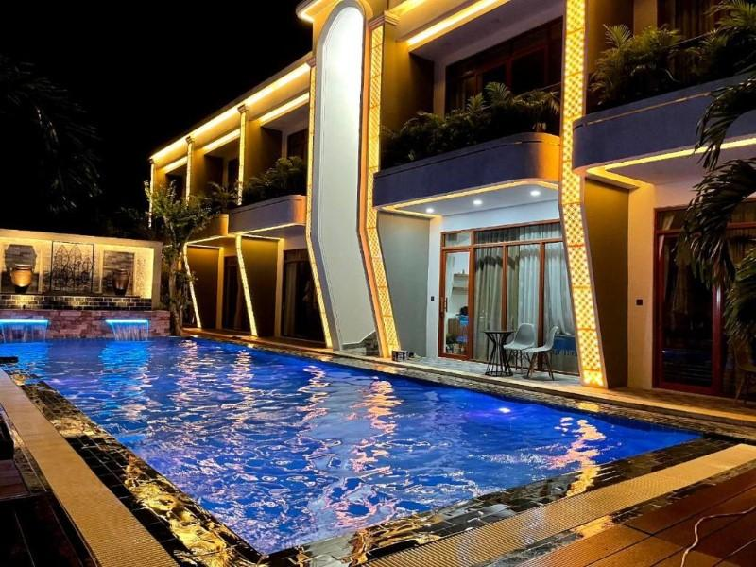
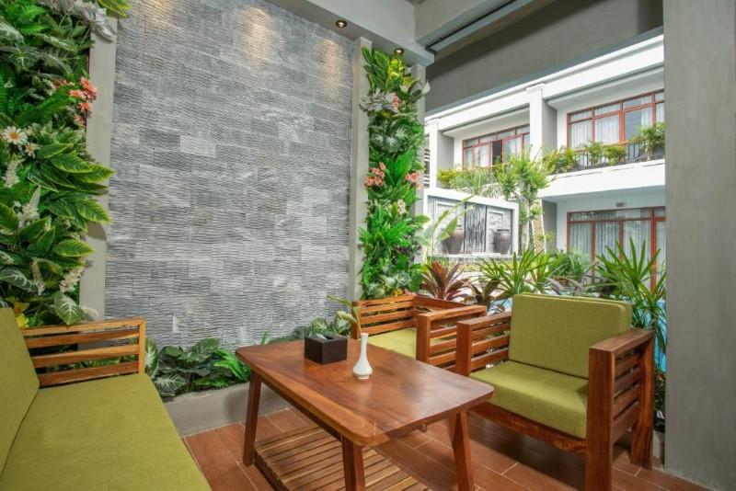

Rooms photos
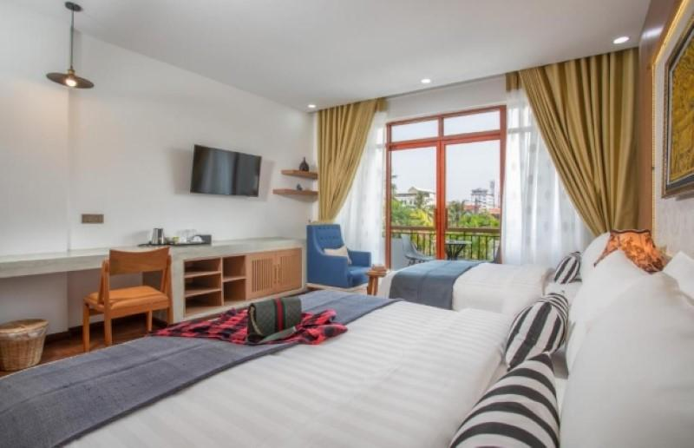
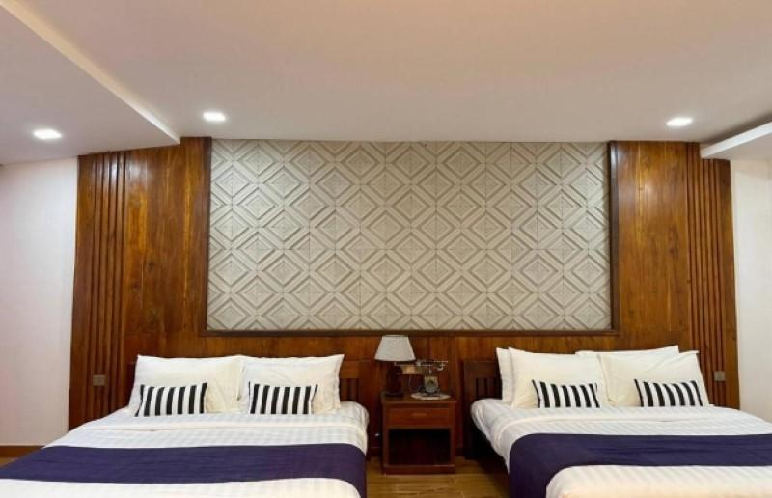
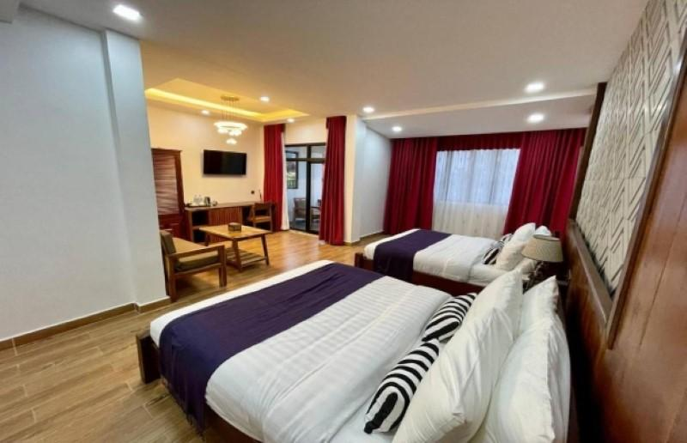
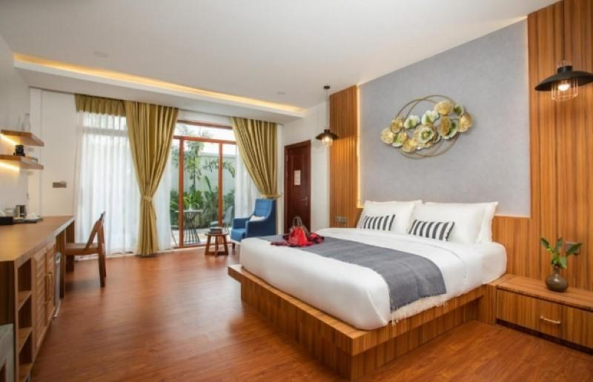
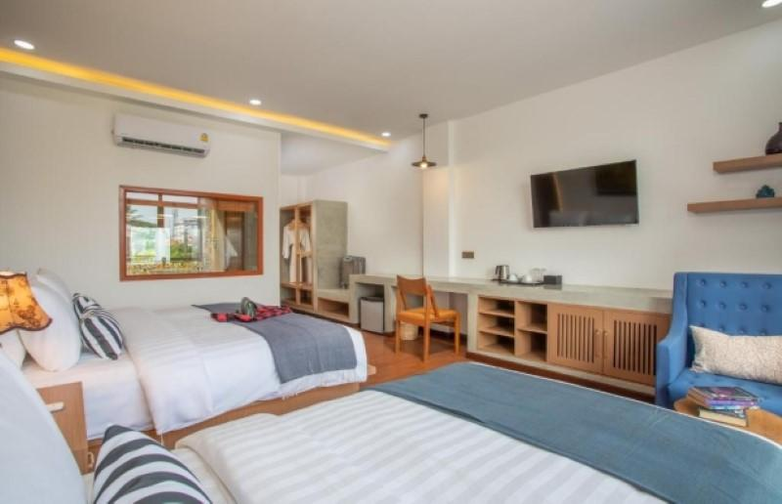
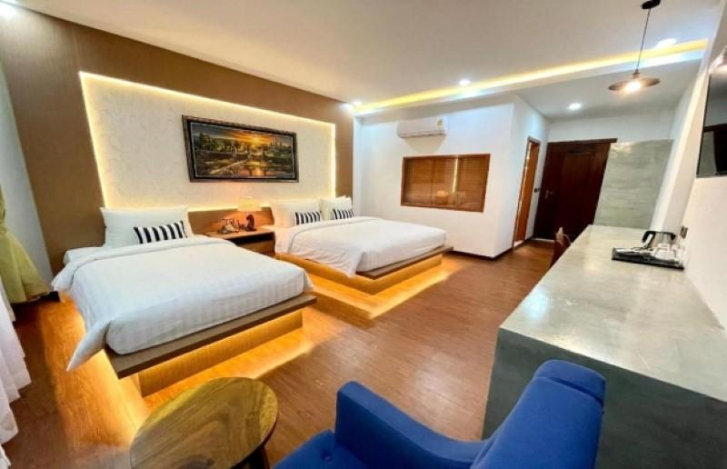
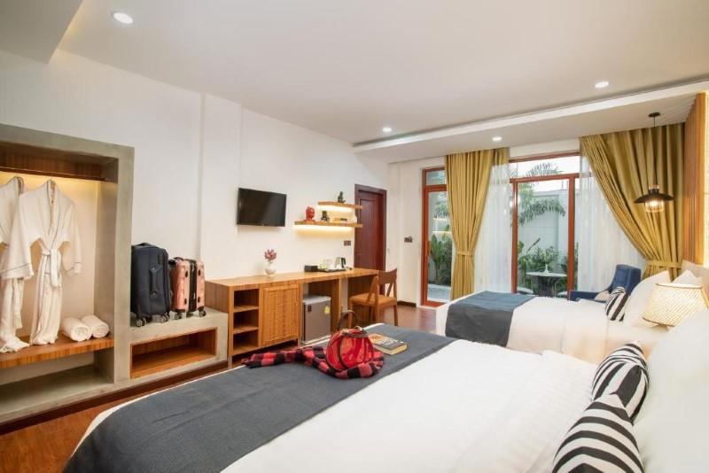
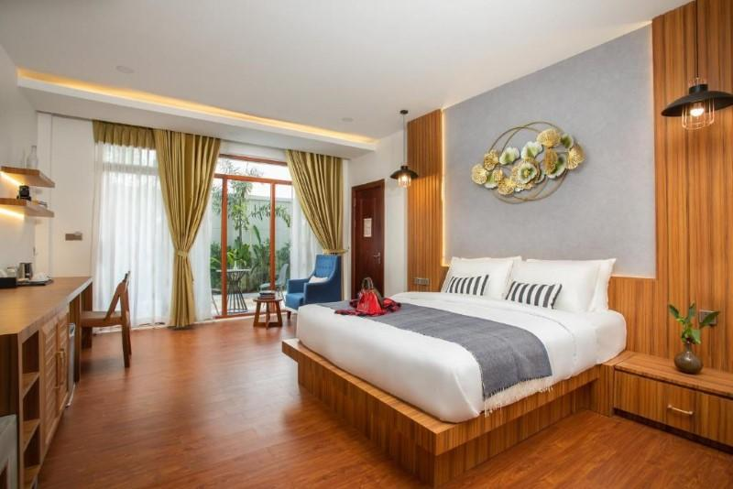
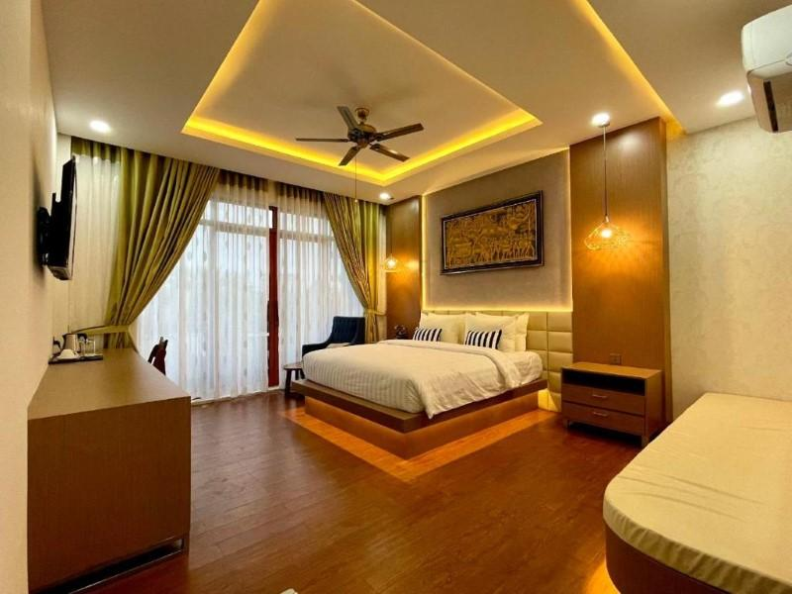
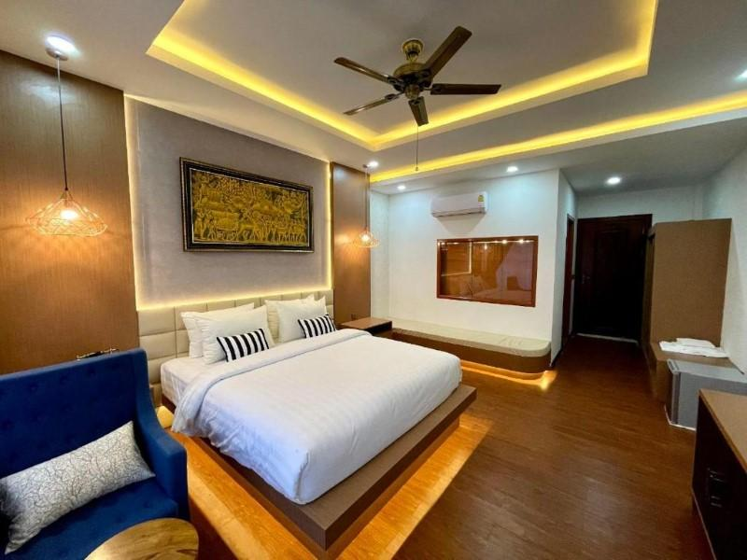
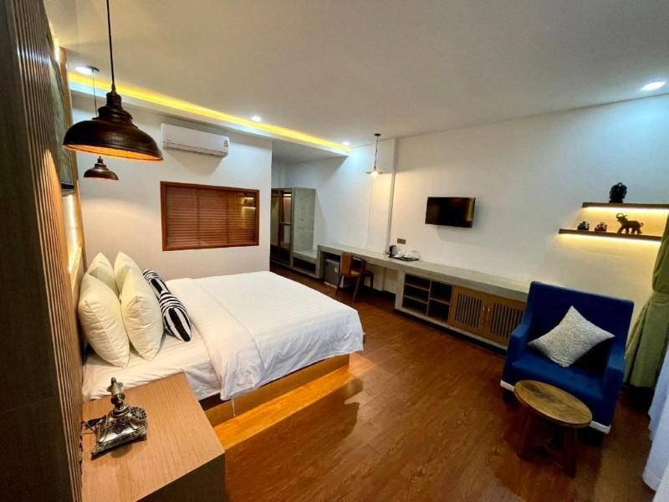
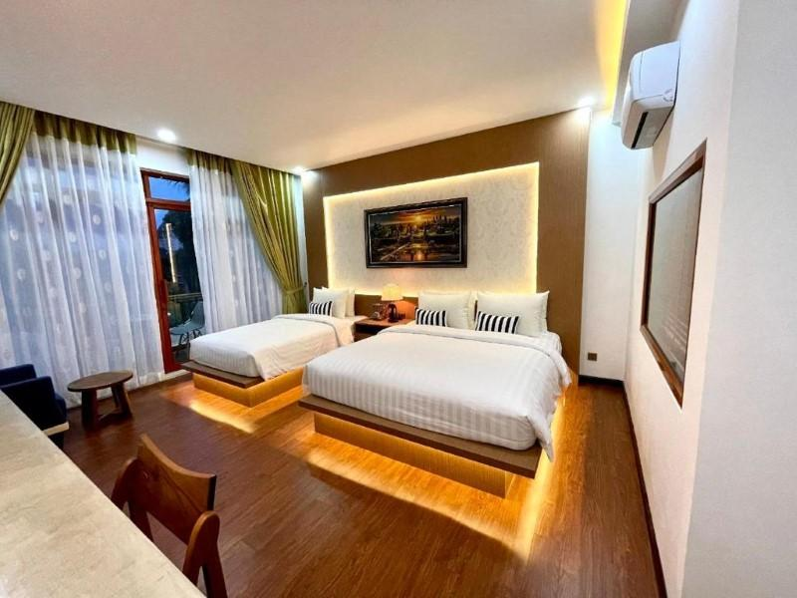
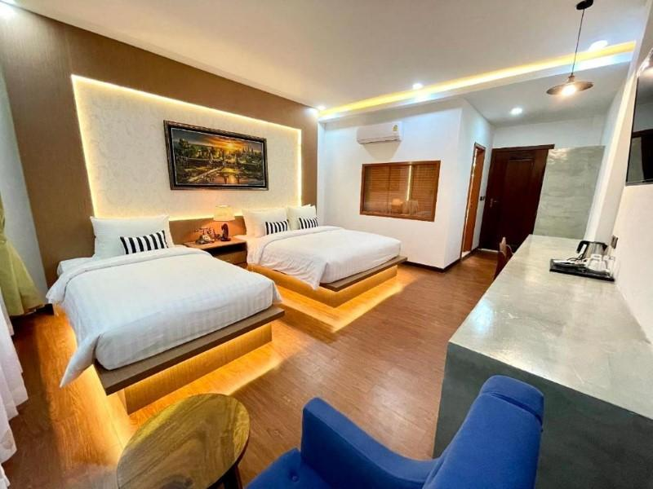

Restaurant photos
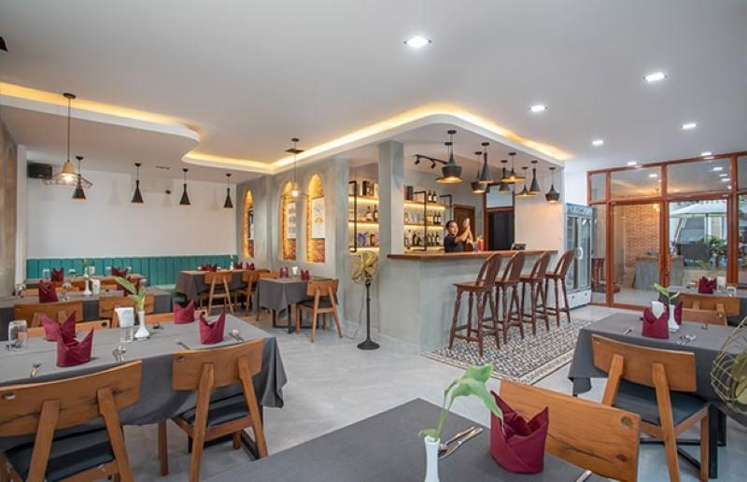
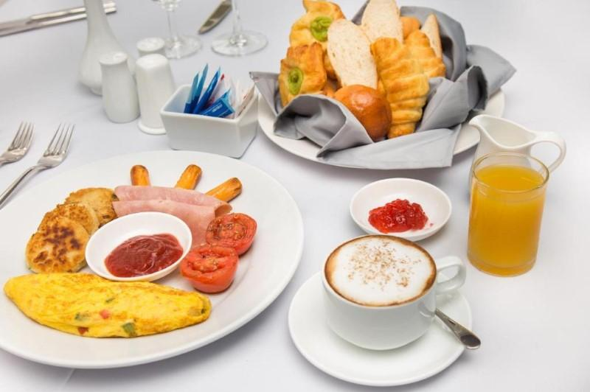
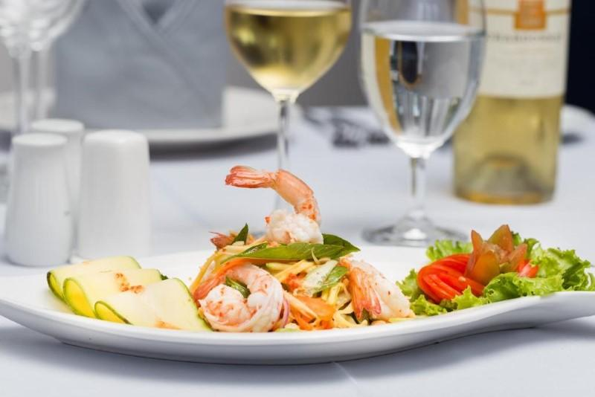
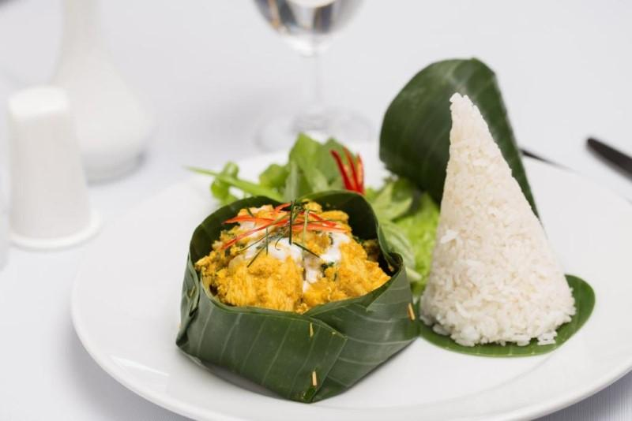
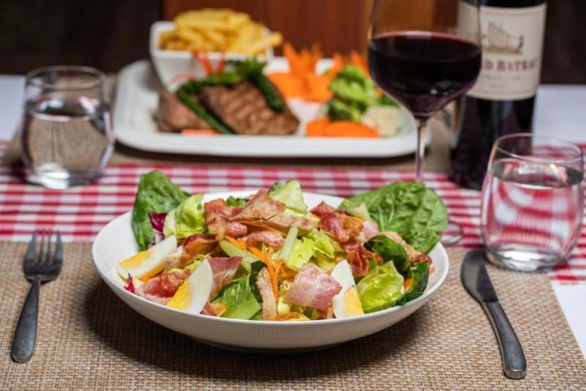
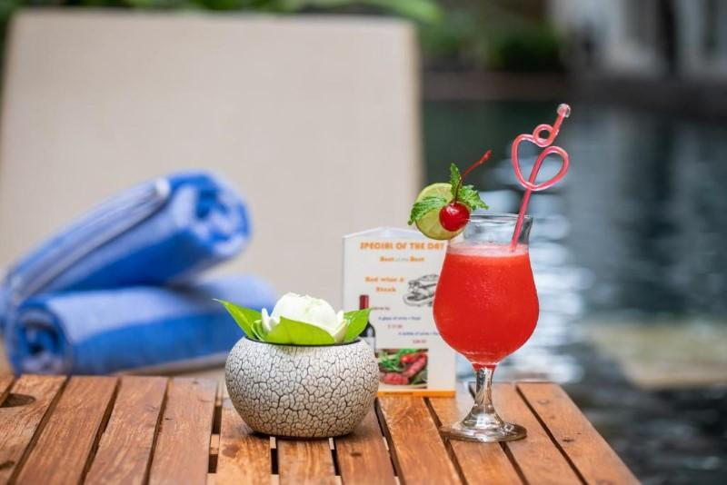
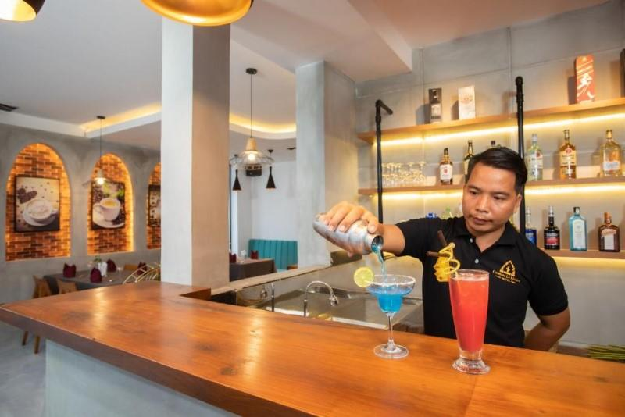

Services & facilities photos
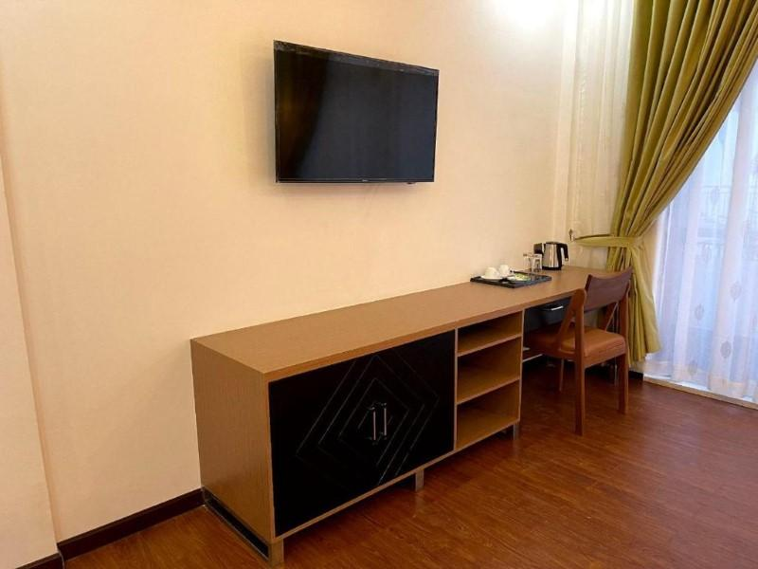
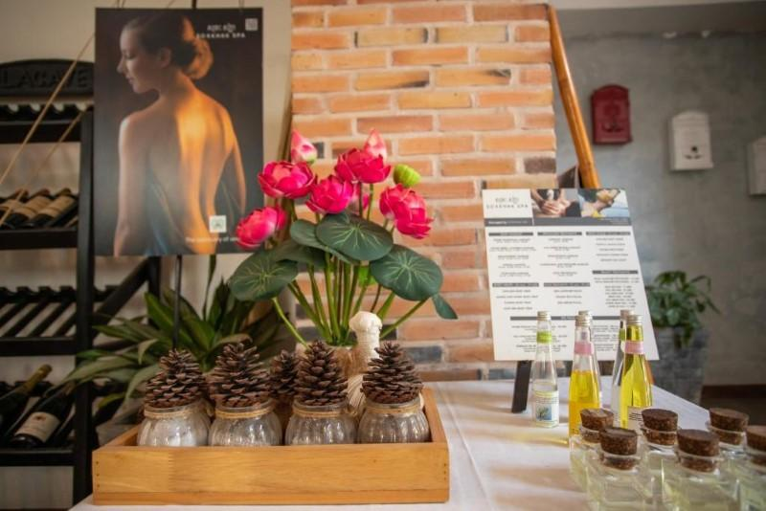
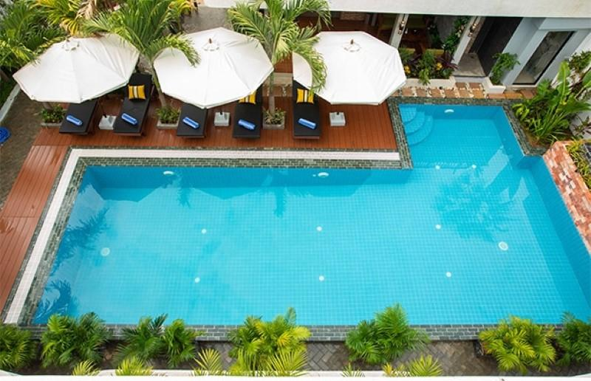
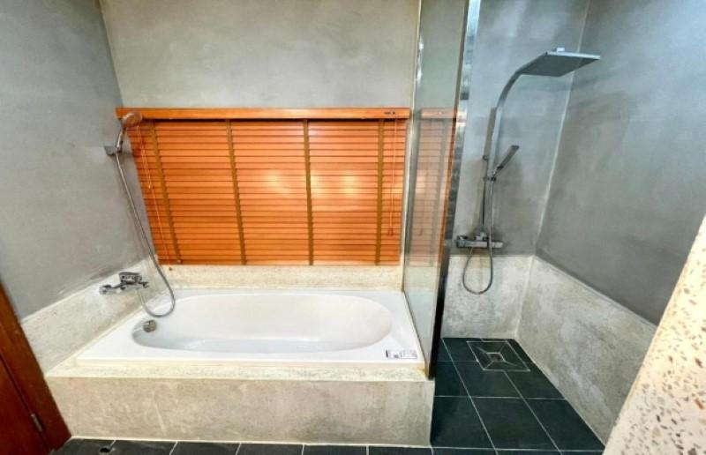
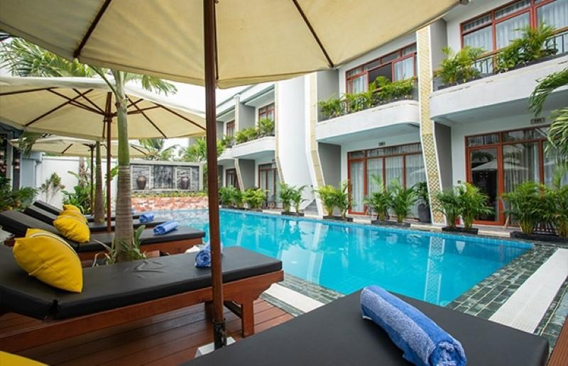

Easia Travel Head Office

