THAILAND – Koh Samui – Kamalaya Koh Samui
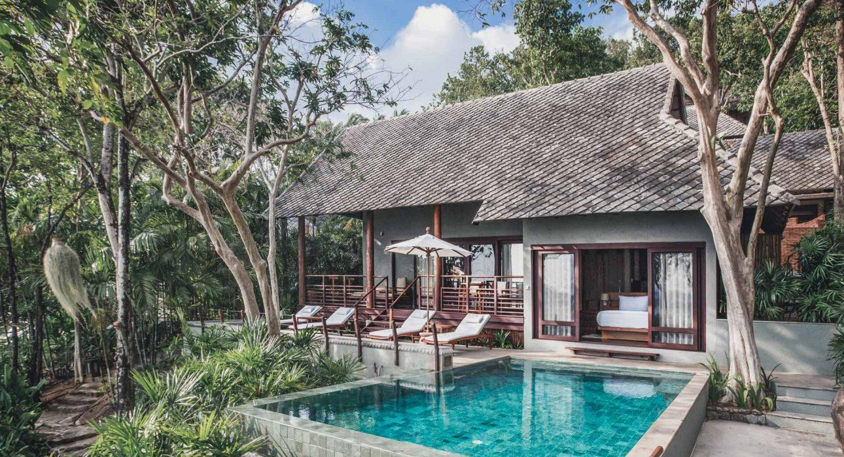

Over View

Theme
Beach Stay, Honeymoon, Wellness

Country - City
Thailand - Koh Samui

Market segment
Thematic Leisure

Official category
5*

Easia category
First Class

Price level
$$$$

Description

Located on Koh Samui’s serene south coast, the resort weaves around a sacred hillside where Buddhist monks and nuns have been coming to seek enlightenment for hundreds of years. The landscape is beautiful, with all boulders, banyan trees, birdsong, and a beach, with plenty of enchanting corners for contemplation. The resort is around a 40-minute drive from the airport.Humming with peaceful vibes, it attracts an astonishing array of characters; slide onto the communal table at breakfast and you might end up sitting alongside a U.N. ambassador, a BAFTA winner, a Fortune 500 CEO, a musician, or a runway model, all happily casting off their high-profile roles for a few days or weeks of peace.There are over a dozen different room categories, ranging from sunny hillside suites with balconies and magnificent sea views to split-level villas hidden in the jungle, to cavernous beachfront villas perched on giant boulders with outdoor bathrooms and private infinity pools. The styling is intentionally simple; creamy walls, indigenous woods, large comfortable beds, and a smattering of local artworksKamalaya has two lovely al fresco restaurants and an approach to nutrition which eschews dieting in favor of promoting healthy eating habits, which are both mentally and physically nourishing.At the center of Kamalaya are the Spa and Wellness Centre, Amrita and Soma restaurants as well as the communal Alchemy Lounge and well-stocked library. Kamalaya is a network of pathways surrounded by green foliage that links the accommodation to the rest of the resort. Above the wellness center at the top of Kamalaya, you will find the fitness center, lap pool, and yoga pavilion. Some of the hills are quite steep but if anyone has walking difficulties a buggy is always on hand.

Selling points

- Multi-award-winning synergistic wellness sanctuary and holistic spa resort that helps people embody their life’s potential and achieve optimal lifelong well-being.
- The cuisine, the service style, the environment, and even the architecture are designed to support and enhance the wellness journey and well-being of the guests.
- The land itself offers a powerful direct experience of the healing power of nature.
- Offering life-enriching holistic wellness programs which combine healing therapies from East and West, in a breathtakingly beautiful natural environment.
- The sanctuary rests on an idyllic location on the southern coastline of Koh Samui surrounded by a lush tropical hillside, sloping down to a tranquil secluded beach.

Time & Transportation

FROM | TO | KM | DURATION | BY | ROAD CONDITION
Hotel | Samui Airport | 22.2 | 40 minutes | Car | Good

Rooms

Easia's recommend room type
- Hillside Room
- Hillside Room Garden View
- Hillside Room Sea View
- Rock Top Suite
- Villa Garden View, Superior Suite Garden View
- Suite Sea View
- Villa Sea View
- Superior Suite Sea View
- Garden Pool Suite
- Plunge Pool Villa
- Beachfront Villa
- Penthouse Pool Suite 1 Bedroom
- Beachfront Pool Villa 1 Bedroom
- Rock Top Pool Villa 1 Bedroom
- Beachfront Pool Villa 2 Bedroom
- Penthouse Pool Suite 2 Bedroom
- Rock Top Pool Villa 2 Bedroom

Room configuration

Connecting rooms
YES

Extra bed
YES

King bed
YES

Queen bed
NO

Twin beds
YES

Services & Facilities

Services
24 hour reception, 24h security service, Airport transfer, Catering (beach, river, cave, other), Concierge service, Iron, Laundry service, Luggage Storage, Massage, Porter, Room Service, Spa, Swimming Pool, Wake-up service, Wi-fi Free

Facilities
Air Conditioning, Bar, coffee and tea making facilities, Garden, Hair Dryer, In-Room safe, Mini Bar, Restaurant, Safety Box, Shower With Hot Water, Umbrella

Restaurant information

SOMA Restaurant:
- For Breakfast and Diner
Amrita Cafe:
- For Lunch
Alchemy Tea Lounge:

Photos

Hotel Photos
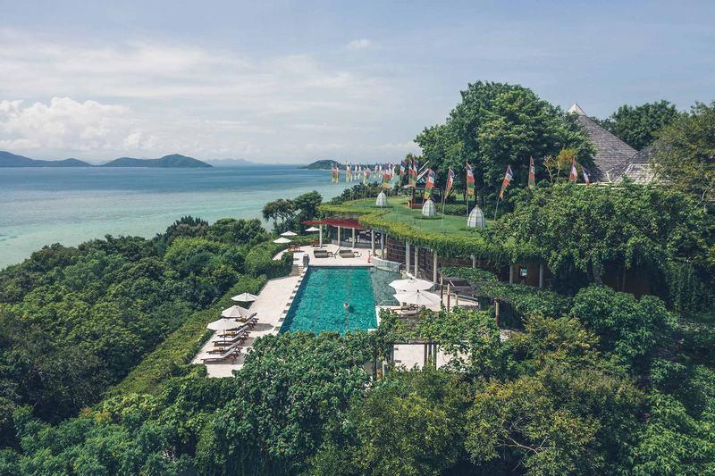
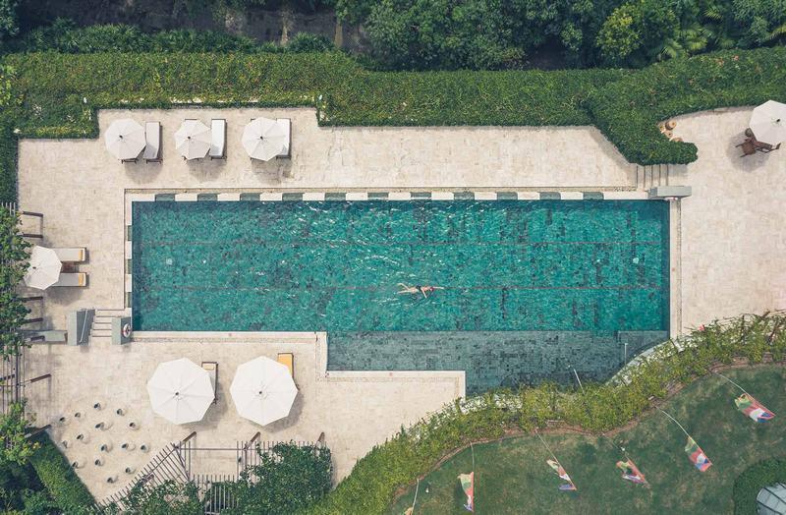
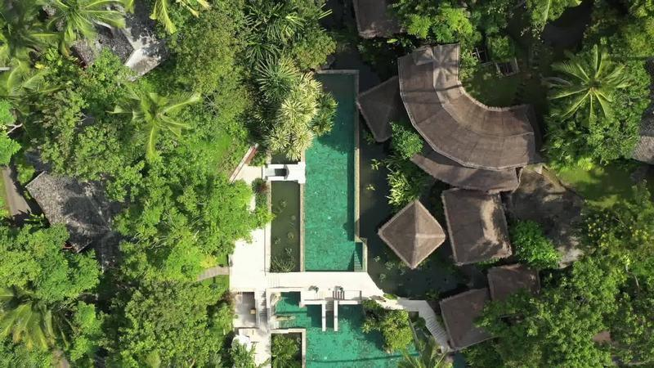

Rooms photos
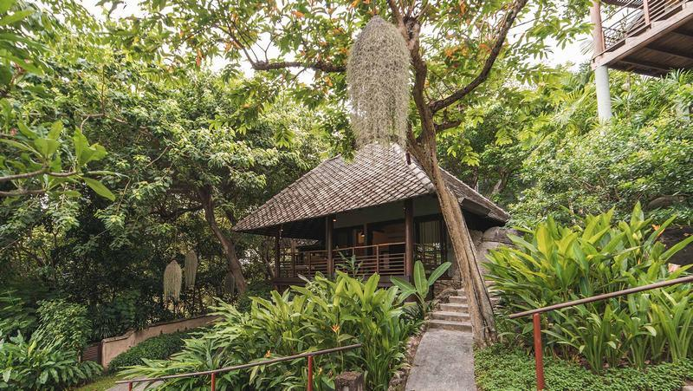
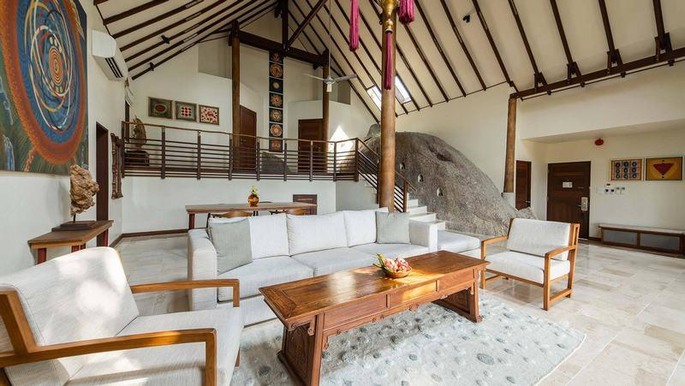
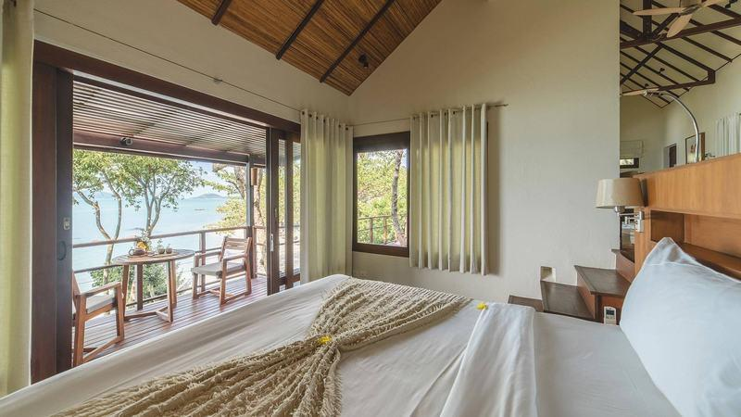
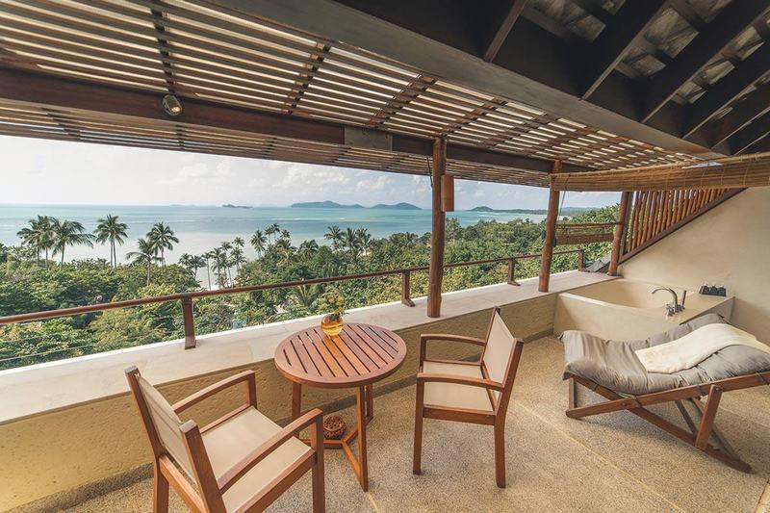
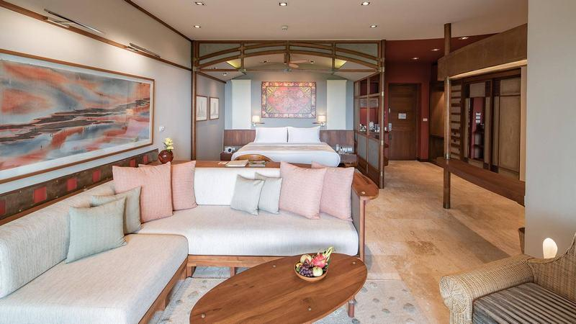
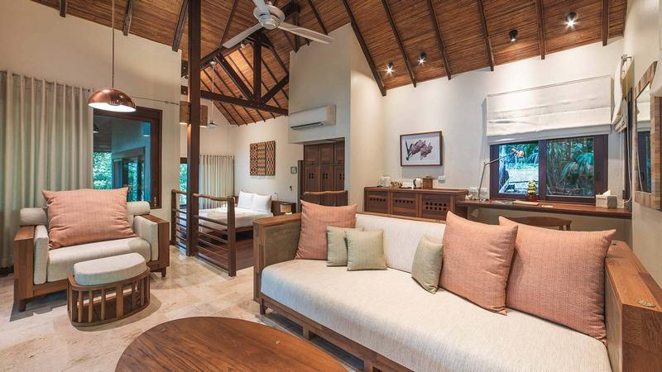
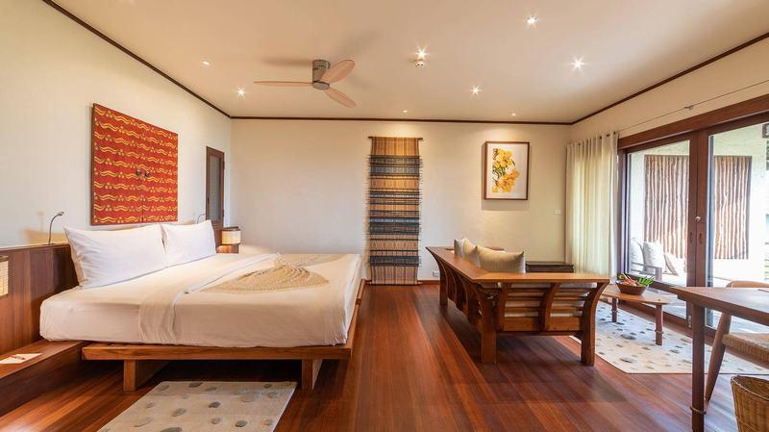
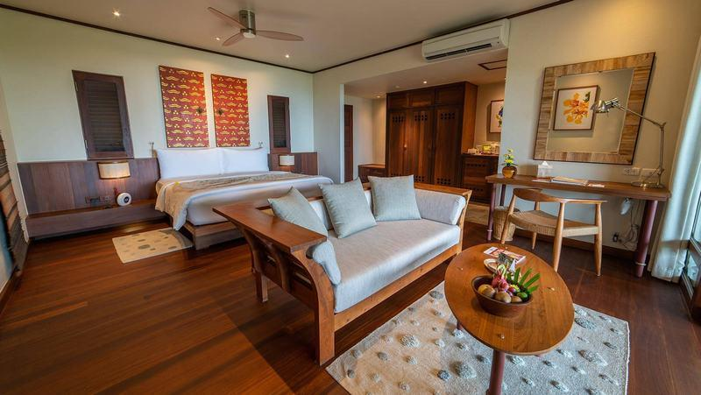
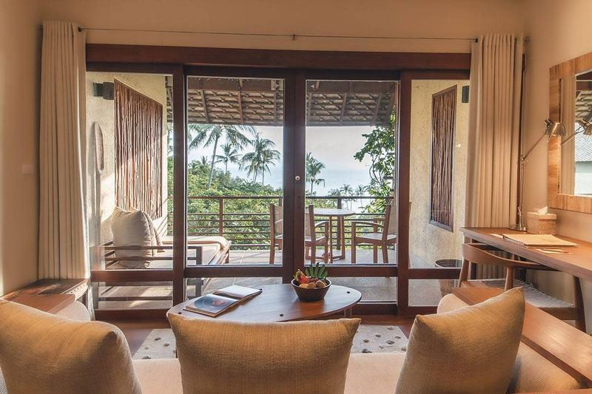
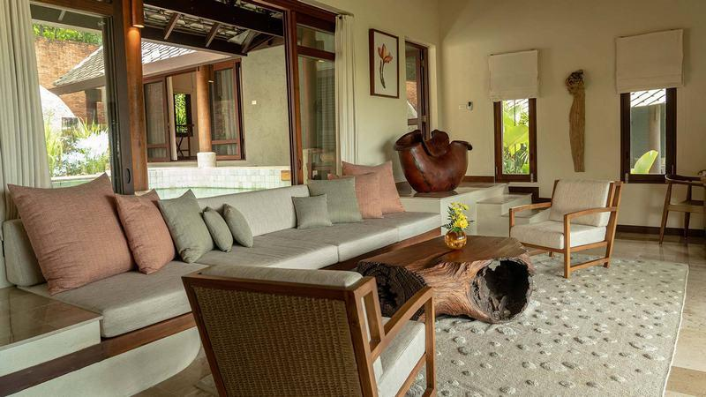
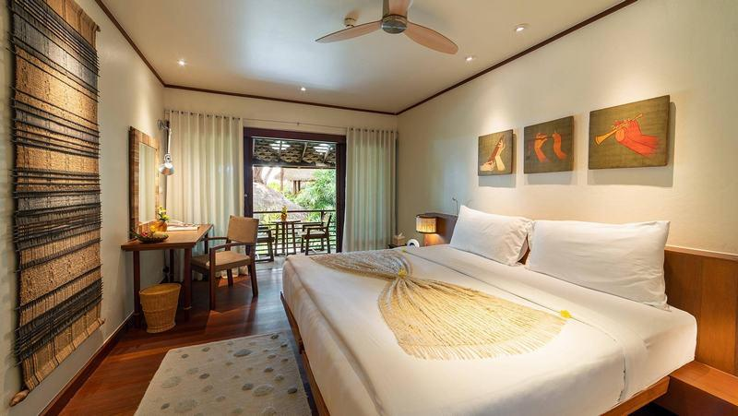
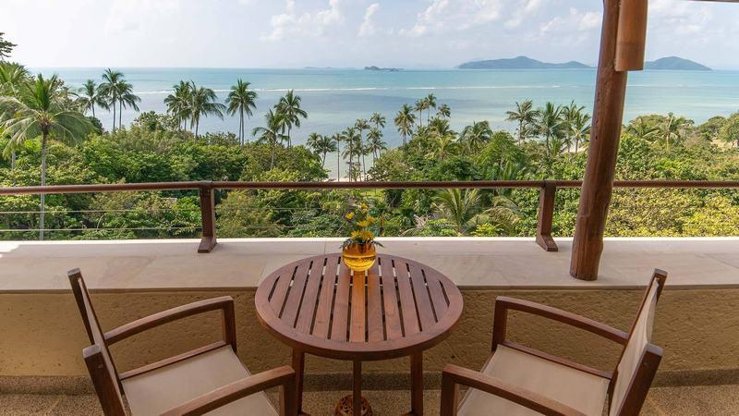
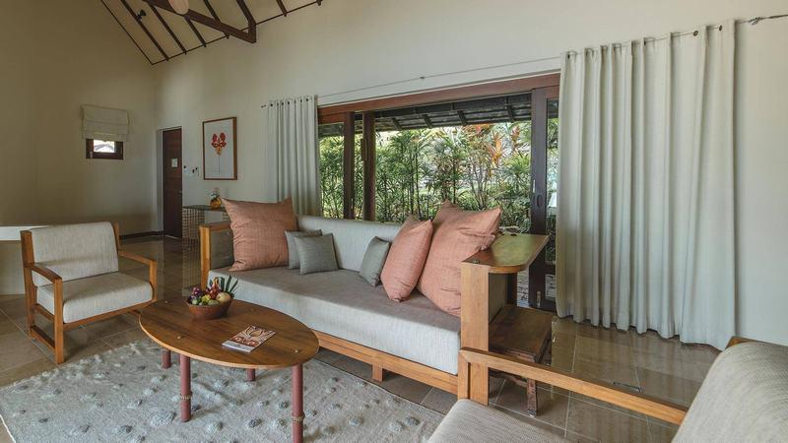
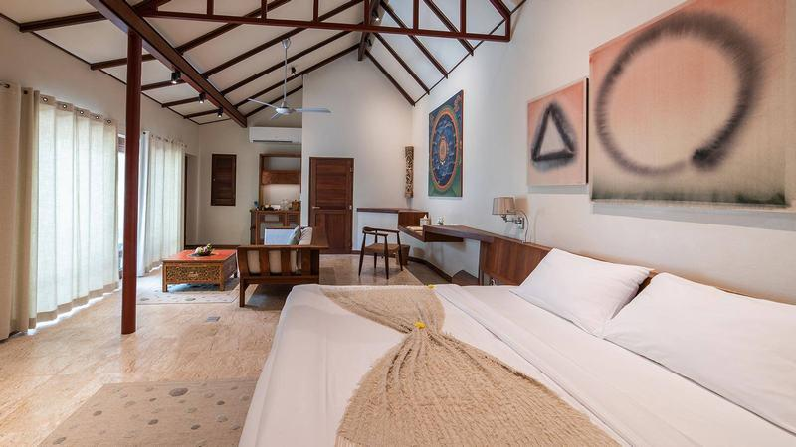
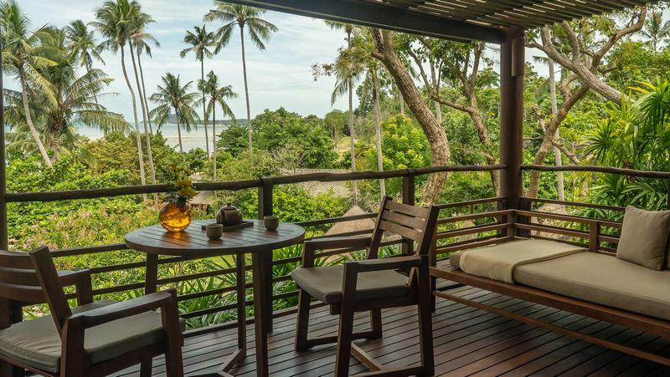

Restaurant photos
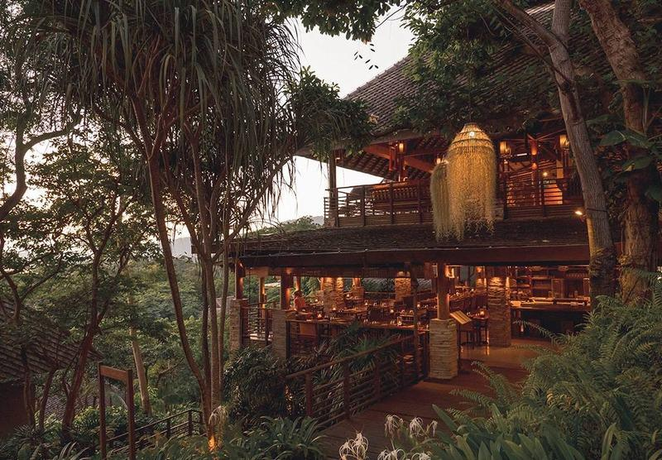
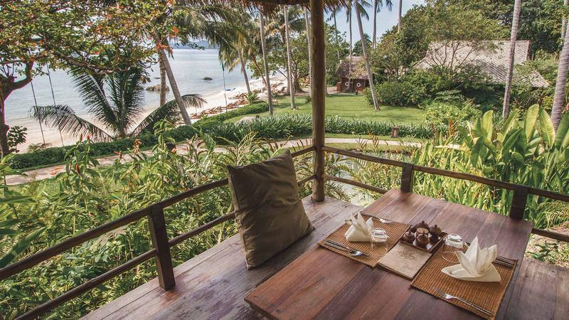
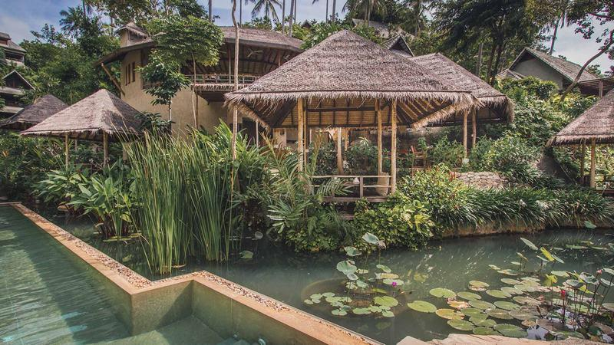
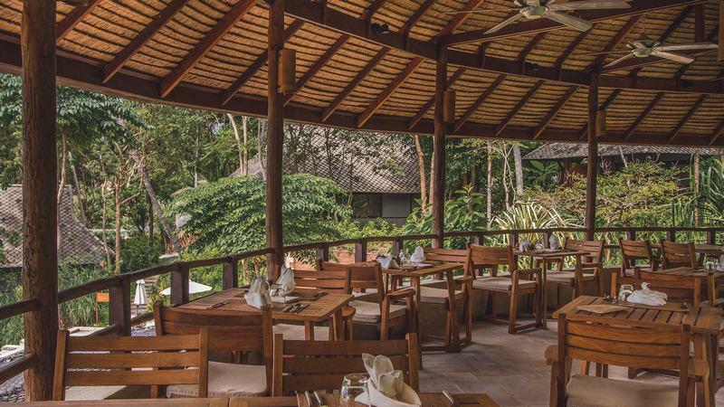
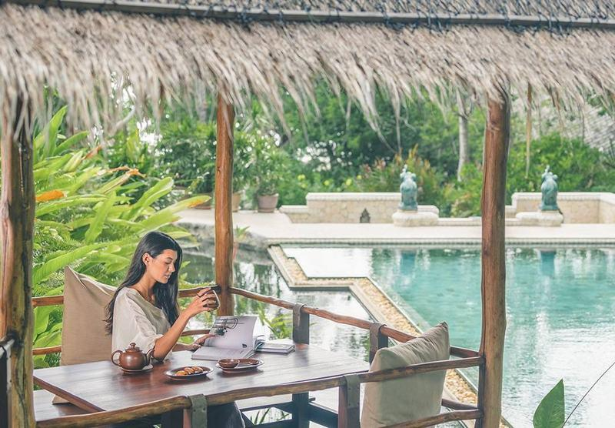
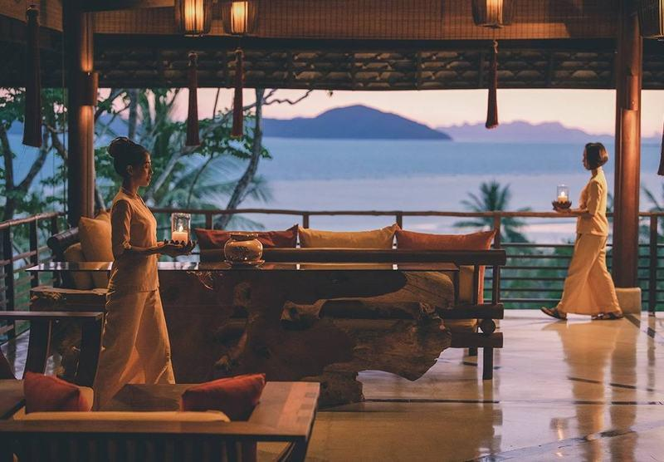
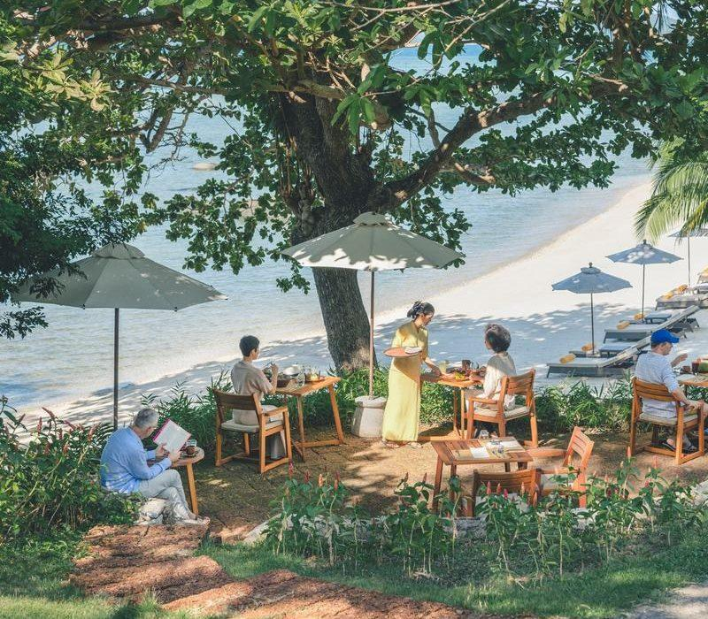
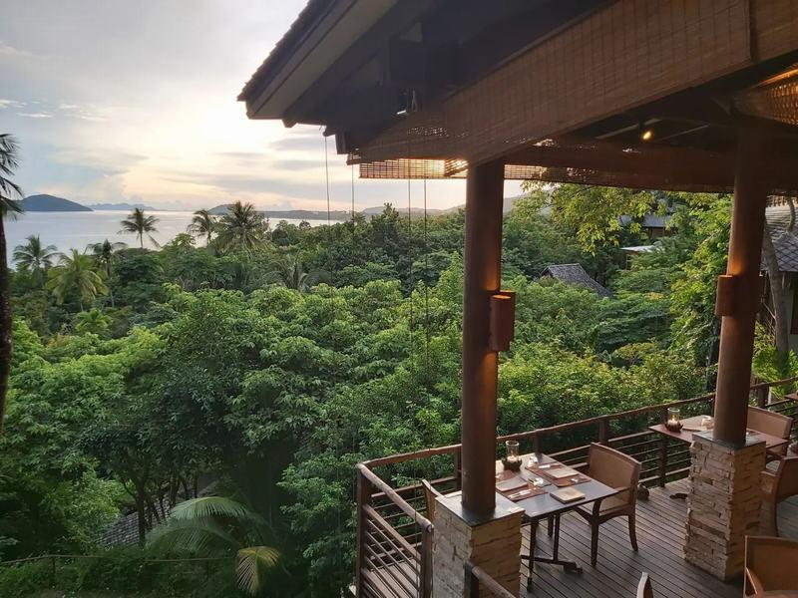

Services & facilities photos
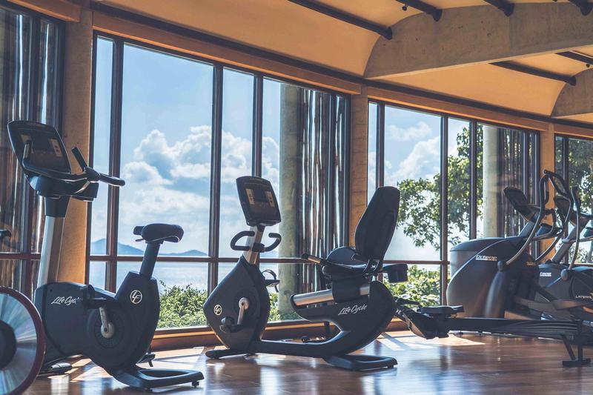
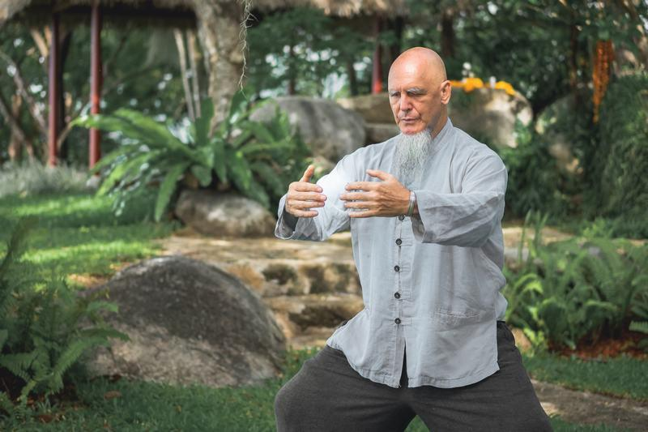
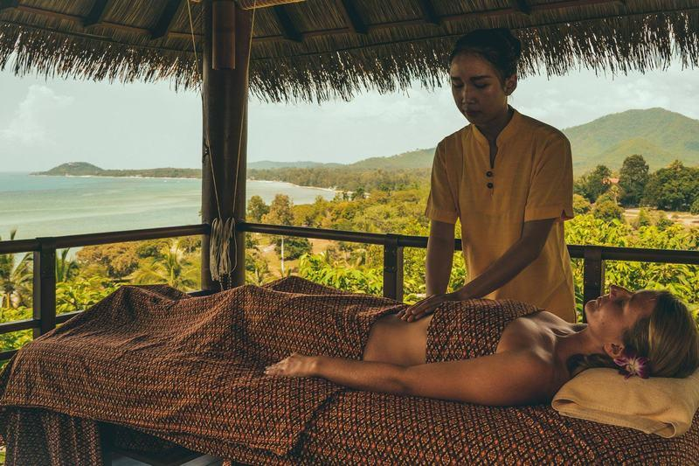
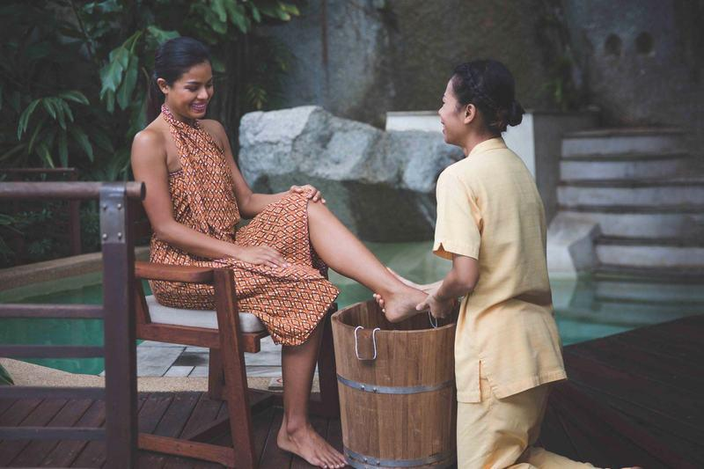
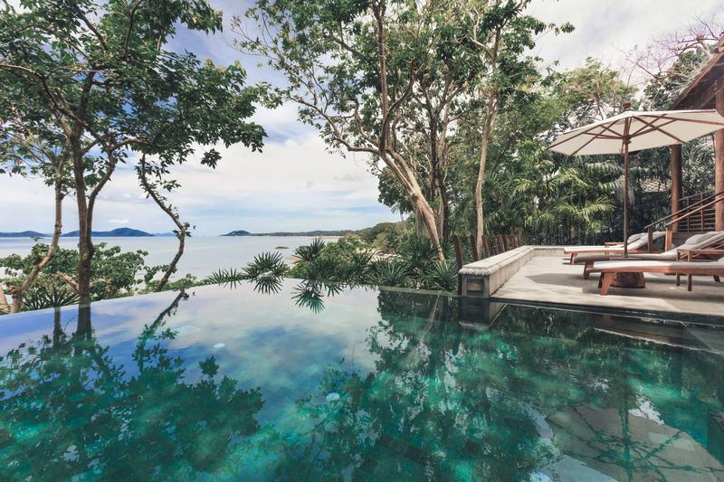
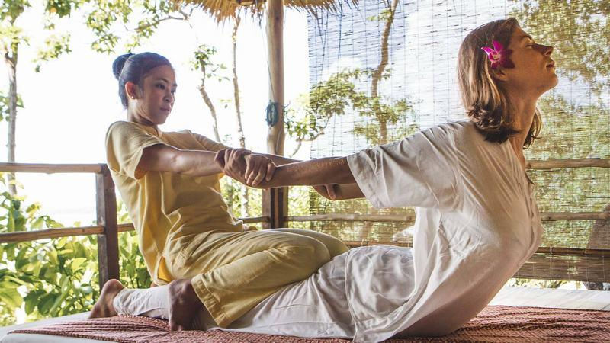
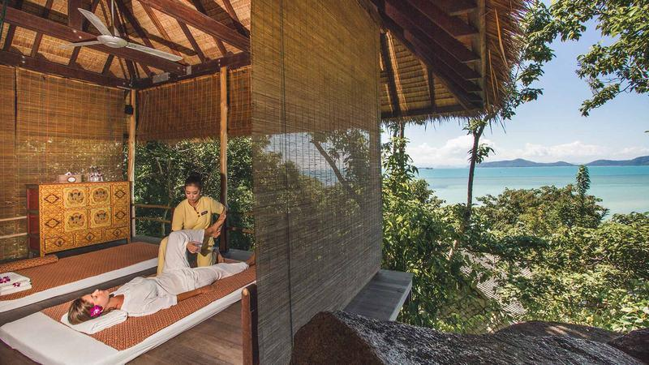
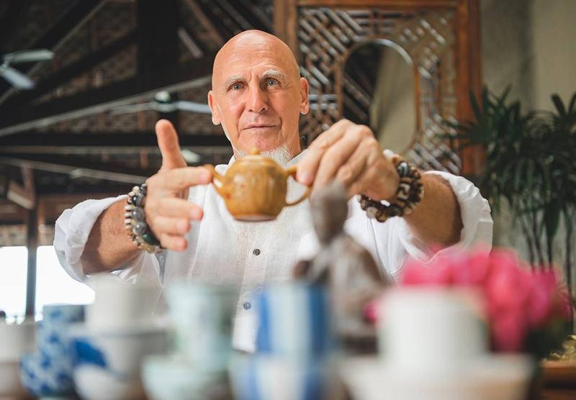
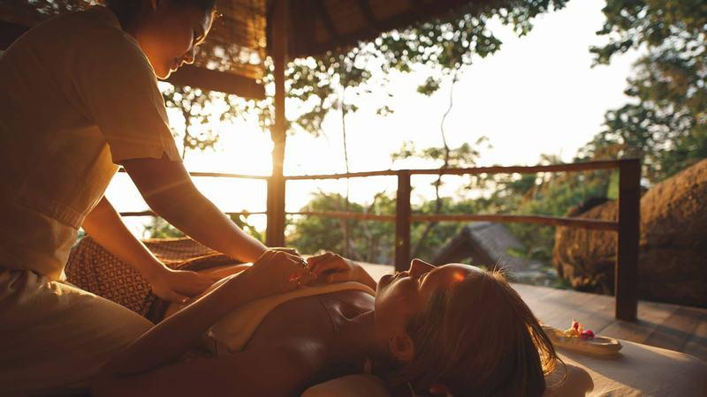
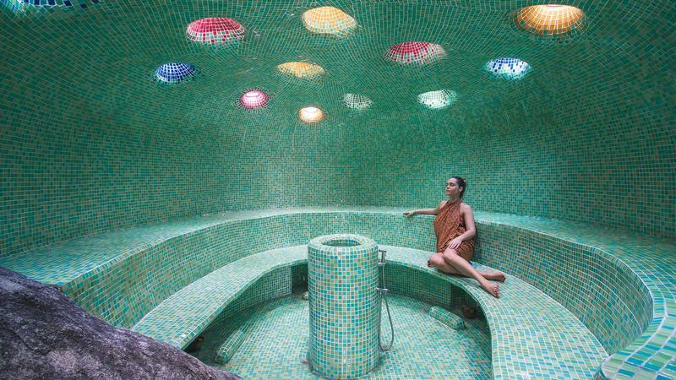
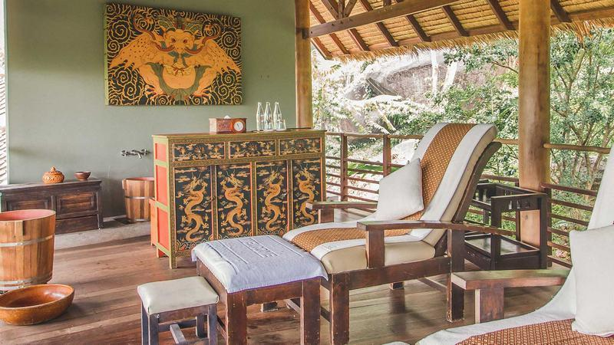
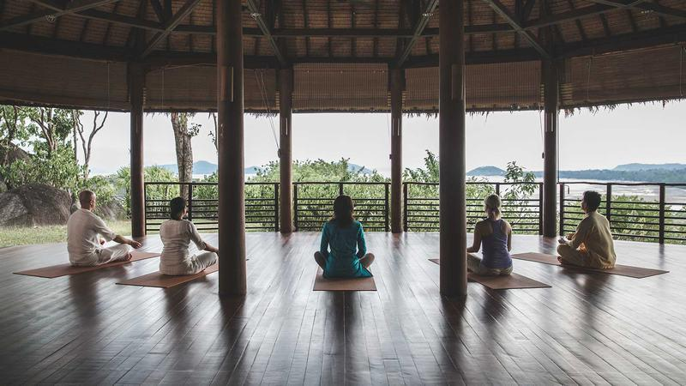
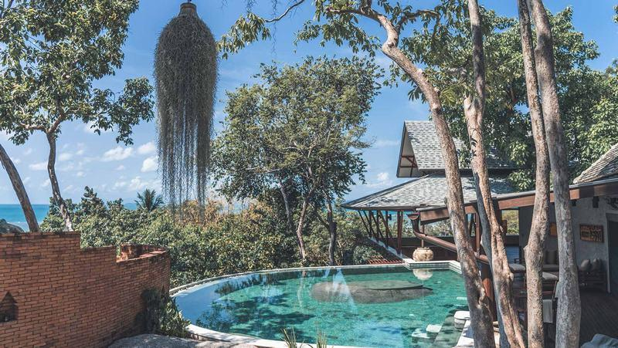
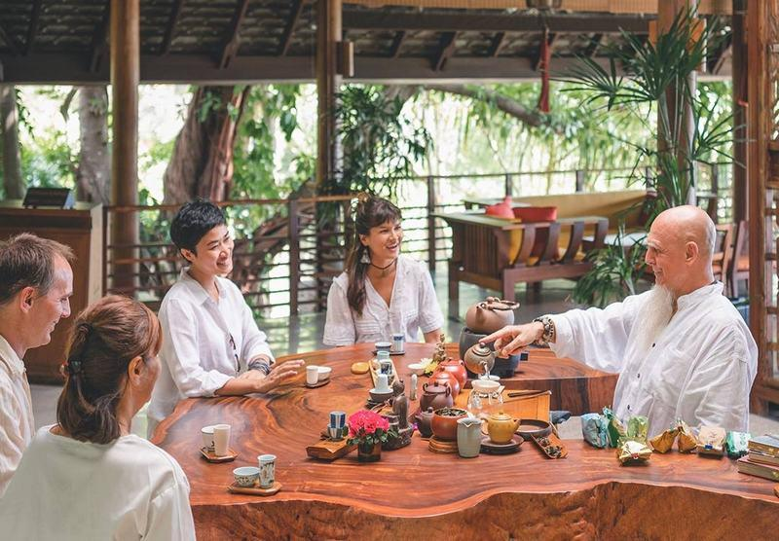
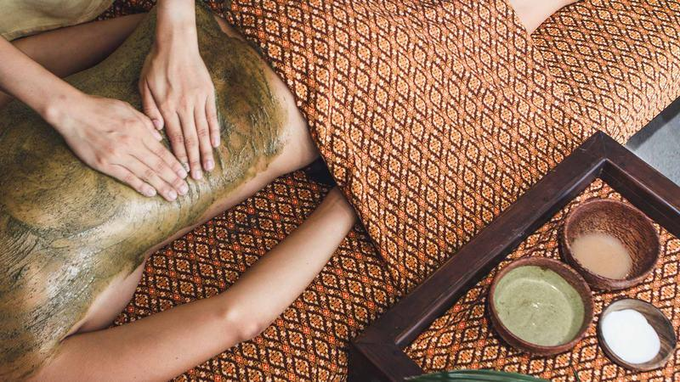
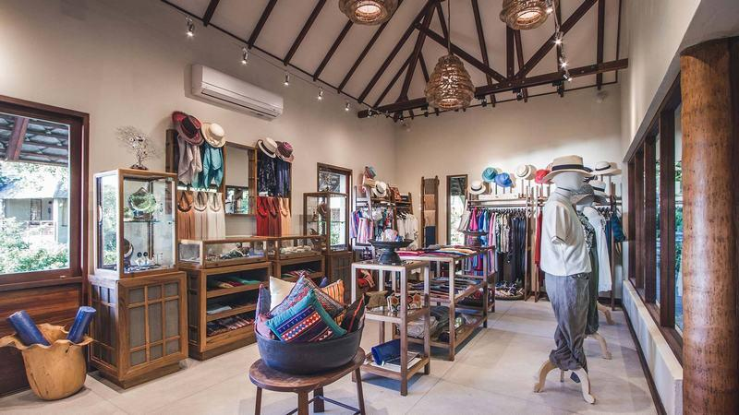
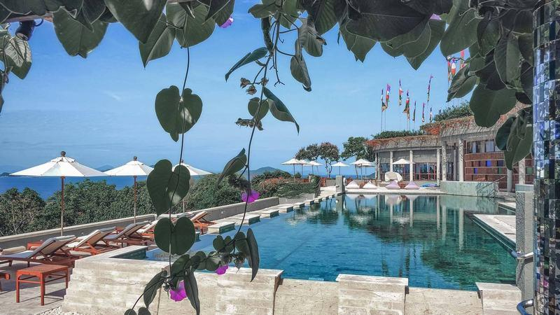
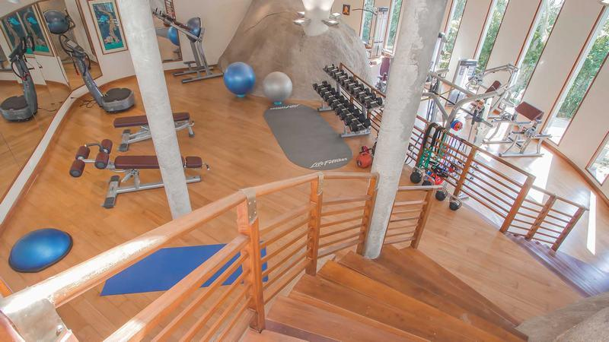
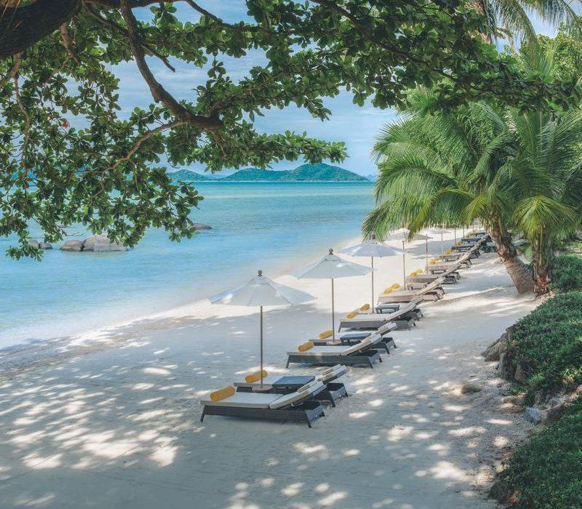
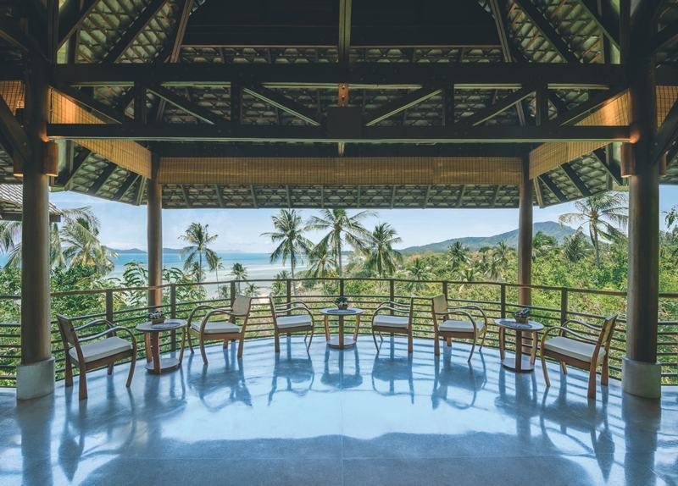
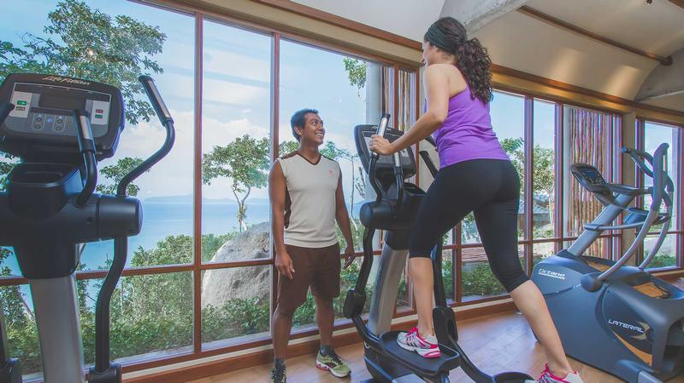
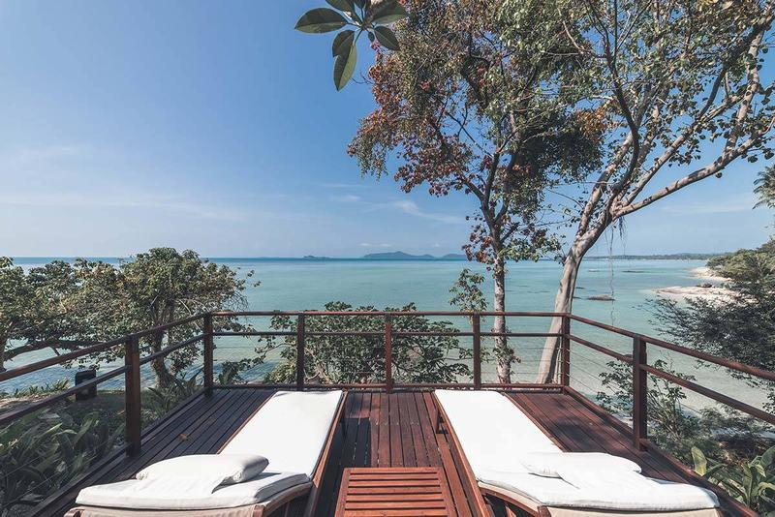
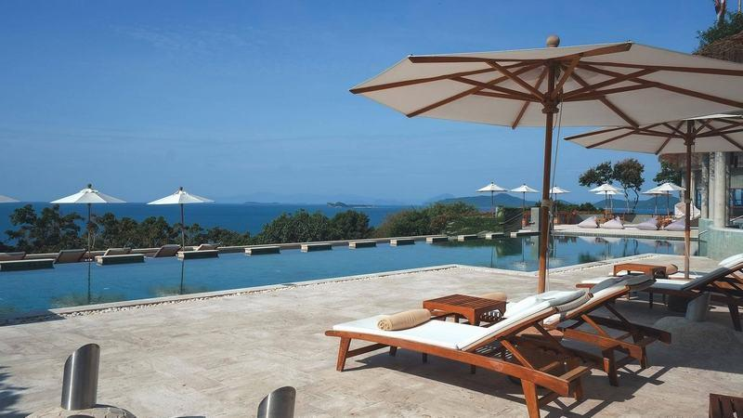

Easia Travel Head Office

