CAMBODIA – Kep – Vakara Hotel Kep
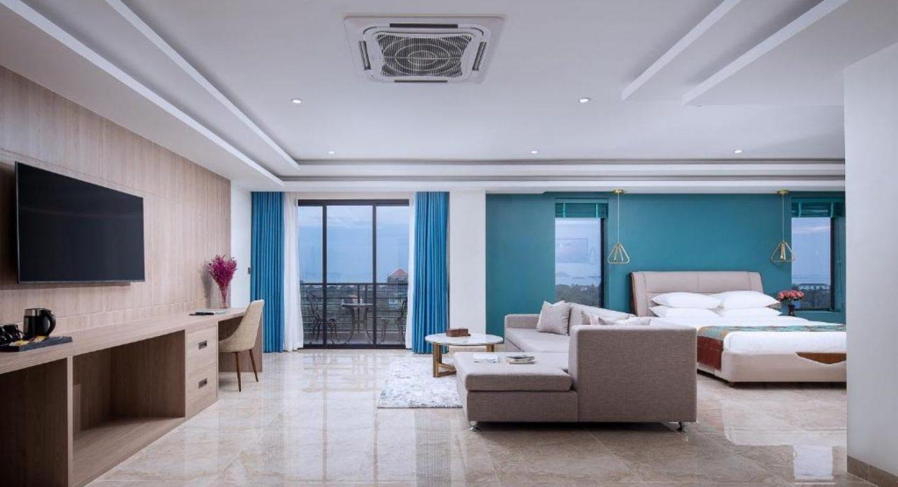

Over View

Theme
Classic, Family, Honeymoon, Sustainable, Wellness

Country - City
Cambodia - Kep

Market segment
Groups, Thematic Leisure

Official category
4*

Easia category
First Class

Total number of rooms
70

Price level
$$$$

Description

Vakara Hotel is a modern-style resort hotel in the heart of Kep and the center of the tourist attraction area. The hotel is just 0.8 kilometers from the seaside and 2 kilometers from Kep Beach. From the hotel, travelers can enjoy the view of the mountain near the seaside with the beautiful green forest of Kep National Park.The Vakara Hotel Kep is family-friendly, with a vast outdoor playground next to a hug and a beautiful outdoor swimming pool and garden. The hotel featured 70 air-conditioned rooms and bungalows. All rooms offer views of the beautiful swimming pool and the National Park or the Bay. All rooms have a seating area, a flat-screen TV with satellite channels, a safety deposit box, and a private bathroom with a shower, bathrobes, and slippers. Every room includes a kettle, while certain rooms here will provide guests with a patio and others also provide guests with pool views. The accommodation offers an outdoor swimming pool 34 meters long with lush tropical greenery. A-24 hour front desk where staff can assist guests and provide free WIFI throughout the property. The hotel has a fitness center where guests can work out and a sauna & steam bath where guests can enjoy and relax. This hotel provides exceptional breakfast, buffet, or a la carte breakfast.

Selling points

- Very charming hotel with excellent design rooms and bungalow
- The family-friendly hotel with a vast outdoor playground for a kid just next to a vast outdoor swimming pool 34 m long
- The hotel a hug space of a fitness center or gym, which is comfortable and easy for guests to work out
- The hotel with sauna and steam room
- The charming hotel is surrounded by beautiful greenery, National Park, and seaside or a Bay.
- The hotel, which is set in the center of a tourist attraction area
- The high recommend four stars hotel with high-quality of facilities and hospitality

Sustainability

Supplier Actions
Protection of Environment, Support local communities, Child Protection

Time & Transportation

From | To | By | Distance | Duration | Road Condition
Vakara Hotel | Kep Beach | Car | 2.2 km | 5 mn | Good
Vakara Hotel | Kep National Park | Walk | 1 km | 10 mn | Good
Vakara Hotel | Crab Market | Car | 2.7 km | 5 mn | Good
Vakara Hotel | Koh Tunsay Beach | Car | 5 km | 10 km | Good
Vakara Hotel | Kampot Provincial Museum | Car | 19.1 km | 30 mn | Good

Rooms

Easia's recommend room type
Standard RoomStyle : Modern
- Room Size : 35 sqm
- Unit : 4 double rooms, 2 twin rooms
- Bed : 1 Large double bed for double room or 2 large double beds for twin room
- Extra bed : Not available
Deluxe RoomStyle : Modern
- Room Size : 60 sqm
- Unit : 8 double rooms, 38 twin rooms
- Bed : 1 Large double bed for double room or 2 large double beds for twin room
- Extra bed : Yes
Vakara Executive RoomStyle : Modern
- Room Size : 80 sqm
- Unit : 4 double rooms
- Bed : 1 Large double bed, a living room with 1 sofa
- Extra bed : Yes
One-bedroom bungalowStyle : Modern
- Room Size : 43 sqm
- Unit : 11 double rooms
- Bed : 1 Large double bed
- Extra bed : Not available
Two-bedroom bungalowStyle : Modern
- Room Size : 136 sqm
- Unit : 3 twin rooms
- Bed :4 large double beds
- Extra bed : Not available

Room configuration

Connecting rooms
No

Extra bed
Yes 1.20 m x 2 m

King bed
1.80 m x 2 m

Queen bed
1.60 m x 2 m

Twin beds
1.60 m x 2 m

Services & Facilities

Services
24 hour reception, 24h security service, Afternoon Tea, Babysitting, Buffet Breakfast, Catering (beach, river, cave, other), Children Activities, Children Swimming Pool, Complimentary bottle of water, Complimentary fresh towel, Concierge service, Credit Card payment, Currency exchange, Dry Cleaning, Iron, Kid Corner, Laundry service, Luggage Storage, Massage, Mobile phone, Private event, partying, Room Service, Services for children, Spa, Swimming Pool, Wake-up service, Wheelchair, Wi-fi Free

Facilities
Air Conditioning, Bar, BBQ Facility, Cable, satelite, Children Pool, coffee and tea making facilities, Coffee Machine Facilities, Conference hall, Disabled Facility, Elevator, Family Room, Fan, Fitness centre, Flat screen TV, Free private parking, Garden, Hair Dryer, In-Room safe, Internet, Massage room, Meeting room, Newspapers and magazine, Restaurant, Safety Box, satellite LCD TV, Steam/Sauna, Terrace, Umbrella

Disabled Facilities
Outside access, Restaurants, Rooms are adapted, Elevator

Business facilities details
Kep Meeting RoomWith high-tech equipment and experienced events team will ensure a successful, smooth event that meets guests specifications. Meals and snacks are available from hotel’s chefs, plus luxury accommodation and full hotel facilities for overnight guests.Meeting room capacity : 60 people

Restaurant information

KIRI DiningOpen daily from 6:00 AM – 10:00 PMGuests can enjoy delicious international cuisine and authentic local food, including fresh seafood at Kep. The restaurant offers an extensive list of home-cooked dishes prepared using fresh and high-quality local ingredients. The outdoor terrace sits by the pool, a perfect favorite location for guests prepared to be mesmerized by the breathtaking mountain view while feeling the refreshing cool breeze.Restaurant Capacity: 100 seatsVakara CafeOpen daily 6:30 AM – 9:30 PMThe Vakara cafe shop is conveniently located right off the hotel lobby and is a meeting place and relaxing for travelers, family, and friends. It is a great spot to grab early morning drinks, coffee, or tea. Stop in and enjoy the warm, comfortable decor that invites you to sit down and savor all the tastes and services of Vakara Kep. The Cafe serves menu selections ranging from lighter fare to hearty dinners.Cafe capacity: 40 seatsPool BarOpen daily 7:00 AM – 9:00 PMEnjoy drinking by the swimming pool and munching away on afternoon snacks and delicious desserts at the pool bar. Guests can enjoy drinks and good food in a beautiful atmosphere while watching a magical sunset over the mountains and surrounding tropical garden.Pool bar capacity: 15 seats

Photos

Hotel Photos
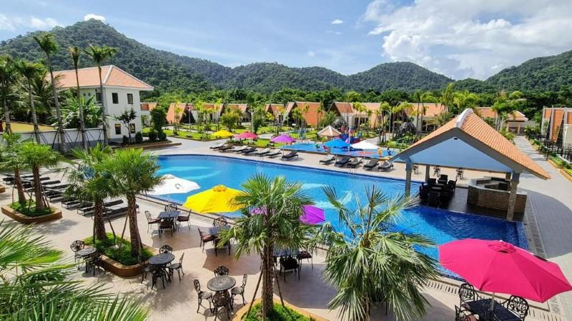
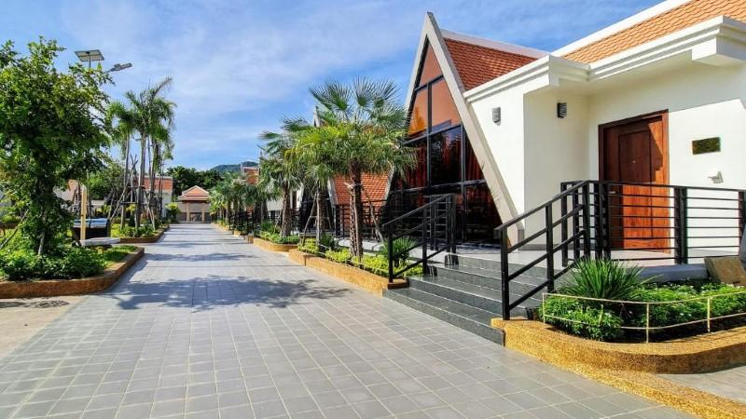
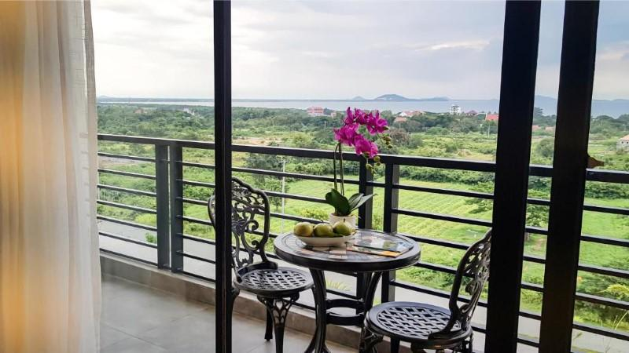
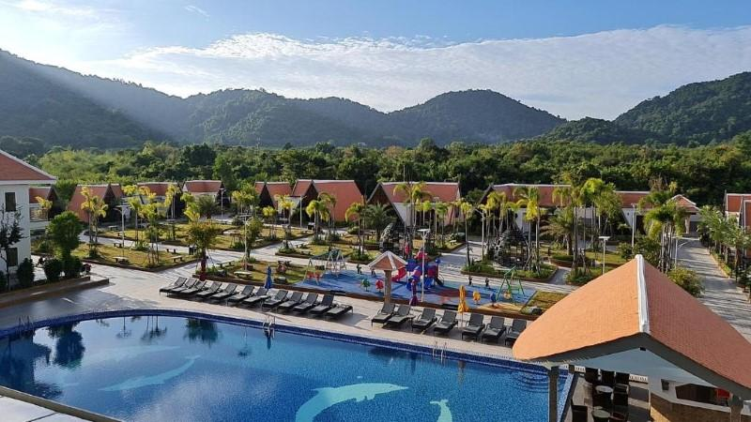
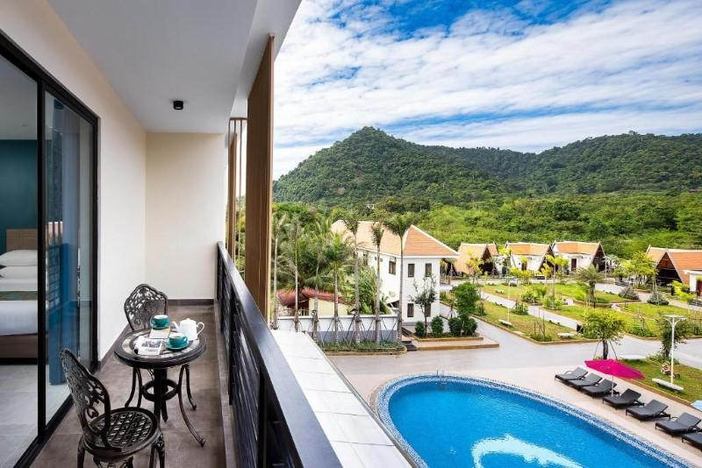
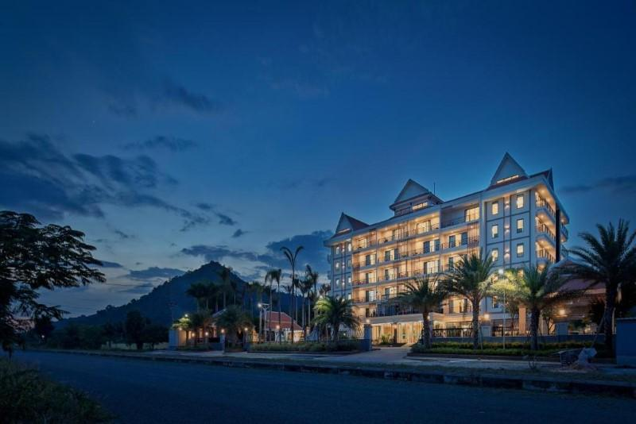
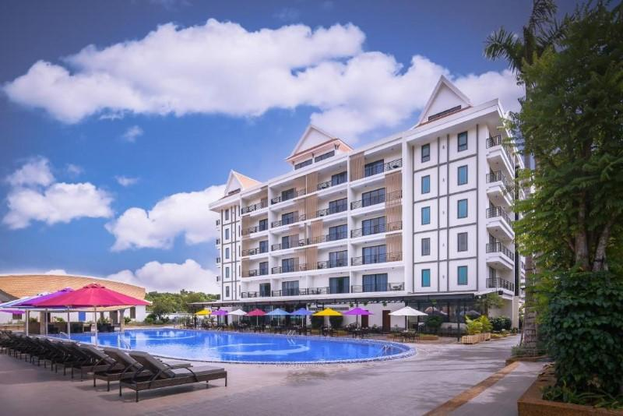
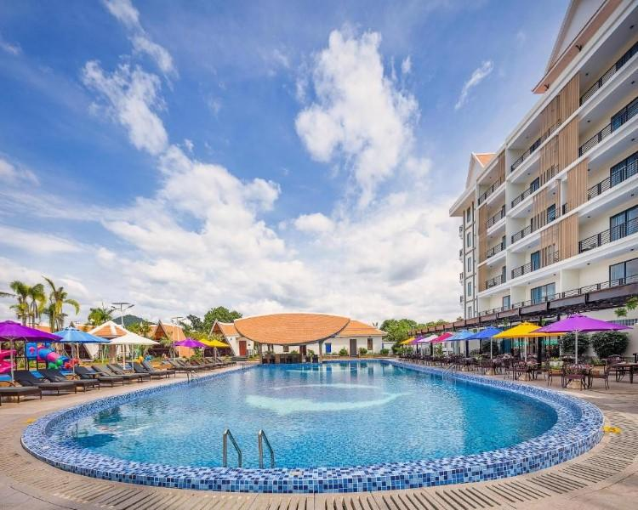
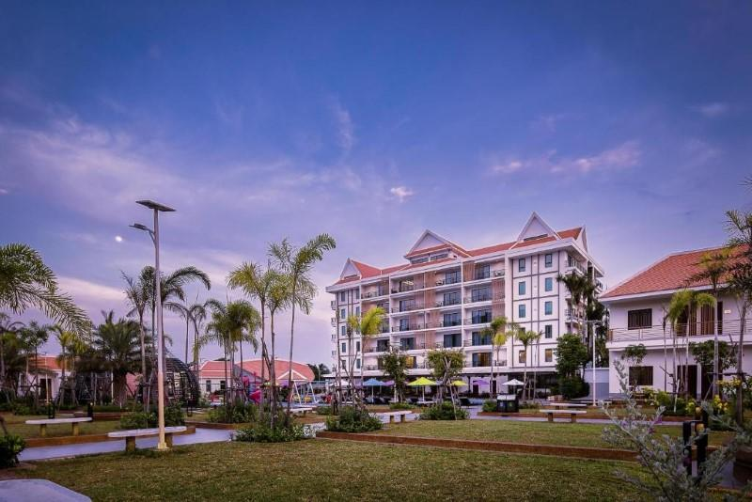
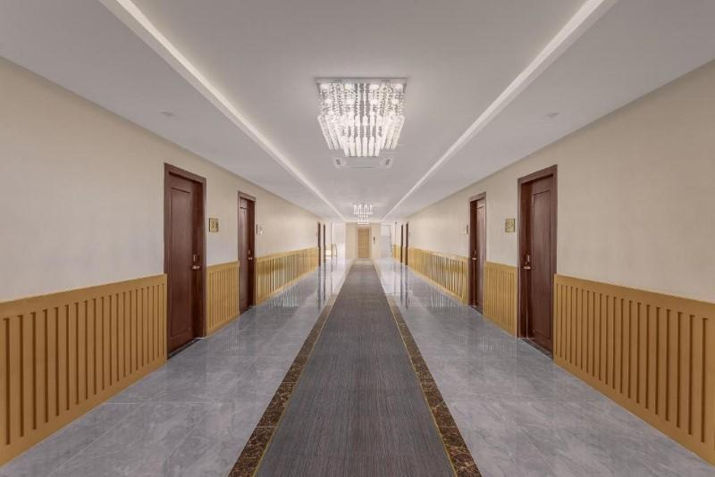
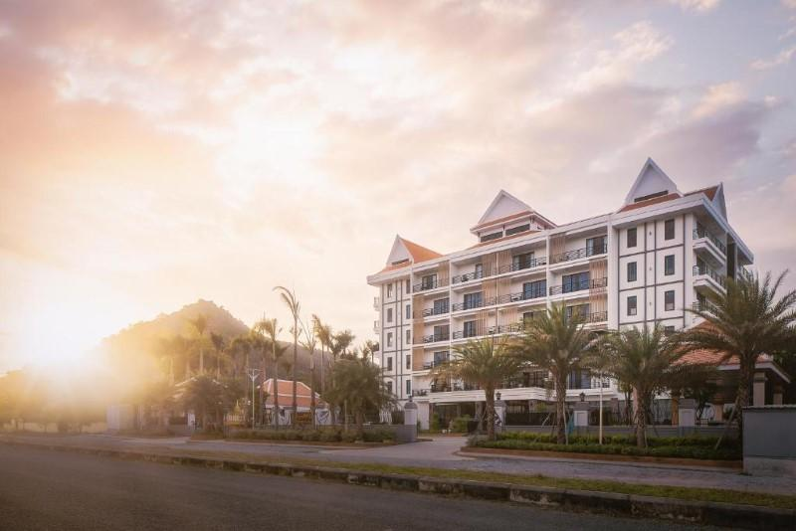
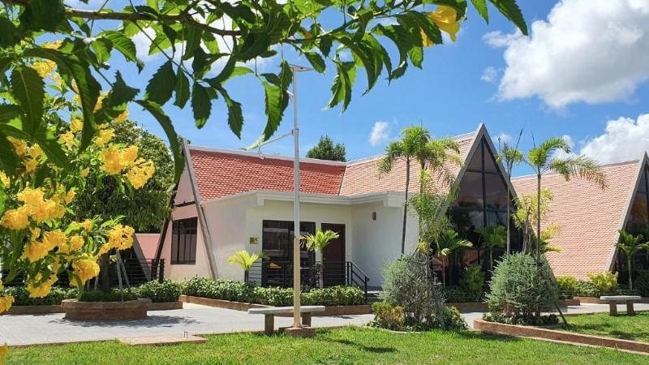

Rooms photos
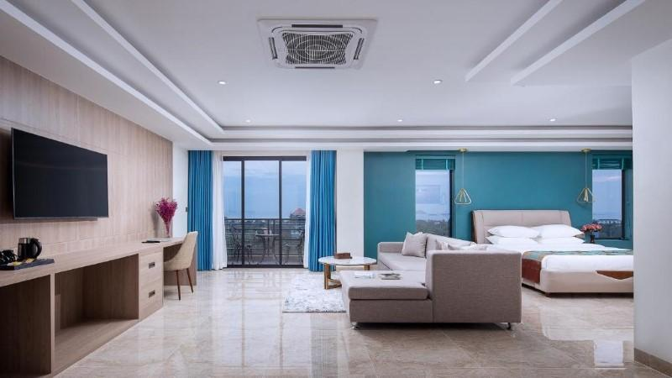
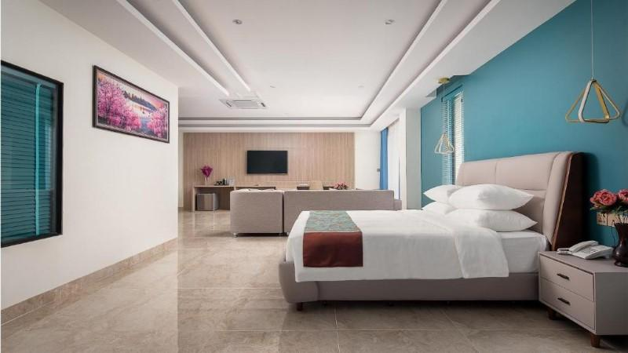
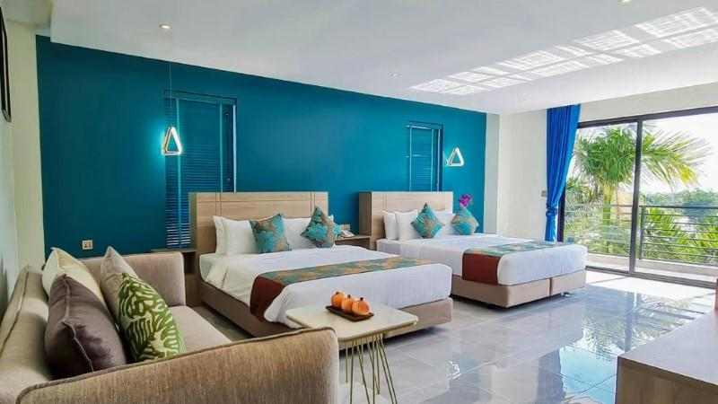
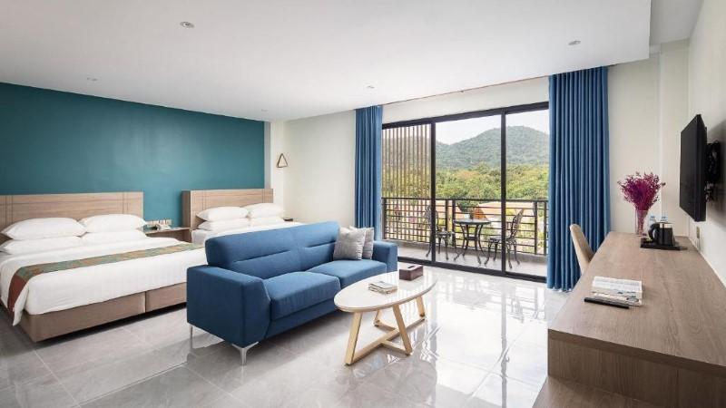
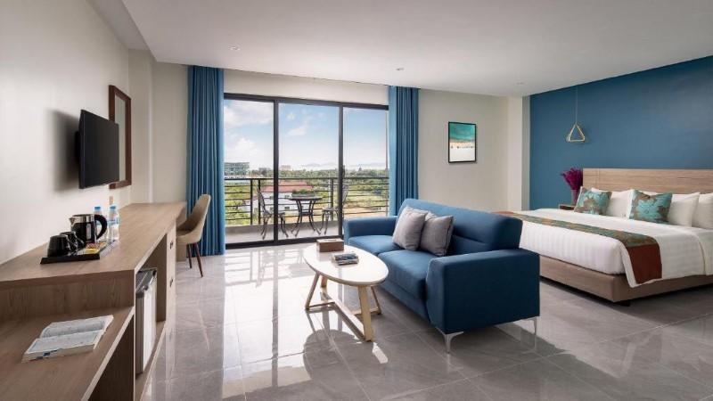
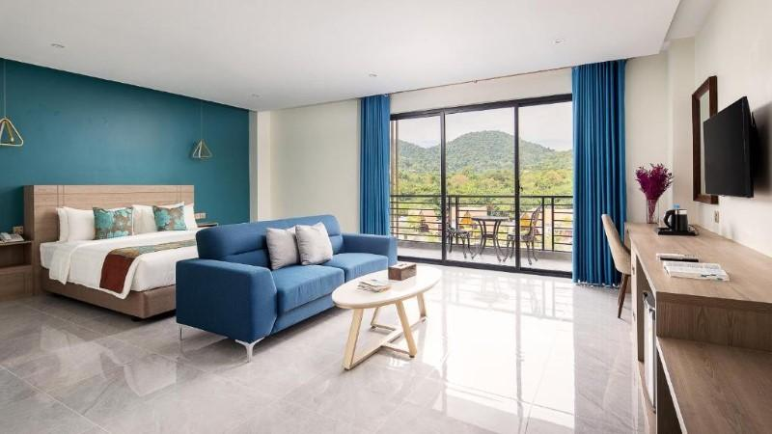
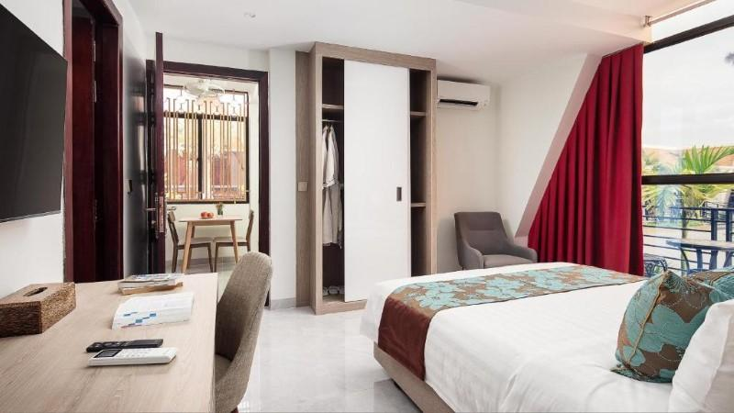
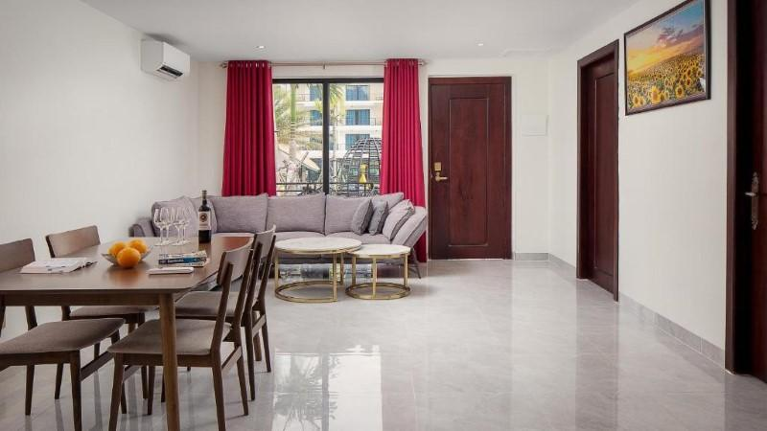
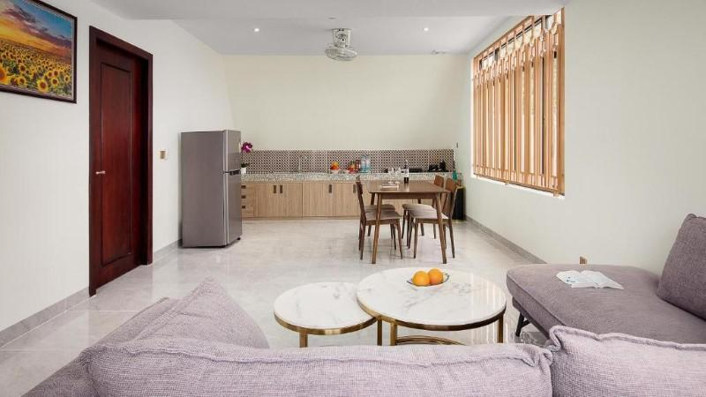
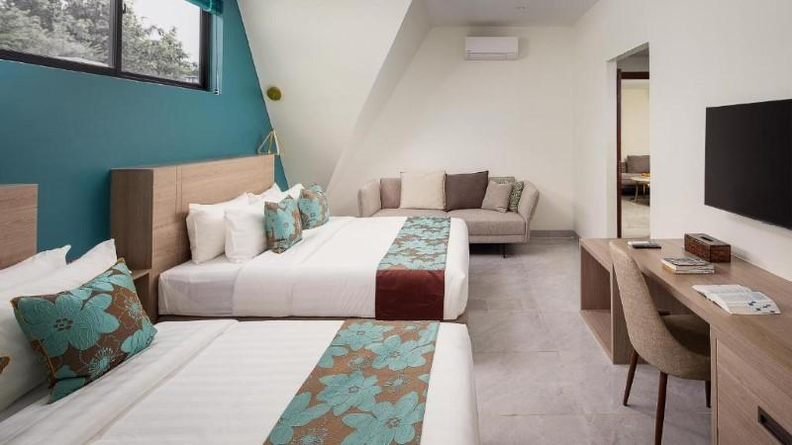
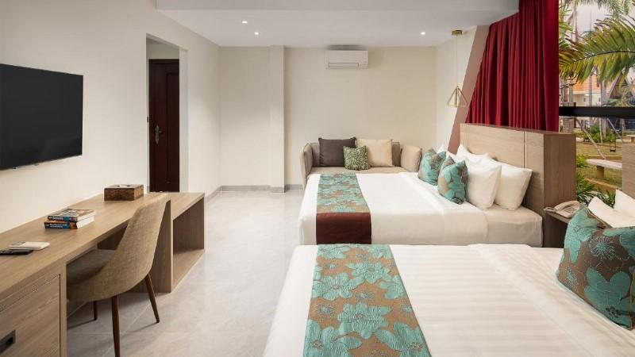

Restaurant photos
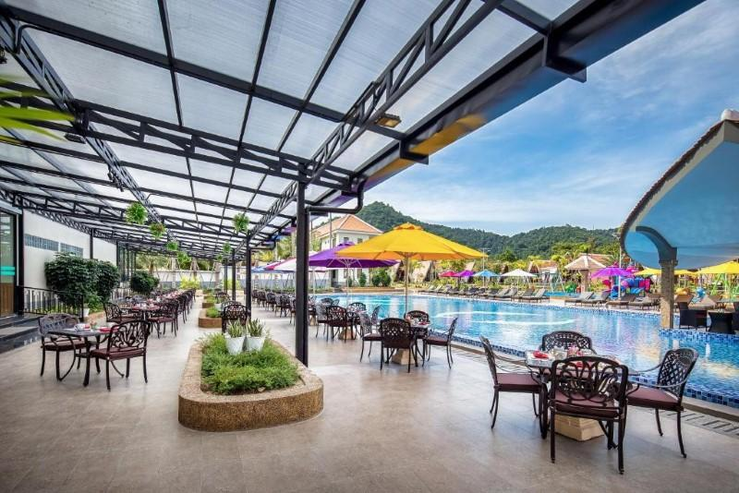
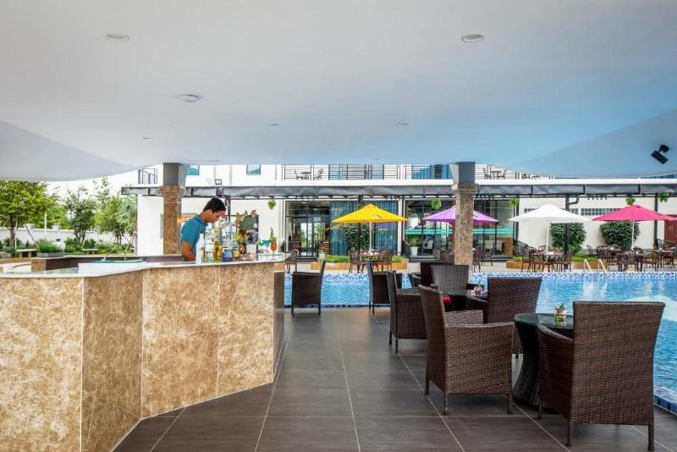
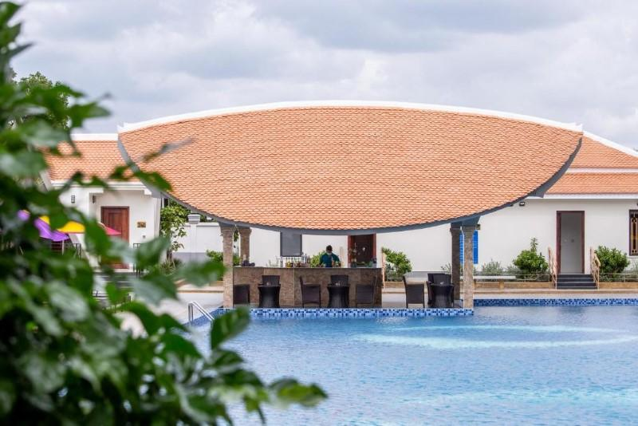
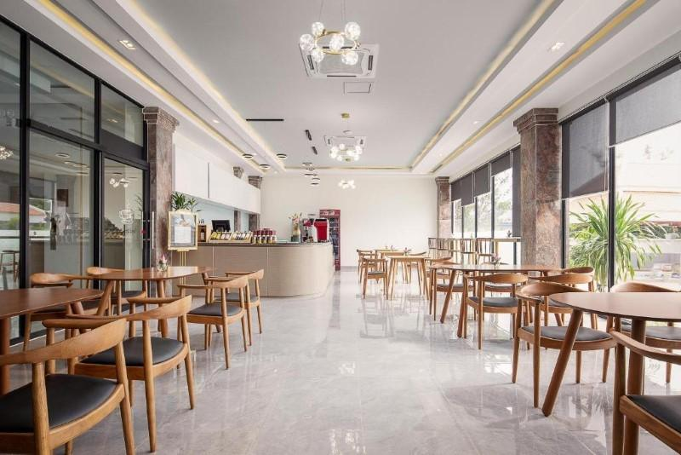

Business facilities photos
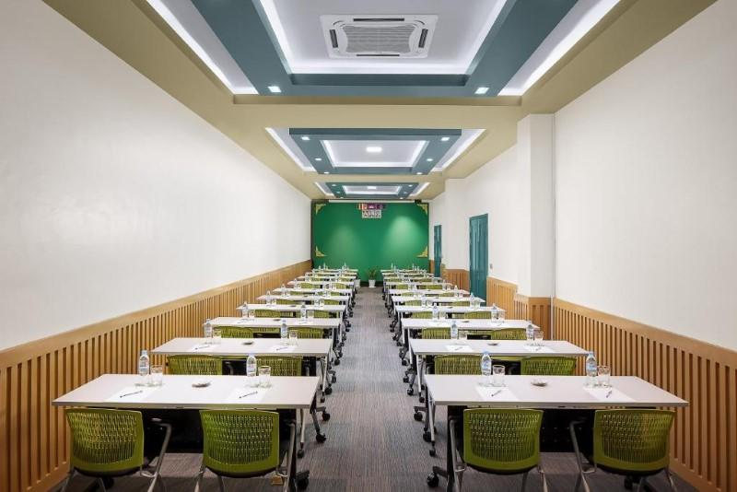
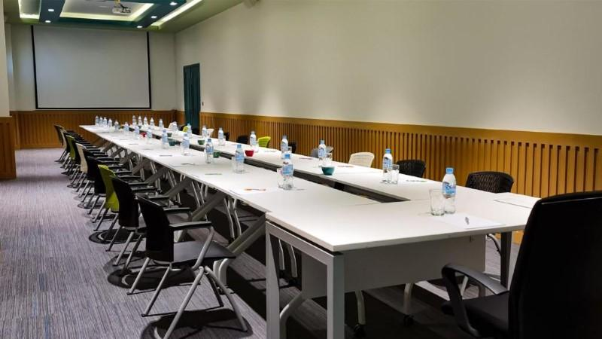

Services & facilities photos
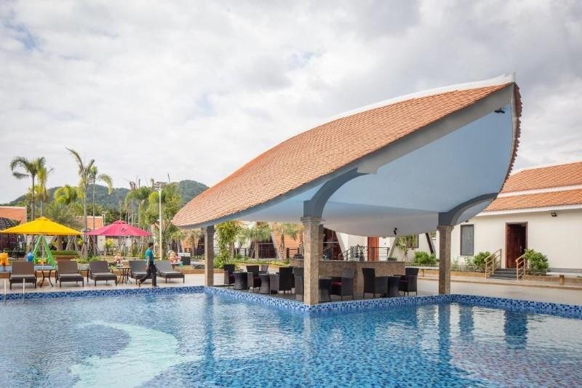
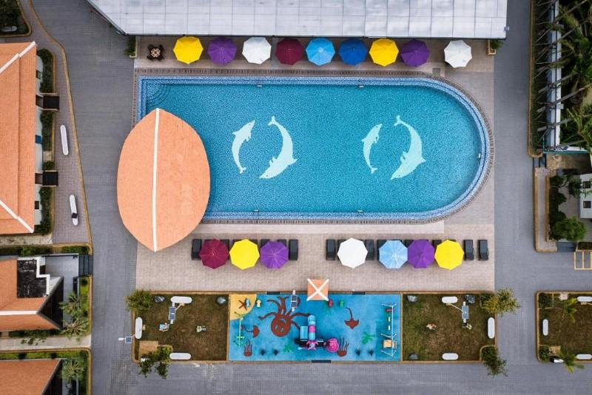
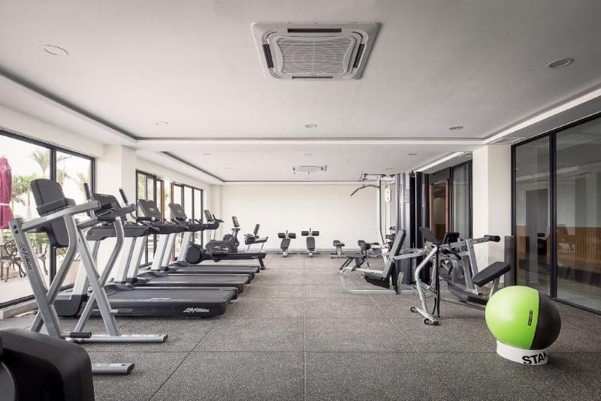
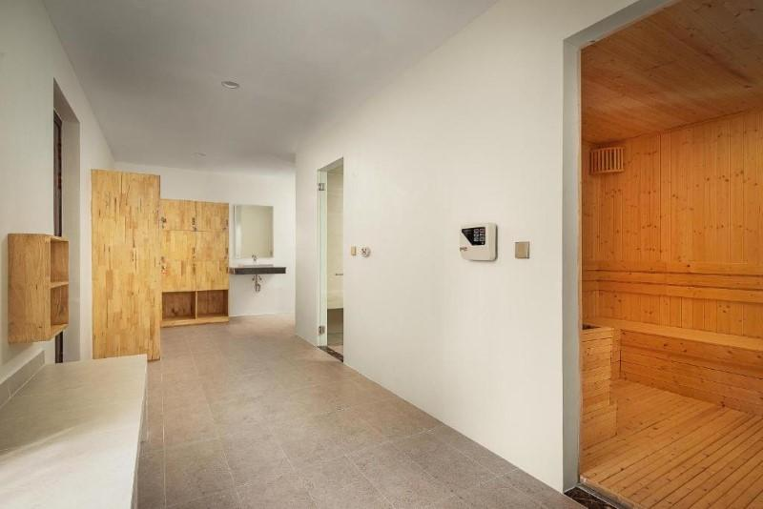
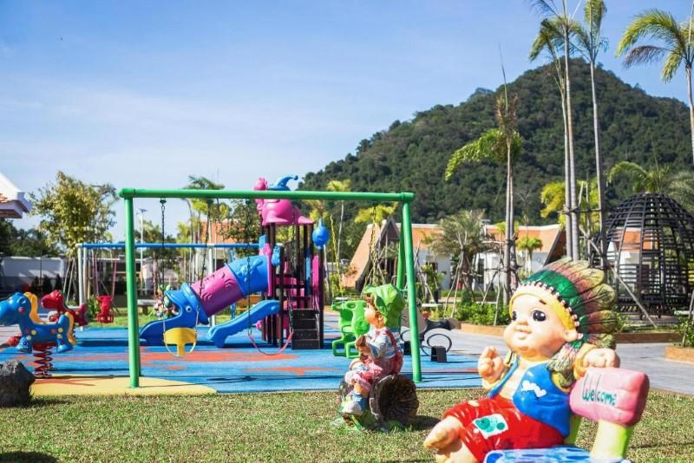
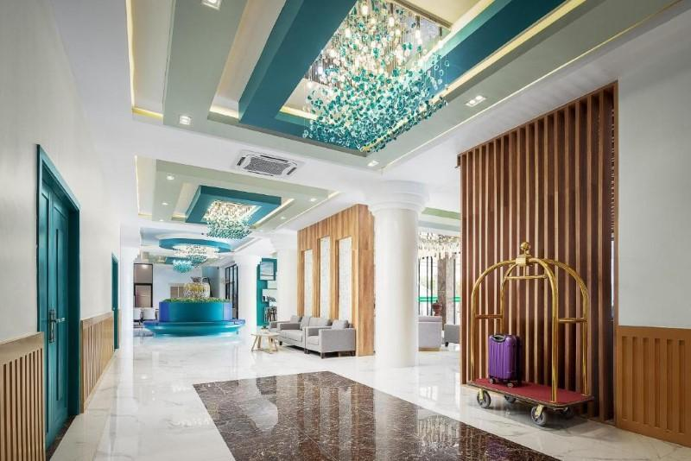
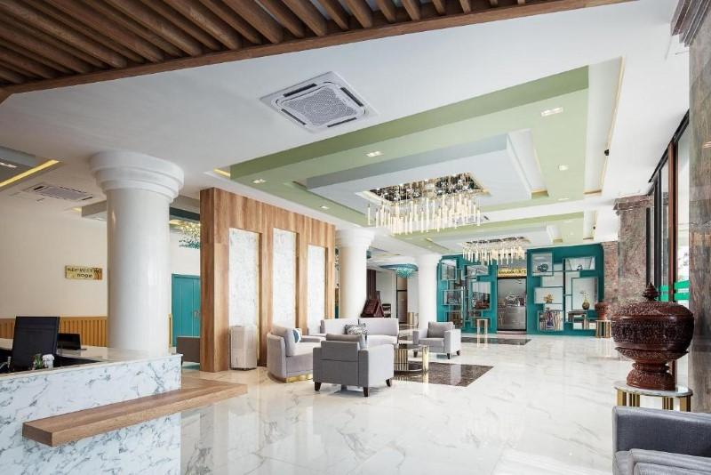
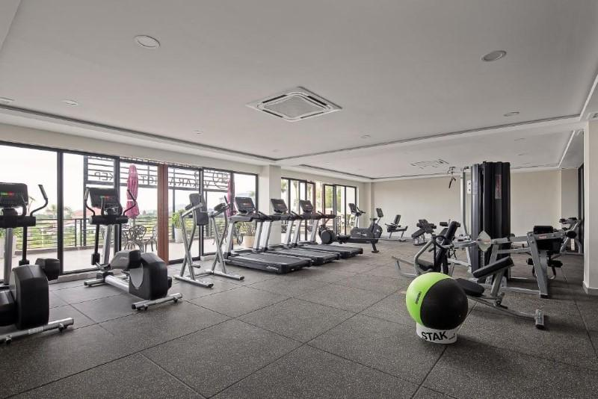
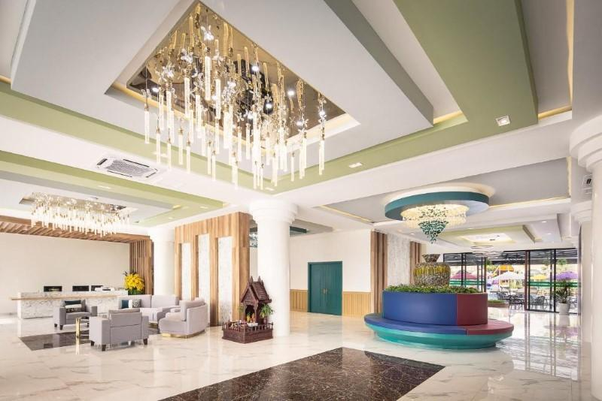

Easia Travel Head Office

