CAMBODIA – Sihanoukville – The Secret Garden Koh Rong
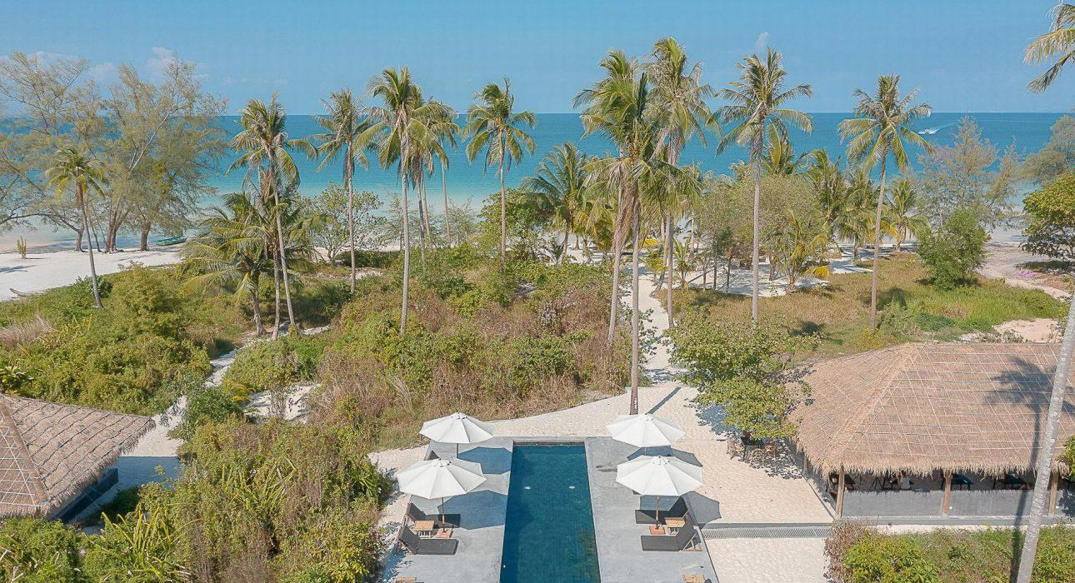

Over View

Theme
Beach Stay, Classic, Family, Honeymoon, Sustainable

Country - City
Cambodia - Sihanoukville

Market segment
Groups, Thematic Leisure

Official category
4*

Easia category
Superior

Total number of rooms
16

Price level
$$$$

Description

The Secret Garden Koh Rong is situated on the pristine pagoda beach of Koh Rong, which is unique in its natural and untouched beauty. The crystal clear waters and white sand beach offer unique surroundings for a perfect holiday. From The Secret Garden Koh Rong to Coconut beach is only 2.70 km, while Sok San port is 6 km from this hotel.The Secret Garden Koh Rong features 16 air-conditioned rooms and a beautiful swimming pool with a children’s pool attached. All guest rooms at the hotel come with a safety deposit box and a seating area. The private bathroom is fitted with a bidet, bathrobes, and slippers. A continental breakfast is available every morning at the accommodation. The beachside restaurant and bar serve a menu of great Asian and Western cuisine, cocktail, wine, and different kinds of beer are served by the friendly staff with happy-hour specials every night. Free WIFI is provided throughout the property.

Selling points

- Situated on the pristine pagoda beach of Koh Rong, which is unique in its natural and untouched beauty
- Has the beach with crystal clear waters and white sand
- Lovely design and charming room with a beautiful outdoor swimming pool with children’s pool attached
- Spacious and spotless room
- A perfect place to enjoy the holiday as a beach stay

Sustainability

Supplier Actions
Protection of Environment, Support local communities, Child Protection

Time & Transportation

From | To | By | Distance | Duration | Road Condition
The Secret Garden | Koh Rong Dive Center | Car | 6 km | 15 mn | Good
The Secret Garden | Long Set Beach | Car | 3 km | 10 mn | Good
The Secret Garden | Sok San Port | Car | 6 km | 15 mn | Good
The Secret Garden | Sihanoukville | Speed ferry | 41 km | 45 mn | Good / water way

Rooms

Easia's recommend room type
Deluxe Double RoomStyle : Modern
- Room Size : 36 sqm
- Number of Room : 13 units
- Bed Type : Double Bed, King size bed
- Extra Bed : Yes
- Remark : Sea view, patio, ensuite bathroom, air-conditioning, Free WIFI
Deluxe Twin RoomStyle : Modern
- Room Size : 36 sqm
- Number of Room : 1 unit
- Bed Type : Twin Bed, Single size bed
- Extra Bed : Yes
- Remark : Sea view & pool view, patio, ensuite bathroom, air-conditioning, Free WIFI
Family Connecting RoomStyle : Modern
- Room Size : 50 sqm
- Number of Room : 1 unit
- Room Type : 1 connecting room of Deluxe Double Room connected to Deluxe Twin Room
- Bed Type : Twin Bed of Single size bed and Double Bed of King size bed
- Extra Bed : Yes
- Remark : Garden view & pool view, patio, ensuite bathroom, air-conditioning, Free WIFI

Room configuration

Connecting rooms
Yes. 1 connecting room of Deluxe Double Room connected to Deluxe Twin Room

Extra bed
Yes. 0.60 m x 2 m (Rolling Bed)

King bed
1.80 m x 2 m

Queen bed
No

Twin beds
1.20 m x 2 m

Services & Facilities

Services
24 hour reception, Babysitting, Catering (beach, river, cave, other), Children Activities, Children Swimming Pool, Complimentary bottle of water, Complimentary fresh towel, Credit Card payment, Diving, Dry Cleaning, Iron, Kayaking, Laundry service, Luggage Storage, Massage, Mobile phone, Private event, partying, Room Service, Spa, Swimming Pool, Wake-up service, Wi-fi Free

Facilities
Air Conditioning, Bar, BBQ Facility, Cable, satelite, Children Pool, coffee and tea making facilities, Coffee Machine Facilities, Family Room, Fan, Flat screen TV, Full Board - B/L/D, Garden, Hair Dryer, In-Room safe, Internet, Massage room, Outdoor swimming pool, Private Beach, Restaurant, Safety Box, satellite LCD TV, Shower With Hot Water, Terrace, Umbrella

Disabled Facilities
Rooms are adapted

Restaurant information

The secret Garden RestaurantOpen daily : 6:30 AM – 9:00 PM
- Breakfast : 6:30 AM – 9:00 AM
- Lunch : 11:30 PM – 2:00 PM
- Dinner : 5:00 PM – 9:00 PM
- Room Service : 11:00 AM – 10:00 PM
- Menu : Asian & Western Cuisine
- Capacity : 60 seats
The Secret Garden BarOpen daily : 11:00 AM – 10:00 PM
- Happy Hour : 5:00 PM – 7:00 PM
- Capacity : 6 seats
The Secret Garden SpaOpen daily 11:00 AM – 9:00 PM
- Capacity : 1 person

Photos

Hotel Photos
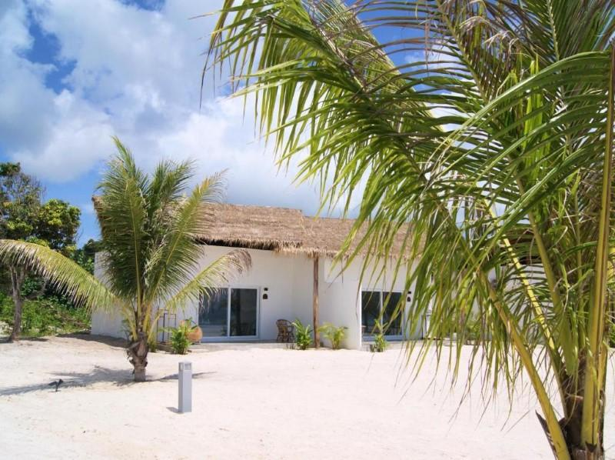
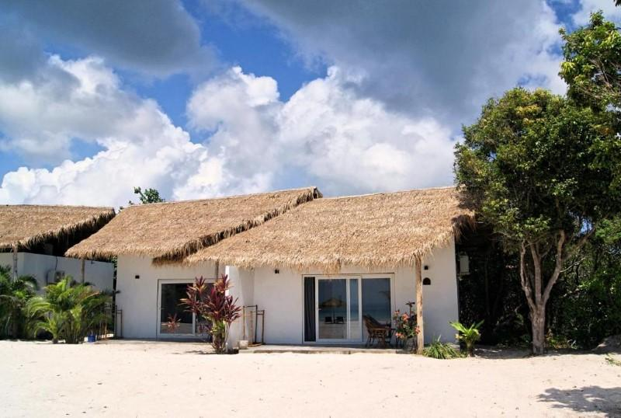
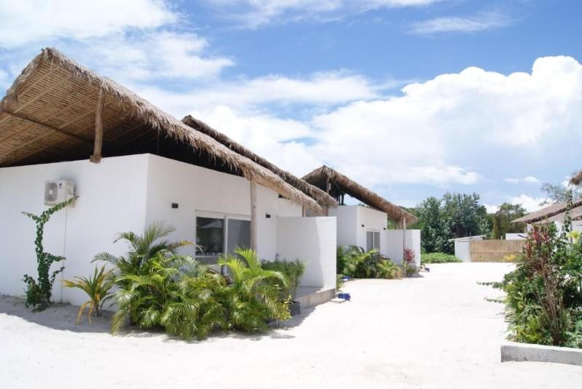
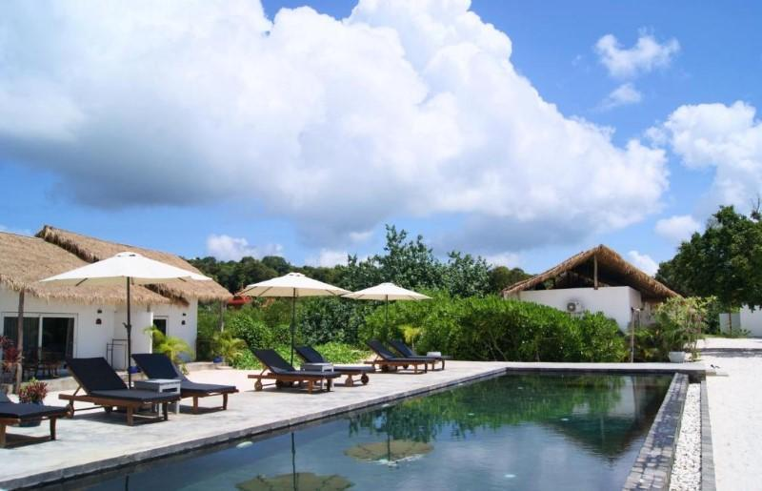
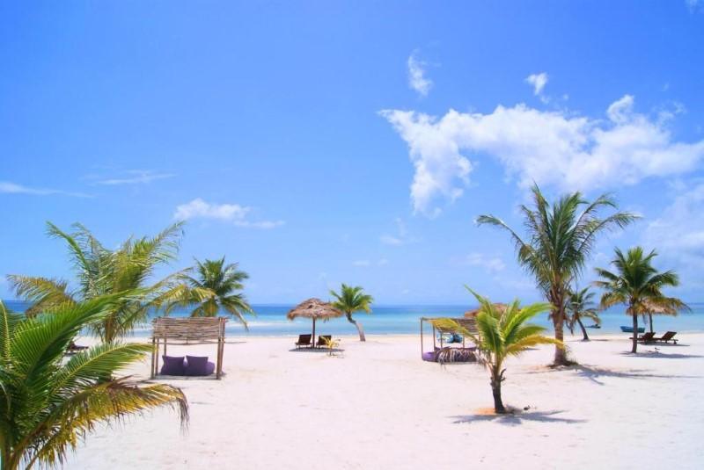

Rooms photos
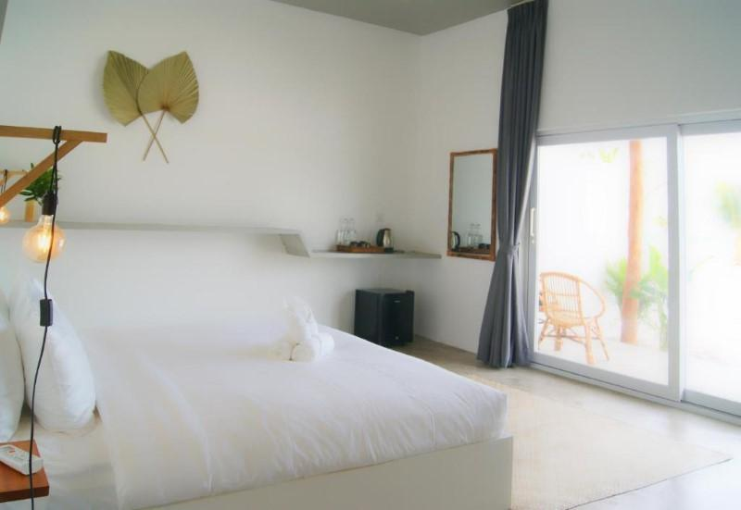
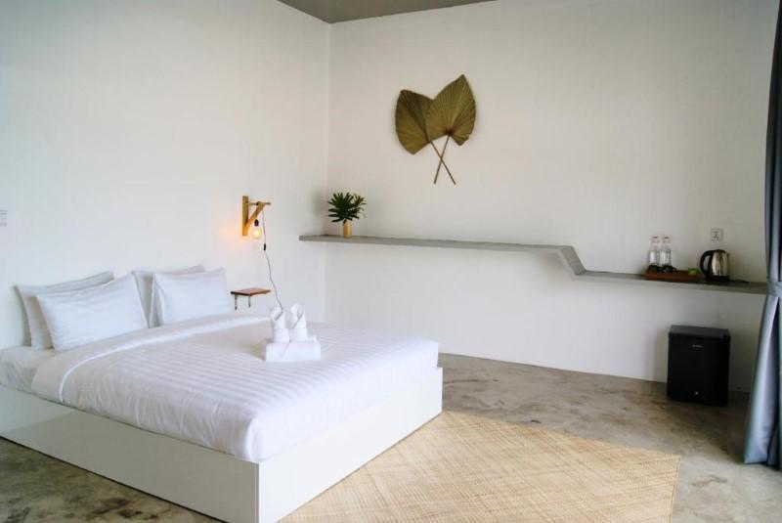
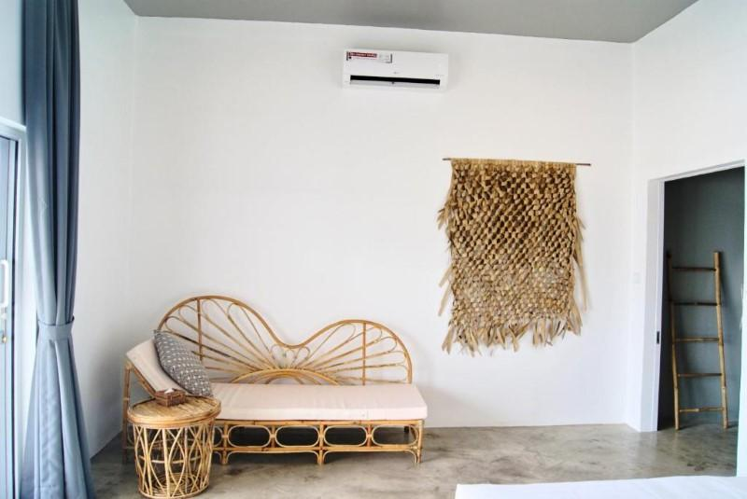
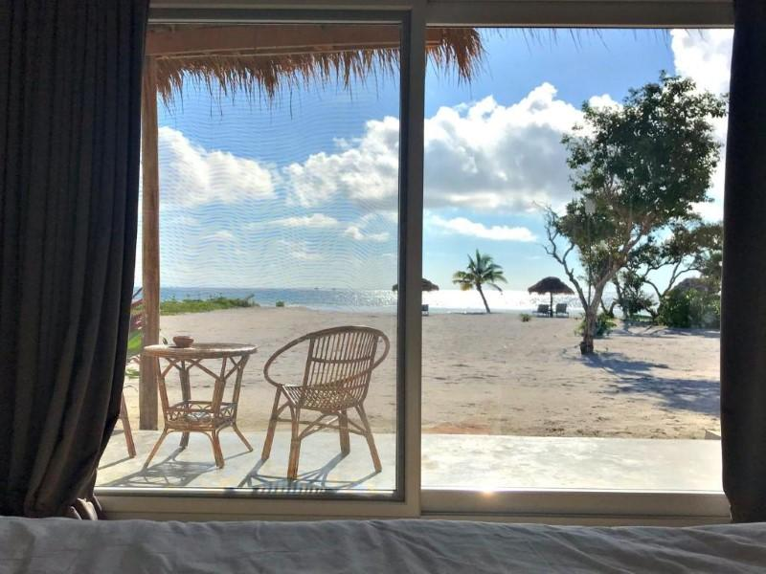
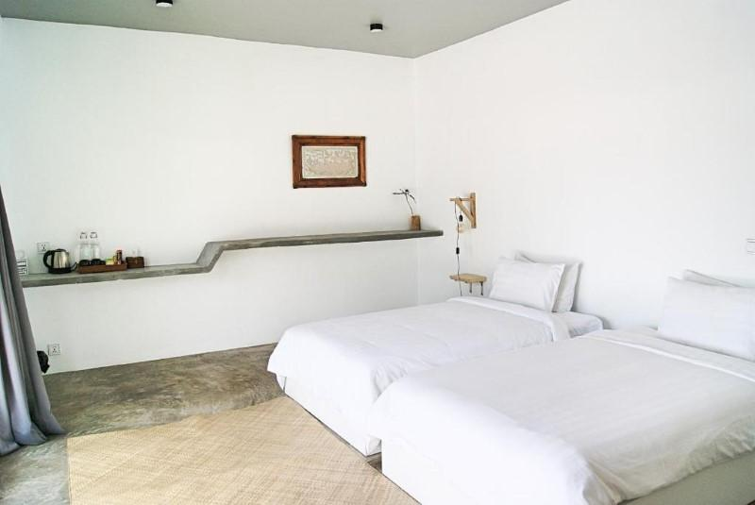
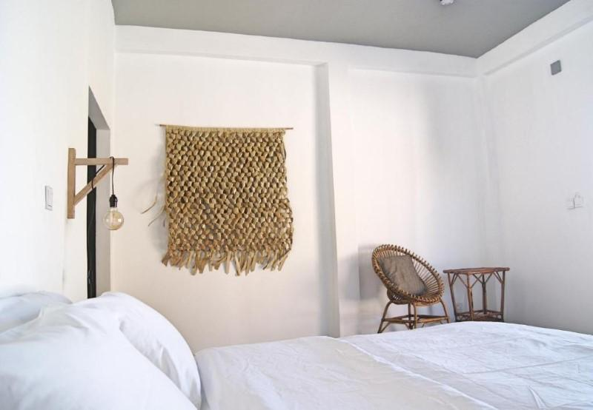
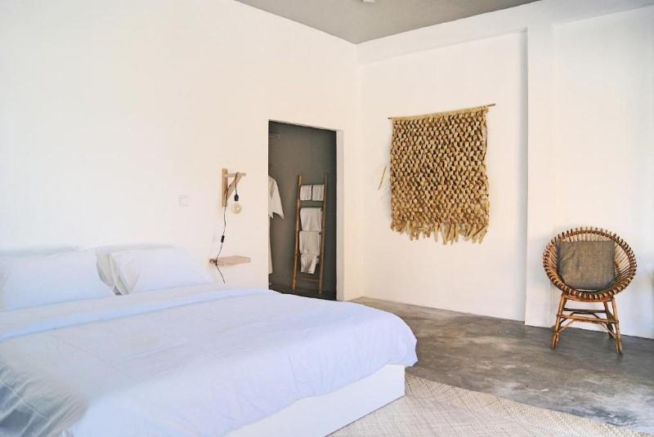
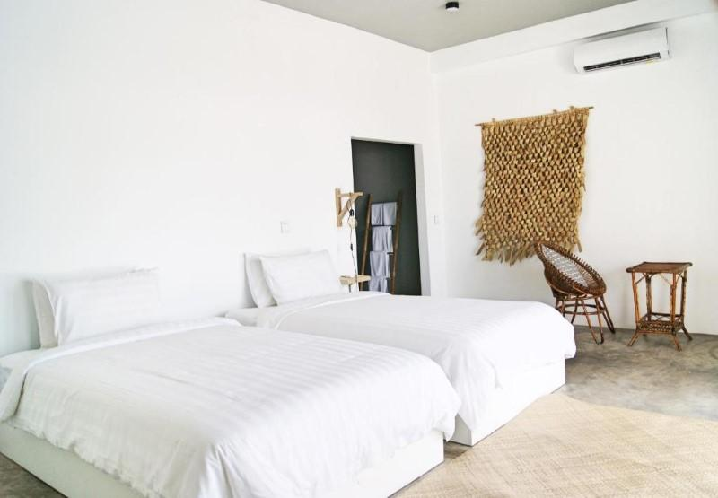
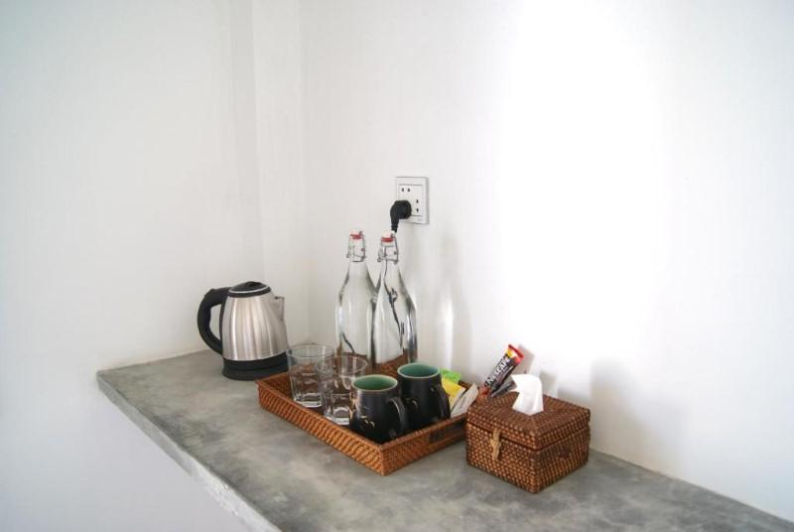

Restaurant photos
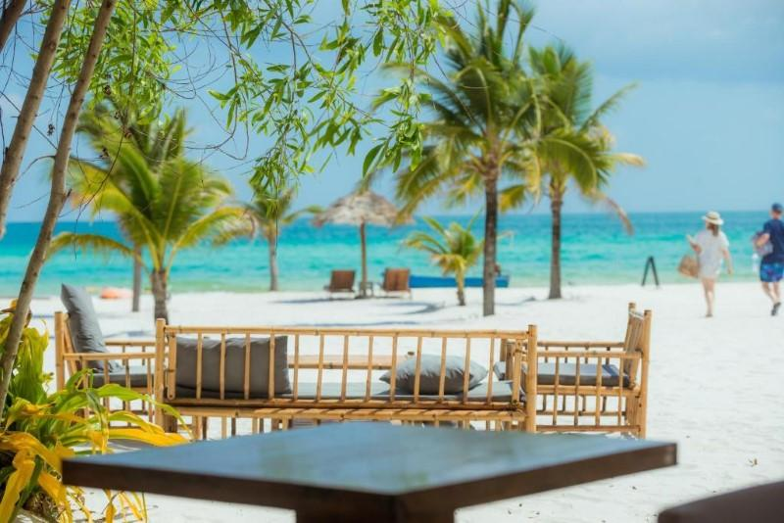
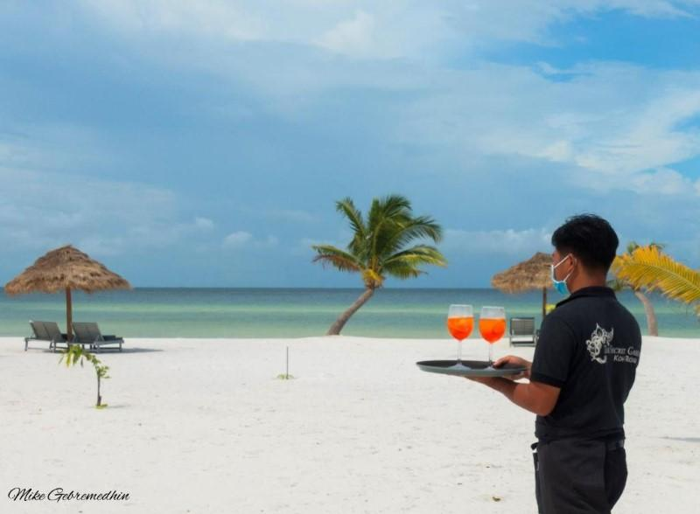
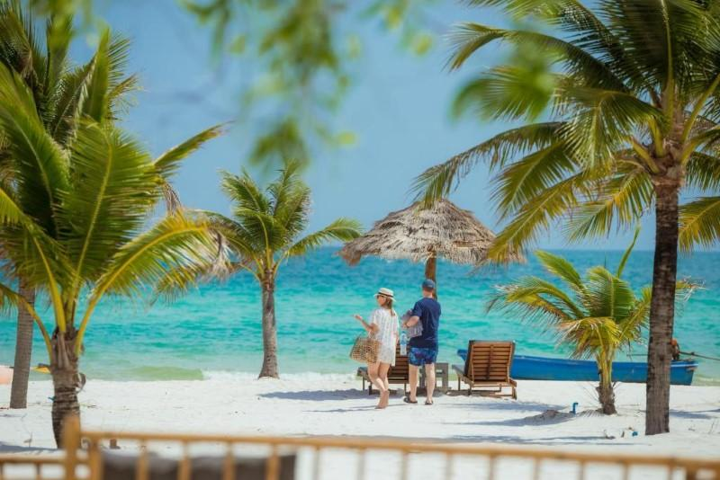
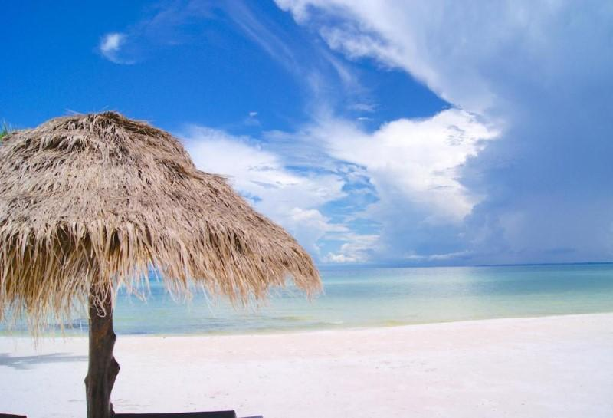
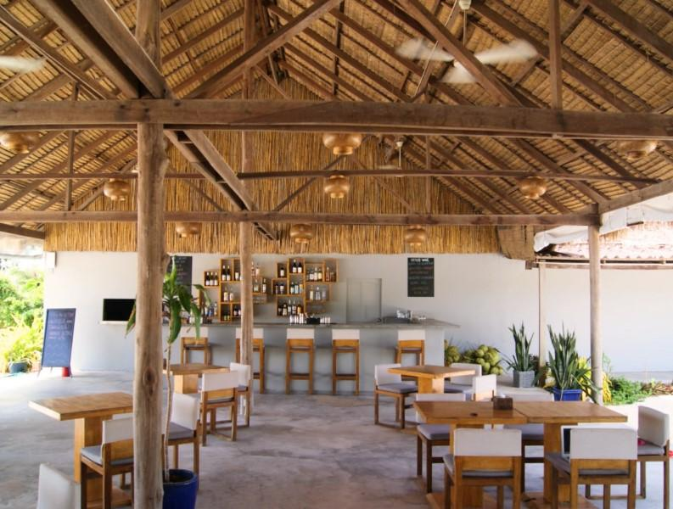

Services & facilities photos
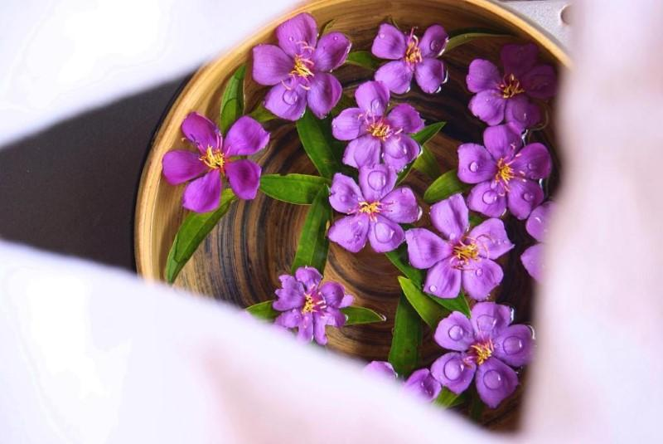
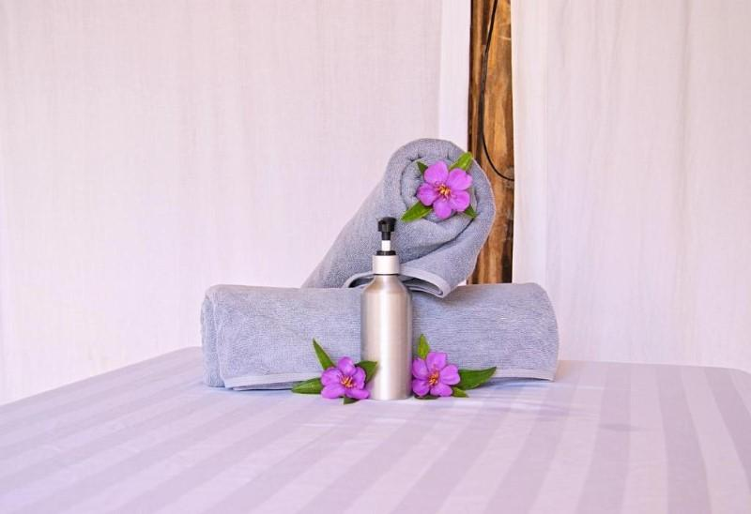
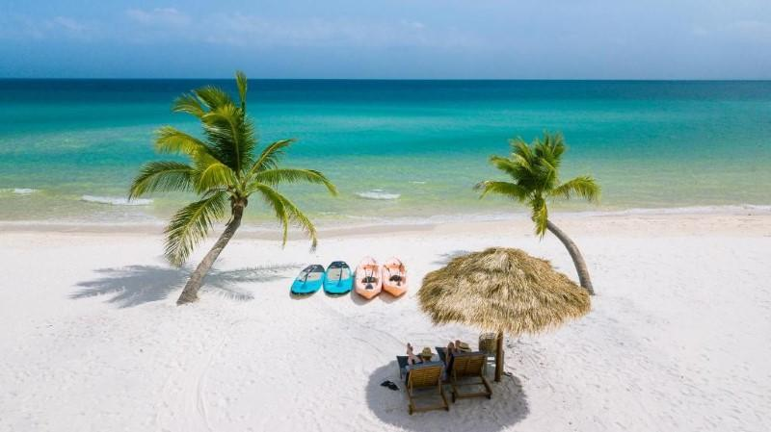
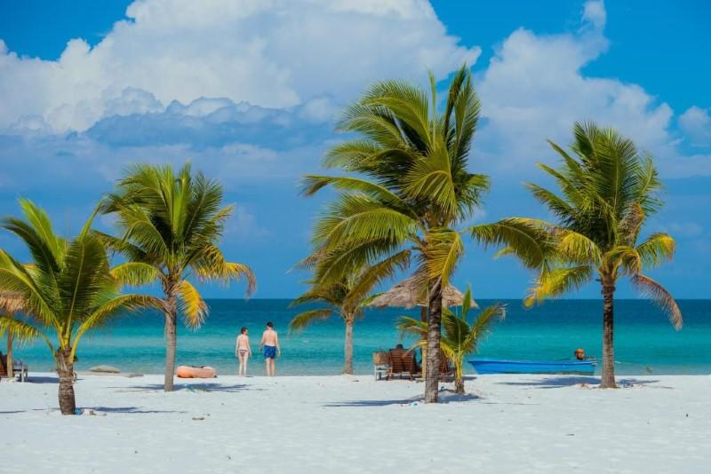
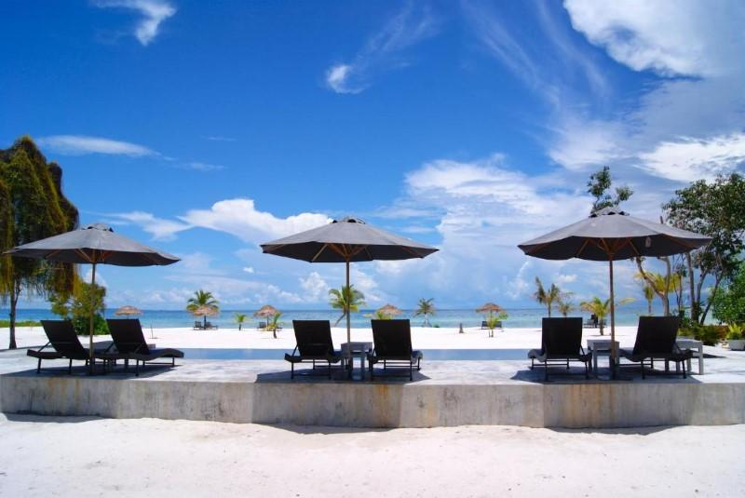
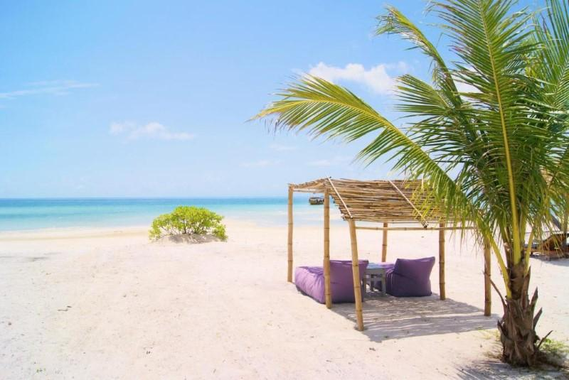
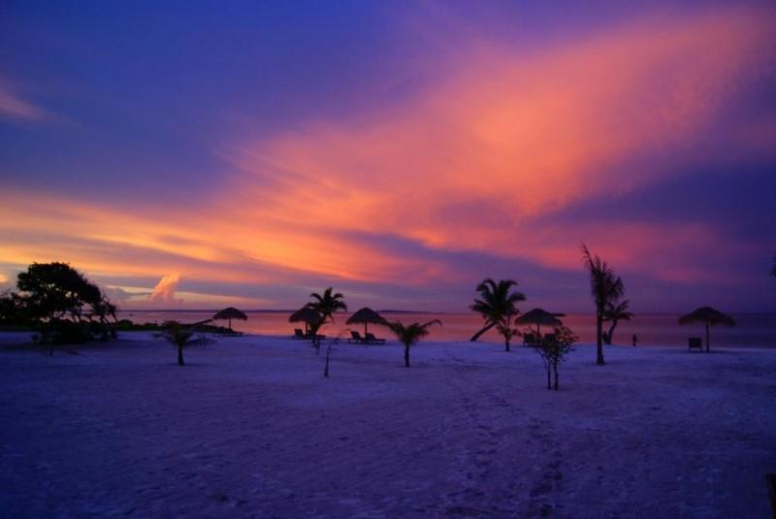
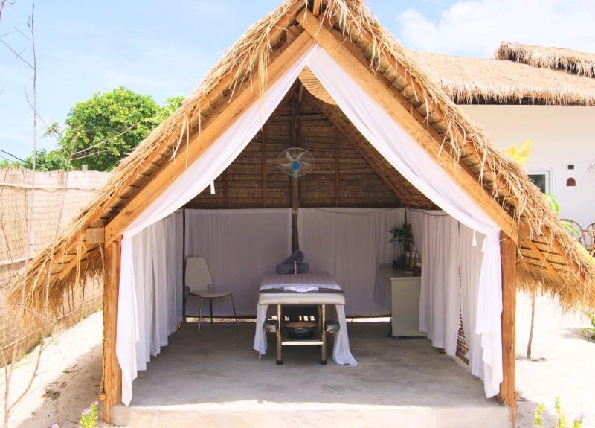
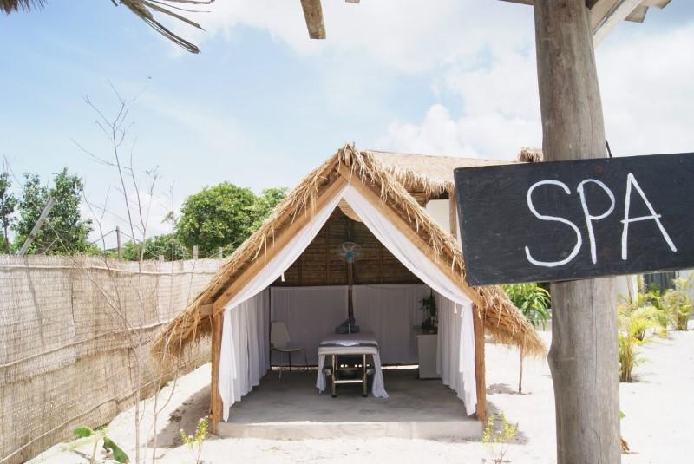
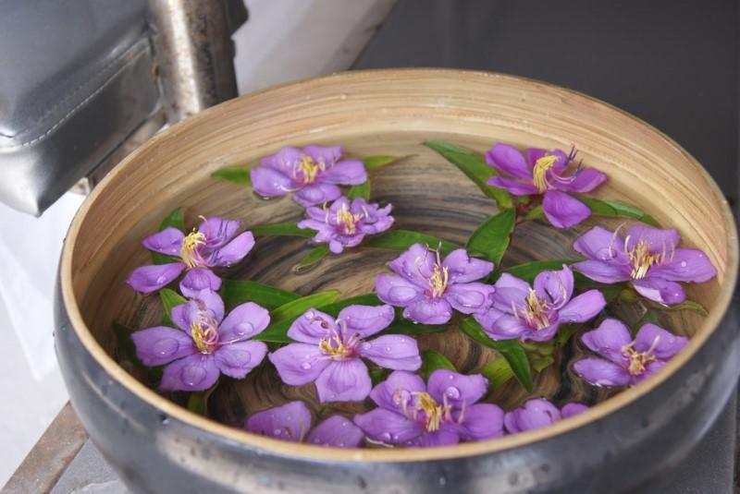
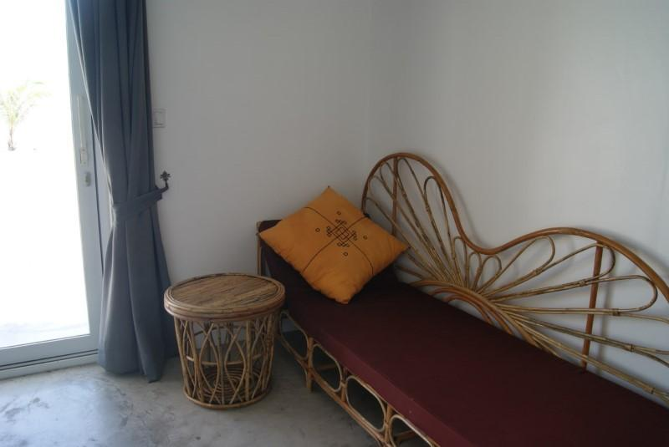
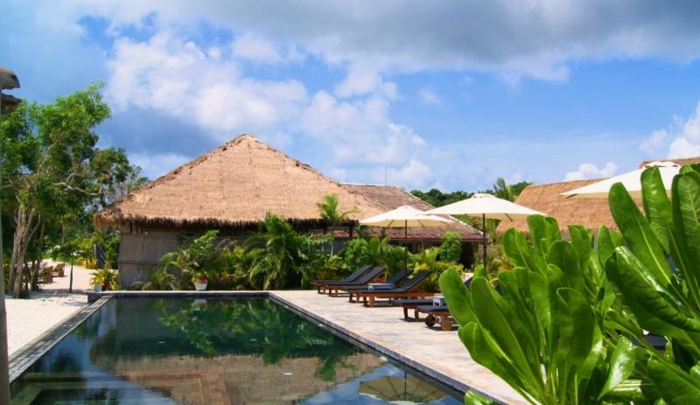

Easia Travel Head Office

