VIETNAM – Hoi An – Hoi An Blue Sky Boutique Hotel
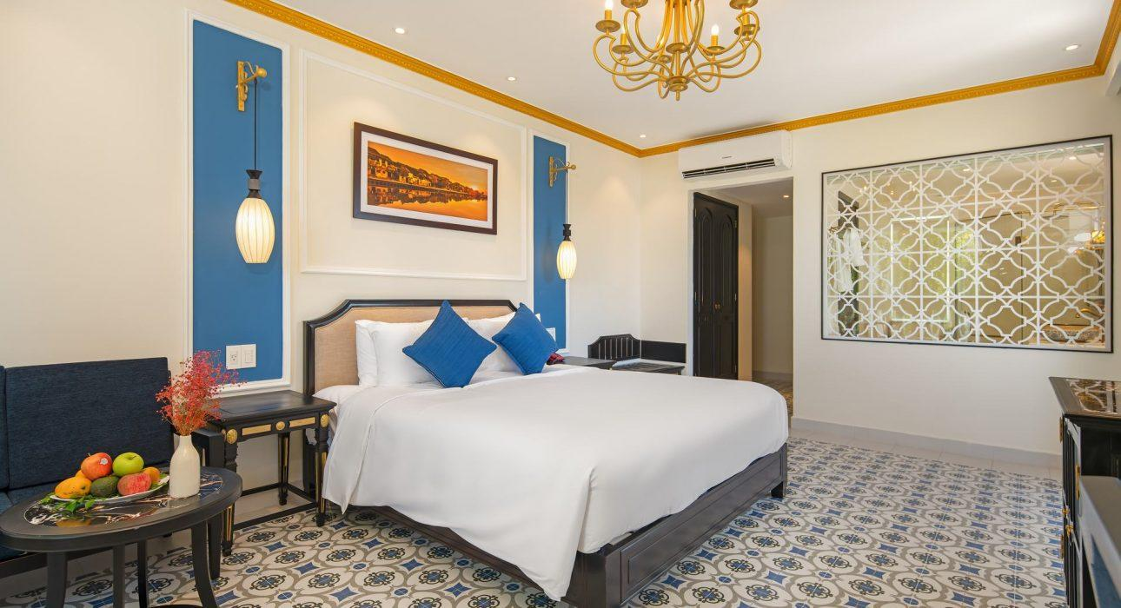

Over View

Theme
Classic

Country - City
Vietnam - Hoi An

Market segment
Groups, Thematic Leisure

Official category
4*

Easia category
Superior

Total number of rooms
76 rooms

Price level
$$

Description

This is a newly built hotel with 76 rooms designed in a variety of different styles, bringing a sense of comfort to visitors when choosing to stay. Coming to the hotel, visitors also have the opportunity to experience many types of services such as restaurants, gyms, spas …. Especially, the Bar space is airy on the rooftop.

Selling points

Time & Transportation

FROM | TO | DISTANCE (KM) | BY | DURATION | ROAD CONDITION
Hoi An Ancient Town | Hotel | 2,5km | Car | 07 Minutes | Good
Da Nang Airport | Hotel | 30km | Car | 50 minutes | Good

Rooms

Easia's recommend room type
Room type: Superior Pool View, Deluxe Pool View, Deluxe Triple Pool View, Deluxe Family Pool View, Deluxe Family 2 bedrooms with balcony & pool view, Apartment 2 bedrooms, Family Suite with private pool.
- 31 Superior pool view : 30m2
- 21 Deluxe pool view: 35m2
- 06 Deluxe Family 2 bedrooms with balcony & pool view: 70m2, Each Deluxe Family can be split into 2 seperated Deluxe rooms
- 1 Apartment 2 bedrooms : 80m2
- 1 Family Suite with private pool: 70m2 + private pool 20m2

Room configuration

Connecting rooms
No connecting but have 06 Deluxe Family 2 bedrooms with balcony & pool view, , Each Deluxe Family can be split into 2 seperated Deluxe rooms.

Extra bed
6 extra bed size 1m x 1m1

King bed
No

Queen bed
1m8 x 2m

Twin beds
1m x

Services & Facilities

Services
24 hour reception, 24h security service, Babysitting, Bicycle Rental, Billiards, Cycling, In-Room Dining, Massage, Private event, partying, Room Service, Services for children, Spa, Swimming Pool, Wake-up service, Welcome fruits in room upon arrival, Wi-fi Free

Facilities
Air Conditioning, Bar, Bicycle, Business centre, Children Pool, Family Room, Garden, Gift Shop, Hair Dryer, In-Room safe, Internet, Massage room, Mini Bar, Private Dining Room, Private Pool, Restaurant, Safety Box, Smoking Area, Terrace, TV Room, Umbrella

Business facilities details
ROOM NAME | SIZE | CLASSROOM | THEATER | U SHAPE | BOARDROOM | BANQUET
Meeting room | 50m2 | 30 | 30 | 20 | N/A | N/A

Restaurant information

– Name: HOI AN BLUE SKY RESTAURANT– Capacity: 100– Opening Hours: 06:30 AM – 10:00 PM– Type of Cuisine: Western, Vietnamese cuisine– Note:

Photos

Hotel Photos
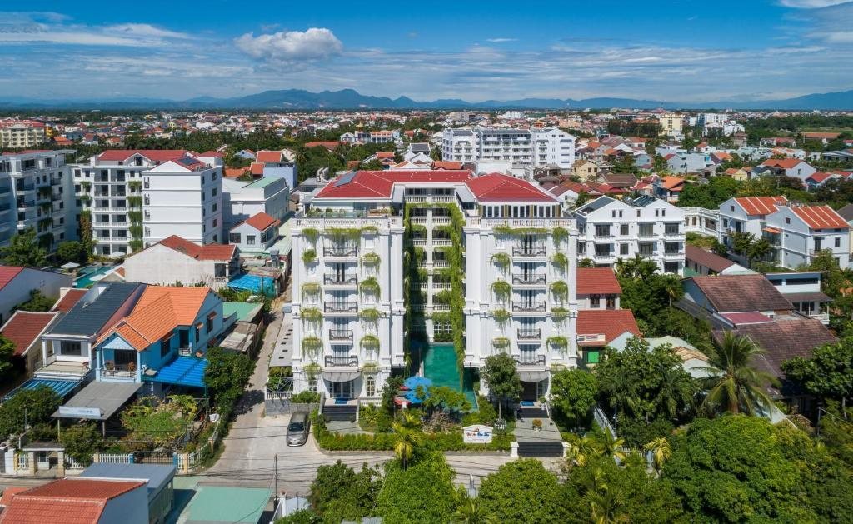
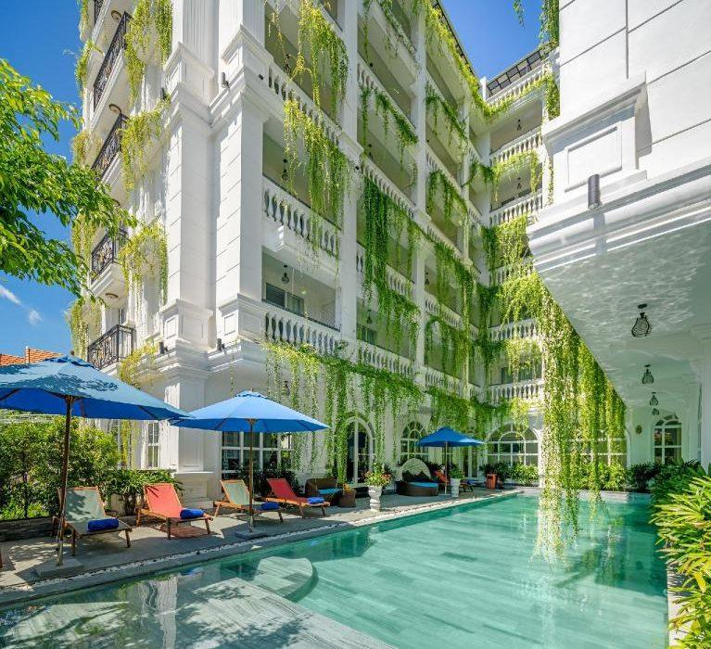
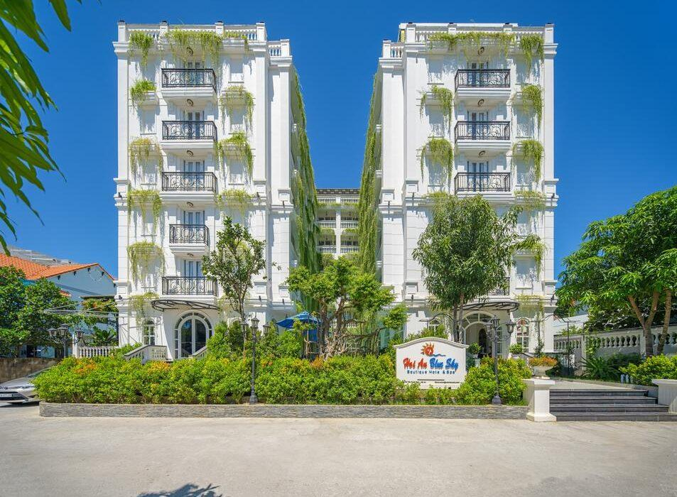
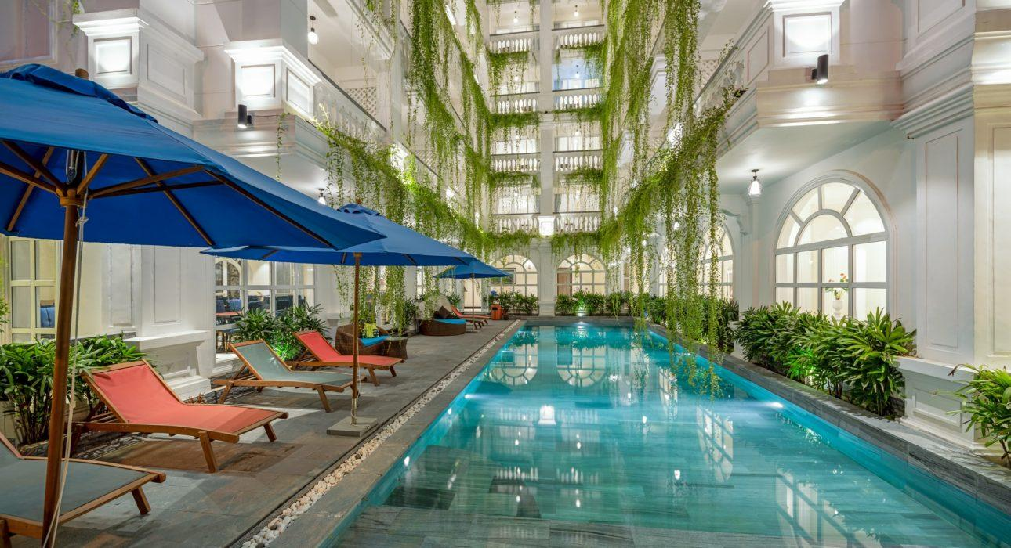
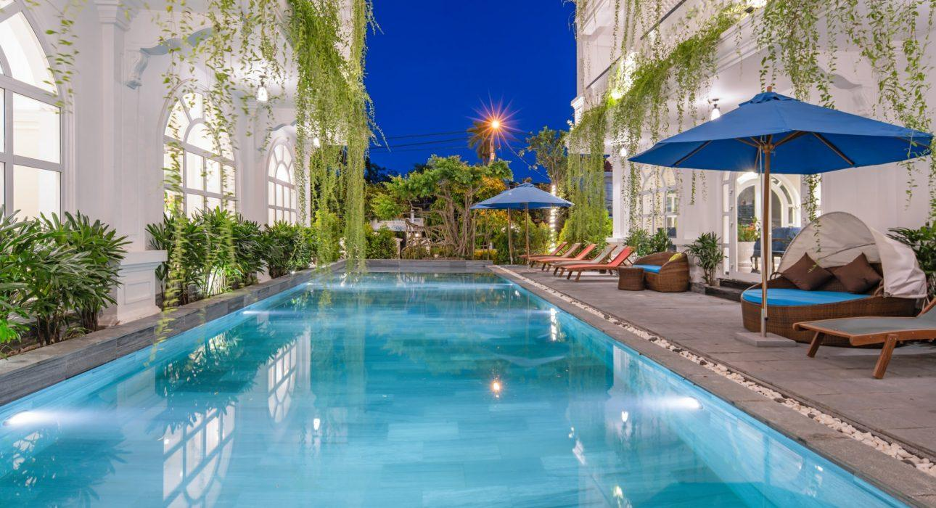

Rooms photos
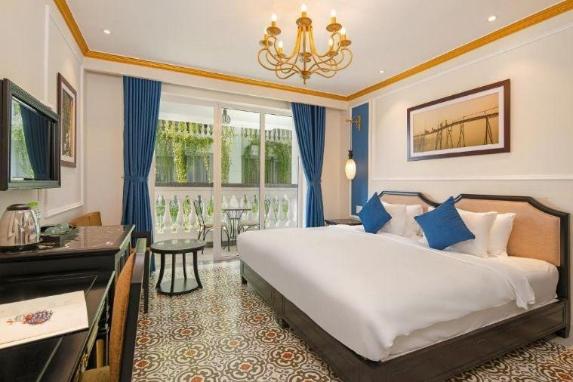
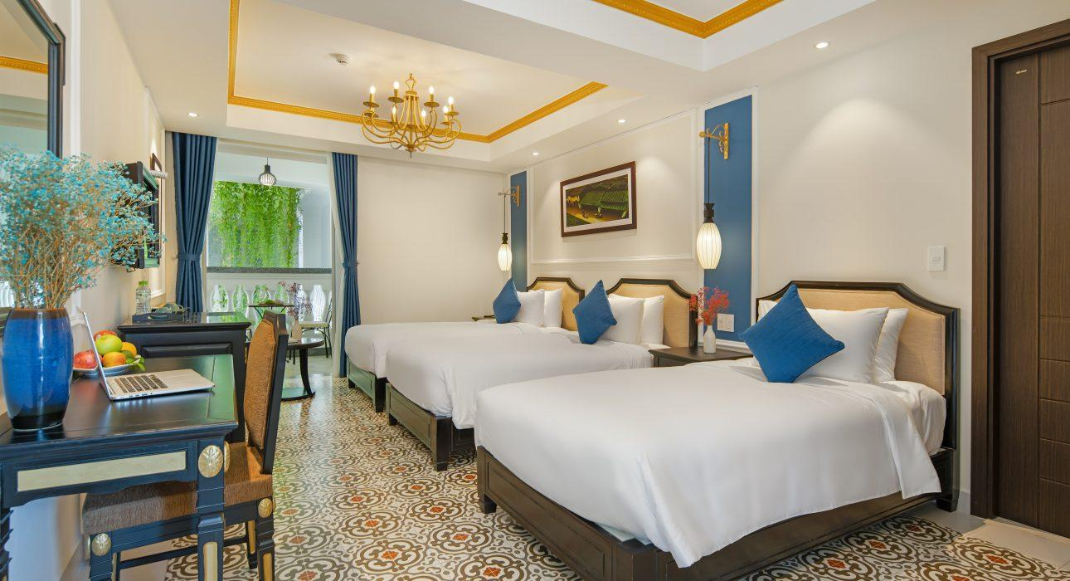
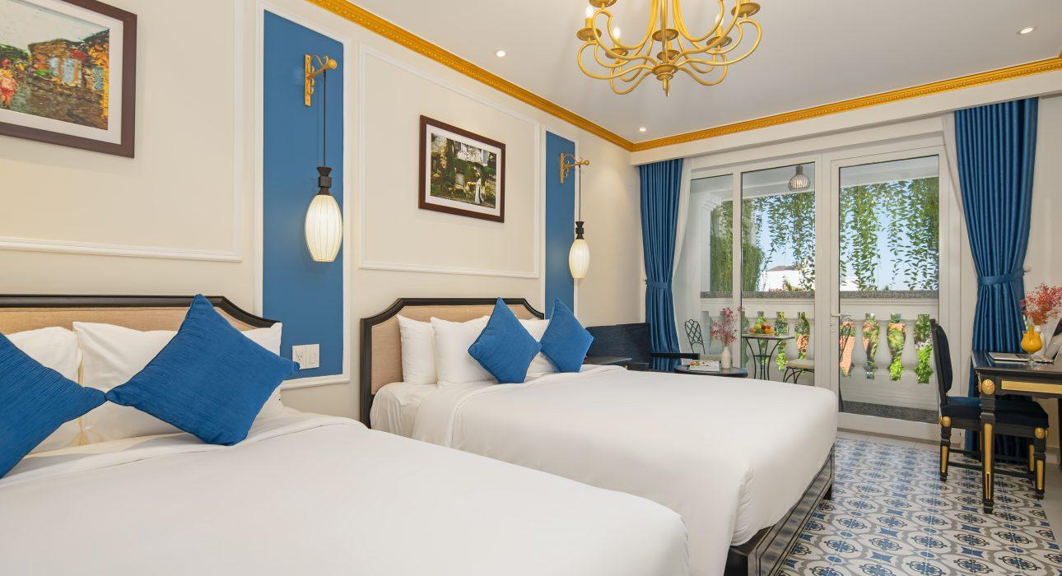
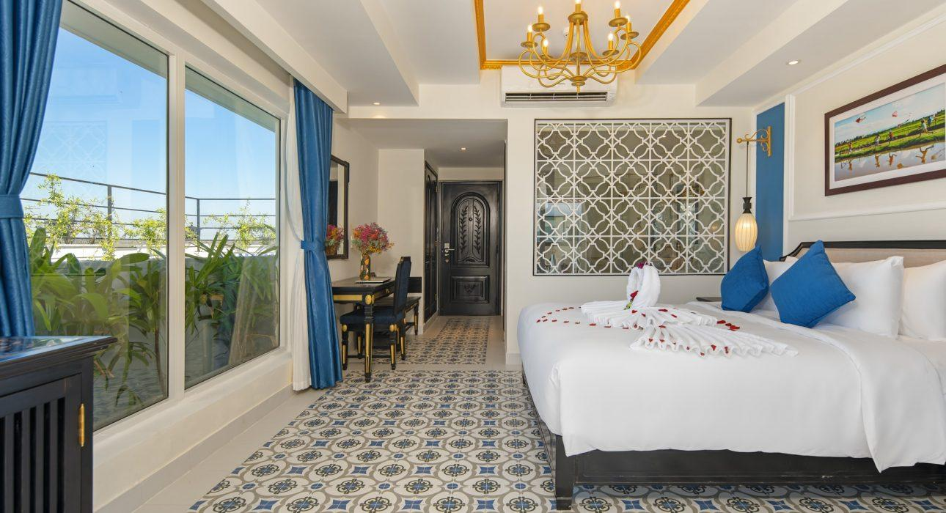
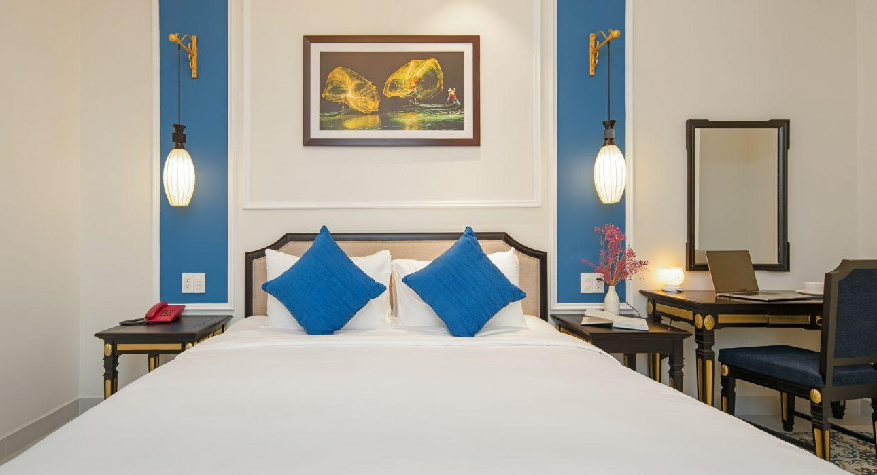

Restaurant photos
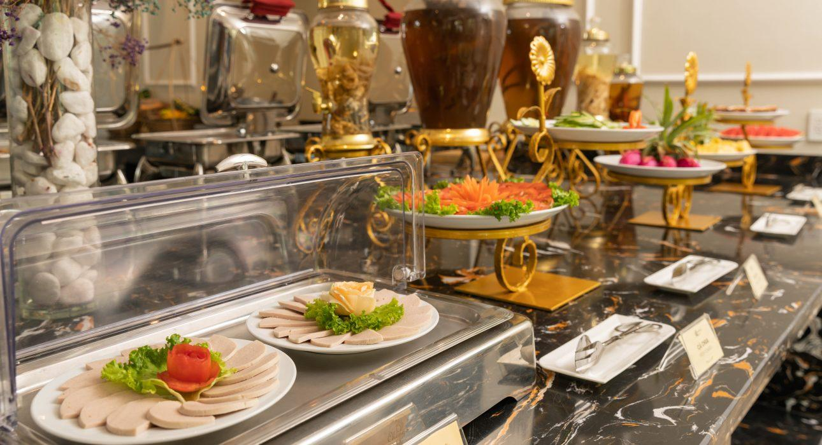
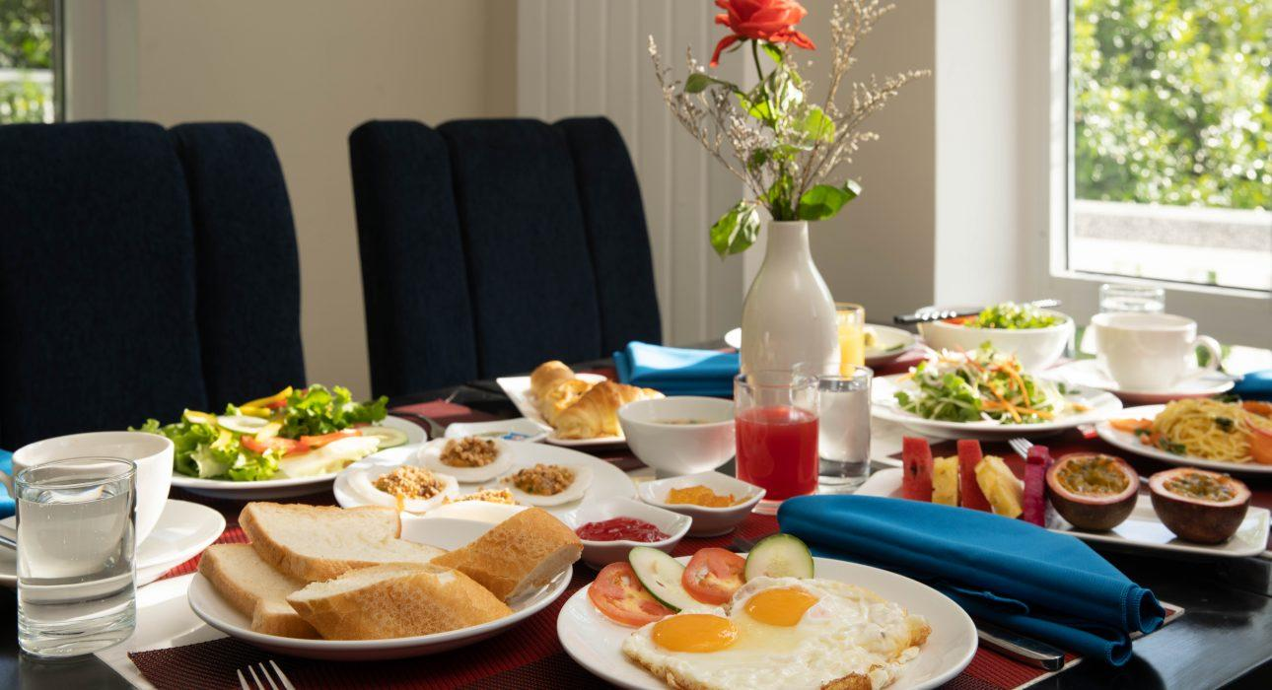
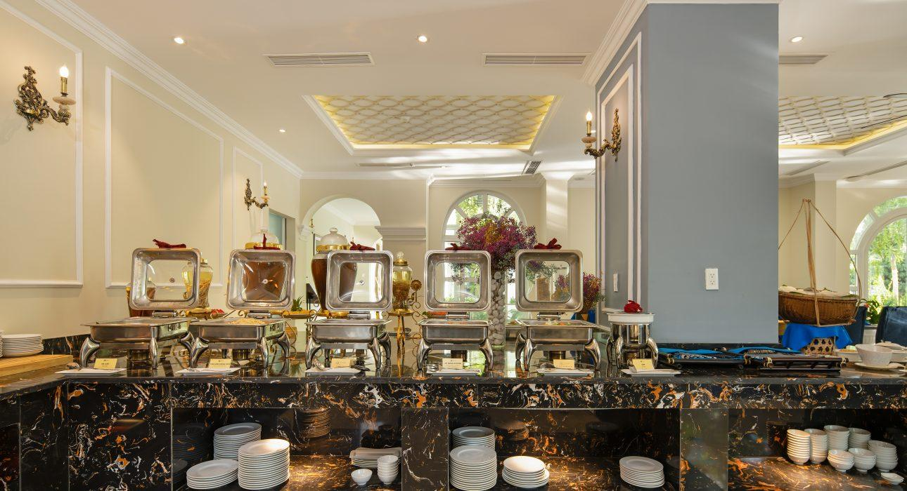
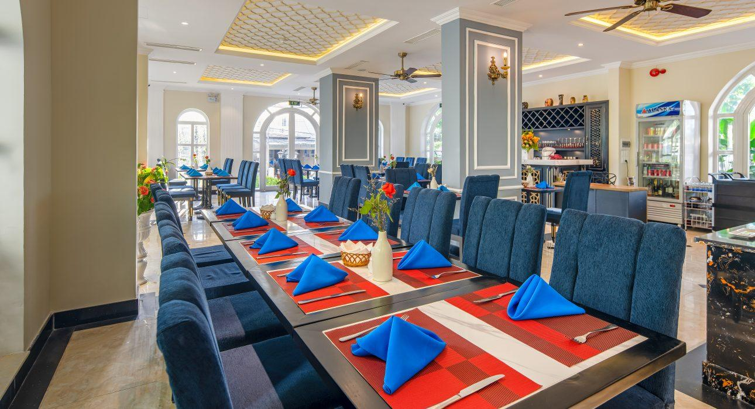

Easia Travel Head Office

Vietnam Head Office Address: 33B Phạm Ngũ Lão, Phan Chu Trinh, Hoàn Kiếm, Hà NộiPhone: 84 24 39331362Email: info@easia-travel.com

