VIETNAM – Ben Tre – Mekong Home
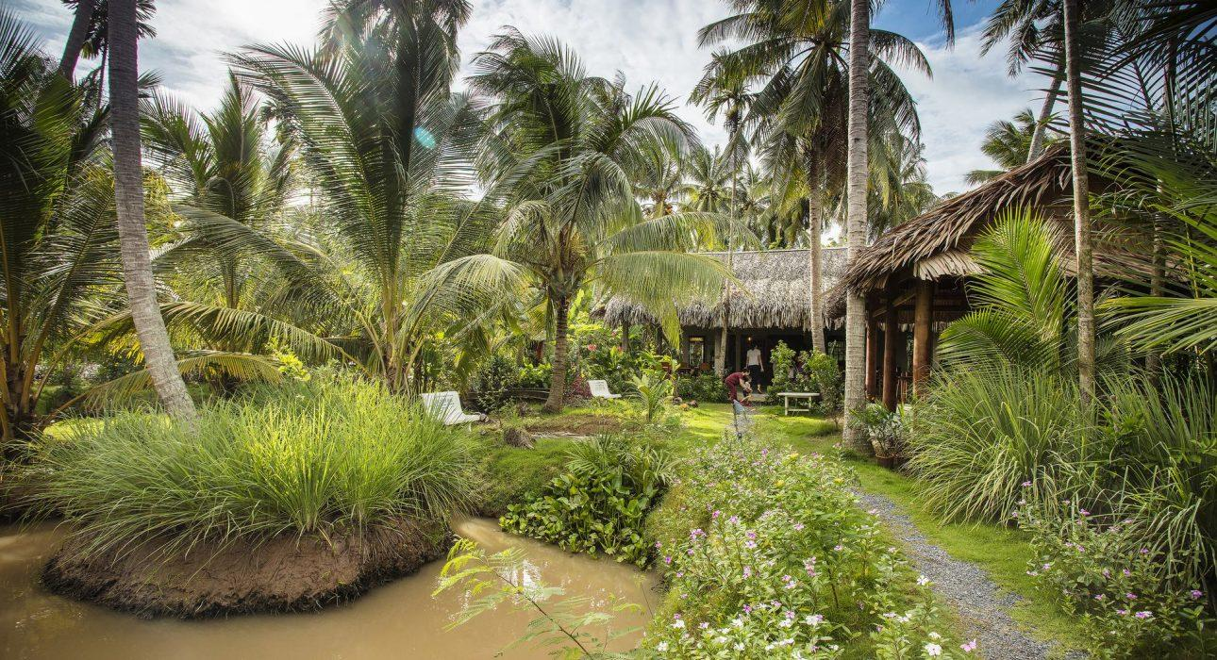

Over View

Theme
Classic

Country - City
Vietnam - Ben Tre

Market segment
Thematic Leisure

Official category
Homestay

Easia category
Homestay

Total number of rooms
10

Price level
$$

Description

Located on the stretch of Ham Luong River in Ben Tre, Mekong Home’s accommodation designed as a rural house, all rooms have private balconies and large windows overlooking a lush garden. Rooms have air conditioning, ensuite bathroom, mosquito net, hammock,…With free bicycles at your disposal, you can slowly stroll on impressive small paths shaded by palm trees, along the lazy channels, and through fruit gardens in which some typically hidden houses of the neighbors are always willing to welcome you to the beautiful country.

Selling points

- Quiet place and near the river.
- Spacious and comfortable rooms.
- Friendly and helpful staff.
- A swimming pool and spa are available.

Sustainability

Supplier Actions
Protection of Environment

Time & Transportation

FROM | TO | DISTANCE (KM) | BY | DURATION | ROAD CONDITION
Hotel | Ben Tre Center | 12km | Car | 20 minutes | Good

Rooms

Easia's recommend room type
Mekong Home offers spacious rooms with comfortable facilities such as air conditioning, a private entrance, a terrace with lake views as well as a private bathroom boasting a walk-in shower. The hotel provides 3 types of rooms that suite for couple, friends and families:
- Double room: (6 rooms, sized 38m2)
- Twin room: (2 rooms, sized 38m2)
- Triple room: (2 rooms, sized 38m2)

Room configuration

Connecting rooms
No

Extra bed
0.8m x 1.9m (Total: 02 extra beds)

King bed
1.8m x 2.0m

Twin beds
1.2m x 2.0m

Services & Facilities

Services
24 hour reception, 24h security service, Air ticket Reservation, Airport transfer, Bicycle Rental, Boat rental, Boat Transfer from/to, Buffet Breakfast, Car rental, Children Activities, Complimentary bottle of water, Complimentary fresh towel, Concierge service, Cooking Lesson, Credit Card payment, Currency exchange, Cycling, Fishing, In-house English speaking tour guide, Massage, Picnic boxes, Private event, partying, Spa, Swimming Pool, Tour desk, Wake-up service, Welcome fruits in room upon arrival, Wi-fi Free

Facilities
Air Conditioning, Bar, BBQ Facility, Bicycle, Family Room, Fan, Free private parking, Garden, Gift Shop, Hair Dryer, Internet, Massage room, Meeting room, Outdoor swimming pool, Restaurant, Shower With Hot Water, Smoking Area, Terrace, Umbrella

Restaurant information

- Name: Mekong Home
- Capacity: 20
- Opening Hours: 06:00 – 22:00
- Type of Cuisine: Traditional Vietnamese Cuisine

- Name: Mekong Home outdoor terrace
- Capacity: 30
- Opening Hours: 06:00 – 22:00
- Type of Cuisine: Traditional Vietnamese Cuisine

Photos

Hotel Photos
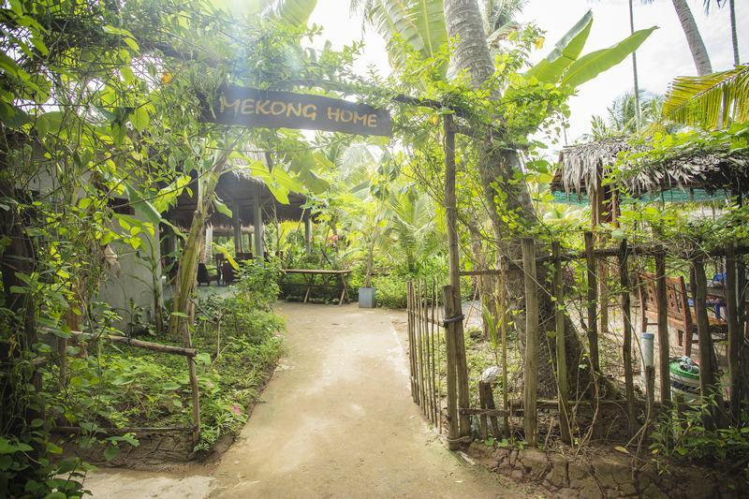
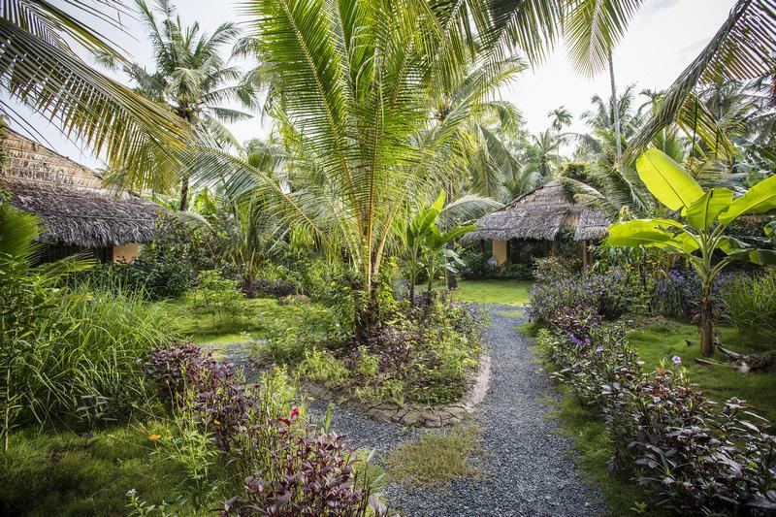

Rooms photos
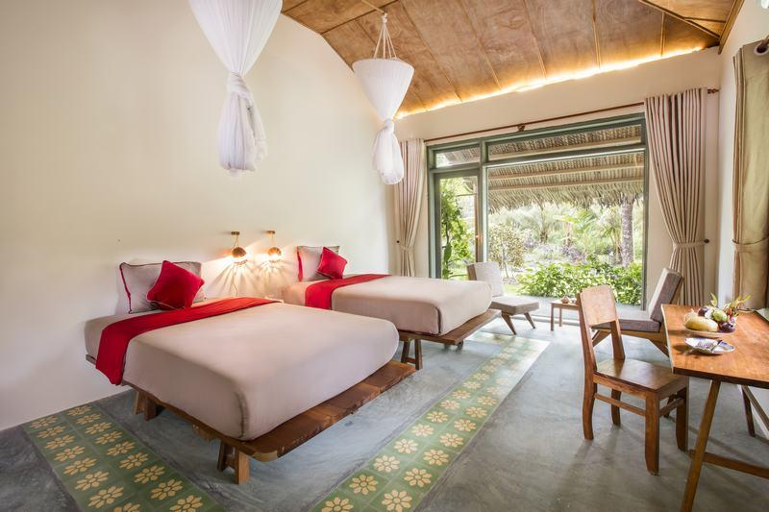
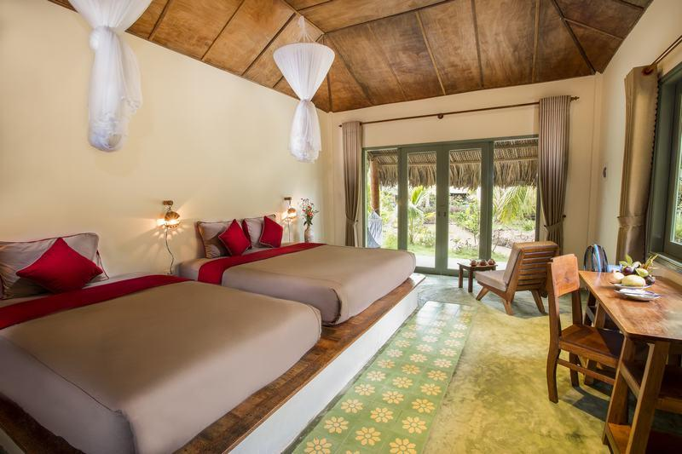
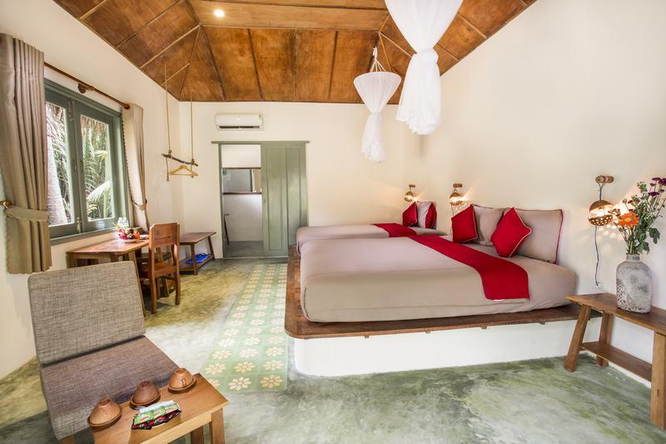
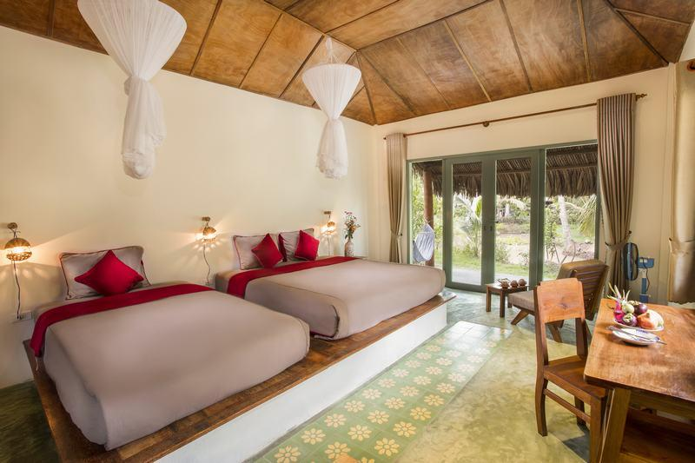
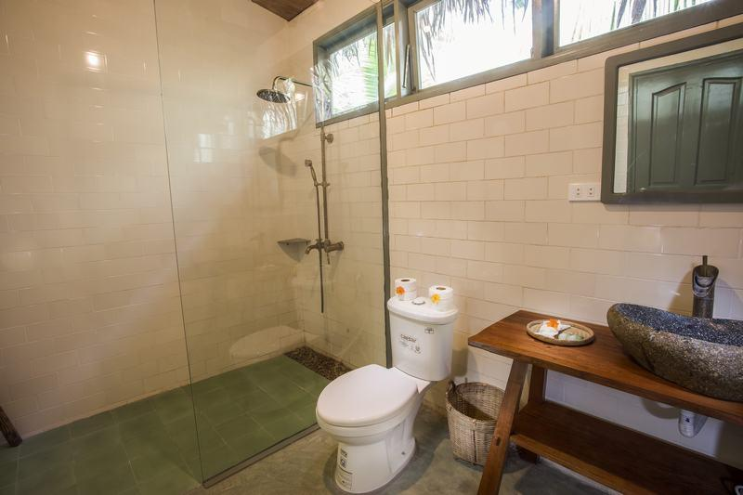
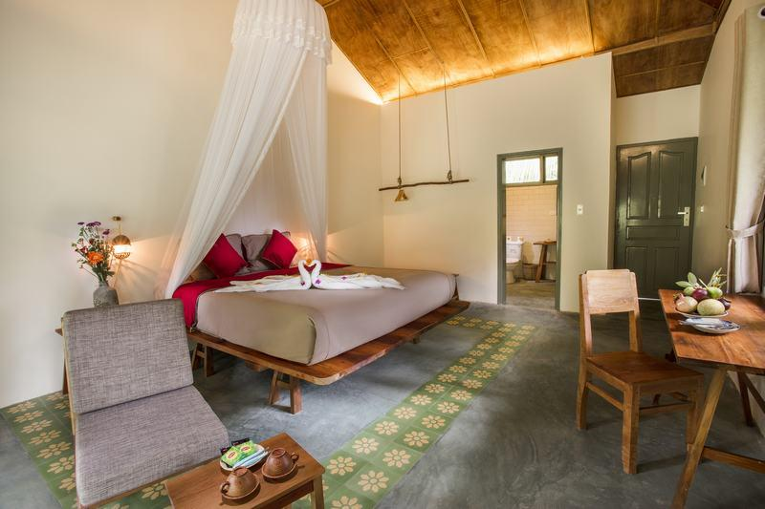
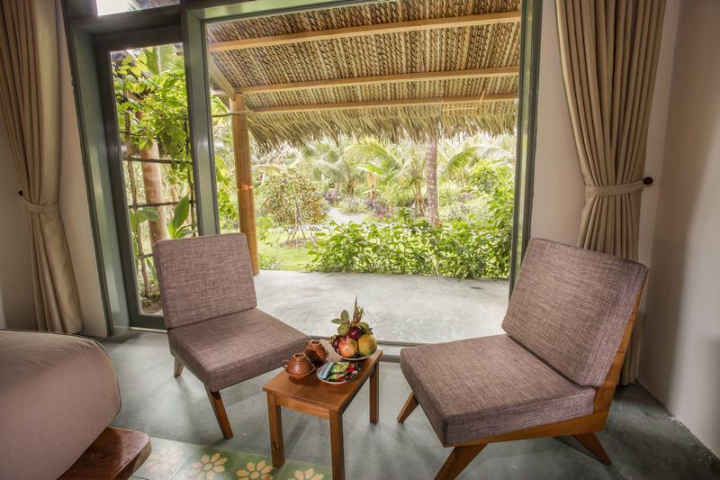

Restaurant photos
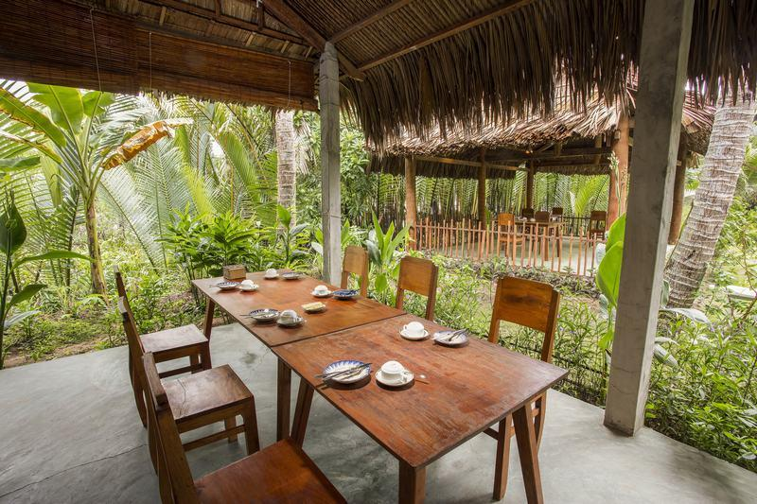
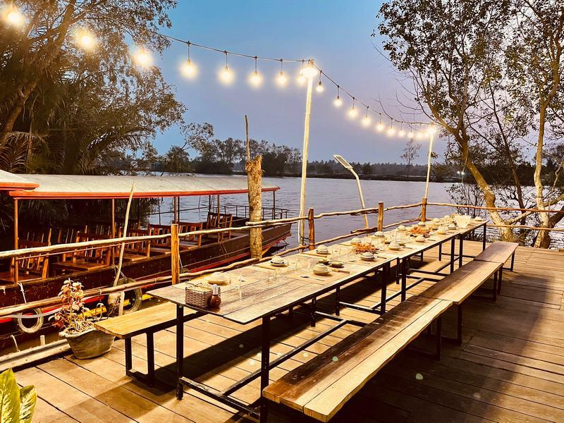
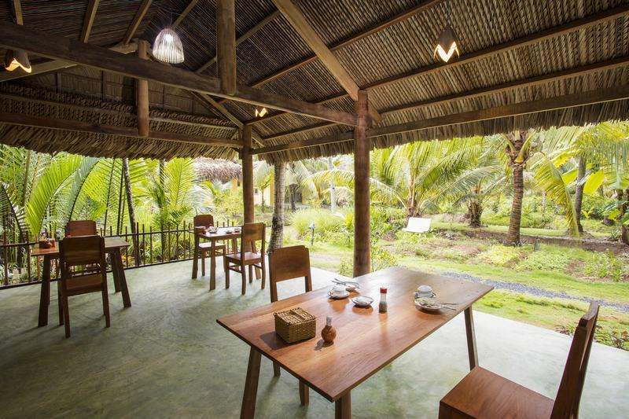
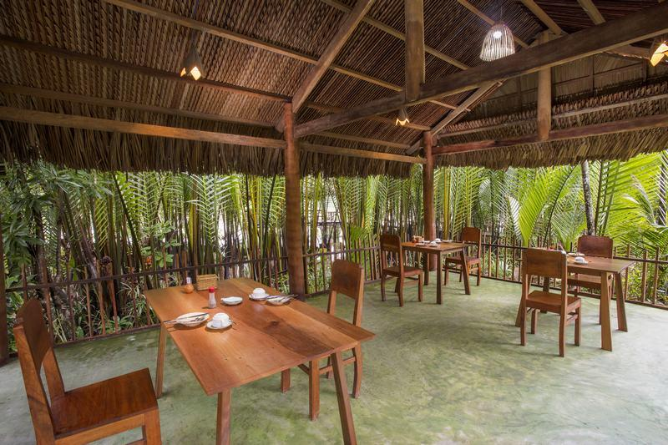
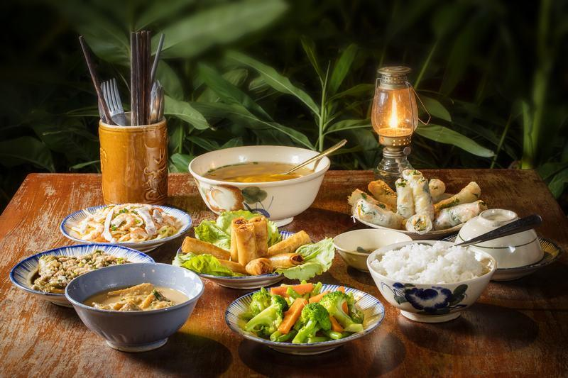
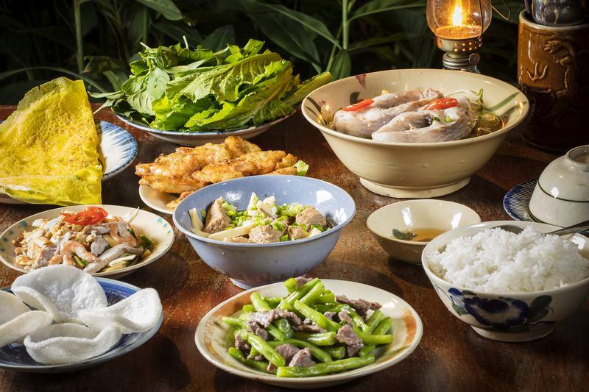
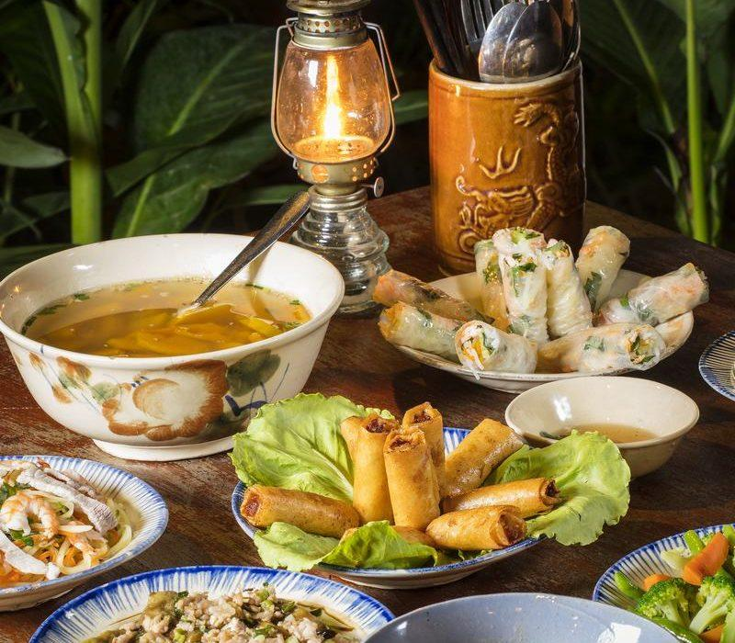

Services & facilities photos
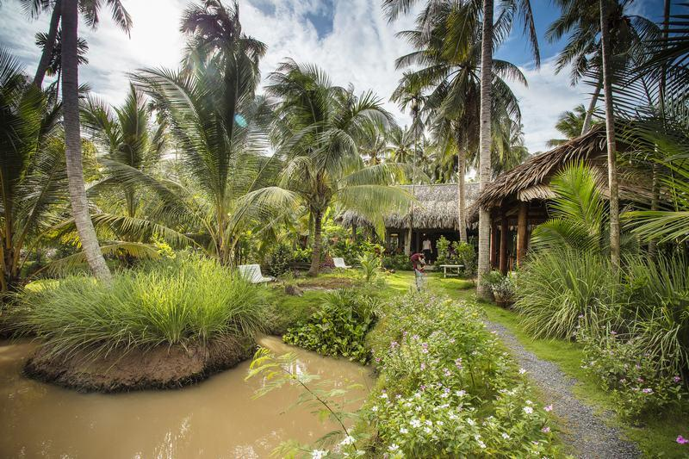
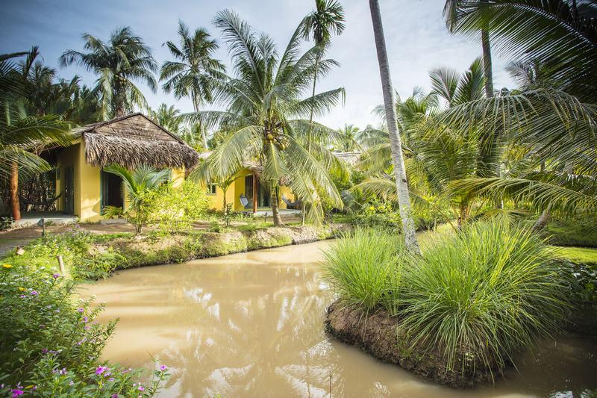
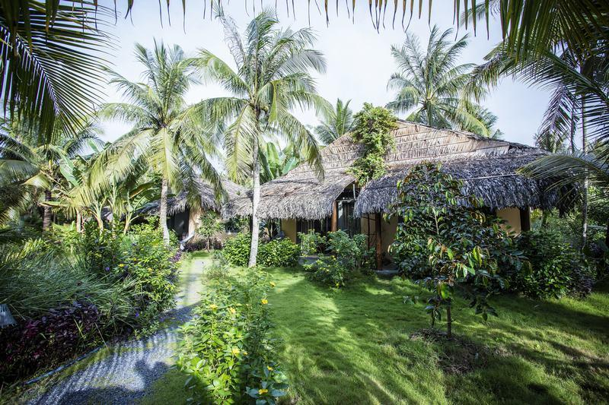
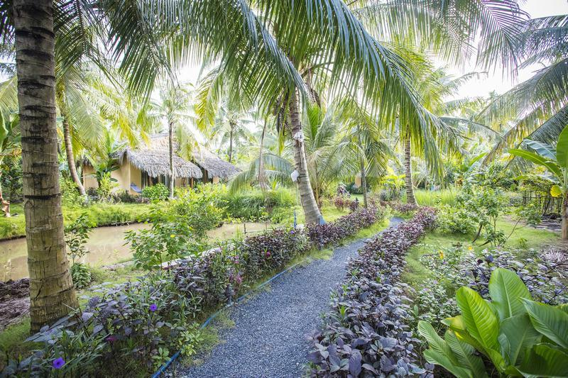
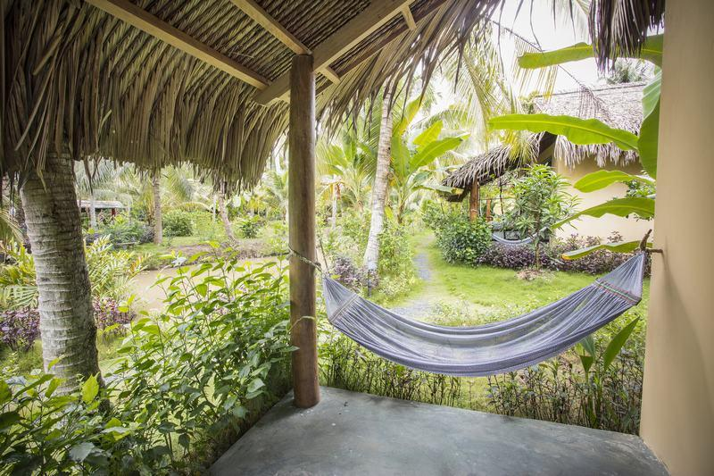
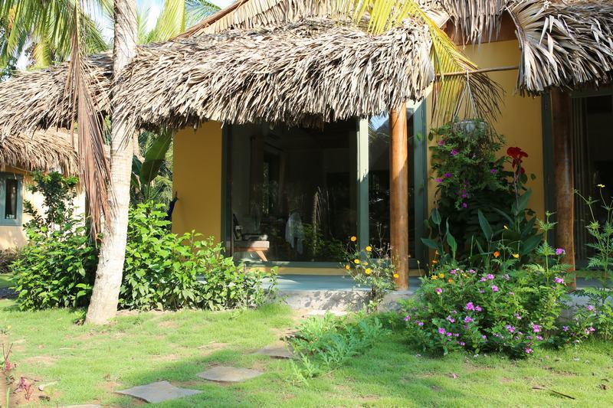
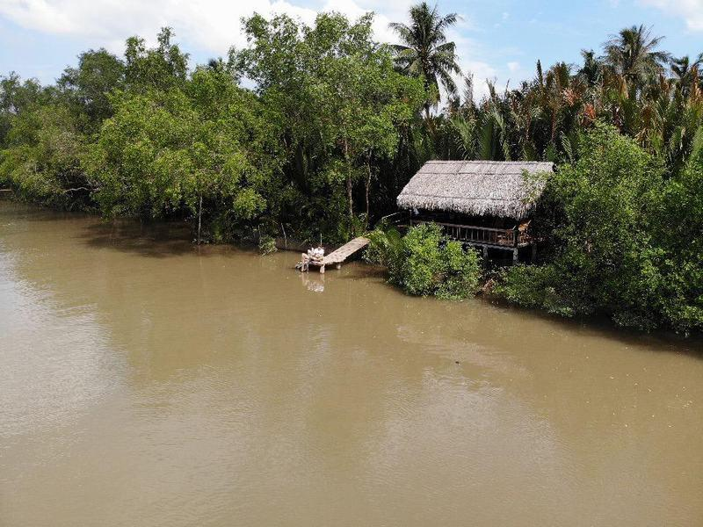
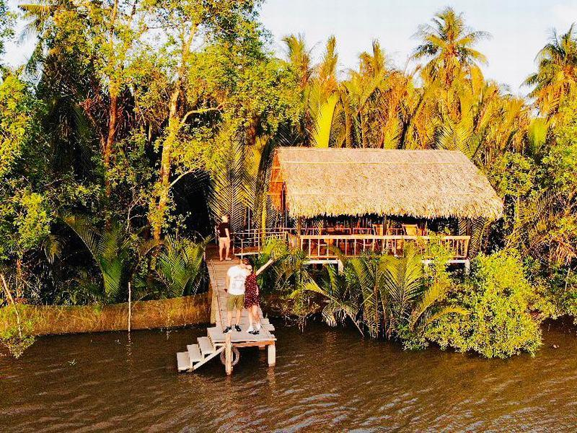
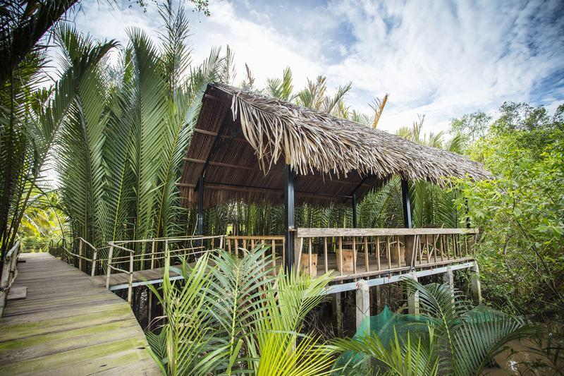
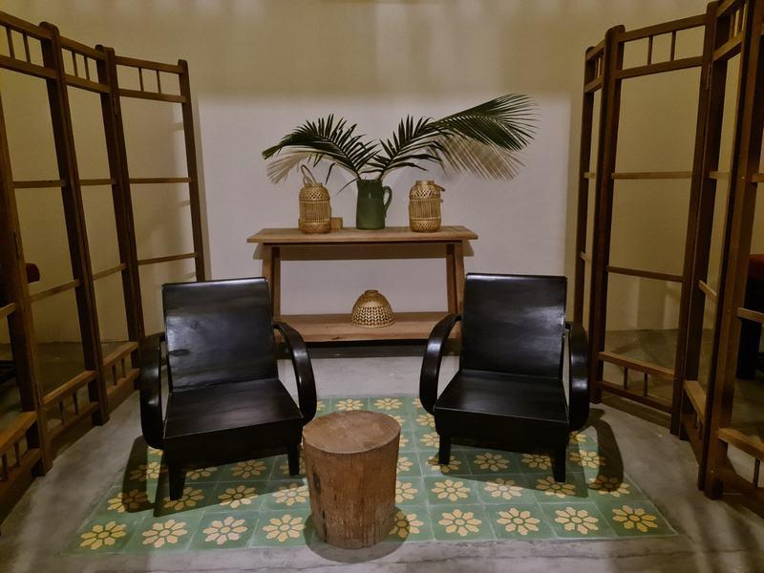

Easia Travel Head Office

