LAOS – Champasak – The Don Daeng Private Residence
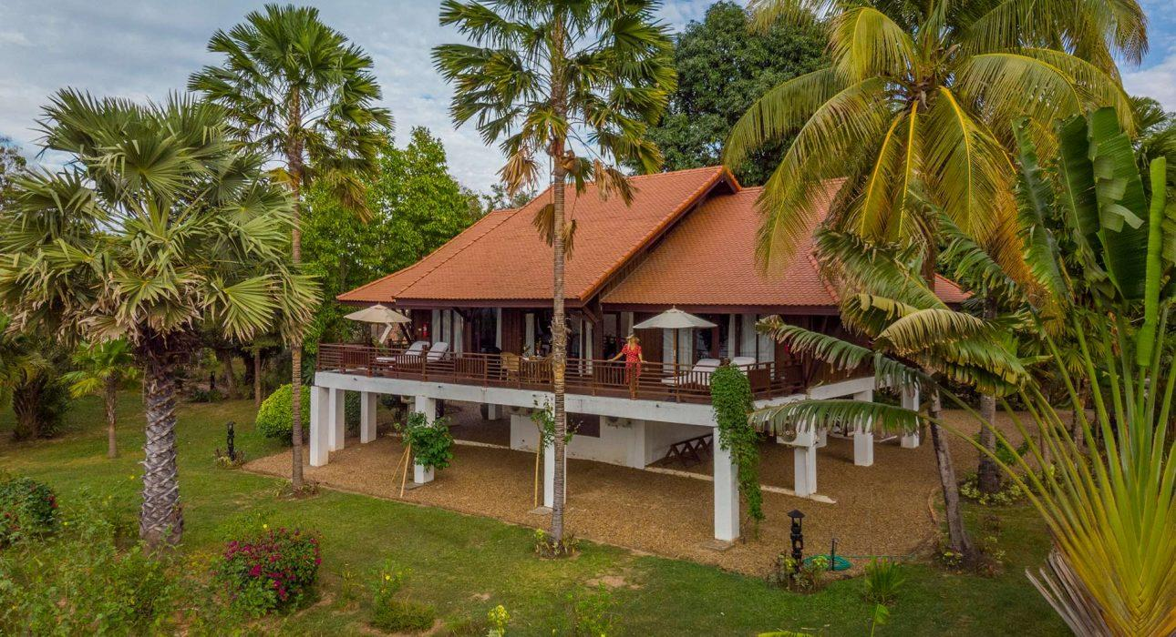

Over View

Theme
Classic, Family, Honeymoon, Self-Guided Tours, Wellness

Country - City
Laos - Champasak

Market segment
Thematic Leisure

Official category
Homestay

Easia category
Superior

Total number of rooms
2

Price level
$$$$

Description

The Residence is a private villa with a large panoramic terrace facing the Mekong and the sacred mountains. Originally built as the La Folie Lodge owner’s house, it is now open to all guests, with its style and intimacy making it a favorite place for artists/novelists and VIPs.It offers two bedrooms, two bathrooms and a large living area within approximately 160 square meters, as well as a 50 square meter terrace. It is fully furnished and decorated in a colonial style, with all modern amenities such as air-conditioning in all rooms, kitchen/bar, spacious bathrooms, hi-fi, 32 inch flat screen LCD Monitor, DVD player plus a selection of DVDs, free Wi-Fi.The Residence, with its wide living space, comfort and peaceful atmosphere is the ideal place for VIP guests, families or travelers who wish to spend a few days relaxing in total privacy, and while technically it is a part of the La Folie Lodge resort, the house stands alone and is set apart from the rest of the resort offering the utmost privacy and tranquility.

Selling points

- A private 2-bedroom riverfront villa set within its own gardens.
- While it is set apart from the rest of the resort, guests still have access to all the resort’s facilities such as the swimming pool, spa, and restaurant.
- Set on the tranquil island of Don Daeng, an ideal place for some rest and relaxation.
- Located in an ideal location from which the UNESCO archaeological site of Wat Phou can be explored.
- Ideal for a family or group of friends looking for a private house all to themselves!
- Friendly, helpful and multilingual staff.

Time & Transportation

From | To | Km | By | Duration | Road condition
La Folie Lodge | Pakse International Airport | 45 | Boat & Minivan | 1h 30 minutes | Good

Rooms

Easia's recommend room type
- The property has just 2 bedrooms, both able to fit a queen-size bed or twin beds .

Services & Facilities

Services
24 hour reception, 24h security service, Complimentary bottle of water, Complimentary fresh towel, Fishing, Laundry service, Luggage Storage, Porter, Spa, Swimming Pool, Visiting local villages

Facilities
Air Conditioning, Bar, Bicycle, coffee and tea making facilities, Garden, Gift Shop, Hair Dryer, Internet, Mini Bar, Restaurant, Safety Box, Shower With Hot Water, Smoking Area, Terrace, Umbrella

Disabled Facilities
No disable access

Restaurant information

Restaurant of La Folie Lodge
- Capacity: 50 pax
- Type of food: International, Laotian
- Opening hours: 06:00 – 09:00 (Breakfast) 12:00 – 14:00 (Lunch) 18:00 – 21:00 (Dinner)
- Note: the private house is set just outside the resort, about 200m from the resort’s restaurant.

Photos

Hotel Photos
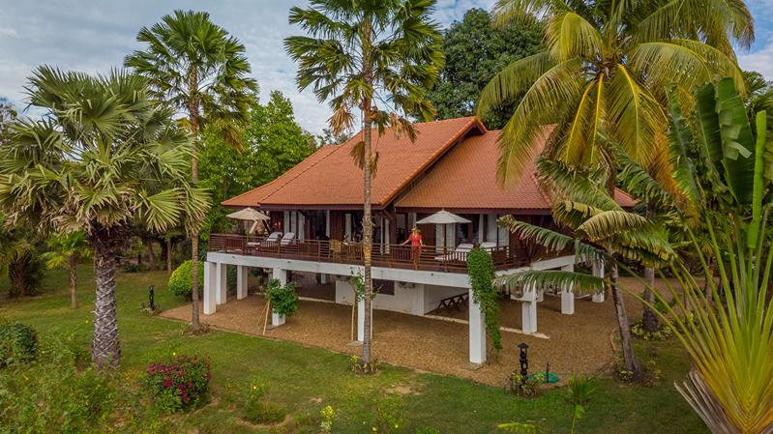
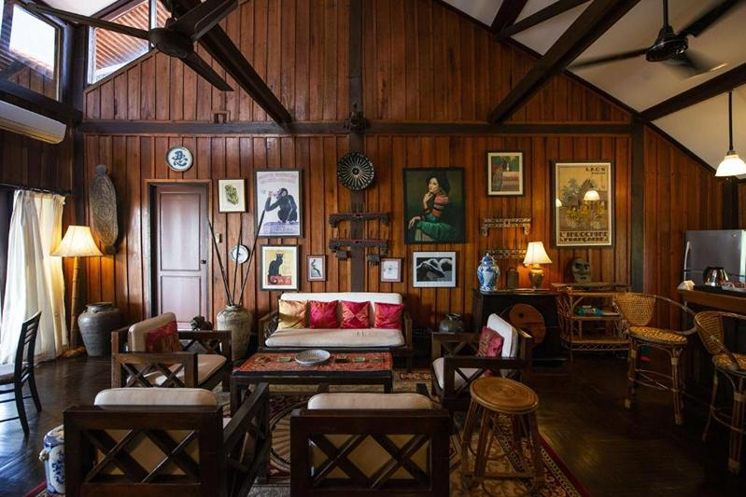
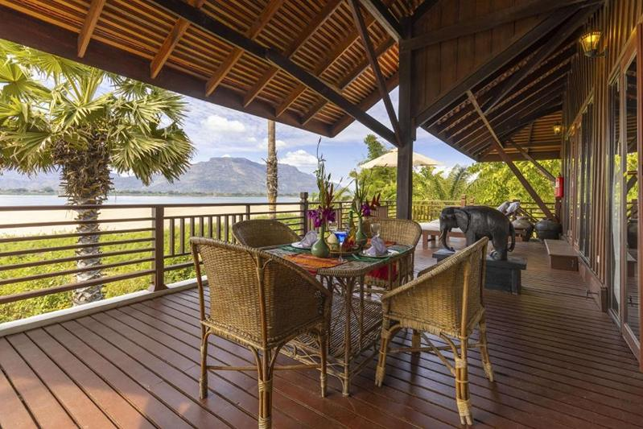
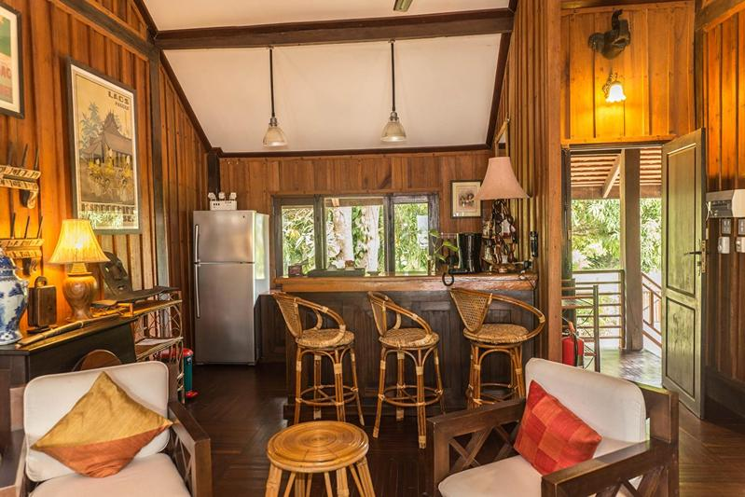
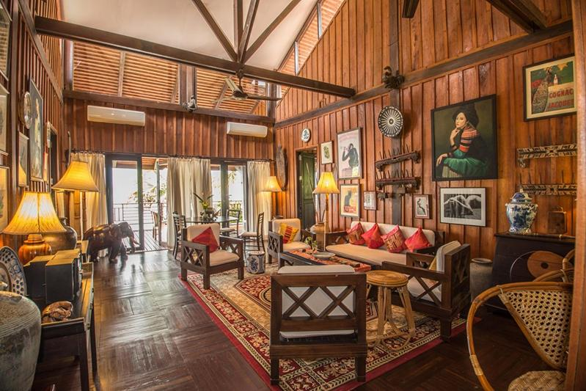

Rooms photos
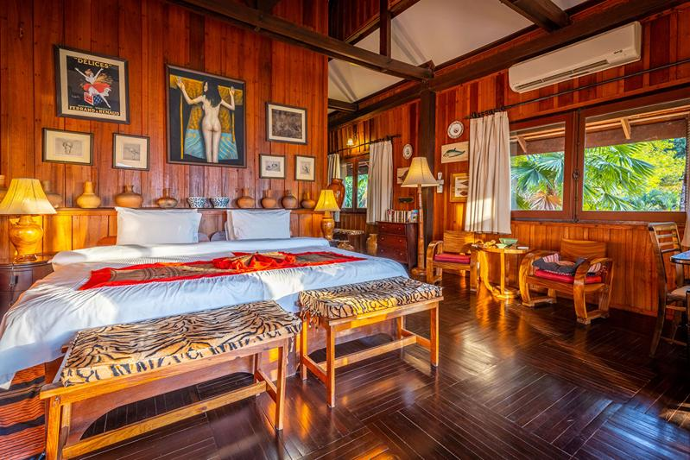
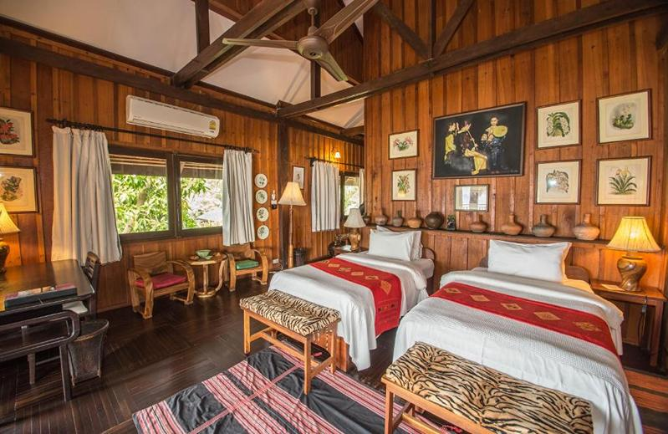
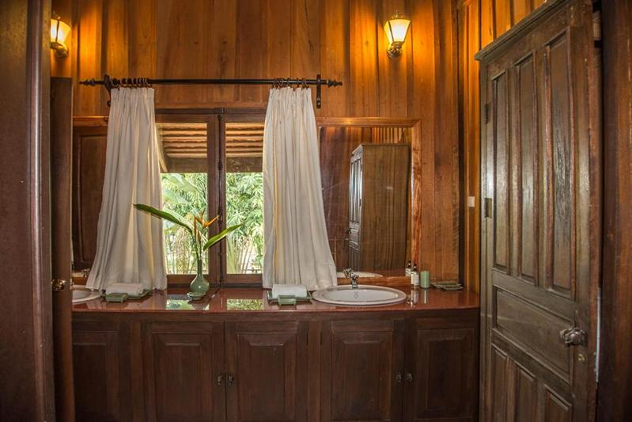

Restaurant photos
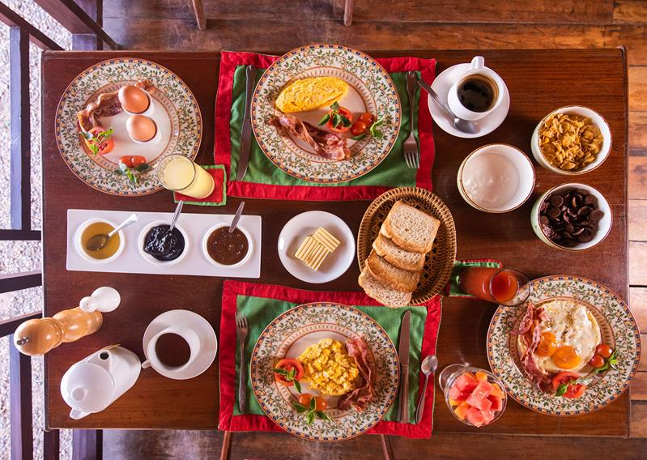
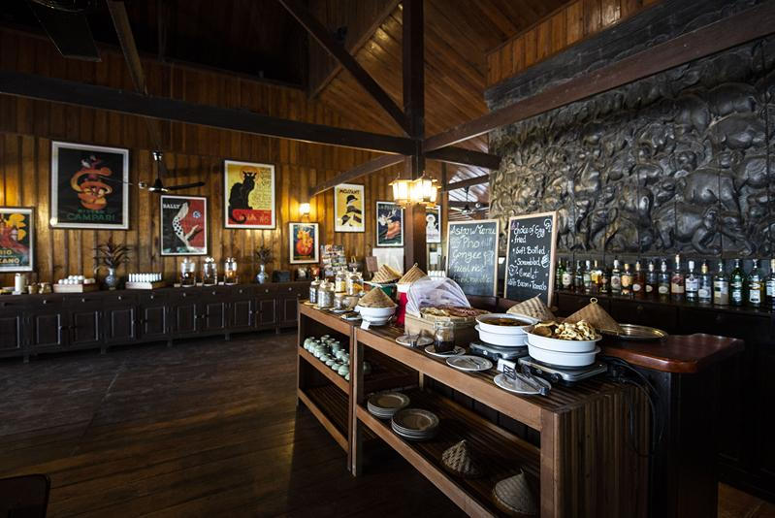
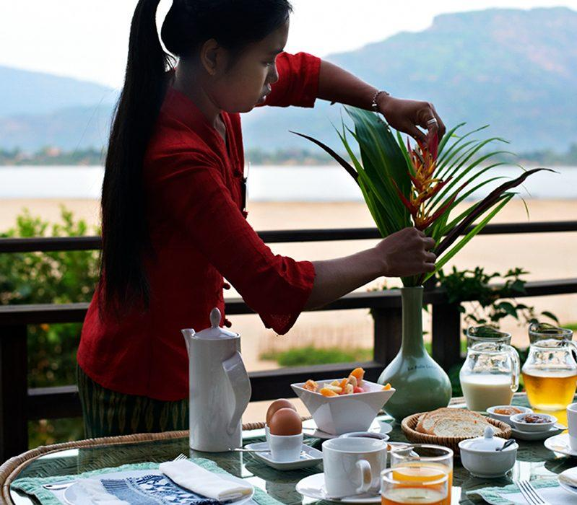
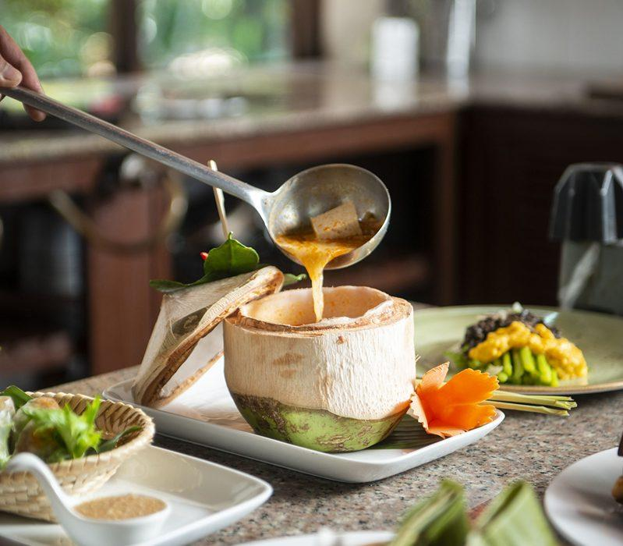
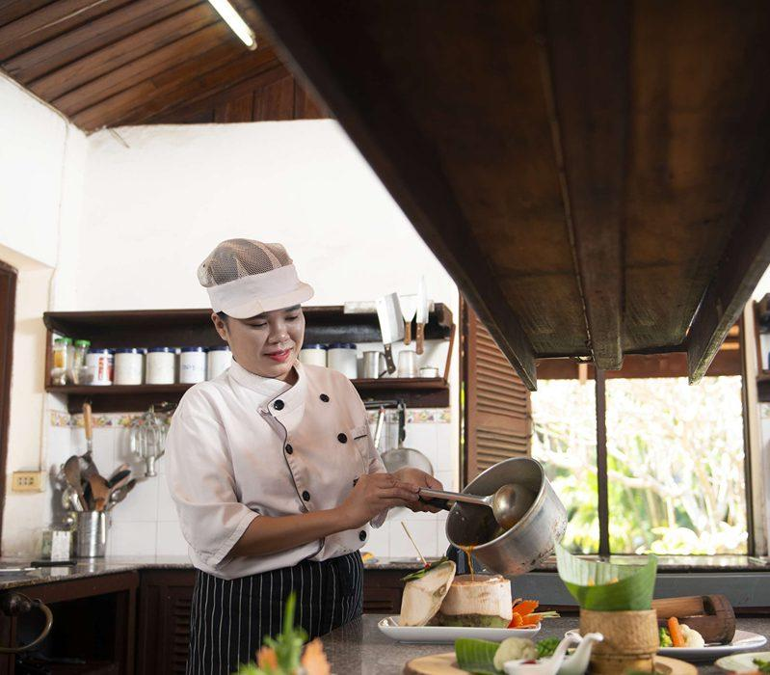
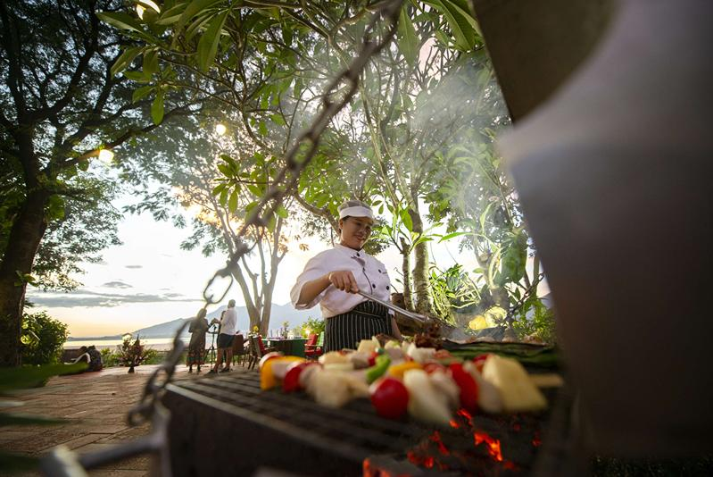
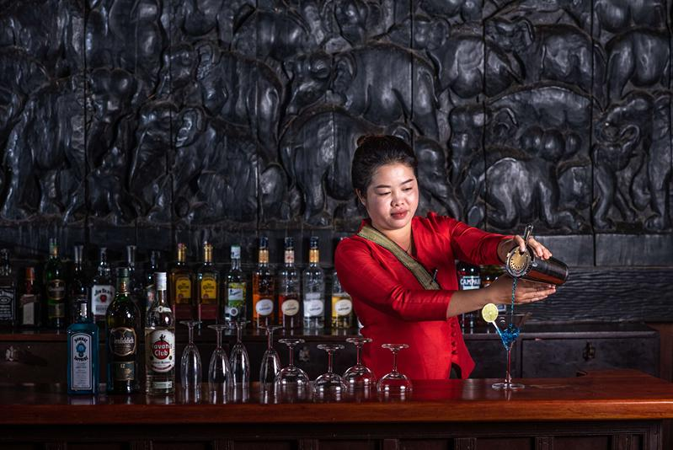
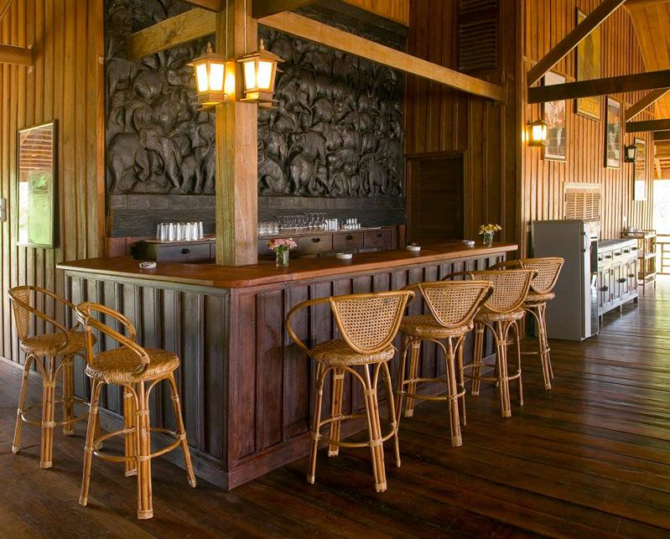
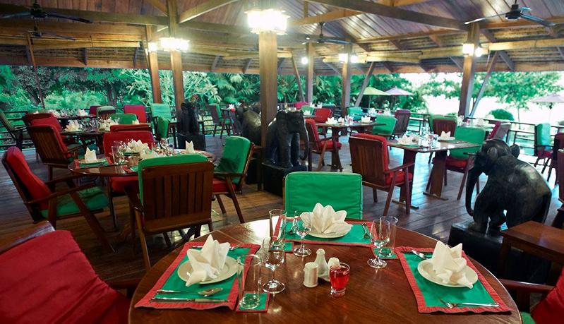
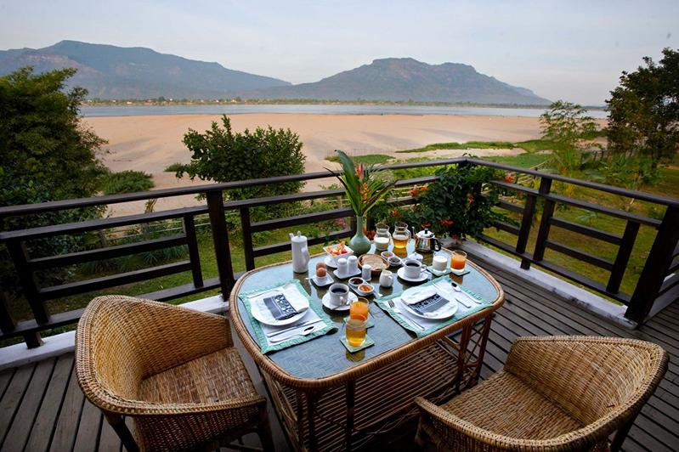

Services & facilities photos
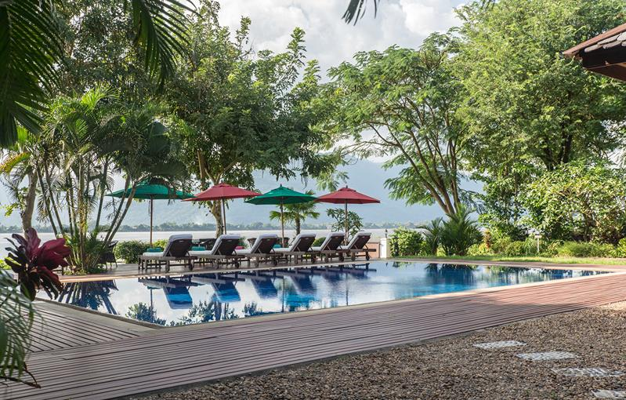
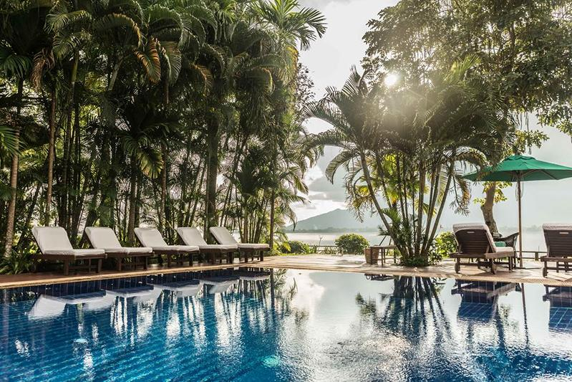
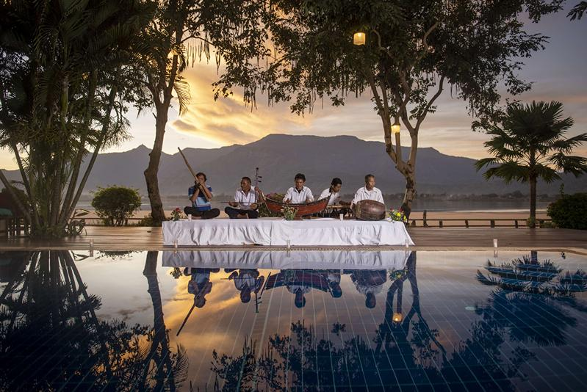
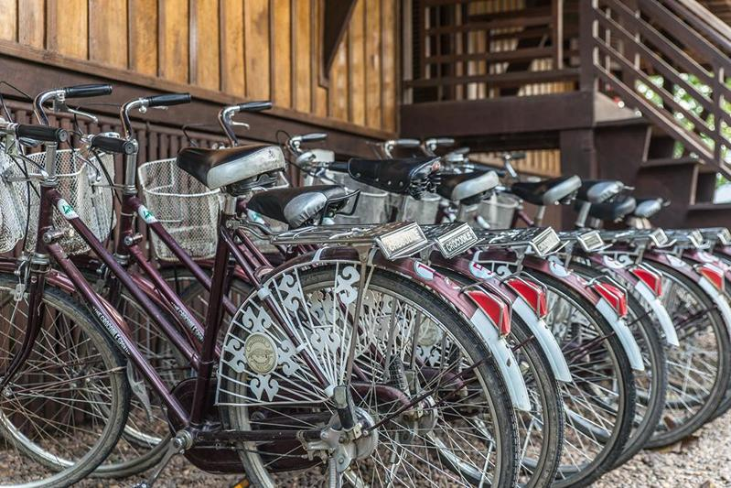
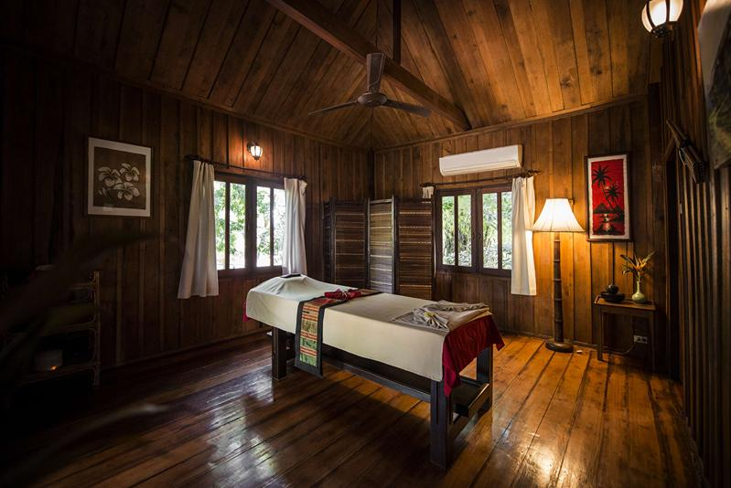
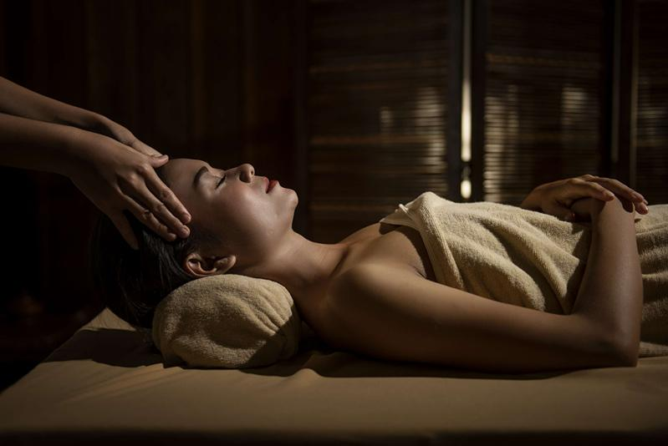
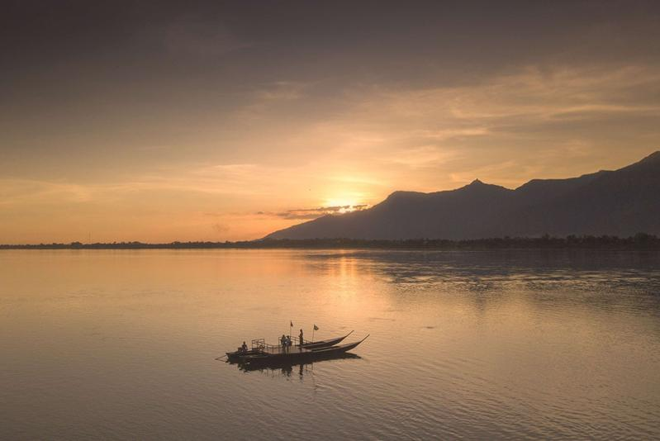

Easia Travel Head Office

Vietnam Head Office4th Floor – ATS hotel,33B Pham Ngu Lao Street,Hoan Kiem District, Hanoi.T: +84 24-39 33 13 62 (ext. 251)

