LAOS – Luang Prabang – Villa Luang Prabang
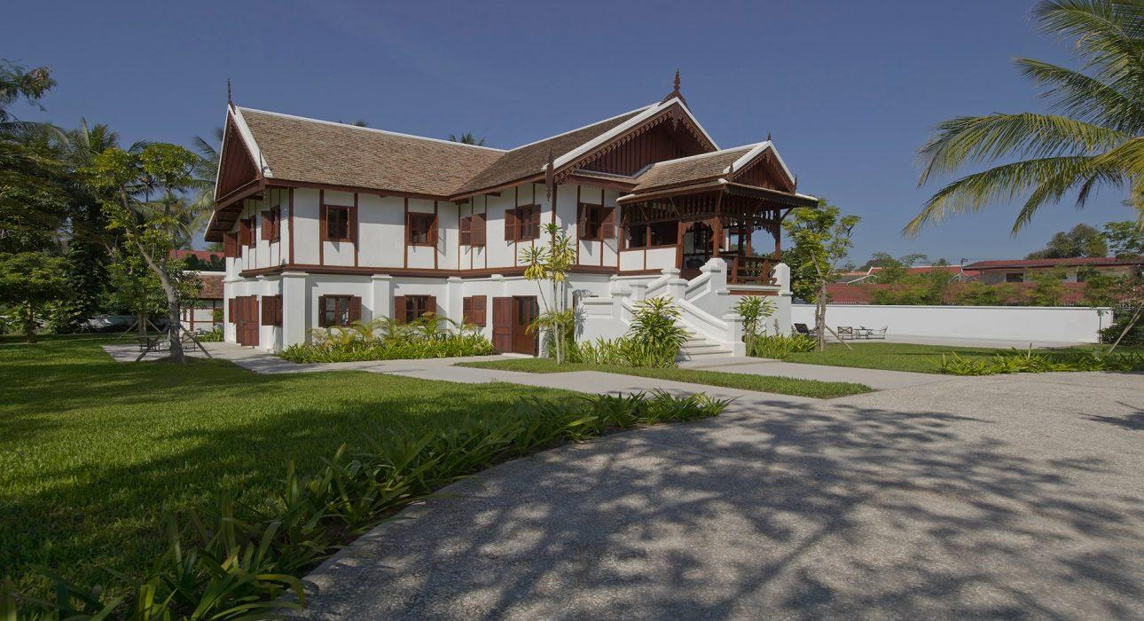

Over View

Theme
Art &amp; Culture, Family, Honeymoon, Wellness

Country - City
Laos - Luang Prabang

Market segment
Thematic Leisure

Official category
5*

Easia category
First Class

Total number of rooms
4

Price level
$$$$

Description

Villa Luang Prabang is a stunning 4-bedroom property that flawlessly combines French colonial influences with traditional Lao architecture. Formerly the residence of Prince Boun Kong of the Laotian Royal Family, this unique villa is one of the most luxurious private residences in the UNESCO World Heritage Town of Luang Prabang.With four elegantly-designed bedrooms, each furnished with four-poster king-sized beds and ensuite bathrooms, this property is perfect for families and groups of friends who are looking for somewhere special to stay on their visit to this magical part of the world.The grounds feature expansive gardens dotted with mango, coconut and tamarind trees as well as an 18-meter private swimming pool. Breakfast is served daily by the live-in butler.

Selling points

- Charming and luxurious villa with a rich royal history.
- Modern facilities and comfortable rooms.
- Excellent location within walking distance of the centre.
- Ideal for families or small groups.
- Ideal venue for private events.

Time & Transportation

From | To | Km | By | Duration | Road condition
Villa Luang Prabang | Luang Prabang Airport | 7km | Car | 15min | Good

Rooms

Easia's recommend room type
Room type:
- There are 4 bedrooms (King bed, Bathroom, Tv, and Air-conditioning)
- A maximum of 2 extra beds can be provided.

Services & Facilities

Services
24h security service, Complimentary bottle of water, Iron, Laundry service, Swimming Pool

Facilities
Air Conditioning, coffee and tea making facilities, Garden, Internet, Safety Box, Shower With Hot Water, Umbrella

Restaurant information

- The property has no restaurant, though it does have a fully-equipped kitchen for those who would like to prepare their own meals.
- Breakfast is included and provided daily.
- A private chef can be provided for a supplement.

Photos

Rooms photos
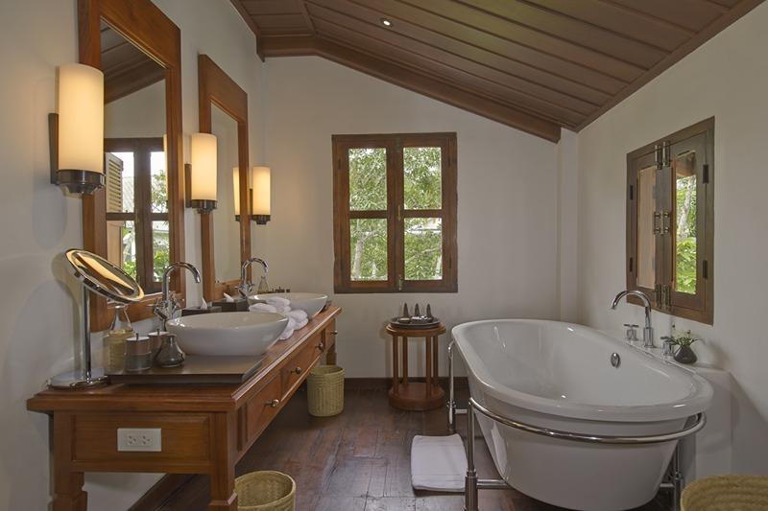
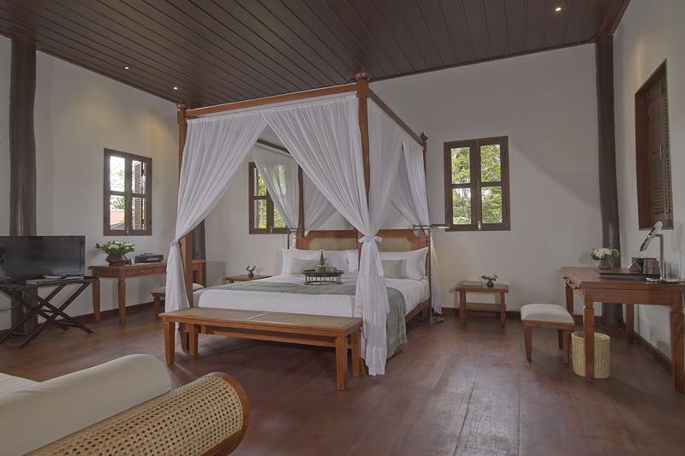
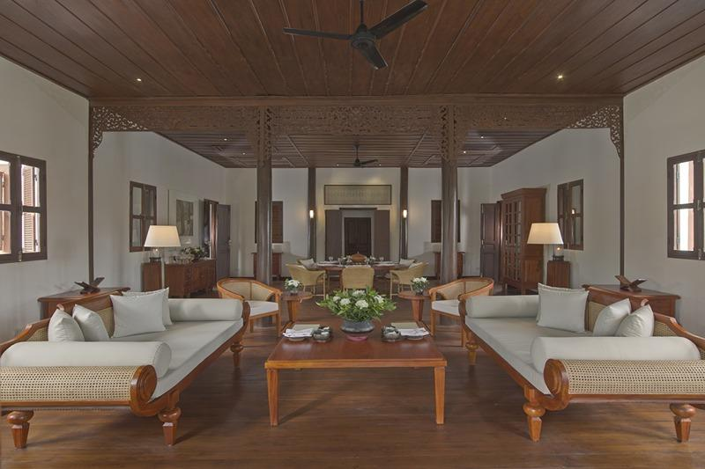
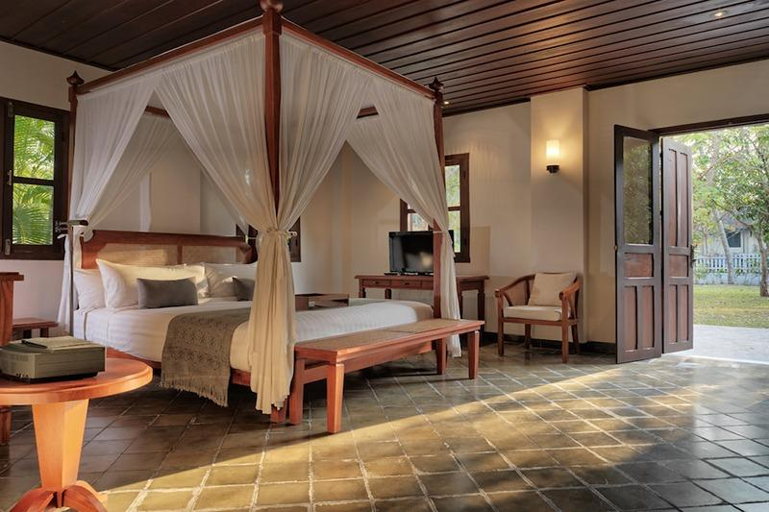
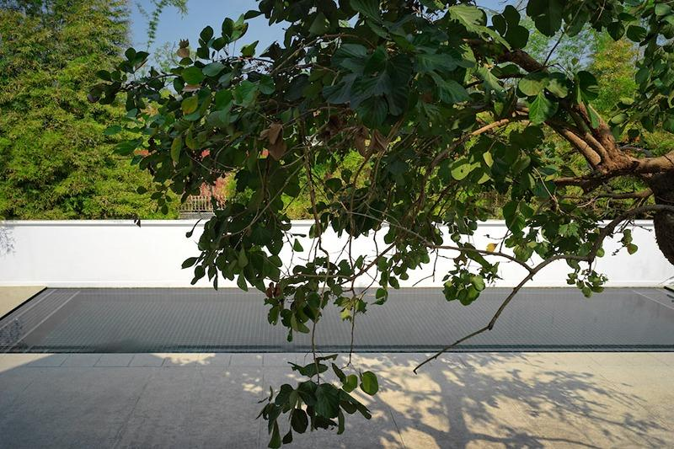

Restaurant photos
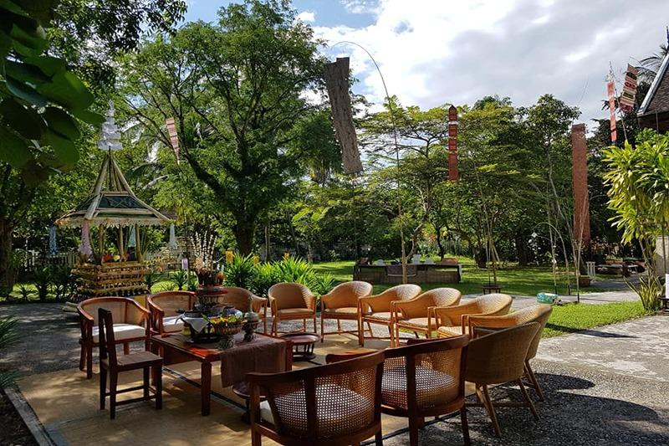

Services & facilities photos
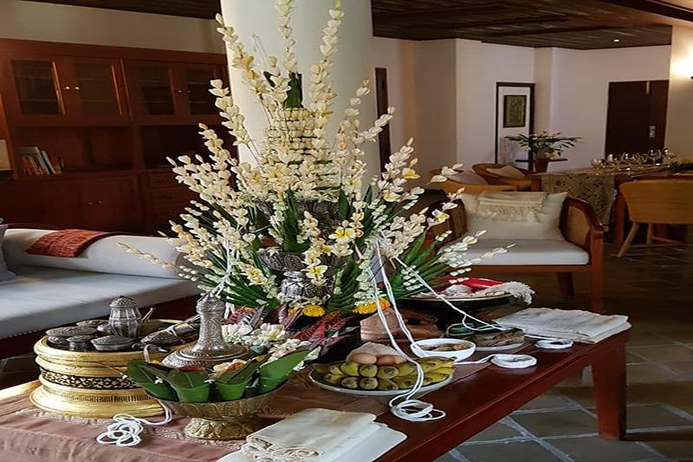
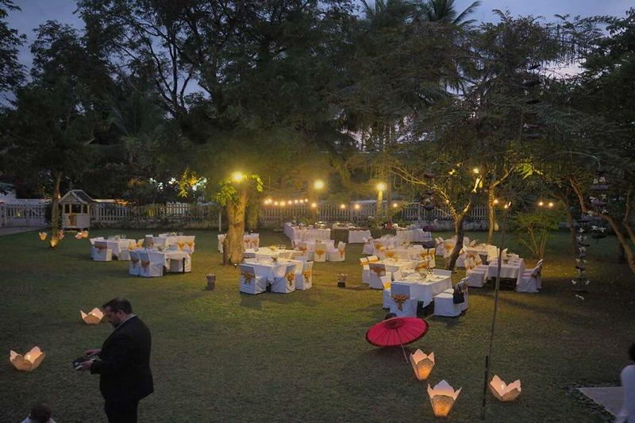
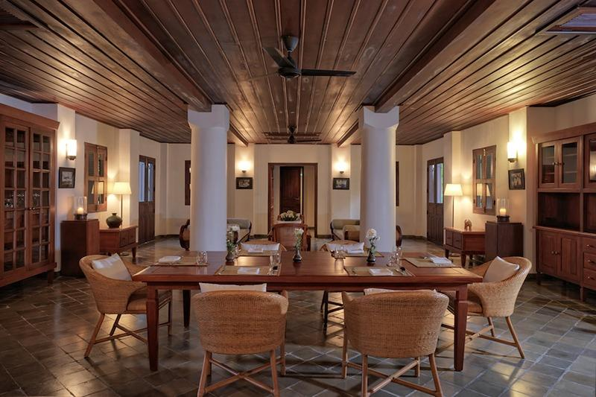

Easia Travel Head Office

Vietnam Head Office4th Floor – ATS hotel,33B Pham Ngu Lao Street,Hoan Kiem District, Hanoi.T: +84 24-39 33 13 62 (ext. 251)

