CAMBODIA – Siem Reap – Viroth’s Villa
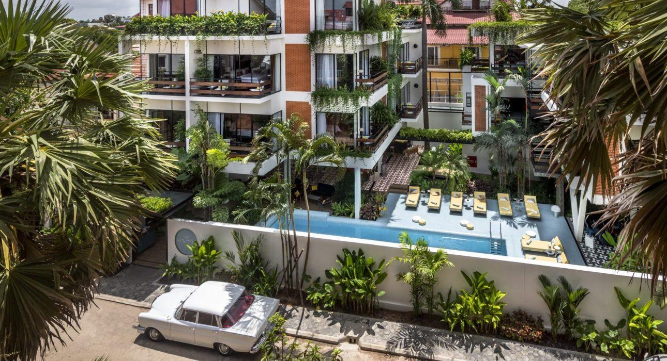

Over View

Theme
Classic, Family, Sustainable

Country - City
Cambodia - Siem Reap

Market segment
Groups, Thematic Leisure

Official category
4*

Easia category
Deluxe

Total number of rooms
19

Price level
$$$$

Description

Located in the city center of Siem Reap town, VIROTH’S VILLA is just 500 meters from Old Market the most tourist attractive place at night and 1.30 km from Angkor National Museum while from this villa to Angkor Wat temple the world famous heritage site is only 6 km.VIROTH’S VILLA has an outdoor swimming pool, garden, a terrace, and a restaurant. This modern style villa featured 19 air-conditioned room with modern art and design. All rooms comes with air-conditioning, a flat screen TV with satellite channels, a seating area, a safety deposit box, and a private bathroom with a shower, a free toiletries, and hairdryer. VIROTH’S VILLA features some units with city views, and rooms with a balcony. The villa has two buildings, one building has 2 floors while another one has 3 floors. The accommodation offers a 24-hour front desk, airport transfer, room service, and free WIFI. The daily breakfast offers a la carte, continental or American options.

Selling points

- Very lovely and charming villa with 19 air conditioning rooms
- Very well designed villa with modern art, spacious and clean room
- Well-trained staff, smiling, friendly, and very helpful
- The villa with Travel Sustainable Level 3
- The villa that firmly takes action in supporting and working on sustainable action
- The villa is situated in the city centre of Siem Reap; it is just 500 m from Pub Street, while from the villa to Angkor Wat temple is only 6 km.

Sustainability

Supplier Actions
Protection of Environment, Support local communities, Child Protection

Time & Transportation

From | To | By | Distance | Duration | Road condition
VIROTH’S VILLA | Old Market | Tuk Tuk | 500m | 5 mn | Good
VIROTH’S VILLA | Angkor National Museum | Tuk Tuk | 1.30km | 7 mn | Good
VIROTH’S VILLA | Phnom Kroam – Tonle Sap | Car | 15km | 30 mn | Good
VIROTH’S VILLA | Angkor Wat temple | Car | 6km | 10 mn | Good
VIROTH’S VILLA | Roluos Group Temple | Car | 15km | 30 mn | Good

Rooms

Easia's recommend room type
Deluxe RoomStyle : Modern
- Room Size : 32 sqm
- Bed Configuration : 1 King or Twin with city view, balcony, air conditioning, Ensuite bathroom, flat screen TV, terrace, soundproofing
- Extra Bed : No
Deluxe Room with pool viewStyle : Modern
- Room Size : 32 sqm
- Bed Configuration : 1 King or Twin with pool view, balcony, air conditioning, Ensuite bathroom, flat screen TV, terrace, soundproofing
- Extra Bed : No
Deluxe Triple RoomStyle : Modern
- Room Size : 35 sqm
- Bed Configuration : 1 King or Twin + 1 Single with city view, balcony, air conditioning, Ensuite bathroom, flat screen TV, terrace, soundproofing
- Extra Bed : No
Deluxe Triple Room with Pool ViewStyle : Modern
- Room Size : 35 sqm
- Bed Configuration : 1 King or Twin + 1 Single with pool view, balcony, air conditioning, Ensuite bathroom, flat screen TV, terrace, soundproofing
- Extra Bed : No
Junior Suite Pool ViewStyle : Modern
- Room Size : 45 sqm
- Bed Configuration : 1 King with pool view, balcony, air conditioning, Ensuite bathroom, flat screen TV, terrace, soundproofing
- Extra Bed : Yes

Room configuration

Connecting rooms
No

Extra bed
Yes , 1m x 2m

King bed
Yes, 1.80m x 2m

Queen bed
No

Twin beds
Yes, 1m x 2m

Services & Facilities

Services
24 hour reception, 24h security service, Airport transfer, Car rental, Complimentary bottle of water, Complimentary fresh towel, Dry Cleaning, Laundry service, Luggage Storage, Massage, Mobile phone, Room Service, Spa, Swimming Pool, Wake-up service, Wi-fi Free

Facilities
Air Conditioning, Bar, Coffee Machine Facilities, Fan, Flat screen TV, Full Board - B/L/D, Garden, Hair Dryer, In-Room safe, Internet, Massage room, Outdoor swimming pool, Restaurant, Safety Box, satellite LCD TV, Shower With Hot Water, Terrace, Umbrella

Disabled Facilities
No disable access

Restaurant information

VIROTH’S Restaurant
- Breakfast: 6:30 AM to 10:30 AM with a la carte, continental or American options
- Lunch: 11:00 AM to 2:30 PM
- Dinner: 5:30 PM to 10:00 PM
- Room Service: 7:00 AM to 10:00 PM
- Capacity: 20 seats
VIROTH’S BarOpen daily from 10:00 AM until 10:00 PM with a capacity of 8 seatsSwimming PoolOpen daily from 7:00 AM until 10:00 PM

Photos

Hotel Photos
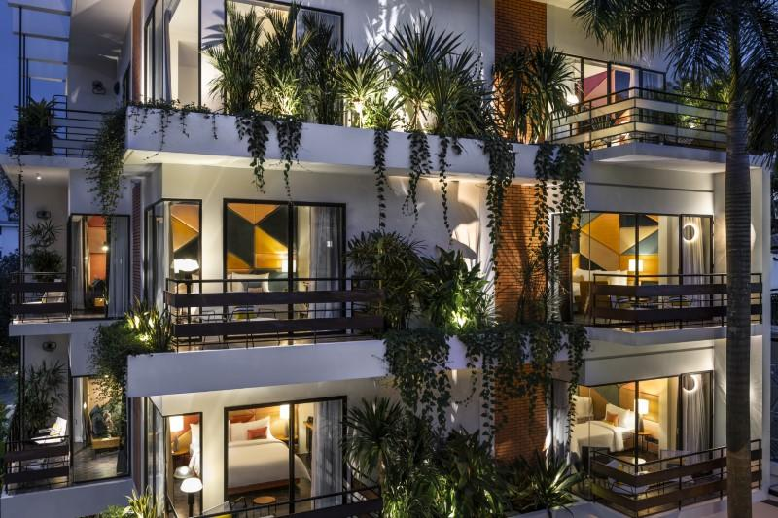
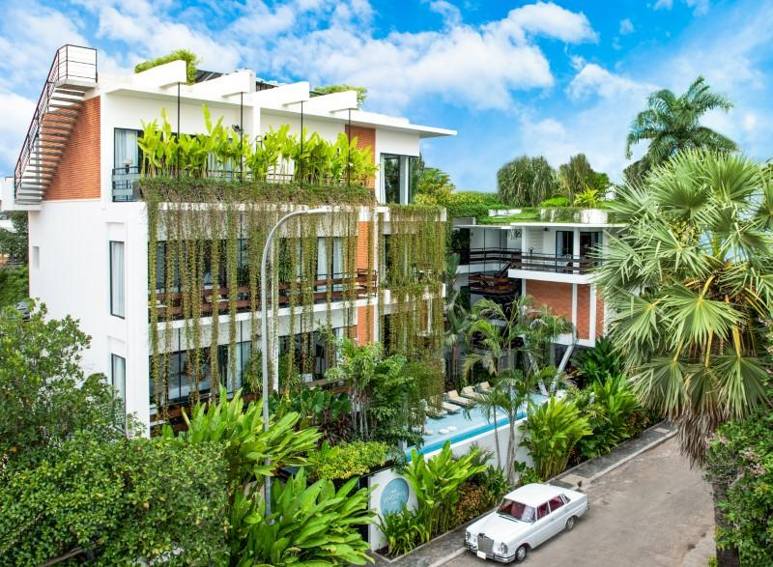
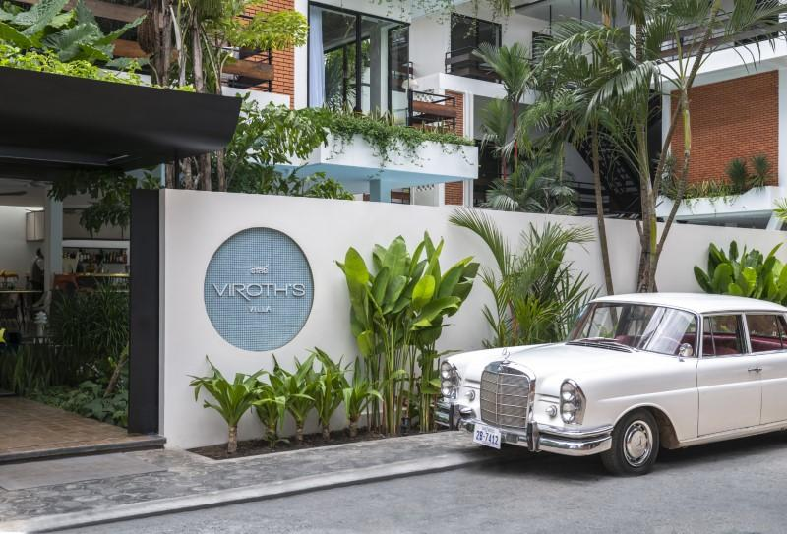

Rooms photos
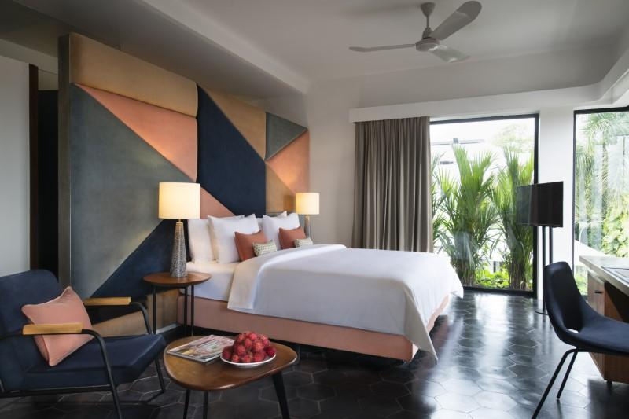
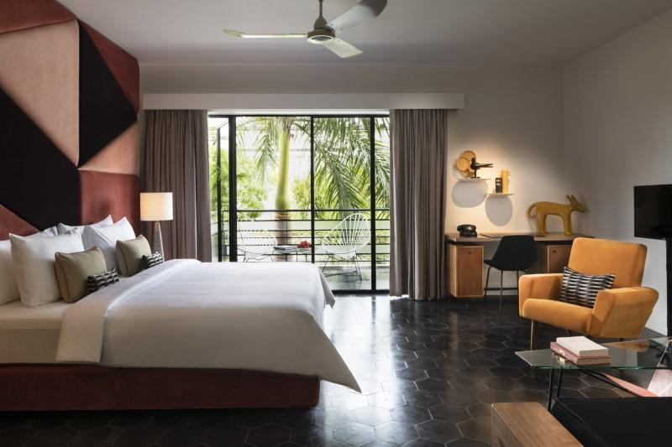
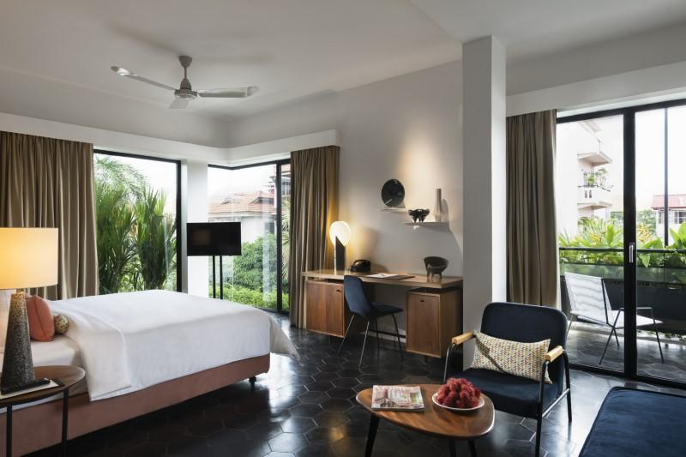
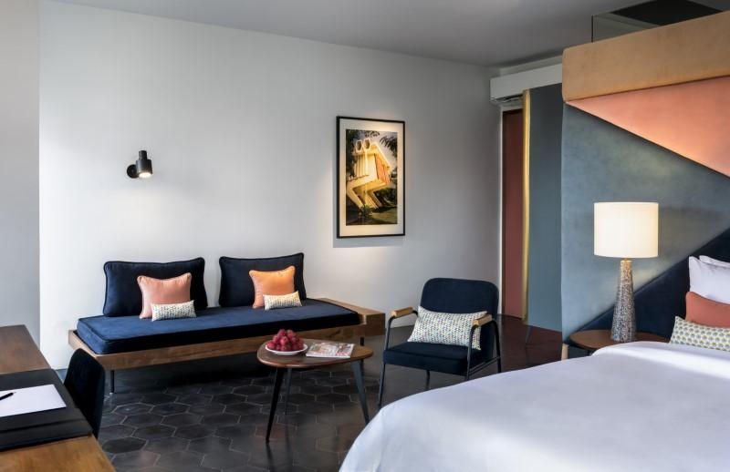

Restaurant photos
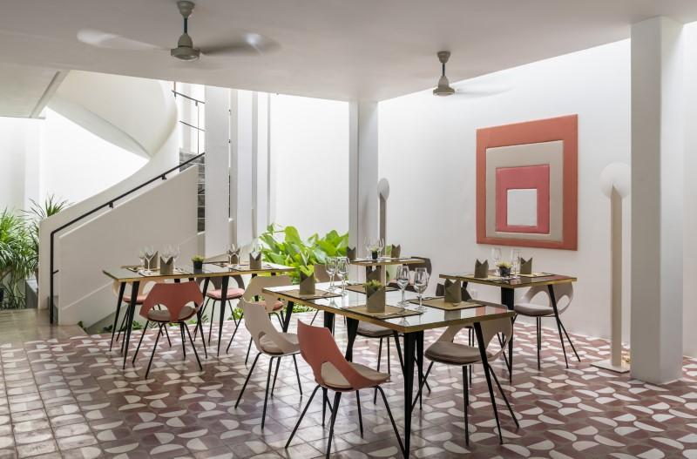
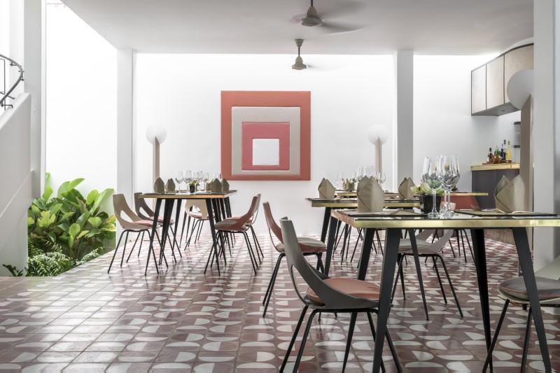
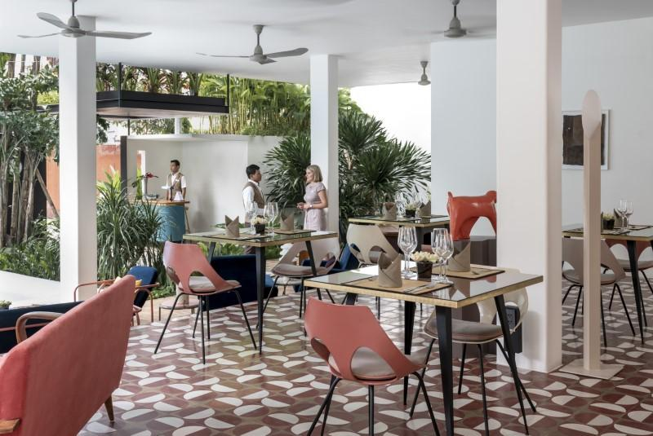
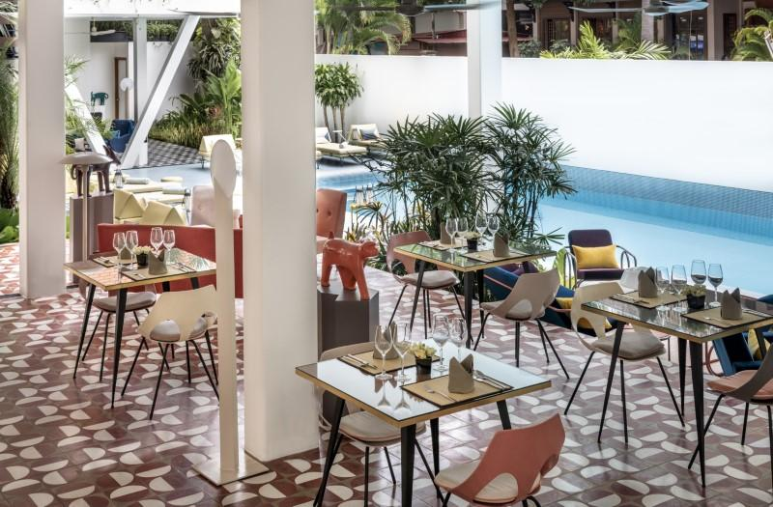
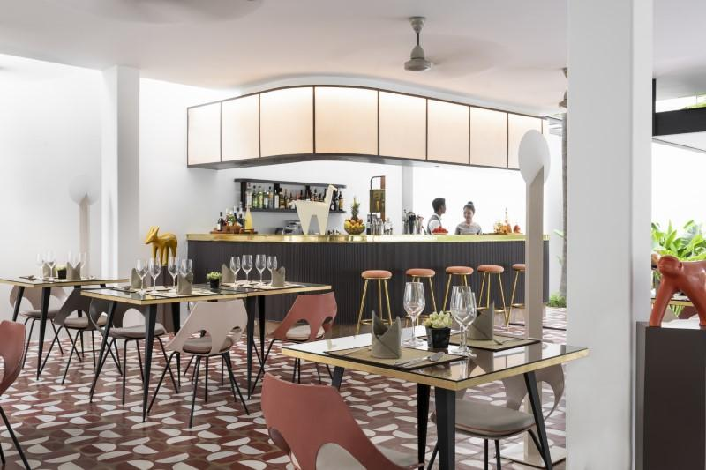
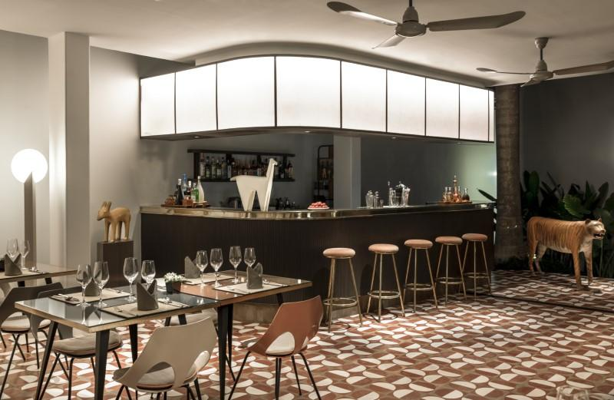
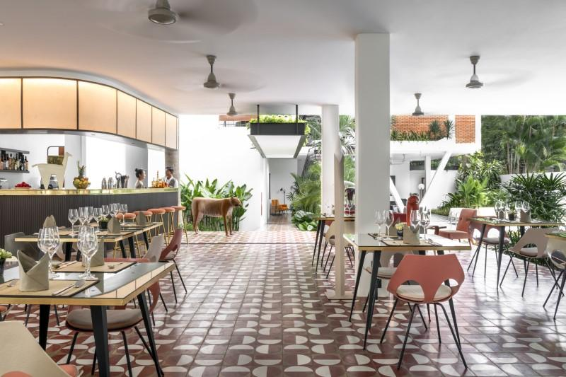

Services & facilities photos
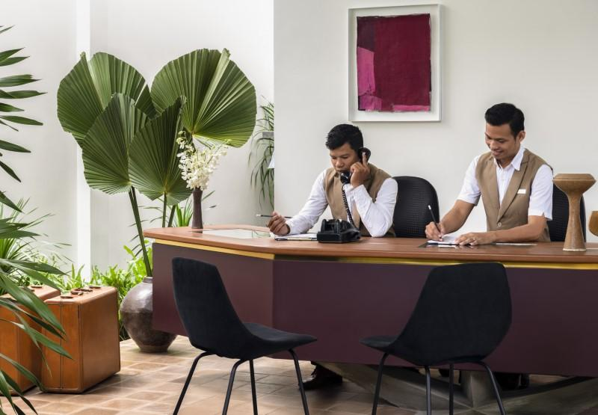
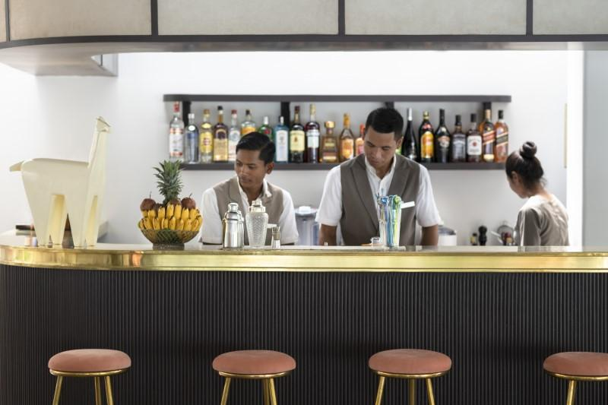
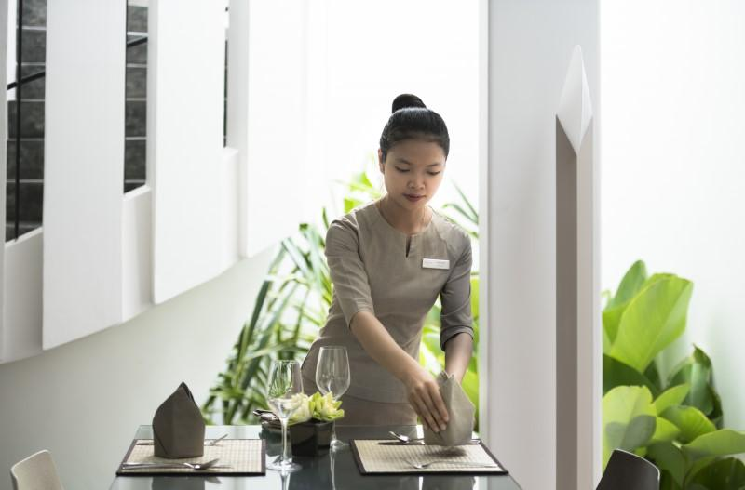
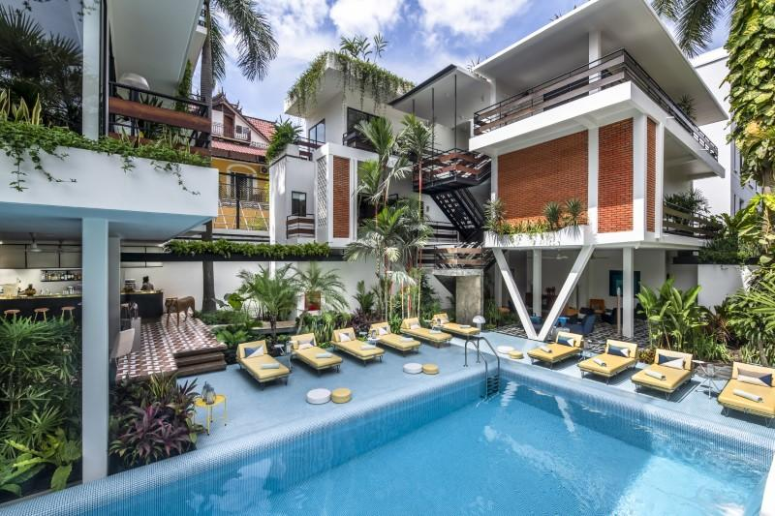
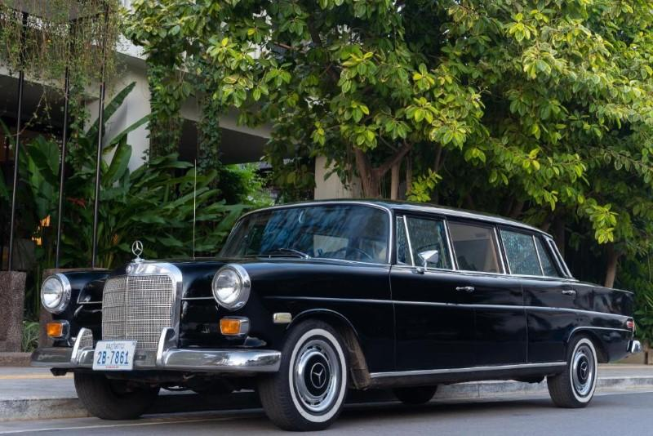
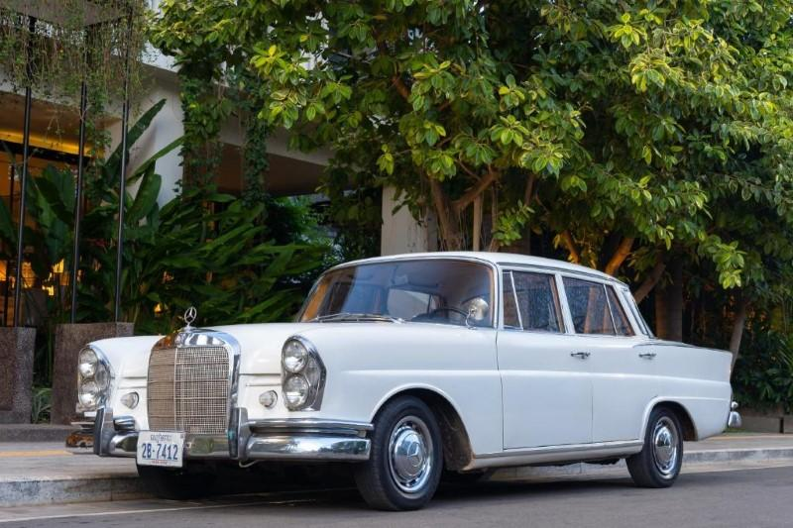
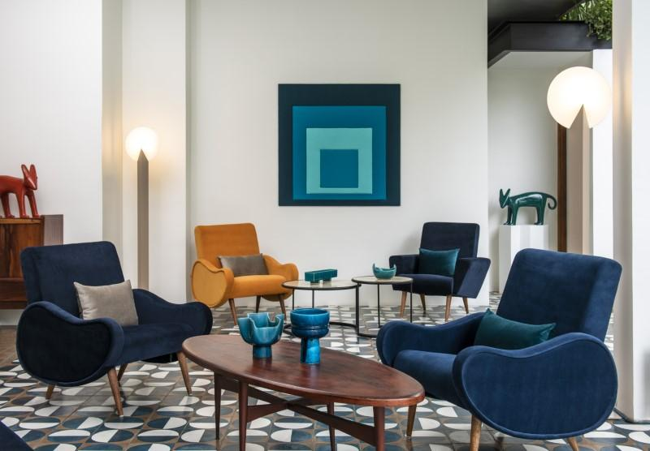
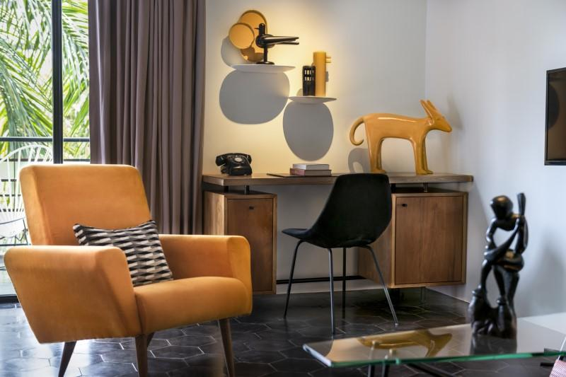
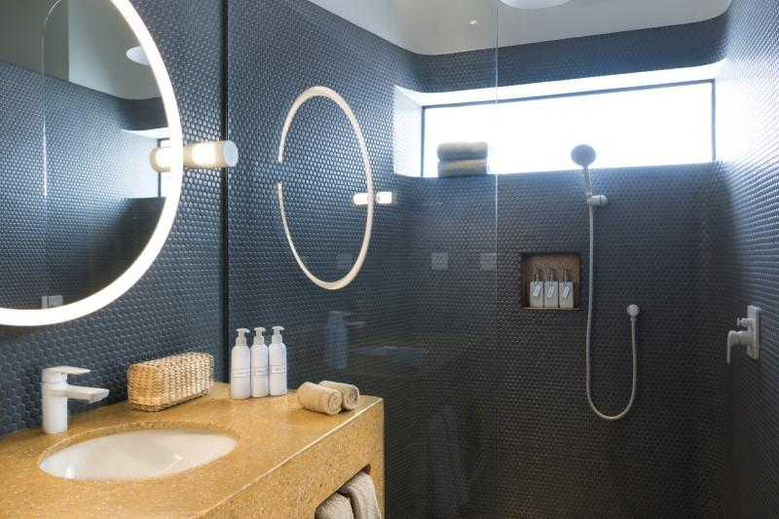

Easia Travel Head Office

