Vietnam – Hanoi – Photography Tour in Northern Vietnam 7D6N
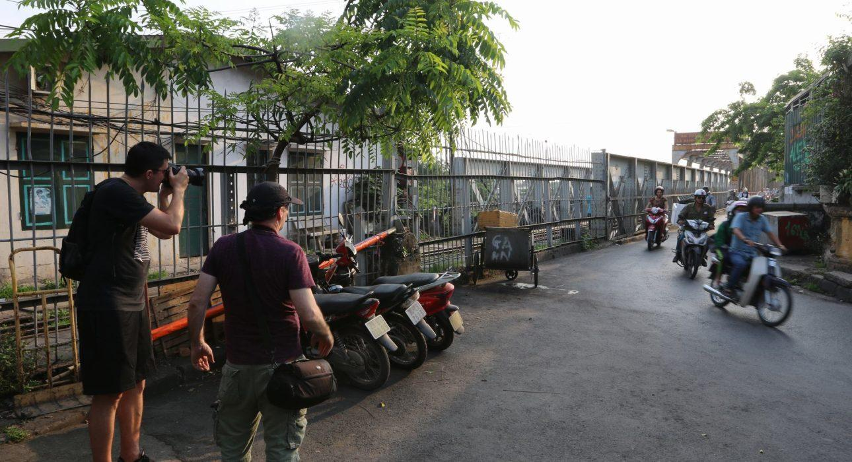

Over View

Theme
Classic

Country - City
Vietnam - Hanoi

Level of difficulties

Price level
$$$$

Seasonality
All year long but better from March to October

Max Pax
6

Market segment
Thematic Leisure

Arrival City
Hanoi

Departure city
Hanoi

Itinerary

Number of days and nights
7 days - 6 nights

Day by day description
This photography tour has been specifically designed for photographers and takes advantage of the gorgeous regions of Northern Vietnam, with beautiful and easily-accessible rice terraces. Many experiences are included in the itinerary, such as a photography tour in the heart of Hanoi, a meeting with local ethnic minority tribes or a cruise in Halong Bay.

Selling points

- A talented photographer to teach travel photography
- A flexible itinerary to cater to all type of guests with limited time spent in the car and maximum time spent outside during the golden hours
- A program to discover the different faces of northern Vietnam, from the rice terraces to Halong Bay
- Perfect to combine with other destinations in central and/or southern Vietnam
- Different types of accommodation available, from home-stays to boutique hotels

Options

Activities
- Hanoi – Evening story of street food
- Hanoi – Marvelous night with Jeep and Lotte Tower

Extensions
- Continuing the trip to Center and/or South of Vietnam
- Combining Vietnam with Laos and/or Cambodia

Photos

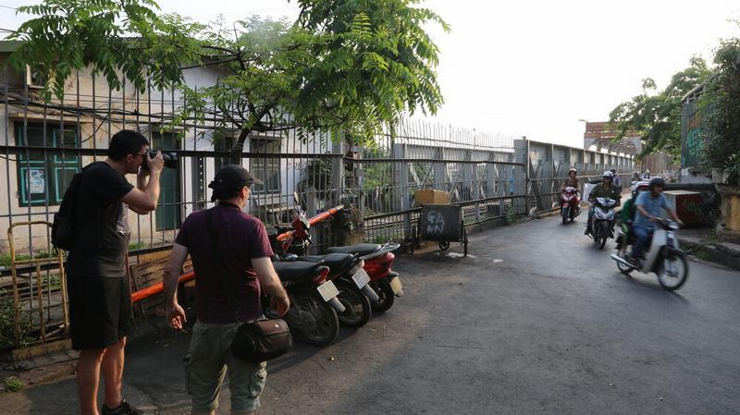
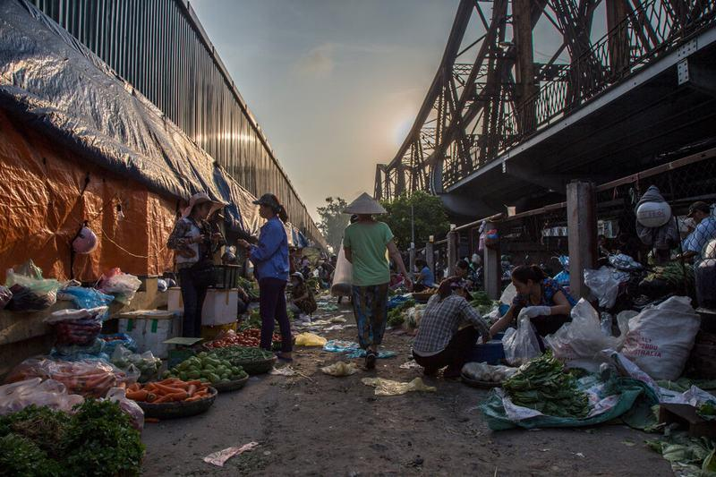
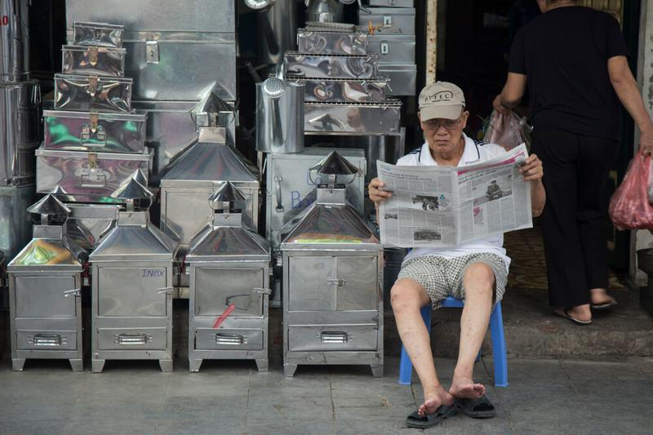
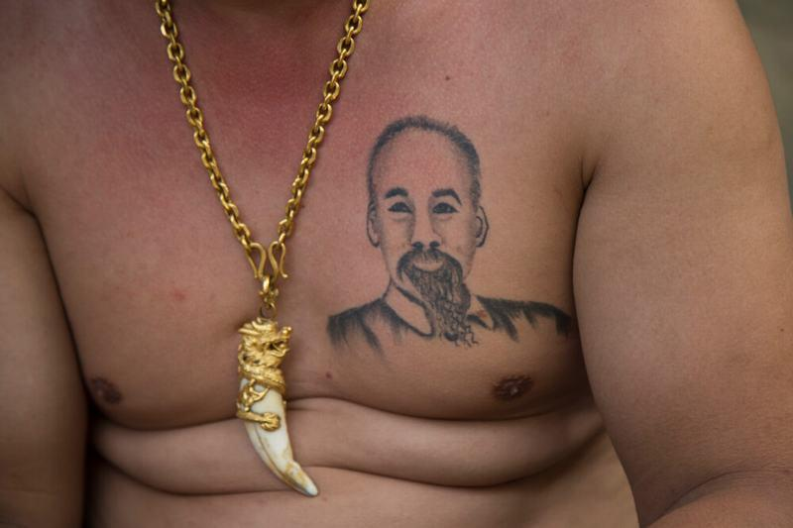
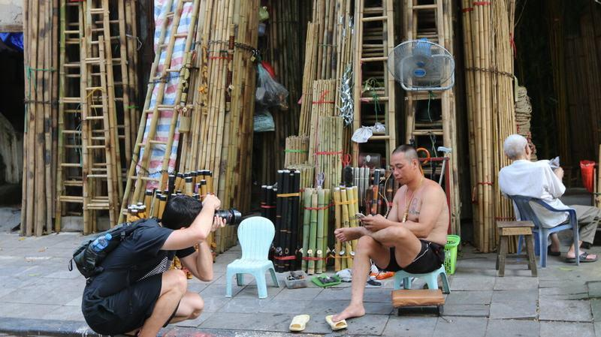
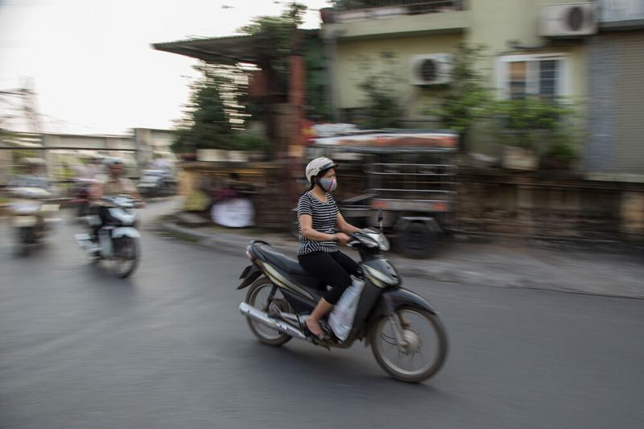
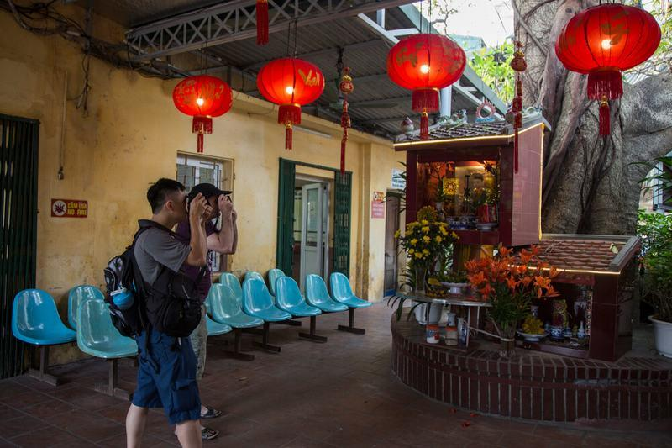
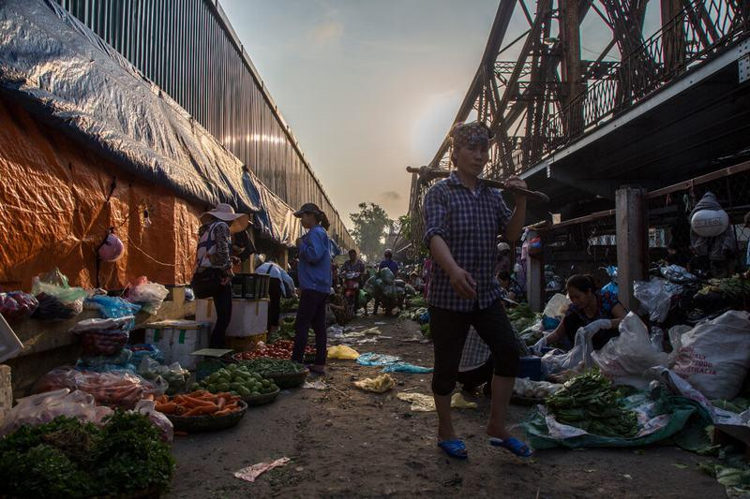
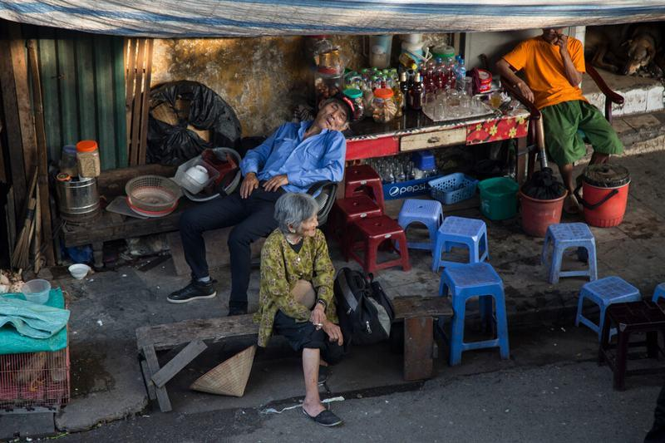

Easia Travel Head Office

Vietnam Head OfficeC/o: ATS Hotel, Suite 326 &327, 33B Pham Ngu Lao Street, Hanoi, VietnamTel: +84 24-39 33 13 62www.easia-travel.com

