VIETNAM – Pu Luong – Hiking Between Rice-Field Terraces and Forest 3D2N
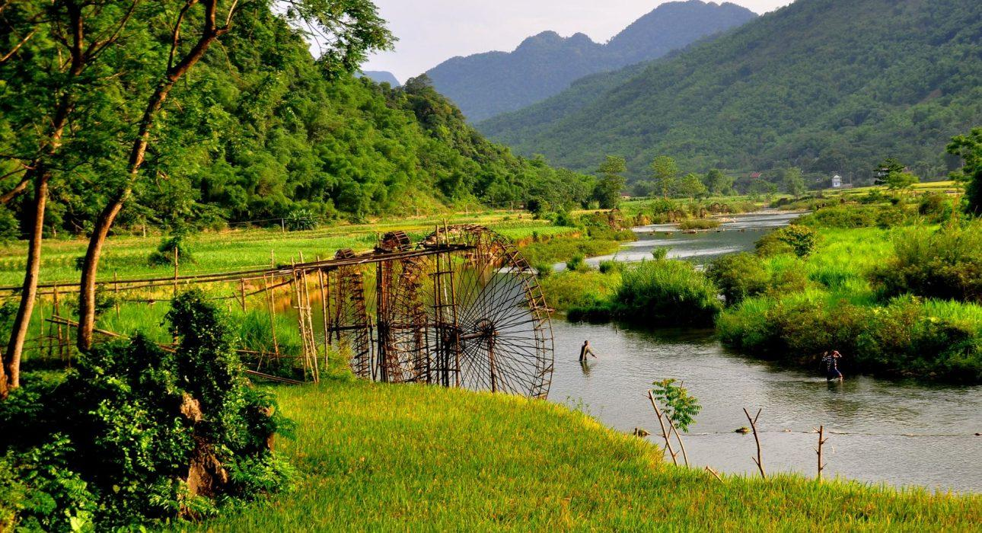

Over View

Theme
Art & Culture, Classic, Sustainable

Country - City
Vietnam - Pu Luong

Level of difficulties
LEVEL 2

Price level
$$

Seasonality
All year round - rainy season June - September

Max Pax
15

Arrival City
Pu Luong

Departure city
Pu Luong

Itinerary

Number of days and nights
3 days - 2 nights

Day by day description
Pu Luong is a beautiful region in northern Vietnam that offers fantastic opportunities for hiking and outdoor adventures. It’s known for its stunning landscapes, terraced rice fields, lush forests, and traditional villages. Hiking in Pu Luong allows you to experience the natural beauty and cultural richness of this area. Hiking in Pu Luong allows you to immerse yourself in the natural beauty and local culture of this serene region. It’s an excellent destination for travelers who want to explore a less touristy area of Vietnam and experience its rural charm.During this itinerary, travelers can explore the area on two different hikes. One is a little more challenging, passing through numerous valleys and a forest, giving hikers a stunning overview of the region.

Selling points

- To see the bamboo waterwheels and beautiful rice terraces in the Natural Reserve
- To discover the rural villages of the Black Thai ethnic people, their local life, and experience a Vietnamese homestay
- An active walk for intermediate-level hikers

Sustainability

Level Of The Excursion
High – This activity strongly supports local communities and/or helps preserve the culture and environment

The Impact Of This Excursion

Social/cultural Impact
Homestays, Involving minorities

Environment Impact
Transportation

Economic Impact
Community benefits

Additional Information
Positive Impact:This itinerary takes place in a rural region of Vietnam, where travelers have a positive impact by staying in a homestay and hiking in lesser-visited parts of the valleys. The Thai minority inhabits the area, and the homestay provides income to the local family.

Options

Extensions
- Mai Chau – Hiking in the enchanted Mai Chau landscape
- Ninh Binh – Lunch in a Local House

Photos

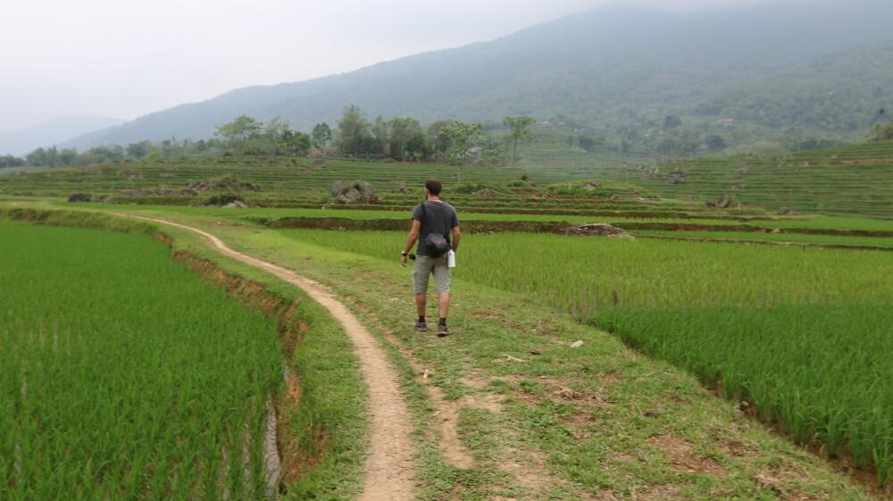
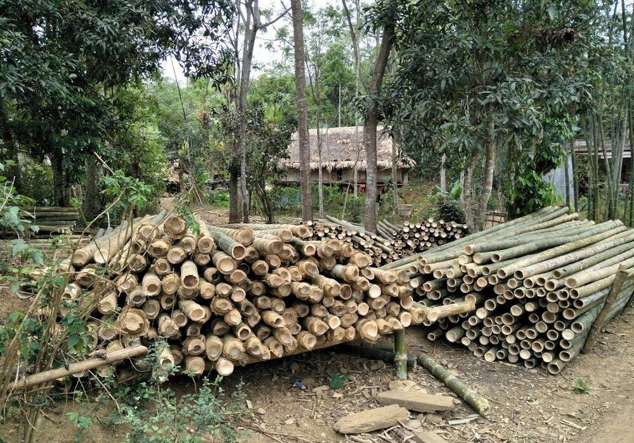
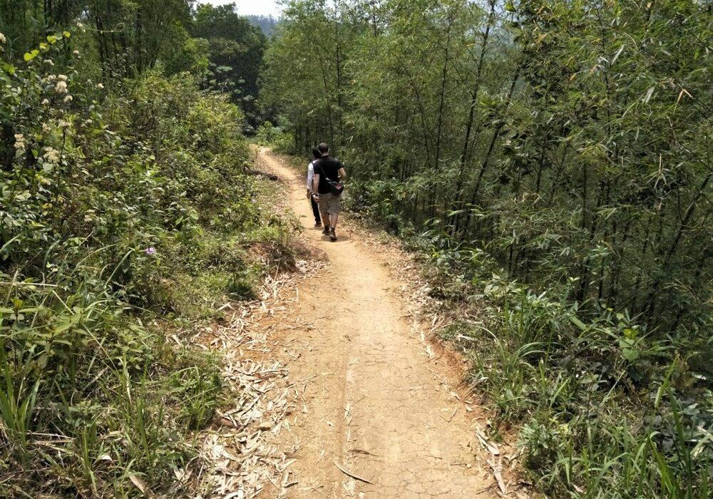
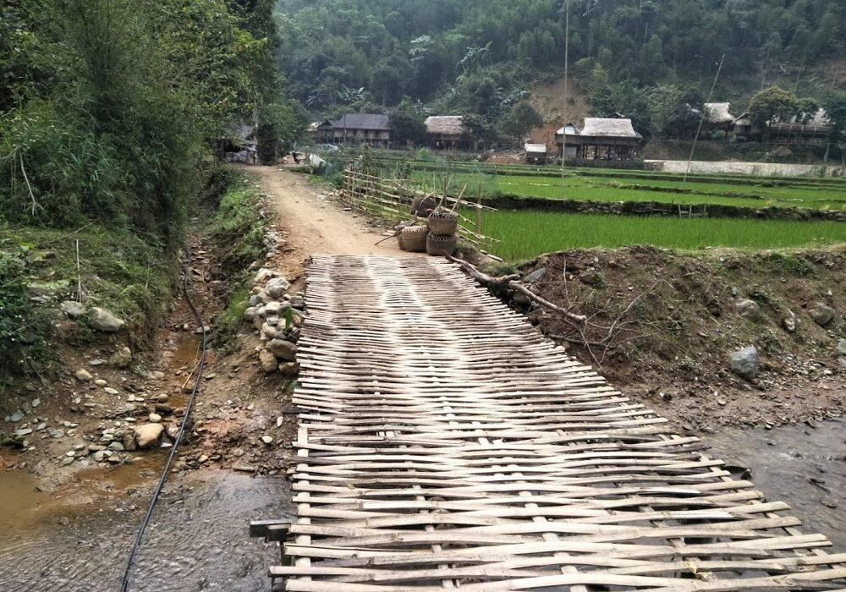
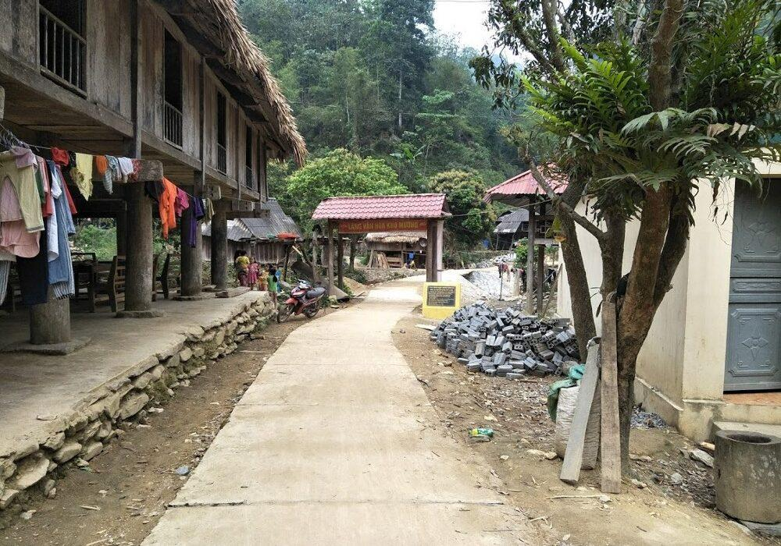
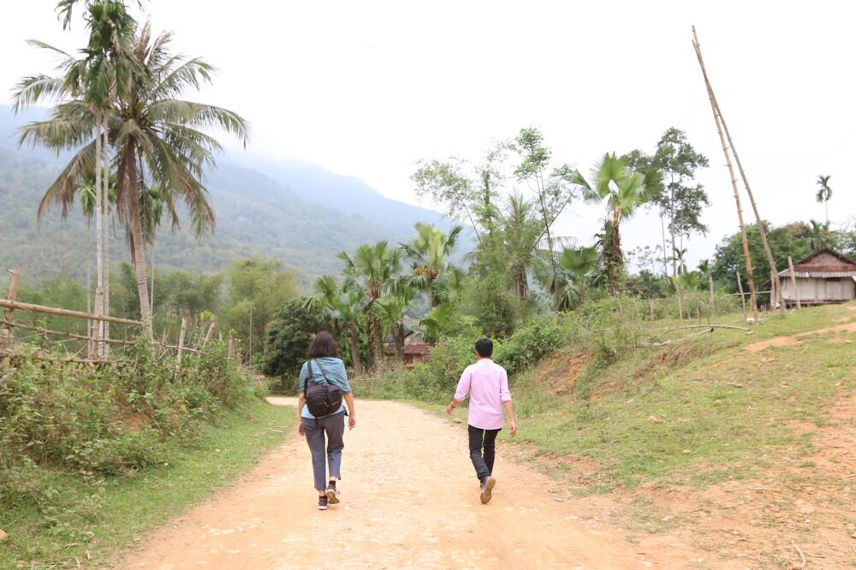

Easia Travel Head Office

