THAILAND – Chiang Mai – Hiking and Hill Tribe Immersion in Akha Culture 2d1n
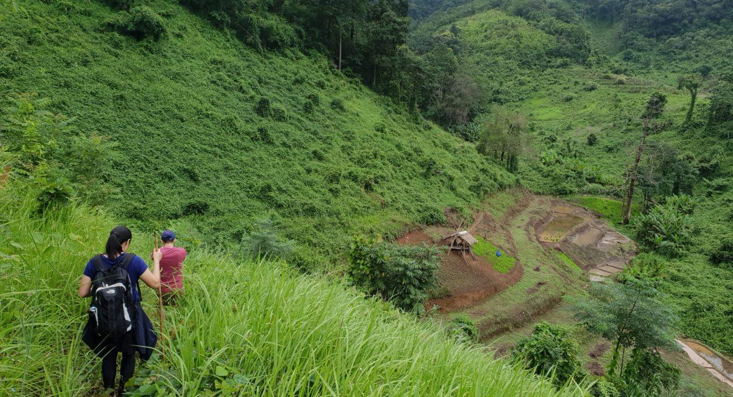

Over View

Theme
Art & Culture, Sustainable

Country - City
Thailand - Chiang Mai

Level of difficulties
LEVEL 3

Price level
$$$$

Seasonality
From October until June - not operated during the rainy season (July - September)

Max Pax
15

Arrival City
Chiang Mai

Departure city
Chiang Mai

Itinerary

Number of days and nights
2 days - 1 night

Day by day description
Day 1: Chiang Mai – Akha Community After driving to the Phrao region by minivan, the adventure starts by driving to a village in a local truck. Small forest trails link different areas of the mountains, offering an excellent opportunity for hikes through the community forests and agricultural areas. Local people are happy to cook up a meal for you along the way, as you learn more about the history and culture of the ethnic peoples in the region. If the weather is favorable, the last, steep ascent to the top of a mountain is rewarded with seemingly-infinite views of the stunningly beautiful surrounding valleys. At night, the villagers will host a dinner, and accommodation is provided in a simple and clean house.Level: 2Distance and duration of the trek: 9 kilometers – 5-6 hours including breaks – Challenging hike – only ascent Total Gain elevation: +1,200 meters Transportation: 140 kilometers from Chiang Mai – Doi Mon Lan – 3h 30min + 15 kilometers by truck – 40 minutes from Doi Mon Lan to the villagesDay 2: Akha Village – Chiang Mai After breakfast, sipping on a delicious cup of locally grown coffee, the exploration continues. More villages are waiting to be explored, and the locals are ready to explain their way of life to all comers. A final walk down a small, agricultural trail toward the valley marks the end of this unforgettable excursion before returning to Chiang Mai.Level: 1Distance and duration of the trek: 5 kilometers – 2 hours, including breaksTotal Gain elevation: – 500 metersTransportation:15 kilometers by truck – 45 minutes + Doi Mon Lan – Chiang Mai – 140 kilometers – 3h 30min

Selling points

- A private excursion, into an amazing undeveloped region still not on the map of mass tourism
- A sustainable Easia Product in direct cooperation with the local communities
- Exciting hikes combined with authentic cultural experiences in local Akha villages
- A remote area for adventure lovers
- Simplicity of accommodation but great human experience
- A challenging hike of 9 kilometers with 1200 meters elevation

Options

Activities
There is a choice between a “big” and “small” cultural performance in the evening:
- Big performance: the whole village will gather in a common area and there will be cultural performances like dances and songs by approximately 10-15 people in traditional dress. Recommended for bookings of more than 5 people. Cost is relatively high (2100THB) for smaller groups, and may be a “too big” event.
- Small performance: more intimate performance with songs and traditional music. Can be held at one of the local houses only 2-3 people will perform. Cost friendly (500THB) and more suitable for small groups up to 5 pax
During the first day of the module, travelers will have the choice to do the last part of the hike or not as the last part is quite steep. For real “active” people there shouldn’t be a problem, but people who are more into Active leisure may have difficulties with the last steep part. This choice can be made on spot, and the guide and local people can advise on the choice, depending on the fitness of the travelers and the timing of the day.

Extensions
- Chiang Mai – A trip into the countryside by bike and boat
- Chiang Mai – Half day cycling tour in Wiang Kum Kam area
- Chiang Mai – Hiking in the footsteps of the Hmong

Photos

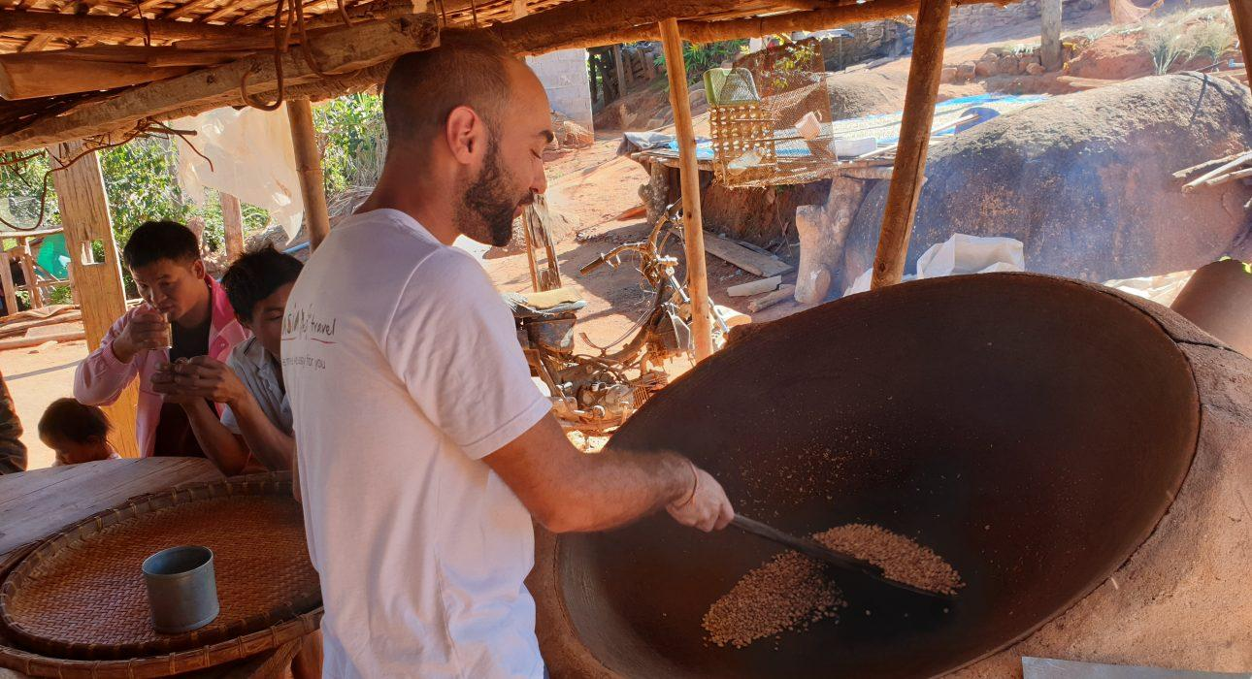
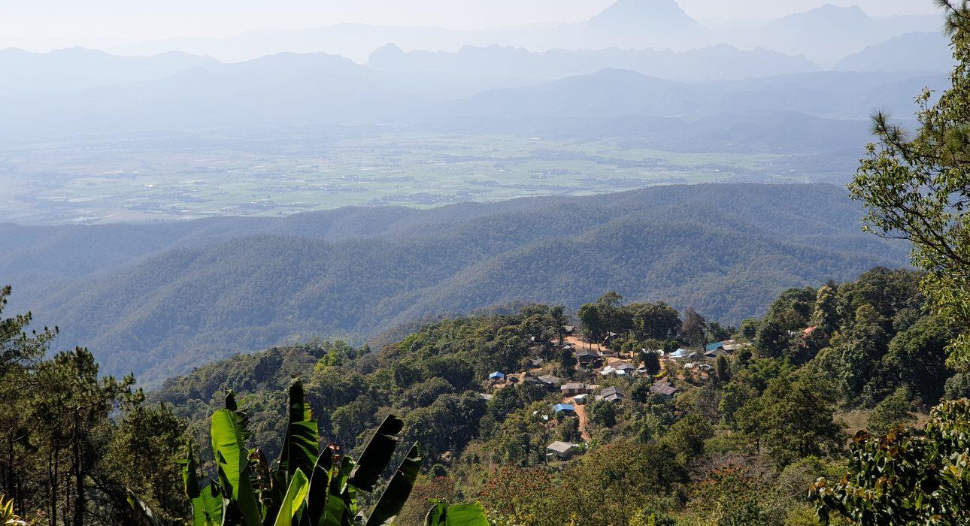
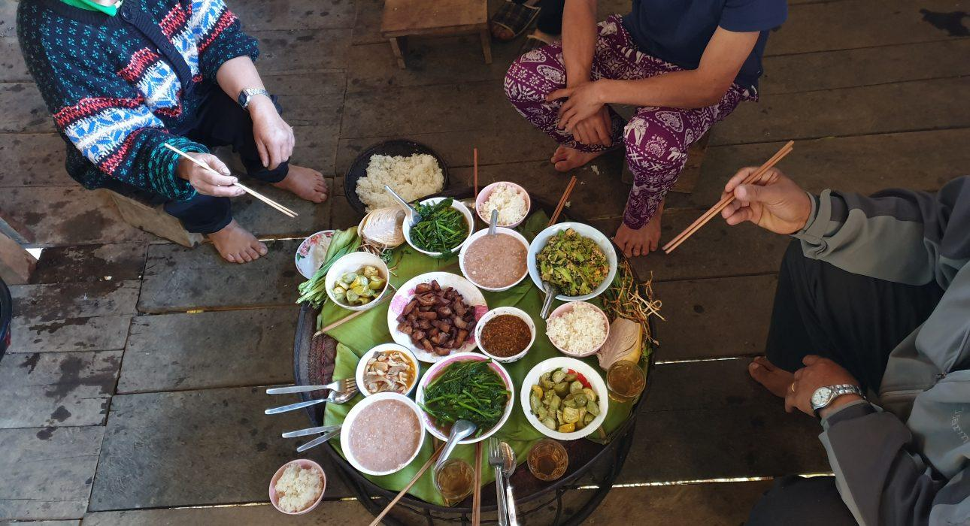
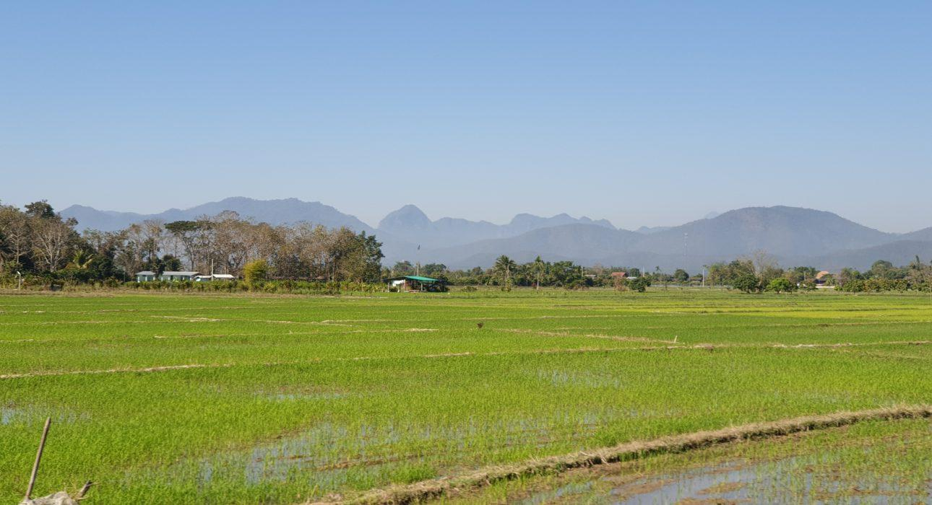
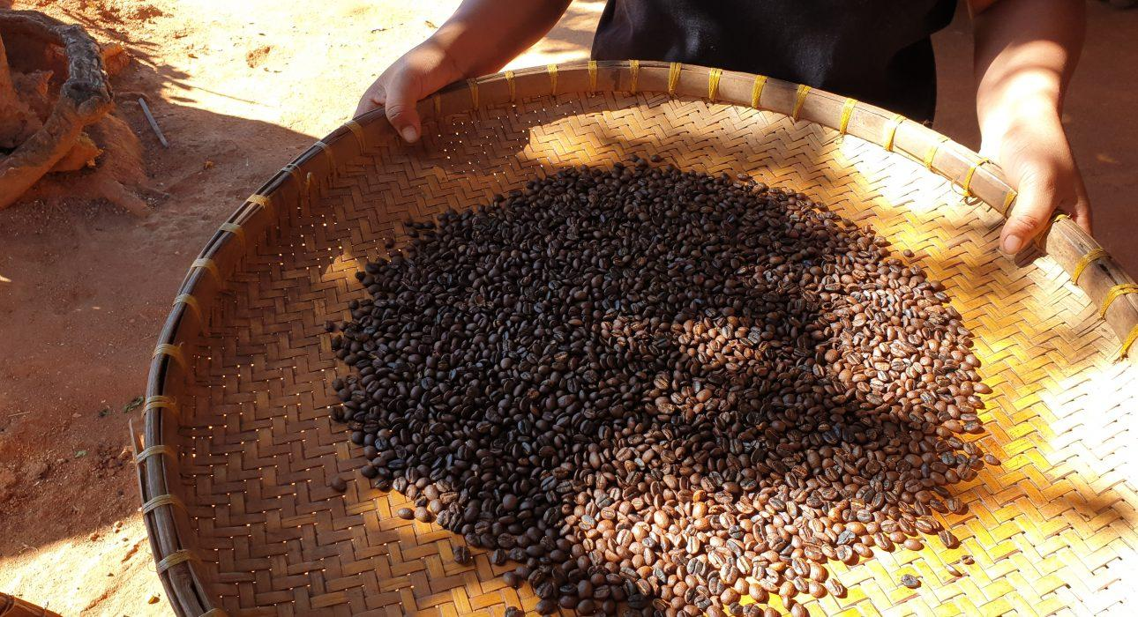
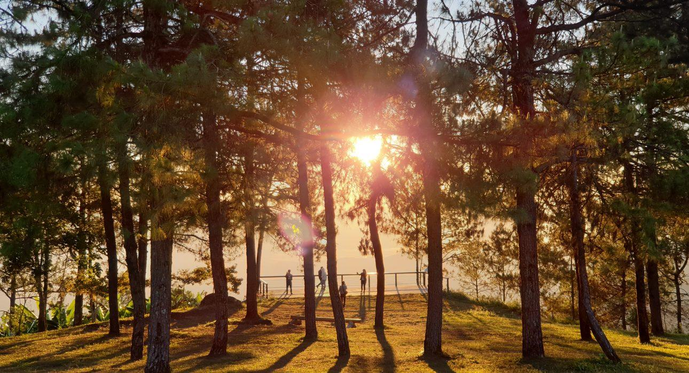
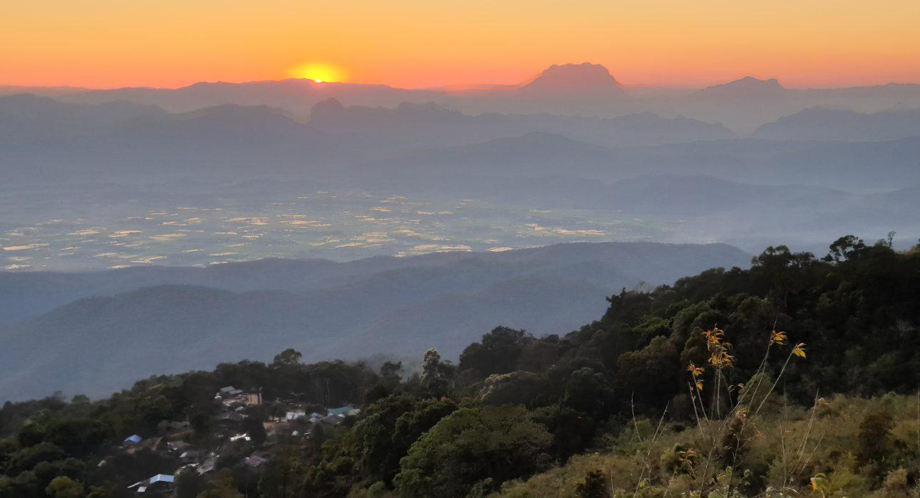
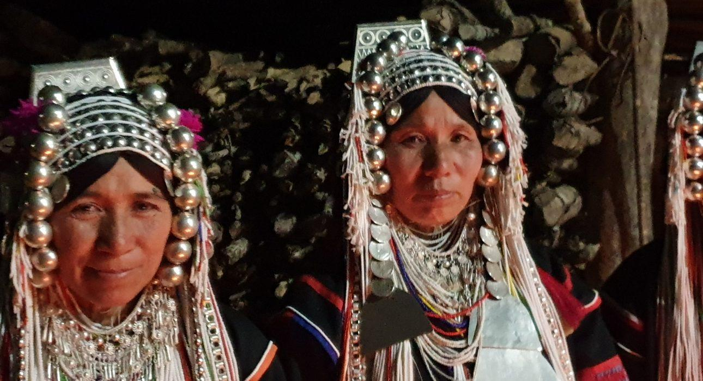
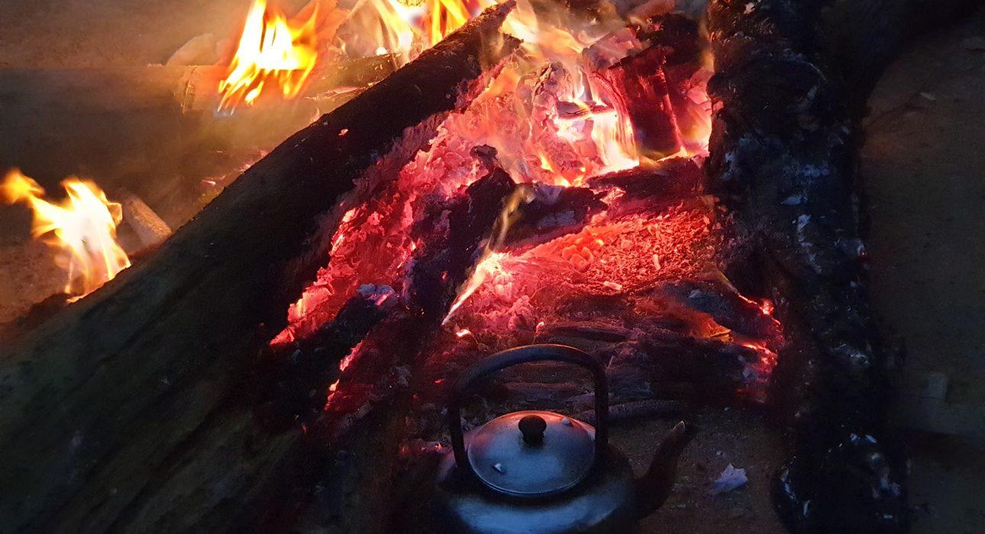

Easia Travel Head Office

Vietnam Head OfficeC/o: ATS Hotel, Suite 326 &327, 33B Pham Ngu Lao Street, Hanoi, VietnamTel: +84 24-39 33 13 62www.easia-travel.com

