LAOS – Oudomxai – A Night in a Tent at the Top of Phu Ya Ka Mountain 2D1N
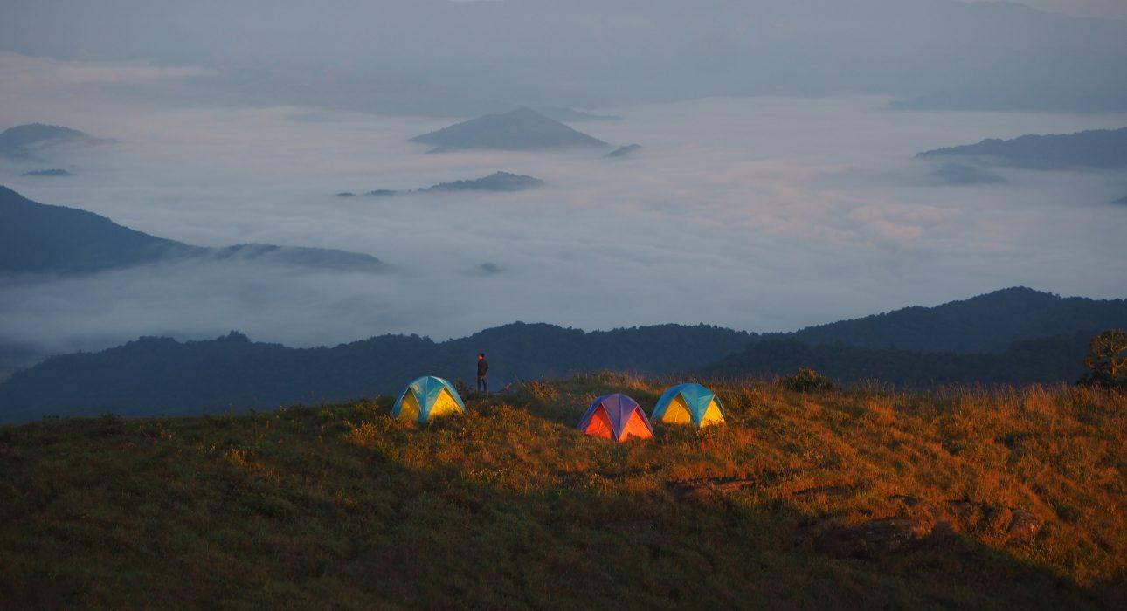

Over View

Theme
Art & Culture, Sustainable

Country - City
Laos - Oudomxai

Level of difficulties
LEVEL 3

Price level
$$$$

Seasonality
From October to May

Max Pax
15

Arrival City
Oudomxai

Departure city
Oudomxai

Itinerary

Number of days and nights
2 days - 1 night

Day by day description
Day 1:The adventure kicks off at 09:00 at Nam Kat Yolapa National Park. From here the trek will start, up steep slopes through the jungle, to the top of Phu Ya Ka mountain. The local guides will lead the way, wandering through the stunning natural environment and stopping at a viewpoint to enjoy a picnic lunch. After this, the climb to the summit of the mountain will continue, where there will be rewarding panoramic view over the whole area. Local guides will set up the tents and the camp fire to cook dinner while a stunning sunset will shed its last rays of light over the mountains.Level: 3 Distance and walking time: 9 kilometers – 6 to 7 hours Terrain – Steep slopes, jungle trail on the first half, mountain trail on the second half, including short and easy rock climbing Total Elevation Gain: + 900 meters, (+ 721 / +1622 meters) Note: The trek requires good walking shoes, long pants and sun protection. Seasonality: from October to May.Day 2:The highlight of this day is awakening above the sea of mist and witnessing the sun slowly rising and filling the atmosphere. After breakfast, the trekkers will head back down to the valley, with many scenic points along the way.Level: 2 Distance and walking time: 9 kilometers – 3 to 4 hours Terrain – descent of the mountain, by the same way than the previous day Total Elevation Gain: – 900 meters, (+ 1622 / +721 meters) Note: The trek requires guests to be equipped with good walking shoes, long pants and sun protection. Seasonality: from October to May.

Selling points

- The awakening at the top of the mountain above the sea of clouds guarantees ever-lasting memories.
- The evening around the camp fire with the local guides and the overnight in the tent offers a very immersive experience.
- A trek intermediate level with stunning views along the way.

Options

Photos

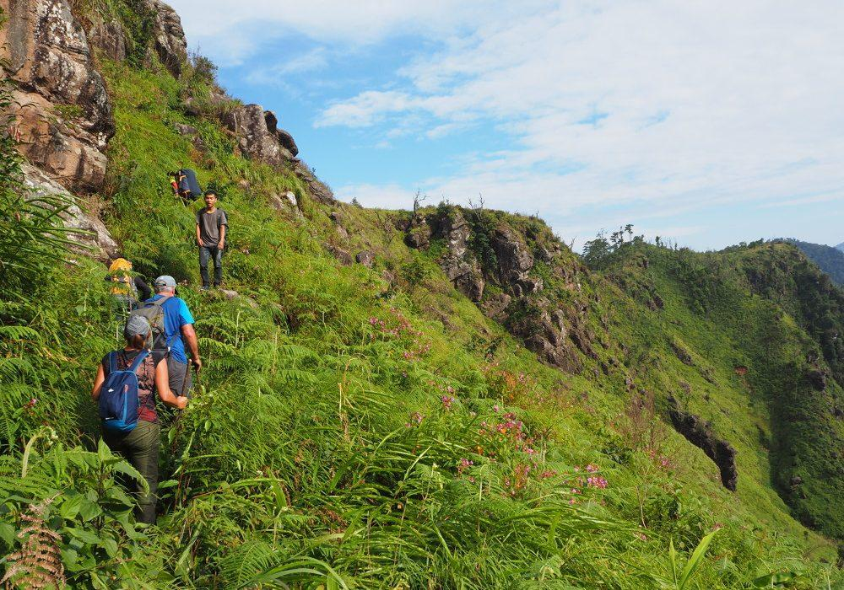
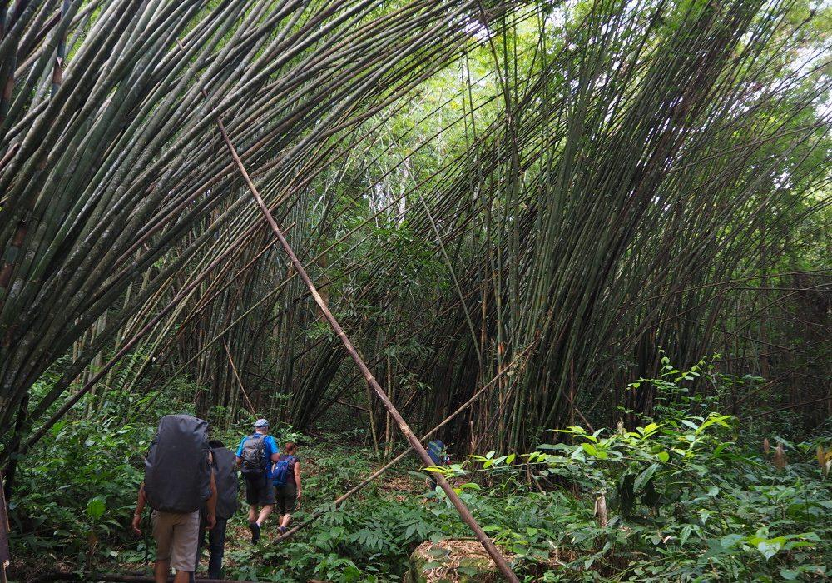
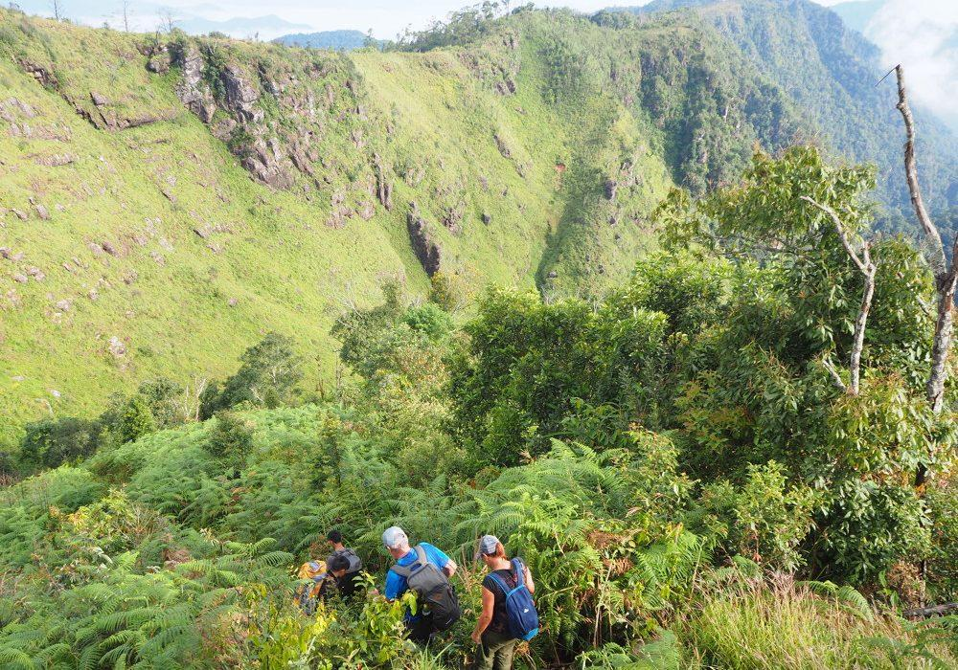
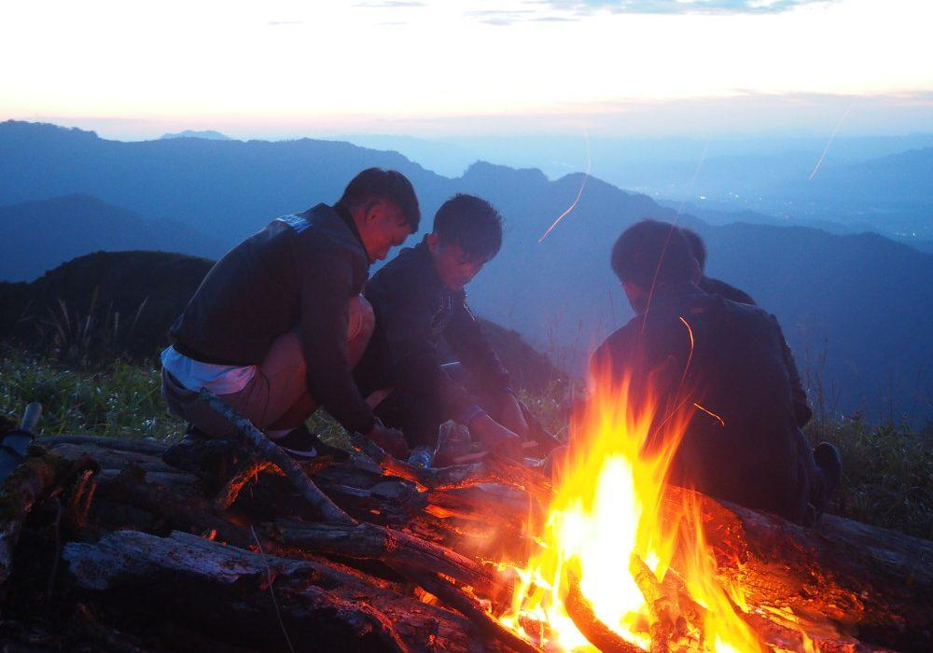
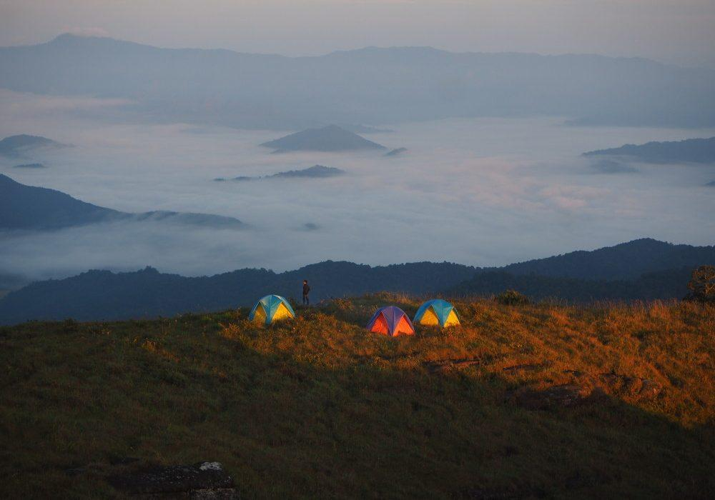
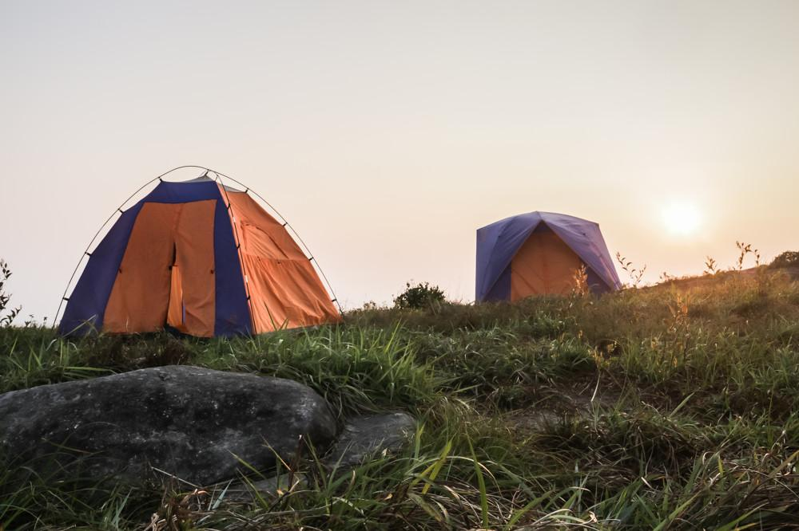
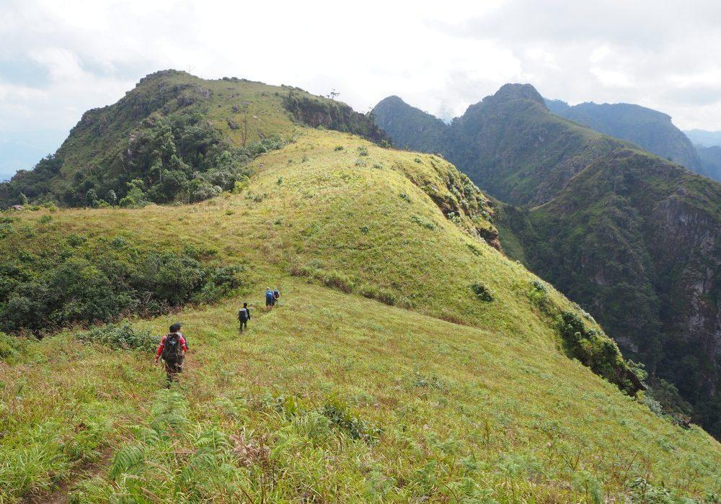
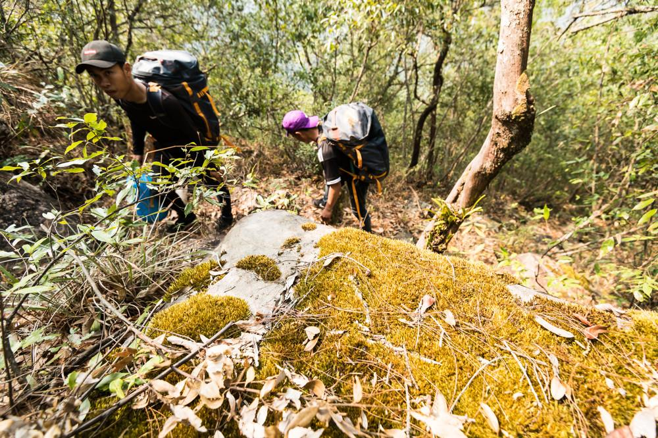
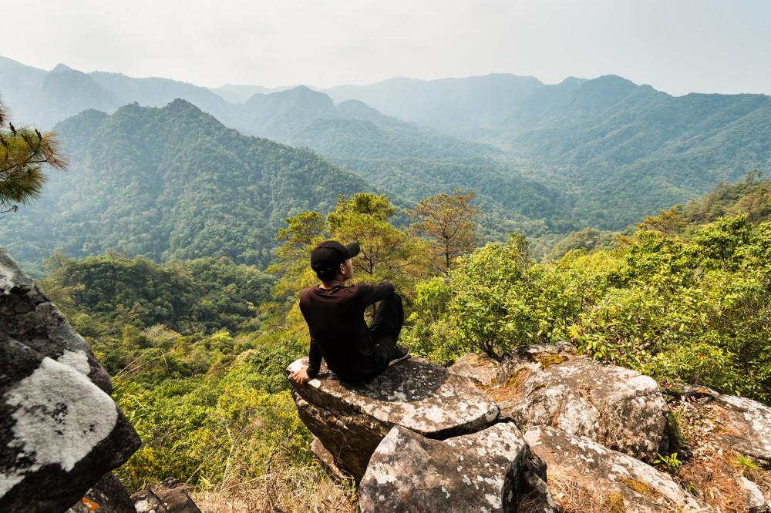
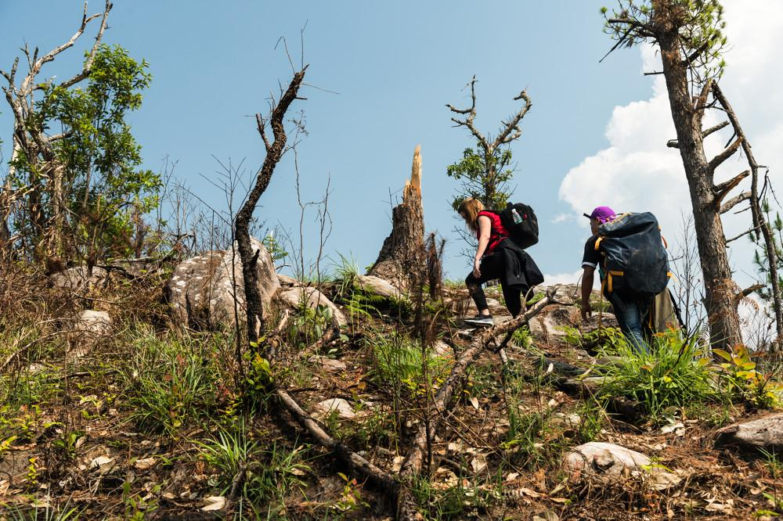
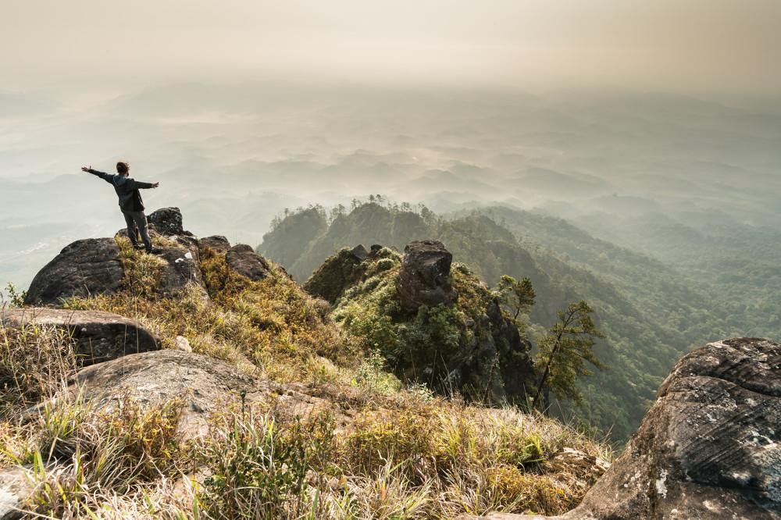
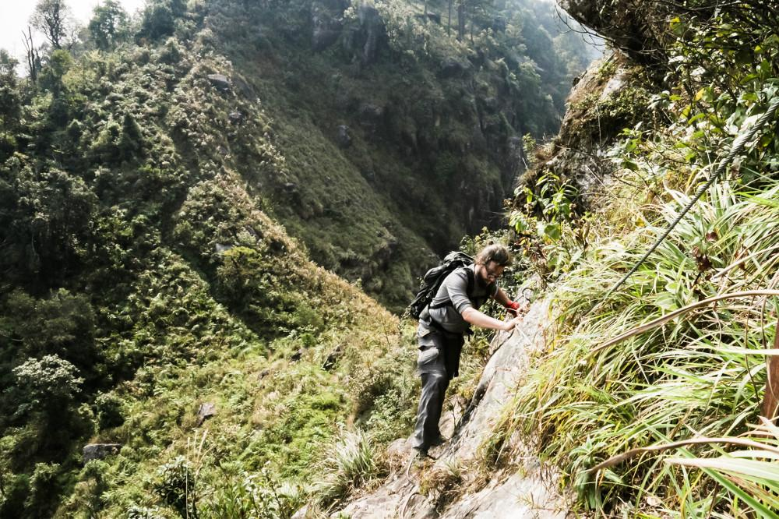
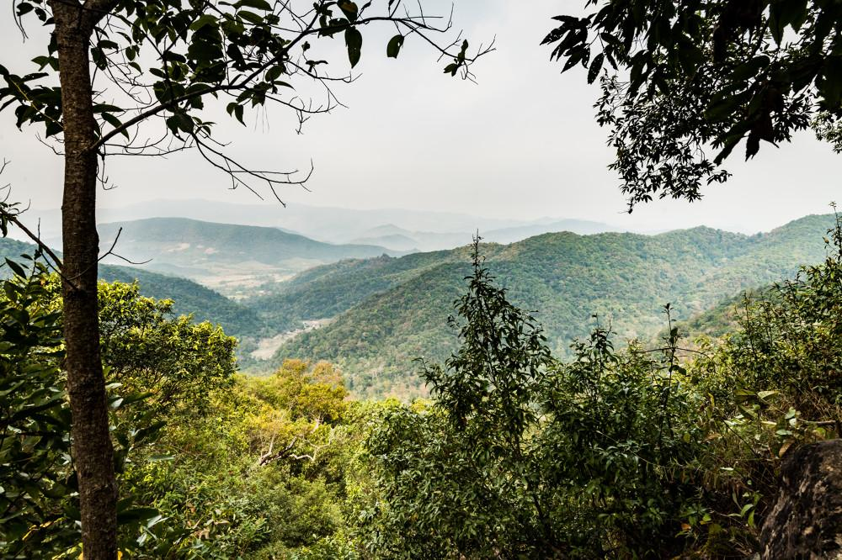

Easia Travel Head Office

Vietnam Head OfficeC/o: ATS Hotel, Suite 326 &327, 33B Pham Ngu Lao Street, Hanoi, VietnamTel: +84 24-39 33 13 62www.easia-travel.com

