VIETNAM – Pu Luong – Mountains and Villages Trekking 3D2N
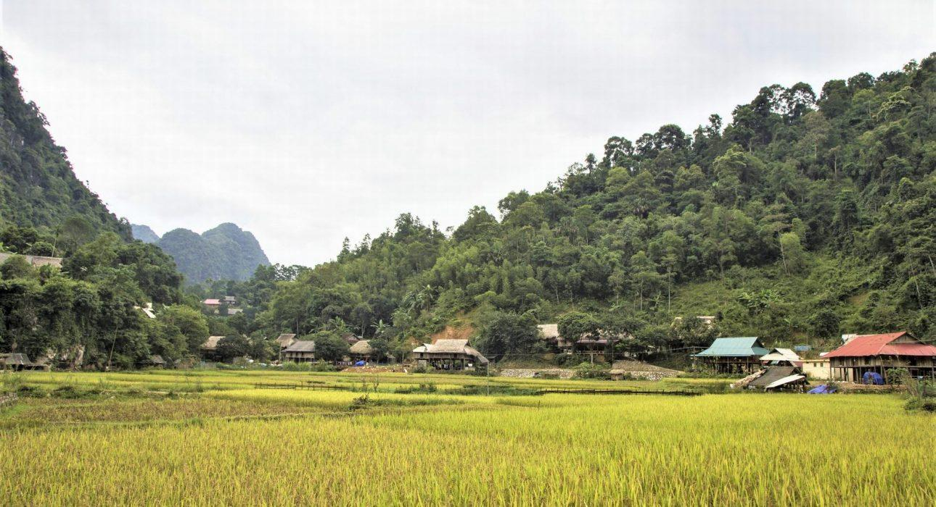

Over View

Theme
Art & Culture, Classic, Sustainable

Country - City
Vietnam - Pu Luong

Level of difficulties
LEVEL 3

Price level
$$$$

Seasonality
All year round - rainy season June - September

Max Pax
15

Arrival City
Pu Luong

Departure city
Mai Chau

Itinerary

Number of days and nights
3 days - 2 nights

Day by day description
This 3-day, 2-night itinerary is designed for active travelers who are eager to put on their hiking shoes to explore Pu Luong and its valleys brimming with forests, rice paddies and rice terraces. The trails of the valley lead hikers through the villages of Thai minority tribes and give them the opportunity for close contact with the inhabitants, as they stop to sleep in village homestays.

Selling points

- To discover Pu Luong National Reserve by going through many villages, rice terraces and forest
- To interact with local people from the Thai, Muong minority group and understand their local life by visiting the villages and staying at the homestays
- An active routine for a hiker experienced in everyday hiking.

Sustainability

Level Of The Excursion
Medium – This activity offers tangible positive contributions to the local community, culture and/or environment

The Impact Of This Excursion

Social/cultural Impact
Involving minorities

Environment Impact
Transportation

Economic Impact
Community benefits

Additional Information
Positive Impact:This itinerary takes place in Pu Luong and has a positive impact on the region. Travelers stay in two different homestays of the Thai minority, with money spent directly on dinner at the homestay, lunch in the countryside, etc.). No cars are used during the tour; only walking & trekking. Tourism has helped support the region in terms of infrastructure (particularly for roads) but also to keep the young people moving away from the region by providing job opportunities.

Options

Extensions
- Mai Chau – Hiking in the enchanted Mai Chau landscape
- Ninh Binh – Lunch in a Local House

Photos

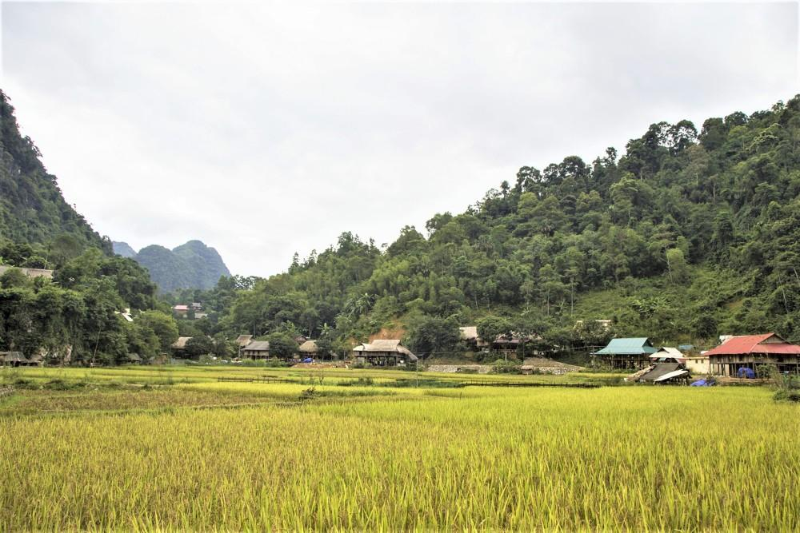
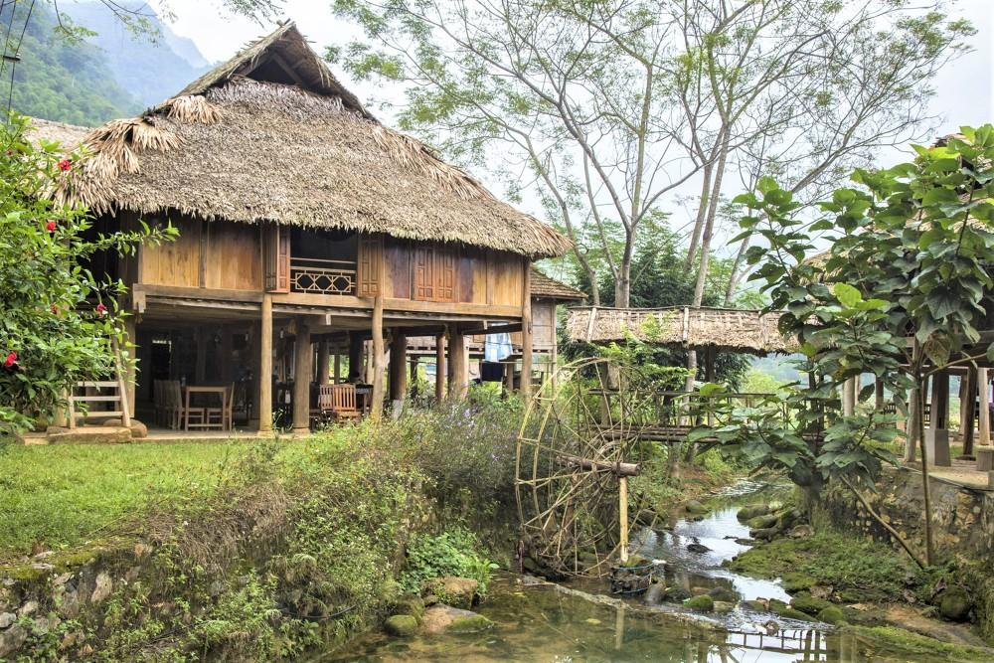
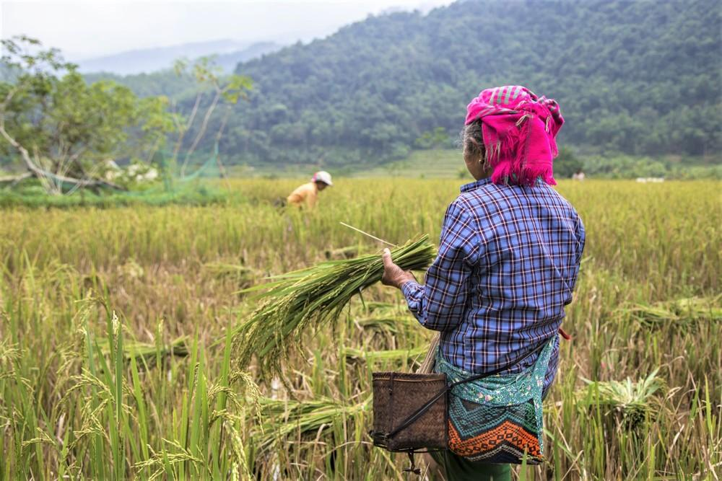
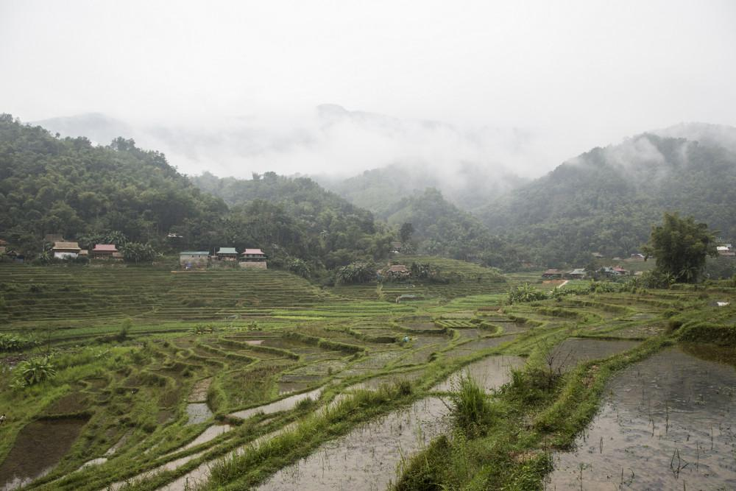
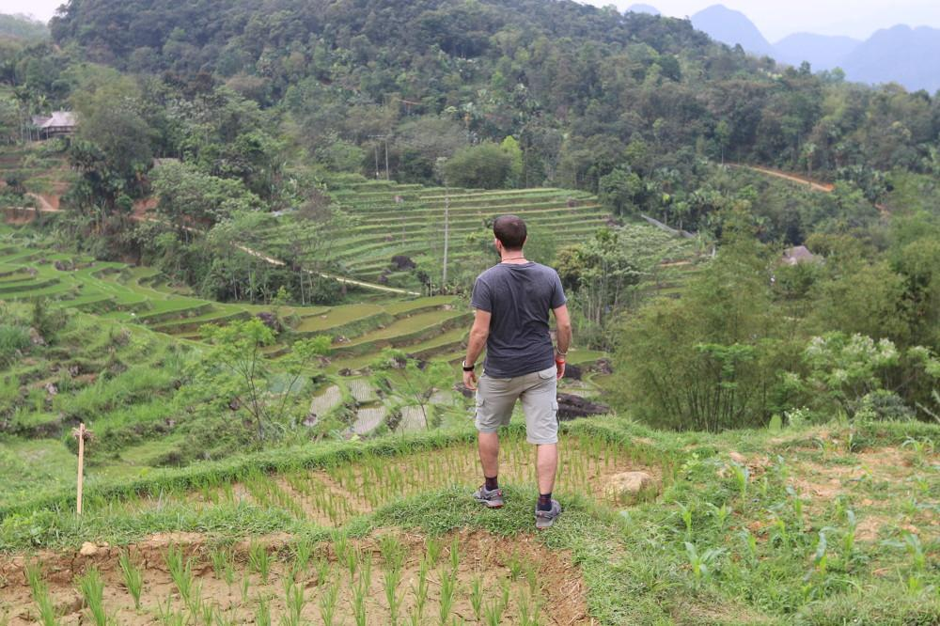
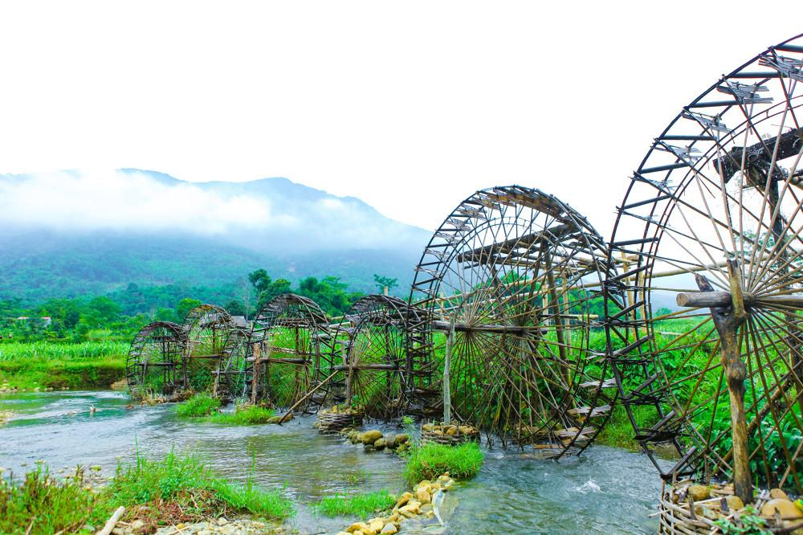

Easia Travel Head Office

Vietnam Head OfficeC/o: ATS Hotel, Suite 326 &327, 33B Pham Ngu Lao Street, Hanoi, VietnamTel: +84 24-39 33 13 62www.easia-travel.com

