Private: (Cancelled) CAMBODIA – Siem Reap – Phnom Kulen Trek and Homestay, Discover the Holy Mountain 2D1N or 3D2N
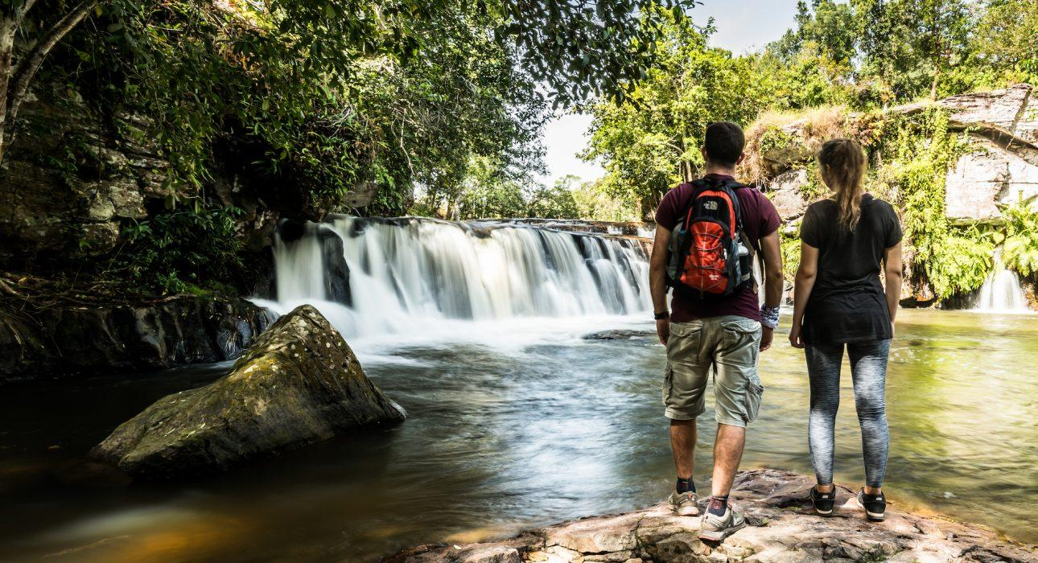

Over View

Theme
Art & Culture, Sustainable

Country - City
Cambodia - Siem Reap

Level of difficulties
LEVEL 2

Price level
$$$$

Seasonality
All year long. Best period from November to March and from July to August. To avoid April, May, September &amp; October.

Max Pax
12

Arrival City
Siem Reap

Departure city
Siem Reap

Itinerary

Number of days and nights
2 days - 1 night or 3 days - 2 nights

Day by day description
DAY 1: Siem Reap – Phnom Kulen TrekIn the morning, around 7:00, guests will travel from Siem Reap to Phnom Kulen, the largest forested area in the Siem Reap province. After only 5 kilometers of driving, travelers will already find themselves in the middle of the Cambodian countryside, passing through rural villages, endless rice fields, and coconut trees.Arriving at the National Park checkpoint, located at the foot of Kulen Mountain, the group will stop to show the tickets and proceed along the road to reach the starting point. There, the local ranger will meet everyone, along with our professional guide, both of whom will accompany the travelers over the course of the 2-day trek. After a short briefing, everyone will set out, first reaching The River of 1000 Lingas. It’s hard not to stand in awe at the carvings located around the river, dedicated to the Hindu God Shiva, as well as the golden Reclining Buddha situated at Preah Ang Thom. After visiting these classic sites, a refreshing stop at the Phnom Kulen Waterfall will give everyone a chance to refresh themselves.After a rousing dip in the Falls, guests will plunge deep into the forest to spot some Cambodian wildlife. By the afternoon, travelers will reach a peaceful lunch area along a small river, where they’ll help the guide and the ranger to set up the picnic, and dine on some well-earned food, surrounded by natural splendor.After lunch and a rest along the river, the trek continues on, ending at the local homestay – the night’s accommodation.Accommodation: Home-stay Phnom KulenMeals: Breakfast, Lunch, Dinner
Level: 2
Distance & duration of hiking: 12 kilometers – 3 hours (Excluding site visits)
Total Elevation Gain: 253 meters ascent / 212 meters descent
Starting point / Ending point elevation: + 322 meters / + 372 meters
Terrain: mainly jungle trails, through forest
Transportation: full-day vehicle support – 50 kilometers – 1 hour 30 minutes (From hotel to starting point) – Emergency vehicle available (Motorbike taxi – possible to access in most of the areas)
Note: flexible trails, possible to reduce the kilometers trekking
DAY 2: Phnom Kulen Trek, the loop – Siem Reap or Phnom Kulen trek LoopWaking up in the early morning, everyone will surely enjoy the fresh, tranquil atmosphere of the local village, hedged in by palm and coconut trees. After a delicious local breakfast cooked by the family, the second day of trekking starts by taking on the Phnom Kulen plateau.Climbing along a diverse mix of trails, starting with a jungle trail through the forest, the paths will take trekkers by some hidden temples dated to the 10th century, as well as some of cashew nut plantations managed by local villagers.Today’s highlight is surely the famous Sra Damrei site, which houses a holy Elephant statue and shrine, carved in sandstone, representing the mountain’s guardian. This site is very important for Cambodian people, who travel from all over the country to visit and pray.Continuing to make headway through the forest, a pagoda will serve as a serene dining spot, where guests will have another scrumptious, local lunch and a short rest before continuing the hike, visiting some other archaeological beautiful sites along the trail. Being sure to stop at the impressive Phnom Tbal, history and architecture buffs will love the stone carvings representing Shiva, Vishnu and other Hindu gods. Prasat Rong Chen, a small pyramid temple, is, by far, one of the most important sites of the area: Jayavarman II announced his growing empire’s independence from Java and declared himself King of the Khmer Empire.Today’s tour will end at the previous night’s homestay. After bidding farewell to the local family, guests will take a van to Siem Reap, leaving the National Park from the opposite end.
Accommodation: Hotel Siem Reap
Meal: Breakfast, Lunch,
Level: 3
Distance & duration of hiking: 20 kilometers – 5 hours (Excluding site visits)
Total Elevation Gain: 412 meters ascent / 315 meters descent
Starting point / Ending point elevation: + 372 meters / + 372 meters
Terrain: mix of trails, crossing a local village, plantations, forest and the rocky plateau
Transportation: full day vehicle support – 22 kilometers – 40 minutes (From ending to homestay) – Emergency vehicle available (Motorbike taxi – possible to access in most of the area)
Note: flexible trails, possible to reduce the kilometers trekking
DAY 3: Phnom Kulen – Siem ReapWake up in the morning and enjoy a home-made breakfast by the local family. After saying your farewells, travel by van to Siem Reap, leaving the national park from the entrance opposite to the one from which you entered.Meals: Breakfast

Selling points

- To offer intermediate level trek in Kulen National Park
- To learn how the Khmer Empire began by visiting some important archaeological sites
- To cross the Phnom Kulen plateau along 32 kilometers of jungle trails
- To visit exotic waterfalls and learn about Cambodian flora and fauna
- Overnight in a homestay; hosted by a friendly local family

Options

Extensions
- One night more on the Homestay in Phnom Kulen – then day after back to REP, or visit Beng Melaea or travel to Preah Vihear
- Extension one night more in Beng Mealea Homestay,
- Extension Siem Reap combining with other hiking day tours around Angkor Archaeological Park

Photos

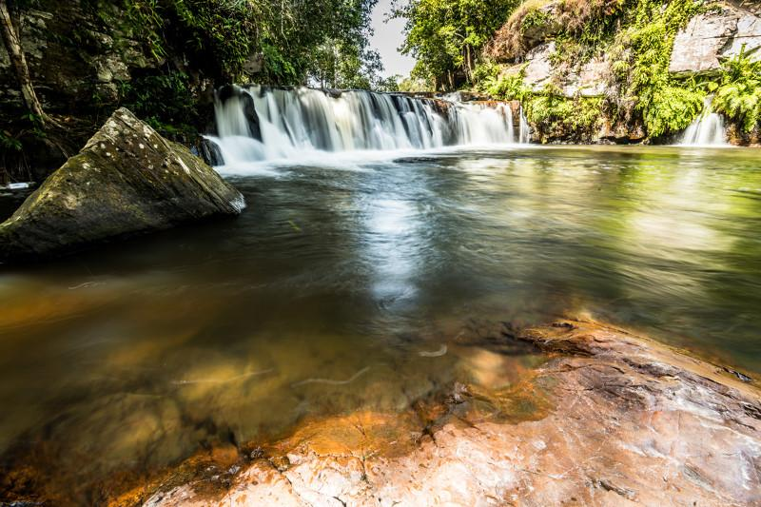
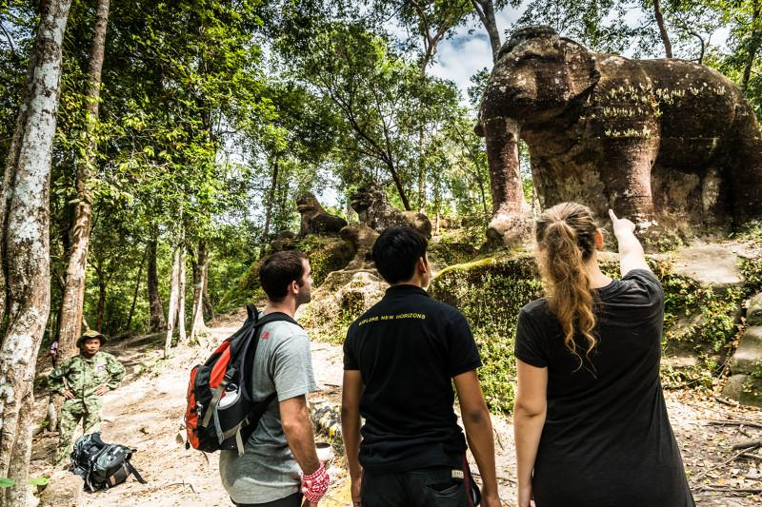
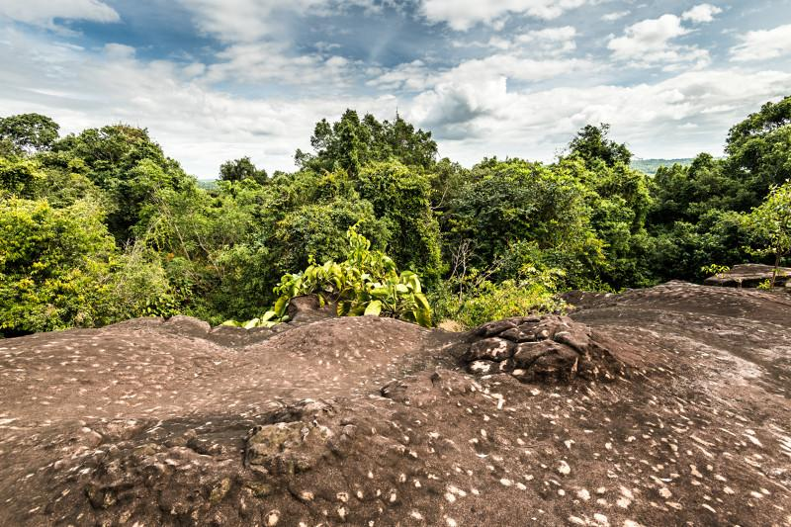
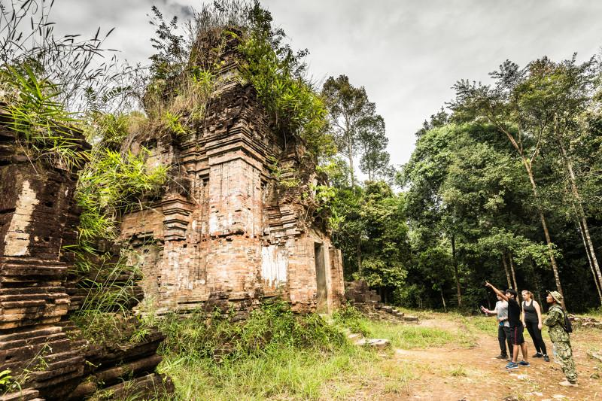
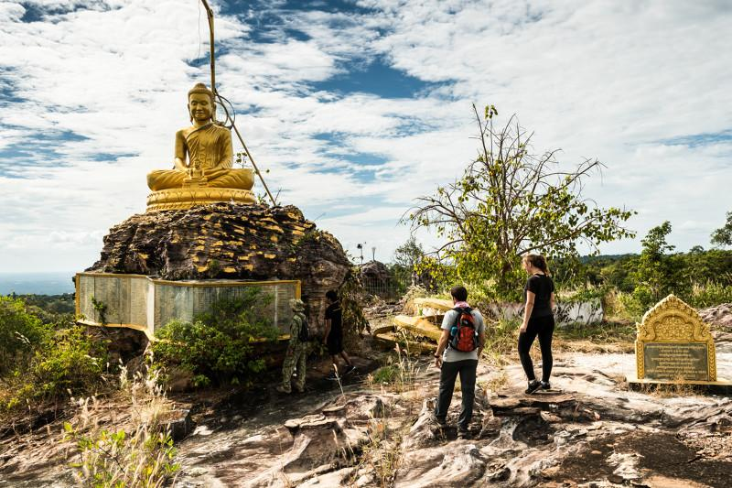
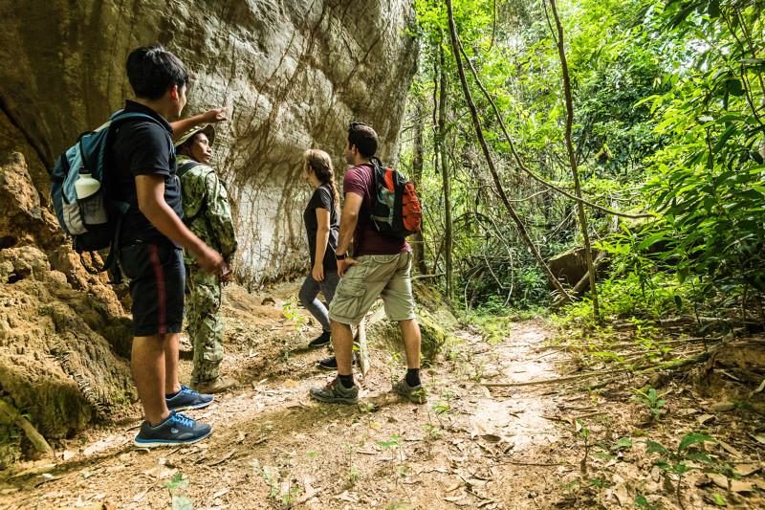

Easia Travel Head Office

Vietnam Head OfficeC/o: ATS Hotel, Suite 326 &327, 33B Pham Ngu Lao Street, Hanoi, VietnamTel: +84 24-39 33 13 62www.easia-travel.com

