LAOS – Xayaboury – Discover the Elephant Conservation Center 2D1N
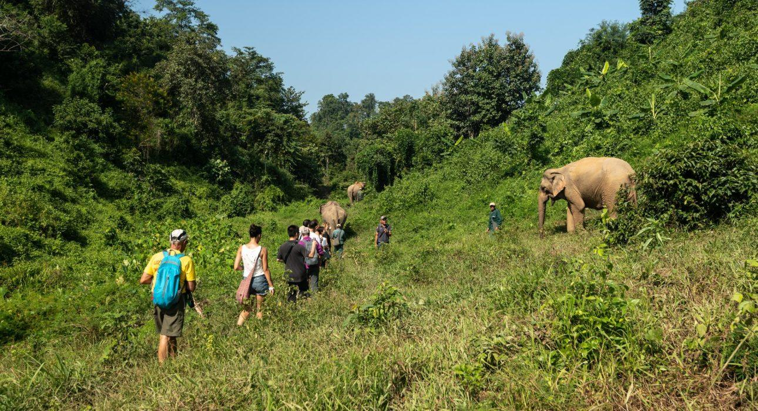

Over View

Theme
Art & Culture, Classic, Family, Sustainable

Country - City
Laos - Xayaboury

Level of difficulties

Price level
$$

Seasonality
All Year Round

Max Pax
20

Market segment
Thematic Leisure

Arrival City
Xayaboury

Departure city
Xayaboury

Itinerary

Number of days and nights
2 days - 1 night

Day by day description
Day 1: Luang Prabang – Xayaboury – Elephant Conservation CenterAfter travelling from Luang Prabang you will arrive at Nam Tien pier, then after a short boat trip, you will reach the Center. You will have time to settle into your private bungalow before your guide will take you to the forest and show you the center and its inhabitants. You will discover the resident mother and baby at the nursery, then you will take the boat back to the Center for the hospital visit, where you will meet the Laotian Vet Assistant or Biologist, who will tell you more about common and uncommon injuries and their respective treatments. You will then observe the elephants’ daily bath and learn more about the elephants’ playful characters. After that, you will have the opportunity for some soft interaction with the mahouts by your side. After a short hike in the forest, the mahouts will decide on a place where the elephants can graze for a while. Before dinner, you will have the opportunity to walk in the surroundings, or go for a swim in the lake, take a canoe, or visit the museum of the conservation center.Day 2: Elephant Conservation Center – Luang PrabangToday you will meet up with the elephants in the forest. After spending the night grazing in the jungle, it is time for another bath. Enjoy strolling together with these magnificent creatures in their natural environment. Follow the guide around the perimeter to learn more about the group and its dynamics. Take your time on the different platforms to see how a new herd is being formed. This rare opportunity will bring you closer to their natural life. After some time to relax, you will travel back to Luang Prabang.

Selling points

- The elephant conservation centre offers a new eco-tourism concept to discover the elephant and its environment in a respectful way.
- The quality of the service, the relaxing surroundings and the complete information about the elephants makes this product interesting and revitalizing.

Sustainability

Level Of The Excursion
High – This activity strongly supports local communities and/or helps preserve the culture and environment

The Impact Of This Excursion

Social/cultural Impact
Empowerment and education

Environment Impact
Involving Wildlife

Economic Impact
Community benefits

Options

Photos

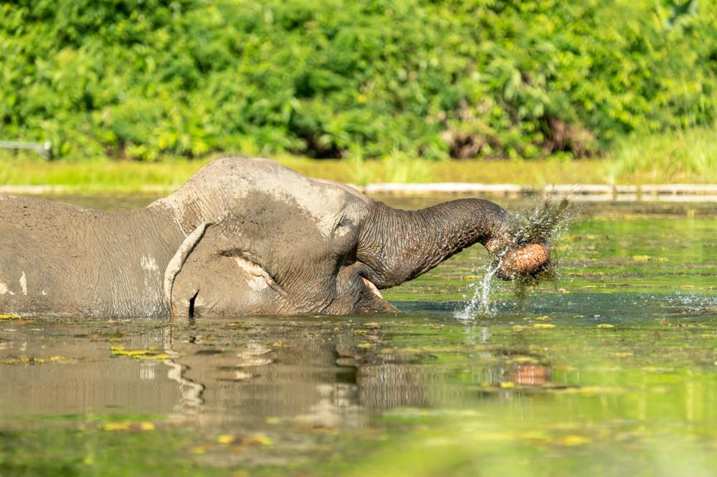
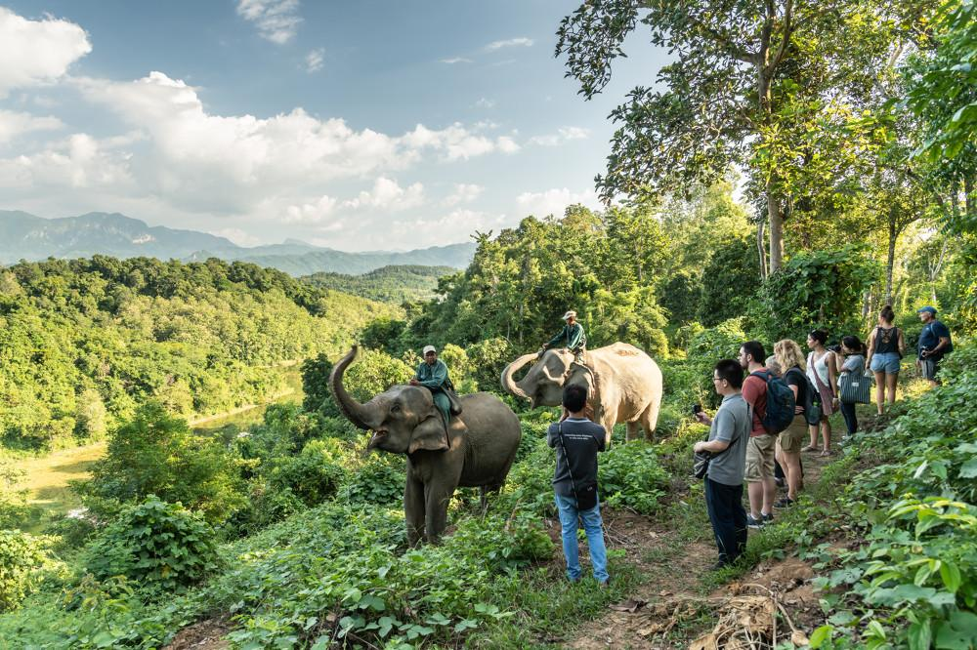
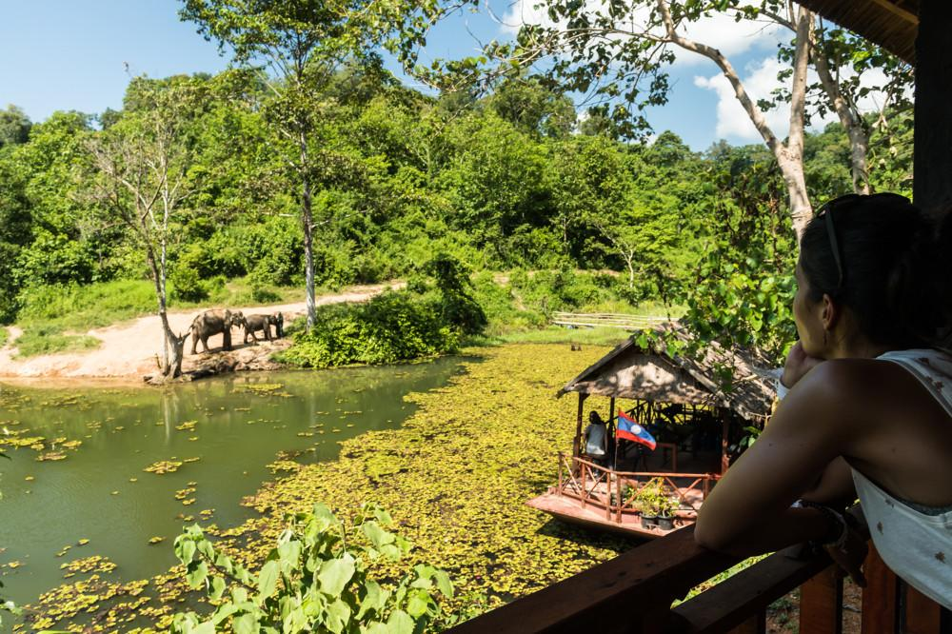
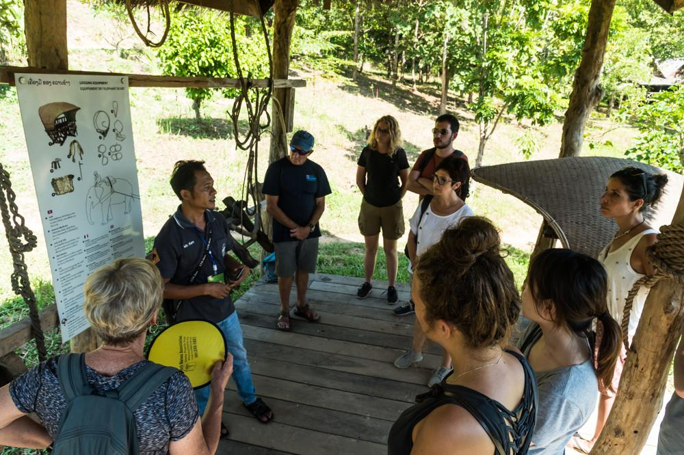
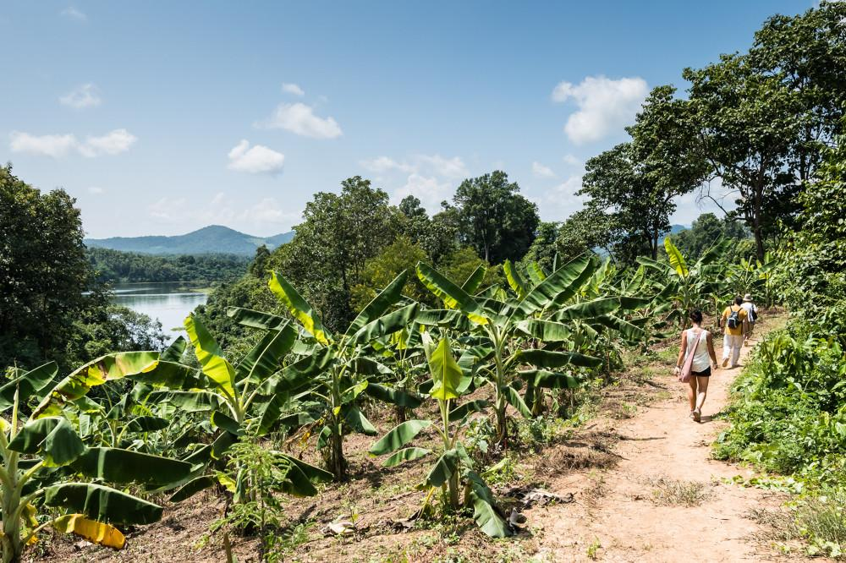
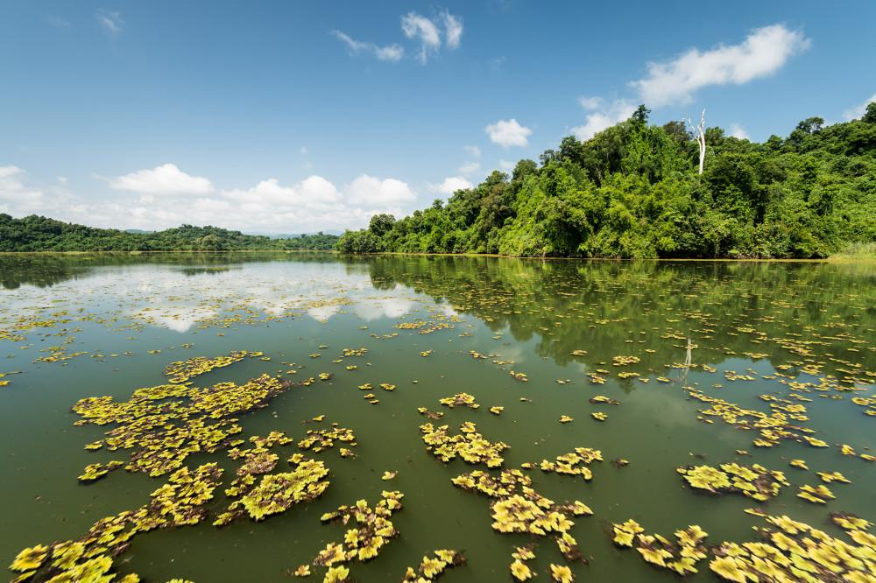

Easia Travel Head Office

Vietnam Head OfficeC/o: ATS Hotel, Suite 326 &327, 33B Pham Ngu Lao Street, Hanoi, VietnamTel: +84 24-39 33 13 62www.easia-travel.com

