CAMBODIA – Siem Reap – Discover Angkor Self-Guided Cycling Module 4d3n
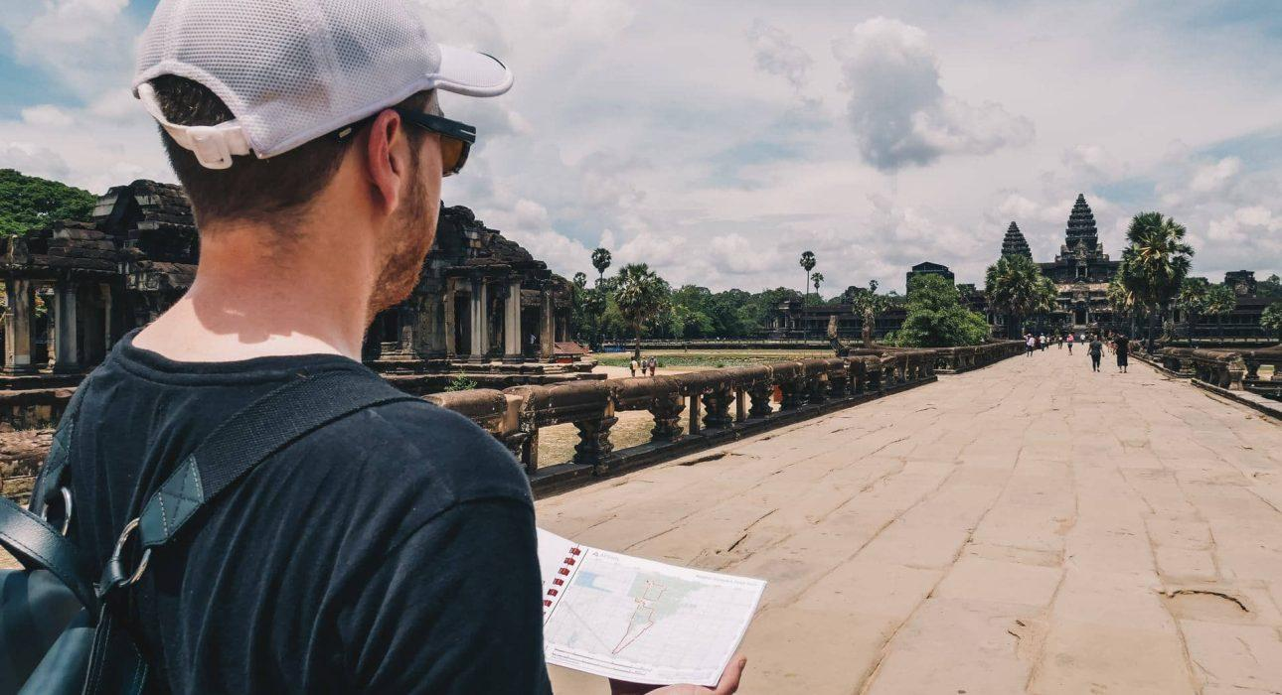

Over View

Theme
Art & Culture, Family, Self-Guided Tours, Sustainable

Country - City
Cambodia - Siem Reap

Level of difficulties
LEVEL 2

Price level
$

Seasonality
All year long. Best period from November to March and from July to August.

Max Pax
5

Arrival City
Siem Reap

Departure city
Siem Reap

Itinerary

Number of days and nights
4 days - 3 nights

Day by day description
Discover Angkor is a 3-day self-guided cycling module that allows travelers to explore the incredible Angkor Wat Archaeological Park along with the support of a mobile device loaded with detailed digital maps. Travelers have three different itineraries available to cycle at their rhythm, exploring off-the-beaten paths through the forest local villages and offering the opportunity to discover the main highlights of the park as well as hidden temples lost in the dense, mysterious jungle.Upon arrival, travelers are welcomed by their self-guided local assistant, who will provide the traveler with everything required and answer the questions (if any).Our assistant will always contact the traveler through the device, and a stand-by vehicle is always on call over the three days to support travelers and to pick them up during or at the end of each day if they are tired or need to stop.This module is designed for travelers looking to independently explore one of the largest UNESCO archaeological parks in the world at their own pace with complete freedom.

Selling points

- Explore Angkor Archaeological Park on a self-guided cycling trip
- 3 Moderate cycling tours available, adaptable to all types of travelers in reasonably good physical condition
- Visit Angkor Wat, UNESCO site, and other must-see attractions
- Cycle along ancient royal pathways through the forest, visiting some lesser-known temples
- Interact with the local communities
- Local assistant on spot 24/7 available

Options

Activities
- Siem Reap – “Phare, The Cambodian Circus” Show
- Siem Reap – Attend a divine performance of The Sacred Dancers of Angkor

Extensions
- Phnom Penh – Cycling, from the Capital Phnom Penh to majestic Angkor Wat 6D/5N
- Battambang – Cycling – Discover Battambang and the authentic Cambodian countryside – 3D/2N

Photos

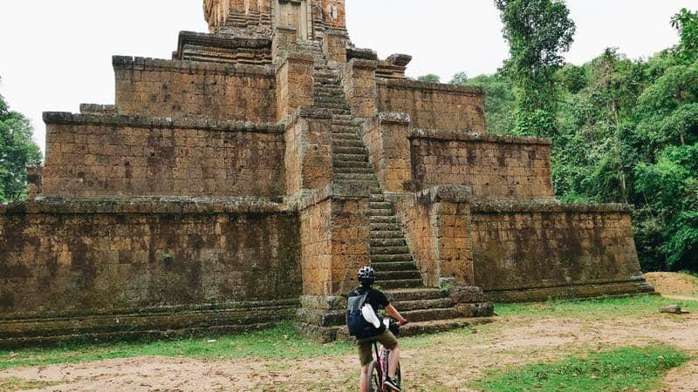
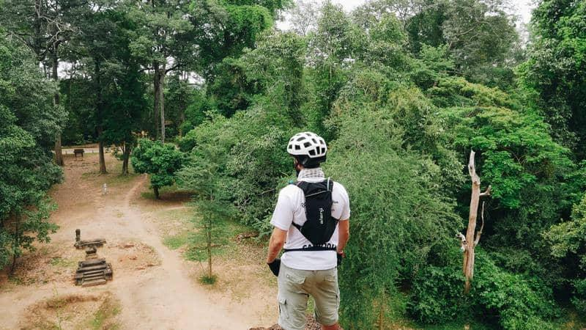
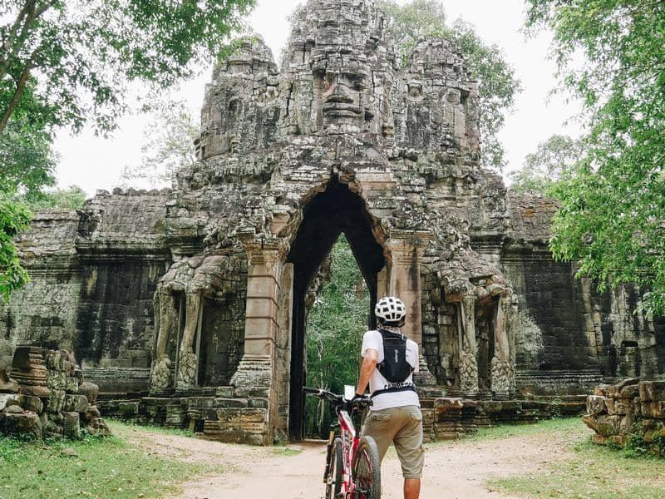
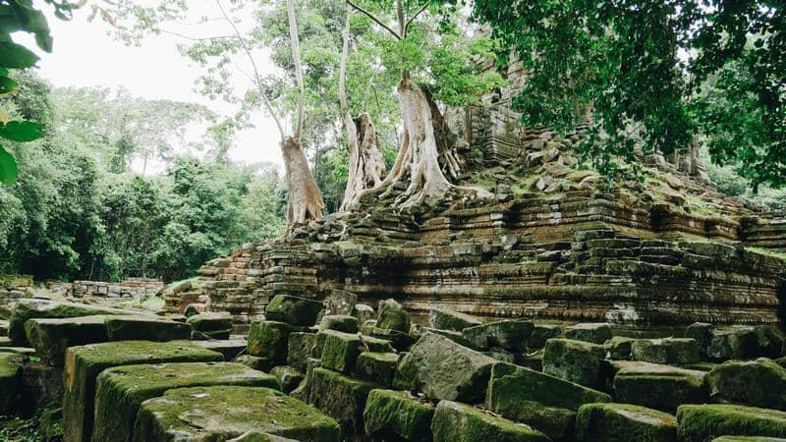
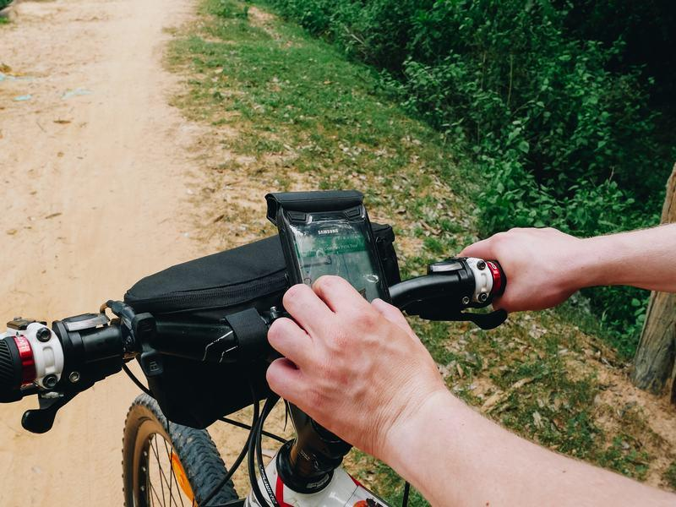

Easia Travel Head Office

Siem Reap BranchCharming City, No. R32 – R34, Road Rolouse, Trorpeangses Village, Sangkat Koukchork, Siem Reap Province – CambodiaTel: (855-63) 76 14 58Fax: (855-63) 76 14 58

