MYANMAR – Inle Lake – Hike to Inle Boutique House 2D1N
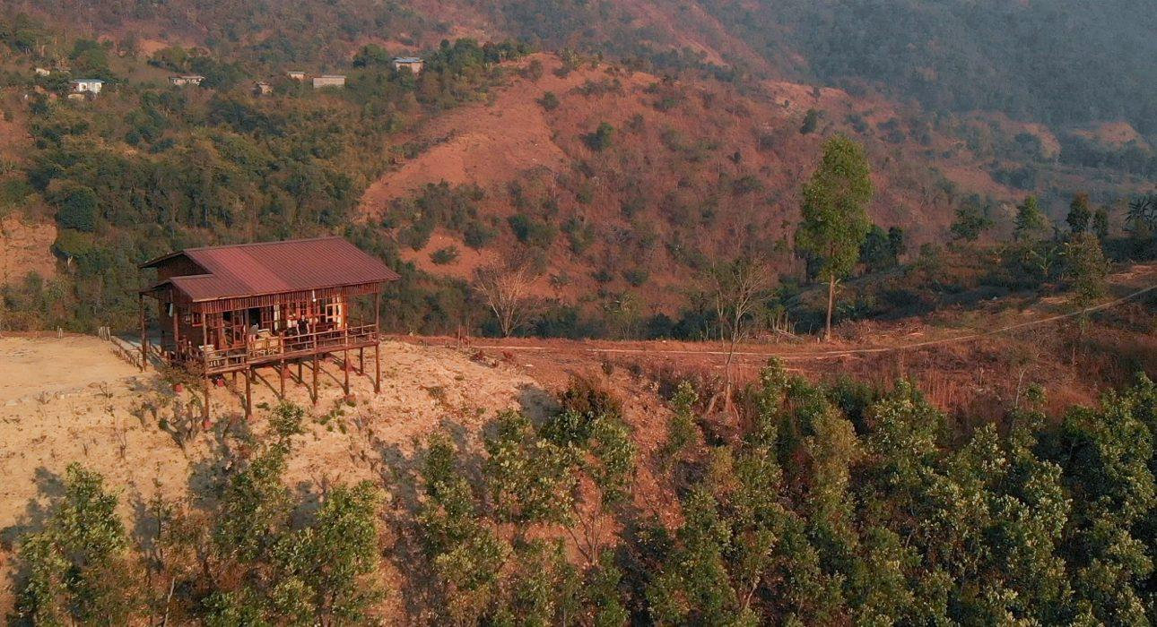

Over View

Theme
Classic, Honeymoon, Wellness

Country - City
Myanmar - Inle Lake

Level of difficulties
LEVEL 3

Price level
$$

Seasonality
All year round - the best season is from September to February

Max Pax
4

Market segment
Thematic Leisure

Arrival City
Inle Lake

Departure city
Inle Lake

Itinerary

Number of days and nights
2 days - 1 night

Day by day description
The journey will start on the lakeside of Inle, in the village of Main Thauk. A first day of trekking crosses bamboo forests, tea plantations and Pa-Oh villages to a private boutique house. The night will be spent in a charming wooden house on stilts overlooking the lake and the surrounding mountains. A pre-prepared picnic lunch will be had at a villager’s house on the way and dinner will be cooked at the private house under the stars. A peaceful night in a secluded and intimate location, on top of the mountain. After waking up with the sun and preparing breakfast, the next morning can begin by sipping on a hot cup of tea or coffee while gazing at the peaceful landscape. The guide will lead the way from the house back down to Nyaung Shwe where the journey ends.

Selling points

- Overnight in a private boutique house on top of the mountain
- A private location with all the amenities and services provided: wine, private dinner, tea, coffee, etc.
- A balance between a day of trekking across the local villages and the comfort of a private house for the night
- A sunrise and sunset overlooking the Shan mountain range, the city of Nyaung Shwe and Inle Lake from a height of 1,727 meters
- Suitable for active travelers who really want to go to less touristic and lesser visited parts of the countryside as well as less sportive guests who are looking for unique location to spend the night – the trekking distance can be shortened or direct transfer to the house can be organized

Options

Activities
- MYANMAR – Inle Lake – Balloon flight over Inle
- MYANMAR – Inle Lake – Surprise Cocktail on the Lake
- MYANMAR – Inle Lake – Float Across the gardens
- MYANMAR – Inle Lake – Cooking Experience on the lake

Photos

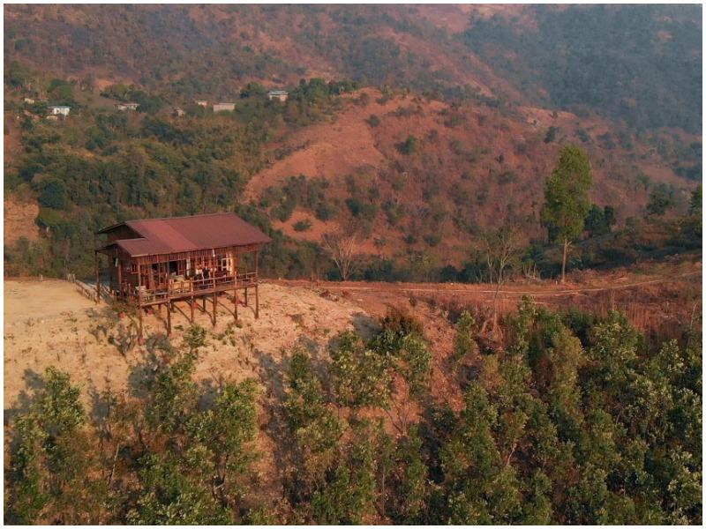
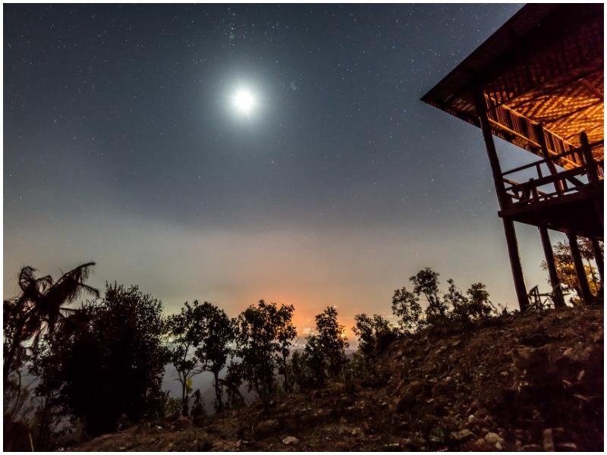
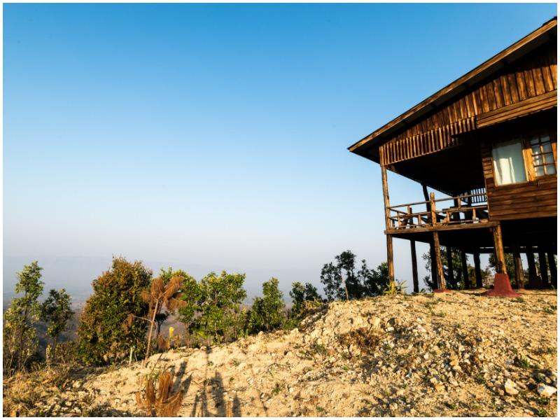
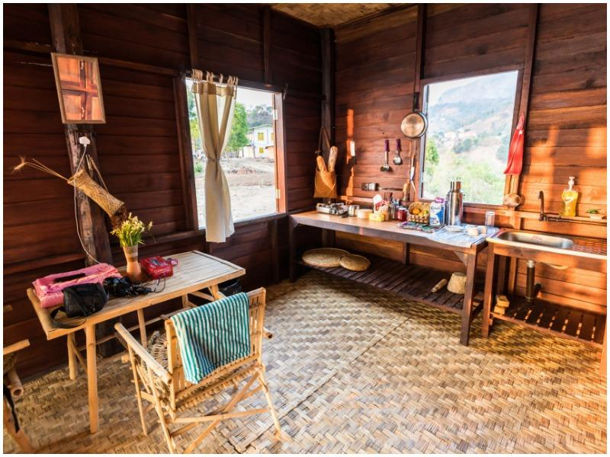
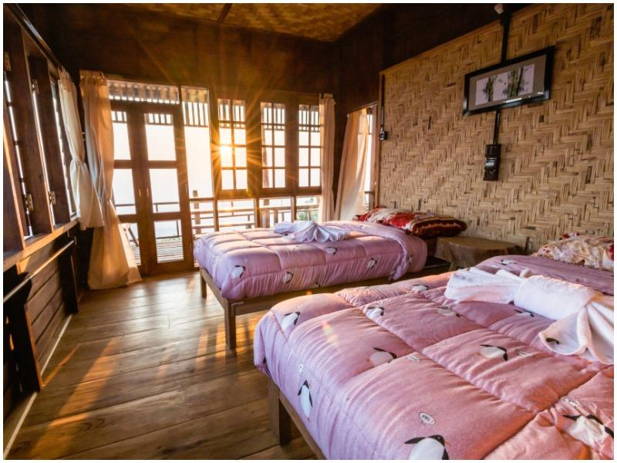
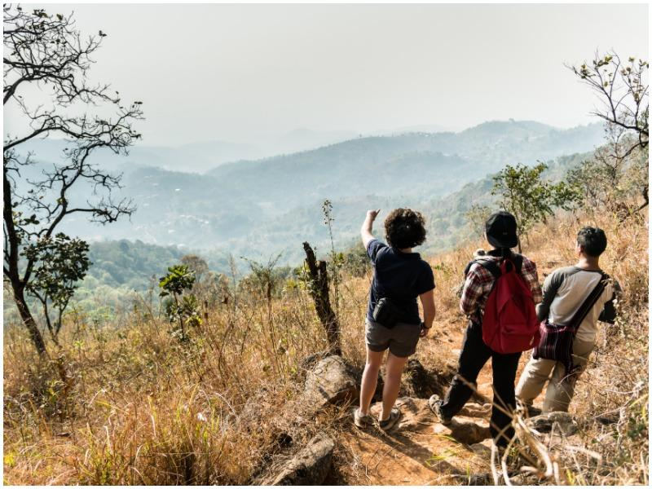
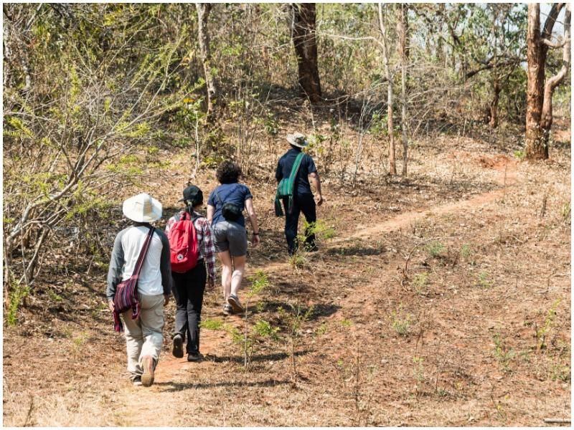
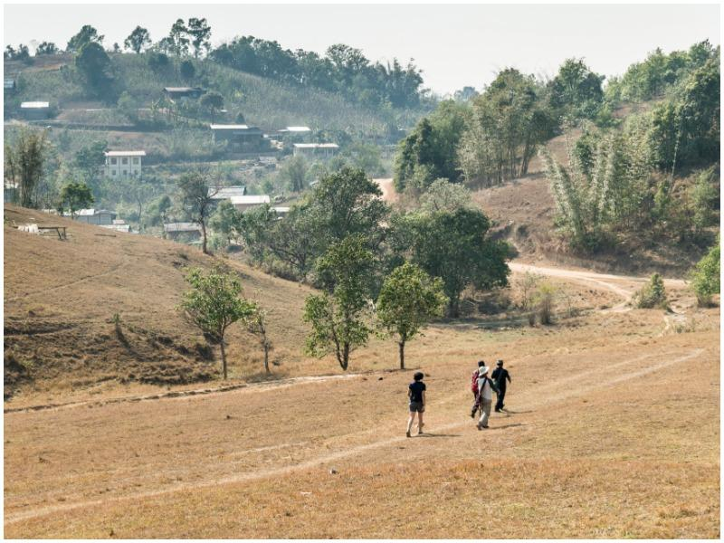
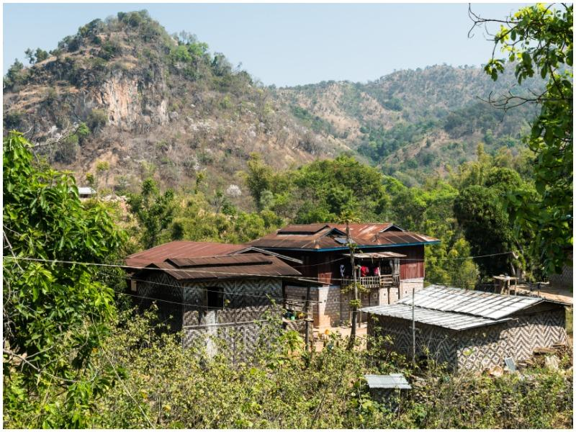
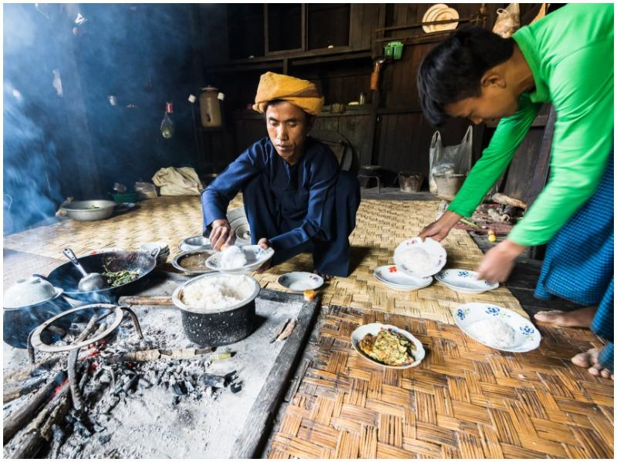
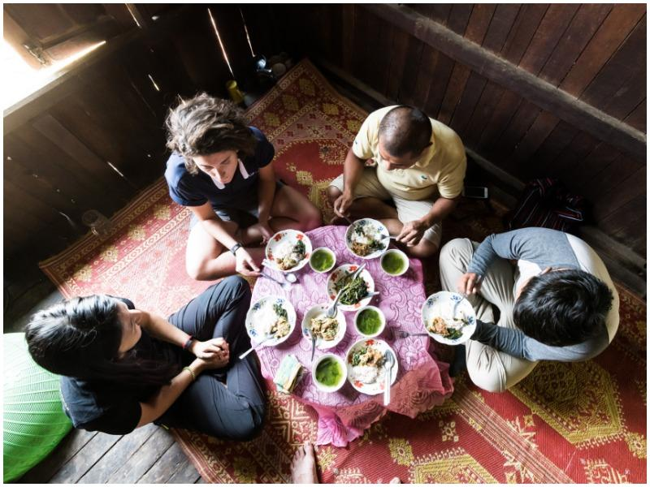
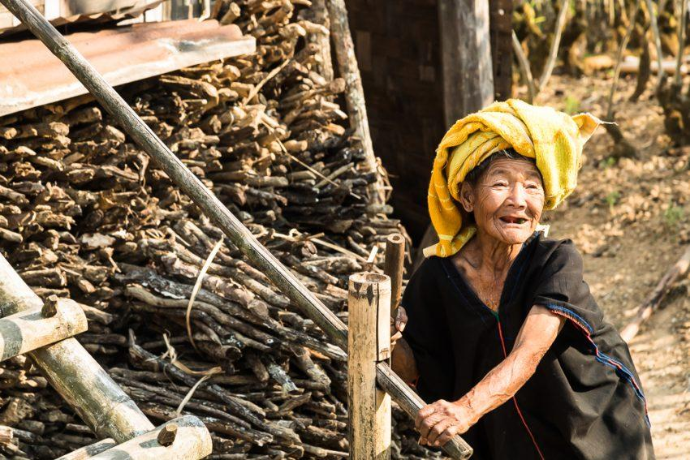
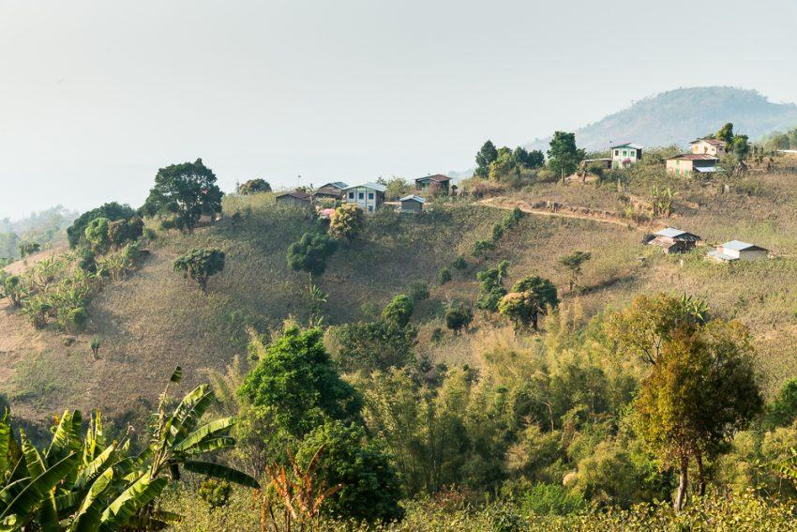
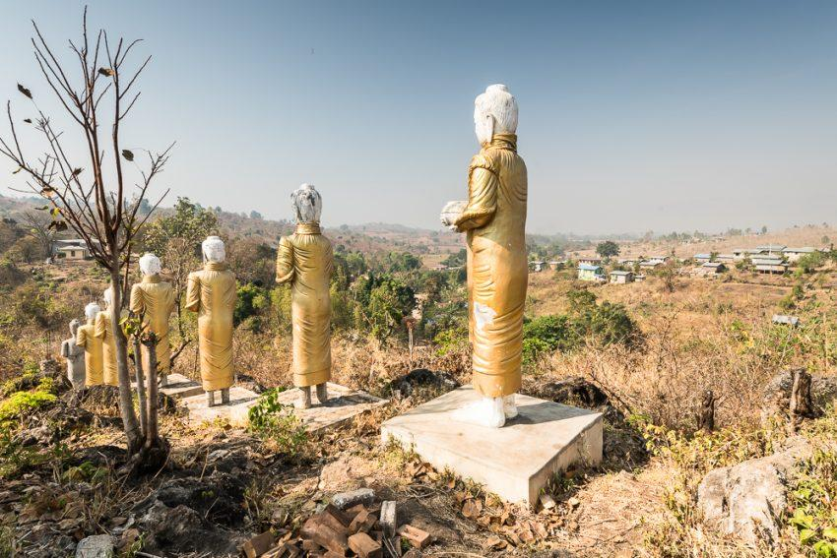

Easia Travel Head Office

Vietnam Head OfficeC/o: ATS Hotel, Suite 326 &327, 33B Pham Ngu Lao Street, Hanoi, VietnamTel: +84 24-39 33 13 62www.easia-travel.com

