MYANMAR – Kalaw – Trek from Kalaw to Khaung Daing 2D1N
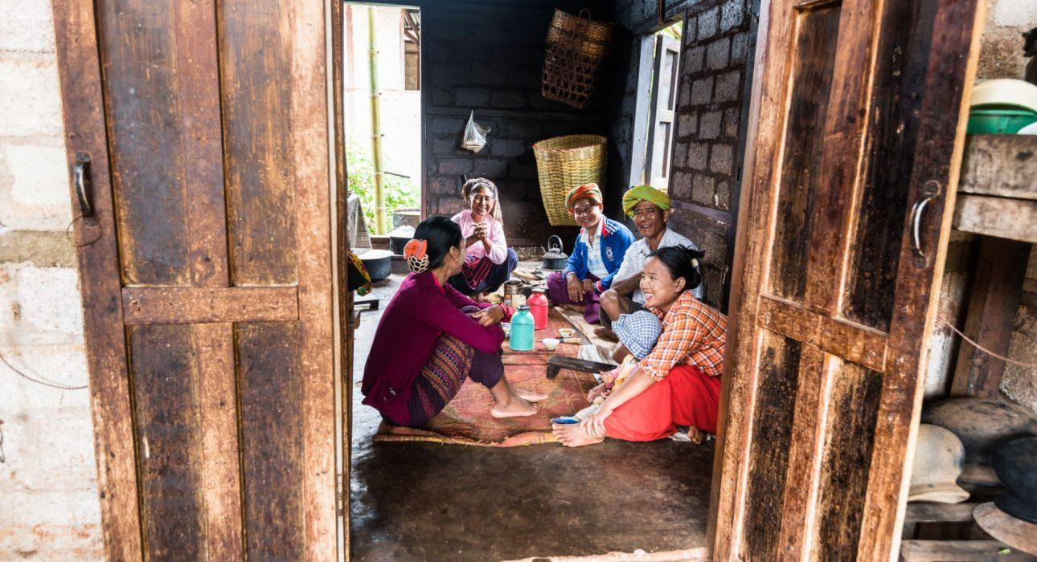

Over View

Theme
Classic, Sustainable

Country - City
Myanmar - Kalaw

Level of difficulties
LEVEL 2

Price level
$

Seasonality
Best period from October to March. Avoid May, August and September

Max Pax
20

Market segment
Groups, Thematic Leisure

Arrival City
Kalaw

Departure city
Inle Lake

Itinerary

Number of days and nights
2 days - 1 night

Day by day description
This overnight trekking connects Kalaw to Khaung Daing, a village nested on the shores of Inle Lake. A leisure trek with a challenging ascent which will finish off the first day. This itinerary is characterised by a long enjoyable stretch on the first day, crossing a thick bamboo forest in the countryside around Kalaw. The backdrop for two days will be the colourful patchwork of seasonal crops and orange soil, many fields as far as the eye can see. The added touch of a trekking in Myanmar is of course the accommodation, in a monastery. If monasteries have Spartan comfort, the experience is worth it!

Selling points

- Intermediate level trek suitable for most level of fitness – one of our best seller
- A unique opportunity to spend the night in monasteries
- A trek across many villages which gives the chance to travellers to really come closer to the population
- Beautiful landscapes with colourful patchwork formed by the seasonal crops: discover or rediscover local products such as ginger and peanuts plantations
- Slow travel – take the time to experience Myanmar’s countryside at a slower pace
- A direct arrival on the lake shores with minimum car transportation during the trek

Options

Extensions
Inle Lake – One Day Walk Around NampanInle Lake – Hike to Inle Boutique House 2D1NInle Lake – Adventure on the lake

Photos

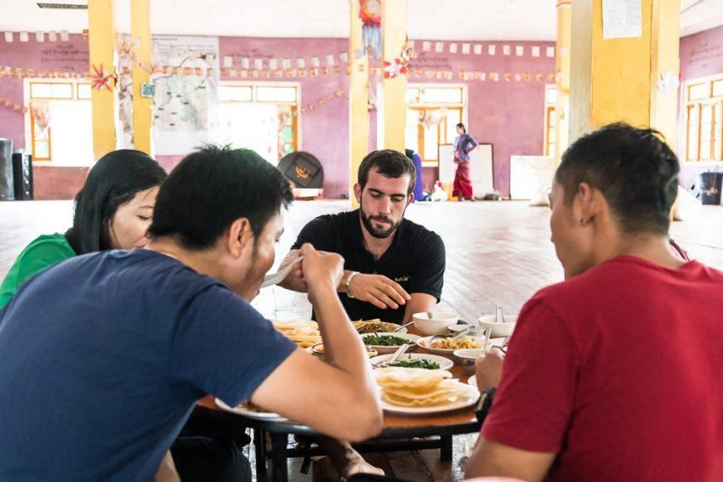
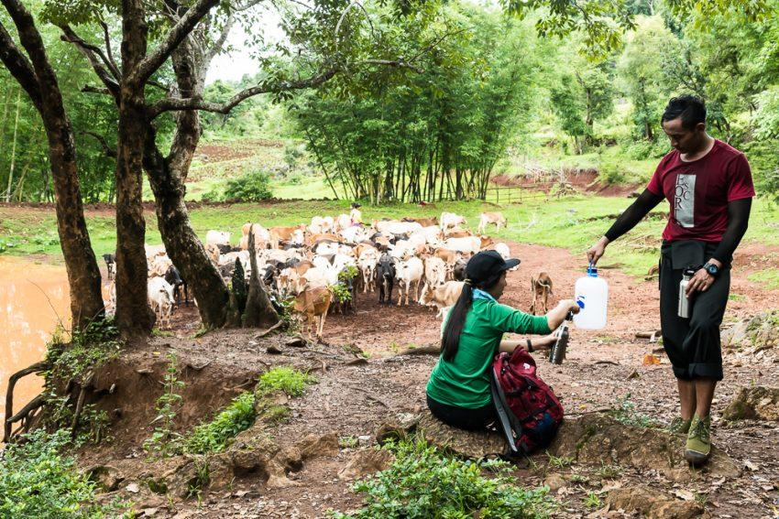
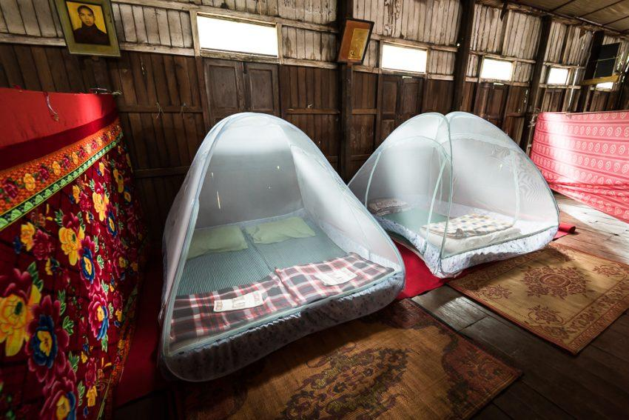
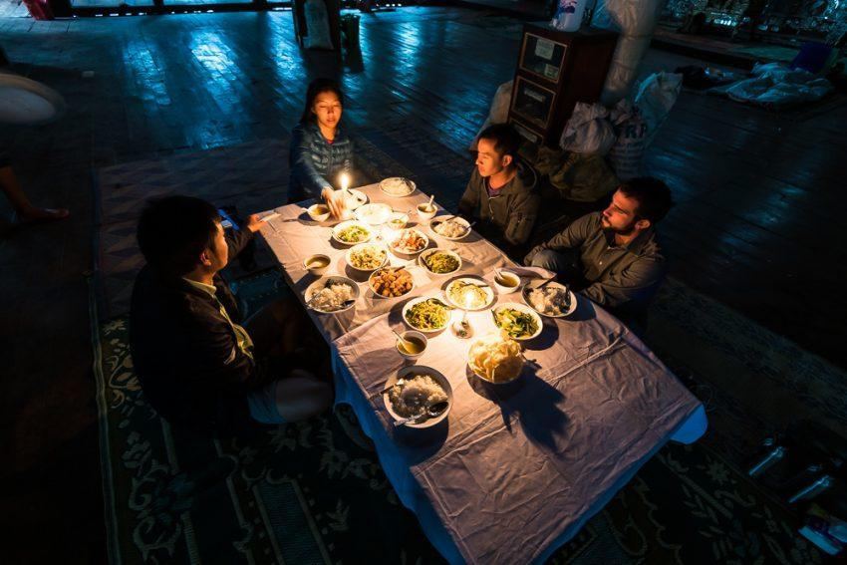
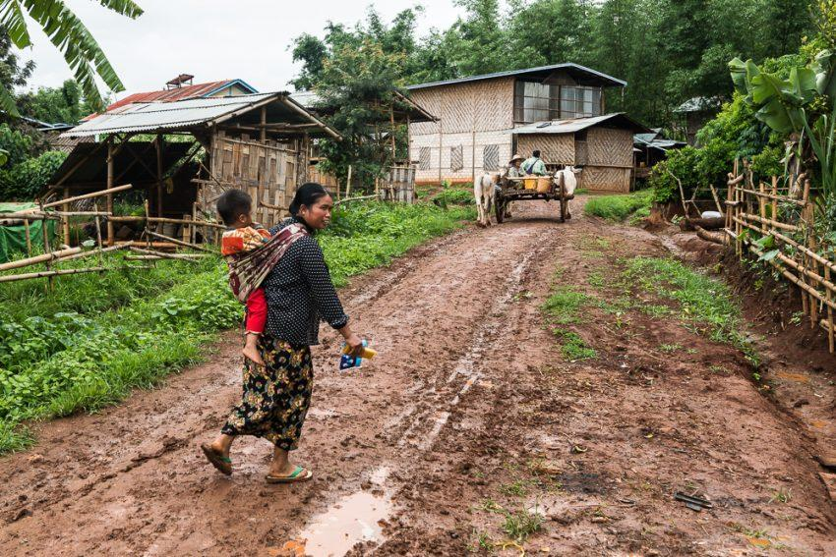
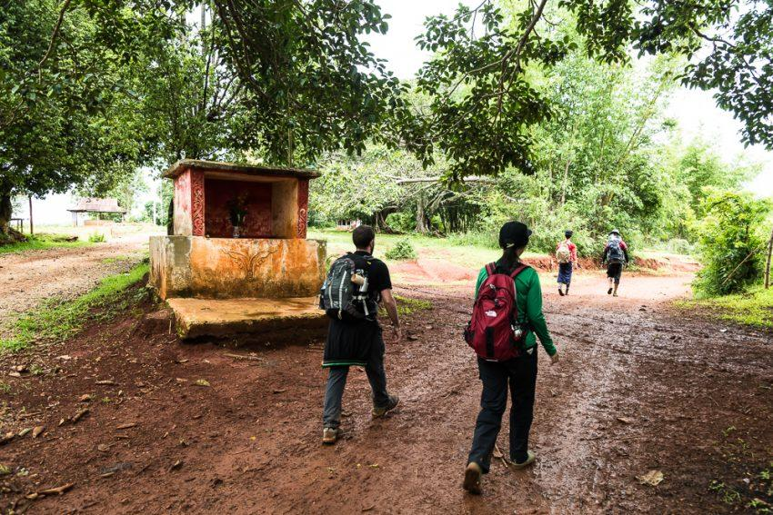
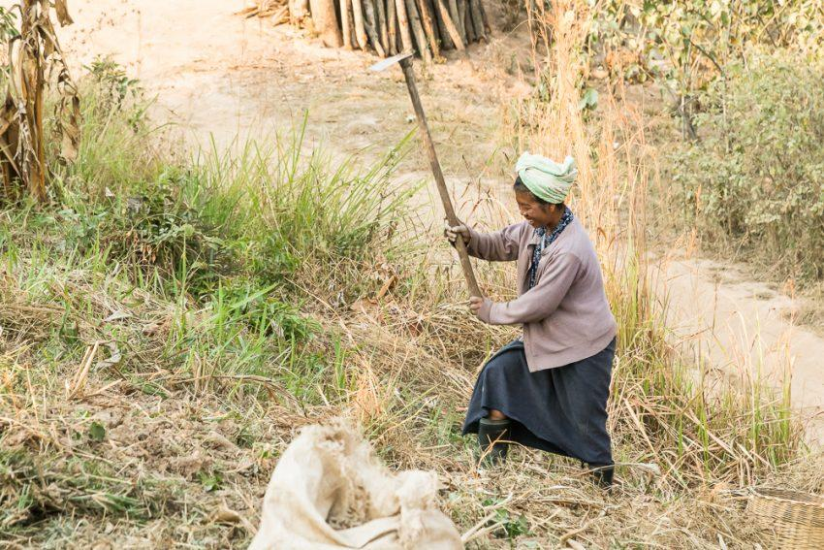
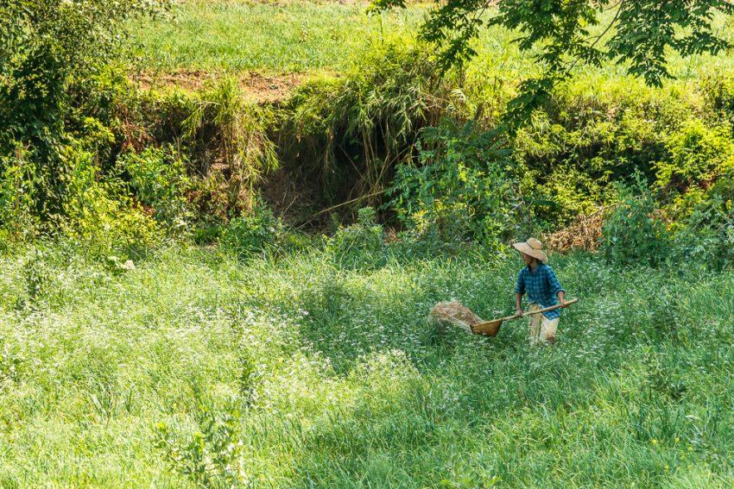
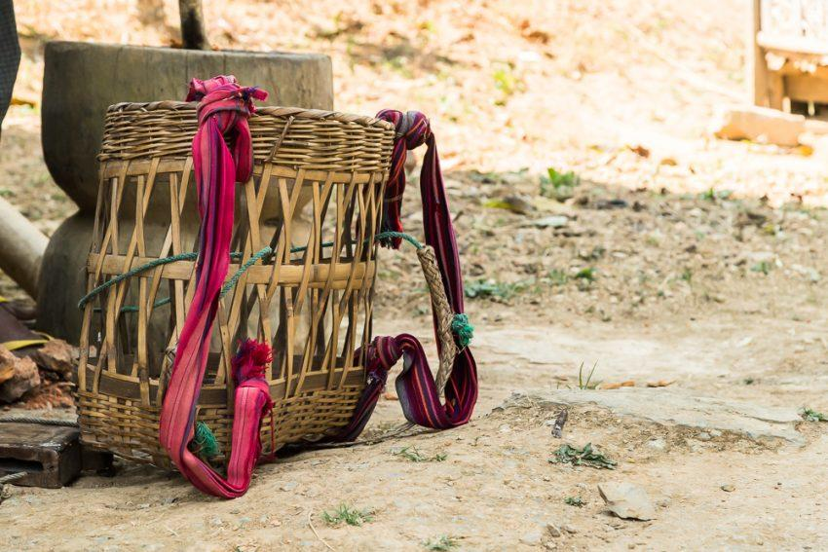
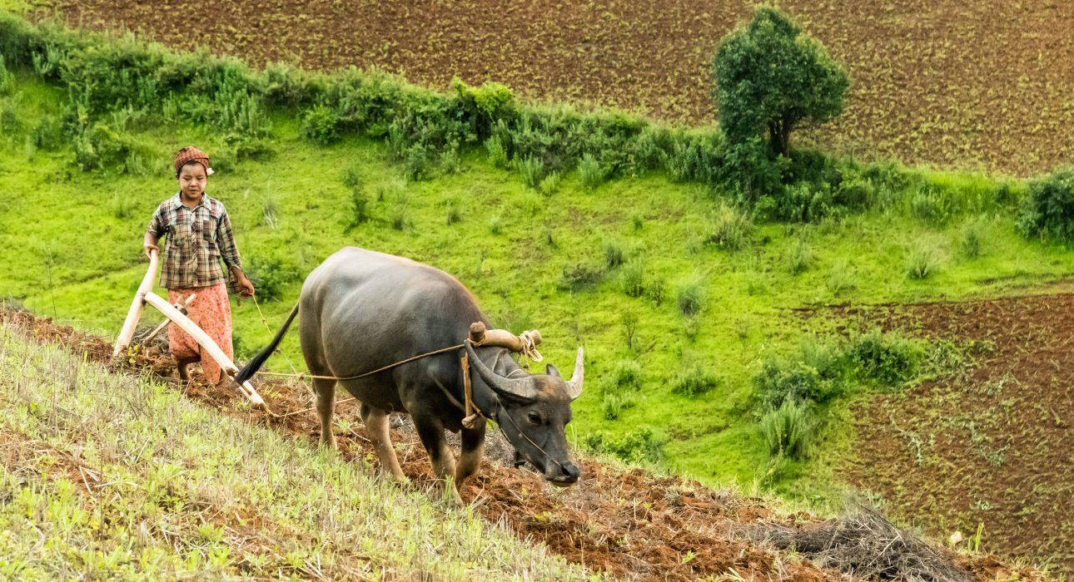

Easia Travel Head Office

Vietnam Head OfficeC/o: ATS Hotel, Suite 326 &327, 33B Pham Ngu Lao Street, Hanoi, VietnamTel: +84 24-39 33 13 62www.easia-travel.com

