MYANMAR – Pindaya – Trek from Pindaya to Inle Lake 4D3N
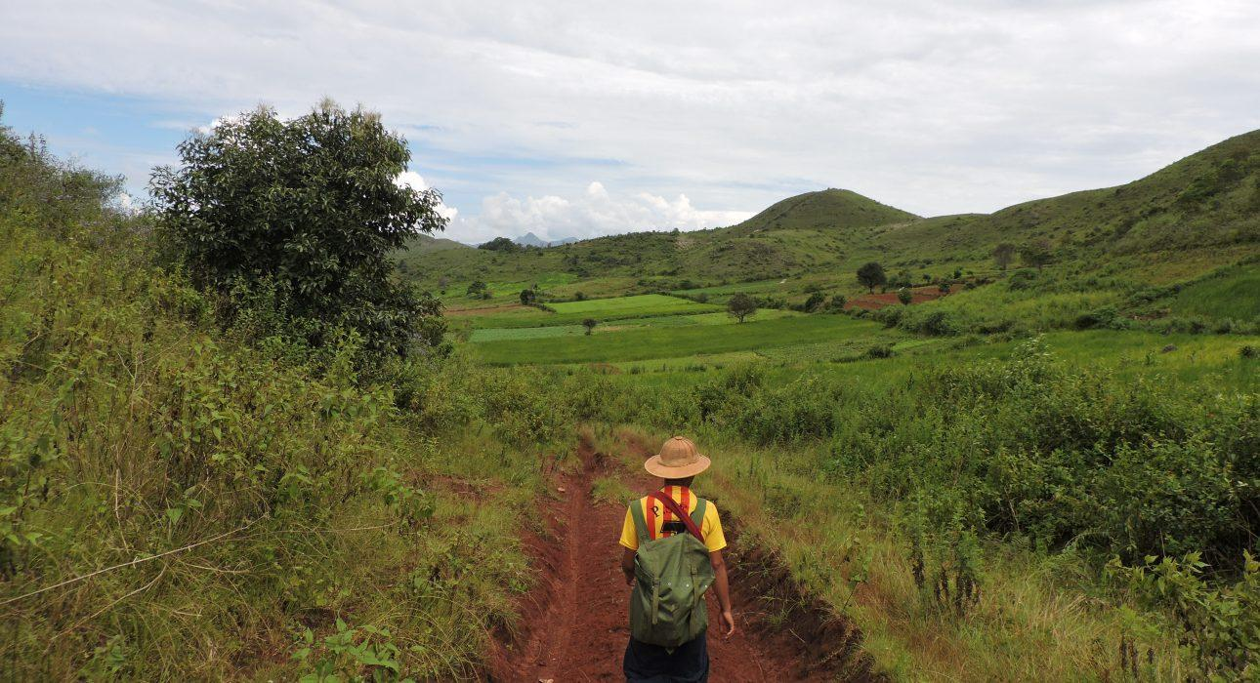

Over View

Theme
Classic, Sustainable

Country - City
Myanmar - Pindaya

Level of difficulties
LEVEL 3

Price level
$$

Seasonality
Best period from October to March - not advised from April to August

Max Pax
15

Market segment
Groups, Thematic Leisure

Arrival City
Pindaya

Departure city
Nyaung Shwe

Itinerary

Number of days and nights
4 days - 3 nights

Day by day description
This itinerary will lead across villages, tea plantation, seasonal and local crops. With a good balance of easy paths and more challenging portions, this trekking will please the most active travellers looking for a nature getaway while connecting with local population. The added touch of a trekking in Myanmar is of course the accommodation. Spending the night in monasteries, sleeping in praying halls and using the same shower system (bucket shower!) is a unique experience. If monastery have Spartan comfort, the experience is worth it! The trekking will lead to the top of the hills surrounding Inle Lake from where, after enjoying bird’s-eye view on the placid lake, the path leads down the lake with panoramic views all the way down.

Selling points

- A trek with steep sections for active travellers looking for a challenge and a longer nature break
- The unique opportunity to spend the night in monasteries
- A trek across many villages which gives the chance to travellers to really come closer to the population
- Beautiful landscapes with colourful patchwork formed by the seasonal crops: discover or rediscover local products such as ginger and peanuts plantations
- Slow travel – take the time to experience Myanmar’s countryside at a slower pace

Options

Photos

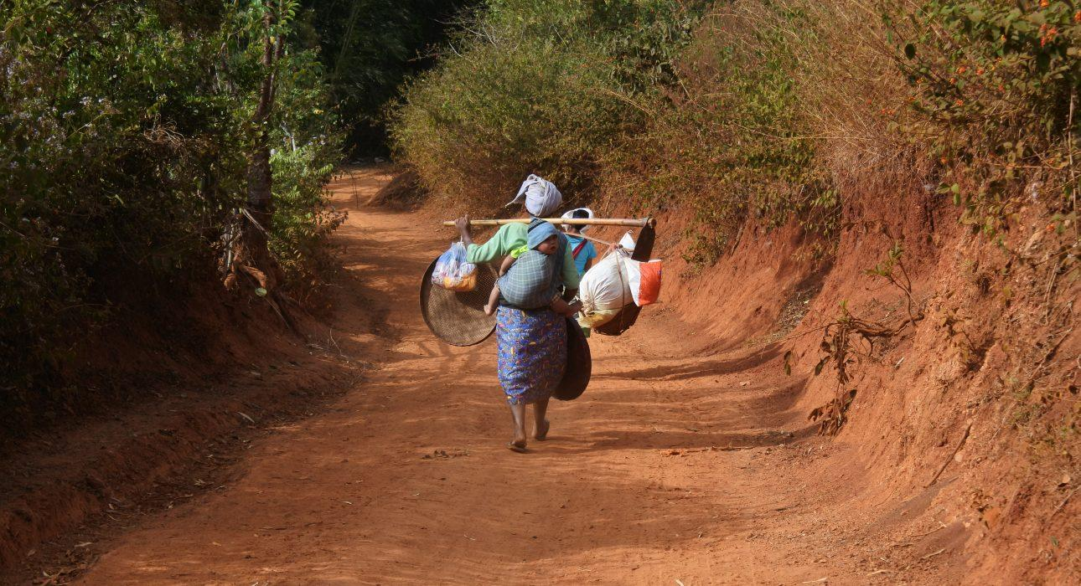
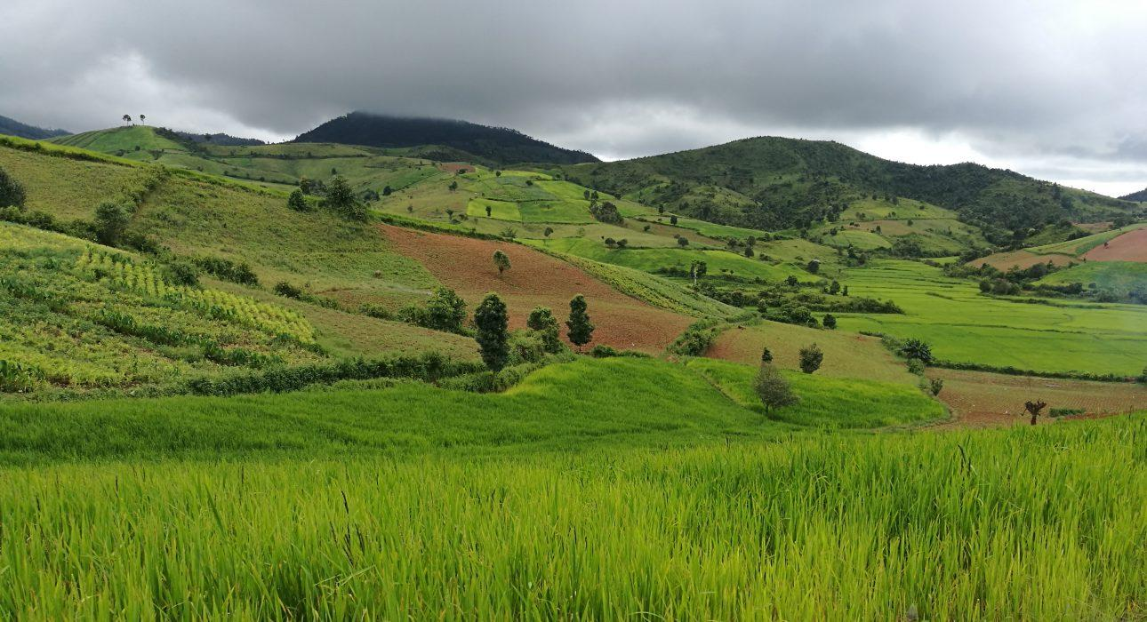
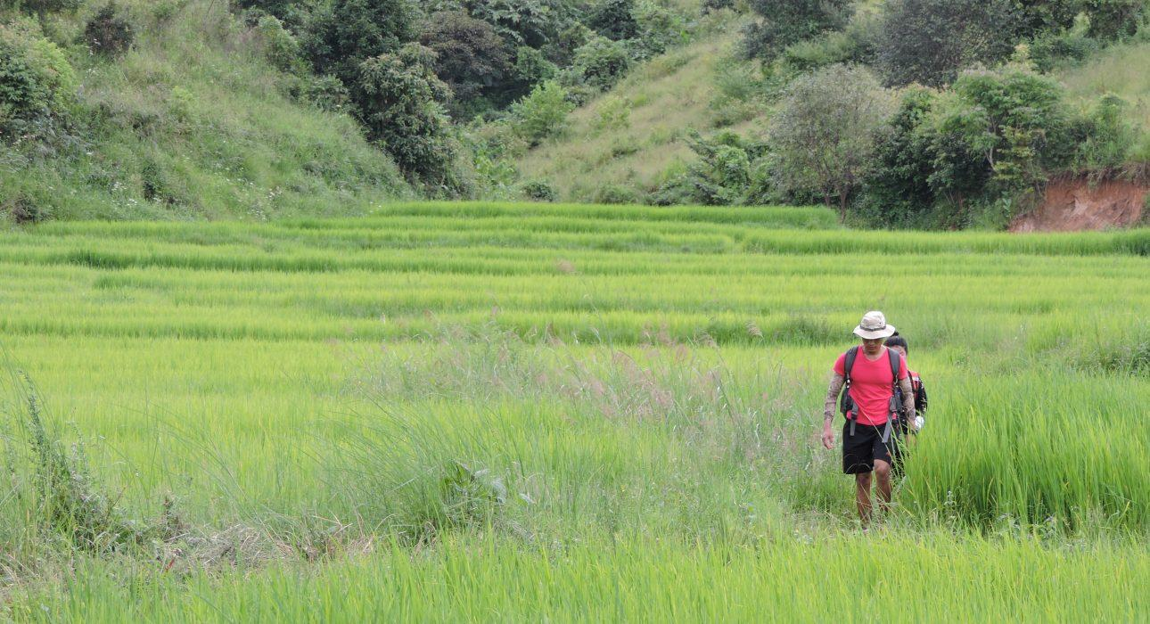
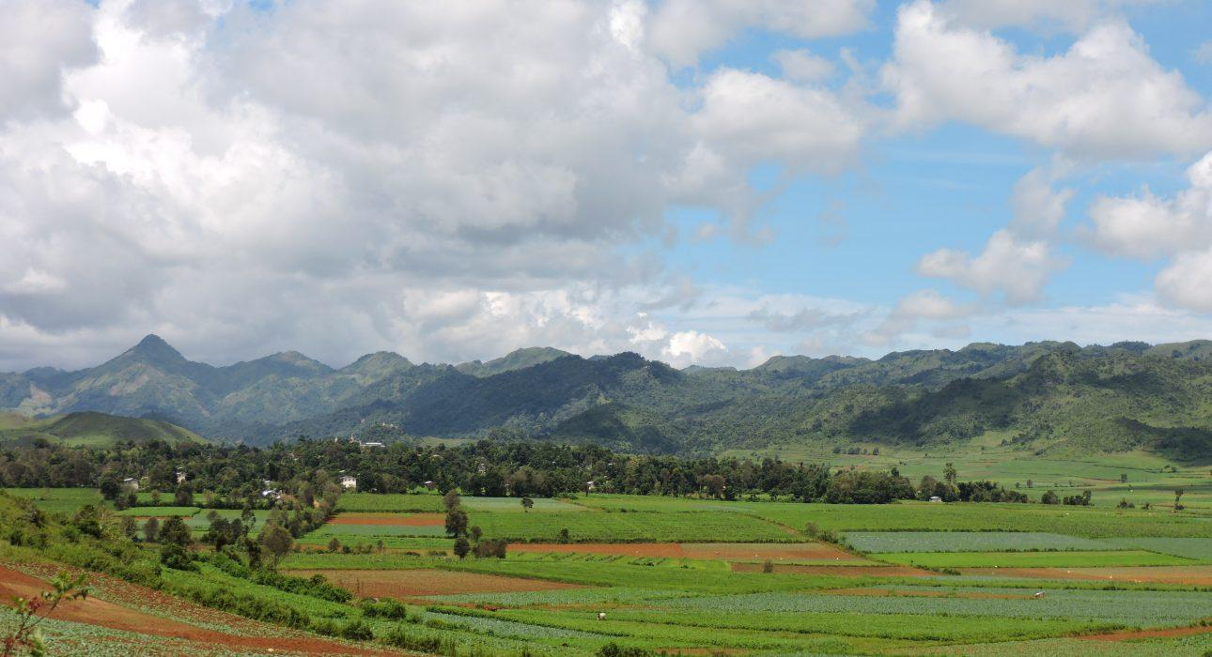
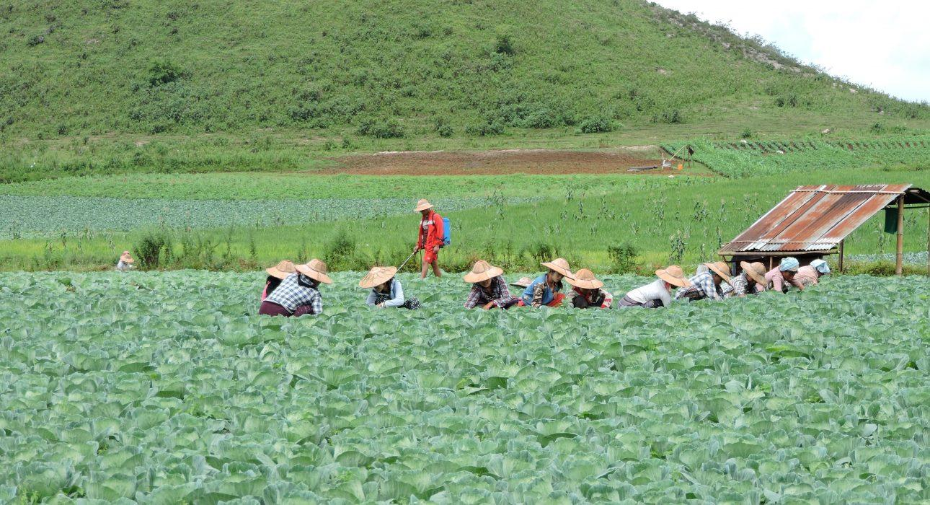
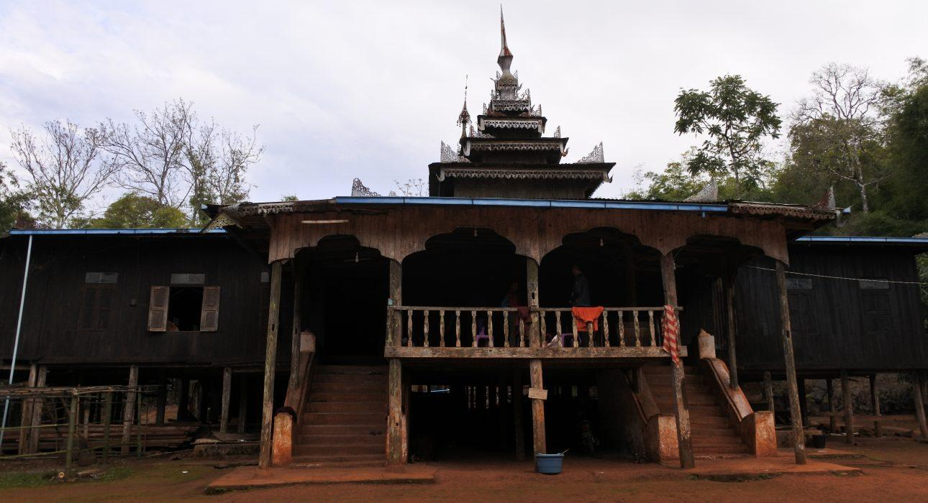
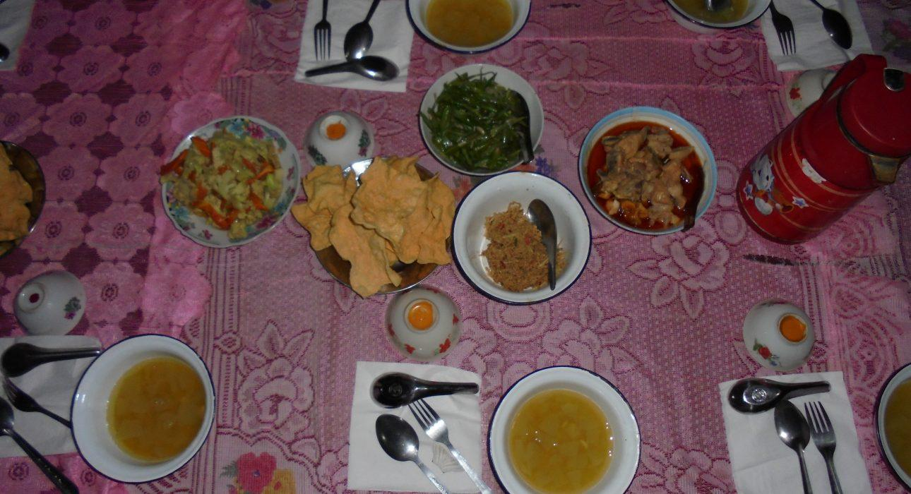
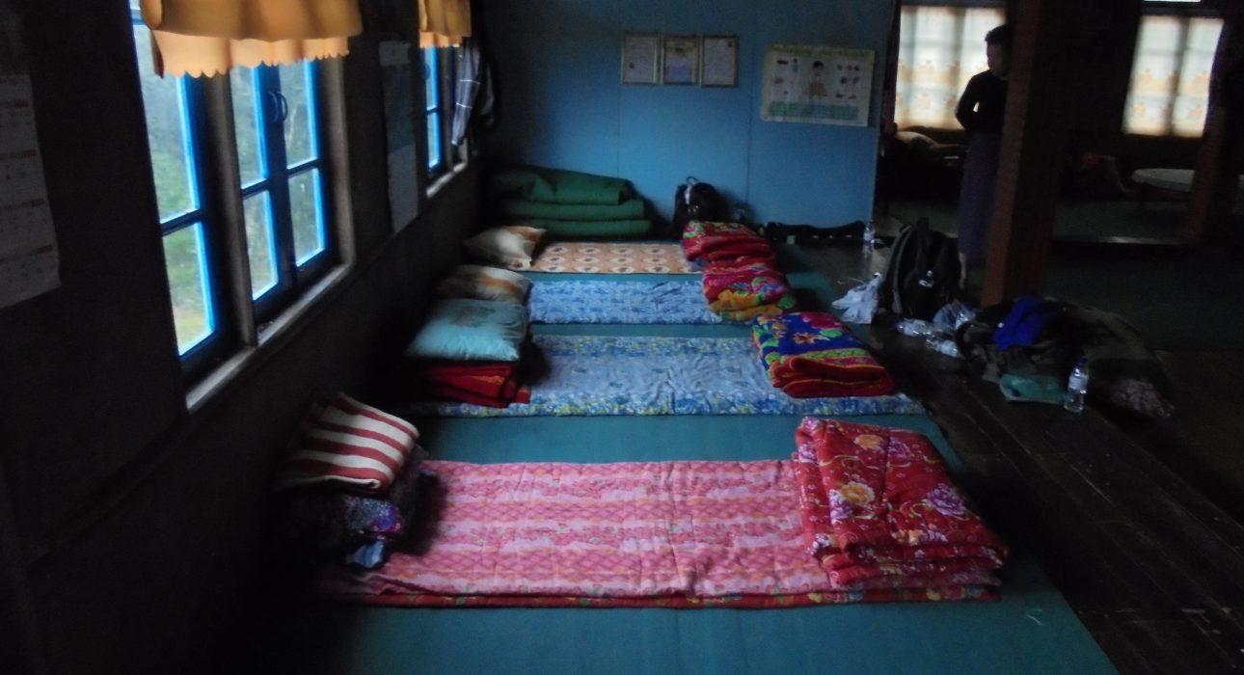

Easia Travel Head Office

Vietnam Head OfficeC/o: ATS Hotel, Suite 326 &327, 33B Pham Ngu Lao Street, Hanoi, VietnamTel: +84 24-39 33 13 62www.easia-travel.com

