MYANMAR – Kalaw – Hike from Kalaw to Khaung Daing 3D2N
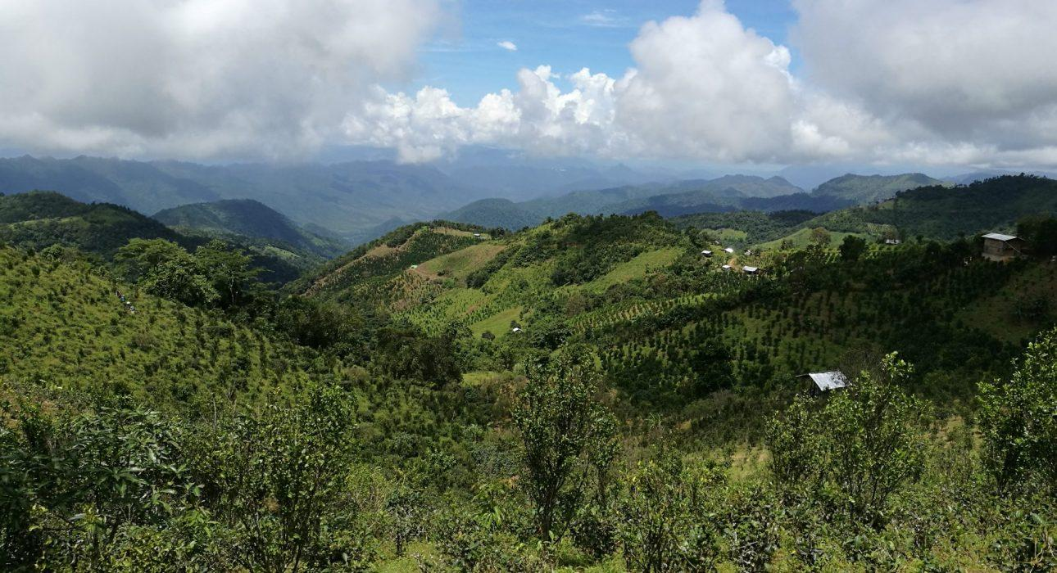

Over View

Theme
Classic

Country - City
Myanmar - Kalaw

Level of difficulties
LEVEL 3

Price level
$$

Seasonality
Best period is from October to March. Avoid May, August and September.

Max Pax
20

Market segment
Groups, Thematic Leisure

Arrival City
Kalaw

Departure city
Inle Lake

Itinerary

Number of days and nights
3 days - 2 nights

Day by day description
A 3-day trekking, from Pindaya to Khaung Daing, a small village on the shores of Inle Lake. This itinerary meanders around villages, tea plantation, seasonal and local crops. On the way, the hike will be punctuated by encounters with many villagers, either busy in the fields or going about their daily life in their home. The first two days cover long distances with rolling hills until a last steep ascent to reach the top of the hill where the village of War Gyi Myaung is nestled. The last day is a descent to the shores of Inle Lake which will mark the end of almost three days of trekking in the colourful countryside of Southern Shan State. The added touch of a trekking in Myanmar is of course the accommodation. Spending the night in monasteries, sleeping in praying halls and using the same shower system (bucket shower!) is a unique experience. If monastery have Spartan comfort, the experience is worth it!

Selling points

- To enjoy beautiful scenery and panoramic views of the Shan Plateau by crossing different plantations: ginger, tea, oranges, etc.
- To learn about ethnic minority tribes and their culture
- To immerse in nature, disconnected from the bustling cities by taking travelers deep into Myanmar’s countryside
- Can be easily combined with classic program in Myanmar

Options

Photos

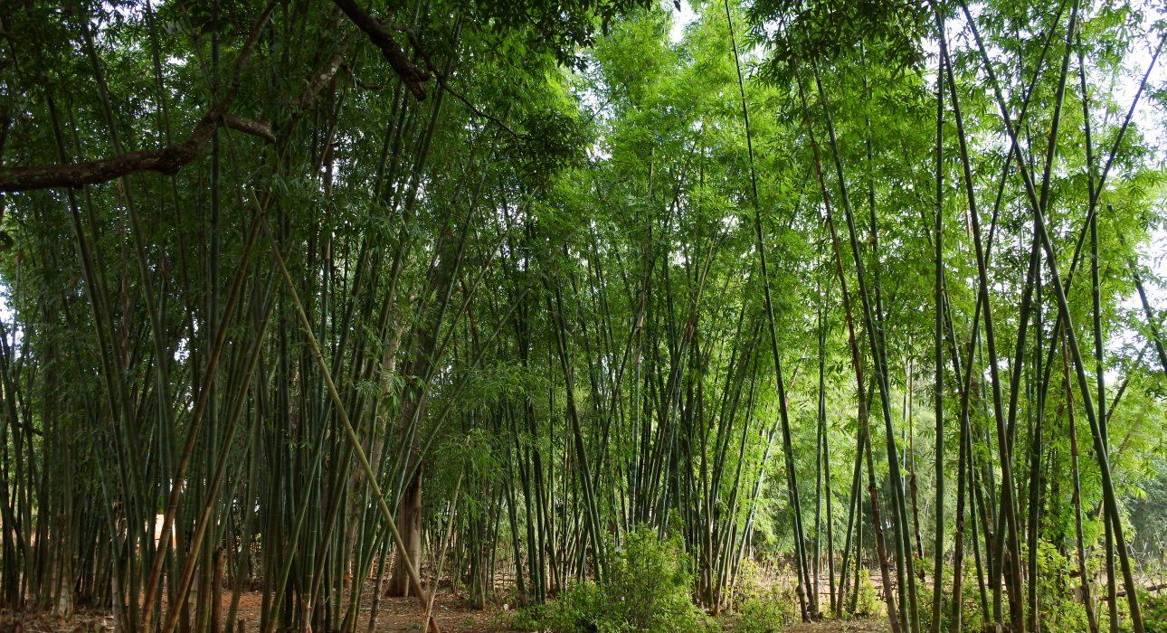
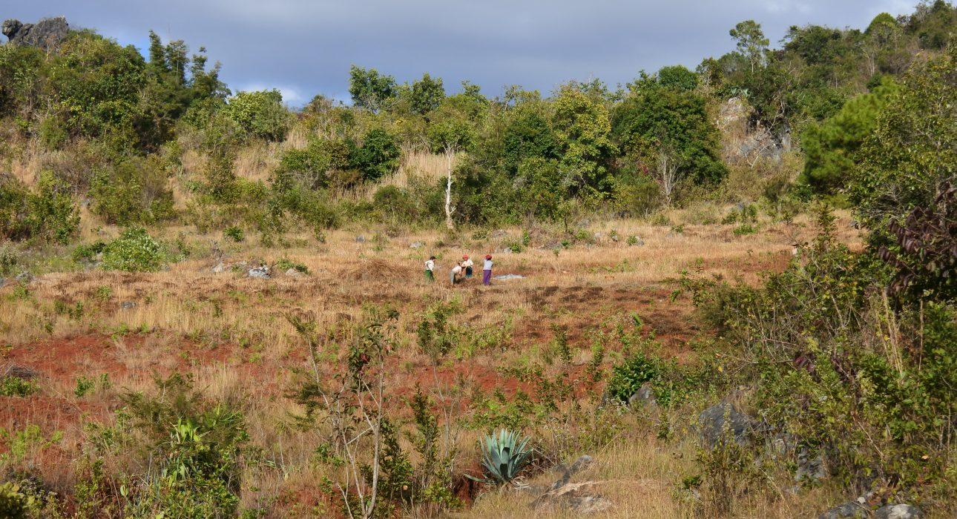
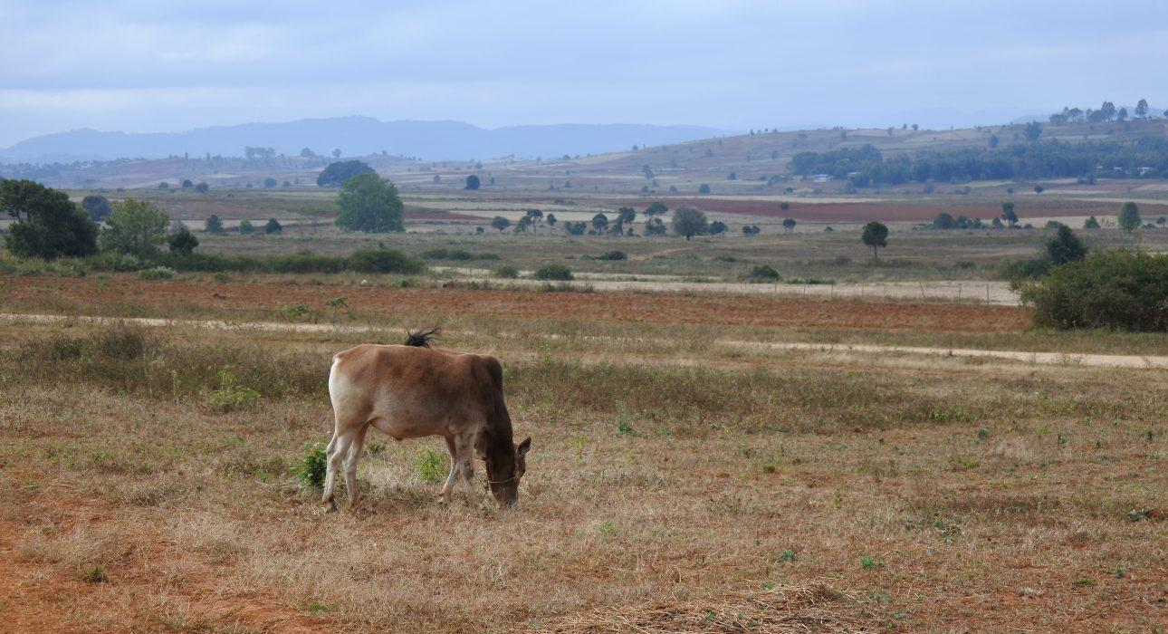
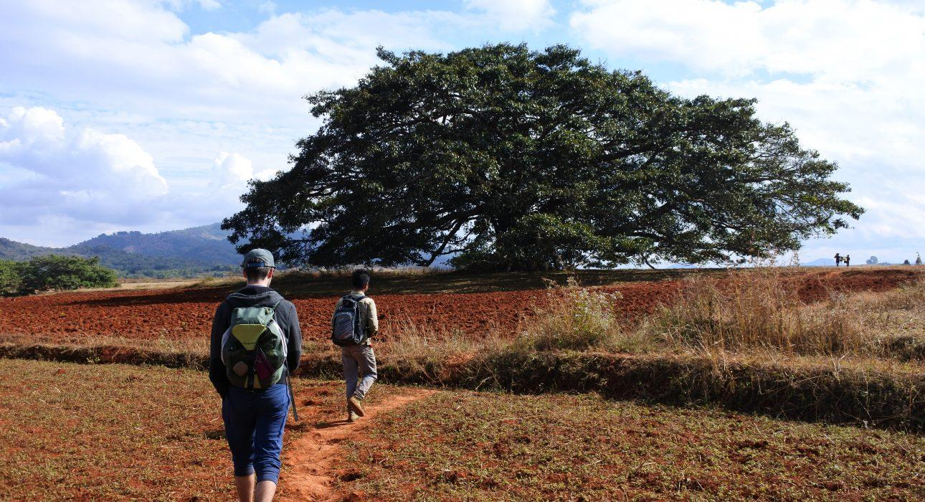
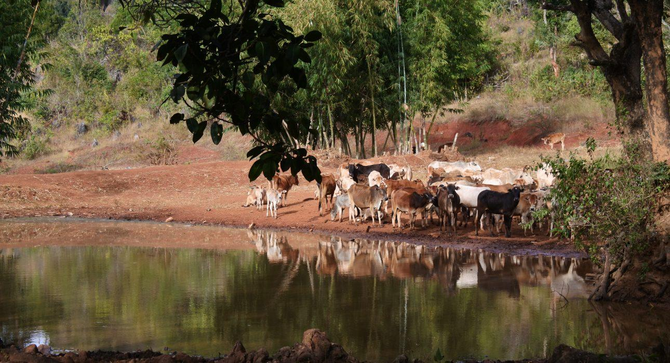
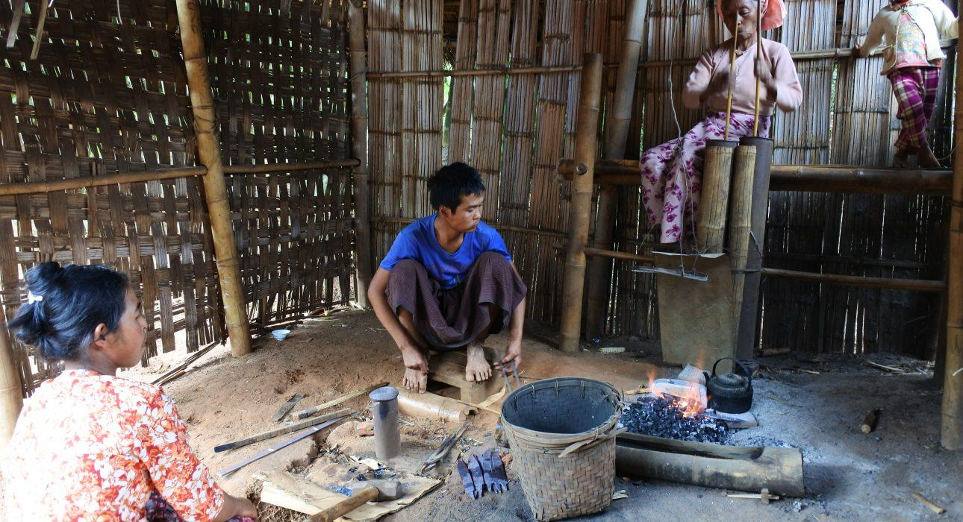
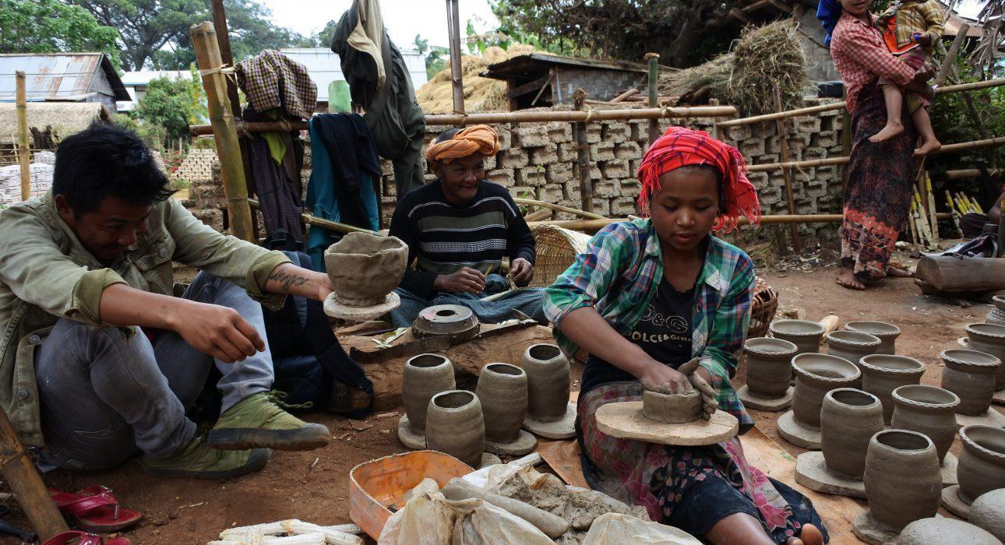
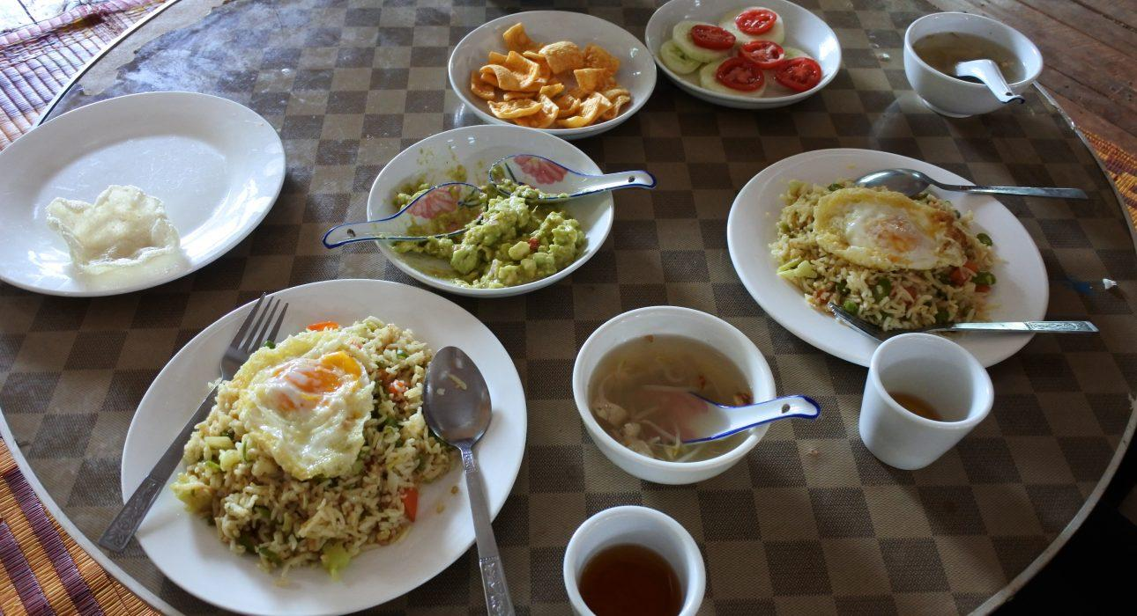

Easia Travel Head Office

Vietnam Head OfficeC/o: ATS Hotel, Suite 326 &327, 33B Pham Ngu Lao Street, Hanoi, VietnamTel: +84 24-39 33 13 62www.easia-travel.com

