Cambodia – Koh Kong – Cardamom Mountains Jungle Trek With Hammock Camping Experience 4d3n
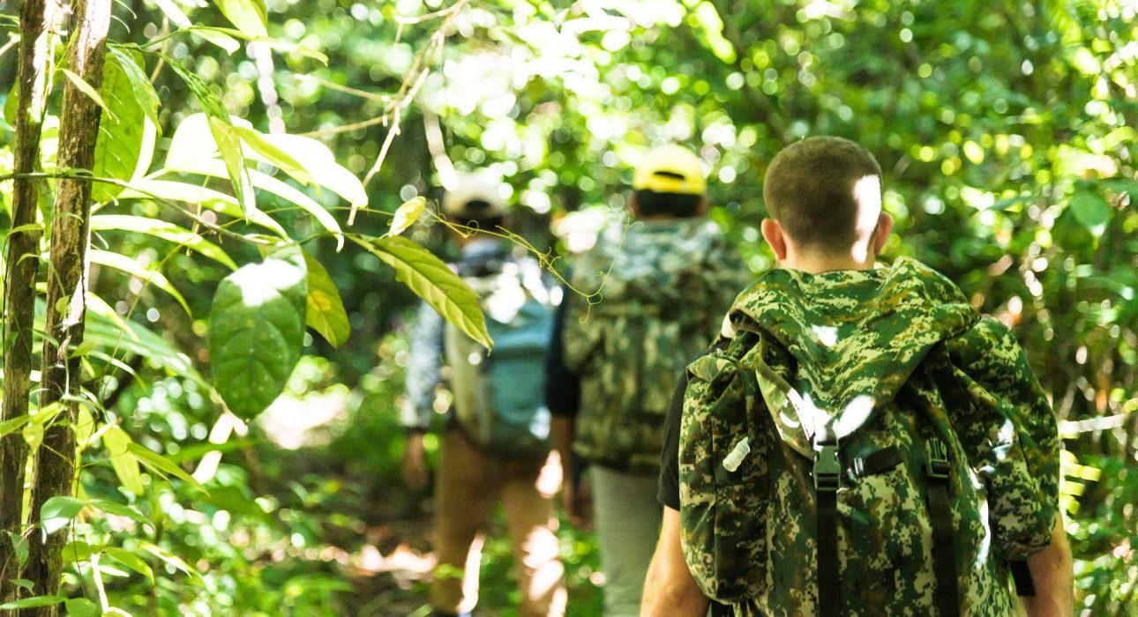

Over View

Theme
Sustainable

Country - City
Cambodia - Koh Kong

Level of difficulties
LEVEL 3

Price level
$$$

Seasonality
Best period from November till end of May

Max Pax
20

Arrival City
Koh Kong

Departure city
Koh Kong

Itinerary

Number of days and nights
4 days - 3 nights

Day by day description
This ‘4 days and three nights’ module allows travelers to experience a two-day jungle trek, camping, and sleeping in hammocks in the wild Cardamom rain forest.This product is a collaboration between Easia Active and Chi Phat community-based Ecotourism to support the community by providing additional income to the villagers to stop the poaching and deforestation in the area. The Chi Phat CBET project started in 2007. It was supported by the Wildlife Alliance, which helped and educated the community and villagers to make a living from tourism instead of poaching, cutting down, and selling trees. This project has helped incredibly to conserve part of the Cardamom rainforest.The main highlight of the module is the scenic sunrise boat journey along the river to reach the beginning of the trail. Along the way, travelers can try to spot some incredible birds that live here and spend two days trekking in the jungle with our expert Easia Active guide and knowledgeable local guides. They will explore the area and learn about the jungle habitat and wildlife, camp in the forest with hammocks, and enjoy the staple food cooked by local villagers.It is a perfect experience for intermediate hikers. They can walk deep into the jungle on trails surrounded by wild nature in a fascinating environment.Easia Level: 3 Distance & duration of hiking: Day 1: 13 kilometers – 3 hours Day 2: 17 kilometers – 5 hours Difference in elevation: Less than 300 meters Terrain: Mainly jungle trail with some open forest paths and village trails Transportation: Van, long-tail boat, motorbike taxi back-up – possible to access in most of the areas

Selling points

- Experience jungle trekking in the Cardamom mountains, one of the most extensive rain forests in Southeast Asia, an exceptional immersion into nature
- Discover and learn more about the rainforest’s flora and fauna and the importance of Chi Phat Ecotourism, a nature conservation project.
- Get the chance to spot rare and endangered birds
- Experience overnight camping in hammocks, surrounded by incredible nature
- Support the local community and the Chi Phat community-based ecotourism project

Options

Photos

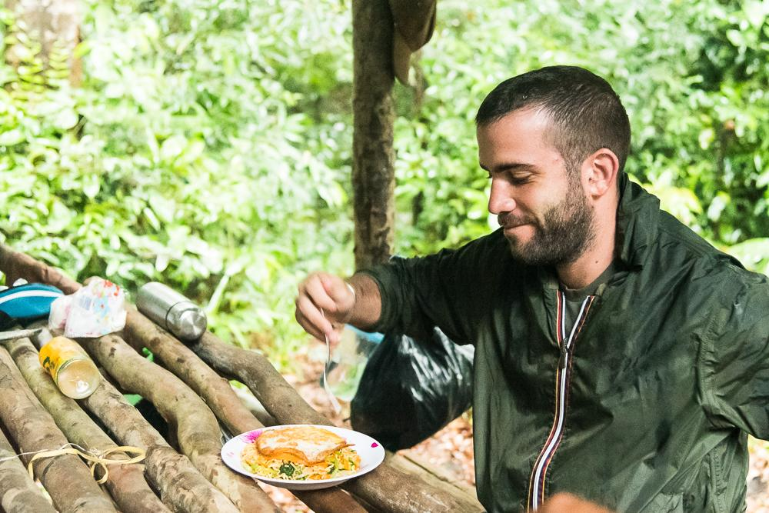
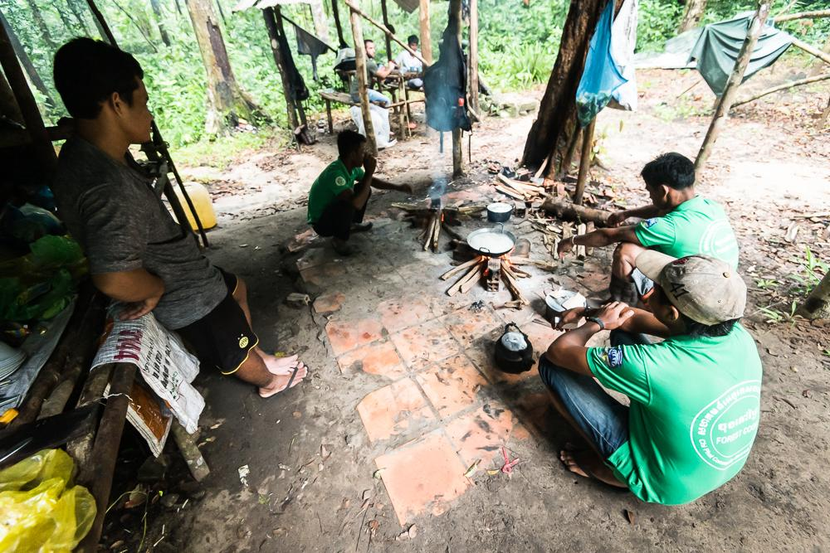
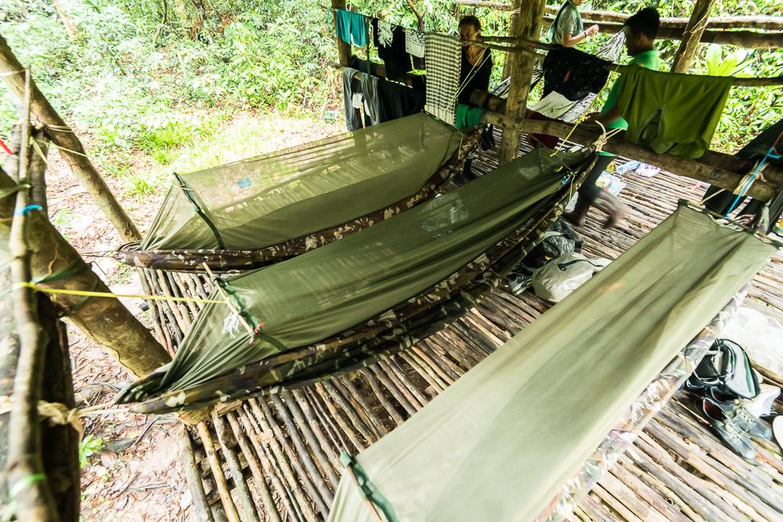
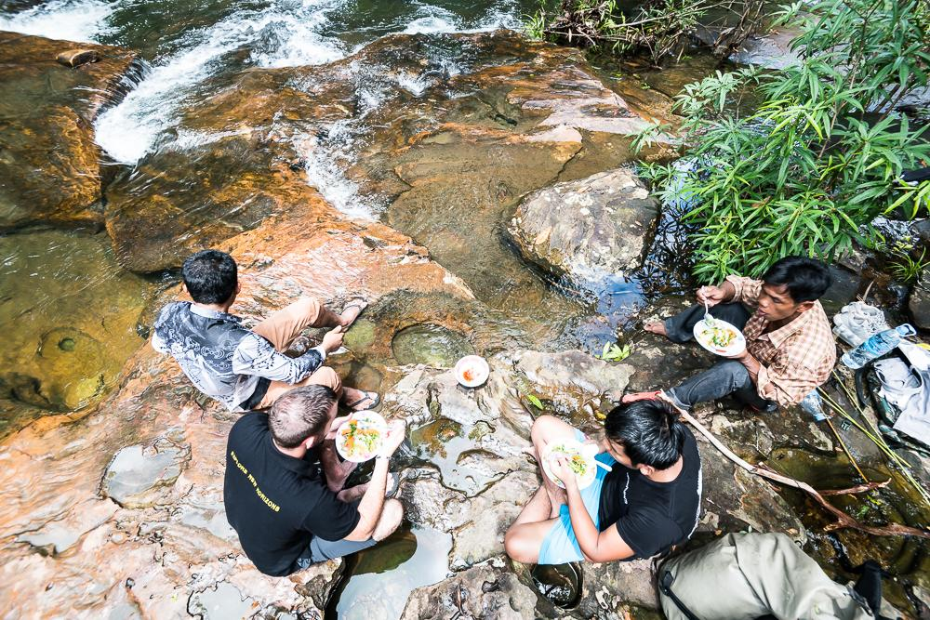
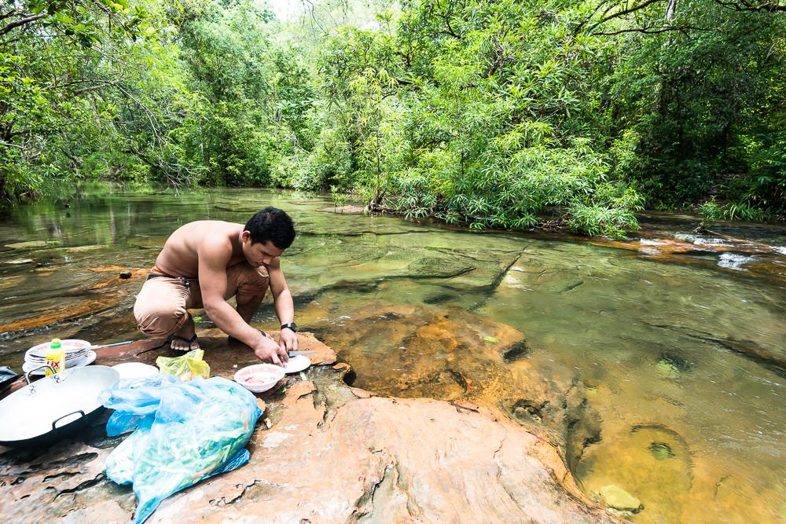
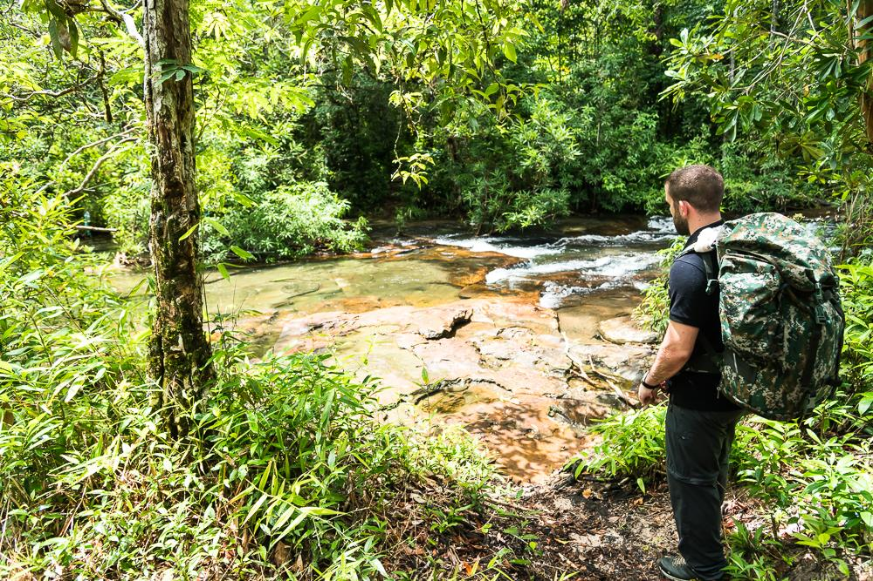
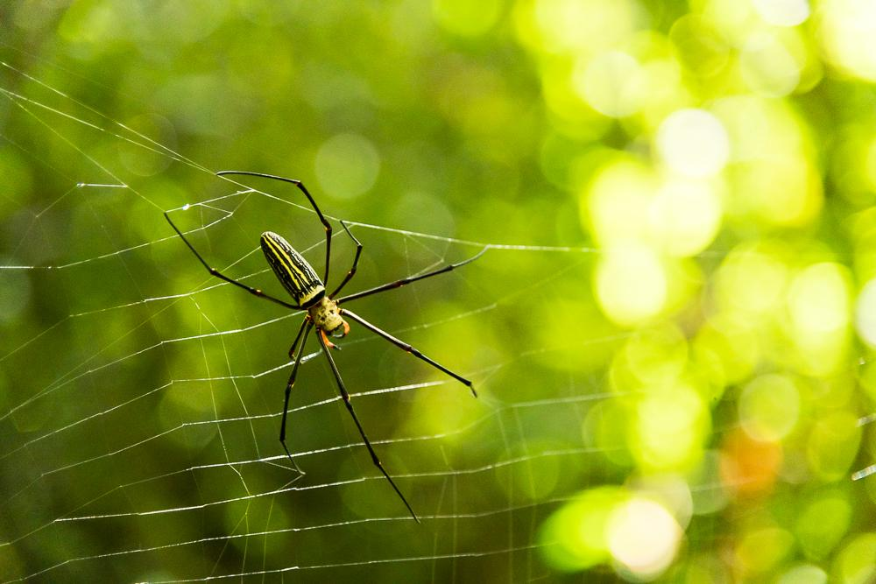
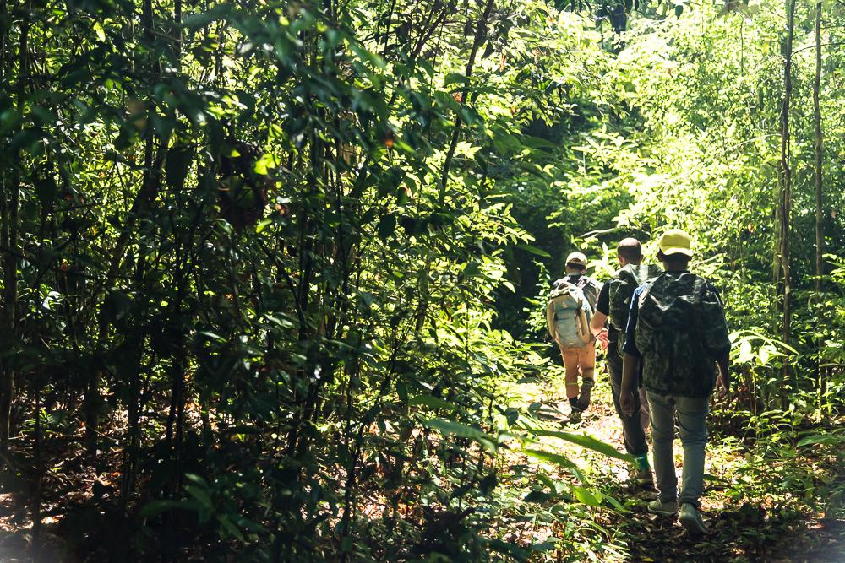
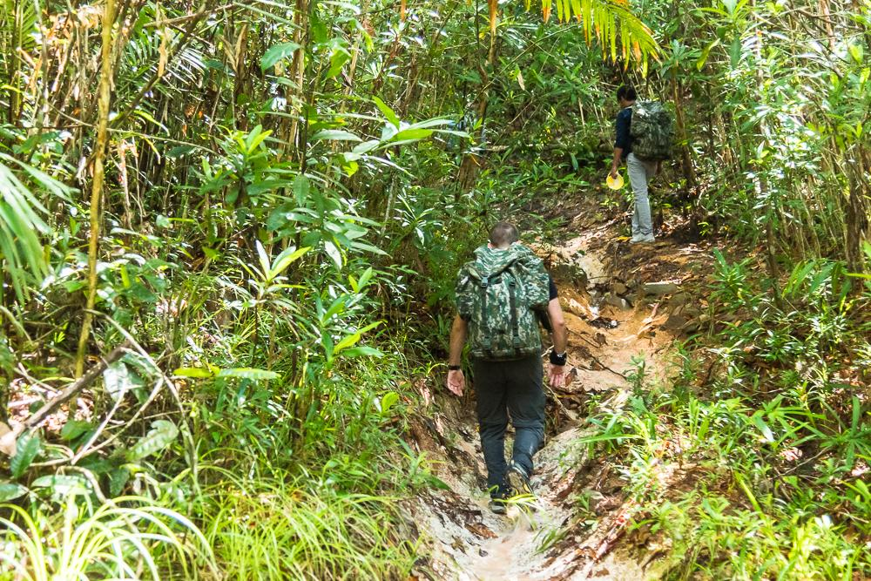
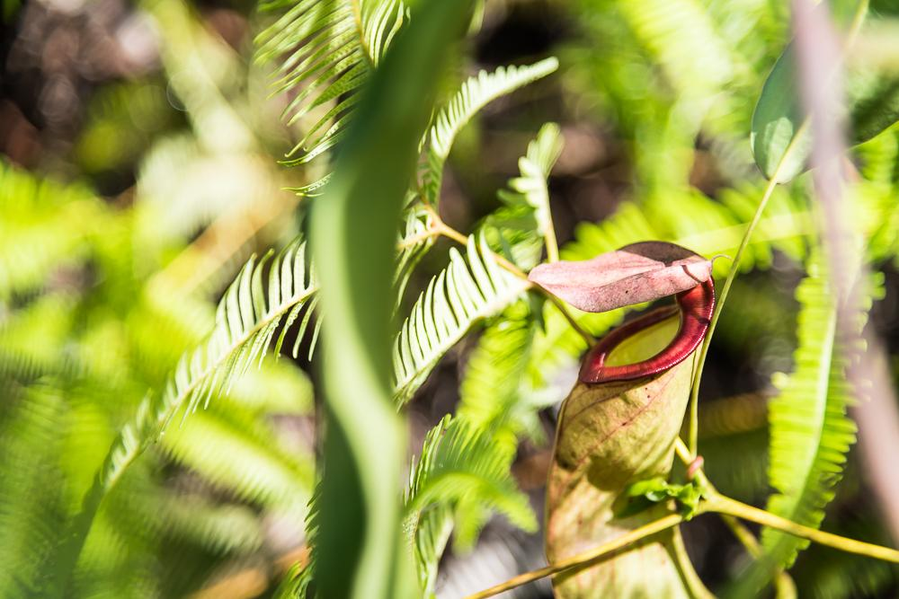
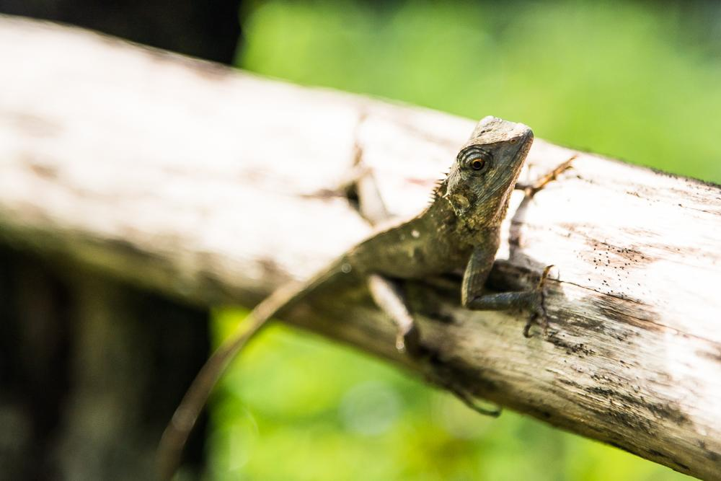
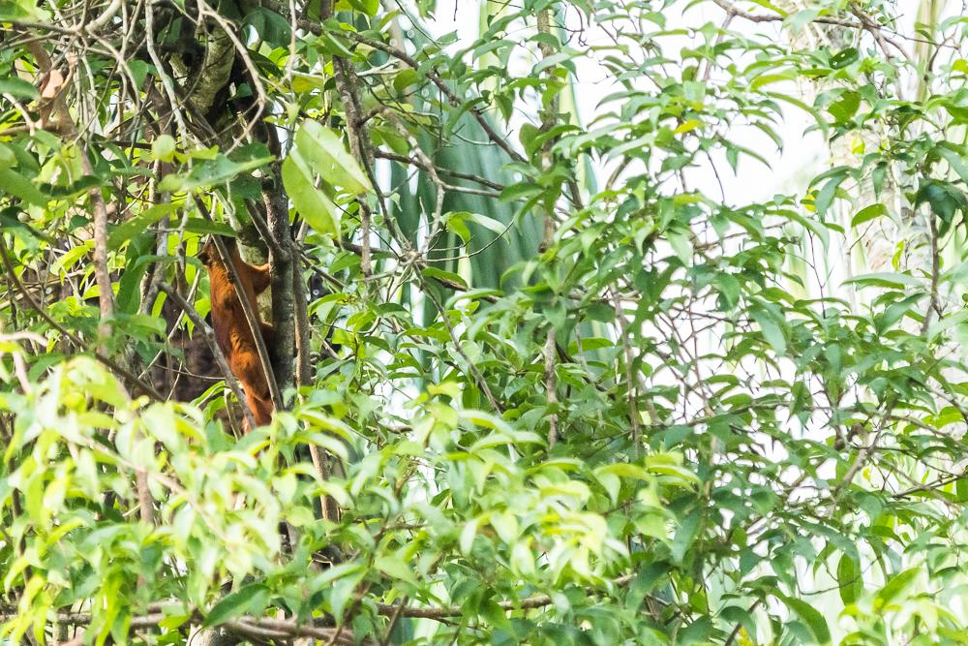
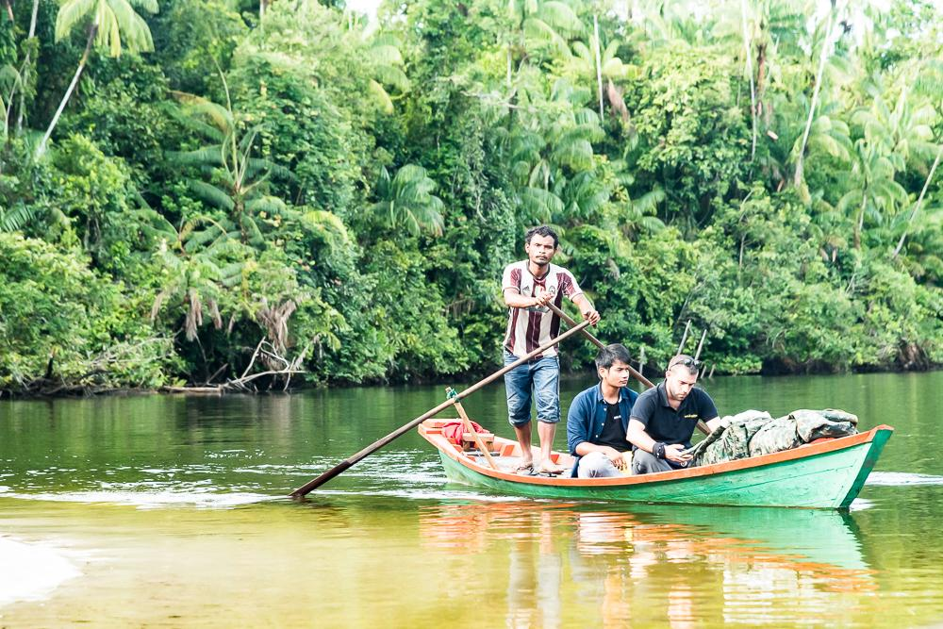
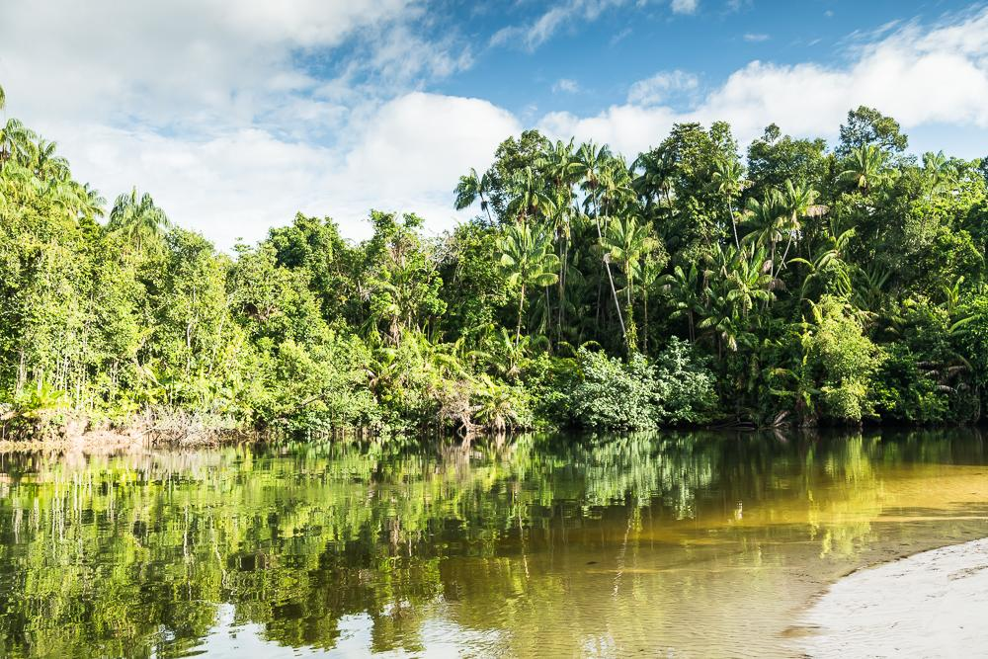
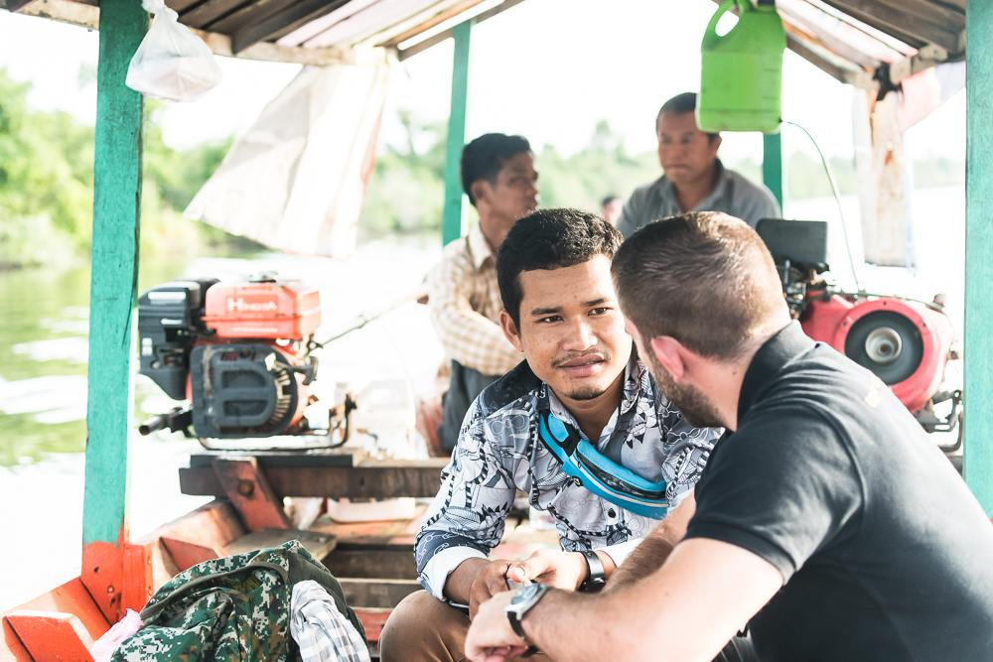
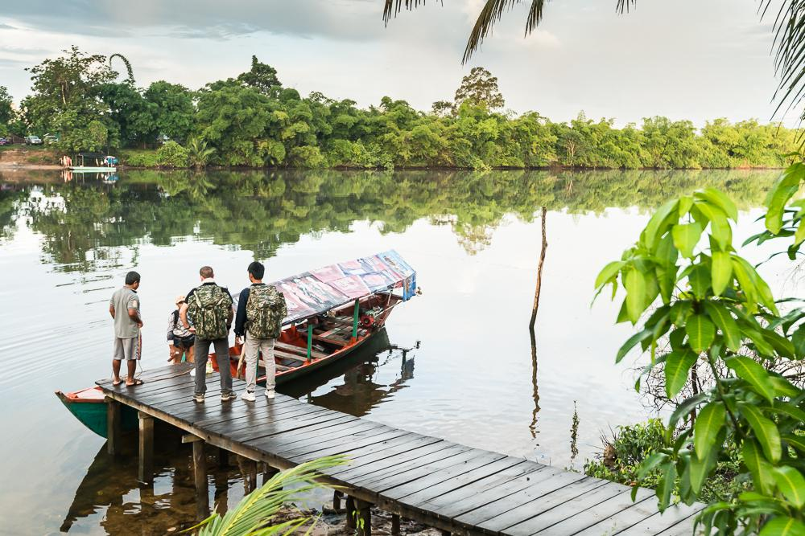
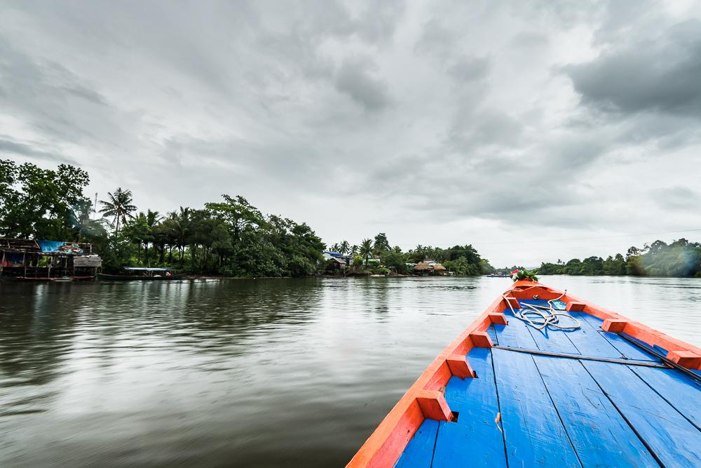
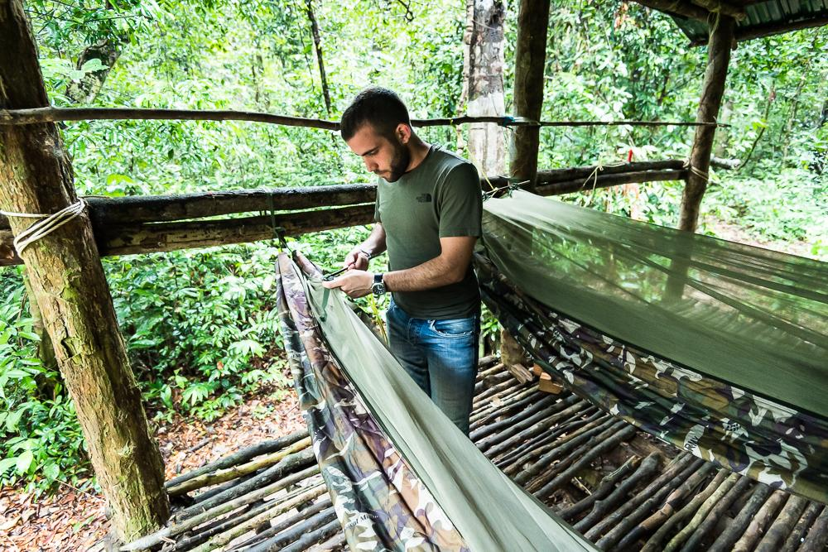
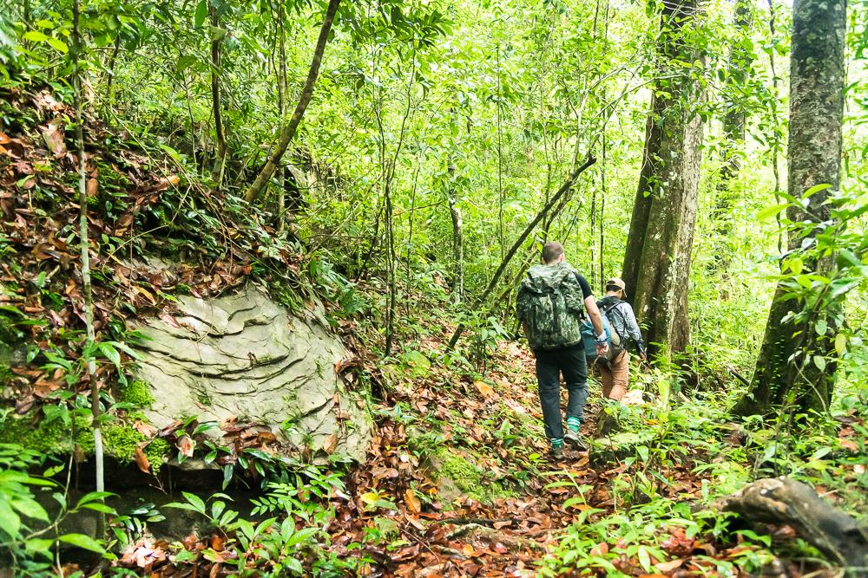
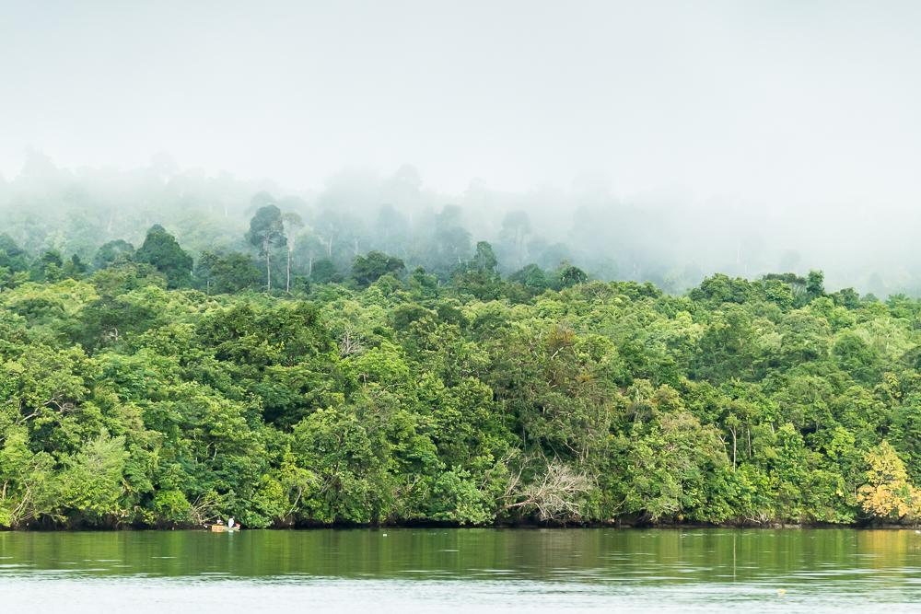
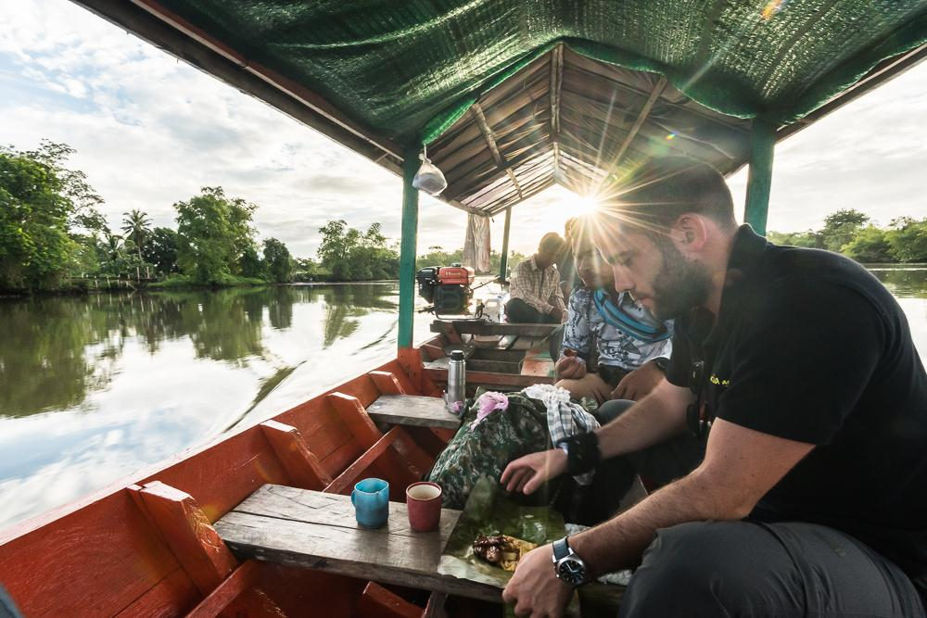
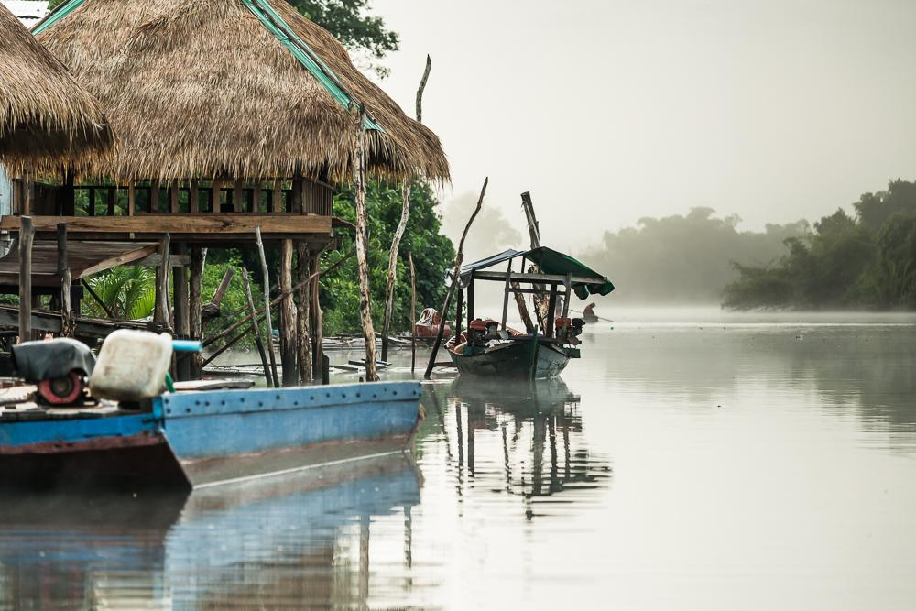
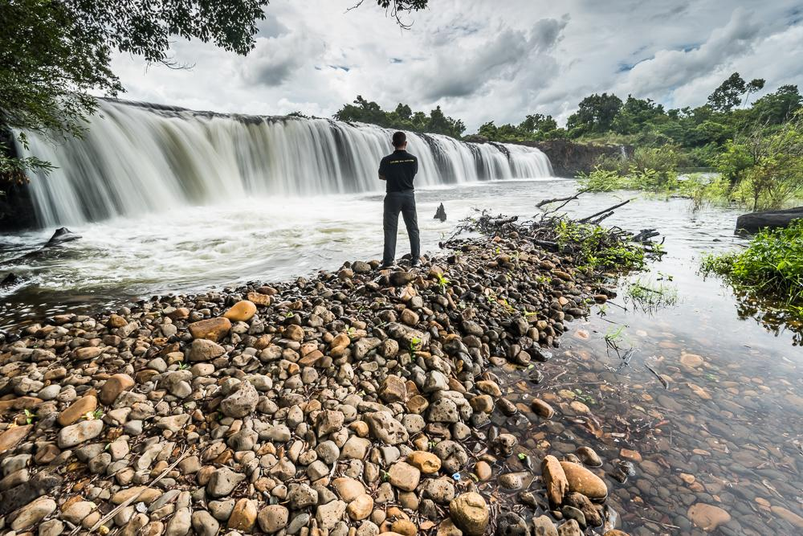

Easia Travel Head Office

