VIETNAM – Son La – Moc Chau and Pa Co Market 2D1N
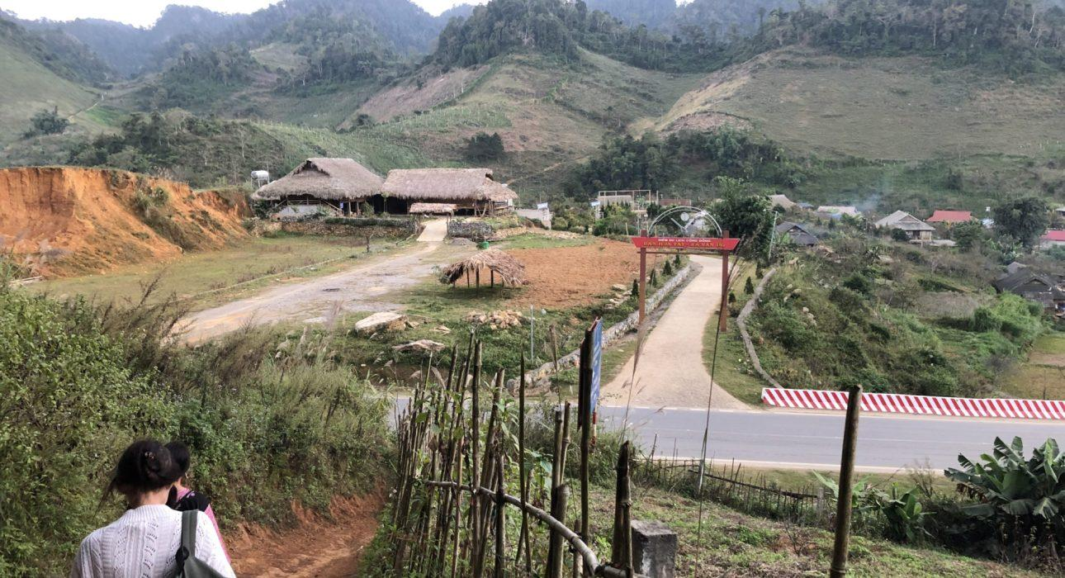

Over View

Theme
Art & Culture, Classic, Family, Sustainable

Country - City
Vietnam - Son La

Level of difficulties
LEVEL 1

Price level
$$

Seasonality
Weekend only, start from Saturday (be careful with the rainy season: July, August)

Max Pax
10

Market segment
Thematic Leisure

Arrival City
Moc Chau

Departure city
Hanoi

Itinerary

Number of days and nights
2 days - 1 night

Day by day description
This itinerary combines a quick hike on the mountain of Moc Chau with a visit of the beautiful ethnic market of Pa Co (which takes place every Sunday). It’s a great way to meet the H’mong minority group as well as to discover the nature and the culture of the region. Moc Chau is a stunning area with mountains and endless pine forests, and is home to some good homestays.

Selling points

- It is an excellent opportunity for interaction with the H’mong minority people of Vietnam
- Light hike, suitable for most travelers, even for families with kids
- A visit to the non-touristy Pa Co minority market, which is full of colorful goods on sale and bustling with local people
- Overnight in the homestay of H’mong people

Sustainability

Level Of The Excursion
High – This activity strongly supports local communities and/or helps preserve the culture and environment

The Impact Of This Excursion

Social/cultural Impact
Empowerment and education, Homestays, Involving minorities

Environment Impact
Transportation

Economic Impact
Community benefits

Additional Information
Positive Impact:The homestay used in this itinerary is a Community-Based Tourism (CBT) project funded by a French association. H’mong areas such as Moc Chau are often stuck in a cycle of poverty due to a lack of opportunities. Promoting tourism here helps provide jobs (homestay staff for cleaning, serving, hiking guide, etc.). It gives the younger generation a reason to stay in the area instead of seeking employment in a different region or city.

Options

Activities
- Hiking around the village of H’mong people
- Hiking to the farming hill
- Hiking to the pines hill
- Visiting minority market

Extensions
Lunch in Duong Lam or Mai Chau on the first day

Photos

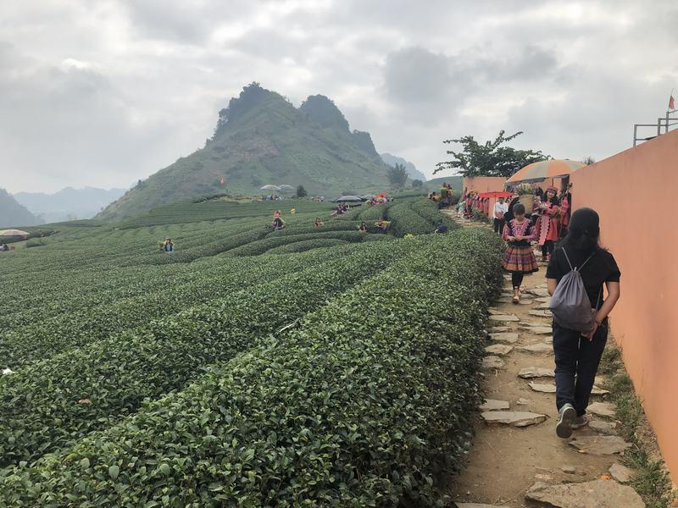
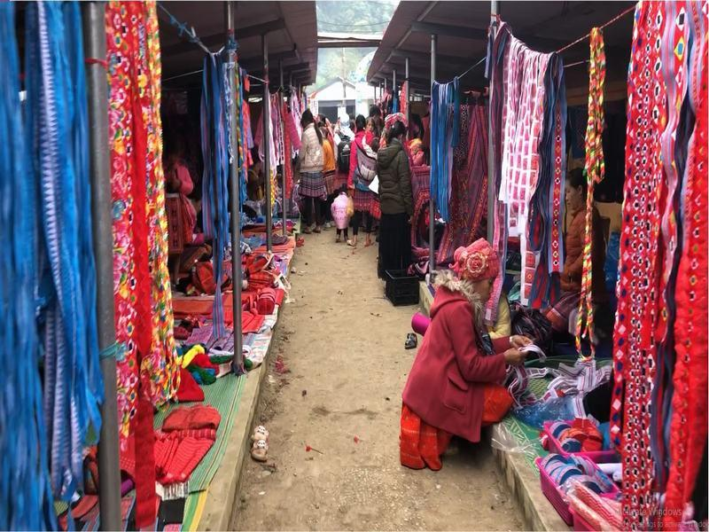
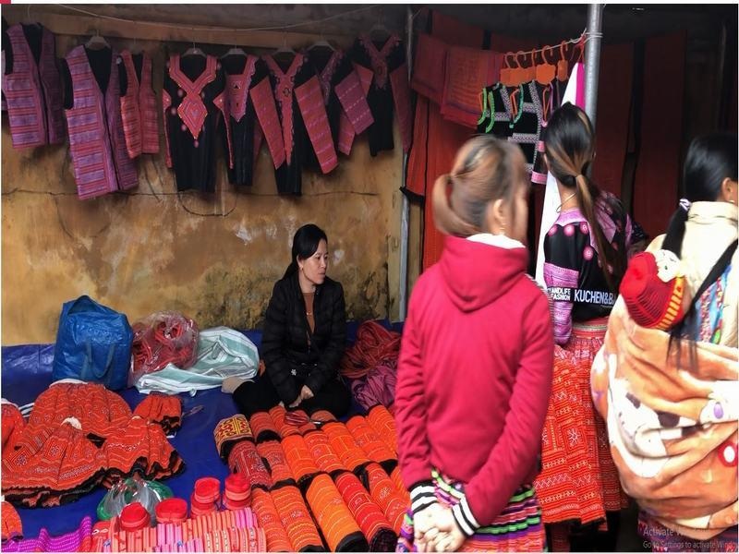
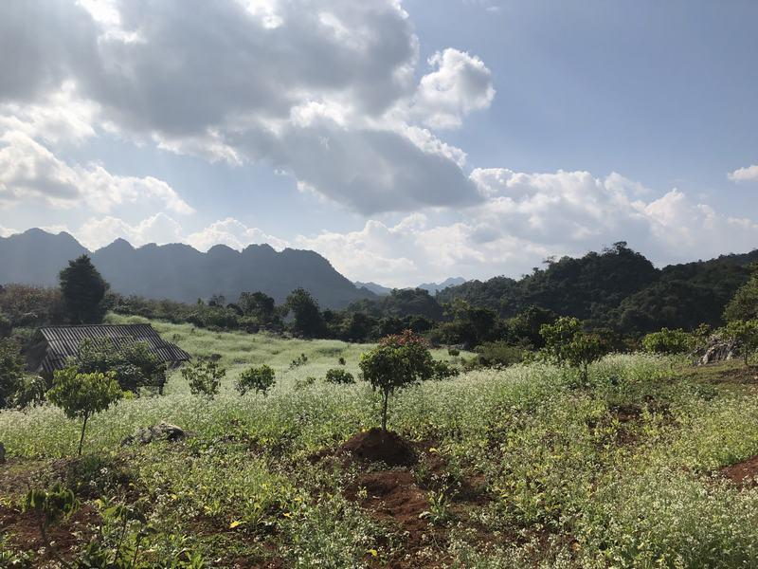
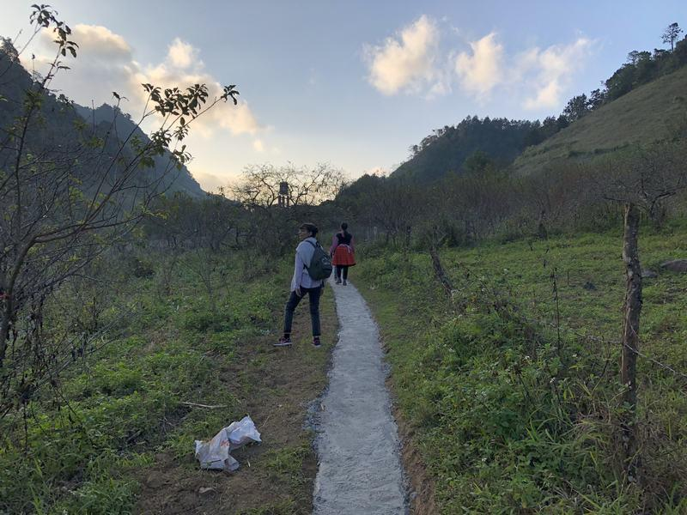

Easia Travel Head Office

Vietnam Head OfficeC/o: ATS Hotel, Suite 326 &327, 33B Pham Ngu Lao Street, Hanoi, VietnamTel: +84 24-39 33 13 62www.easia-travel.com

