MYANMAR – Dawei – Beyond the beaches of Dawei 4D3N
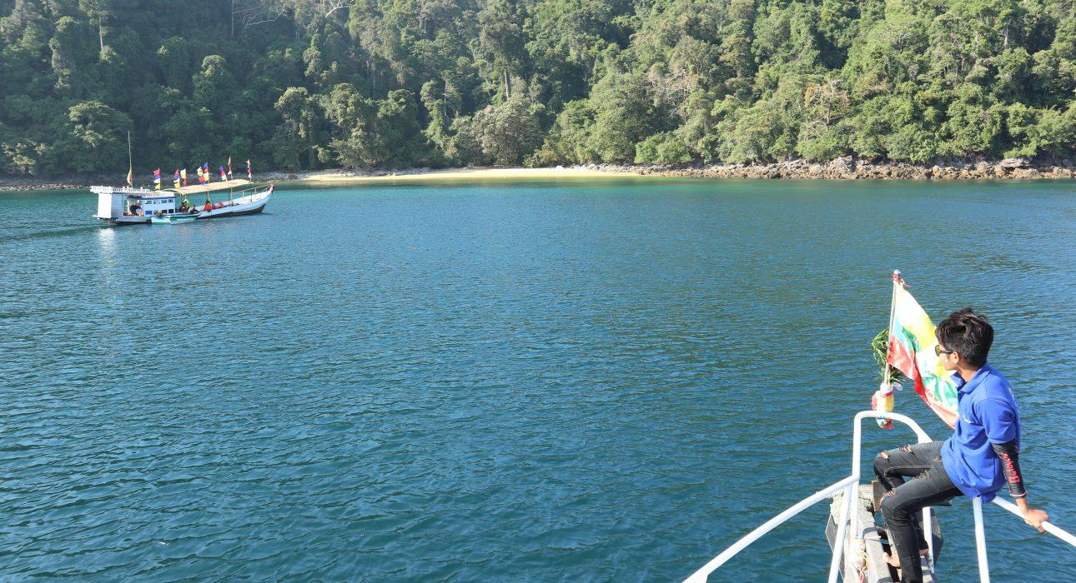

Over View

Theme
Beach Stay, Family

Country - City
Myanmar - Dawei

Level of difficulties

Price level
$$

Seasonality
Available all year (except for boat tour) - but strongly advised from October to April (in dry season)

Max Pax
20

Market segment
Groups, Thematic Leisure

Arrival City
Dawei

Departure city
Dawei

Itinerary

Number of days and nights
4 days - 3 nights

Day by day description
This journey to the South of Myanmar is dedicated to the wild beaches of Dawei, still a relatively unknown part of Myanmar. From the depth of the turquoise water to the fishermen villages and the lush jungle, Dawei has a lot to offer and perfectly represents the wild, exotic South of Myanmar. This balanced and complete program includes a snorkeling adventure around the nearby islands, a private sunset seafood barbecue on a deserted beach as well as a thrilling jungle hike to a jungle hotspring. Each and every activity in this itinerary offers ample opportunity to also connect with the inhabitants of Dawei, from the boatmen to the artisans, no doubt Dawei will surprise by its rich culture and its untouched nature.

Selling points

- A thorough discovery of Dawei and its surroundings, from its beaches to its jungle
- Several occasions to meet with the inhabitants of the villages and Dawei town and understand their daily life better: from fishermen to artisans
- A good balance between beach relaxation and jungle adventure
- Comfortable hotel in town and day tours organised everyday
- A lesser-known part of Myanmar which offers a large array of discoveries
- Only 1-hour flight from Yangon, Dawei is easily accessible
- The current module of 4D3N can be extended with additional leisure time to explore the beaches at their own pace (with car available) or can be combined with a stay in one of the basic beach bungalow hotels for additional relaxation – disconnected from the world
- The visits of Tizit Beach and Ka Lone Thar Village are both organized by a local CBT, whose purpose is to encourage vocational training and greater revenues through tourism activities

Options

Activities
Dawei – Fishing experience at Tizit BeachDawei – Moscos Island Snorkeling TripDawei – Dawei Arts and CraftsDawei – Jungle trail and Forest Spa

Extensions
- Extend this module with a stay in the Mergui Archipelago (direct flights from Dawei to Kawthaung)
- Extend this module with border crossing to Kanchanaburi (Htee Khee border)
- Extend this module with a stay in one of the basic beach bungalow hotels:
  - Sin Htauk Beach Bungalow
  - Myanmar Paradise Beach Bungalow

Photos

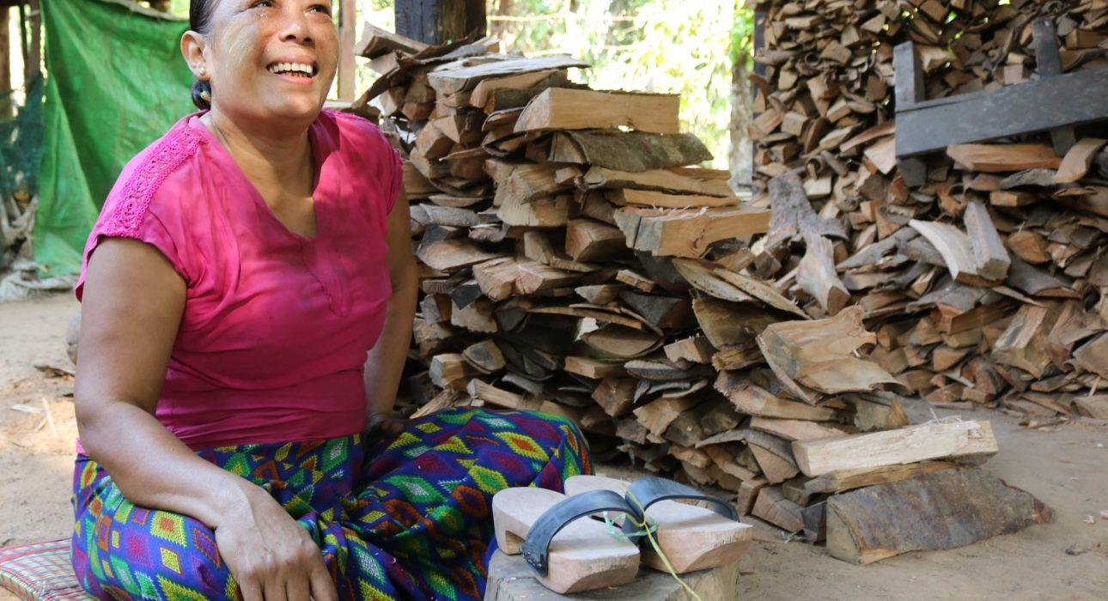
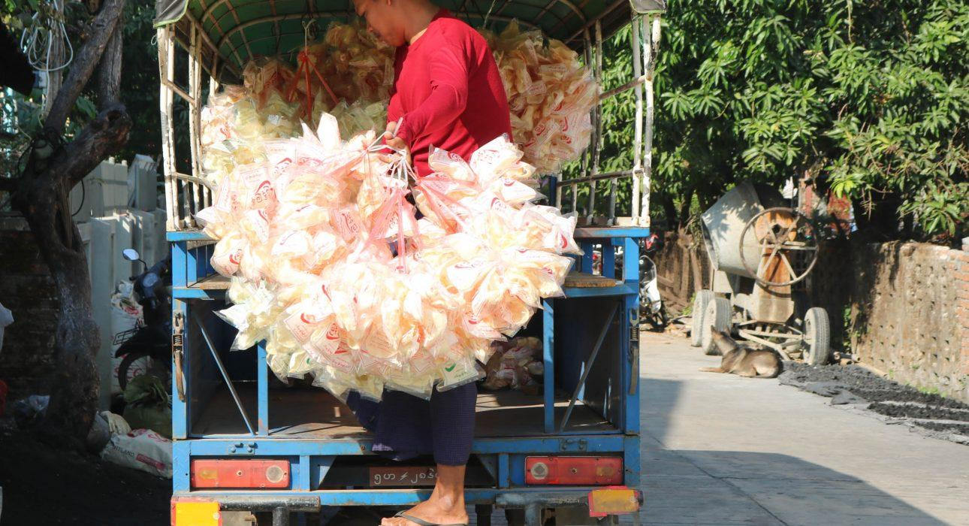
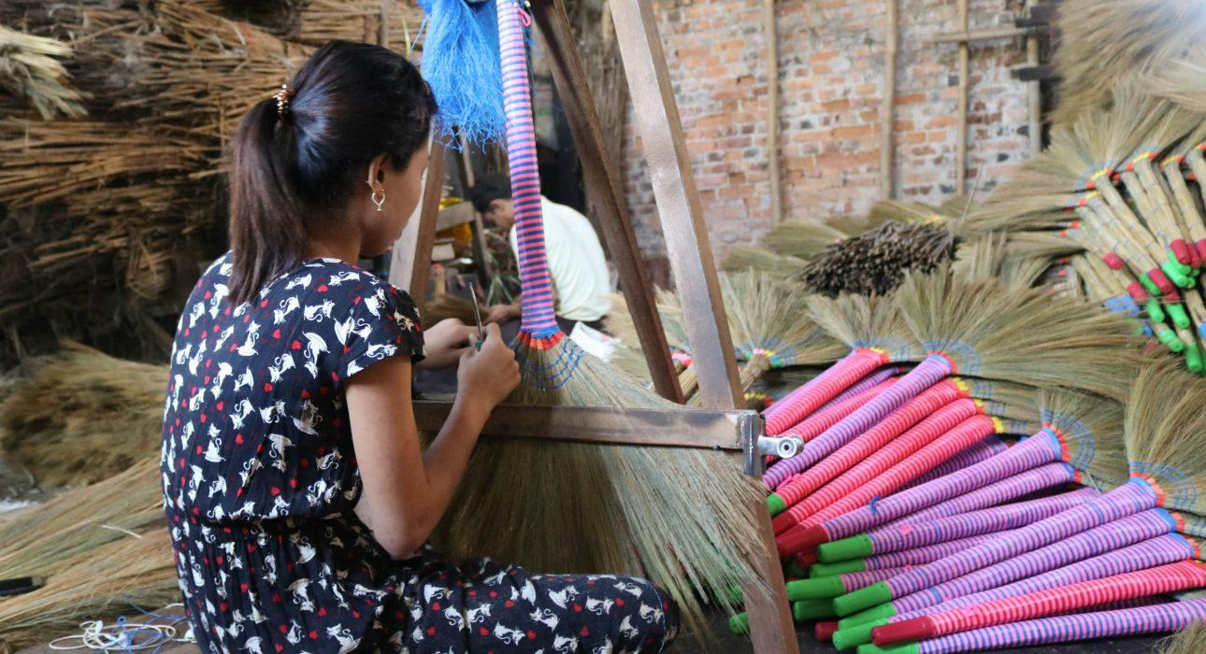
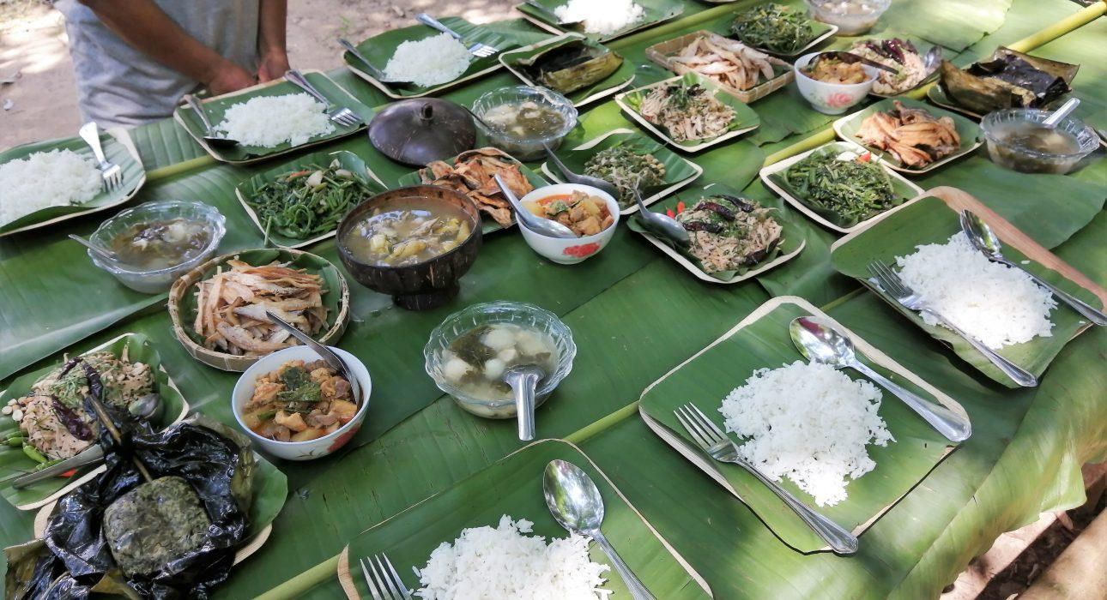
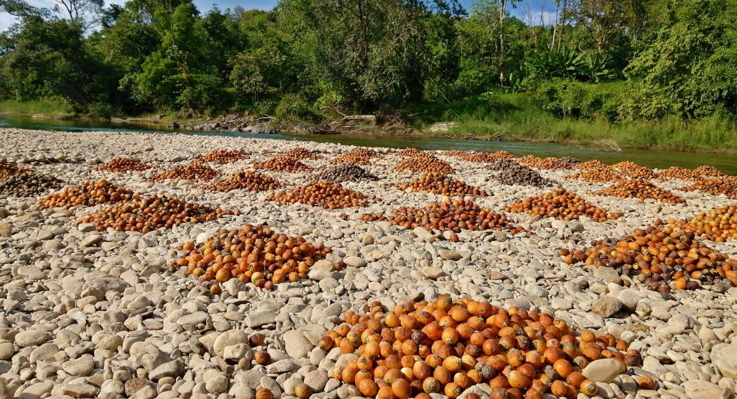
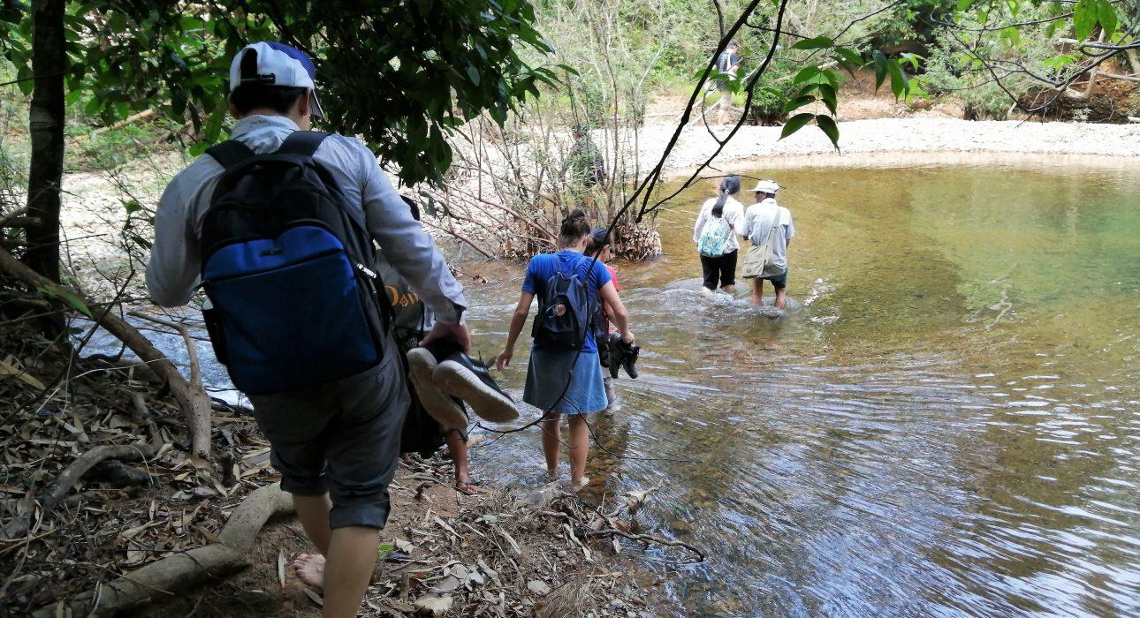
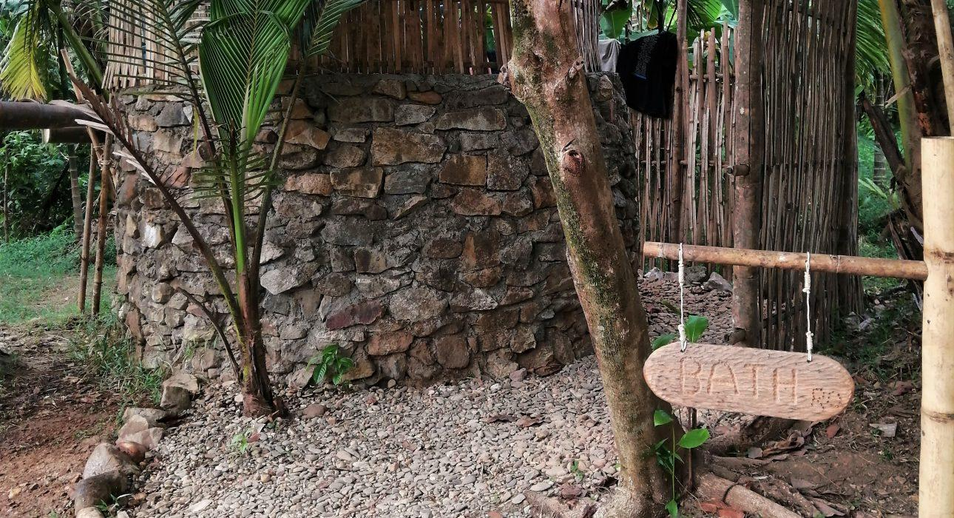
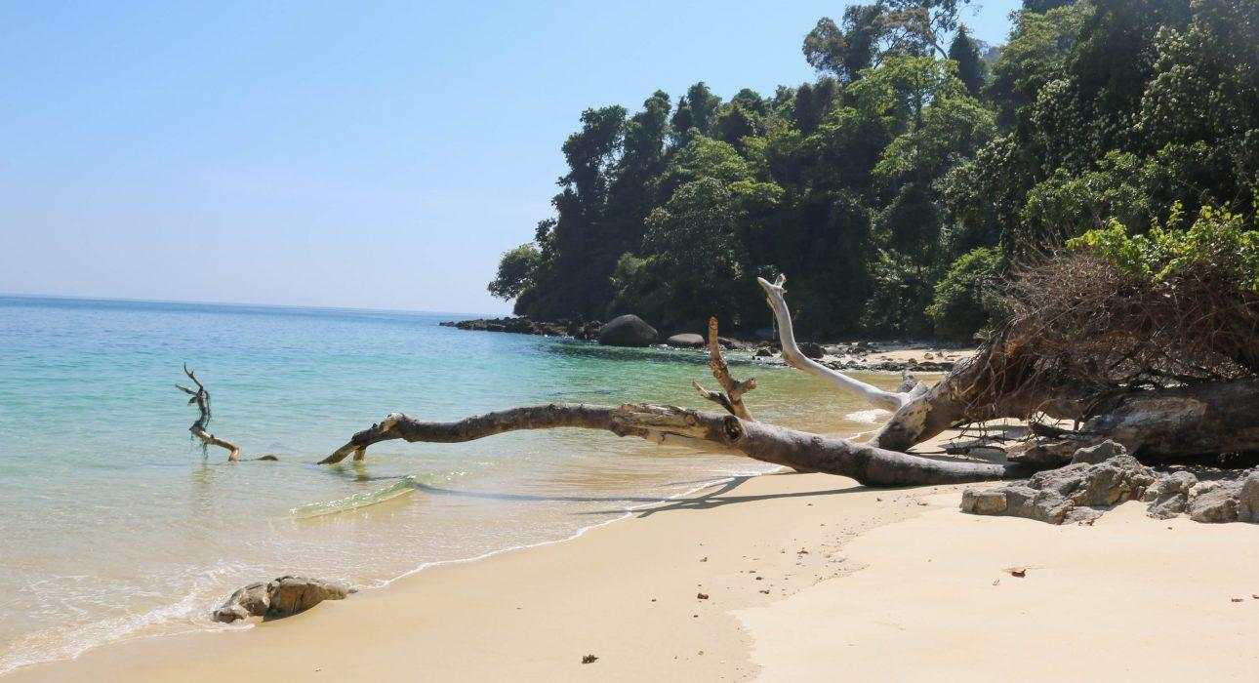
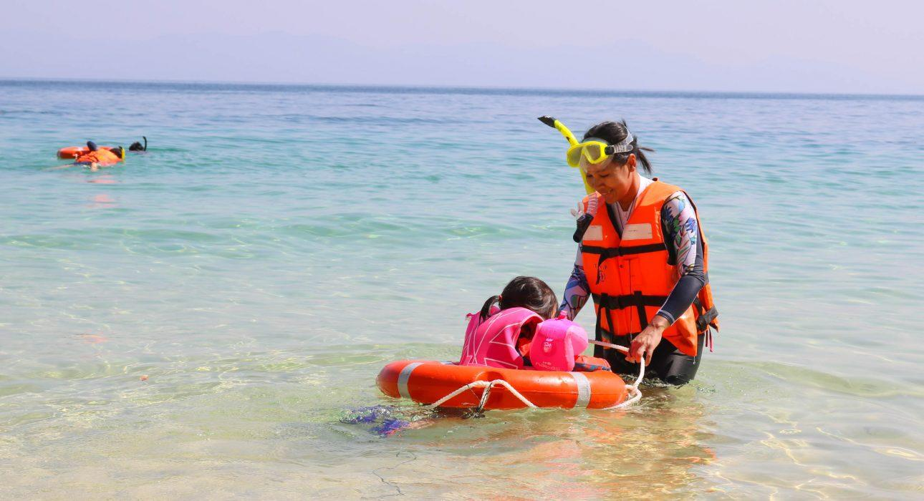
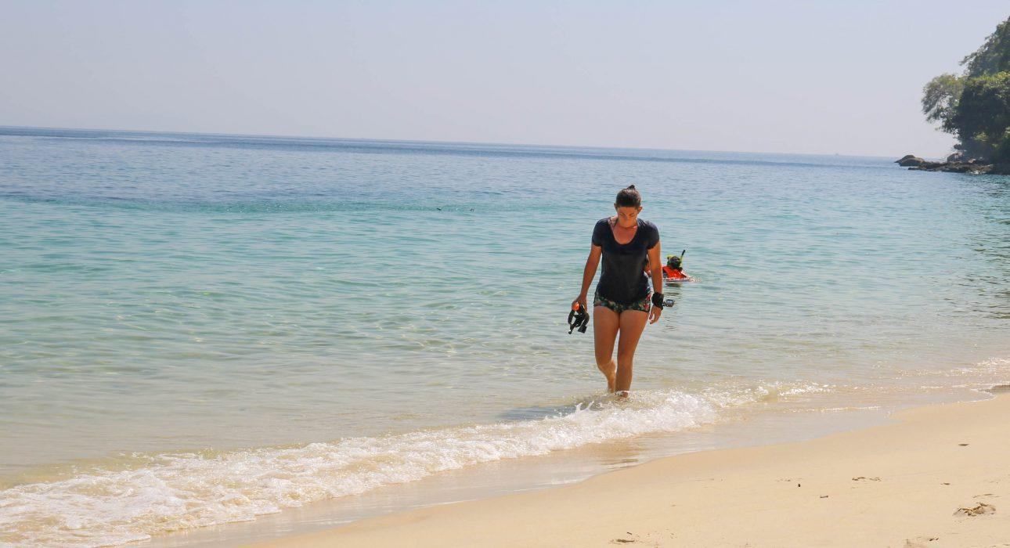
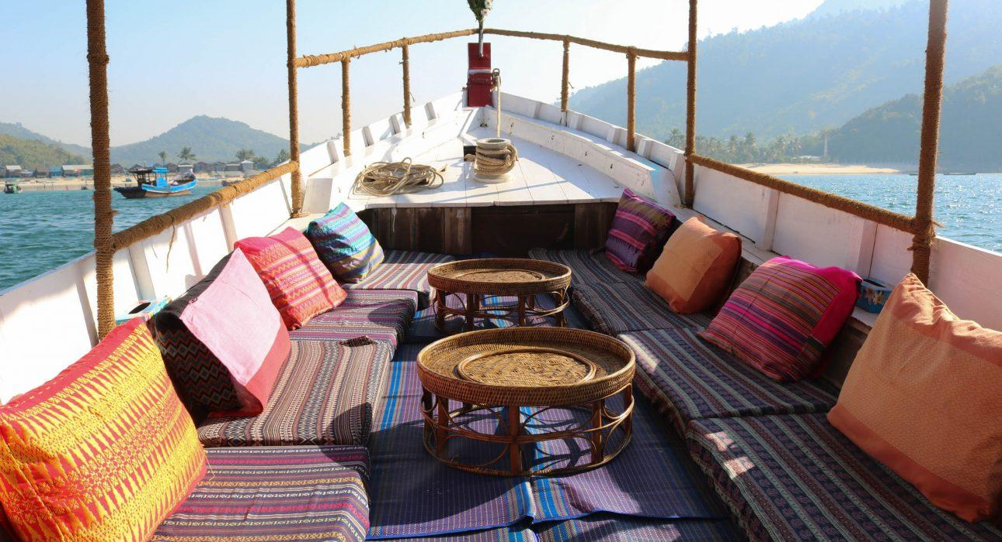
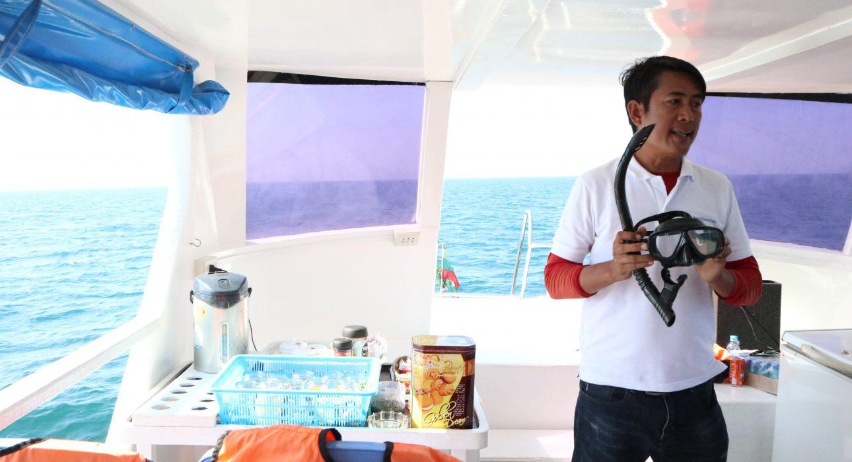
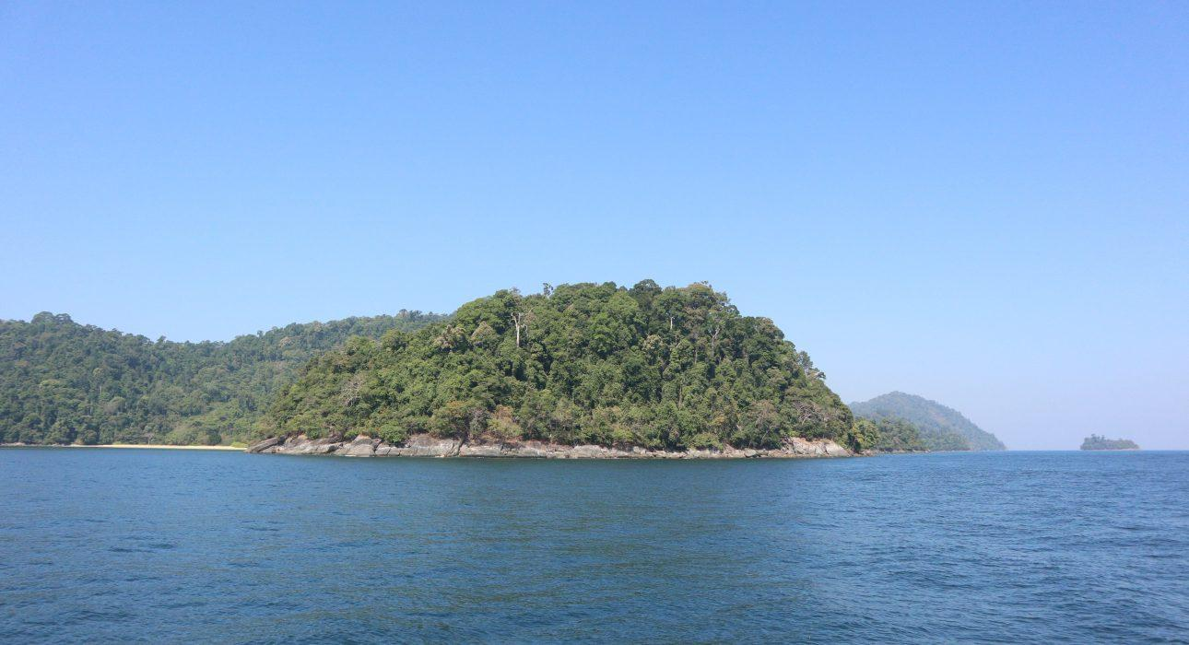
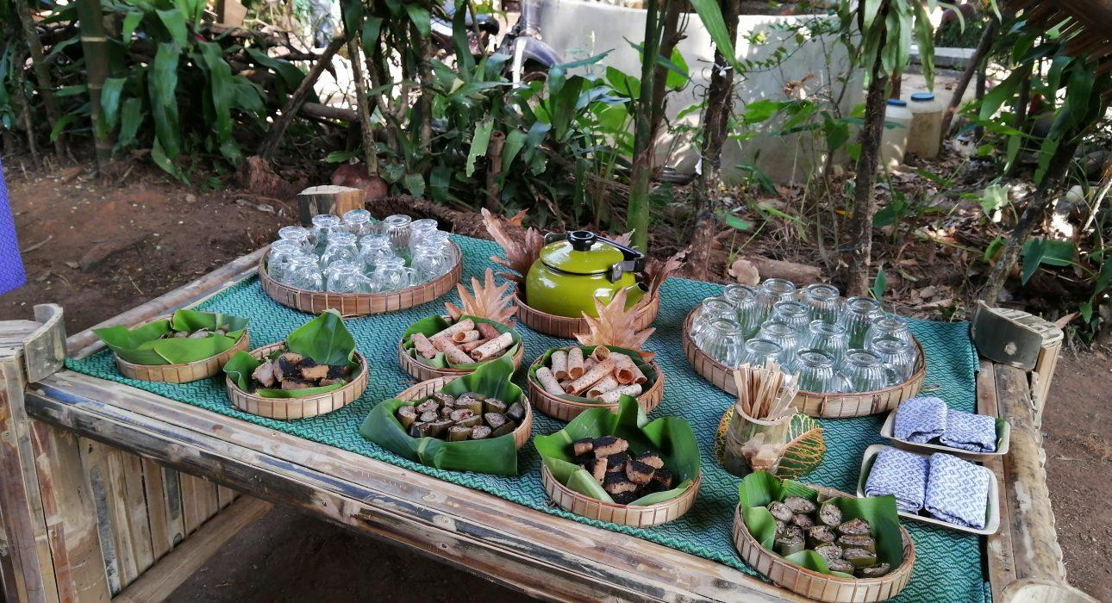
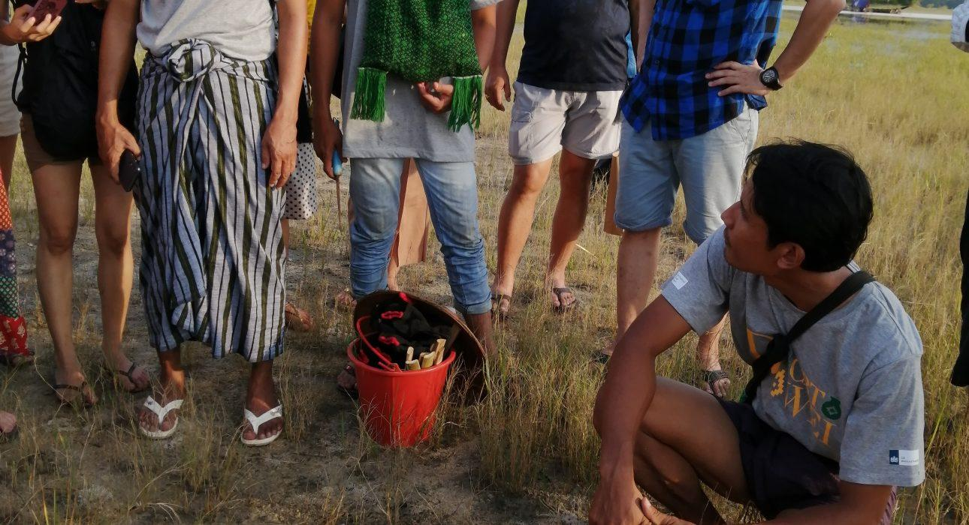
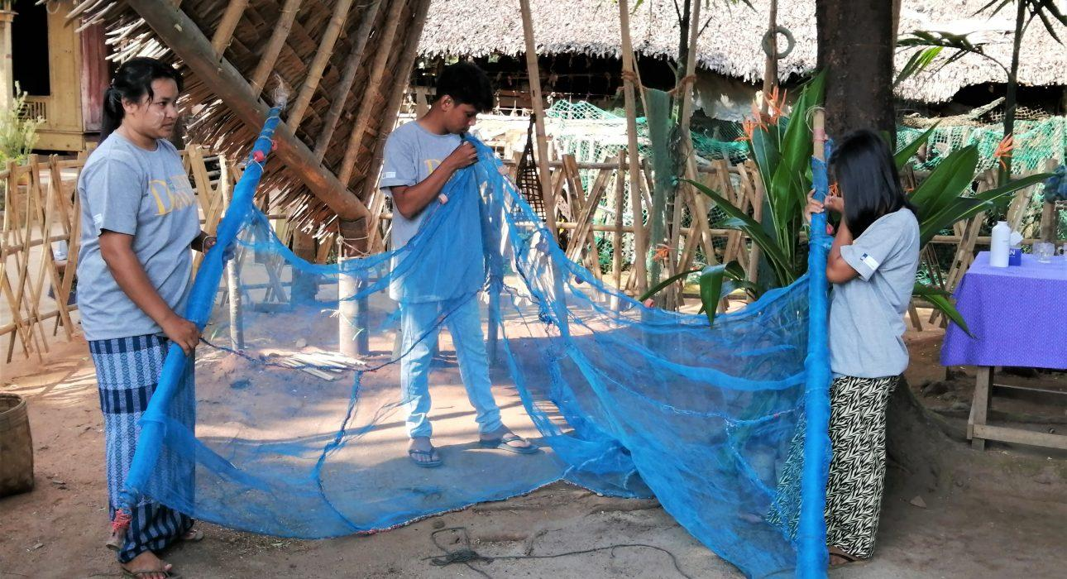
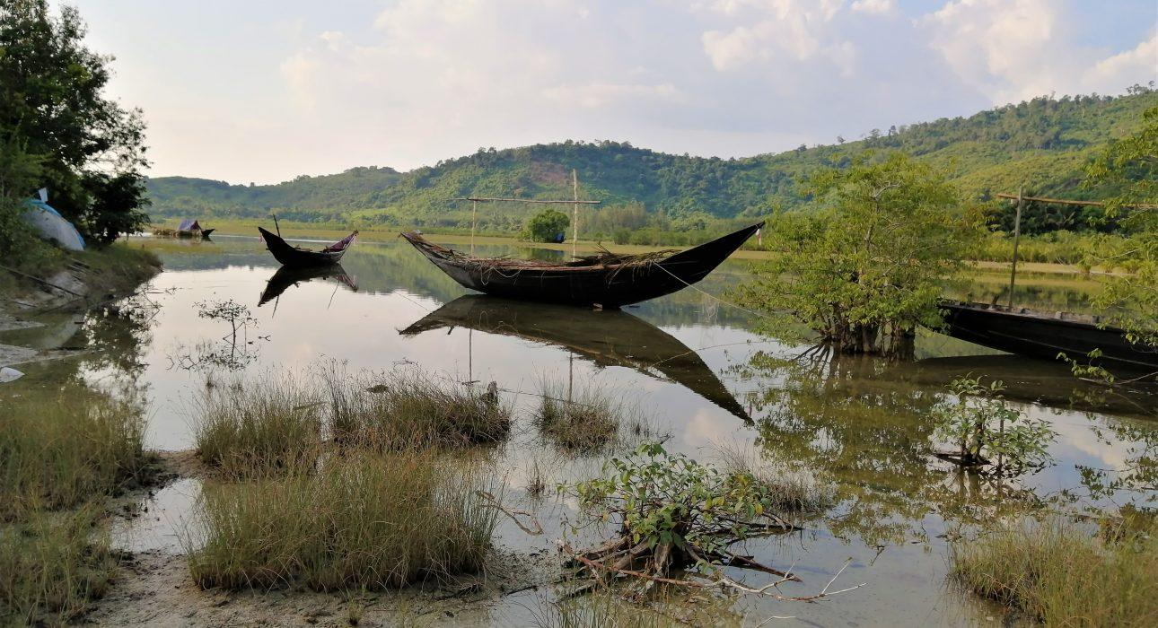

Easia Travel Head Office

Vietnam Head OfficeC/o: ATS Hotel, Suite 326 &327, 33B Pham Ngu Lao Street, Hanoi, VietnamTel: +84 24-39 33 13 62www.easia-travel.com

