MYANMAR – Bagan – Myaing Community Lodge and Village Experience 2D1N
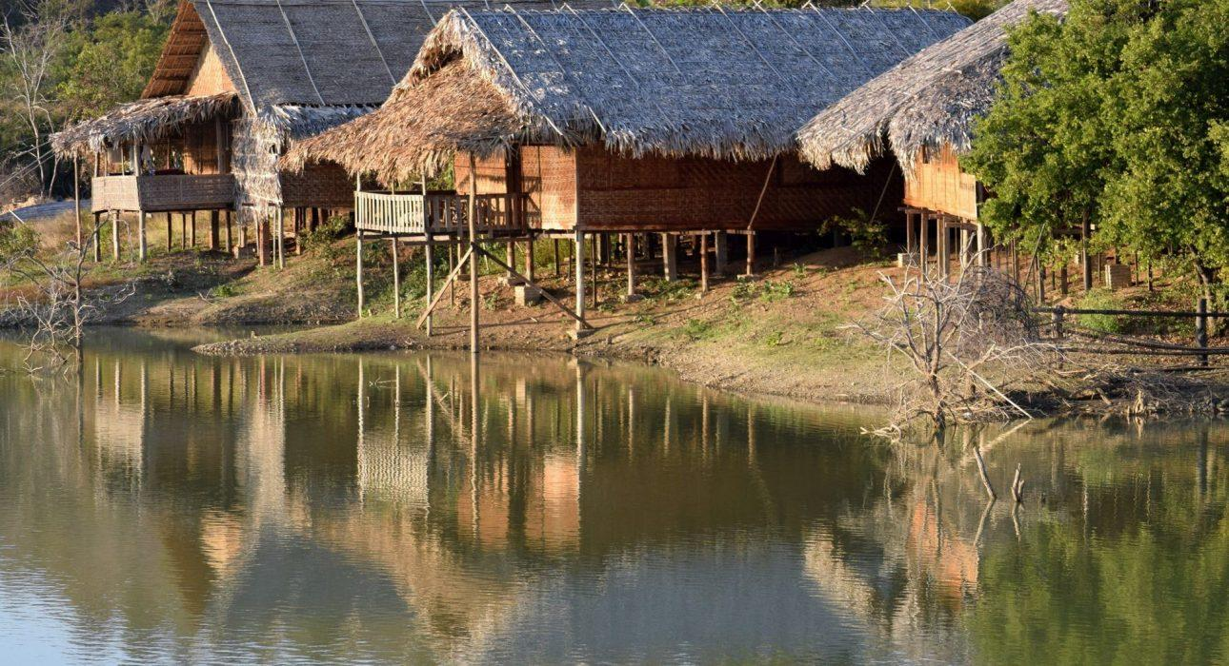

Over View

Theme
Art & Culture, Sustainable

Country - City
Myanmar - Bagan

Level of difficulties

Price level
$$

Seasonality
All Year Round

Max Pax
40

Market segment
Groups

Arrival City
Bagan

Departure city
Mandalay

Itinerary

Number of days and nights
2 days - 1 night

Day by day description
Most villagers in the ‘dry zone’, between Bagan and Mandalay, rely on farming, but climate change has taken its toll on the agriculture, which has since become a dangerously unreliable source of revenue. In order to generate sustainable job opportunities for the young villagers and help them learn new skills, Action Aid, in partnership with the local communities, built a sustainable community lodge to welcome visitors. An immersive experience is awaiting, meeting with the local communities, observing their daily routine, sharing a meal with them, and exploring the surroundings by bike. This is definitely a village experience that will show you a different face of Myanmar.

Selling points

- An authentic village experience combined with a comfortable community lodge in the dry zone between Mandalay and Bagan
- Genuine cultural immersion built around a sustainable project of ActionAid
- Cultural immersion and a direct encounter with villages/locals by taking part to their daily life in the dry zone
- A perfect way to connect Mandalay and Bagan with an immersive break in the village life

Options

Photos

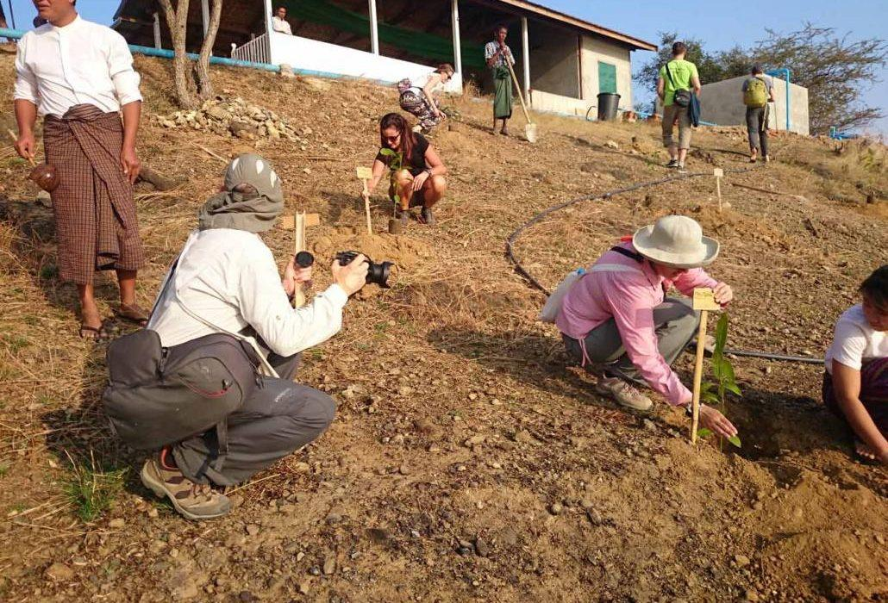
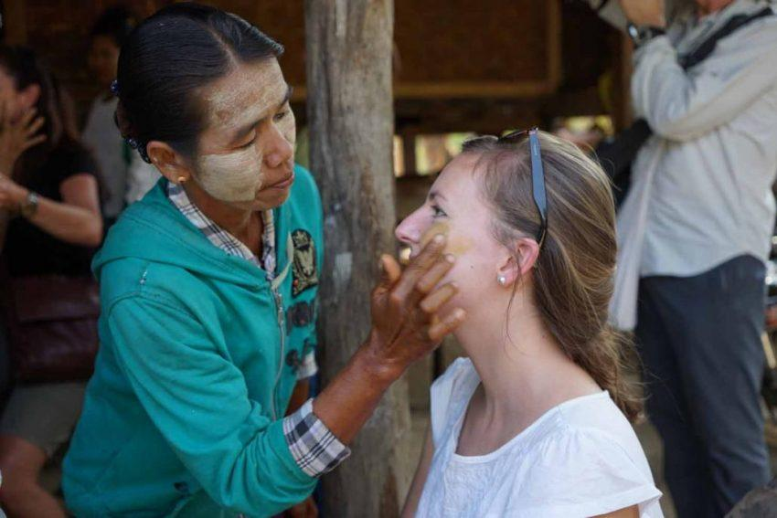
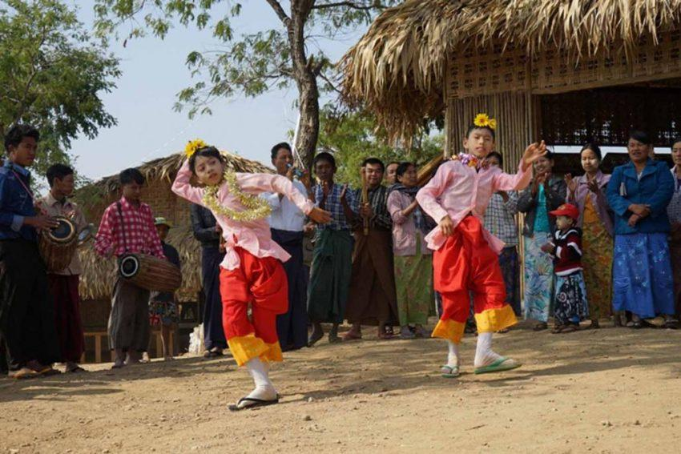
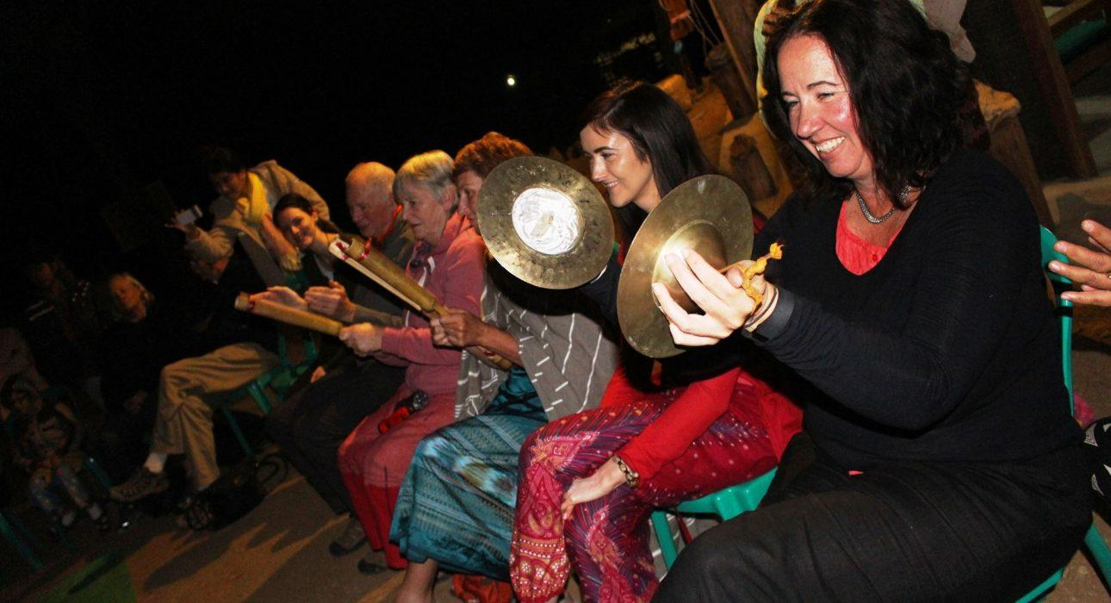
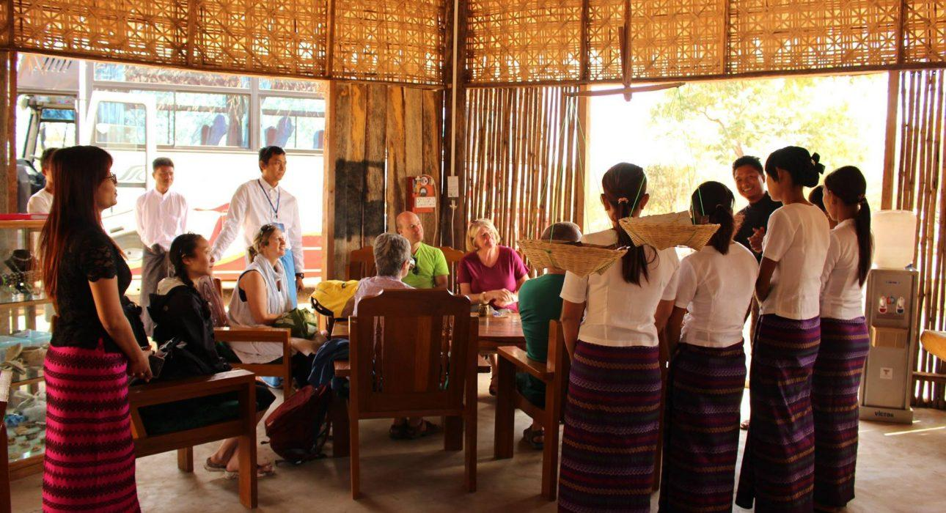
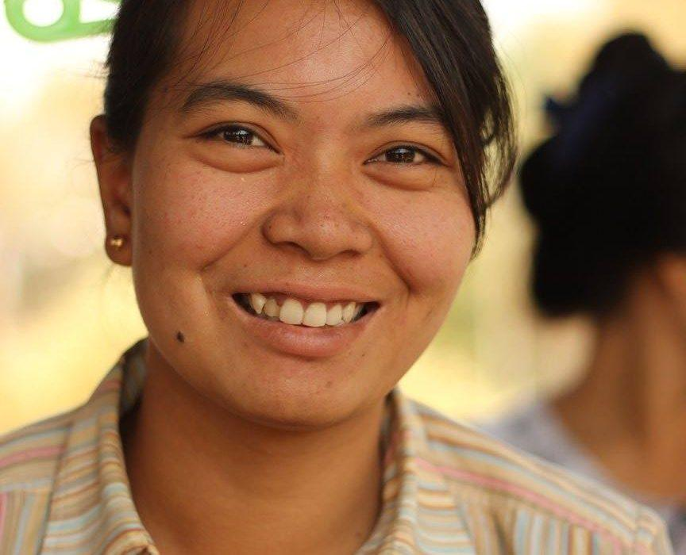
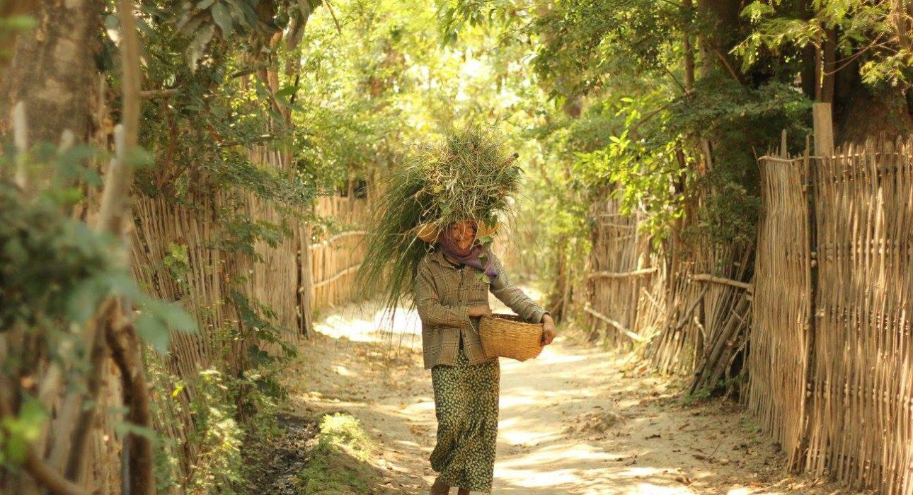
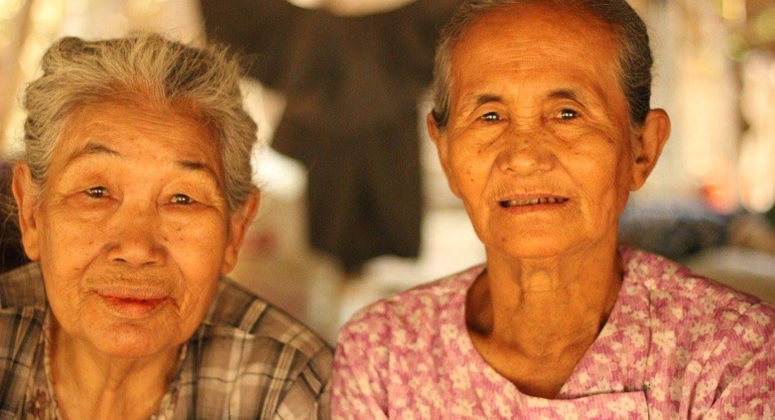
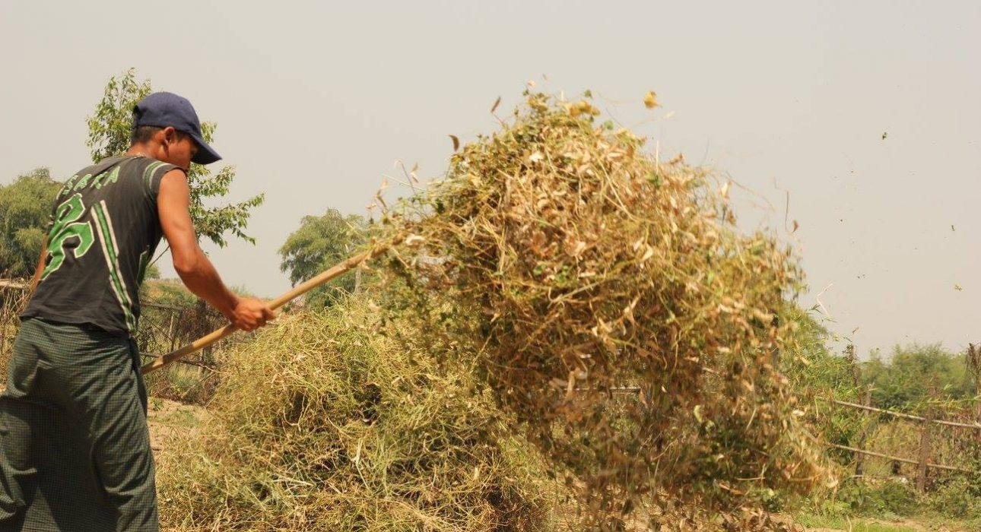
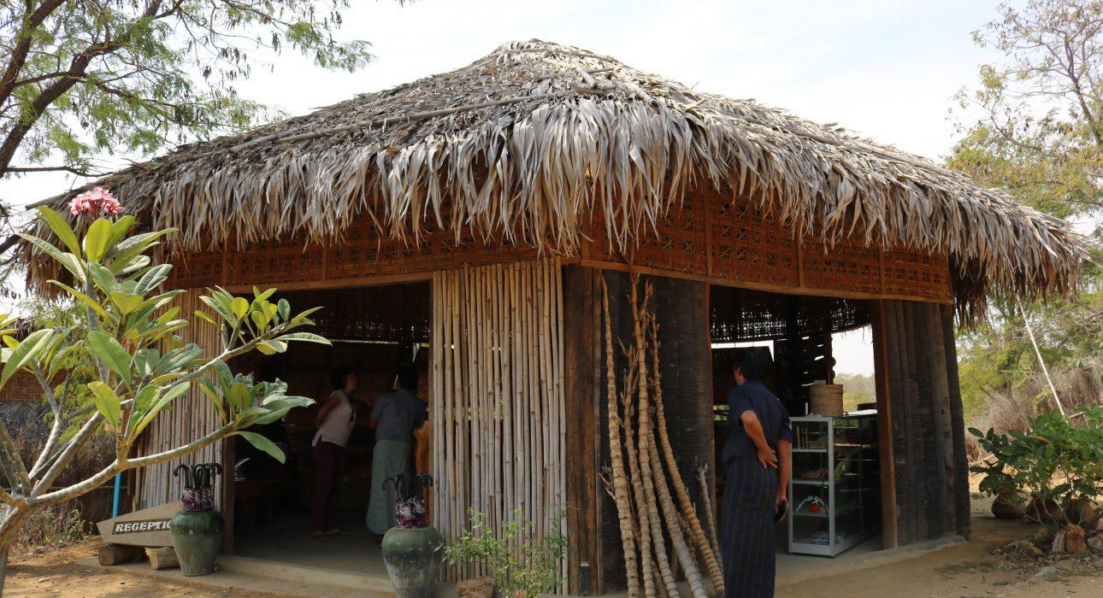
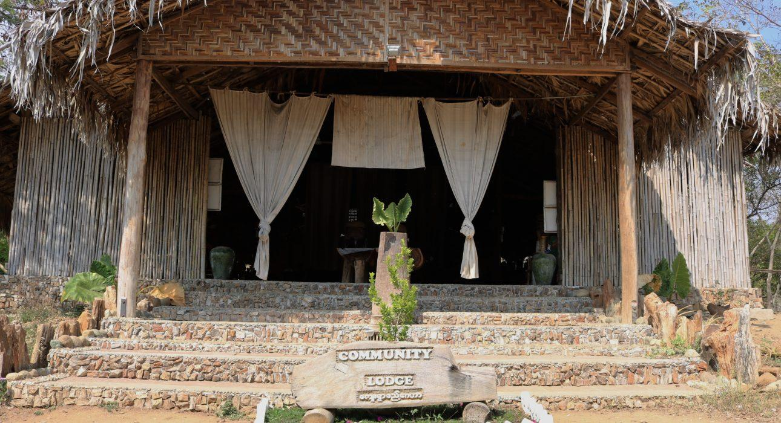

Easia Travel Head Office

Vietnam Head OfficeC/o: ATS Hotel, Suite 326 &327, 33B Pham Ngu Lao Street, Hanoi, VietnamTel: +84 24-39 33 13 62www.easia-travel.com

