VIETNAM – Easia Collection – Hidden Villages - Markets of Northern Vietnam 13D12N
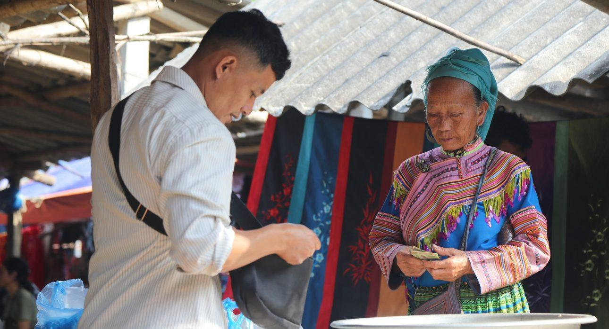

Over View

Theme
Classic

Country - City
Vietnam

Level of difficulties
LEVEL 1

Price level
$$$$

Seasonality
March to November

Max Pax
6

Market segment
Thematic Leisure

Arrival City
Hanoi

Departure city
Hanoi

Itinerary

Number of days and nights
13 days - 12 nights

Day by day description
This itinerary combines some of the most beautiful regions of Northern Vietnam, highlighting diverse landscapes and minorities. From rice terraces to cinnamon plantations and ethnic minorities markets, travelers explore several hidden treasures of Northern Vietnam while avoiding the classic, overexposed destinations. This program offers travelers a deep understanding of the different faces of Northern Vietnam with overnight experiences in a local homestay to understand how to grow cinnamon or how the Hani minority build their houses at an altitude of almost 2000 meters and why.Day 1: HanoiIn the morning, you will be welcomed by your local guide at the airport, followed by a car transfer to the hotel for check-in. In the afternoon, you will have the chance to experience the life of a Hanoian in the 1950s and travel through the Old Quarter on a cycle rickshaw for 45 minutes. Discover the bustling streets of the “Quarter of the 36 guilds” – a place of unique charm and endless activity: artisans, stalls, tinsmiths, jewelers, calligraphers, carpenters, mobile kiosks, leather or rattan goods, people selling fans, votive objects, lacquer ware, silk, mats, paper, pipes and so much more. Then, you will stroll around Sword Lake and stop to visit the beautiful Ngoc Son Temple on an island in the middle of the lake, accessed via a red wooden bridge.Day 2: HanoiDiscover Hanoi through the lens of a Polaroid camera today. Start by heading to the old city gate before walking through an old neighborhood and discovering a small, bustling market. Then, after visiting one of the oldest temples in Hanoi, you will stroll through the small alleys of the Old Quarter, where you’ll see (and possibly buy from) many food stalls and street vendors. Walking, you will also visit some of the city’s most iconic monuments from different eras, from an old Chinese-style temple to a French-inspired colonial hotel. Occasions to use the Polaroid are countless, but remember to snap a few specific places mentioned in your “Polaroid Pack” to get complimentary tea or coffee. You will finish the walking tour at the Opera House.In the afternoon, visit the Temple of Literature (Van Mieu in Vietnamese), once known as the first university of Vietnam. Built in 1070 by Emperor Ly Thanh Tong, the university was opened exclusively for princes and mandarins. With its ancient courtyards, altars, and roofs, Van Mieu is an excellent example of Vietnamese architecture. Then you will proceed to the Ethnology Museum. Founded in November 1997 at the Francophonie Summit, it is both a research center and a public museum featuring the 54 ethnic groups found across Vietnam.In the late afternoon, you will have a chance to understand what makes Hanoi’s Old Quarter such a captivating place. Here, you can taste various Vietnamese specialties, such as banh cuon (steamed rolled rice pancake) and banh mi (the famous Vietnamese sandwich that even appears in the Oxford Dictionary). Then, stop at a bia hoi (beer club) on Ta Hien Street and taste the fresh Vietnamese beer that is incredibly popular with locals and travelers alike. Afterward, head to a pho shop, where you can choose between regular pho or pho tron (noodles with chicken without soup). Then, make your way along Hoan Kiem Lake for one of the tastiest ice creams in Hanoi. You will then say goodbye to your guide and explore Hanoi by night alone.Day 3: Hanoi – Duong Lam – Nghia LoYou will travel from Hanoi to Duong Lam village. Upon arrival, ride a scenic bicycle to Ngo Quyen and Phung Hung King temples and the Mia Pagoda (“sugar cane” pagoda). Built in the 15th century, the Mia pagoda is surrounded by nearly 300 statues representing Buddhist gods. Continue your journey to Nghia Lo and Yen Bai region, one of the four most fertile valleys in Northern Vietnam. Along the way, you will cross medium-altitude areas marked with red-dirt hills, corn fields, cassava, and tea plantations (depending on the season). Arrive in Nghia Lo in the middle of the afternoon and have a chance to visit numerous sites with remains of the French colonization and the battle of Nghia Lo, which took place during the Indochina War.Day 4: Nghia Lo – Mu Cang Chai (Nam Khat)In the morning, you will head towards the Mu Cang Chai area. Along the way, you can go hiking in La Pan Tan, a quaint village in the Mu Cang Chai district, home to some of the most beautiful rice terraces in Vietnam, often called the “road of the photographers.” You will cross the most picturesque landscapes and enjoy splendid views before enjoying lunch at a homestay. After lunch, continue to the Ecolodge. Upon arrival, enjoy a short walk around the area before dinner time to discover this area.Day 5: Mu Cang Chai (Nam Khat and its surroundings)Today you will discover the villages, magnificent rice terrace landscapes, and valleys of Mu Cang Chai during a 15-kilometer walk. Along the way, you will explore the Hmong hillside villages before reaching Sang village, where you will experience the village life of this ethnic group together with the fantastic mountain landscapes.After lunch, continue your walk towards the Thai village with a beautiful view of Chang Valley and where the rice terraces dominate the valley and the river. You will walk through the town and see the beautiful wooden stilt houses. Return to the Ecolodge in the late afternoon.Day 6: Nam Khat – Ta Giang PhinIn the morning, you will enjoy your final exploration of the area with a short drive to a Hmong village – Hang Co Bua, and a walk along the rice paddies, through a pine forest, and see the wild orchids. In the town of Hua Khat, you will meet with the inhabitants and discover their simple way of life. Climax your journey by traveling through the landscapes of rice terraces before returning to the Ecolodge. After a lunch break, continue to Ta Giang Phin. En route, several stops can be made to take pictures of the splendid mountain landscapes. You will arrive in Ta Giang Phin in the late afternoon.Day 7: Ta Giang Phin – Y Ty Market – Muong HumIn the morning, after arriving at Y Ty, you will visit the Y Ty market, a weekly market of local ethnic groups in this area. The market is colorful, with locals in ethnic costumes selling farm products and housewares. Despite not being a large market, the deeper you move inside, the more you discover. One area presents beautiful traditional clothes, and one place freshly picked vegetables. At the same time, in the square, people from the same minority sit chatting together – all of this creates a unique Y Ty market. After the market, visit a village in the nearby valley, which is also the home of the Ha Nhi people, the owners of the unique clay houses in the mountainous area of Vietnam. Hike downhill, passing by some fields along the way, to find yourself in the middle of the village. Following the road, you will have the opportunity to see the local life here, together with their impressive houses. By the end of the road, discover an inspirational viewpoint of the valley below. This is also one of the most photogenic spots of Y Ty and is very famous among Vietnamese people. After enjoying your picnic lunch, if the time allows, you will also visit another village by crossing the fields nearby.On the way to Muong Hum, continue your hike in Ky Quan San, a beautiful rice terrace valley surrounded by a range of high mountains. Challenge yourself by walking around this area, passing through some villages, and climbing higher for a better view of the whole valley.You will arrive at the homestay in the late afternoon, and dinner will be served after time to refresh.Day 8: Muong Hum – Vinh YenIn the morning, you will visit the weekly Muong Hum Market. The market is very active, lively, and colorful. It offers a great chance to interact with local people from different ethnic groups, like H’mong, Ha Nhi, Red Dao, etc., who wear various colors and designs in traditional outfits. These locals are mainly from the villages around Muong Hum. However, some come from Sapa to this market to sell and buy their wares. You will see many products, from farming equipment to clothes or essentials such as bowls and spoons. Enjoy exploring the market to understand the tradition and culture of this area.After the market, you will go to Vinh Yen, a lovely region in the East of Lao Cai Province, where you will enjoy the end of the afternoon at your leisure. Day 9: Vinh YenIn the morning, you will head to the cinnamon plantations surrounding the lodge. You will receive an introduction to cinnamon and a more precise understanding of how cinnamon is harvested in the area. Depending on the time of the year, you can gather your cinnamon. Continue your walk and pass through several valleys inhabited by the Thai minority before returning to the lodge for lunch.Head to the Khuoi Phuong region in the afternoon and walk in the rice fields. The broad valley offers beautiful views of the rice fields covering much of the area. Groups of Thai minority people working in the fields are a common sight. During your walk, you will reach a village with many stilted houses where you will find a small waterfall, the perfect place for a quick swim. End your walk after crossing a bridge and locate the main road for a short return to your lodge.Day 10: Vinh Yen – HanoiAfter breakfast, you will enjoy your morning freely at your leisure. If you wish, go for a walk in the countryside and discover some of the rice fields of the valley next to the Cinnamon Ecolodge, where you will see small rice terraces. Local people might work on maintaining the areas or watching their buffalo. You will walk back to the lodge by crossing a small bamboo bridge over the river or by way of a typical bridge (the bamboo bridge can be an adventure in and of itself, so that you can decide on the spot with your guide).In the afternoon, you will travel back to Hanoi.Day 11: Hanoi – Halong– Lan Ha BayIn the morning, you will travel to Halong and arrive around noon. You will embark on a cruise there in the must-see Lan Ha Bay, a part of Halong Bay. This world-famous bay is one of the most beautiful landscapes in Vietnam, with its giant rock islets covered in luxuriant vegetation overlooking the waters. Halong Bay includes some 1,900 islands and islets of rocky peaks, often uninhabited and unvisited. This scene creates a spectacular marine landscape, which earned it UNESCO World Heritage status in 1994. You will be served lunch and dinner aboard with freshly caught seafood from the bay.Day 12: Lan Ha Bay – Halong – HanoiEarly in the morning (depending on the season), you will wake up to enjoy the sunrise over the aquamarine waters of the bay. Then the cruise will tour the bay until you disembark at the end of the morning. After that, you will then return to Hanoi.Day 13: HanoiAfter checking out, you will meet your driver and travel to Hanoi airport for your outbound flight.

Selling points

- Incredible landscapes with the most beautiful rice terraces in Vietnam, large mountainous valleys, tea plantations, cinnamon plantations, etc.
- The north without mass tourism; the itinerary includes remote locations and off-the-beaten-path experiences yet very accessible hikes
- Some of the most beautiful markets in Northern Vietnam, with various ethnic minorities (Hmong, Hani, Red Dzao, Thaï)
- It a heaven for photographers with limited transportation (for Northern Vietnam), yet diverse minorities and landscapes
- Different options for accommodations, from homestays to small eco-friendly lodges

Options

Photos

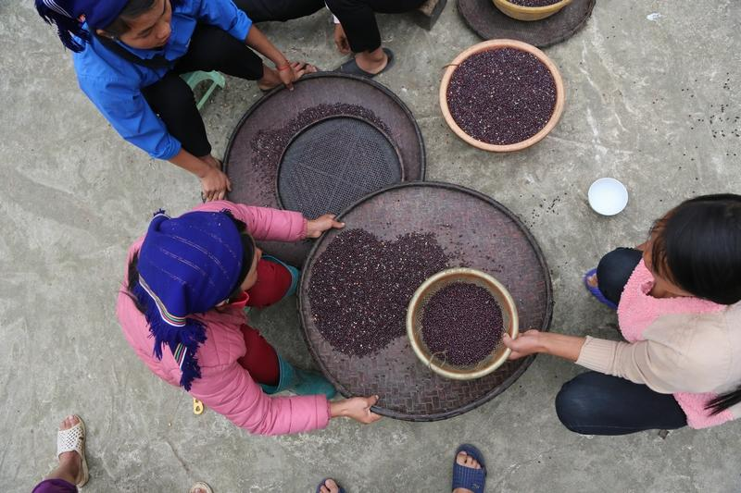
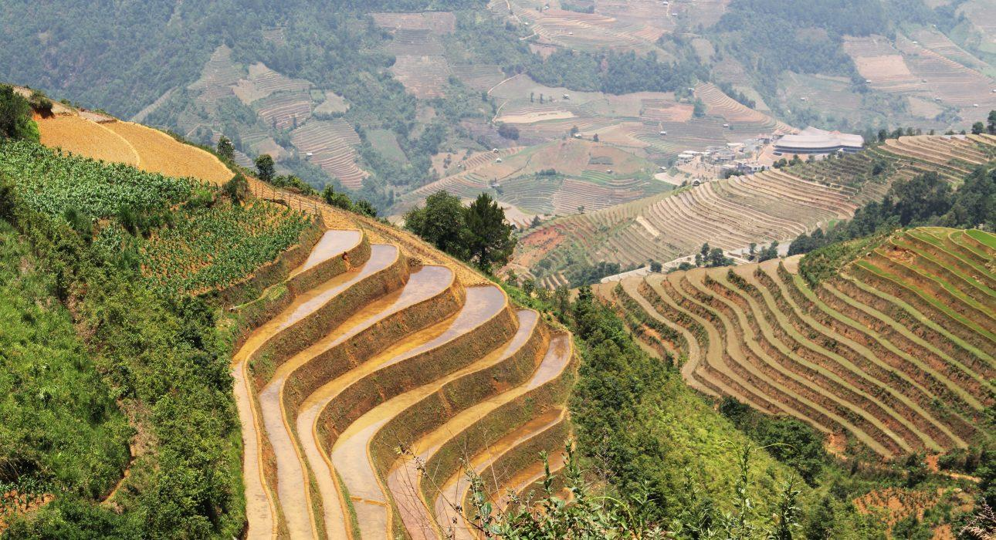
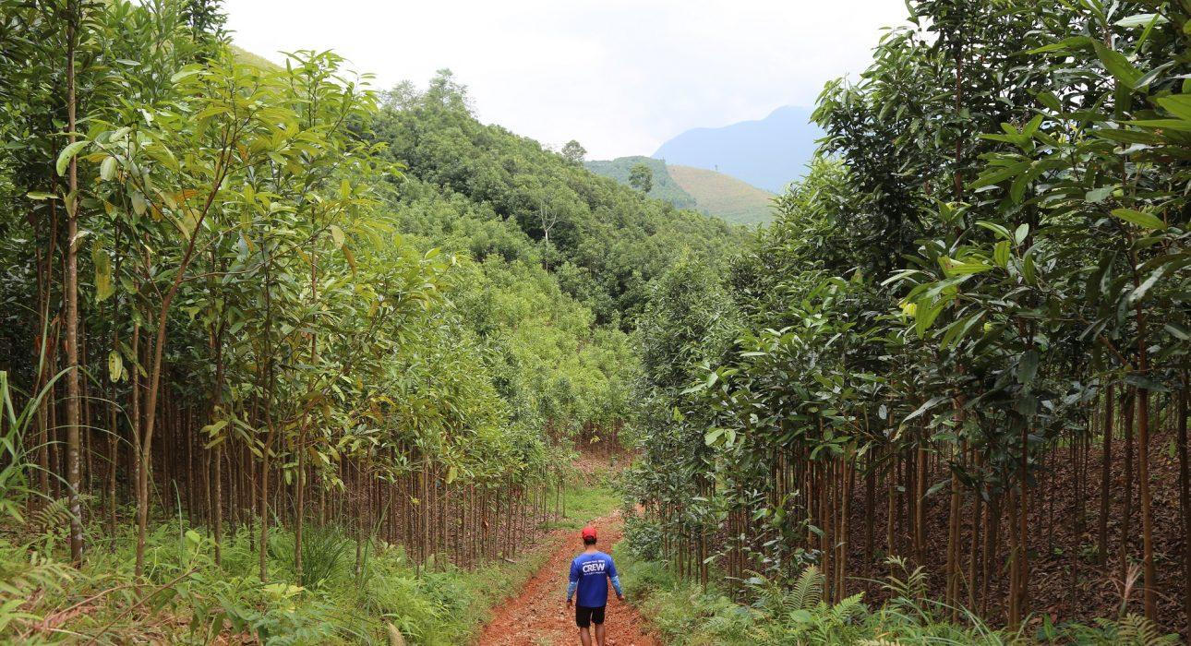
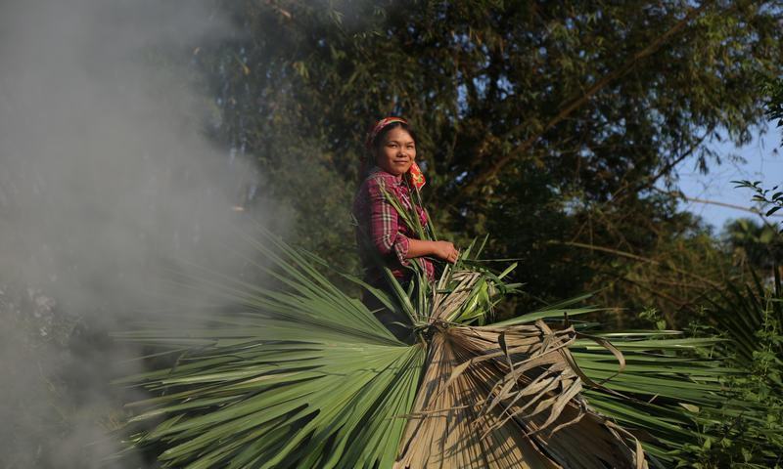
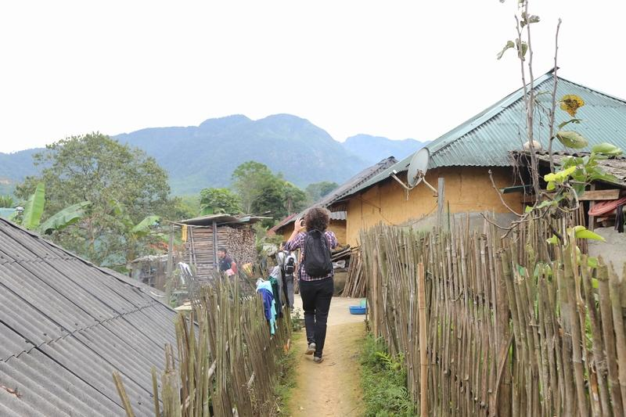
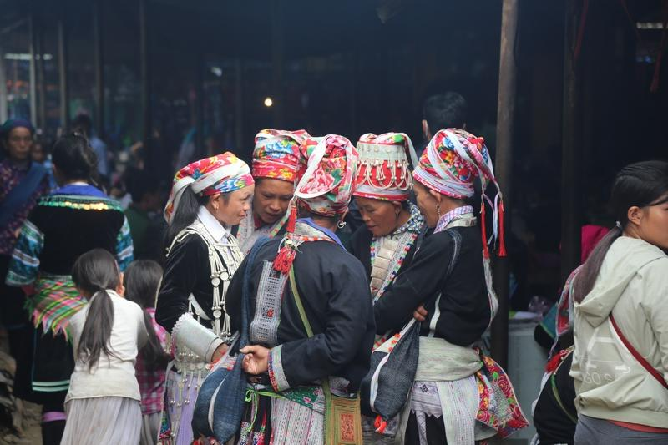
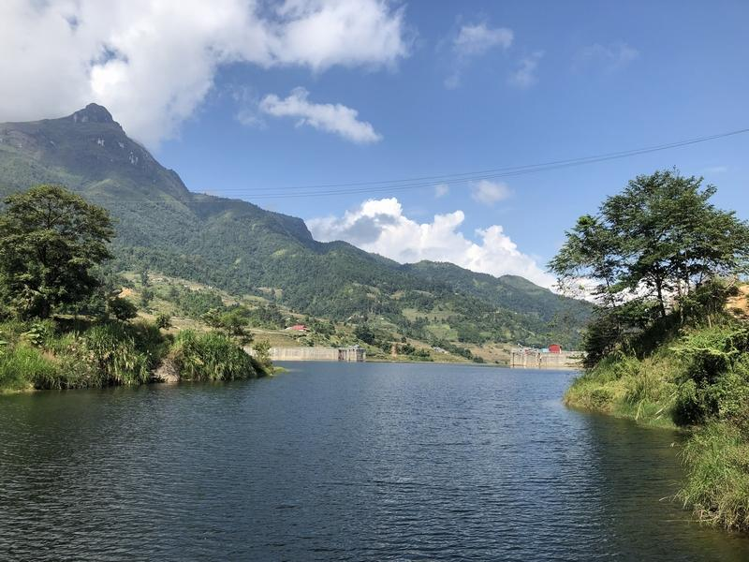
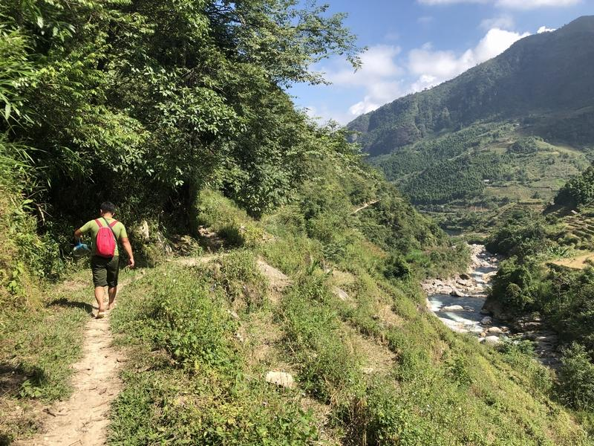
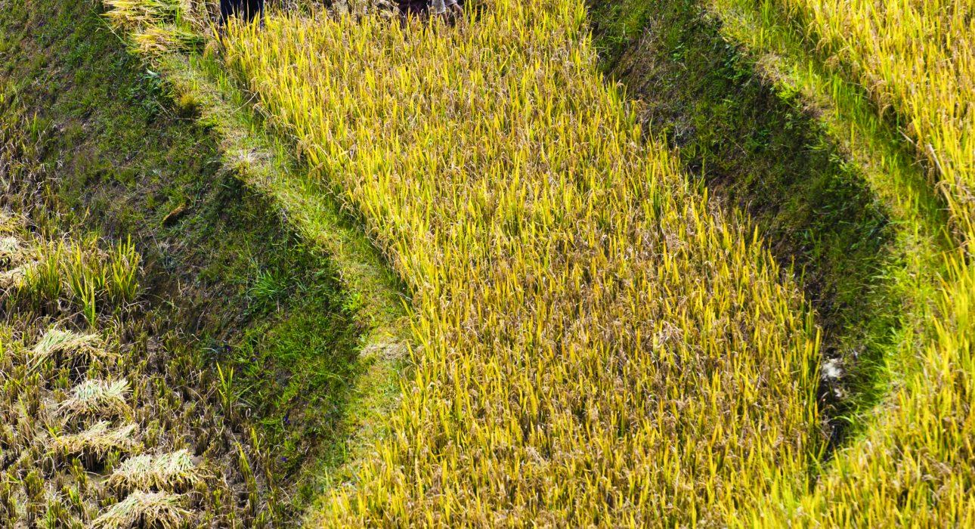
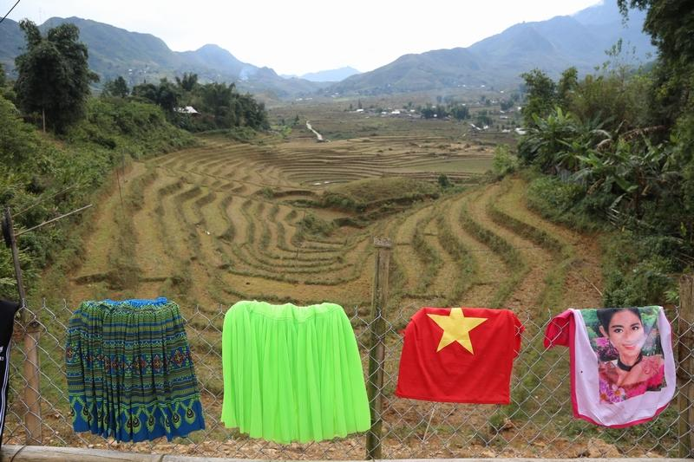

Easia Travel Head Office

EASIA TRAVEL HEAD OFFICEVietnam Head OfficeATS Hotel, Suite 326 &327, 33B Pham Ngu Lao Street, Hanoi, VietnamTel: +84 24-39 33 13 62www.easia-travel.com

