THAILAND – Bang Saphan – Koh Talu Experience 3D2N
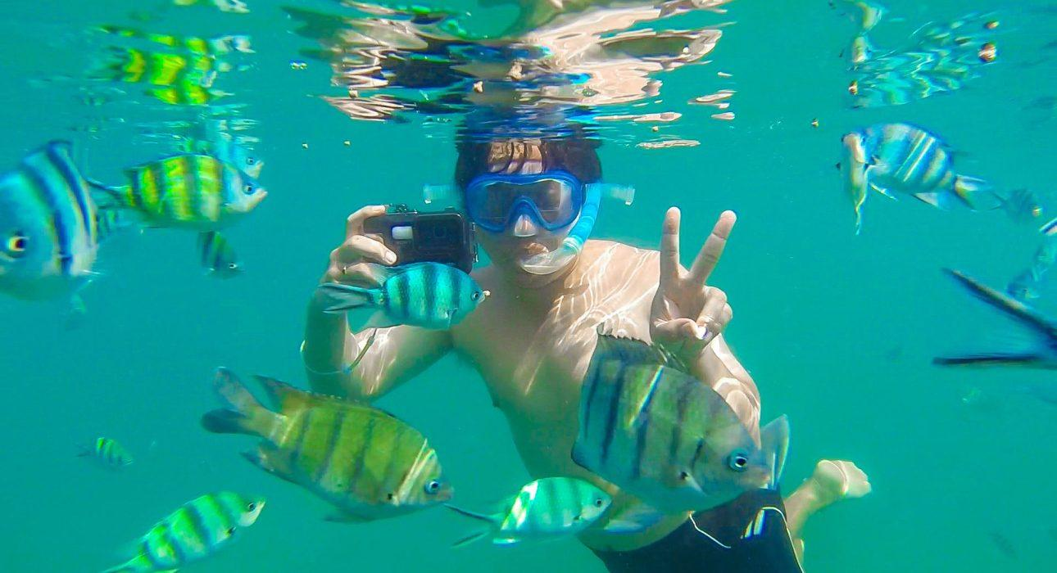

Over View

Theme
Beach Stay, Classic, Family, Honeymoon, Sustainable

Country - City
Bang Saphan

Level of difficulties
LEVEL 0

Price level
$$$$

Seasonality
All year round but recommended from the end of December to April - Not recommended in October

Max Pax
20

Market segment
Groups, Thematic Leisure

Arrival City
Hua Hin / Cha Am / Pranburi / Bang Saphan

Departure city
Bang Saphan

Itinerary

Number of days and nights
3 days - 2 nights

Day by day description
Day 1: Transfer to Bang Saphan – Koh TaluEarly in the morning, a join-in shuttle will operate a pick-up service from the main tourist areas around the island: Cha Am, Hua Hin, and Pranburi – these are the possible pick-up points to be transferred to Bang Saphan District to the pier where a speedboat will be waiting. After approximately 30 minutes on the speedboat, the Koh Talu experience will begin. In a very laid-back atmosphere, there will be an introduction by the Koh Talu Islanders before continuing to check in and enjoy lunch with a view over the bay.The afternoon is dedicated to discovering the island, with the possibility of doing a gentle hike to the best viewpoint, where the reward will be excellent panoramic views of the surroundings. Around 17:00, it will be time for one of the highlights of the Koh Talu Experience: squid fishing in the ocean at sunset. On board a floating raft, guests can catch their squid and eat them, grilled there and then, as delicious natural appetizers before returning to the island for dinner and relaxation in a peaceful atmosphere.
Day 2: Koh Talu DiscoveryThe second day will start with the second highlight of Koh Talu: a raft cruise to Chong Talu, a giant rock formation that is easily recognizable thanks to the large natural hole that gave the island its name. The surroundings, rock, sea, coral, and colorful underwater fauna make the snorkeling experience here unique. After lunch, the afternoon will be spent leisure, enjoying the beach entertainment, continuing snorkeling or kayaking (possibly right from the beach), or even trying some of the other sea activities proposed by the resort. At 17:00, there will be a visit to the Hawkbill Sea Turtle Nursery, which will provide the opportunity to learn more about the sea Turtle conservation project implemented by the island’s owner. The day will end with a seafood barbecue set (available for a 2-night stay only) – an ideal way to spend the last evening on the island.
Day 3: Koh Talu – Bang Saphan (Back to the mainland)The speedboat transfer back to the mainland is scheduled for 14:30, allowing plenty of time to enjoy Koh Talu (beach, snorkeling, kayaking, relaxing) until lunchtime.At 15:00, the speedboat will arrive at the pier and let travelers continue their holiday adventure to their next destination.

Selling points

- An eco-responsible experience with a nice story behind: (reconversion of Khun Preeda, a former fisherman, the Coral Conversation project, the story behind the Sea Turtle Nursery)
- An ideal escape (quickly accessible by boat) to experience with family, with a group of active friends, or even honeymooners
- A very lovely snorkeling and diving spot due to the coral replanting and rehabilitation project
- Currently, it is a destination that is not well known in Western markets.
- The private island concept (no other hotel to spoil the surroundings)
- The possible combination with Hua Hin (3 hours drive north)

Options

Activities
A lot of optional activities are available and possible (with supplement) – Please consult the sales department for a quotation
- Thai massage
- Sailing Introduction (Catamaran) – 3 persons)
- Squid fishing (Sunset cruise) (Private) – Max. 8 Persons
- Karaoke computer
- Live Music & Theme decoration
- Scuba diving (Trial dive)
- Scuba diving (Certification dive)

Extensions
- Package also available in 2D1N only.
- Additional extra night possible (with surcharge)

Photos

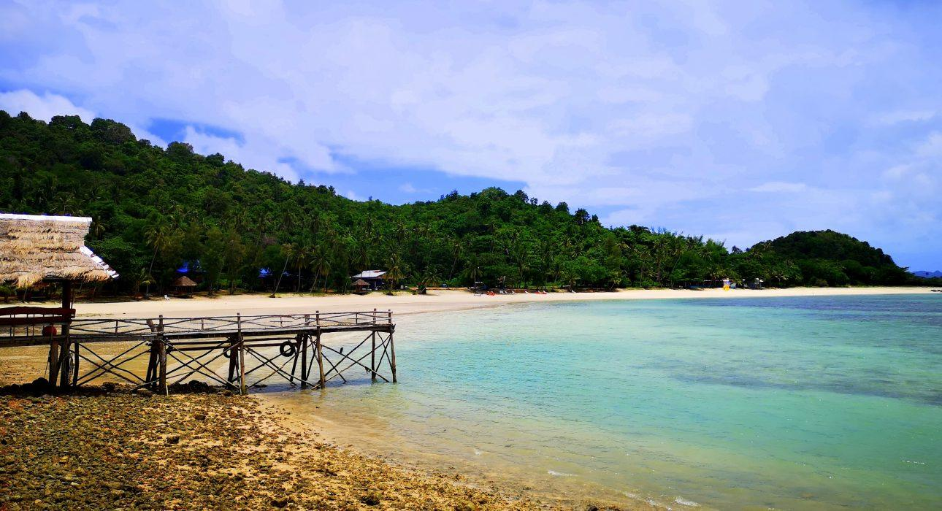
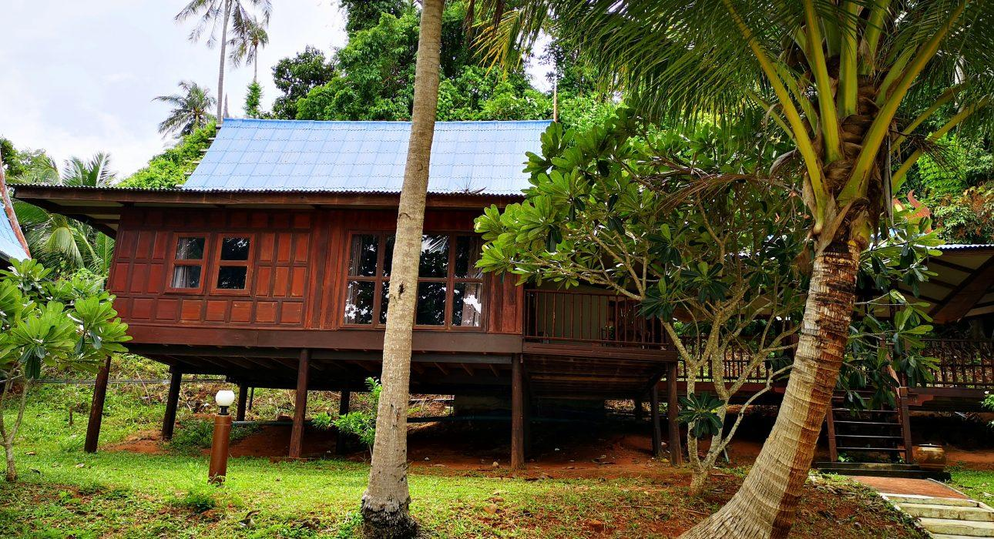
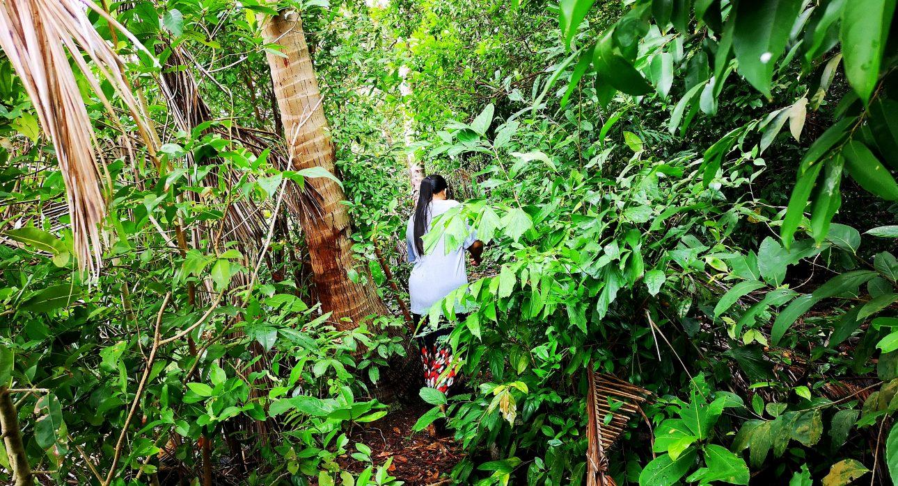
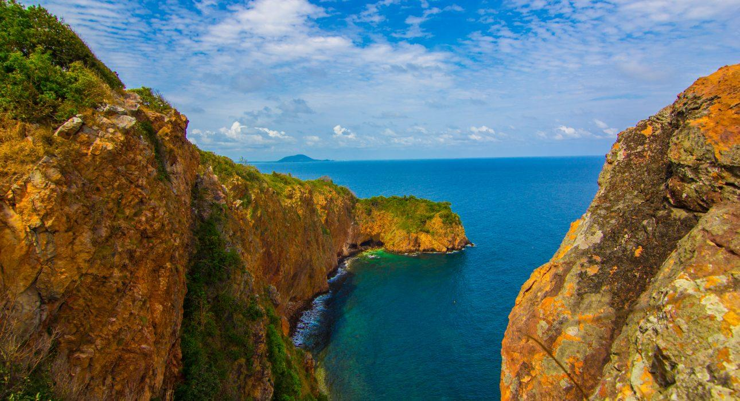
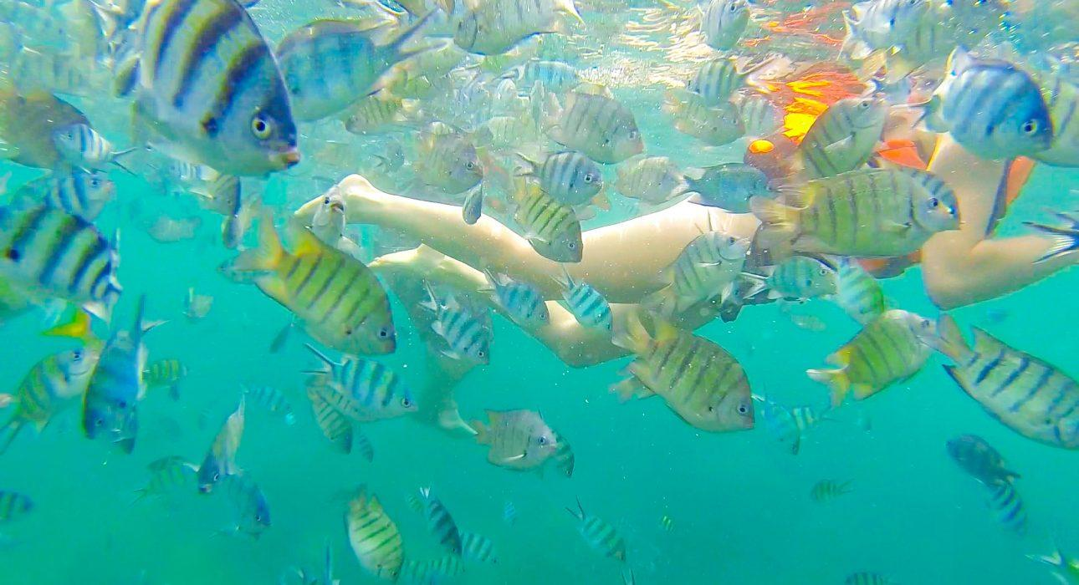
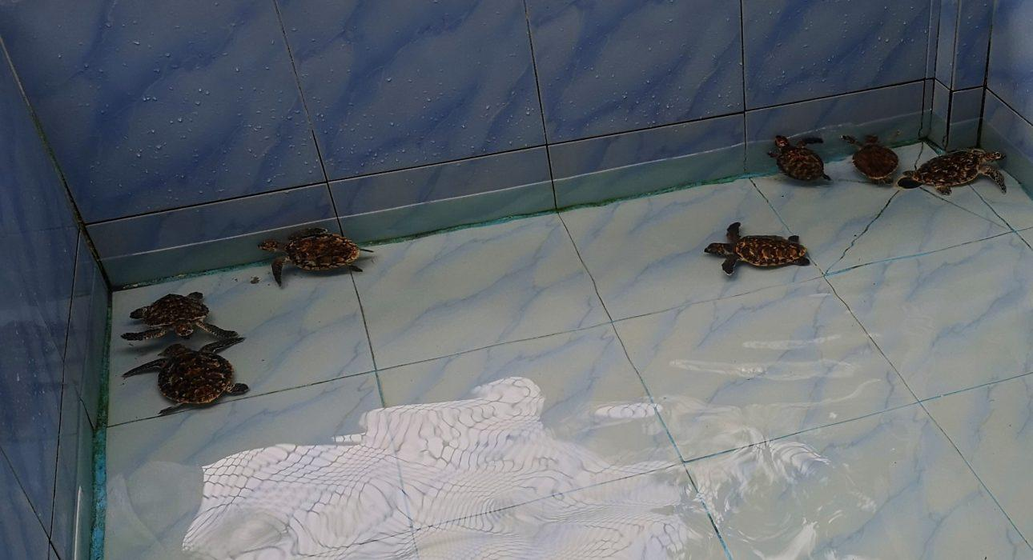
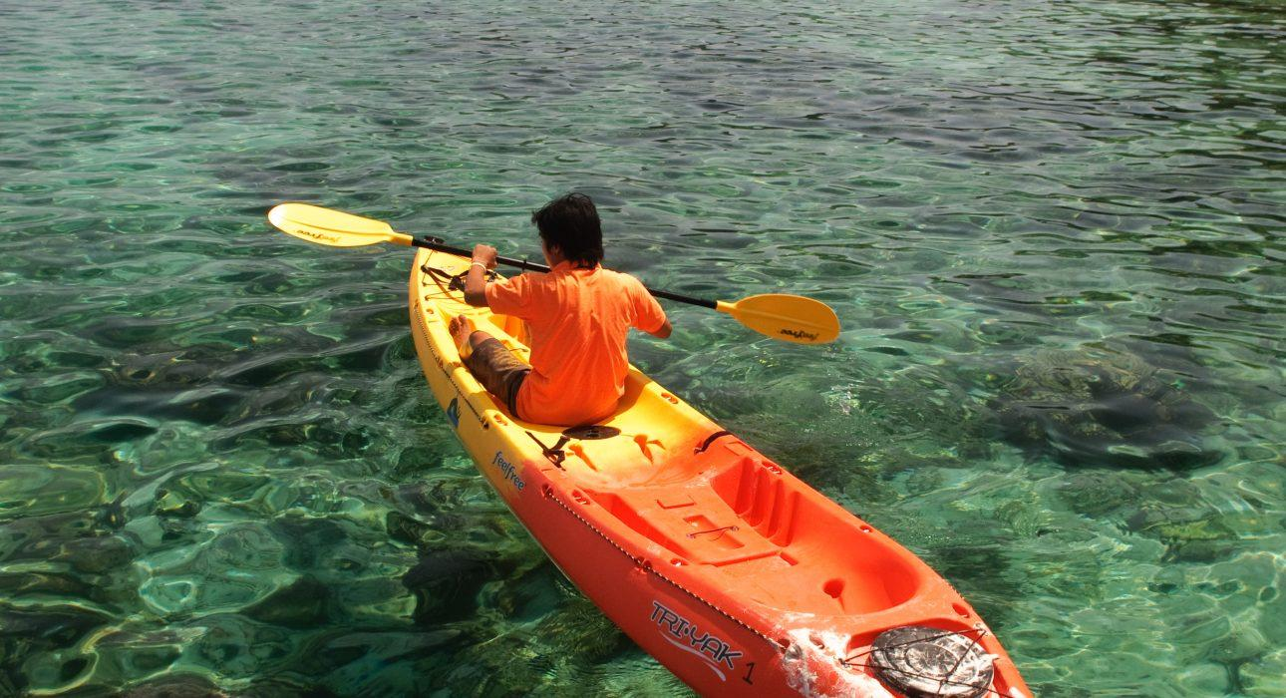
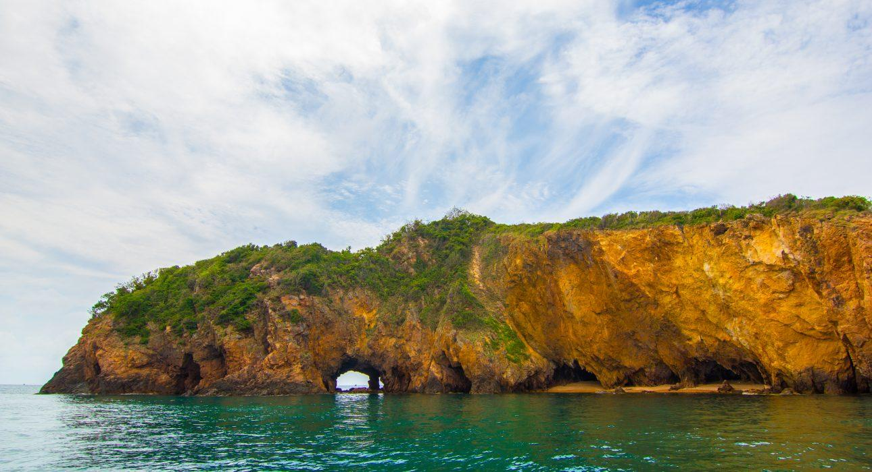
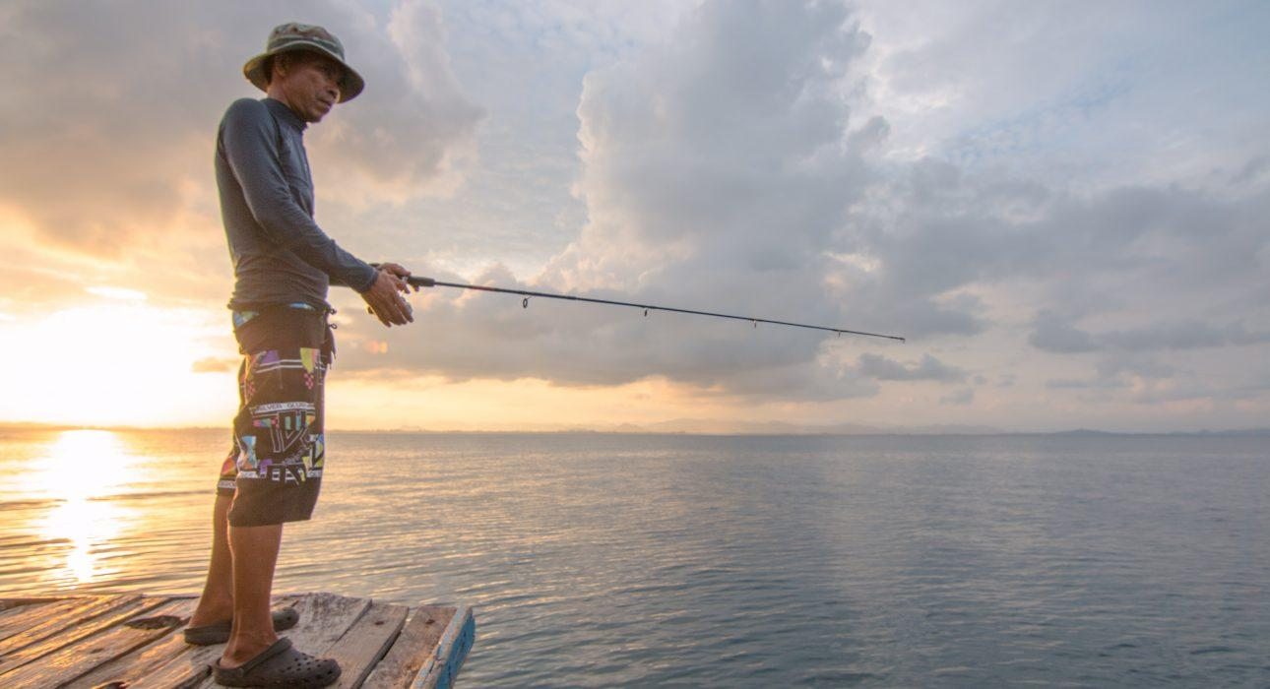
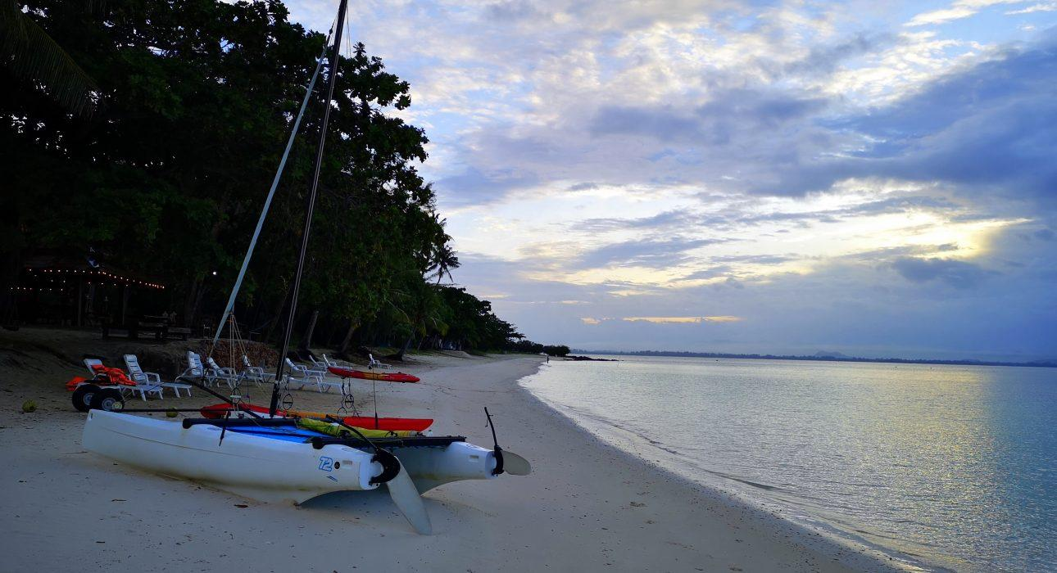

Easia Travel Head Office

