THAILAND – Khao Sok – Khao Sok Nature Adventures 4D3N
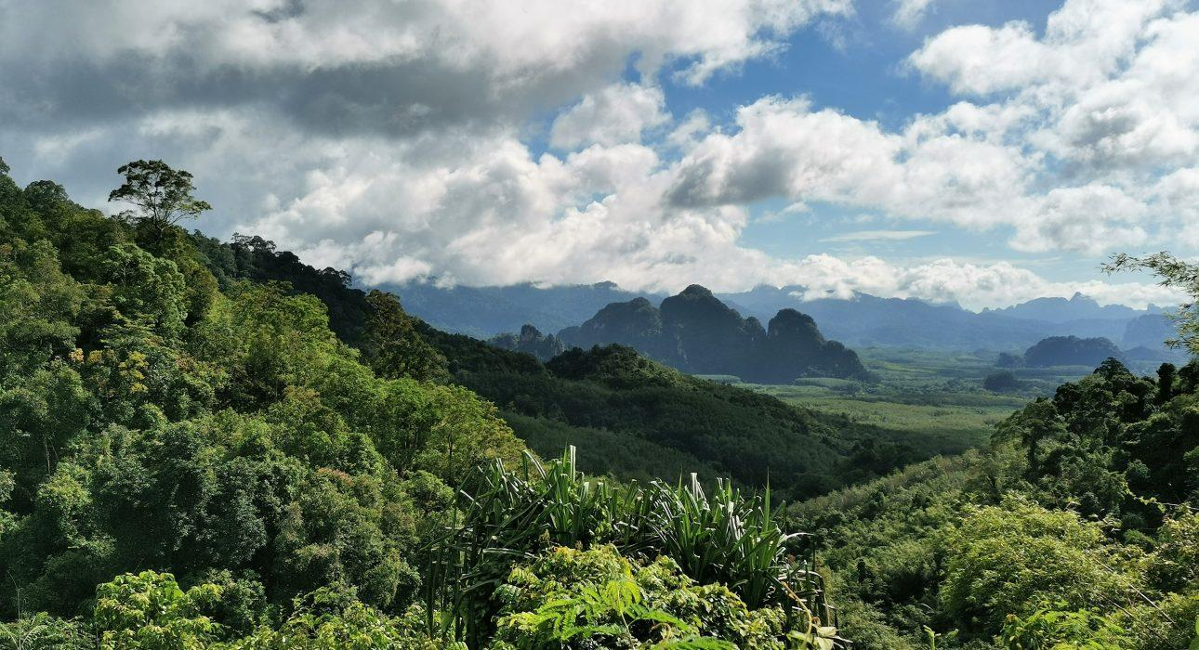

Over View

Theme
Sustainable

Country - City
Thailand - Phuket - Krabi - Phang Nga - Khao Lak - Khao Sok

Level of difficulties
LEVEL 1

Price level
$$$$

Seasonality
Recommended from November to May (will be humid and wet in the rainy season)

Max Pax
12

Market segment
Thematic Leisure

Arrival City
PHUKET/ SURAT THANI / KHAO LAK / KHURA / BURI / KRABI / RANONG

Departure city
PHUKET/ SURAT THANI / KHAO LAK / KHURA BURI / KRABI / RANONG

Itinerary

Number of days and nights
4 days - 3 nights

Day by day description
The itinerary begins with a private transfer from either Surat Thani / Khao Lak / Phuket / Krabi to Khao Sok National Park and the Khao Sok Riverside Cottages. Arrival is scheduled for lunch, after which a small overnight bag should be prepared for the exciting adventure of an overnight stay in a hammock in the jungle. Hiking in the heart of the jungle and rainforest, jungle cooking, and sharing moments with the expert guide around the campfire will provide an exciting and memorable experience in nature.
Return to the resort will be in time for lunch and the afternoon can then be spent at leisure relaxing in the bucolic settings along the riverbank. The overnight stay will be at Khao Sok Riverside Cottage.
The third day will be dedicated to the discovery of Cheow Larn Lake, culminating with the unique opportunity to stay overnight on the lake amidst dream-like scenery. The sounds of nature and wildlife on the lake provide a natural wake-up call before guests spend free time enjoying the last moments on the lake: kayaking, swimming or relaxing until lunch and the longtail boat transfer back to the Ratchaprapha dam and then onward transfer to the next destination.

Selling points

- A tailor-made tour offering a different perspective and discovery of Khao Sok National Park
- 3 alternative experiences and ways to experience Khao Sok: cottage / camping in the jungle / floating raft
- The unique experience of a night in a hammock in the jungle
- Ideal for soft adventurer travelers, but also families or couples looking for adventure
- An experience close to nature – ideal for nature lovers
- A true discovery of Khao Sok guided by trained expert local guides

Options

Activities
The program is already quite full but on either of the 2 days, during the afternoon at leisure, guests can enjoy the following optional activities (not included but possible to add in the program)
- Canoe Tour on Sok River
- Bamboo rafting
- Elephant bathing experience
- Massage

Extensions
- Additional nights in Khao Sok or in Cheow Larn Lake are always possible

Photos

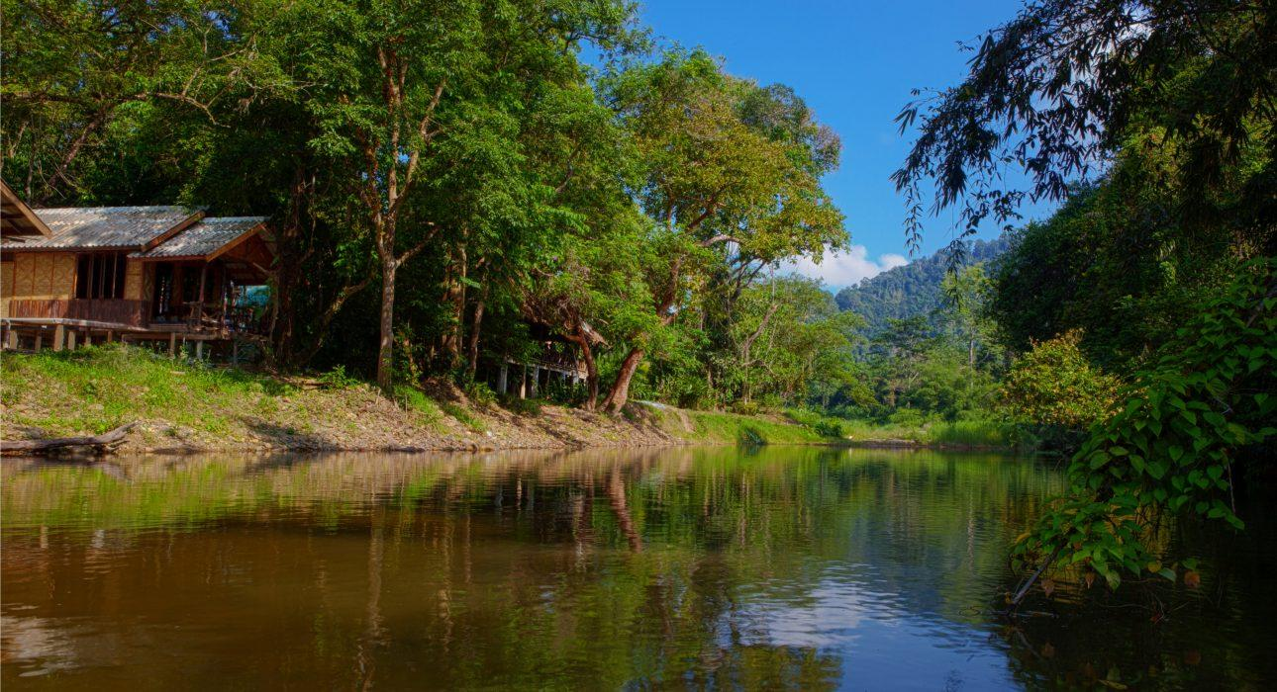
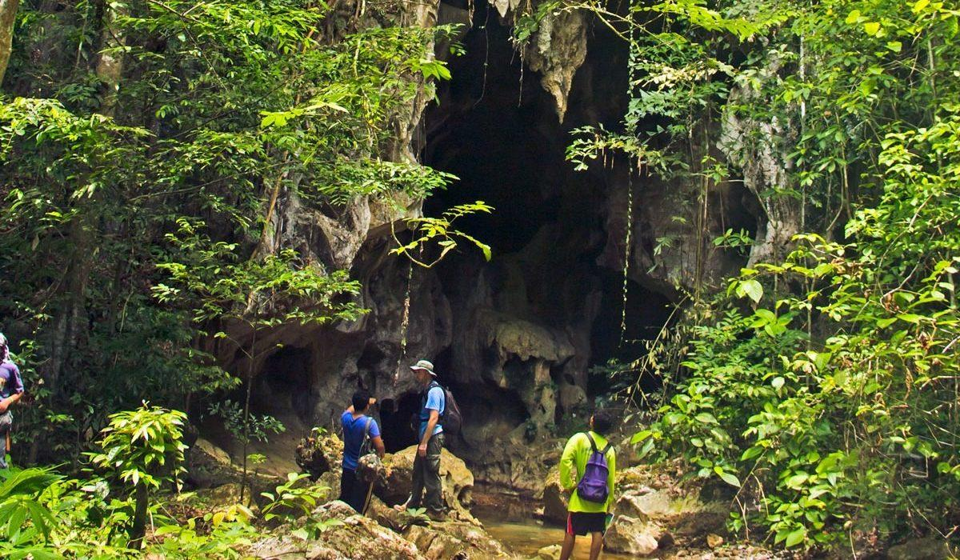
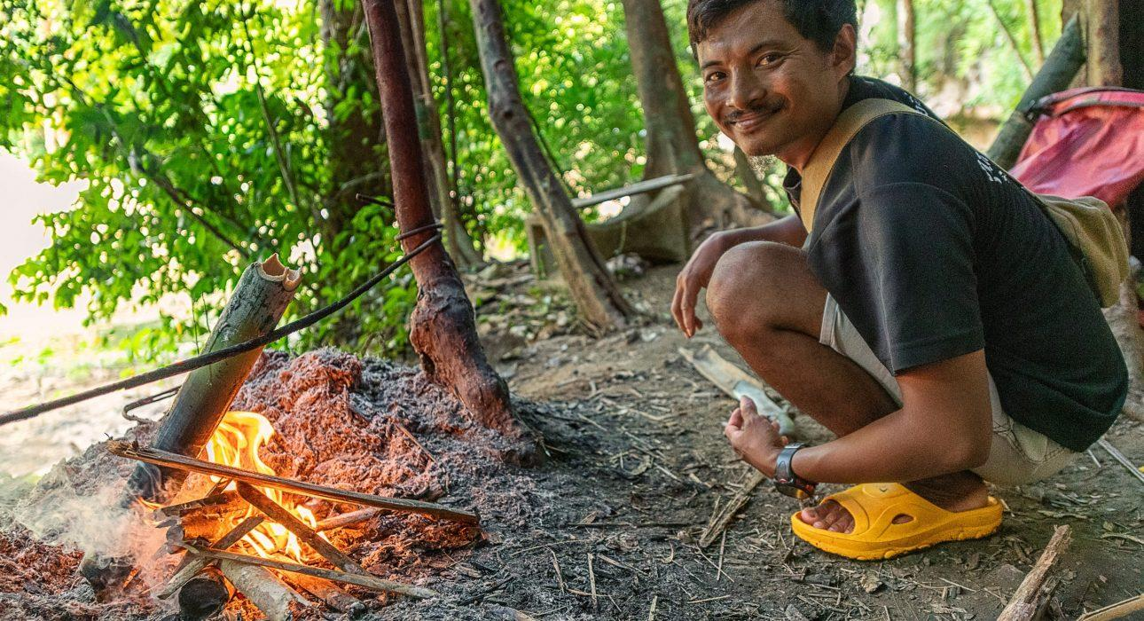
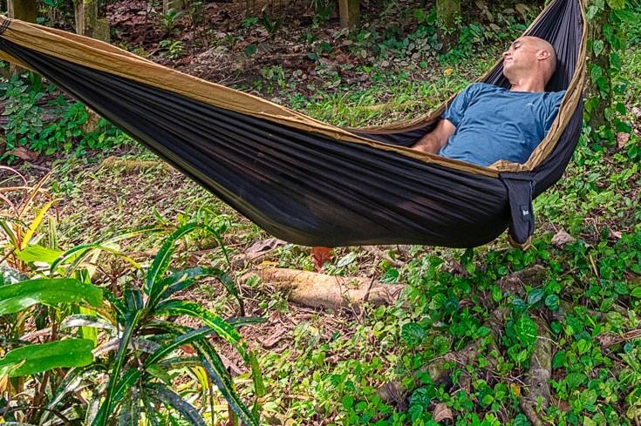
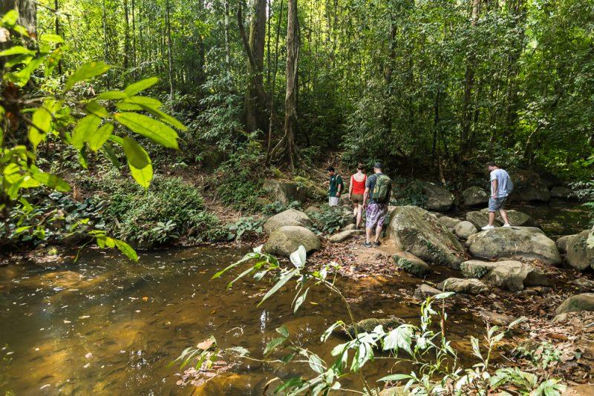
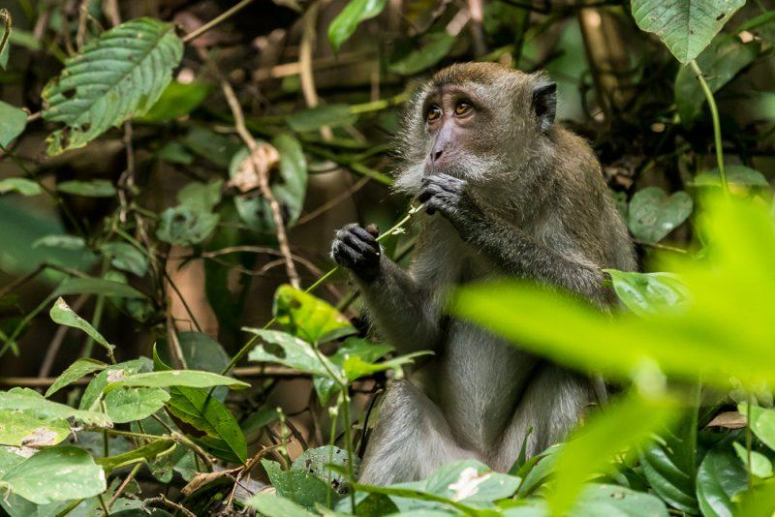
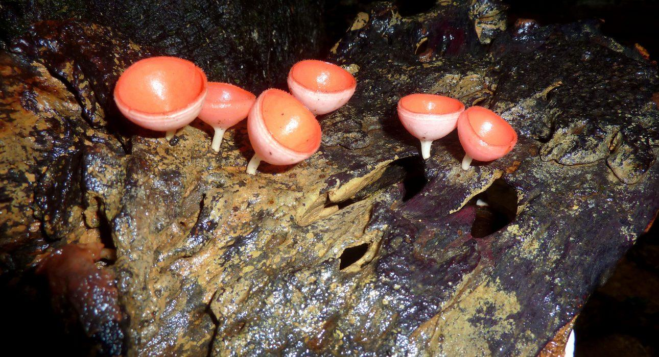
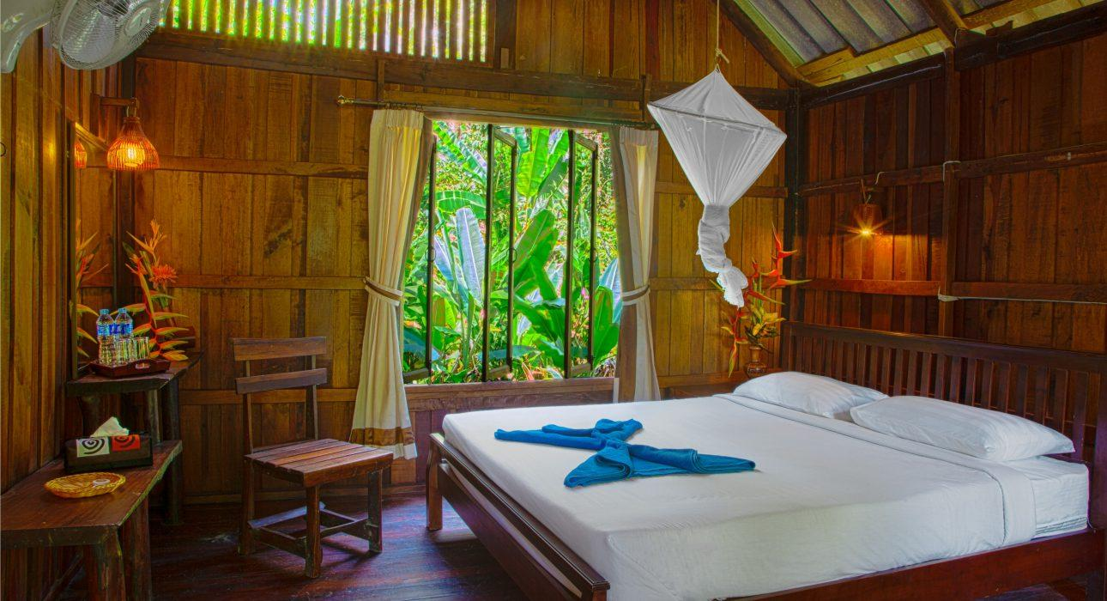
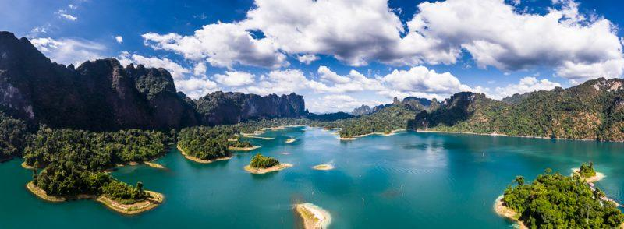
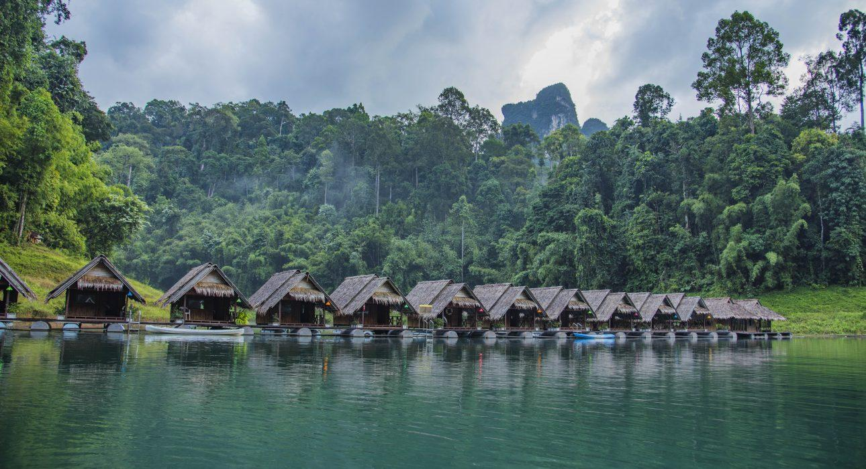

Easia Travel Head Office

