LAOS – Nong Khiaw- Self-Guided Tour in Nong Khiaw - Muang Ngoi 3D2N
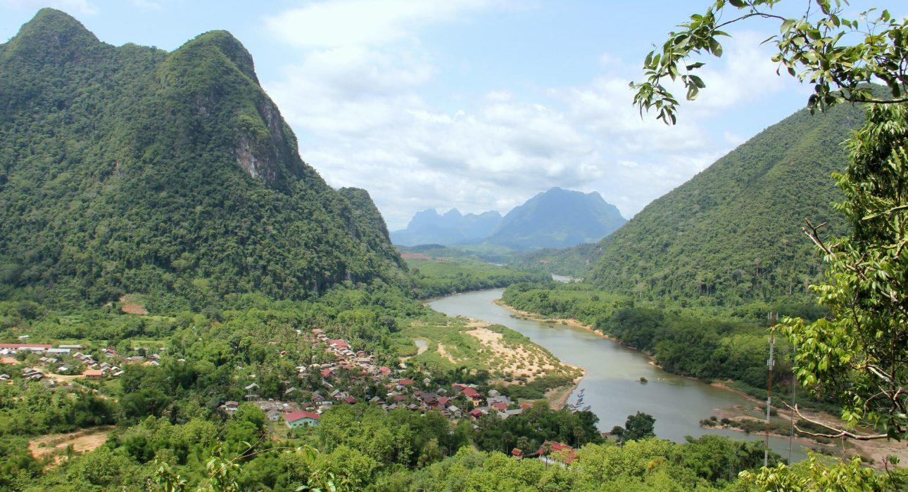

Over View

Theme
Self-Guided Tours, Sustainable

Country - City
Laos - Muang Ngoi - Nong Khiaw

Level of difficulties
LEVEL 1

Price level
$$$$

Seasonality
October to March

Max Pax
10

Market segment
Groups, Thematic Leisure

Arrival City
Luang Prabang

Departure city
Luang Prabang

Itinerary

Number of days and nights
3 days & 2 nights

Day by day description
This experience provides an in-depth discovery of Nong Khiaw and Muang Ngoi with the help of pre-loaded itineraries on the smartphone of the travelers. With clear GPS routing and indications (including pictures & videos) on the navigation & points of interest, this itinerary focuses on exploring the beautiful countryside and the stunning natural wonders in and around Nong Khiaw and nearby Muang Ngoi. The highlights of this adventure are the river cruise to Muang Ngoi along the picturesque Nam Ou River and the hike through the rice fields of Ban Na. These are complemented by a visit to Phatok Cave – a hideout from the Indochina War – and a hike to a stunning panoramic viewpoint overlooking Nong Khiaw and considered by many to be the best viewpoint in Laos. A visit to Nong Khiaw and Muang Ngoi provides travelers with a unique and unforgettable experience, on their own and at their own pace and without the need for a local guide.

Selling points

- Carefully selected activities providing a guided discovery of one of the most beautiful regions of northern Laos and its rice fields, mountains, caves, viewpoints, and small villages.
- An application filled with GPS routes and point of interests for travelers to explore the Nong Khiaw and Muang Ngoi regions of northern Laos on their own.
- A well structured program providing a full visit of these stunning places.
- A 3 day 2 night trip with stunning riverside accommodation providing a level of comfort rarely found in rural Laos.
- Possible to combine with other self-guided tours in Laos to create a self-guided itinerary.

Options

Extensions
It is good to combine with the following modules:
- LAOS – Luang Prabang – Self-Guided Tour in Northern and Central Laos 7D6N
- LAOS – Luang Prabang – Self-Guided Tour in Luang Prabang 4D3N
If travelers include Vang Vieng in their self-guided Laos itinerary we suggest including:
- LAOS – Vang Vieng – Vang Vieng Self-Guided Hiking
If travelers include Vientiane in their self-guided Laos itinerary we suggest including:
- LAOS – Vientiane – Vientiane Self-Guided City Tour
If travelers include Luang Prabang in their self-guided Laos itinerary we suggest including:
- LAOS – Luang Prabang – Luang Prabang Self-Guided City Tour (full day or half day options available)
- LAOS- Luang Prabang – Luang Prabang Self-Guided Food Tour
- LAOS – Luang Prabang – Self-Guided Hike from Ban Long Lao to Kuang Sy
If travelers include Hinboun in their self-guided Laos itinerary we suggest including:
- LAOS – Hinboun – Self-Guided Tour in Hinboun 3D2N

Photos

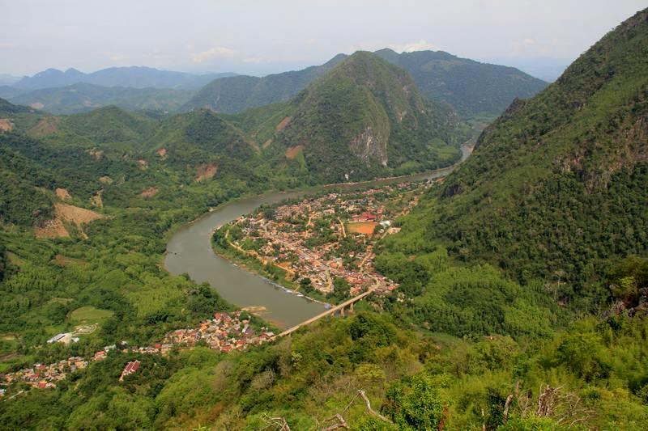
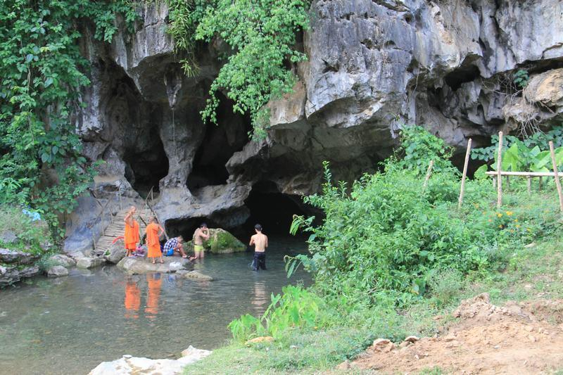
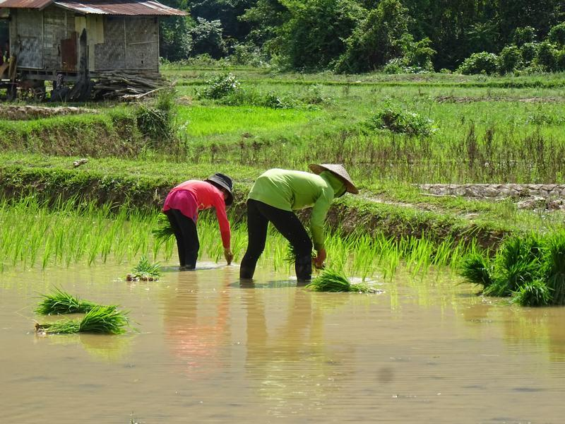
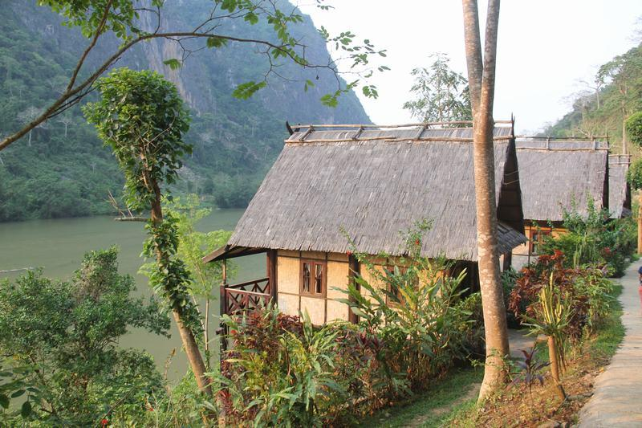
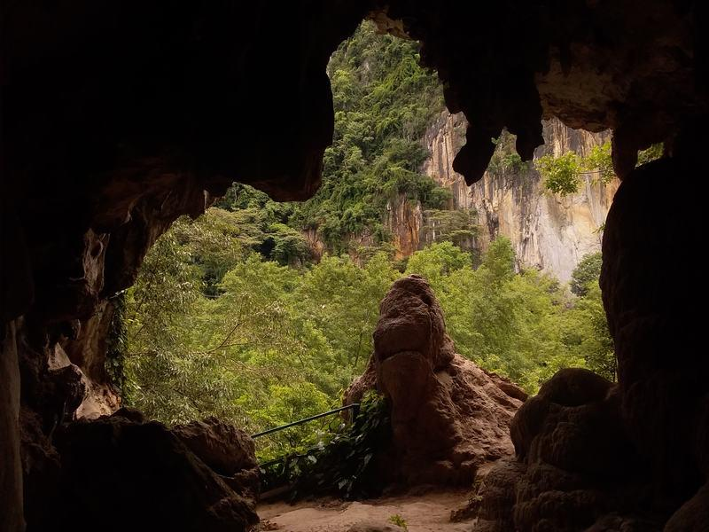
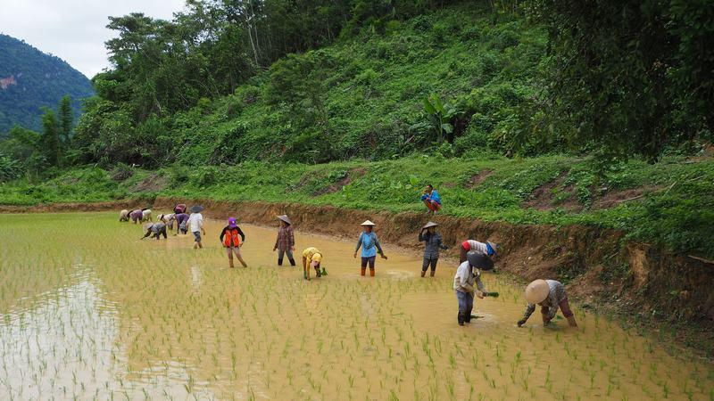
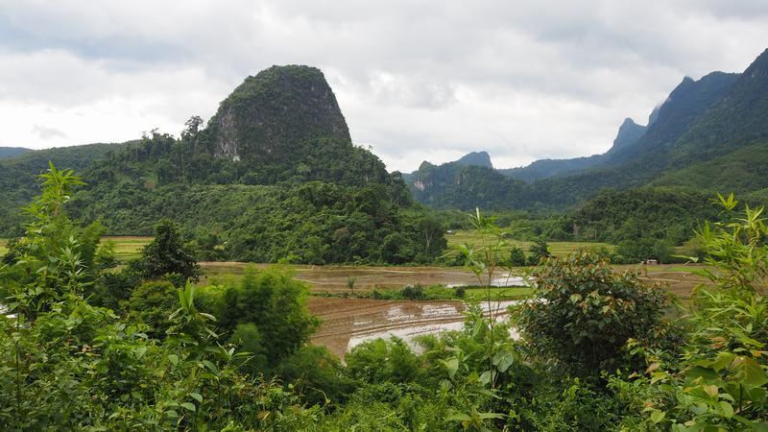
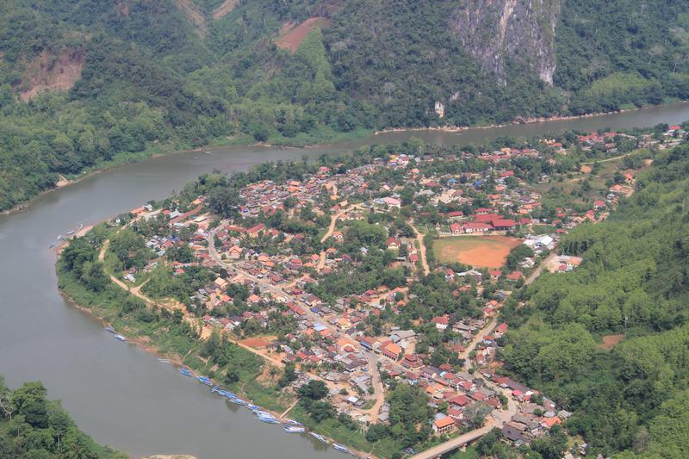
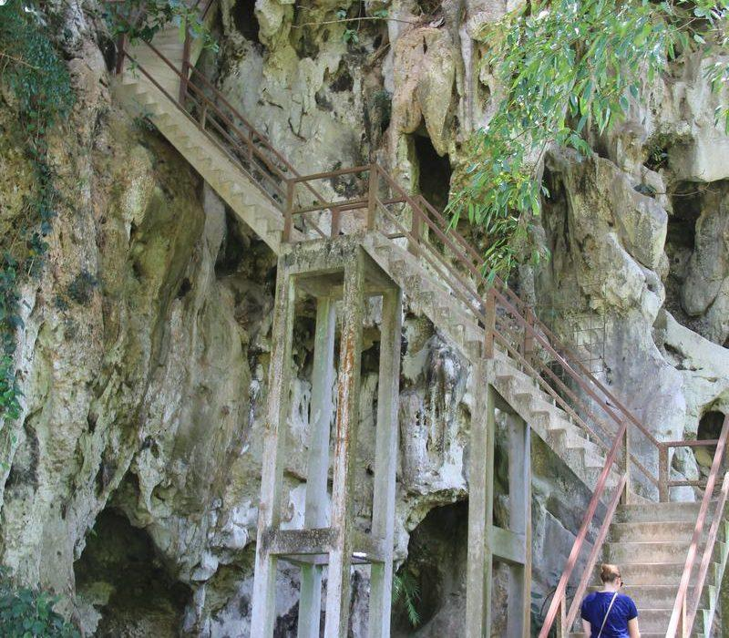
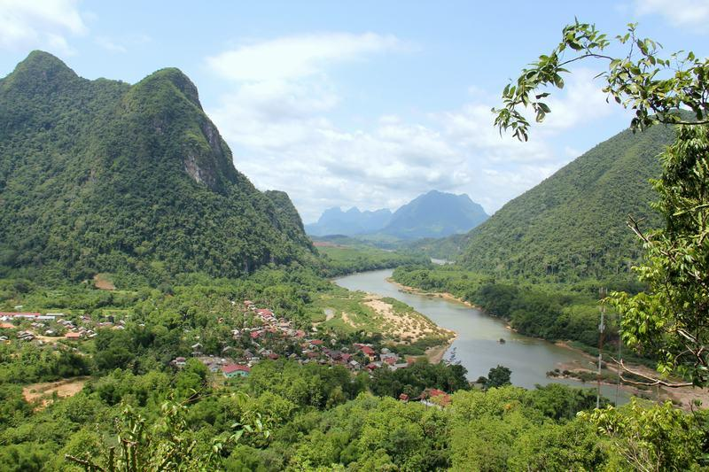
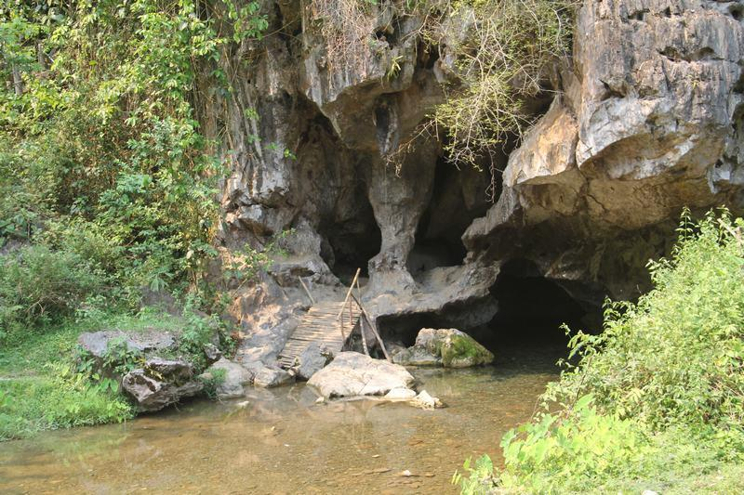
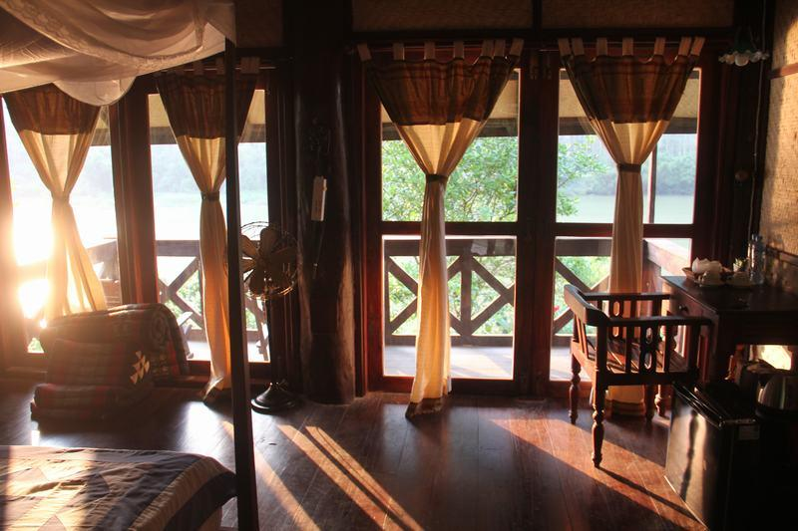
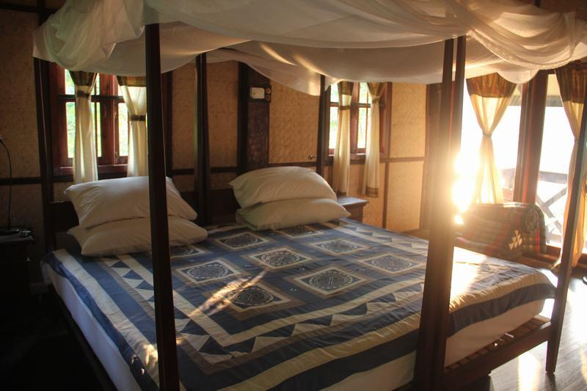

Easia Travel Head Office

Vietnam Head OfficeC/o: ATS Hotel, Suite 326 &327, 33B Pham Ngu Lao Street, Hanoi, VietnamTel: +84 24-39 33 13 62www.easia-travel.com

