VIETNAM – Hanoi – Self-Guided Tour in the Red River Delta 5D4N
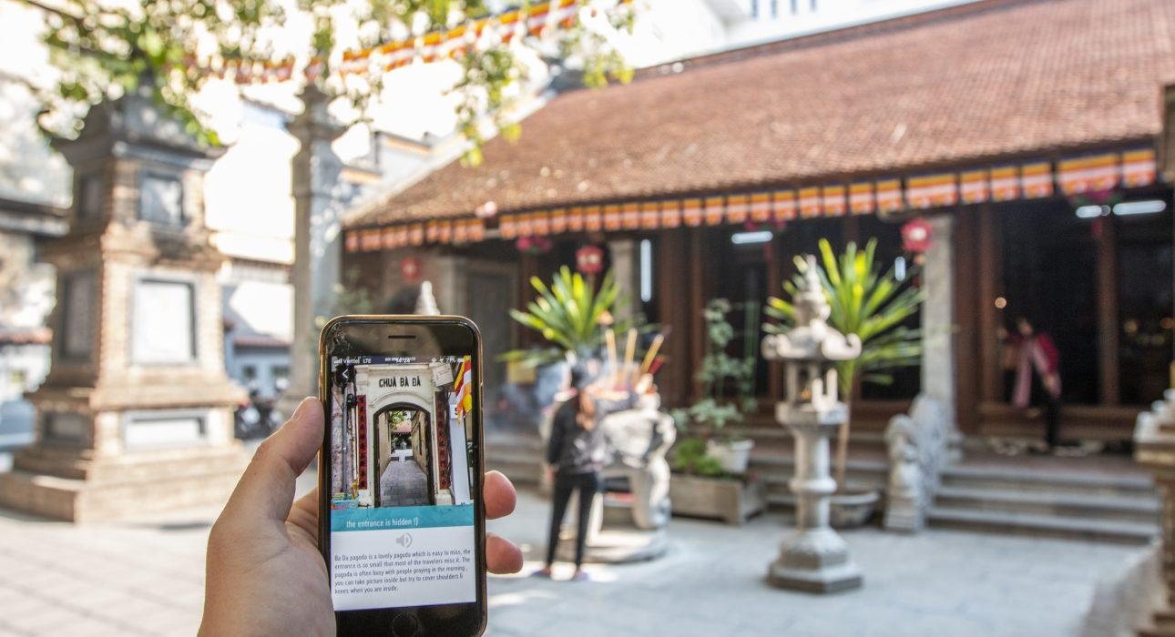

Over View

Theme
Classic, Self-Guided Tours

Country - City
Vietnam - Hanoi - Ninh Binh

Level of difficulties
LEVEL 0

Price level
$$$$

Seasonality
All year long

Max Pax
10

Market segment
Thematic Leisure

Arrival City
Hanoi

Departure city
Hanoi

Itinerary

Number of days and nights
5 days & 4 nights

Day by day description
This itinerary provides a chance to explore Hanoi, Ninh Binh, and Halong Bay on a self-guided tour. By using an App pre-loaded with essential practical information and an itinerary, it will be easy to explore Northern Vietnam in-depth and self-guided. The valuable information includes recommendations of small hidden restaurants, suggested itineraries for food tours (both for lunch & dinners), sustainable shopping places, and clear guidance on rowing-boat tours in Ninh Binh. Several activities include a walking tour to explore Hanoi’s rich history, a cycling tour in Ninh Binh, and an overnight cruise in Halong Bay on land.

Selling points

- Most travelers requested the highlights of Vietnam… but without a guide!
- A 5 days program packed with different experiences, from walking in Hanoi’s old quarter to cycling in Ninh Binh or kayaking on Halong Bay!
- Great recommendations for foods with some of the best local restaurants in Hanoi already loaded in the App
- A balanced itinerary with specific activities, free time, and different options available for travelers (potential more extended cycling tour in Ninh Binh, recommended food excursion in Hanoi, etc.).
- Additional documents available for the travelers (the signature dishes not to be missed, for example).

Sustainability

Level Of The Excursion
Low - This activity impacts local community, culture and/or environment in a small but meaningful way

The Impact Of This Excursion

Social/cultural Impact
Cultural Conservation

Environment Impact
Transportation

Economic Impact
Local individual benefits, Community benefits

Additional Information
Positive Impact:This itinerary introduces travelers to Vietnamese culture in an easy way for them to understand. While some visits are done walking, cycling, or kayaking, the impact remains low due to the inclusion of the overnight cruise in Halong (which has a negative impact).Negative Impact:The itinerary does not provide employment to local guides. It also includes an overnight cruise in Halong, which is generally seen as having a negative impact on sustainability.

Options

Photos

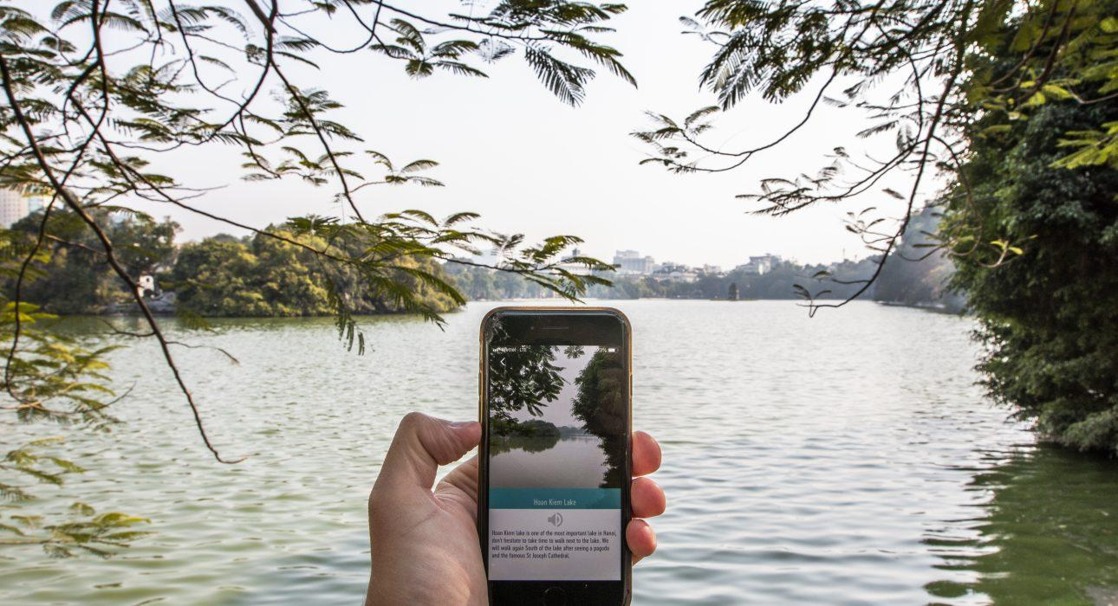
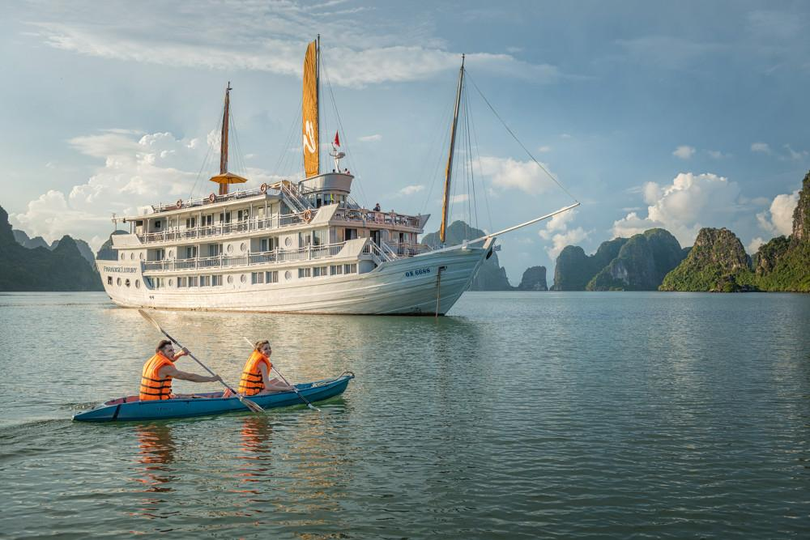
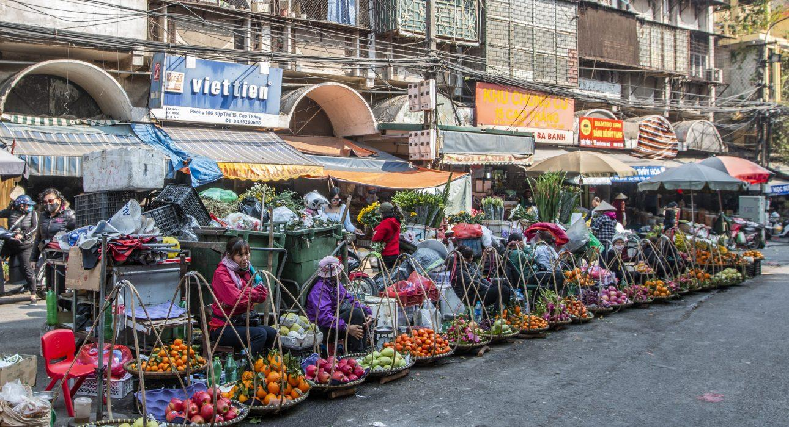
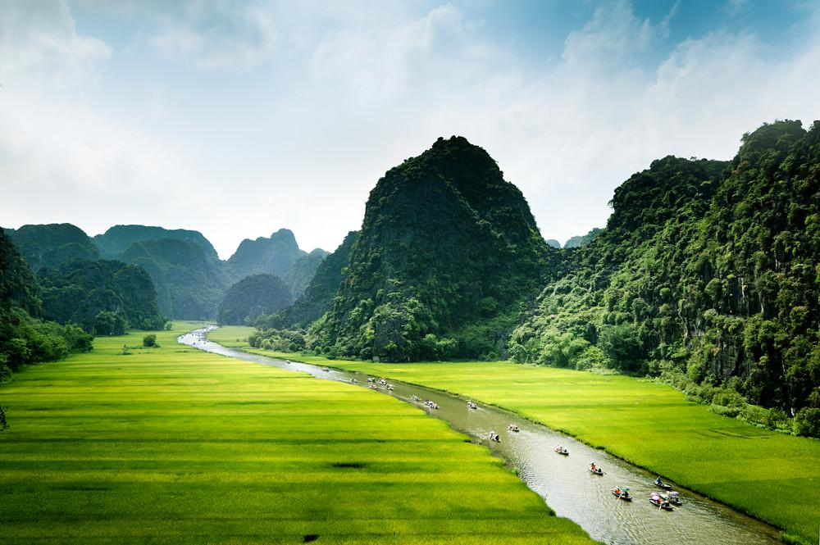
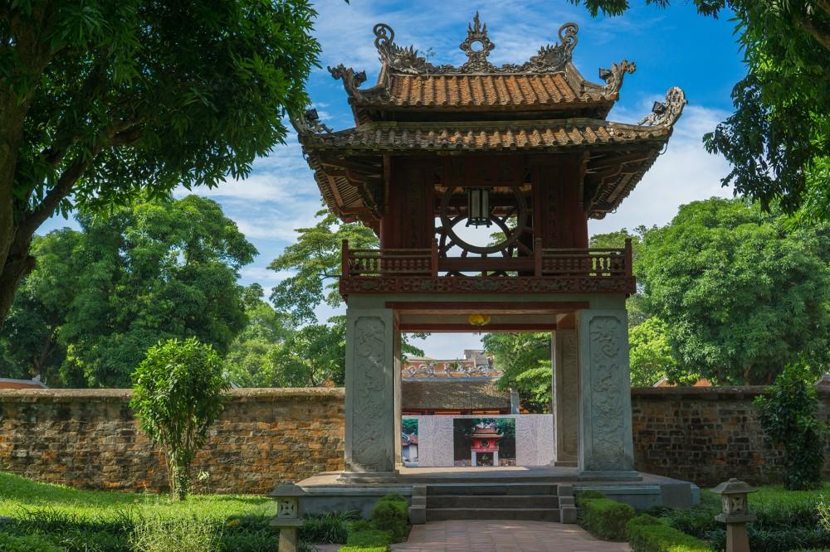
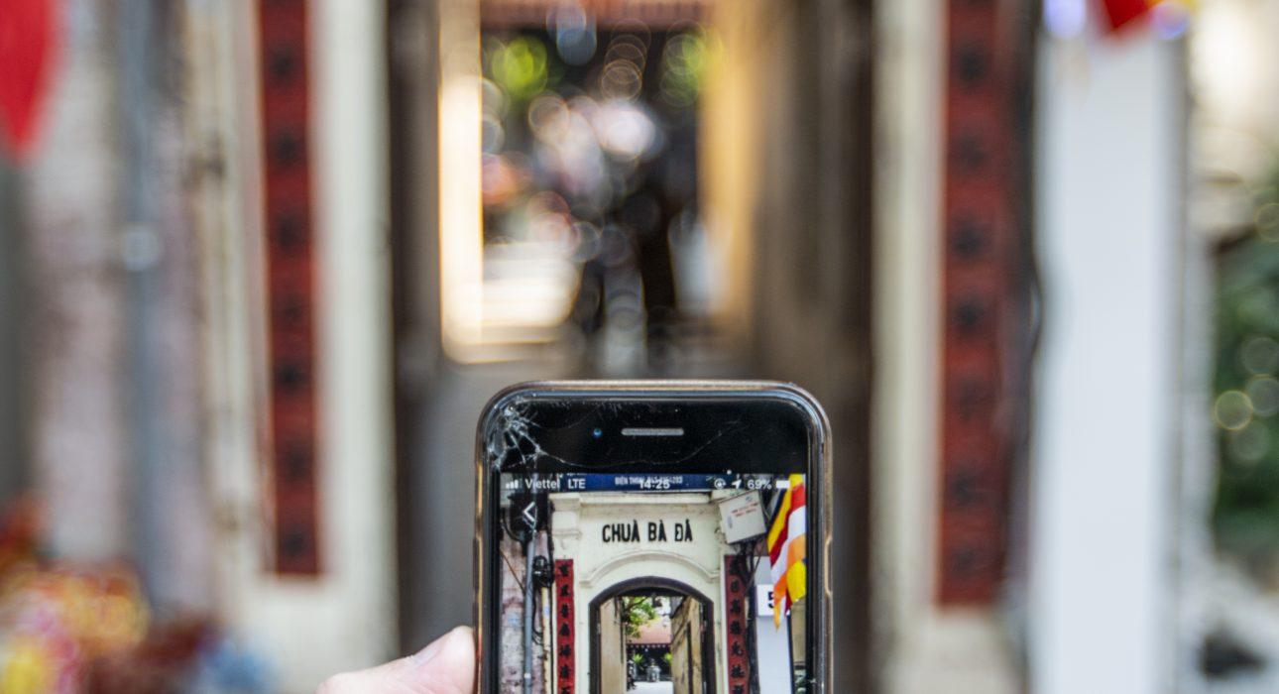
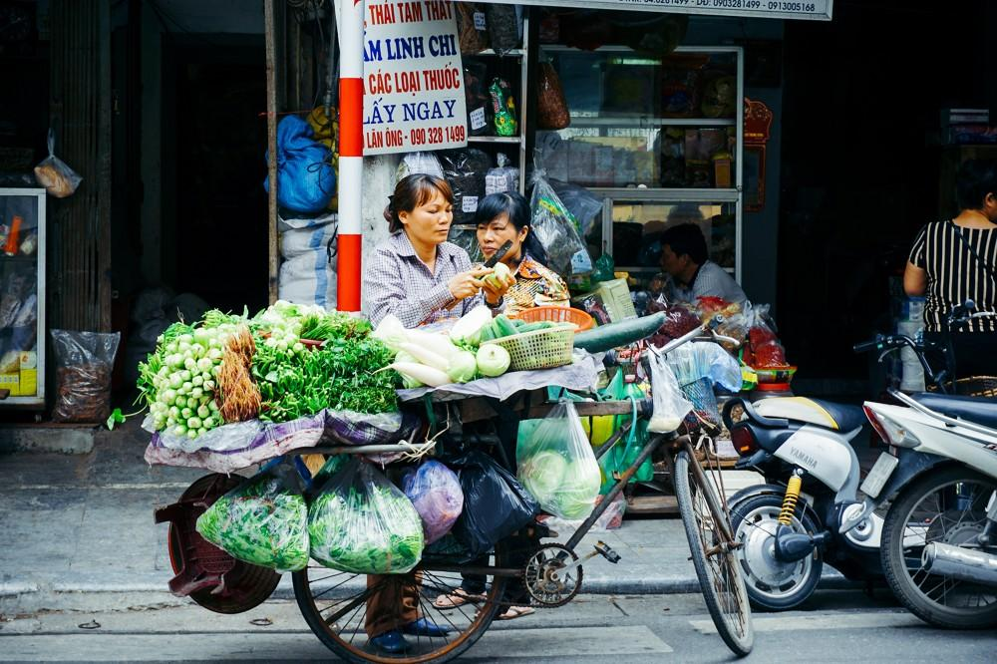
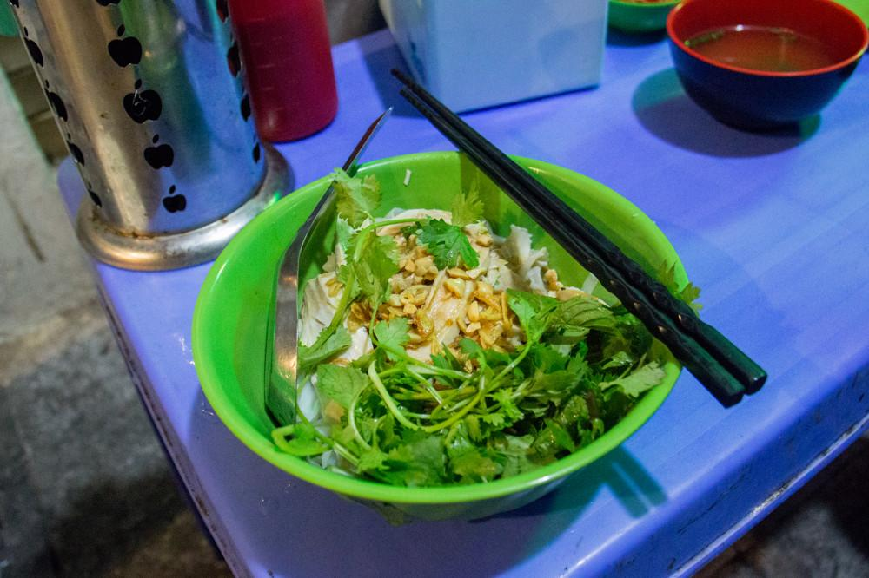
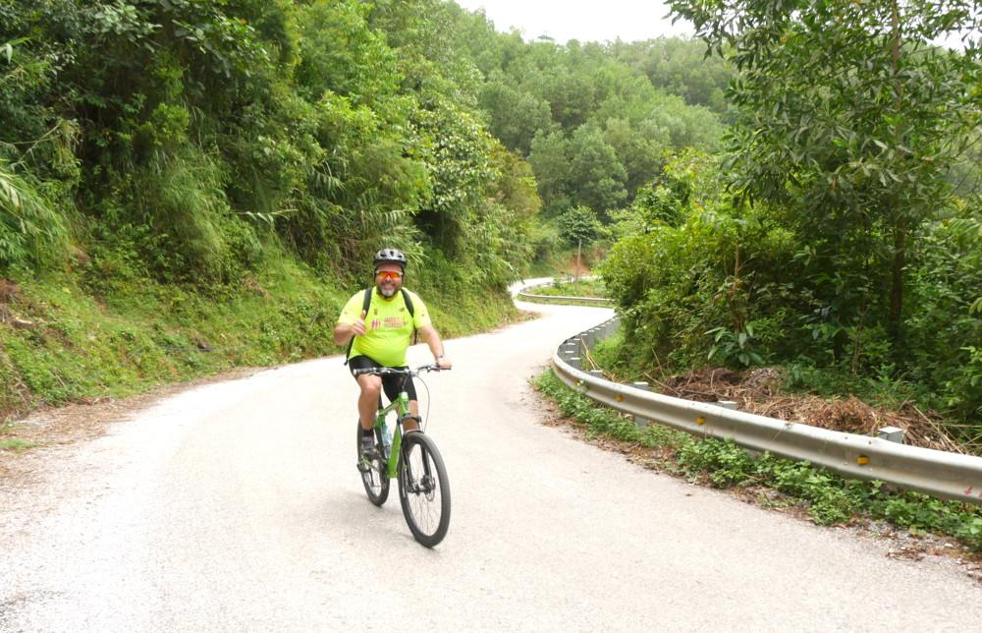
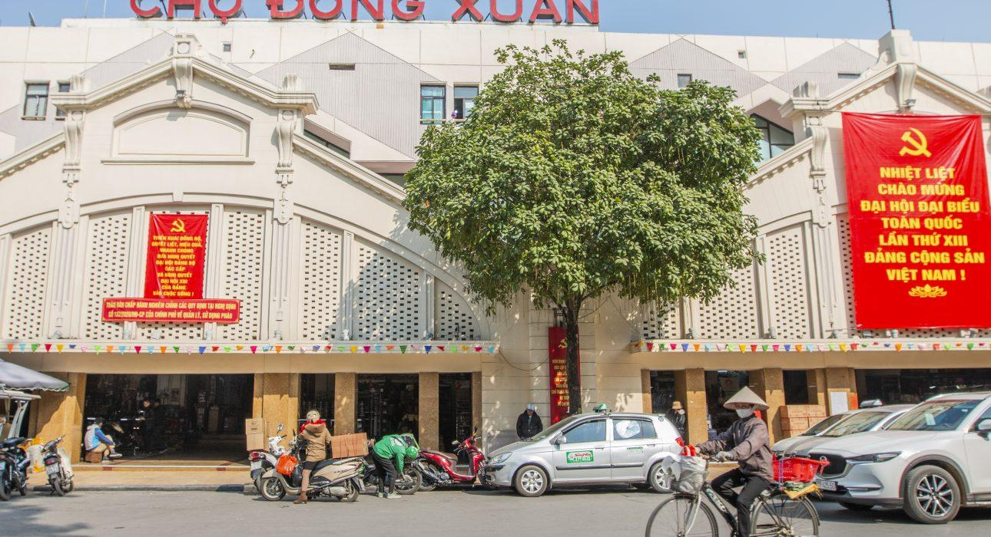
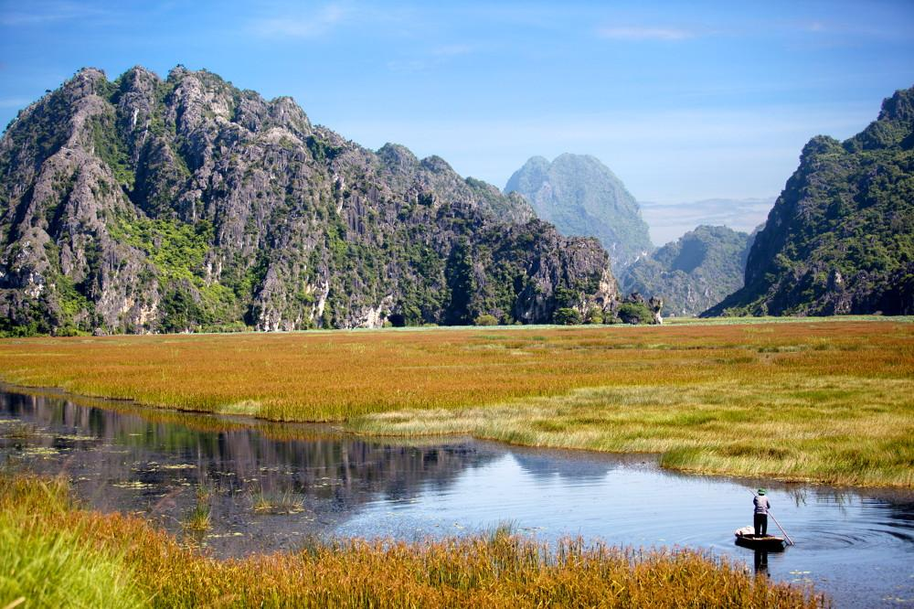
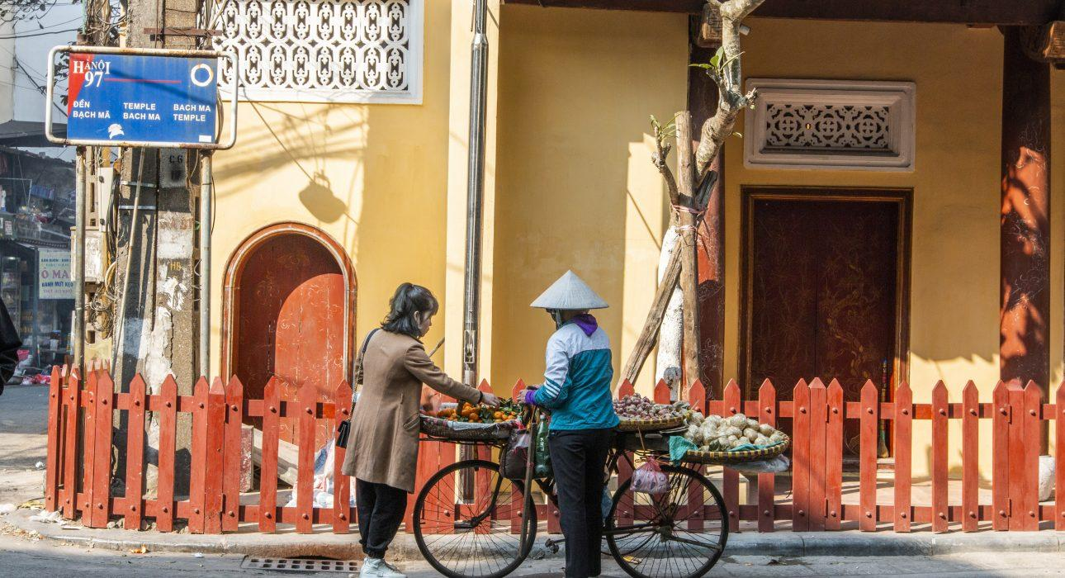
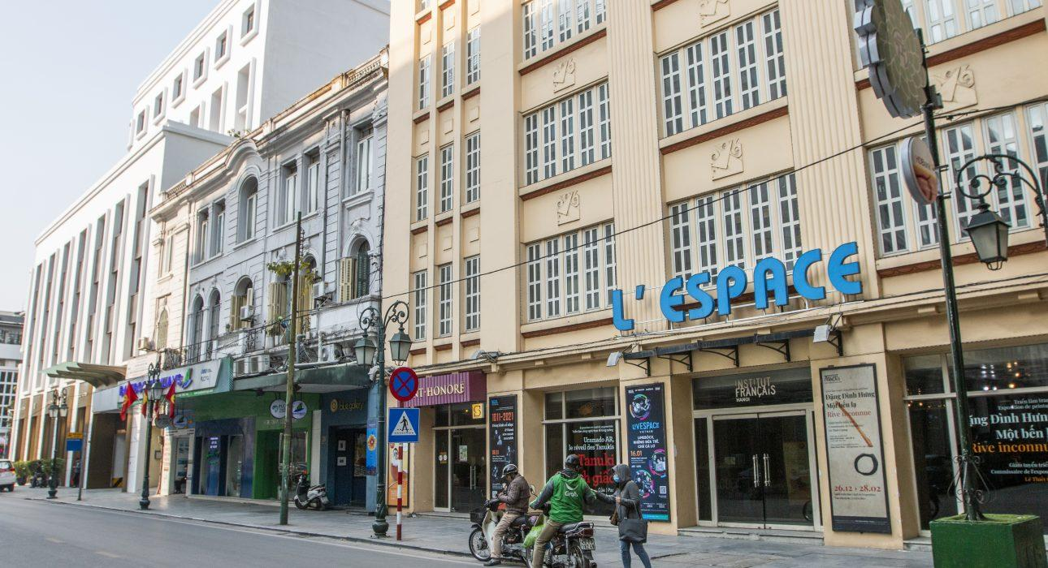
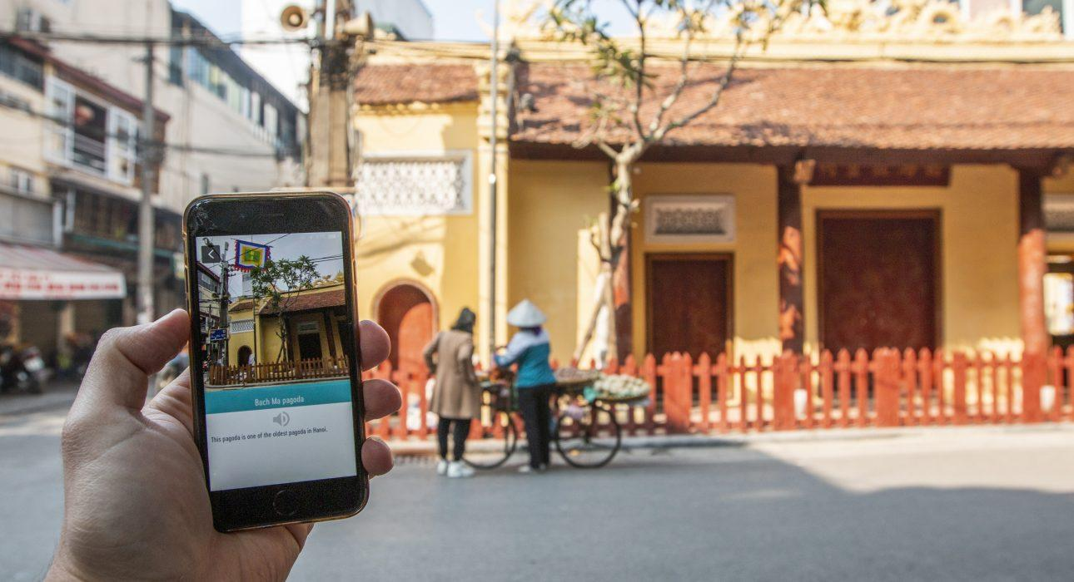
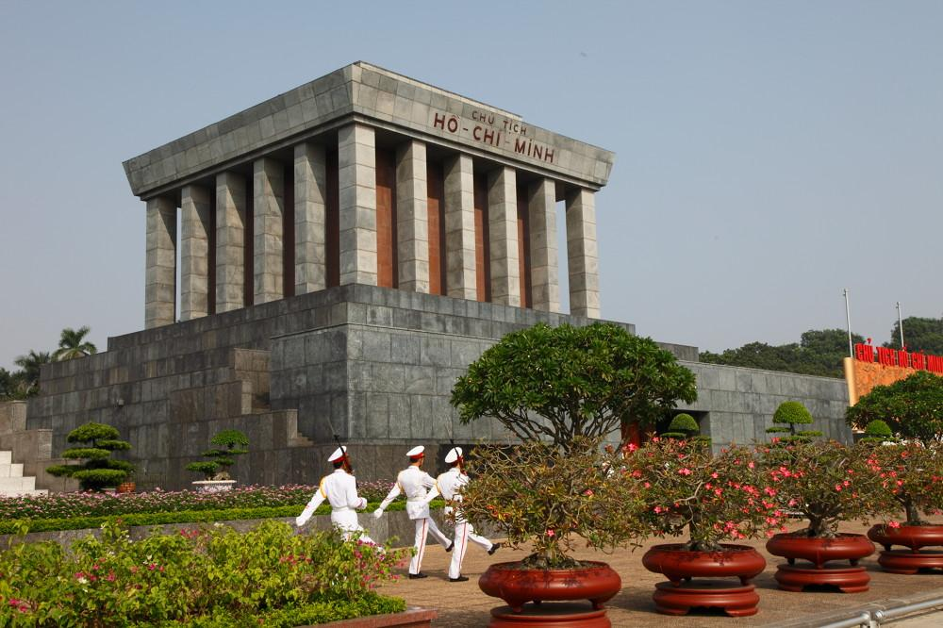

Easia Travel Head Office

Vietnam Head OfficeC/o: ATS Hotel, Suite 326 &327, 33B Pham Ngu Lao Street, Hanoi, VietnamTel: +84 24-39 33 13 62www.easia-travel.com

