THAILAND – Classic Thailand Self-Guided 10D9N
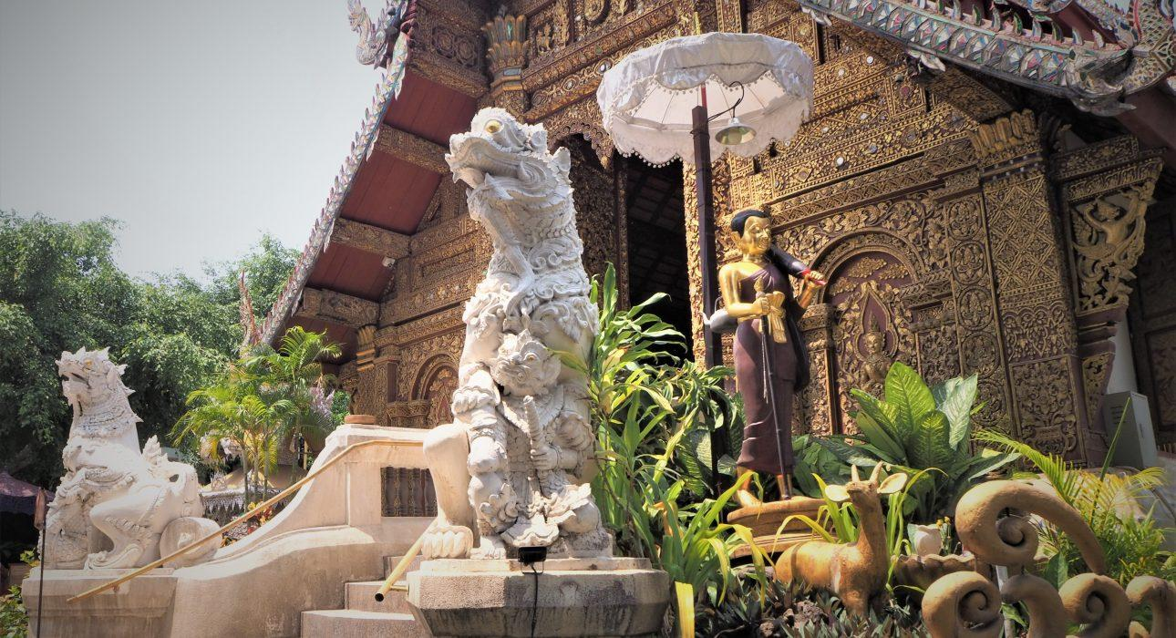

Over View

Theme
Art & Culture, Classic, Family, Self-Guided Tours

Country - City
Thailand - Bangkok - Chiang Mai - Phuket - Ayutthaya

Level of difficulties
LEVEL 1

Price level
$$$$

Seasonality
All year round, best period from November until March

Max Pax
10

Market segment
Thematic Leisure

Arrival City
Bangkok

Departure city
Phuket

Itinerary

Number of days and nights
10 days & 9 nights (but possible to customize and/or extend)

Day by day description
This experience provides an in-depth discovery of Thailand’s classic destinations like Bangkok, Ayutthaya, Chiang Mai, and Phuket with the help of pre-loaded itineraries on travelers’ smartphones. With precise GPS routing and indications (including pictures & videos) on the navigation & points of interest, this itinerary focuses on exploring Bangkok, the country’s bustling capital, the ancient ruins of Ayutthaya that are designated as UNESCO World Heritage, and the charming northern city of Chiang Mai before heading south the famous beach destination Phuket. Various self-guided activities provide a way to discover the lesser-known side of the must-see places, like an in-depth exploration of local neighborhoods in Bangkok, cycling along century-old ruins in Ayutthaya, exploring the old trade district of Chiang Mai or immersing in the food and culture of Phuket’s Old Town. This is balanced with some free time to allow for maximum flexibility and independent exploration.Depending on the needs of the travelers, there are endless options to add classic guided extensions to each destination.

Selling points

- Carefully selected activities provide a self-guided discovery of Bangkok, Ayutthaya, Chiang Mai, and Phuket.
- An application filled with GPS routes and points of interest for travelers to explore the towns and local neighborhoods on their own.
- A well-structured program providing a complete visit to Thailand’s leading destinations in a new way
- Excellent accommodation options in each of the destinations, making it suitable for a wide range of clients
- Easy to upsell with guided experiences or extensions in each of the places visited

Options

Extensions
- Possible to extend with day trips in each of the places visited
- Kanchanaburi extension between Bangkok and Ayutthaya
- Mae Hong Son Loop between Chiang Mai and Phuket
- Extension to Chiang Rai between Chiang Mai and Phuket

Photos

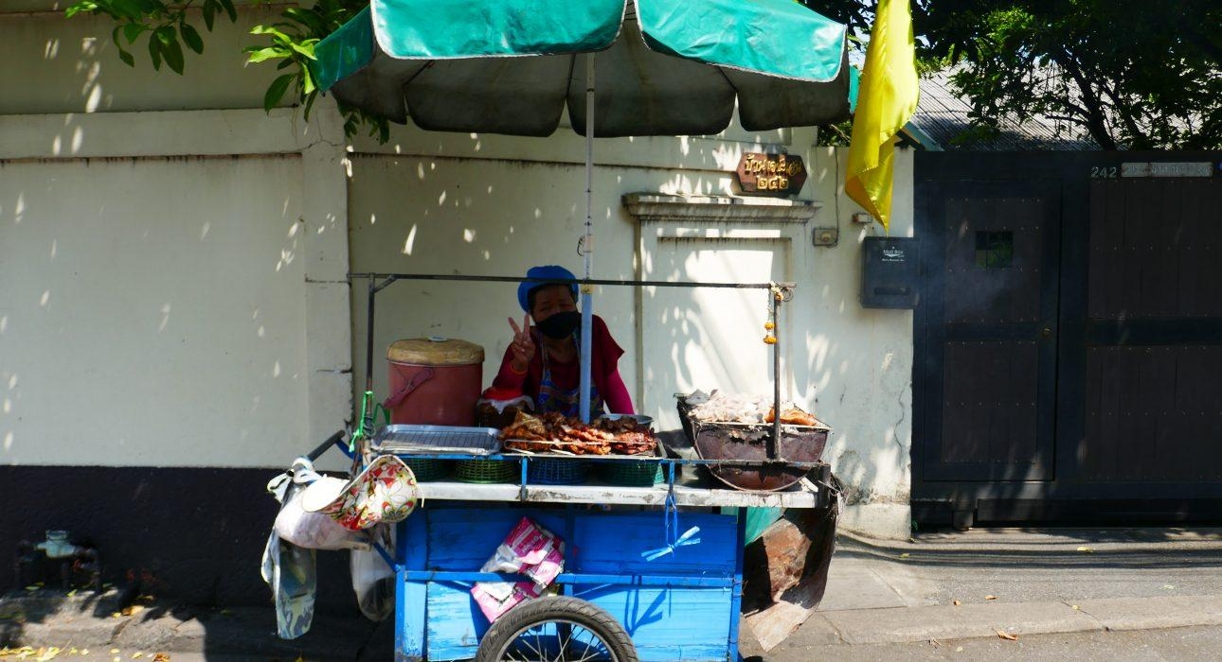
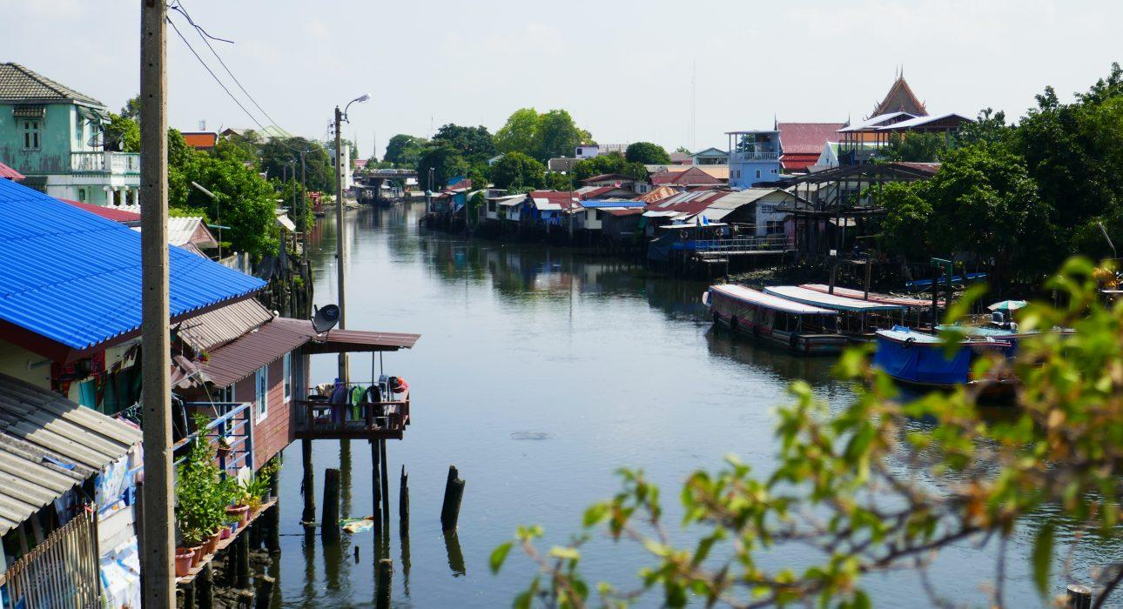
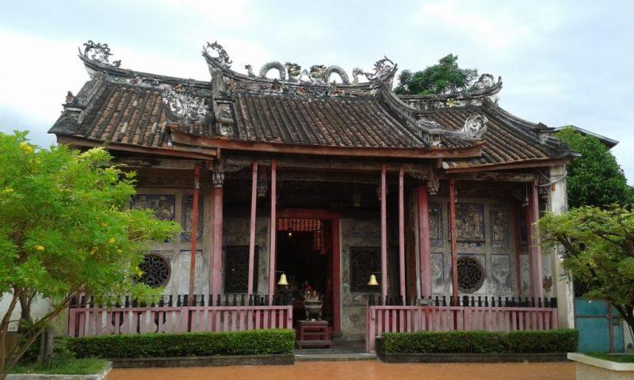
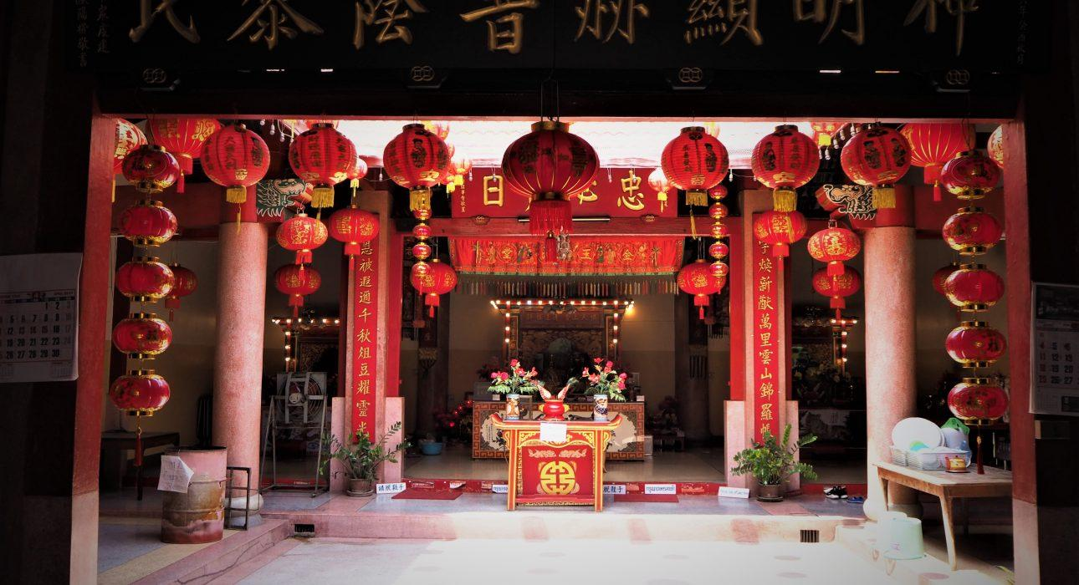
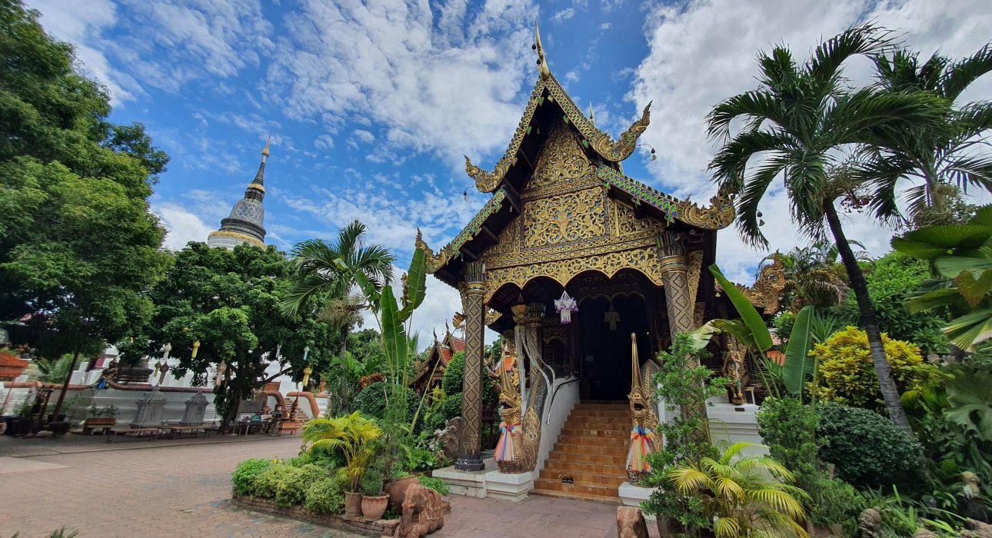
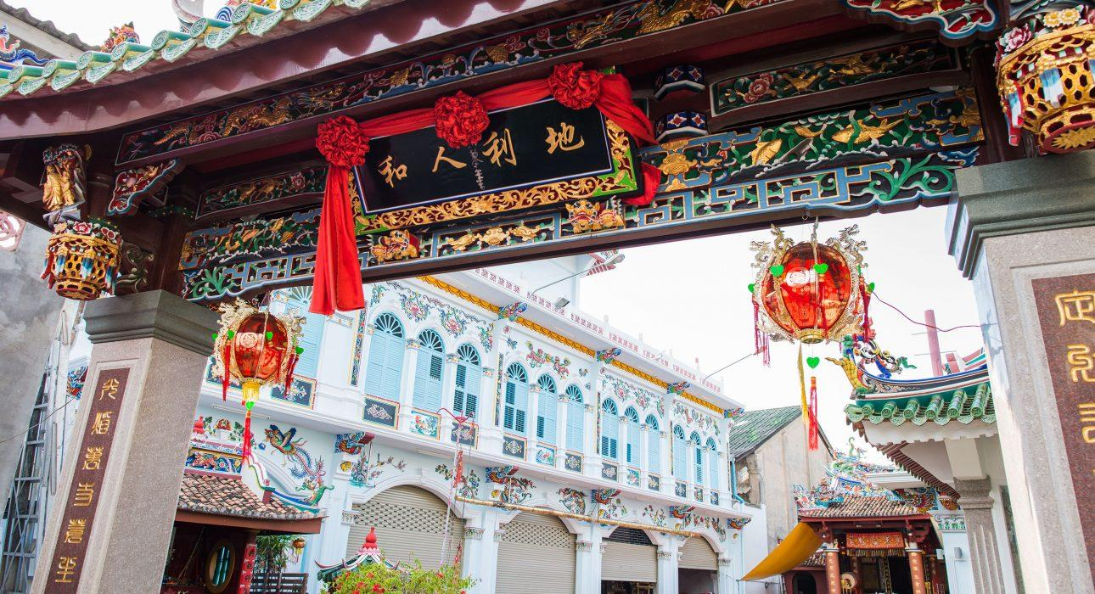
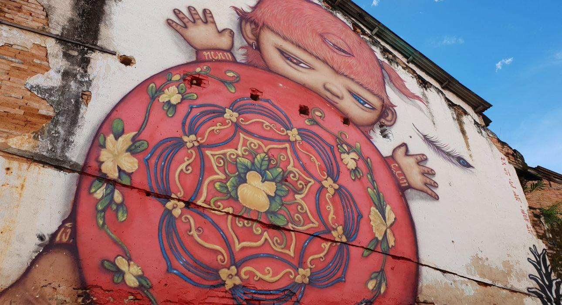
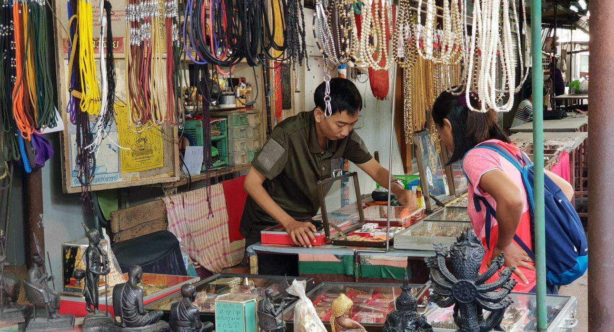

Easia Travel Head Office

