THAILAND – Bangkok – Bangkok Explorer 4D3N (Hybrid)
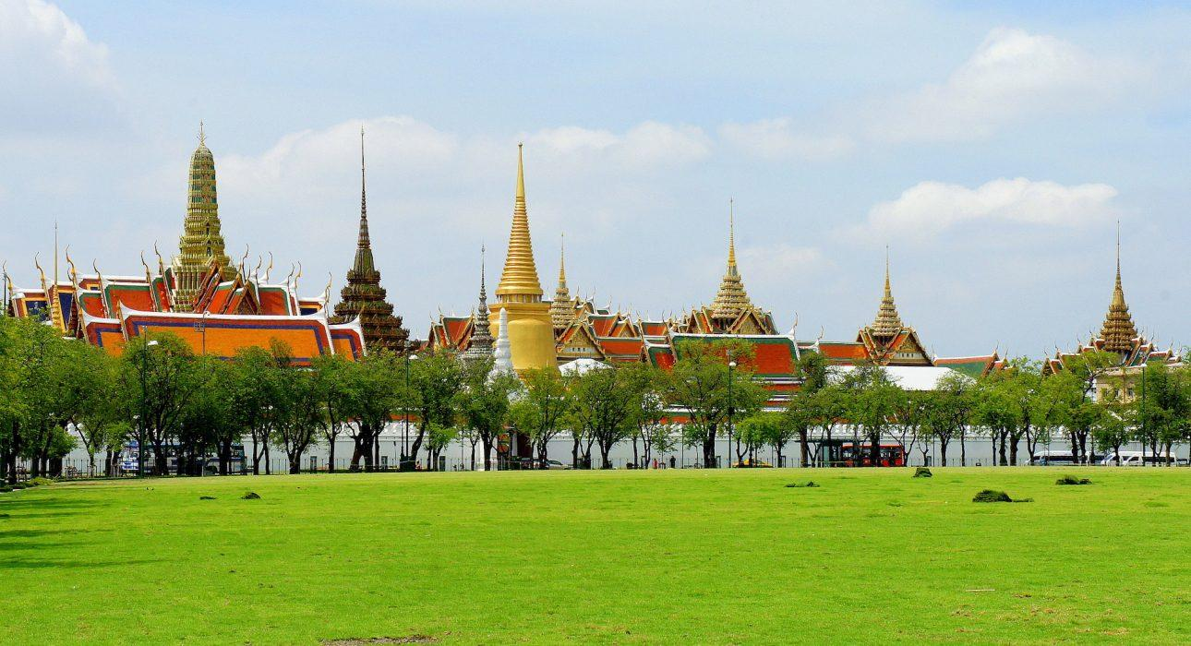

Over View

Theme
Art & Culture, Classic, Self-Guided Tours, Sustainable

Country - City
Thailand - Bangkok

Level of difficulties
LEVEL 1

Price level
$

Seasonality
Possible all year round, best period from November to February

Max Pax
10

Market segment
Thematic Leisure

Arrival City
Bangkok

Departure city
Bangkok

Itinerary

Number of days and nights
4 days & 3 nights (but possible to customize and/or extend)

Day by day description
This module provides an in-depth discovery of Thailand’s bustling capital with the help of pre-loaded itineraries on the travelers’ smartphone, combined with a guided experience to provide the best possible experience. With precise GPS routing and indications (including pictures & videos) on the navigation & points of interest, this itinerary focuses on a walking tour in Chinatown, Bangkok’s cultural melting pot, and a cycling tour in Bang Krachao, an unexpected green oasis hidden in plain sight. It also includes a private, guided Khlong tour that allows a behind-the-scenes look at daily life on the canals and some free time to explore some of Bangkok’s other attractions independently. Depending on the needs of the travelers, there are endless options to add classic guided extensions or self-guided experiences in other destinations.

Selling points

- Carefully selected activities providing a mix of self-guided and guided discovery of Bangkok’s highlights and lesser-known areas
- An application filled with GPS routes and point of interests for travelers to explore Bangkok on their own.
- A well structured program providing a full visit of Bangkok in a new way
- Easy to upsell with guided or self-guided experiences or extensions in other destinations

Options

Extensions
- Possible to extend with a day trip to Ayutthaya (self-guided or guided)
- Potential to grow any guided activities
- Kanchanaburi extension
- Classic itineraries in the rest of the country
- self-guided experiences in Chiang Mai and Phuket

Photos

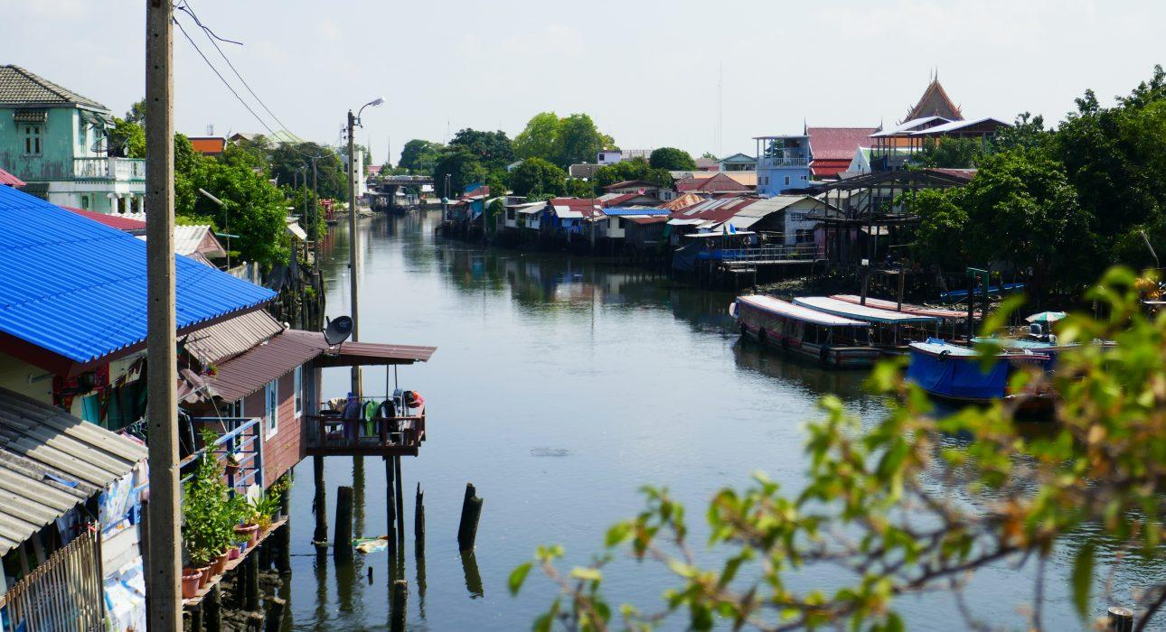
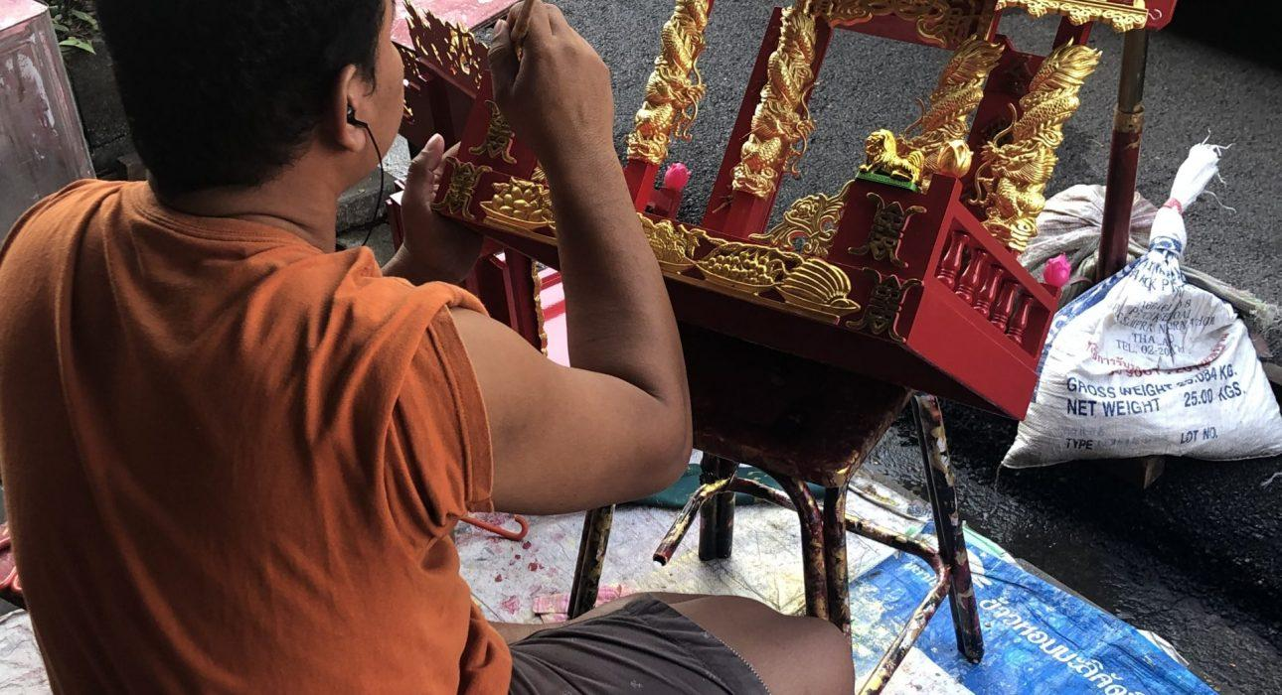
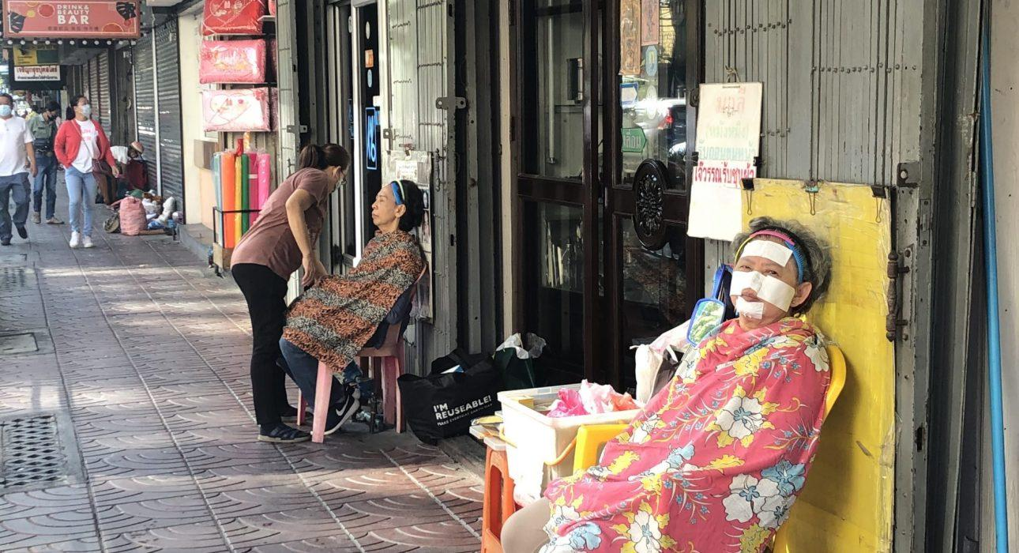
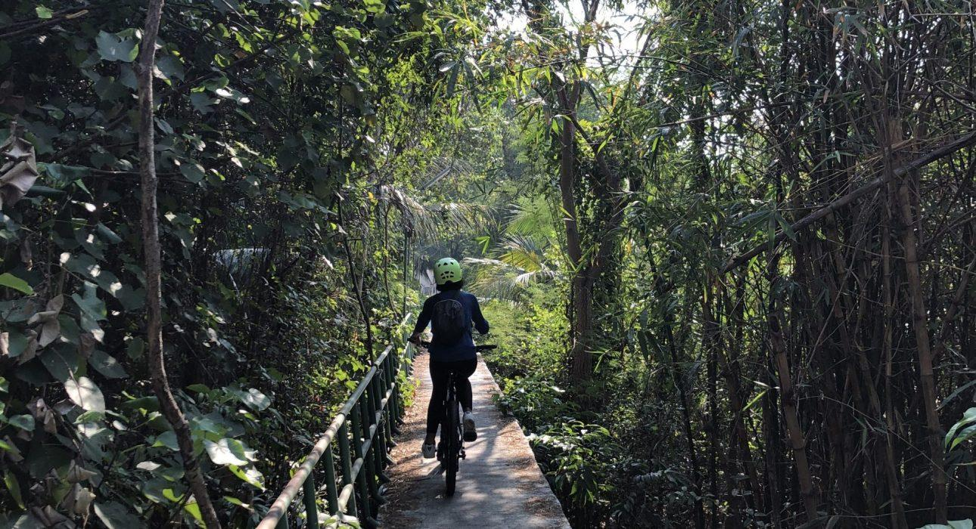
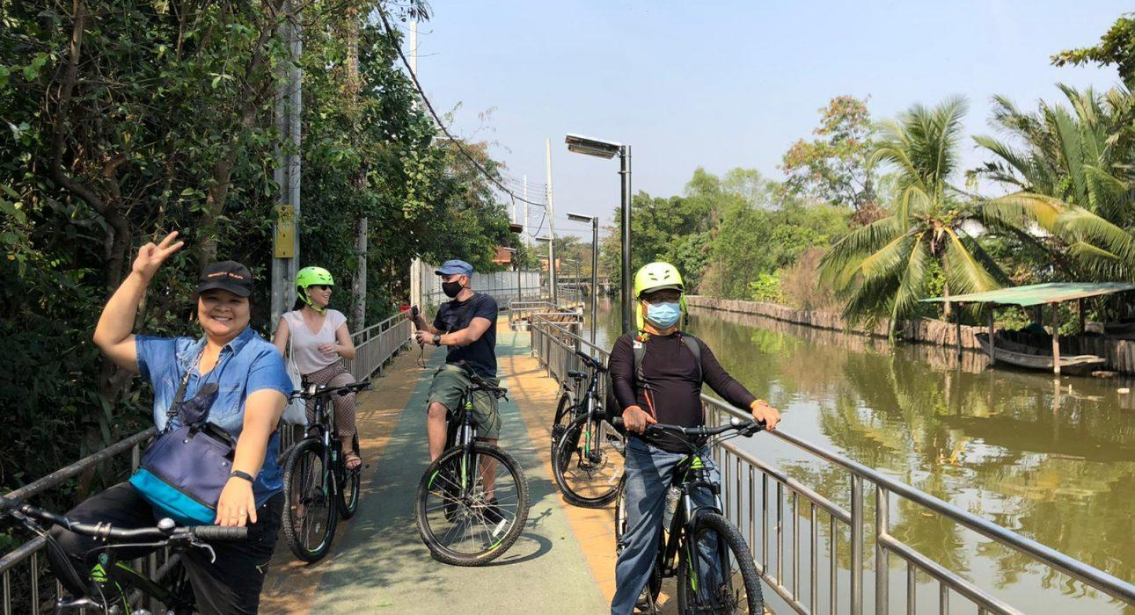
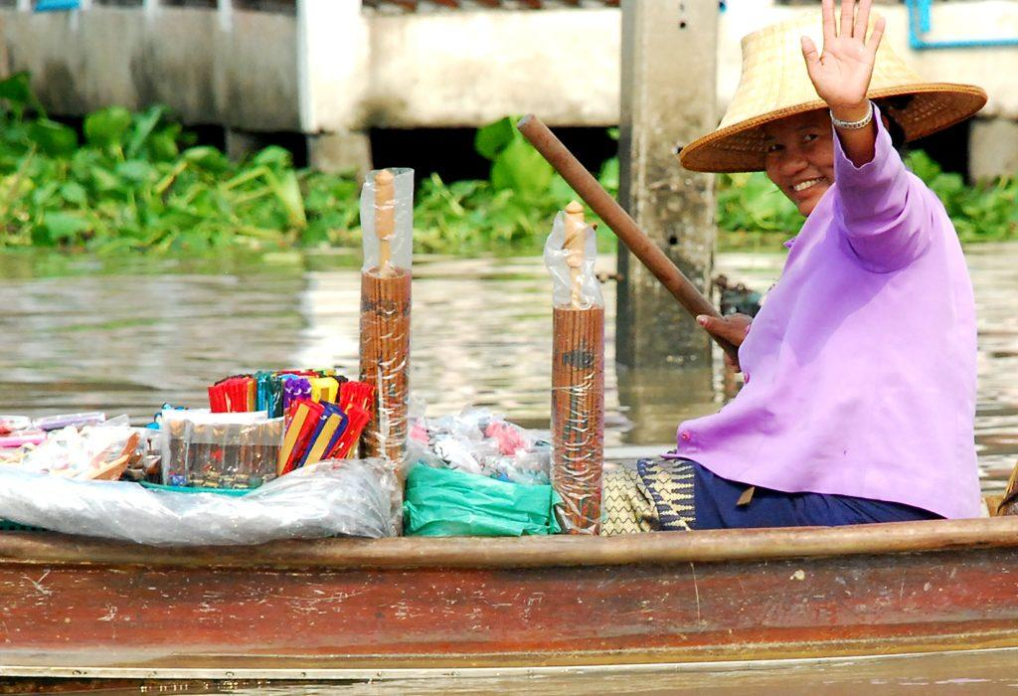
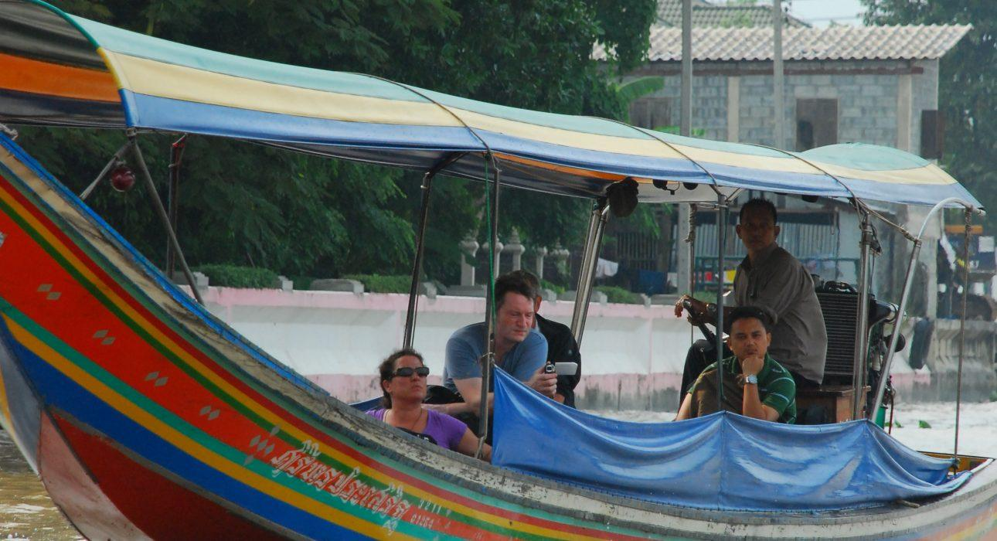

Easia Travel Head Office

Vietnam Head OfficeC/o: ATS Hotel, Suite 326 &327, 33B Pham Ngu Lao Street, Hanoi, VietnamTel: +84 24-39 33 13 62www.easia-travel.com

